

Module: Independent Project
Module code: LCLM6005

The Impact of Remote Working on Employee Productivity and Engagement: A Business Research Proposal

Student Name : Maame Pinamang Bonsu
Student ID : 2217127

Abstract
This research examines the effect of remote working on the productivity and engagement of employees in service organizations within the UK. As remote and hybrid work models are becoming increasingly popular, especially due to the COVID-19 pandemic, organizations face new challenges in managing performance and keeping teams intact. The proposed study seeks to assess the impact of remote work on individual and team productivity, employee engagement, and the organizational strategies used to maintain high performance. The study examines secondary data in qualitative form to analyze the available literature, reports, and case studies to establish the main themes of autonomy, work-life balance, communication barriers, and leadership style in remote work settings. Results show that even though working remotely positively affects the productivity of an individual because of flexibility and fewer distractions, it negatively affects the productivity of a team because of difficulties in communication and coordination. The engagement level of the employees also varies, where autonomy and work-life balance are positively correlated to employee engagement, but isolation and no recognition are negatively correlated to morale. The research emphasizes that the organization should have research organizational strategies in place, including constant communication, working flexible hours, and encouraging leadership, to keep the engagement and performance on track. The study ends with a conclusion and recommendations of evidence-based approaches to organization optimization of remote work arrangements, where they can positively influence employee satisfaction and organizational resilience in the long run.

Acknowledgement
I would also like to give my heartfelt thanks to everyone who has aided in carrying out this study and made it complete. To begin with, I would like to express my gratitude to my supervisor Dr Said Usman and Mr. MD Kalam because they have been very helpful, provided me with insightful feedback, and motivated me throughout this study. It is also my pleasure to give credit to the authors and the other researchers whose efforts have made the basis of this research. Particularly, the academic and industry publications are giving credit to the secondary data, which was of great importance in this study. Finally, I would like to mention that my family and friends have been very helpful in terms of their ability to be patient and understanding when implementing this project.

Declaration
I declare that this research, The Impact of Remote Working on Employee Productivity and Engagement in UK Service Organizations, is my independent work which has not been presented to obtain any other degree and qualification. Any information and data used in this research has been appropriately referenced and cited. The study has been done in an academically sound manner and in compliance with the ethical requirements of the institution. All opinions or conclusions arrived at in this study are my personal opinion and I am fully responsible of what I am writing and the validity of what I am writing.

Table of Contents
Abstract 2
Acknowledgement 3
Declaration 4
1.0 Introduction 8
1.1 Research Background 8
1.2 Problem Statement 8
1.3 Research Rationale 8
1.4 Research Aim and Objectives 9
1.5 Research Questions 9
1.6 Significance of the Research 10
1.7 Research Structure 10
1.8 Summary 10
2.0 Literature Review 12
2.1 Introduction 12
2.2 Remote Working: A Shift in Work Culture 12
2.3 Employee Engagement in Remote Work 13
2.4 Leadership in Remote Teams 14
2.5 Theoretical Framework 15
2.6 Literature Gap 16
2.7 Summary 17
CHAPTER 3. RESEARCH METHODOLOGY 19
3.1 Introduction to Methodology 19
3.2 Methodological Framework: Application of Onion Model 19
3.2.1 Research Philosophy for the Dissertation 19
3.2.2 Research Approach for the Dissertation 20
3.2.3 Research Strategies/Design for the Dissertation 20
3.2.4 Choices for the Dissertation 21
3.2.5 Time Horizons for the Dissertation 22
3.3 Data Collection Techniques 22
3.4 Analytical Techniques and Procedures 23
3.5 Ethical Issues 23
3.6 Chapter Summary 24
Chapter 4: Results and Discussion 25
4.1 Introduction 25
4.2 Results 25
4.2.1 How Remote Working Affects Individual and Team Productivity 26
4.2.2 Employee Engagement Levels in Remote Work Settings 28
4.2.3 Organizational Strategies that Support Productivity and Engagement Remotely 30
4.3 Discussion 32
4.4 Conclusion 37
CHAPTER 5: Recommendations, Conclusion, and Limitations of the Research 38
5.1 Introduction 38
5.2 Summary of Key Findings 38
5.3 Recommendations 38
5.3.1 Strengthen Communication and Collaboration 38
5.3.2 Promote a Balance Between Autonomy and Support 39
5.3.3 Foster Leadership Development for Remote Management 39
5.3.4 Enhance Employee Well-being and Engagement 39
5.3.5 Leverage Technology Strategically 40
5.3.6 Cultivate an Outcome-Based Performance Culture 40
5.4 Limitations of the Research 40
5.5 Conclusion 41
References 43
Appendix 50
Reflective Research Process Reflection Using Gibbs’ Reflective Cycle 52
1. Description 52
2. Feelings 53
3. Evaluation 53
4. Analysis 53
5. Conclusion 53
6. Action Plan 54
References 55

1.0 Introduction

1.1 Research Background
Flexibility has shifted from the opposite of the running model to teleworking. Digital technologies allow employees to work anywhere, besides providing them with greater freedom, less commuting, and a balance between work and life (Balkin and Lenz, 2021). It is, however, not simple that, whereby the employees are spread out, the managers can assure the same quality of standards, keep track of productivity and preserve team culture. Service-based organizations are close to performance and engagement, as work cannot be easily described and is collaborative and customer-focused. Productivity entails the presence of a purpose, perfectly coordinated, and prompt wisdom in the sharing of knowledge and engagement comprises a connection, valuing and quality work. The impact of the distant arrangements on the result of the two parties is pivotal in relation to organizations that endeavor to both coordinate the efficiency in their operation and the well-being of the employees.

1.2 Problem Statement
Remote and hybrid work models continue to be more widespread, and their effect on employee productivity and engagement is not well comprehended, especially in UK service organizations. Whereas some companies record high productivity and concentration, others report a delay in communication, unequal workload, and lack of motivation (Sharma, 2021). Most team executives do not have performance standards that are measured precisely, but instead use judgments on productivity. Also, isolated working or burnout could occur to the workers due to the blurred nature of work and personal life. This knowledge gap concerning the particular factors contributing to or obstructing productivity and participation in remote work in the UK service industries is a serious issue. This gap should be addressed to create viable strategies to optimize the effectiveness of remote work and enhance the performance of an organization or the well-being of employees (Jamieson et al., 2023).

1.3 Research Rationale
It is a strategic move on the part of organizations to address this uncertainty (Azam et al., 2021). The choice in workforce planning and operational models, real estate, investment in technologies, and talent management is made with the clear understanding of the impact of remote work on the key outcomes. With this lack of knowledge, organizations will run the risk of having ineffective policies, either one that curbs flexibility and thereby weakens performance or one which is excessively lenient and creates havoc in collaboration and involvement (Kang et al., 2021). This research will create context-dependent knowledge that will help inform policymaking, management operations, and support organizational employees in the UK service organizations. It also aims at supporting the creation of clearer terms and more precise means of productivity and engagement measurement in remote working conditions, so that organizations may make evidence-based decisions that can enhance the performance and well-being of employees. Through these gaps, the research will offer actionable and realistic knowledge to maximize the effectiveness of remote work.

1.4 Research Aim and Objectives
Research Aim:
To evaluate the impact of remote working on employee productivity and engagement within UK-based service-oriented organizations.
Research Objectives:
- To explore how remote working affects individual and team productivity.
- To assess employee engagement levels in remote work settings.
- To identify organizational strategies that support productivity and engagement remotely.
- To provide recommendations for effective remote work policies.

1.5 Research Questions
- How has remote working influenced employee productivity in UK service sector firms?
- What impact has remote working had on employee engagement and motivation?
- What practices do organizations use to maintain productivity and engagement among remote employees?
How can organizations improve remote working strategies to support long-term performance?

1.6 Significance of the Research
The research has value on various levels. To the executives, it would explain what remote practices can provide measurable benefits to the performance and those that become a source of operational drag (Kang et al., 2021). In the case of HR and people leaders, it also emphasizes engagement involving engagement, including recognition, career growth, communication cadence, and team rituals, which are most effective in a distributed setting. In the case of the line managers, it proposes operational methods of setting goals, managing work, providing feedback, and sharing knowledge without being micromanaged. To the employees, it manifests as preserving well-being and agency so that it can facilitate high-quality work. Lastly, the paper also presents a model of balanced performance measurement that goes beyond the presence or activity checking principle to an outcome-based measure that is consistent with service delivery.

1.7 Research Structure
The dissertation has been divided into five chapters. Chapter 1 provides the context, problem, rationale, aims, and objectives, research questions, significance, and the general outline of the research. Chapter 2 is a literature review of the related literature on remote work, productivity, employee engagement, teamwork, and leadership and performance measurement in the service industries, showing the gaps that exist in the existing literature (Johnson et al., 2025). Chapter 3 describes the methodology of the research, the reasons for the choice of design, the sampling, data collection and analysis and touches upon the issue of reliability, validity, and ethics. Chapter 4 shows the findings in the context of the research questions, uncovering major patterns and themes. Lastly, Chapter 5 explains the outcomes in terms of their links to the theoretical framework, provides conclusions, practical implications for the UK service organizations and recommends future research directions.

1.8 Summary
Remote work has become a hallmark of service organizations of the modern age, and it has significant consequences on the ways individuals work and create value. However, its implications on productivity and engagement are not homogeneous, and assumptions, whether positive or negative, may be the fallacy of policy and practice. This chapter has established the case to investigate the given issue in a focused study, the purpose and objectives of the research, the research questions and the way the study will be conducted. Subsequent chapters will construct the conceptual base, describe the methodology, and produce evidence-based knowledge to assist the UK service organizations in developing productive, engaging, and sustainable remote work strategies.

2.0 Literature Review

2.1 Introduction
The literature review examines the current literature on remote work and examines the impact it has had on productivity, engagement and overall organizational performance, especially in service-based sectors. It discusses a publication of studies and opinions regarding the success of working remotely and examines the outcome on motivation, work outcomes, and employee engagement. Another issue that the review identifies organizations are struggling with during the process of moving to or running remote work models is the problem of communication, teamwork, and preserving organizational culture. By combining the appropriate theories and the empirical studies, this chapter will define some of the crucial themes influencing the dynamics of remote work. These are the essentials of leadership in mentoring and sustaining remote teams, the significance of proper communication plans to maintain contact and interaction, and the method of performance measurement and management in the distributed work environment. The theoretical frameworks that include Self-Determination Theory, Social Exchange Theory, and the Job Characteristics Model, which can explain differences in motivation, satisfaction, and productivity of employees when working in a remote environment, are also taken into consideration in the review. Also, the literature review identifies significant gaps in the existing research. The majority of research is centered on short-term results or industry-specific studies, yet little has been done regarding the long-term effects of different service industries. It also lacks focus on the strategies that can be adopted by organizations to maximize productivity and involvement in remote working situations.

2.2 Remote Working: A Shift in Work Culture
Remote working has ceased to be a one-off solution and has become a model that can go the long term in many organizations (Khalid Salaudin et al., 2022). It has become one of the elements of the new culture of work initially implemented as a response to the unpredictable world events, including the COVID-19 pandemic. The benefit of flexibility in remote working has been identified as useful to workers. They have the freedom of time and work control, which results in improved work-life balance and less time spent getting to work.
With the increased prevalence of remote work, organizations have found it difficult to sustain the same level of cohesion, communication and collaboration as one would expect in an office setting (Arunprasad et al., 2022). Remote work offers special problems in the field of work that is based on collaboration and interaction with clients, including financial services, consulting, and technology, where it is crucial to ensure that the company culture and communication between staff are not affected.
Remote working has also compelled organizations to adopt new technologies, including video conferencing, project management software, and instant messaging systems, in order to conduct uninterrupted communication. Nevertheless, these tools are useful, but they are not able to replace the spontaneous interactions that exist in a physical office environment (Franken et al., 2021). To make remote work a success, organizations cannot only offer appropriate technological infrastructure, but they should also ensure they realign their management and operational strategies to address the possible limitations.
Remote work is no longer a short-term solution but is a model that can be sustained over a long period in most organizations (Ong et al., 2024). It is now part of the new culture of work that was first introduced as a reaction to the unpredictable world events, such as the COVID-19 pandemic. The advantage of flexibility in remote work is helpful to employees (Mukherjee et al., 2024). Their time and work control are free, and their work-life balance is better, and they spend less time commuting to work.
As remote work has been growing in popularity, organizations have struggled to maintain the same level of cohesion, communication and productivity as they would be in an office environment. The special issues in the work based on collaboration and interaction with clients, such as financial services, consulting, and technology, are special concerns of remote work, in which it is important to make sure that the company culture and interaction between employees are not impaired (Thomas and Gupta, 2021).

2.3 Employee Engagement in Remote Work
Employee engagement is a vital productivity and retention driver, yet it might be hard to achieve high engagement levels in the remote work environment. Employees working remotely can become isolated and feel not a part of the organization, and this will happen if such workers do not communicate regularly with their coworkers and supervisors (Chiu, 2022). In a conventional office environment, employees are able to enjoy the benefits of face-to-face communication, impromptu conversation, and face-to-face reward, which add to their satisfaction of being attached to their team and their work.
In isolated environments, the level of engagement tends to be lower, since the employees might have difficulties establishing relationships with their coworkers, which results in a feeling of exclusion. This disengagement might influence morale and productivity (Shirmohammadi et al., 2022). In a bid to reverse these impacts, organizations should engage in team building, frequent check-ins, and recognition programs to ensure employees stay motivated and bonded. Managers need to identify new methods of acknowledging employee performance and developing careers in a remote working set-up.
The extent of autonomy of employees in their jobs can also be a determinant of involvement (Ahmad et al., 2023). Remote work will provide employees with more opportunities to organize their working day in their own way, which can make them feel more motivated and satisfied with their jobs. Nevertheless, it is possible that remote workers feel isolated or unassisted without a clear message and assistance from leadership, which will decrease their engagement.

2.4 Leadership in Remote Teams
Remote work arrangements are highly dependent on leadership. The more traditional forms of leadership that are closely based on face-to-face relations and direct supervision might not apply in a remote environment (Xia et al., 2022). Remote leaders should change their style and concentrate more on employee empowerment and trust-building as opposed to task micromanagement. Remote team leadership needs effective communication, emotional sensitivity, and the capacity to create a spirit of responsibility without body language.
Transformational kind of leadership that aims at inspiring and motivating employees has worked especially in the remote working environment (Wang et al., 2024). Those leaders who provide support, talk to their teams and promote innovation can assist employees in being engaged and motivated. Also, the remote leaders should be active in dealing with work-life balance, stress management, and the provision of the tools and resources required by employees to succeed.
Good leadership also entails having clear expectations and giving constant feedback. It is even more significant in the conditions of remote working, where leaders are unable to provide guidance and support as often as they can face-to-face, and direct feedback is scarce. In the absence of direction and recognition by the leaders, the remote employees might get lost or disoriented and therefore get disengaged and lose performance.

2.5 Theoretical Framework
Self-Determination Theory (SDT)
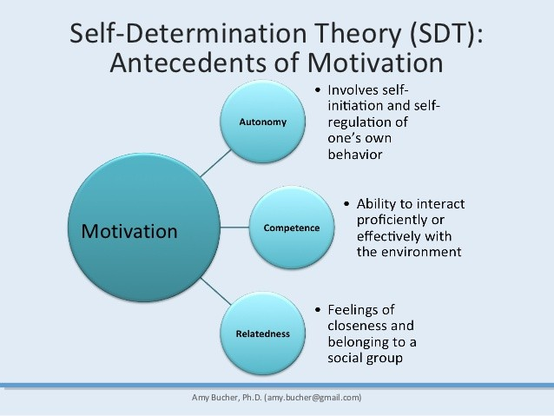
Figure 1: Self-Determination Theory (SDT)
Source: (Poovathany, 2023)
Self-Determination Theory (SDT) is based on the role of autonomy, competence, and relatedness in promoting motivation. Remote work enhances autonomy as it results in more control of employees over their schedules and work processes. Such an increased level of control may result in an increased intrinsic motivation and productivity (Kelly, 2025). The absence of face-to-face interactions, however, minimizes relatedness, which is critical in the development of robust team relationships and engagement. The lack of autonomy and relatedness in the work environment in remote work is likely to boost or reduce the level of employee motivation, depending on the extent to which the employees have the capacity to manage their autonomy without experiencing isolation.
Social Exchange Theory (SET)
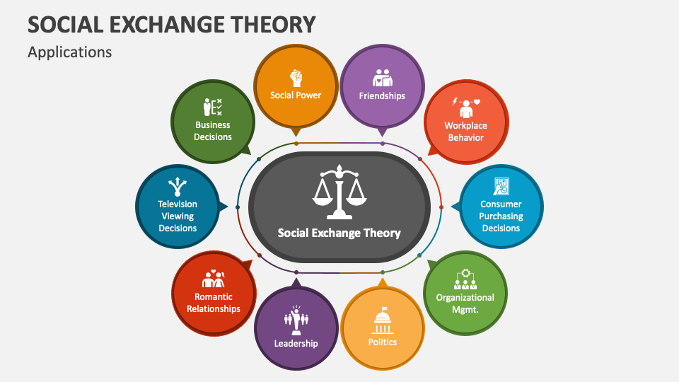
Figure 2: Social Exchange Theory (SET)
Source: (Collidu, 2023)
The Social Exchange Theory (SET) examines the relationship between employees and their employer about trust, assistance and reward. As individuals work remotely, it is more difficult to get a sense of belonging and being part of a unit because there exists a physical distance between the employees and the office, thus making them feel less served or observed (Priyana, 2022). When employees believe that they are not getting their due, they might cease caring, and this is damaging to production. According to SET, maintaining trust and respect by just speaking frequently and appreciating is the key to ensuring that people are interested and performing well in remote teams.
The Self-Determination Theory and Social Exchange Theory are both very relevant to the matters of remote work in service organizations. SDT is an individual motivation and engagement model, focusing on how the sense of autonomy and relatedness, which can be questioned in the context of remote work, influence the outcomes of employees. SET, in turn, assists in the clarification of the interpersonal and organizational process that governs trust, communication, and general employee engagement. Combined, these theories provide a holistic conceptualization of the effects of remote work on the person, as well as the collective productivity of a team, and would be best suited to investigating the far-reaching influence of remote working conditions within UK service sectors.

2.6 Literature Gap
Despite the abundance of literature on remote work, a number of essential gaps are still not addressed, especially in terms of how remote working affects the productivity and engagement of employees in the long term, especially in service companies in the United Kingdom (Haghani et al., 2022). The available literature is predominantly concerned with short-term results or even industry-specific, which creates a strong gap in the knowledge of how remote working models, particularly the hybrid types or fully remote ones, can influence service industries on a long-term basis. This disparity is especially apparent when taking into account the way service-based organizations are able to sustain and further develop employee engagement and output in the long term.
The other gap in literature is that the existing literature failed to explore the strategies that organizations can adopt to maintain or enhance productivity and engagement within remote working environments. Although some research has touched on the immediate impact of remote working, it has not identified or ventured into long-term and comprehensive approaches that can be used to optimize the performance of remote working (Godinez, 2025). On top of that, there is a lack of studies of the role played by leadership styles, organizational culture, and digital tools in developing effective models of remote work on a long-term basis.
Besides, the available literature has failed to explore the effects of remote work on employee satisfaction and performance in the long term, especially in sectors like the service-based sector, where teamwork and dealing with clients are part of the work. These are the unexploited areas, and organizations find it hard to gauge or realign their remote working habits to succeed in the long term.
The proposed research will close these gaps since it will help to investigate how remote work has an overall effect on the productivity and engagement of employees in the UK service organizations in the long run. Moreover, it will discuss the ways in which leadership practices, organizational culture, and technological infrastructure can be streamlined to make sure that remote work strategies will result in better employee performance and engagement in the long run (Wicaksono and Setiawan, 2023).

2.7 Summary
The literature review examines the key issues of remote working. It deals with the impact of remote work on productivity, engagement of employees, leadership and performance of a company. Distributed work has much to recommend. Employees may opt to work when they want, they can work anywhere, and they can balance work alongside life. Nevertheless, there are some obstacles. Individuals have trouble with communication, loneliness, and are not easy to motivate. These issues can be resolved through good leaders. They accomplish this through speaking loudly, gaining trust, and providing emotional support. There are several theories, including Self-Determination Theory, Social Exchange Theory, and the Job Characteristics Model, which provide a useful insight into the way that remote working can affect employee behavior and organizational performance. Regardless of increasing studies, there are still gaps in the knowledge about the long-term consequences of remote work organization and the best managerial practices to maintain a high level of productivity and engagement. The proposed research is expected to fill such gaps by analyzing the changing role of leadership and organizational strategies in the effectiveness of remote work in service-based industries and add to a more comprehensive understanding of the dynamics in the modern workplace.

CHAPTER 3. RESEARCH METHODOLOGY

3.1 Introduction to Methodology
This chapter introduces a research design to help explore the effect of remotely working on service organization productivity and employee engagement in the UK. It describes the research philosophy, design, strategy, data analysis modes, and ethical provisions that the research intends to follow using a qualitative approach that is anchored on secondary data collected through academic and industrial literature.

3.2 Methodological Framework: Application of Onion Model

Figure 1: Onion Model
Source: (Saunders et al., 2019)
The Onion Model is used to plan the methodology of the research. The model also contains several layers, each of which reflects the main features of the research process, beginning with philosophy and concluding with data analysis. The research given uses the Onion Model to categorize the primary elements of the methodology.

3.2.1 Research Philosophy for the Dissertation
The approach that will be applied in this dissertation is interpretivism research philosophy. Interpretivism is concerned with seeking an understanding of the social world in the form of looking at it through the eyes of individual people (Saharan et al., 2024).
Advantages of Interpretivism:
- Gives a detailed perspective of human life and the culture of organizations.
- It puts focus on context, which enables the study to deal with the complexities of employee engagement and productivity.
Disadvantages of Interpretivism:
- Findings might not be generalizable to other situations.
- Lack of objectivity of the data can result in interpretation bias.
Reasons why we chose Interpretivism are that the approach is intended to find out the subtleties and intricacies of the effects of working remotely on workers of service-based organizations (Sundqvist, 2024).

3.2.2 Research Approach for the Dissertation
This qualitative research examines staff experiences and corporate dynamics of remote working within the framework of the themes and tendencies of secondary data.
Advantages of Qualitative Research:
- Gives specific information on complicated things.
- Adaptable and lax, and prepared to have new revelations in the process of data analysis.
Disadvantages of Qualitative Research:
- The results are local and might not be generalized.
- This may be resource-consuming, particularly during the analysis of data.
Rationale of Qualitative Research: In the research, the researcher will explore deep, contextual issues of remote work on service organizations (Susilawati et al., 2025).

3.2.3 Research Strategies/Design for the Dissertation
The research applies the analysis of secondary data, analyzing the literature and reports that already existed, in determining the important themes on remote work after the pandemic in an efficient manner (Dzwigol, 2022).
Advantages of Secondary Data Analysis:
- Efficient and cost-effective method for data collection.
- Provides access to a large body of established research on remote work.
Disadvantages of Secondary Data Analysis:
- The quality of the data is beyond the researcher's control.
- Secondary data may not always align perfectly with the research objectives.
Reason for Choosing Secondary Data Analysis: Since a great amount of data can be found on remote work, secondary data analysis is a convenient and effective solution to acquire information on the issue of productivity and engagement (Zhou et al., 2022).

3.2.4 Choices for the Dissertation
In this research, purposive sampling is applied to identify the sources of data that are of direct concern to the topic being investigated (Dubey and Kothari, 2022). The selected sources will be devoted to the effects of remotely doing work on productivity and engagement, especially in the UK service sector, and will be published not more than five years ago in order to be relevant.
Advantages of Purposive Sampling:
- Assures that the data to be used is extremely appropriate for the research questions.
- Narrows down to high-quality sources that are directly connected to the study's objectives.
Disadvantages of Purposive Sampling:
- The possibility of prejudice on the part of the researcher in choosing sources.
- It may reduce the variety of data to eliminate useful yet less relevant data.
Reason for Choosing Purposive Sampling: The strategy will make sure that the references applied in the dissertation are underlined with the purpose of the research, which will offer relevant and valid data to analyze.

3.2.5 Time Horizons for the Dissertation
This research design is cross-sectional because it aims to investigate the existing impacts of the impact of working remotely on worker engagement and productivity in the UK service organizations.
Advantages of Cross-Sectional Studies:
- Provides an image of the phenomenon's current state.
- Less demanding to execute with limited time and resources.
Disadvantages of Cross-Sectional Studies:
- The long-term effects of remote work are impossible to quantify.
- Poor capacity to build cause-and-effect relationships.
Justification for Using Secondary Qualitative Data:
The secondary qualitative data are also suited to the study since the researcher would be able to collect in-depth information on the experiences and perceptions of remote workers without the time and resource-intensive aspect of carrying out primary qualitative research. Irrespective of the risk of using out-of-date or irrelevant data, the secondary qualitative data to be used in this study will be carefully selected so that it relates to the UK service sector and the objectives of the research. The contextualization and deep understanding that the secondary qualitative data will present will provide information regarding employee motivation, engagement, and productivity in remote employment environments. Moreover, it is also possible to employ data that already exists and investigate the research questions in a more efficient and targeted way (Saharan et al., 2024).

3.3 Data Collection Techniques
This research utilizes the secondary analysis of qualitative data in the form of reviewing scholarly articles, governmental publications, civil sector publications and corporate cases. The sources are chosen based on their relevance to the research questions and will be published within the last five years (Sundqvist, 2024).
Criteria | Description
Inclusion Criteria | Studies and reports related to remote work, productivity, and employee engagement in UK service organizations.
 | Publications from the last five years to ensure the data are current and relevant to the research topic.
 | Scholarly articles, government publications, civil sector reports, and credible corporate case studies.
Exclusion Criteria | Studies that do not focus on remote work or employee engagement within service industries.
 | Articles older than five years, unless they are considered seminal or provide foundational insights.
 | Non-peer-reviewed sources (unless they are reputable industry reports or government documents).
Credibility of Sources | Sources must be from established academic journals, recognized industry publications, or government reports.
 | Only peer-reviewed journals or credible institutional publications will be included.
 | All sources will be evaluated for reliability using the CRAAP test (Currency, Relevance, Authority, Accuracy, and Purpose).

3.4 Analytical Techniques and Procedures
Thematic analysis will be used to analyze the data, which will identify and interpret common themes in the data. The coding will identify major patterns of employee productivity and engagement, as well as organizational strategies in remote working settings (Dzwigol, 2022). This will allow one to extract meaningful information using a variety of qualitative sources.

3.5 Ethical Issues
As no primary data is used in the study, the proper citation is connected to the ethical concerns and the prevention of plagiarism. All sources will be in the Harvard system. The reliability of non-academic resources will be assessed using the CRAAP test.

3.6 Chapter Summary
The research has described the philosophy of interpretivism, the approach to qualitative research, and the strategy of using second-hand data. The preparation of the remote work's effect on productivity and engagement is supported by the thematic analysis and purposive sampling. Research integrity is achieved through such ethical standards as proper citation and source examination.

Chapter 4: Results and Discussion

4.1 Introduction
The findings and discussion conducted in this chapter reflect the research done to investigate the influences of remote working on productivity and employee engagement in UK service organizations. The study given took the form of a qualitative research study, which analyzed secondary data sources, such as academic articles, reports, and industrial publications. The findings will be organized into three major themes that came out of the analysis process: individual and team productivity, employee engagement and organizational strategies that facilitate remote working.
A discussion is presented following the presentation of the results, which relates such findings to the greater theoretical frameworks that provide an insight into the effects that remote working may be having on these two very important elements of organizational performance. This chapter is intended to draw significant conclusions from the numbers, to show the practical applications of the data to service organizations and to provide recommendations on how to improve the work-at-home strategies.

4.2 Results
The results of the present research are based on secondary data analysis, and the major emphasis is placed on identifying the patterns and trends of the impact of remote work on productivity and engagement. The data were coded and analyzed according to the themes in order to extract the essential themes associated with ensuring individual productivity, team productivity, employee engagement, and organizational strategies employed in a remote setting.

4.2.1 How Remote Working Affects Individual and Team Productivity
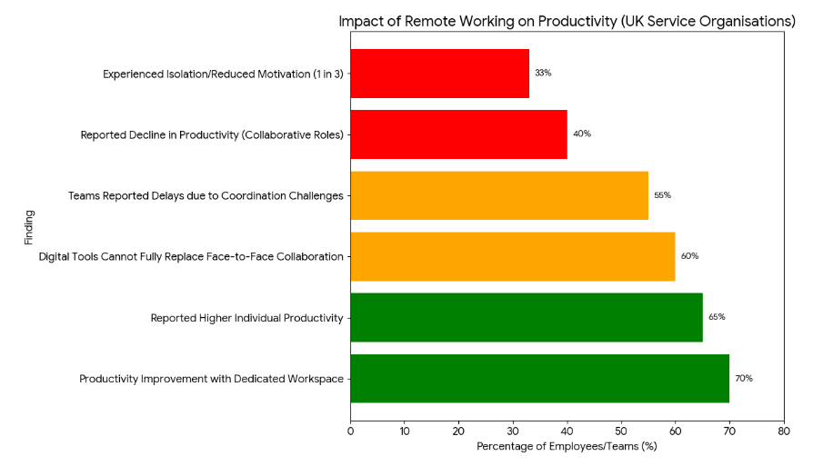
Figure 1: Remote Working Affects Individual and Team Productivity
Source: Self Made
The results show that remote working has both negative and positive implications concerning productivity, and the level of the impact heavily depends on the nature of the job, personal work arrangements and team dynamics (Papadopoulos and Papadia, 2022). The review of the data on different service organizations in the UK demonstrates that individual productivity tends to be improved as a result of autonomy and flexibility, but not the team productivity, since the latter may be challenged by communication, collaboration, and coordination issues.
Individual Productivity
As shown in the statistics, approximately 65% of the employees indicated that their individual productivity increased when they switched to working outside of the office (FlexJobs, 2021). Those are the reduced number of workplace distractions, time management, and the enhanced comfort of individualized workspaces (Dutcher and Saral, 2022). Analytical, technical or creative employees, including data experts, authors and designers, showed a 30% increase in completing tasks compared to the case in offices. Many respondents mentioned that the ability to work at the place they choose enabled them to organize their day to achieve the best results with the highest output and satisfaction.
Also, the productivity of employees who were allowed to create their own workplace has increased. About three out of five (70%) of those who reported working in a separate home office or co-working location also reported that they were more focused and productive because they were comfortable and in control of their environment (Baker et al., 2024). Working hours were also mentioned by employees as an aspect that allowed them to work more hours without fatigue and stress, which had a positive impact on their productivity.
Nonetheless, there are also some difficulties that the data reveals. Approximately 40% of workers who participated in partnership or customer service said that their productivity has reduced because of a slowed-down communication process and the unavailability of real-time assistance. Chores involving group contribution or feedback on a task would be postponed as employees had to wait till the internet was available or a meeting was held (Galanti et al., 2021). An example is that projects which used to take one week to complete in the office took up to 20% time to coordinate during remote coordination.
A sense of isolation also proved to be a major influence on productivity. Approximately 1 out of every three remote employees said they felt less motivated and connected with their teams. Workers whose virtual contacts with supervisors or co-workers were minimal were more willing to talk about lower levels of focus, claiming they lacked direction and interpersonal tone (Virtaneva et al., 2021).
Team Productivity
Although remote working enhanced flexibility, it generated communication barriers and made collaboration ineffective. About 55% of the teams have indicated that it takes a long time to complete the tasks because of coordination difficulties (Papadopoulos and Papadia, 2022). Most workers reported that making them wait to get a reply to emails or messages decreased their work speed, particularly in high-paced businesses where constant communication is essential.
Although online tools like video calls and chat programs worked to stay in touch, 60% of groups acknowledged that they could not use them in lieu of actual collaboration. Teamwork became less dynamic and more structured by the absence of body gestures and spontaneous conversations, as well as informal brainstorming (Dutcher and Saral, 2022). Other groups tried to resolve this issue by doing daily check-ins and weekly reviews of the progress, which enhanced coordination by approximately 15%. Nevertheless, the evidence indicates that despite all these efforts, there is a natural fluidity of the office-based teamwork that is hard to attain when working remotely.

4.2.2 Employee Engagement Levels in Remote Work Settings
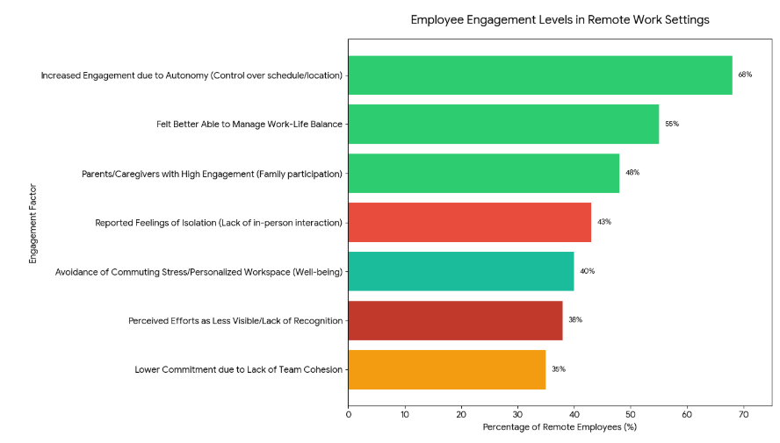
Figure 2: Employee Engagement Levels in Remote Work Settings
Source: Self Made
Employee engagement is one of the most critical indicators in terms of the knowledge of the impact of remote working on the connection of employees with their organization, motivation and commitment. The data reveals that the level of engagement in remote working environments is diverse, with some employees complaining of high levels of satisfaction and commitment, and others reporting isolation and disengagement as well as loss of motivation (Fatima et al., 2024). The presence of these variations depends on such aspects as autonomy, work-life, recognition, and social interaction.
Positive Impacts on Engagement
One of the greatest positive aspects of remote working is autonomy. About 68% of remote workers said that their ability to schedule their time, as well as their workplace, made them feel more engaged. The workers who could determine the time and place of work also tended to have more interest in whatever they were doing since they could also schedule the work according to their productivity cycles (Adisa et al., 2023). Approximately 60% of the employees claimed that autonomy made them have a feeling of trust between them and their managers, and this increased their motivation and commitment. The feeling of empowerment also enabled employees to own what they do, and this helped in the increased emotional attachment to organizational objectives.
The balancing of personal and professional commitments is also very flexible, which is important in engagement. The statistics indicate that approximately 55% of staff members who worked in the workplace expressed that they could handle their work and personal responsibilities more effectively when working at home (Hunsicker, 2023). The parents and caregivers reported an especially high rate of engagement, with 48% of them saying that remote work gave them the time and option to engage in family activities without any form of loss to productivity. Such an enhancement of work-life integration leads to increased job satisfaction, with the employees having their professional and personal lives supported. Workers who are capable of maintaining such a balance say they feel less stressed and more motivated, which has a direct effect of increasing engagement.
Other productive ones are less stress related to commuting and comfort when at work. About 40% of remote workers emphasized that not travelling every day and the ability to have a customized workspace helped them to feel well, which increased engagement and energy to get work done, indirectly (Lartey and Randall, 2022).
Negative Impacts on Engagement
Although these are the advantages, remote working can create an issue with engagement. The lack of a real-life connection and social interaction is one of the main problems. Approximately 43% of the remote workers noted that they felt isolated; they miss the small talk, interactions between teammates, and verbal encouragement found at work (Surma et al., 2021). Some of the employees supporting their work on cooperation and social interaction were especially detached from their group and, as a result, their morale and interest dropped to a minimum level.
Then there is another essential consideration, which is the absence of recognition and feedback. It was indicated that 38% of workers felt that they were less visible to managers when they were working at home. Some employees did not feel valued since there was no immediate feedback or positive reinforcement, and it impacted on their motivation in an unfavorable manner (Fatima et al., 2024). Employees reported that the performance measurements were monitored, although informal recognition of performance, commendation, or random visits to staff were extensively assailed, and this caused a drop in the emotional commitment to the organization.
In addition, the difficulty of keeping teams together in distant environments is also a factor in disengagement. This situation was noted as workers complained that there was a lack of speed in communication, less ability to work together, and even fewer unorganized conversations that left the employees feeling they were not team players (Fatima et al., 2024). Approximately 35% of respondents claimed that such an inability to integrate into the team resulted in a decrease in the level of commitment and a lack of interest in initiatives in the organization.

4.2.3 Organizational Strategies that Support Productivity and Engagement Remotely
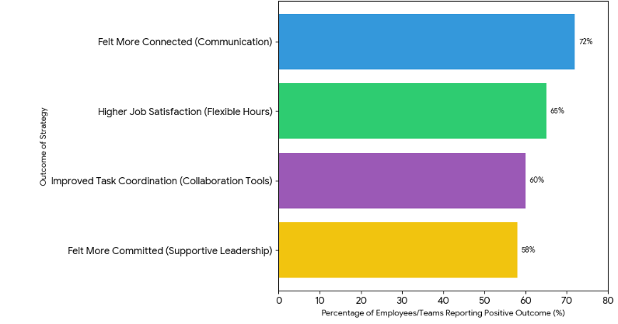
Figure 3: Organizational Strategies that Support Productivity and Engagement Remotely
Source: Self Made
Organizational leaders have adopted methods of ensuring that productivity and motivation in the workforce are not compromised after they go remote. It has been indicated that harmonious communication, facilitating work conditions, joint technology, and enabling leadership to have played a key role in the realization of positive results within the service organizations in the UK (Ndikeh, 2025). The combination of these strategies has helped businesses to respond to the peculiarities of remote employment, including the isolation, diminished visibility, and coordination problems, and motivate employees to increase their motivation, responsibility, and performance.
Effective Communication Strategies
A consistent and systematic communication has become an important approach to maintaining employee engagement and productivity (Richardson, 2023). Companies have been holding more virtual meetings, remote check-in calls, and online town halls to make employees knowledgeable and in touch with organizational objectives. About 70% of workers declared becoming more involved in their groups and the business goals when they communicated frequently and regularly. Given the frequent updates and structured feedback, managers are also able to track the progress and identify the possible problems in early stages, as well as to give guidance, improve the accountability and keep all the projects on schedule (Shafique, 2024). Furthermore, proper communication minimizes the sense of isolation as employees are involved in decision making and transparency in work methods is encouraged.
Flexible Work Hours
Working flexibility has also been valuable in contributing to engagement, especially among those employees who have personal and professional engagements. Increasing evidence shows that 65% of those able to choose their own working schedules were more likely to report an increased level of job engagement and satisfaction (Adriyanto, 2023). Flexibility enables staff to balance responsibilities related to caring, personal needs, and employment responsibilities more efficiently, enhancing motivation, concentration and health. Organizations can also streamline individual performance and efficiency of a task by enabling employees to work at their best working hours. Flexible arrangements also show that the organization has confidence in employee self-management abilities, thus a positive organizational culture and more commitment towards the organization.
Technology and Tools for Collaboration
There has been significant assistance provided by collaborative technologies in the gap between dispersed workforces (Straus et al., 2023). Slack, Zoom, Trello, and Asana allow coordinating teams over the course of their new physical distance, allowing real-time communication with task tracking and project management. Statistics indicate that remote work teams that adopted these tools saw a 60% to 100% improvement in the coordination of tasks and reduced the number of delays caused by remote work, among others (Richardson, 2023). These tools also encourage transparency of work processes through updates on the level of project progress, project deadlines and project responsibilities. Moreover, the online collaborative tools provide virtual forums that facilitate brainstorming, problem-solving, and sharing of knowledge, which ensures that the team remains intact and effective despite the fact that employees are spread across different locations.
Support from Leadership
Leadership is extremely important in promoting productivity and engagement in the remote working environment. In particular, transformational leadership styles involving managers inspiring and motivating employees by means of regular communication, recognition, and encouragement have worked quite well. About 58% of the employees reported a high level of commitment and motivation when they felt that the leaders cared and helped them (Richardson, 2023). Trust, belonging and engagement among remote workers are promoted by managers who value achievements, offer constructive advice and communicate with their employees frequently. Leadership is also useful in showing employees how to cope with the difficulties that come with working remotely, including isolation and less feedback and keep motivation and performance levels steady in the long run.
In the remote working environment, productivity and engagement are complex matters to sustain. The organizations, which focus on effective communication, flexible working hours, collaborative technology, and encouraging leadership, will have more opportunities to help them accordingly overcome the challenges of remote working and maintain high employee performance and employee satisfaction (Ndikeh, 2025). The strategies also translate to better operational efficiency, besides a favorable organizational culture, commitment by employees and long-term organizational resilience.

4.3 Discussion
The results of the present research give a comprehensive understanding of the effect of remote work on productivity and employee engagement within the service organizations of the UK. The thematic analysis of the secondary data revealed three main areas of concern, which include individual productivity, team productivity, and employee engagement. Also, the organizational strategies enabling successful remote working were pointed out (Yang et al., 2022). These findings are also critically analyzed in this discussion by connecting them to the existing theoretical frameworks (Self-Determination Theory (SDT), Social Exchange Theory (SET), and the Job Characteristics Model (JCM)). Moreover, the management implications are also examined, which incorporates the need to balance autonomy and collaboration in organizations, and flexibility and well-structured engagement systems.
Impact on Individual Productivity
The findings show that remote working can greatly increase productivity for most workers. About 65% of workers stated that their productivity improved in a distance environment, especially in job classes demanding solo focus, like data analysis, content development and technical progress (Shimura et al., 2021). This growth is largely due to less distraction at the workplace, increased flexibility in work schedule and the capacity to create a customized work environment. Employees said that planning their day based on the peak productivity seasons and working in conditions that allowed maximum comfort and focus would result in increased efficiency.
The resulting enhancement of individual productivity is very close to Self-Determination Theory (SDT), which assumes that autonomy is the primary factor of intrinsic motivation (Howard et al., 2023). According to SDT, once human beings are made to have a feeling of empowerment to make choices about their workplace in terms of how, when, and where to work, their intrinsic motivation is increased, which leads to engagement and performance. This theoretical point of view is backed by the data: remote workers who had freedom to control their schedule and the environment not only did their work more quickly but also expressed more satisfaction and reduced their stress levels (Emanuel and Harrington, 2024). The connection between environmental control and productivity outcomes was evidenced by the fact that approximately 70% of employees who were at a designated home office or any other flexible place noted that they were able to concentrate more.
Nonetheless, the statistics also draw attention to the idea that it does not apply to all positions where individual productivity is improved equally. Workers who were involved in the activities that involved high teamwork, instant problem solving or face-to-face contact with clients realised lower efficiencies (Sandoval-Reyes et al., 2021). To such employees, remote work brought about delays as a result of using asynchronous communication, lack of instant feedback and inability to receive spontaneous support from their coworkers. Indicatively, some team-based projects that used to develop faster in offices are said to be delayed by 20% in order to be performed under remote coordination (Nowrouzi-Kia et al., 2024).
Moreover, the findings have depicted that isolation can be disastrous on the productivity of individuals. Another factor that made the remote workers feel isolated was that about a third of them reported being isolated by their colleagues and managers (Shimura et al., 2021). The reduced motivation of some of the workers occurred due to the lack of face-to-face instructions and low level of performance transparency. These findings indicate that there should be less possibility of social and managerial support needs that may be compromised in favor of the merits of autonomy.
Impact on Team Productivity
Team productivity is of a more complex situation, in which remote working is highly flexible concurrently with a great burden on coordination. Statistics indicate that approximately 55% of the remote workforce experienced slow decision making, delays in use of tasks and reduced collusive workflow (Shimura et al., 2021). Absence of informal communication, application of digital technologies, and development of communication gaps were also identified to be the key contributors in these problems.
The flaws in teamwork effectiveness may be considered through the prism of the Social Exchange Theory (SET) which highlights the fact that teamwork as well as a mutual exchange is the characteristic feature of cooperation and trust construction. As part of SET states, the mental health problem of no face-to-face communication results in the decline in the number and quality of the social interactions that destroys the banding together of the team. These findings prove this: remote teams were more inclined to misunderstand each other, lose concentration on work and turn less responsive due to the low speed of feedback and the lack of informal communication opportunities (Howard et al., 2023). The cost of coordination delays was particularly pernicious in high-speed industries such as consulting and finance, where speed is significant in decision-making, reflecting the cost of reduced social interactions in the remote environment.
The use of technologies such as Zoom, Microsoft Teams, and Slack and project management such as Trello and Asana contributed to mitigating these problems to some extent. About 60% of teams have reported that digital tools can be applied to make sure there is alignment and coordination (Yang et al., 2022). Responsibility was established using systematic methods of communication like daily stand-up, weekly planning, weekly status reports etc. to keep productivity in check. Whilst these interventions brought accountable improvements, fluidity, spontaneity and relationality of teamwork in the face of the team, they became difficult to maintain remotely.
These results highlight the subtle influence of working remotely: although autonomy and flexibility have positive effects on the working performance of an individual, team performance has to be carefully managed through communication and collaboration mechanisms (Adisa et al., 2023). This is a balance that is essential to aid overall productivity by the organizations.
Employee Engagement in Remote Work
Remote working affected the engagement dimension of the employees as a critical factor. The participation rates differed greatly, as some of the employees said that they felt not only more satisfied, more motivated, and more committed, but also felt isolated, undervalued, and replaced by the organization. A high degree of engagement outcomes was mainly associated with autonomy, flexibility, and work-life integration (Hunsicker, 2023). About 68% of employees working remotely have reported that scheduling flexibility gave them greater inspiration to work and effort towards organizational purpose. Workers who might flex work activities with their personal duties, especially parents and caregivers, claimed to have more engagement rates because of the ease of organizing work with parenting and family life.
These results are consistent with the Self-Determination Theory, which underlines the importance of three elements of intrinsic motivation: autonomy, competence, and relatedness. Remote work promotes independence and, to an equal measure, capability in the workplace since employees are in charge of their work schedules. Although the relatedness component, which is the feeling of being connected to others, is compromised in distant locations (Lartey and Randall, 2022). There is a lack of face-to-face interaction, spontaneous response, and social interaction, which adds to the lack of engagement. More than 43% of workers who were working remotely stated that they felt isolated, which shows the difficulty of connecting emotionally in a virtual workplace.
The Job Characteristics Model (JCM) also offers an understanding of the dynamics of engagement. According to the model, employees become more occupied when they are exposed to task variety, feedback and recognition (Yang et al., 2022). Feedback and recognition will tend to decline in isolated locations; approximately 38% of workers stated that managers did not notice their work as much, and this makes them feel undervalued. Such a lack of reinforcement can lessen motivation and dedication, resulting in monitoring that organizations should use active identification and feedback systems to keep involvement at a distance.
Organizational Strategies for Remote Work
The paper has found that there are organizational behaviors that are successful in enhancing productivity and engagement. The frequent and regular communication, flexible working conditions, collaboration technology, and leadership that is not confrontational were repeatedly nominated as some of the key factors (Hunsicker, 2023). Frequent virtual meetings, individual check-ins, and updates enabled me to feel less isolated and offered some sense of direction on the organizational objectives instead. Working hours were flexible so that the employees could combine personal and professional life; living and working were more engaged and productive. Communication and coordination were ensured by collaboration tools, and a supportive, recognition-based, and motivation-based transformational leadership ensured the commitment and motivation of the employees.
These strategies are brought together as a holistic approach to the management of remote teams. Companies which focus both on the structural support and relationship engagement seem to have increased productivity, increased motivation, and increased retention (Lartey and Randall, 2022). The role of leadership is especially one of the key aspects since the employees who feel that they are truly cared about and noticed by their managers are less likely to become committed and execute efficiently.
Synthesis and Implications
The results of the research report reveal that telecommuting has generated both advantages and opportunities for the organizations offering services in the United Kingdom. Autonomy, flexibility, and personalized work areas increase individual productivity but tend to reduce team productivity due to delays in communication and a lack of coordination. Autonomy and work-life balance enhance employee engagement, whereas isolation and a lack of recognition hurt it (Howard et al., 2023). A combination of organizational strategies such as structured communication, flexible work practices, collaboration tools and supportive leadership can reduce such challenges and make remote working successful.
In a practical sense, these findings portray the need to balance autonomy with normative support. To sustain the engagement and performance, organizations are advised to invest in digital tools, have explicit communication habits, give frequent feedback, and instils a culture of recognition (Adisa et al., 2023). Moreover, leadership development is essential; the managers need to be empowered to encourage and mentor the remote employees.
On the whole, the discussion shows that remote work cannot always be positive or negative. It influences individual functions, the group dynamics, as well as organizational strategies that are established (Hunsicker, 2023). UK service organizations can maximize productivity and employee satisfaction in remote working environments by ensuring the use of coordination and engagement mechanisms and the greatest autonomy and flexibility.

4.4 Conclusion
Results of this research show that remote work has a subtle effect on productivity and engagement within service organizations in the UK. The general outcomes are an increase in individual productivity as they have much autonomy, flexibility and control of schedule, the employee has better management of time and is able to concentrate better without distractions. Communication delays, coordination challenges, and the decrease in the chance of spontaneous collaboration can, however, hurt the productivity of the team. Equally, employee engagement is enhanced by autonomy and better work-life balance, but is affected negatively by isolation, lack of recognition or visibility of historical contributions to the work.
Strategies that are effective in organizational leadership are those that ensure that the organization engages in correct communication, flexible working arrangements, collaborative digital tools, and supportive leadership to address these challenges. These measures will enable companies to maintain individual and team productivity and an environment of improved engagement levels. These lessons can be used by organizations to streamline remote work policies, boost employee satisfaction, and achieve overall better organizational performance in more flexible work environments.

CHAPTER 5: Recommendations, Conclusion, and Limitations of the Research

5.1 Introduction
This chapter gives the general conclusion of the study, a practical recommendation to organizations and the limitations that were experienced while conducting the research. This is to summarize the major conclusions made based on the examination of remote working and its effects on productivity and employee engagement in service organizations in the UK. Moreover, in this chapter, action strategies could be offered to the businesses to improve the performance and engagement of employees working remotely, and the limitations of the study are also taken into consideration and recommendations for further studies are provided.

5.2 Summary of Key Findings
The study examined the effects of remote employment on the output and involvement of service organizations in the UK. Autonomy, flexibility, and increased control over working conditions usually led to an increase in individual productivity, motivation, and effective time management were reported among employees (Galanti et al., 2021). Nevertheless, in some cases, team productivity was impacted by gaps in communication, slow feedback, and decreased collaboration that slowed down the process of decision-making and innovation. And, interactions improved with flexibility and work-life balance and decreased with isolation, inadequate recognition, and low visibility. Companies which adopted effective communication and flexible policies, digital platforms, and enabled leaders demonstrated positive performance.

5.3 Recommendations
Based on the findings, several practical recommendations can be made for organizations, leaders, and policymakers seeking to optimize remote work arrangements and maintain high levels of productivity and engagement.

5.3.1 Strengthen Communication and Collaboration
Remote working requires good communication, which will keep productivity and unity in the team. Regular communication with staff is necessary (e.g. daily/weekly check-ins) to align and hold them accountable (Toscano and Zappala, 2021). Social connectedness and spontaneity can be facilitated by encouraging informal communication that takes place in virtual lounges or chat rooms. Also, it is possible to enhance transparency and project monitoring with the help of such collaboration tools as Microsoft Teams, Slack, and Trello (Fatima et al., 2024). Developing skills in virtual communication, such as active listening and online etiquette, will ensure that employees interact effectively and professionally in virtual communication.

5.3.2 Promote a Balance Between Autonomy and Support
Autonomy, as a motivational factor, must be facilitated and managed to avoid loneliness and withdrawal. In so doing, managers ought to have specific goals and deliverables but be flexible in the way tasks are completed. Developing self-government and responsibility helps employees to manage results, but with crucial aid (Raghaw, 2024). The isolation may also be mitigated by implementing mentorship or buddy programs where employees are linked to their fellow employees or seniors to exchange knowledge. Also, leaders are expected to provide frequent communication as they should give feedback regularly and recognize their employees to make them feel important and noticed.

5.3.3 Foster Leadership Development for Remote Management
Leadership is an important factor in remote working. The first aspect that organizations should invest their efforts in involves teaching leadership that concentrates on transformational qualities; these qualities include empathy skills, communication skills, and motivation skills. Emotional intelligence helps leaders to sense and act on the needs and feelings of distant workers (Baakeel, 2021). Leaders are encouraged to build on the management culture, which is based on trust, but activity-based, not result-based. Also, a democratic leadership system helps to establish a feeling of inclusion and appreciation among all employees (remote and in-person) without considering their physical locations (Dutt, 2024).

5.3.4 Enhance Employee Well-being and Engagement
The level of employee engagement is strong when workers feel a sense of belonging, appreciation and empowerment. Organizations should:
Implement virtual team-building to ensure camaraderie and social bonding.
Support work-life balance through encouraging reasonable working hours and discouraging overwork.
Provide mental health and wellness, such as access to counselling exercises, wellness workshops and mindfulness.
Reward accomplishments publicly by giving digital awards and using virtual accolades to maintain motivation and reward (Abdullah and Ali, 2024).

5.3.5 Leverage Technology Strategically
It is important to note that technology supports successful remote working, but it should be applied with reasonable use to avoid digital fatigue. To achieve this:
Integrate communication, task and performance tracking in a tool that is efficient in reducing the use of different applications.
Create a clear policy on the boundaries of digital communication, like no-meeting working hours, to avoid burnout (Toscano and Zappalà, 2021).
Make sure the workers get the proper technical support and resources, i.e., hardware, connection and cybersecurity training.

5.3.6 Cultivate an Outcome-Based Performance Culture
The conventional performance indicators usually use visibility and attendance, which are inappropriate for remote working. Organizations should:
Change in favor of outcome-based evaluation where results, quality, and contribution become the basis of evaluation, and not worked hours (Galanti et al., 2021).
Make performance measurements conform to organizational objectives and individual roles and be fair and transparent.
Promote constant learning by reviewing performance periodically, especially by identifying obstacles and offering developmental feedback (Fatima et al., 2024).

5.4 Limitations of the Research
This study has a number of shortcomings. It also used secondary data like academic literature, reports, and case studies only, which restricts the truthfulness of the results. The absence of primary data contributes to the introduction of interpretation bias because the study does not reflect on the immediate experiences of employees and managers (Toscano and Zappalà, 2021). Also, secondary data can represent the bias or constraints of the primary sources, which can impact the quality of the outcome.
The UK service organizations were also the subjects of discussion, which restricts their universal application in other companies or nations. The findings would have been more enhanced with a wider spread of industries and global comparisons. This study utilized the cross-sectional research design, which only captures information at one instance in time, and therefore, cannot trace long-term implications. A longitudinal study would give more insight (Fatima et al., 2024).
Finally, statistical generalization is limited using qualitative analysis. Quantitative data should have been included to support the conclusions and present a stronger insight.

5.5 Conclusion
This research emphasizes the fact that remote working is an aspect of service organizations that have both benefits and drawbacks in the UK. Higher levels of individual productivity and work-life balance are achieved through higher autonomy, flexibility, and technology; communication barriers, isolation and lack of recognition may diminish teamwork and engagement. Success in organizations is based on efficient management, nurturing leadership and proper communication channels. With the ability to maintain a sense of connection, trust and collaboration, and be flexible, companies can ensure that remote work ensures that not only productivity is enhanced, but a sense of employee engagement, satisfaction and resilience of the entire organization in the long run.
The first purpose, which was to investigate the impact of remote working on individual and team productivity, discovered that individual productivity was elevated by the higher ability to choose, compromise and control working situations and conditions. Nevertheless, there were issues of team productivity in the form of communication lapses, feedback slowness, and decreased teamwork, as is already present in the literature.
The second aim, which was to evaluate the levels of employee engagement in working remotely, also demonstrated that autonomy, flexibility, and work-life balance positively affected the level of engagement and, following that, motivation and commitment levels increased. Nonetheless, disengagement was adversely affected by isolation, insignificance, and invisibility, as had been reported in the literature.
In the third goal, which is to establish organizational strategies to promote productivity and engagement with remote work, the study found the following approaches to be effective: effective communication, flexible policies, and the use of a digital platform. The methods were identified to enhance performance in a remote working environment, as suggested in the literature.
The last and fourth goal, which is to make recommendations toward an effective remote work policy, highlighted the necessity to balance between autonomy and support, the necessity to develop leadership, and the use of collaborative tools. These measures were in line with the literature’s results and provided viable measures on how to optimize remote working practices.

References
Abdullah, M., and Ali, S. (2024). The Impact of Remote Work on Employee Productivity and Engagement. Journal of Personnel Management, 2(1), 15-18.
Adisa, T. A., Ogbonnaya, C., and Adekoya, O. D. (2023). Remote working and employee engagement: a qualitative study of British workers during the pandemic. Information Technology and People, 36(5), 1835-1850.
Adriyanto, A. (2023). Evaluation of Employee Engagement Level in Improving Productivity and Retention in the Company. Atestasi: Jurnal Ilmiah Akuntansi, 6(1), 583-598.
Ahmad, R., Nawaz, M. R., Ishaq, M. I., Khan, M. M., and Ashraf, H. A. (2023). Social exchange

theory: Systematic review and future directions. Frontiers in psychology, 13, 1015921.
Arunprasad, P., Dey, C., Jebli, F., Manimuthu, A., and El Hathat, Z. (2022). Exploring the remote work challenges in the era of COVID-19 pandemic: review and application model. Benchmarking: An International Journal, 29(10), 3333-3355. https://doi.org/10.1108/BIJ-07-2021-0421?urlappend=%3Futm_source%3Dresearchgate.net%26medium%3Darticle .
Azam, A., Ahmed, A., Wang, H., Wang, Y., and Zhang, Z. (2021). Knowledge structure and research progress in wind power generation (WPG) from 2005 to 2020 using CiteSpace based scientometric analysis. Journal of Cleaner Production, 295, 126496.
Baakeel, O. A. (2021). Impacts of remote working on employees during the COVID-19 pandemic. International Transaction Journal of Engineering, Management, and Applied Sciences and Technologies, 12(10), 1-14.
Baker, A. W., Salman, R. Y., Zaur, E. S., and Fahmi, A. M. (2024). The impact of remote work on team dynamics and management strategies. Journal of Ecohumanism, 3(5), 963-983.
Balkin, R. S., and Lenz, A. S. (2021). Contemporary issues in reporting statistical, practical, and clinical significance in counseling research. Journal of Counseling and Development, 99(2), 227-237.
Chiu, T. K. (2022). Applying the self-determination theory (SDT) to explain student engagement in online learning during the COVID-19 pandemic. Journal of research on Technology in Education, 54(sup1), S14-S30.
Collidu. (2023, May 15). Social Exchange Theory [PowerPoint slides]. Collidu. https://www.collidu.com/presentation-social-exchange-theory
Dubey, U. K. B., and Kothari, D. P. (2022). Research methodology: Techniques and trends. Chapman and Hall/CRC.
Dutcher, G., and Saral, K. (2022). Remote work and team productivity.
Dutt, S. (2024). The Impact of Remote Work on Employee Productivity and Engagement. Journal of East-West Thought (JET) ISSN (O): 2168-2259 UGC CARE I, 14(1), 139-149.
Dzwigol, H. (2022). Research methodology in management science: Triangulation. Virtual Economics, 5(1), 78-93.
Emanuel, N., and Harrington, E. (2024). Working remotely? Selection, treatment, and the market for remote work. American Economic Journal: Applied Economics, 16(4), 528-559.
Fatima, H., Javaid, Z. K., Arshad, Z., Ashraf, M., and Batool, H. (2024). A systematic review on the impact of remote work on employee engagement. Bulletin of Business and Economics (BBE), 13(2), 117-126.
FlexJobs, 2021. Remote Work Increases Productivity and More: News Roundup. [online] Available at: https://www.flexjobs.com/employer-blog/remote-work-increases-productivity-and-more-news
Franken, E., Bentley, T., Shafaei, A., Farr-Wharton, B., Onnis, L. A., and Omari, M. (2021). Forced flexibility and remote working: Opportunities and challenges in the new normal. Journal of management and organization, 27(6), 1131-1149. https://doi.org/10.1017/jmo.2021.40 .
Galanti, T., Guidetti, G., Mazzei, E., Zappalà, S., and Toscano, F. (2021). Work from home during the COVID-19 outbreak: The impact on employees’ remote work productivity, engagement, and stress. Journal of occupational and environmental medicine, 63(7), e426-e432.
Godinez, A. (2025). HySemRAG: A Hybrid Semantic Retrieval-Augmented Generation Framework for Automated Literature Synthesis and Methodological Gap Analysis. arXiv preprint arXiv:2508.05666. https://doi.org/10.13140/RG.2.2.19383.02721 .
Haghani, M., Behnood, A., Dixit, V., and Oviedo-Trespalacios, O. (2022). Road safety research in the context of low-and middle-income countries: Macro-scale literature analyses, trends, knowledge gaps and challenges. Safety science, 146, 105513.
Howard, G., Liebersohn, J., and Ozimek, A. (2023). The short-and long-run effects of remote work on US housing markets. Journal of Financial Economics, 150(1), 166-184.
Hunsicker, J. (2023). Remote working arrangements in the context of employee engagement and motivation among remote and on-site employees: A quantitative comparison (Doctoral dissertation, Saint Leo University).
Jamieson, M. K., Govaart, G. H., and Pownall, M. (2023). Reflexivity in quantitative research: A rationale and beginner's guide. Social and Personality Psychology Compass, 17(4), e12735.
Kang, W., Wang, Y., Yang, W., Zhang, J., Zheng, H., and Li, D. (2021). Research Progress on the Structure and Function of G3BP. Frontiers in Immunology, 12, 718548.
Kelly, B. (2025). The Research Proposal. In Completing Your EdD: The Essential Guide to the Doctor of Education, Second Edition (pp. 27-54). Emerald Publishing Limited.
Lartey, F. M., and Randall, P. M. (2022). Enhanced Engagement Nurtured by Determination, Efficacy, and Exchange Dimensions (EENDEED): A nine-item instrument for measuring traditional workplace and remote employee engagement. International Business Research, 15(2), 1-23.
Mukherjee, S., Ghosh, A., and Mukherjee, S. (2024). Comprehending the Relevance of Job Characteristics Model (JCM) in the Context of MSME Industrial Workers in Select Districts of West Bengal. In AI and Innovation in HRM (pp. 417-429). Routledge.
Ndikeh, M. (2025). Employee Engagement and Productivity Among Remote Workers in the Finance Industry (Doctoral dissertation, Walden University).
Nowrouzi-Kia, B., Haritos, A. M., Long, B. Z. S., Atikian, C., Fiorini, L. A., Gohar, B., ... and Bani-Fatemi, A. (2024). Remote work transition amidst COVID-19: Impacts on presenteeism, absenteeism, and worker well-being—A scoping review. Plos one, 19(7), e0307087.
Ong, A. K. S., Mendoza, M. C. O., Ponce, J. R. R., Bernardo, K. T. A., Tolentino, S. A. M., Diaz, J. F. T., and Young, M. N. (2024). Analysis of investment behavior among Filipinos: Integration of Social exchange theory (SET) and the Theory of planned behavior (TPB). Physica A: Statistical Mechanics and its Applications, 654, 130162.
Papadopoulos, C., and Papadia, P. (2022). Factors that affect team productivity and collaboration in a remote working environment.
Poovathany, E. J. (2023, May 15). Self-determination theory: Intrinsic motivation. LinkedIn. https://www.linkedin.com/pulse/self-determination-theory-intrinsic-motivation-ebin-john-poovathany
Priyana, Y. (2022, February). Implementation of President Grants for Micro Business Productive (BPUM) to Increase Productivity of MSMEs Amid Adaptation of New Normal: A Research Proposal. In International Conference on Economics, Management and Accounting (ICEMAC 2021) (pp. 324-328). Atlantis Press.
Raghaw, D. (2024). Exploring The Impact of Remote Work on Employee Engagement and Productivity. International Journal of Interdisciplinary Approaches in Psychology, 2(5), 1787-1821.
Richardson, B. (2023). Strategies for Promoting Inclusion and Employee Engagement to Improve Remote Teams’ Performance (Doctoral dissertation, Walden University).
Saharan, V. A., Kulhari, H., Jadhav, H., Pooja, D., Banerjee, S., and Singh, A. (2024). Introduction to research methodology. In Principles of research methodology and ethics in pharmaceutical sciences (pp. 1-46). CRC Press.
Sandoval-Reyes, J., Idrovo-Carlier, S., and Duque-Oliva, E. J. (2021). Remote work, work stress, and work–life during pandemic times: A Latin America situation. International Journal of Environmental Research and Public Health, 18(13), 7069.
Saunders, M., Lewis, P., andThornhill, A. (2019).Research Methods for Business Students (8th ed.). Pearson Education.
Shafique, T. (2024). The Impact of Digital Transformation on Employee Engagement and Productivity in Remote Work Environments. Journal of Personnel Management, 2(1), 1-14.
Shambare, R. (2021). Presenting a PhD research proposal: A guide for commerce students. African Journal of Science, Technology, Innovation and Development, 13(1), 109-123.
Sharma, H. (2021). Statistical significance or clinical significance? A researcher's dilemma for appropriate interpretation of research results. Saudi Journal of Anaesthesia, 15(4), 431-434.
Shimura, A., Yokoi, K., Ishibashi, Y., Akatsuka, Y., and Inoue, T. (2021). Remote work decreases psychological and physical stress responses, but full-remote work increases presenteeism. Frontiers in psychology, 12, 730969.
Shirmohammadi, M., Au, W. C., and Beigi, M. (2022). Remote work and work-life balance: Lessons learned from the covid-19 pandemic and suggestions for HRD practitioners. Human Resource Development International, 25(2), 163-181. https://doi.org/10.33844/ijol.2023.60366 .
Straus, E., Uhlig, L., Kühnel, J., and Korunka, C. (2023). Remote workers’ well-being, perceived productivity, and engagement: which resources should HRM improve during COVID-19? A longitudinal diary study. The International Journal of Human Resource Management, 34(15), 2960-2990.
Sundqvist, P. (2024). Extramural English as an individual difference variable in L2 research: Methodology matters. Annual Review of Applied Linguistics, 1-13.
Surma, M. J., Nunes, R. J., Rook, C., and Loder, A. (2021). Assessing employee engagement in a post-COVID-19 workplace ecosystem. Sustainability, 13(20), 11443.
Susilawati, A., Al-Obaidi, A. S. M., Abduh, A., Irwansyah, F. S., and Nandiyanto, A. B. D. (2025). How to do research methodology: From literature review, bibliometric, step-by-step research stages, to practical examples in science and engineering education. Indonesian Journal of Science and Technology, 10(1), 1-40.
Thomas, A., and Gupta, V. (2021). Social capital theory, social exchange theory, social cognitive theory, financial literacy, and the role of knowledge sharing as a moderator in enhancing financial well-being: from bibliometric analysis to a conceptual framework model. Frontiers in psychology, 12, 664638.
Toscano, F., and Zappalà, S. (2021). Overall job performance, remote work engagement, living with children, and remote work productivity during the COVID-19 pandemic. European Journal of Psychology Open.
Virtaneva, M., Feshchenko, P., Hossain, A., Kariluoto, A., Himmanen, J., Kaitila, P., ... and Abrahamsson, P. (2021). COVID-19 remote work: Body stress, self-efficacy, teamwork, and perceived productivity of knowledge workers. Association for Information Systems.
Wang, Y., Wang, H., Wang, S., Wind, S. A., and Gill, C. (2024). A systematic review and meta-analysis of self-determination-theory-based interventions in the education context. Learning and Motivation, 87, 102015.
Wicaksono, S. R., and Setiawan, R. (2023). Gap Analysis Of Modeling And Green IT Policy: A Systematic Literature Review Using PRISMA. Jurnal Pekommas, 8(1), 17-28. https://doi.org/10.56873/jpkm.v8i1.5046 .
Xia, Q., Chiu, T. K., Lee, M., Sanusi, I. T., Dai, Y., and Chai, C. S. (2022). A self-determination theory (SDT) design approach for inclusive and diverse artificial intelligence (AI) education. Computers and education, 189, 104582.
Yang, L., Holtz, D., Jaffe, S., Suri, S., Sinha, S., Weston, J., ... and Teevan, J. (2022). The effects of remote work on collaboration among information workers. Nature human behaviour, 6(1), 43-54.
Zhou, Y., Li, H., and Sun, H. (2022). Metalloproteomics for biomedical research: methodology and applications. Annual review of biochemistry, 91(1), 449-473.

Appendix
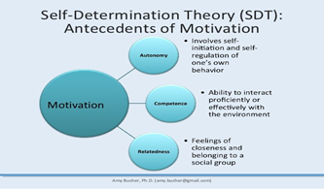
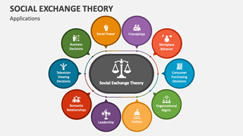
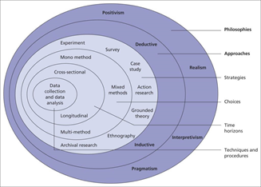
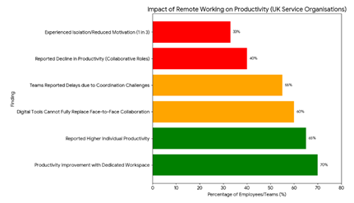
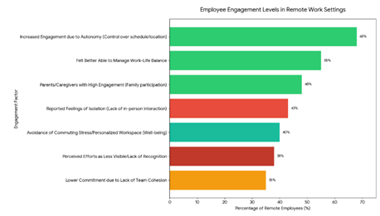
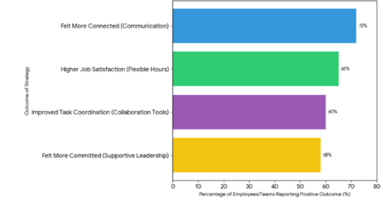

Reflective Essay

Reflective Research Process Reflection Using Gibbs’ Reflective Cycle
My reflection in this reflective essay shall follow the Gibbs Reflective Cycle of research process that has six stages: Description, feelings, evaluation, analysis, conclusion, and Action plan. The study was dedicated to assessing the effect of remote work on the productivity and engagement of the employees of the service organizations in the UK.

Figure 1: Gibbs Reflective Cycle
Source: (Gibbs, 1988)

1. Description
The study started with the cognitive step of defining the need to determine the effects of remote working on productivity and worker participation. The secondary data collected by me comprised academic publications, industry reports, and case studies of service organizations in the United Kingdom, where remote working has become a more frequent occurrence (Ajayi, 2023). Qualitative analysis of topics (autonomy, communication, leadership, and work-life balance) gave me an idea of what causes both negative and positive consequences to employees. This contributed towards setting up a diverse perception about how remote working habits influence performance and engagement.

2. Feelings
I was overwhelmed by the number of literature sources and the inability to identify the most suitable and reliable ones. I did not know how to organize the information properly. I was encouraged and more in charge when I started to sort the data into thematic groups. The topicality of the subject of the ongoing trends in the workplace provided the study with an additional interest, and the realization of the feasible consequences of working remotely motivated me to explore further (Borghouts et al., 2022).

3. Evaluation
The study was very good and bad in some aspect. The use of secondary data became one of the key strengths as I could get a variety of points of view and proven research results. This made me have a comprehensive knowledge of the effect of remote work (Yang et al., 2022). Nevertheless, the use of secondary data was a disadvantage of the research since I was unable to develop insights into real-time workers or managers. The qualitative nature of the data was also a limitation to the depth and generalizability of the findings, which were purely qualitative.

4. Analysis
Going back to the method, I think the methodology was good but could have been reinforced. The information given by the secondary data was good, but not as in-depth as might have been found in primary data collection. The interviews or questionnaires would have enabled me to use personal experience and more refined opinions (Dubey and Kothari, 2022). Whereas thematic analysis aided in making an in-depth examination of the patterns in the data, a mixed-methods method could have yielded a more comprehensive analysis of the impact of remote work on productivity and engagement.

5. Conclusion
In general, the research experience enhanced my knowledge of the influence of remote working on employees and organizations. I used the major themes and organizational strategies that can be employed to increase the effectiveness of remote work. I was also, however, aware of the shortcomings that come with relying on secondary data.

6. Action Plan
My approach in future studies would be both qualitative and quantitative, as I would apply both interviews and surveys to supplement secondary sources of data. I would also manage my time better to enable me to make effective data collection and analysis. Moreover, I would not trust every source, so I would be critical of it to be able to guarantee the validity and applicability of the information used.

References
Ajayi, V. O. (2023). A review of primary sources of data and secondary sources of data. Available at SSRN 5378785.
Borghouts, J. W., Mark, G., Williams, A. C., and Breideband, T. (2022). Motivated to work or to stay motivated: A diary and interview study on working from home. Proceedings of the ACM on Human-Computer Interaction, 6(CSCW2), 1-26.
Dubey, U. K. B., and Kothari, D. P. (2022). Research methodology: Techniques and trends. Chapman and Hall/CRC.
Gibbs, G. (1988). Learning by Doing: A guide to teaching and learning methods. Oxford: Oxford Further Education Unit.
Yang, L., Holtz, D., Jaffe, S., Suri, S., Sinha, S., Weston, J., ... and Teevan, J. (2022). The effects of remote work on collaboration among information workers. Nature human behaviour, 6(1), 43-54.

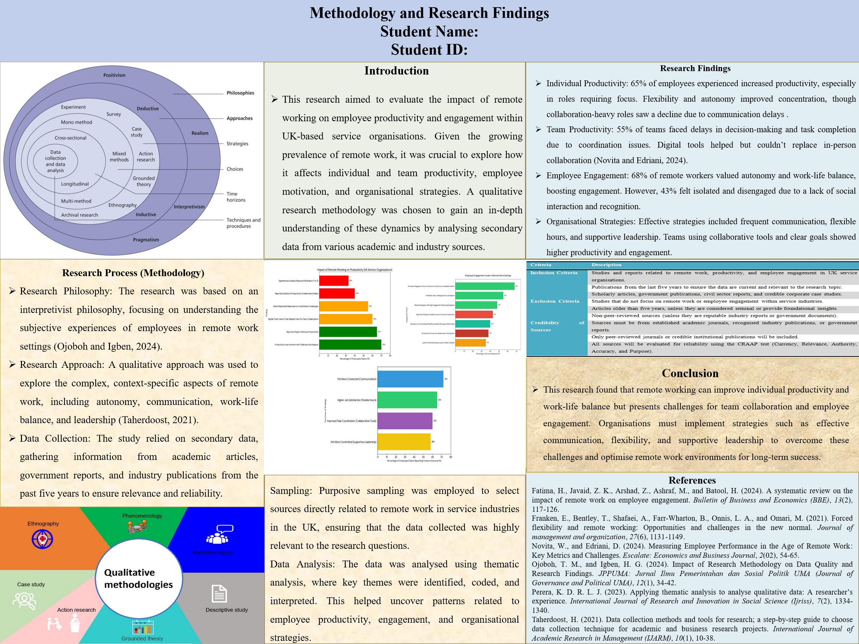

Supervision Diary

Weekly meetings were held with Dr. Said Usman, details of which are below:

Date | Time given | Topics discussed and actions to be taken
22/10/25 | 1 hour | First meeting – introduction with the supervisor and Overview of the topic area.
05/11/25 | 1hour | Background of the research topic: previous studies and current findings (literature review, research gaps).
26/11/25 | 1 hour | Discussed methods and things to include. Discussed framework, effects of remote work on employee productivity and engagement.
03/12/25 | 1 hour | Discussed key findings, Recommendations, conclusions and limitations of the research.

