Student name: Usman Uddin

Student ID number: 2116921

Module code: BMHP5014_BIRM

Module title: Change makers: Creativity
And Value Creation

Lecturer name: Robert Nartowski

Artifact 01:
My mind map is focused on developing a new project plan to improve access to healthcare services for those with disabilities. The main idea of the project is to create an online database of healthcare services that are tailored to meet the needs of those with disabilities. This database would allow individuals and families to easily access information about services available to them near their area.

The first branch off of the main idea is to determine the target population. This includes identifying key demographics, such as age, gender, and disability status, as well as their geographical location. This will be done by researching existing data, conducting surveys and interviews, and consulting with experts in the field.

The second branch of the project focuses on creating the database. This includes designing the database, developing the technology to support it, and creating an online platform for users to access it. The database should be user friendly and simple to navigate, with easy to understand categories and search functions.

The third branch of the project plan focuses on disseminating the information. This includes marketing the database to the target population, and making sure that the information is accessible to all users. Additionally, partnerships with local organizations will be developed to ensure that the database remains up-to-date and accurate.

The fourth branch of the project plan focuses on sustaining the project. This includes identifying potential sources of funding, developing fundraising strategies, and creating a sustainable plan for the long-term success of the project. Additionally, ongoing evaluations and feedback from users will be conducted to ensure that the database is meeting the needs of its users.

Finally, the fifth branch of the project plan focuses on the legal and ethical considerations of the project. This includes ensuring that the database is compliant with all relevant laws and regulations, as well as meeting all ethical standards for data collection and storage. Additionally, privacy and security policies will be developed to ensure the safety of user data.

Artifact 02:
My Campaign: Increasing Awareness of Mental Health Issues

Mental health issues are becoming increasingly prevalent, yet awareness and education on the subject remain inadequate. As a result, individuals suffering from mental health conditions often feel alone and misunderstood. This campaign seeks to raise awareness of mental health issues, encouraging the public to better understand and support those struggling with mental health conditions. Mental health is an essential aspect of overall health and well-being, yet it is often overlooked and undervalued. Despite the widespread prevalence of mental health issues, many people continue to suffer in silence due to the shame and stigma associated with mental illness.

The main objectives of this campaign are to increase public understanding of mental health issues and to reduce the stigma associated with mental health conditions. I seek to achieve these objectives by providing educational resources, organizing public events, and engaging with the media to spread awareness. My campaign aims to raise awareness about mental health and break down the barriers that prevent people from seeking help. I want to promote a message of hope, resilience, and empowerment for those affected by mental health issues. I aim to create a supportive community where people can share their experiences and learn from each other, without fear of judgment.

Educational Resources
The most effective way to reduce the stigma and increase understanding of mental health issues is through education. To provide educational resources, I plan to create a website devoted to mental health awareness. The website will include informative articles, videos, and podcasts to engage visitors. I will also include links to other resources such as mental health support services, mental health research, and mental health advocacy organizations. Additionally, I will create a blog to encourage visitors to share their own stories and experiences.

Public Events
To further increase awareness of mental health issues, I plan to organize public events. These events will include lectures and panel discussions from mental health professionals and advocates. These events will provide an opportunity for the public to engage with mental health professionals and ask questions about mental health issues. Additionally, I plan to host workshops and seminars on mental health topics to provide a comprehensive overview of mental health issues.

Engaging with the Media
To reach a wider audience, I plan to engage with the media. I will use social media to spread awareness of mental health issues and the campaign. I will also use traditional media outlets such as newspapers and radio stations to reach a larger audience. Additionally, I will use press releases and interviews to spread the message of the campaign.

Mental health issues are becoming increasingly common, yet awareness and understanding of these issues remain inadequate. This campaign seeks to raise awareness of mental health issues and reduce the stigma associated with mental health conditions. To do this, I will provide educational resources, organize public events, and engage with the media. By doing so, I hope to increase understanding of mental health issues and support those struggling with mental health conditions.

Explanation:
This mind map aims to demonstrate an approach to understanding the concept of ‘mental health’. Mental health is a complex and multifaceted concept, and this mind map aims to provide an overview of the various components that make up this concept. At the centre of the mind map is the concept of ‘mental health’. This is a broad concept, and encompasses a wide range of topics and ideas related to mental well-being. The concept is connected to a number of other concepts and ideas, which are explored in the map. Overall, this project plan is intended to create a comprehensive online database of healthcare services for those with disabilities. By researching the target population, creating the database, disseminating the information, sustaining the project, and considering the legal and ethical implications, this project plan will help ensure that those with disabilities have access to the healthcare services they need. For the digital storyboard, I will be creating a visual representation of the project plan. This will include images and videos that illustrate the steps of the project, as well as text and audio to explain the project in greater detail. This storyboard will also include links to the sources used in the project plan, as well as website links to any additional resources or information. Overall, my e-portfolio items will provide an in-depth look at my project plan for creating a mental health service for students, as well as a visual representation of the journey of the project.

Poster explanation:

Mental Health is of most important because it is related with brain. So the physical illness of brain causes disturbances in thinking, energy and emotion that make it difficult to cope with day to day ordinary activities. So mental awareness day is observed every year to highlight and educate the public to cope with the mental illness. So talking openly about the mental health will make and understand the public to know and control the symptoms at first place.

The basic mental illness is anxiety, depression, dementia, Mood disorders and eating disorders and many more. The green ribbon is the international symbol of mental health awareness. So the mental health awareness day means that we show colleagues and love ones that we care about their mental health.

The importance of mental health awareness is necessary because it will help to know the public of their symptoms and will be able take precautions at the diagnosable stage and will reduce the risk factors that can lead to the development of a mental disorder. So talking openly about mental health will reduce the misconception and stigma attach to it and will encourage others to seek help and support they need. Showing care and acceptance to them will also help to cope the illness, and respect the people's as an individual and not as a illness will help them in coping this mental illness.

Mental health awareness will also help to learn more about mental health and provide support and help to the community and families. Advocating within our circles of influence helps ensure that these individuals have the same rights and opportunities as other community and family members.

Promotion of health awareness is necessary through seminars, gathering and all other fund raising events. Advertising and openly speaking about mental health encourage individuals to ensure their treatment and leave the misconceptions behind. So mental health awareness will help to educate public to know about the symptoms and how it can be controlled and also prevent itself from further or serious illness.

Poster

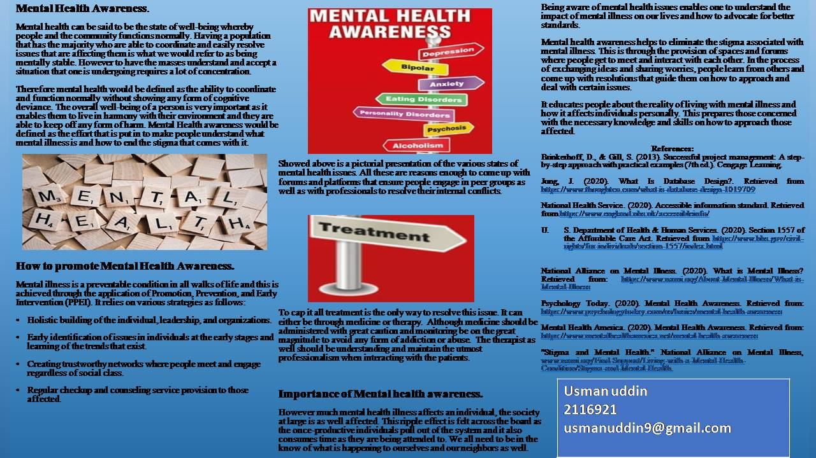

Reference:

Brinkerhoff, D., & Gill, S. (2013). Successful project management: A step-by-step approach with practical examples (7th ed.). Cengage Learning.

Jung, J. (2020). What Is Database Design?. Retrieved from https://www.thoughtco.com/what-is-database-design-1019709

National Health Service. (2020). Accessible information standard. Retrieved from https://www.england.nhs.uk/accessibleinfo/

- S. Department of Health & Human Services. (2020). Section 1557 of the Affordable Care Act. Retrieved from https://www.hhs.gov/civil-rights/for-individuals/section-1557/index.html

National Alliance on Mental Illness. (2020). What is Mental Illness? Retrieved from: https://www.nami.org/About-Mental-Illness/What-is-Mental-Illness

Psychology Today. (2020). Mental Health Awareness. Retrieved from: https://www.psychologytoday.com/us/basics/mental-health-awareness

Mental Health America. (2020). Mental Health Awareness. Retrieved from: https://www.mentalhealthamerica.net/mental-health-awareness

"Stigma and Mental Health." National Alliance on Mental Illness, www.nami.org/Find-Support/Living-with-a-Mental-Health-Condition/Stigma-and-Mental-Health.

