Module: “Financial Management for the Hotel Industry”
Module code: BMIH5007
Assignment 2

Company: Intercontinental Hotels Group (IHG)
Student Name: Sylvester Egbueri
Student ID: 1714548
Teacher Name : Dale Clarke

Table of Contents
Introduction 3
Discussions 3
Comparison of insourced Housekeeping team Vs Outsourcing Housekeeping 3
Abilities of Business employees in IHG 4
Cost implications related to IHG 5
Performance results related to employees of IHG 6
Sustainability related to IHG 7
Employee Consistency in IHG 7
Guest experience in IHG 8
Conclusions 9
References 11

Introduction
The “Financial Management” concept represents the analysis of accounting engagement associated with the managerial support that brings value maintenance support and other growth on a supportive basis. A proper financial management process associated with the business of hospitality business management is initiated for the progressive development and compatibility initiatives mainly that are optimised for the progressive performance support on an effective basis (Atril and McLaney, 2015). This report mainly represents the analysis of Housekeeping department processing including the employee management processing related to the business of Intercontinental Hotels Group (IHG) associated with different contextual support. With the processing of this analysis mainly the operating growth including the balancing formulation is also managed in this business mainly.

Discussions
Generally, the engagement of operating performances including the optimised structural engagement in IHG initiates a significant volume of significance to the approach of insourced Housekeeping instead of Outsourcing Housekeeping engagement, which ultimately initiates the optimised development and operating compatibility initiatives on a sustainable basis. For initiating such a positive approach of outsourced employee engagement with the HR support in IHG has been evaluated.

Comparison of insourced Housekeeping team Vs Outsourcing Housekeeping
According to the basic managerial concept, while an organisation uses its sources including the engagement of the human resource department to appoint adequate employees, it represents the processing of insourced employee engagement. On the other hand, while the same employee recruitment in a business is initiated with the involvement of third-party support, it is recognised as an Outsourcing employee engagement approach (Jia et al., 2019). The primary involvement of such engagement while initiated is related to the processing for a hospitality business therefore such engagement is mainly initiated as insourced or Outsourcing Housekeeping engagement. Through the approach of ensuring engagement, a proper controlling structure including quality development has been initiated in this business. Additionally, the engagement of on-time training support including the optimised cultural processing is also managed which brings the optimised low-cost employee formulation support to this business on a development basis (Kim and Kim, 2021). On the other side, the engagement of Outsourcing employees is initiated with higher staff costing engagement and a higher fluctuation approach regarding the operational objectives in this business mainly.
As per the general details, the primary operating approach related to the business of IHG mainly initiates the formulation of an outsourced Housekeeping approach with the engagement of the human resource department that initiated sustainable progress and optimised development in this business mainly. In the present position around 350,000 total employee engagements is noticed in this business which indicates a progressive development and formulation approach mainly (Statista, 2023).
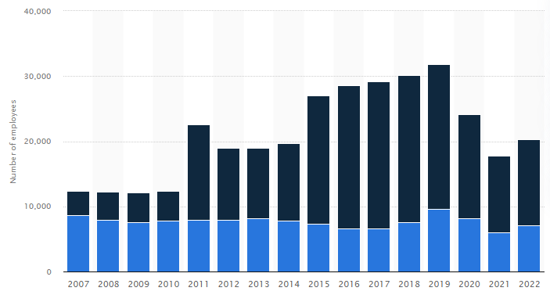
Figure 1: Employee engagement in IHG
(Source: Statista, 2023).

Abilities of Business employees in IHG
According to the general operating engagement, a significant level of employee management approach is generally noticed in IHG that initiates the formulated and optimised growth support mainly. With the engagement of more than 350,000 individual employees in over 100 countries a significant level of operating and labour chain supply has been initiated in this business in general (UNLEASH, 2022). According to the general engagement support a proper global workforce formulation is mainly initiated in IHG initiated with the formulation support of an optimised cultural engagement that brings the employee formulation support on an effective basis. The primary presence of optimised workforce management is generally noticed is initiated for the structural growth support on an effective basis.
In the present position, fundamentally the management of IHG is focused on branding initiatives including the operating development approach in general. For such a purpose, the engagement of IHG Skills Academy has been initiated by the management, which is recognised as IHG’s “Skills Academy programme and new virtual learning platform” for emphasising the skills and development support for individual employees on an effective basis. Additionally, the present management of the business also initiates a significant volume of focus on the employee performance management programme so that the general qualities and operating growth of the business are initiated (IHG, 2023). Additionally, the management also provides a significant importance to the quality and compatibility approach for individual employees mainly that initiate sustainable growth support to the business. An employee recruitment notice by IHG has been provided.
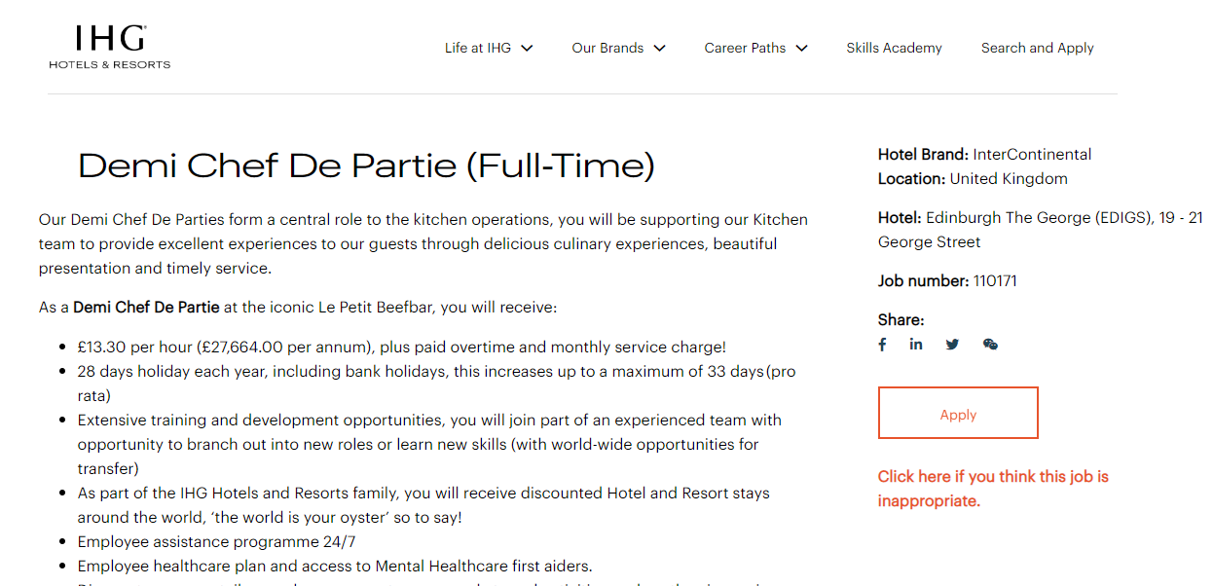
Figure 2: Employee recruitment noticed in IHG
(Source: IHG, 2023).

Cost implications related to IHG
Fundamentally, the engagement of employee cost represents the formulation of financial processing related to individual employees. The primary maintenance support to the engagement of the equality act initiates positive remuneration support to every individual with a structural engagement that is mainly initiated for the formulated operating progressive approach (Drury, 2015). Associated with the general performance structure in the present period, the primary level of Wages and salaries in this business group is $1604 million, which was $1315 million in 2021 respectively. Associated with the general operating processing the primary Costs borne by IHG related to individual employees in the present period is $646 million, which is comparatively higher differentiated from the previous financial position of $569 million in 2021 respectively (IHG, 2022).
Associated with the same approach an optimised development approach including the formulated financial support is mainly initiated that brings stability and accountability development support in IHG. Associated with the general operating approach, the present level of “Staff costs are presented net of government supportive income of $5 million in the present period relates principally to employee costs at certain of the Group’s leased hotels” in an effective basis. Associated with the general operating approach the present management of the business also initiates the formulation support of proper employee beneficial engagement simultaneously that brings the value chain processing growth as well.
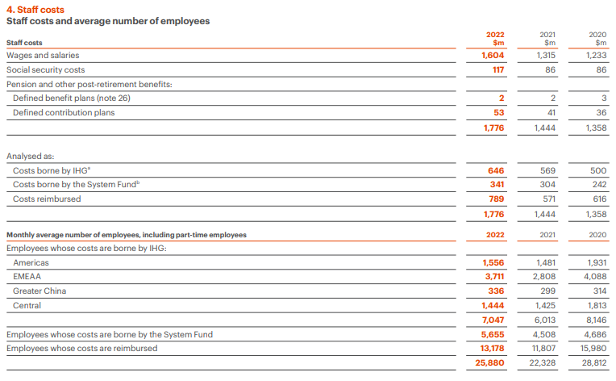
Figure 3: Employee costs in IHG
(Source: IHG, 2022)

Performance results related to employees of IHG
In the present position around 1300 different members of a business employee associated with a diversified cultural approach is initiated in the IHG that brings the formulated development and sustainability progress approach in this business mainly. Associated with the general operating support, in the present position around 86% of overall employee engagement expansions are initiated in this business with the 57000 hours of employee processing support that ultimately initiates the optimised development and cultural formulation support in this business mainly (IHG, 2022). Along with initiating a general volume of importance to the people management approach, the present managerial development process brings the optimised development support mainly that manages the structural development including the optimised workforce engagement and employee stability on an effective basis. According to the general functional performances a supportive volume of employee retention approach in the IHG initiates the optimised developed and cultural formulation support mainly that is comprehensive for enabling infrastructure and technology, a continued focus on rapid and high-quality decision making, plus ensuring that inclusion remains a key focus for the business (ihgplc.com, 2023). Along with the employee developmental support the management of the business also initiated the engagement of diversified operating cultural and suitability support that formulates the employment progress on an effective basis.

Sustainability related to IHG
Importance to the processing and maintenance of employee sustainability is one of the essential approaches for IHG that brings the compatibility development including the progressive structural formulation support in general. With the processing of positive training and programme support the managerial department of the business brings the optimised development including a sustainable operating initiative approach mainly that is progressive for initiating the operating growth initiatives with reduced energy, waste and water consumption volume mainly (Guilding, 2013). Associated with the general formulation support, the engaged sustainability approach related to the business measures the greater investment with a longer pay-back period approach that initiates the stability formulation including internal working cultural growth support on an effective basis.
In the present position along with initiating the environmental processing support, the management also initiates a significant level of focus on sustainability and diversity in supply chain engagement that ultimately brings the optimised cultural development including the marketing initiative approach on an effective basis. Associated with the general processing approach the management of the business also provides a supportive approach over the “high-performing suppliers in sustainability and the circular economy that provide carpeting, showers, furniture, bedding, mattresses, flooring, and air travel to hotels and also engaged in other associated corporate functions. Through the processing of such the business can gain valuable insights into the sustainability journey of suppliers, discuss opportunities for collaboration, and build stronger relationships with top-performing suppliers” that generally initiate the structural growth formulation in this business mainly.

Employee Consistency in IHG
According to the general code of conduct the primary operating position including the operating development support of this business initiates a sustainable development including proper approval support regarding the financial commitments and expenditures in a systematic order. The ethics and compliances of this business initiate the formulated development support including a standardised growth that initiates the value maintenance approach on a structural basis (Our Code of Conduct, 2023).
Along with the initial support of diverse cultural engagement, the overall operating formulation including the employee engagement of this business is structurally formulated that brings optimised development support. Associated with the general operating position, in the present position the management of IHG initiates the following commitments within 2030 so that the standardised growth including the operating development support can also be managed. According to the basic operating structure, the present management of the business provides a significant volume of focus on the gender equality processing mainly that is initiated for the optimised balancing growth including the sustainable development initiative purpose (IHG, 2022). Additionally, the primary formulation regarding the Cultivate an inclusive cultural development associated with individual employee processing is also managed for the employee developmental growth support that brings the value chain analysis support in a proper basis. Additionally, the presence of proper collaboration associated with the individual employees and prioritising employees’ wellbeing by the management initiates a sustainable growth approach including the structural progress support on a proper basis in this business.

Guest experience in IHG
With providing general importance to the formulation and development of the business branding approach, the present management of IHG provides a significant level of focus on cultural development on a proper basis. Additionally, present a global marketing campaign, “Guest How You Guest”, an approach in IHG that initiates the stability formulation including the optimised cultural development approach mainly (Hospitality Net, 2023). With the maintenance of a proper staff management approach the overall operating growth including the stability position of the business is effectively balanced which brings the structural development including a loyalty program with IHG on an effective basis. “The current strategic approach to this business initiates a formulated development and it is designed to inspire the next generation of travellers” in an effective basis (IHG, 2022). With the processing of this support the operating culture including a formulated experience for individual customers’ is mainly initiated which brings stability to formulation support mainly. In the present position, the management of the business mainly provides a supportive focus over the customer-centric approach with the initiative of which a positive structural and cultural formulation has been initiated.
To initiate an optimised development approach the present management of the business initiates 58% digital booking facilities with a 20% digital marketing approach that brings structural growth support on a systematic basis (Ihg.com, 2023). An honest review related to this business group has been provided that indicates the current developmental support of such customer-centric initiatives in IHG mainly.
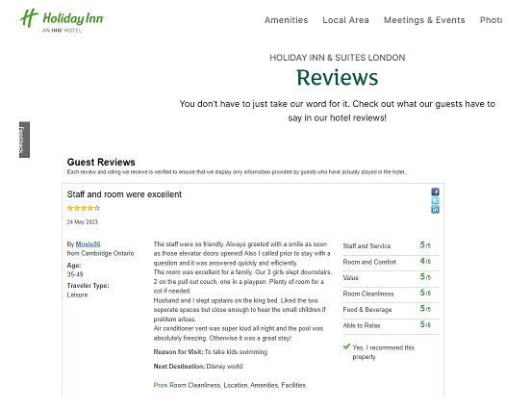
Figure 4: Customers’ review on IHG
(Source: Ihg.com, 2023).

Conclusions
In summary, the present operating engagement including the performance management initiates optimised development support for the managerial processing of IHG. With the initial support of structural progress, a sustainable operating culture is mainly initiated that brings the value chain analysis including the progressive development support on an effective basis. According to the present employee formulation, the primary development including the standardised growth support is also balanced in this business as well that formulates the competitive marketing growth with a significant level of employee management support in an effective order.

References
Atrill P and McLaney E (2015) Management Accounting for Decision Makers, FT Prentice Hall
Drury C (2015) (9th Ed) Management and Cost Accounting, London, Prentice Hall
Guilding,C.(2013) Accounting Essentials for Hospitality Managers, London, Taylor and Francis.
Hospitality Net. (2023). IHG Hotels & Resorts debuts trailblazing new global campaign, Guest How You Guest, inviting all travelers to be their authentic selves. [online] Available at: https://www.hospitalitynet.org/news/4111824.html [Accessed 25 May 2023].
IHG (2022). Annual Report. [online] InterContinental Hotels Group PLC. Available at: https://www.ihgplc.com/en/investors/annual-report [Accessed 25 May 2023].
IHG. (2023). Home. [online] Available at: https://careers.ihg.com/en/ [Accessed 25 May 2023].
Ihg.com. (2023). IHG Customers review. [online] Available at: https://www.ihg.com/holidayinn/hotels/gb/en/london/yxulo/hoteldetail/hotel-reviews [Accessed 25 May 2023].
ihgplc.com. (2023). employee performance. [online] Available at: https://www.ihgplc.com/en/news-and-media/news-releases/2018/ihg-awarded-top-employer-in-the-uk-for-the-fourth-year-running [Accessed 25 May 2023].
Jia, Y., Yan, J., Liu, T. and Huang, J., 2019. How does internal and external CSR affect employees’ work engagement? Exploring multiple mediation mechanisms and boundary conditions. International journal of environmental research and public health, 16(14), p.2476.
Kim, M. and Kim, J., 2021. Corporate social responsibility, employee engagement, well-being and the task performance of frontline employees. Management Decision, 59(8), pp.2040-2056.
Our Code of Conduct. (2023). Available at: https://www.ihgplc.com/en/-/media/ihg/files/pdf/corporate-governance/march-2022/ihg-final-code-of-conduct-pdf-english---external-document.pdf?la=en&hash=C0B600EEA20532FC15A3298E6CECAAD7 [Accessed 25 May 2023].
Statista. (2023). IHG: number of employees 2019. [online] Available at: https://www.statista.com/statistics/223422/intercontinental-hotels-group-number-of-employees/ [Accessed 25 May 2023].
UNLEASH. (2022). IHG: Employee listening is key to inclusion. [online] Available at: https://www.unleash.ai/diversity-equity-inclusion/ihg-employee-listening-is-key-to-inclusion/ [Accessed 25 May 2023].

