Understand the structure and function of the circulatory system

Task 1: Describe the function of the heart. (1.1)

The heart acts as a pump and moves blood and nutrients around the body to the working tissues. There are two sides of the heart, the left side processes oxygenated blood, and the right-side processes deoxygenated blood.

Task 2: Using the image and space below, describe how blood moves through the four chambers of the heart and the stages of systemic and pulmonary circulation. (1.2, 1.3)
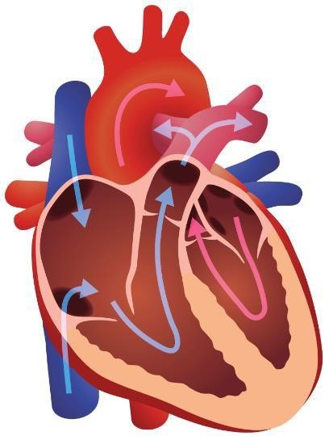
Description of blood flow:
The right atrium receives blood from the body which is then pumped from the body to the lungs through the right ventricle. Some blood then goes from the lungs to the left atrium and then that's pumped around the body through the left ventricle. From the left ventricle the blood will work through to all the tissue and muscle in the body, whereas the right ventricle focuses on delivering blood to the lungs. Also, in the diagram there is a thick pink coloured wall, this separates the heart to prevent the blood crossing over each side.

Systemic and pulmonary circulation:
Systemic circulation is the flow of oxygenated blood from the left ventricle to the body's working tissues.
Pulmonary circulation is the flow of deoxygenated blood from the right ventricle to the lungs to then be oxygenated.

Task 3: Describe the structure and functions of blood vessels. (1.4)

Structure | Functions
Arteries- Contain 3 layers and have thick smoot muscular walls between them. Do not contain any valves and divided into small vessels across the body known as arterioles.  Veins- Joins the arteries through capillaries and divides into small vessels called venules  Capillaries- found in capillary bed and contain walls that are only one cell thick. | Pushes blood along the vessels through muscular contractions, the blood only flows in one direction due to high pressure. Arteries then carry the blood away from the heart whilst also needing to carry oxygenated blood to muscles and tissues.  Pushes blood back to the heart under low pressure, the valves contain make sure the blood pumps directly back to the heart. Aswell as this the veins will carry deoxygenated blood.  Carries blood through an organ or a tissue from arterioles to the venules, gaseous exchange happens between body tissues

Task 4: Explain what blood pressure is and identify the different types of blood pressure classifications. (1.5, 1.6)

Blood pressure
This is a measurement of the pressure that the blood puts on the walls of blood vessels. The reading is measure by 2 numbers for example 140/80 these show two different factors which are systolic and diastolic pressure. Systolic should be the higher out of the two numbers and is the measurement of pressure once the left ventricle has contracted and blood is pumped into the aorta. Diastolic is when the measurement is taken when the heart is resting and refilling with blood, this should be the smaller number as the pressure on the artery wall should be low (usually 80mmHg).

Blood pressure classifications

There are risk categories and classifications on blood pressure because not everyone’s blood pressure is at the optimum level.
Some classifications of blood pressure are:
- Stroke which is a blood clot on the brain and can affect hypertension
- Heart attack
- Aneurysm which is a dangerous expansion of a main artery and can rupture after time
- Kidney failure

Learning outcome 2
Understand the structure and functions of the respiratory system
Task 1: Look at the image below. Using the image and spaces provided, label and describe the structure and function of the respiratory system. (2.1)

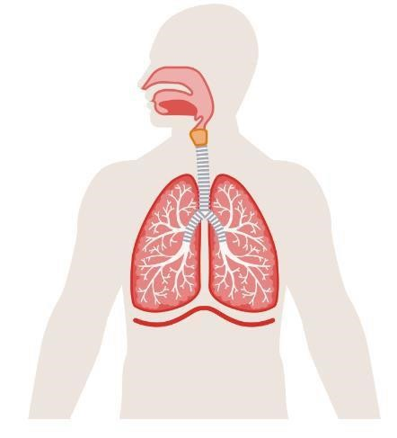
Structure

The structure involves both the upper and lower airways. Air enters the body through the nose or mouth then will travel down through the pharynx and down the trachea. Oxygen then enters the bloodstream through small sacs called alveoli and carbon dioxide will leave.

Function

The main functions of the respiratory system are to provide a route for the supply of oxygen in the atmosphere enters the body and to provide a route for carbon dioxide to leave the body as waste.

Task 2: Identify the main muscles involved in breathing
The diaphragm is the main muscle involved in breathing as it contracts and relaxes to draw air into and push air out of the lungs.

The intercostal muscles are between the ribs and help expand and retract the ribcage which helps the diaphragm with the breathing process.

Task 3: Describe the route of air through the respiratory system.

Air enters the body and is warmed as it travels through the mouth and nose.
It then enters the trachea. The trachea divides into two bronchi. One bronchus enters each lung. Each bronchus branches out into smaller tubes called bronchioles. Air travels through these bronchioles. At the end of the bronchioles, the air enters one of the many millions of alveoli where gaseous exchange takes place.

Task 4: Describe the process of gaseous exchange. (2.4)
Gaseous exchange is a process in which oxygen and carbon dioxide are exchanged in the lungs and muscle tissue. This exchange happens between the alveoli and capillaries; oxygen will pass through the alveoli to the capillary which then after the oxygen in transferred through the blood.

Learning outcome 3
Understand the structure and functions of the skeleton
Task 1: The skeleton provides vital structure to the human body. Below, describe the basic functions of the skeleton. (3.1)
The skeletons main functions are to provide a structure to give the body its shape and to facilitate movement to allow a range of motion in joints. Also, the skeleton provides protection to the internal organs from injury and stores minerals to support muscles in contracting. Aswell as this the skeleton system also supports the production of blood cells due to the bone marrow found within certain bones.

Task 2: Using the images below, identify the bones of the axial and appendicular skeleton. (3.2)
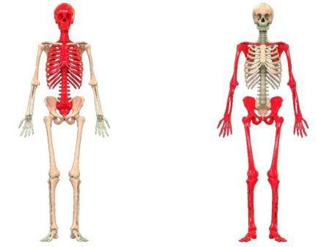

Task 3: Identify the different classification of bones. (3.3)
1. Long bone
2. Short bone
3. Flat bone
4. Irregular bone
5. Sesamoid bone

Task 4: Describe the main features of a long bone. (3.4)
The long bone is a tough bone with an elongated shape; they are designed to bear weight and assist movement. The outer layer of the bone is thick and compact, and the ends contain a spongy bone for movement.

Task 5: Describe the stages of bone growth. (3.5)
The first stage is where the bone has not become hardened yet, after this the making of where bones begin to develop is formed. Partial fusion then occurs where different parts of the bone will start to merge up until complete fusion of the bone which then leads to a formed bone structure.

Task 6: Describe the varying types of posture in terms of: (3.6)
Postural term | Description
Curves of the spine | The curves of the pain are major in maintaining the correct posture and preventing the beginning of difficulties with the forming of the spine. There are 4 different curves within the spine, these include:  - Cervical curve (at the neck)  - Thoracic curve (upper back)  - Lumbar curve (lower back)  - Sacral curve (base of spine)  These curves within the spine help the body distribute weight correctly, whereas abnormal curves can lead to deforming of the spine.
Neutral spine alignment | Neutral spine alignment is a crucial part of maintaining a good posture and the general health of the spine. It involves the aligning of all the curves of the spine and is essential for preventing the potential future injuries especially during sports or physical activity.
Movement  potential of the spine | The movement potential of a spine is characterised by a range of motions that allow for flexibility, these major movements are the following:  - Flexion (forward)  - Extension (backward)  - Lateral flexion (to the side)  - Rotation (twisting)  The muscles within the back allow for this movement to happen as well as the abdominals and neck muscles.
Postural deviations | Postural deviations refer to the misalignments within the body’s posture such as scoliosis, which leads to discomfort in the back and can affect the health of joints in the body aswell as the balance of muscle.

Learning outcome 4
Understand joints in the skeleton
Task 1: Identify the classifications of joints. (4.1)
1. Fibrous
2. Cartilaginous
3. Synovial

Task 2: Describe the structure of synovial joints. (4.2)
Synovial joints are the main joints in the body which are filled with fluid and have articular cartilage to allow a wide range of movement between all joints and bones.

Task 3a: Using the table below, identify the types of synovial joint and their range of motion.(4.3)
Synovial joint | Joint type | Range of motion available
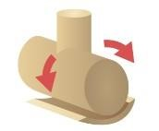 | Pivot | Rotational movement
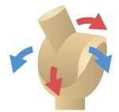 | Gilding | Allow two bones to slide past each other
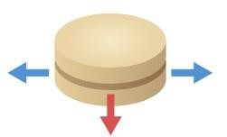 | Saddle | Like ball and socket but at a much less degree
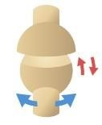 | Ball and socket | Almost any direction
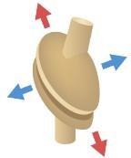 | Ellipsoid | Forwards and backwards, up and down, but no rotations
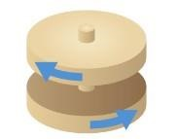 | Hinge | Flexion and extension

Task 3b: Describe joint movement potential and joint actions. (4.4, 5.6)
Joint action | Description | Joint example, eg wrist | Muscle example, eg quads
Flexion and extension | Bending of the joint decreasing the joint angle and straightening the limb to decrease joint angle. | Elbow | Biceps
Adduction and abduction | Separates and pulls a structure away or toward the midline | Hip | Glutes
Circumduction | Circular movement of the limb | Shoulder | Trapezius
Supination and pronation | Rotational movements that are the orientation of the palm or foot | Wrist | Brachioradialis
Plantar flexion and dorsiflexion | Two key movements that involve the positioning of the foot relative to the leg | Ankle | Gastrocnemius
Lateral flexion and reduction | Refers to the movement of bending sideways whereas reduction is the return to the normal position | Neck and Knee | Rhomboids and hamstrings
Horizontal flexion and extension | Movements that occur in the transverse plane | Shoulder | Deltoid
Elevation and depression | Elevation is the upward movement whereas depression is the downward movement | Shoulder | Trapezius

Task 4: Identify the body’s anatomical planes of movement. (4.5)
1. Sagittal- Divides h=the body into left and right halves enabling forward and backward movements
2. Frontal- Divides the body into front and back halves enabling side to side movements
3. Transverse- divides into top and bottom halves allowing twisting movements

Task 5: Define the anatomical terms of location. (4.6)
Table heading | Table heading
Distal | A position further away from the origin of a limb
Proximal | A position closer to the origin of a limb
Anterior | The front of the body
Posterior | The back of the body
Inferior | A position below another structure
Superior | A position above another structure
Deep | Further away from the surface of the body
Superficial | Closer to the surface of the body
Medial | Towards the midline of the body
Lateral | Away from the midline

Task 6: In the table below, describe the exercise variables and their effects on biomechanics and kinesiology. (4.7)
Exercise variable | Description | Effect on exercise
Levers | The joint and bones in the body act as levers. There are three different types of levers which are first, second and third class. | Longer levers require more force but allow for a bigger range of motion. Therefore, the levers determine how much force is needed for each movement
Centre of gravity | The point where the body’s mass is balanced | Influences stability and balance during exercise, a low centre of gravity assists balance
Momentum | The amount of motion with a person which is calculated by mass x velocity | Can make movements within a gym environment easier like lifting weights with momentum can help gym users lift heavier
Force | A push or a pull movement generated by the muscles | Higher force would improve the strength within a gym and not enough force can lead to incompleting exercises

Learning outcome 3
Understand the muscular system
Task 1: Describe the characteristics and functions of the body’s 3 types of muscle. (5.1)
Muscle cell | Muscle type | Function | Characteristic
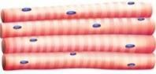 | Skeletal | Produces body movements and maintains posture in the body | Only shortens in one direction and works both aerobically and anaerobically
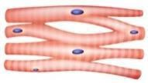 | Cardiac | Contracts the heart | Works aerobically only and is reliant on oxygen
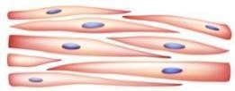 | Smooth | Has the most diversity all through the human body and causes vasoconstriction and vasodilation | Contractible in all directions and work aerobically

Task 2: Describe the basic structure of skeletal muscle. (5.2)
The skeletal muscle is made up of 70% water, 23% protein and 7% minerals. There are several structures of layers within the skeletal muscle, and each layer is made up of small structures.

Task 3: Using the images below, identify and locate the anterior and posterior skeletal muscles.
(5.3)
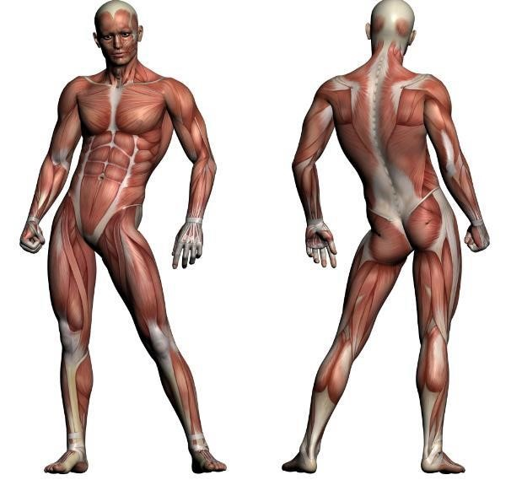
(
Muscles located within this
area under overlying
muscles)

Task 4: Describe the structure and function of the pelvic floor muscles. (5.4)
The core and pelvic floor muscles are located deep within the body underneath the muscles. The core relies on muscular control for stabilisation and control over movement. The shape of the core is like a cylinder with the diaphragm at the top and the pelvic floor at the bottom, if there is any damage to the pelvic floor then it can lead to organ prolapse within the pelvis.

Muscle action Muscle action type and description | Muscle action Muscle action type and description
Movement  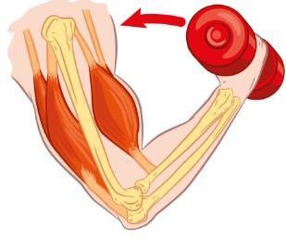 | Concentric muscle action because the force is being generated to lift a weight
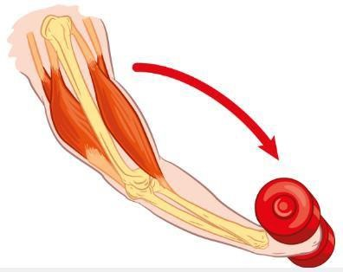  Movement | Eccentric muscle action as the force is decreasing and the weight is being lowered
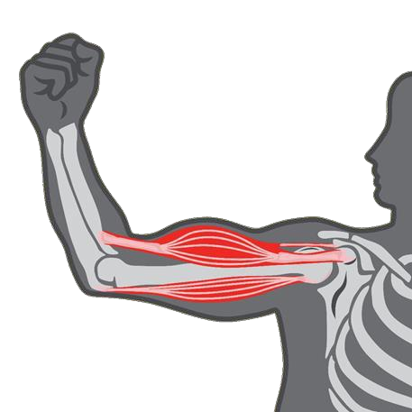  No m  ovement | Isotonic muscle action because of the fact that the muscle is involving in no movement and stays the same

Muscle fibre | Description of characteristics
Type 1 | These are known as slow twitch fibres and are prominently seen within the long distance running Olympians. They allow a large resistance to fatigue and a lower force production allowing runners to last over distance.
Type 2 | These are known as fast twitch fibres and are more built for power and speed which are good for athletes who are sprinter or strongmen. This is because there is a fast contraction speed and there is more force than a type 1 fibre.

Learning outcome 6
Understand the life course of the musculoskeletal system and its implications for special populations’ exercise
Task 1: Describe the life course of the musculoskeletal system and its implications for exercise for the below special populations: (6.1)
Special population | Life course changes | Implications for exercise
Young people (13-18 years) | During this period young people begin puberty therefore would experience factors like growth spurts and muscle strength. | Regular weight training would help those going through growth spurts to get used to support the density of bones. Aswell as this, taking part in physical activity is essential to stimulate the bone development in young people going through puberty
Antenatal and postnatal women | During pregnancy women find significant changes in things like increased bone density and muscle strength. After birth the musculoskeletal system then needs to adapt to the changes of a woman's body composition. | During pregnancy it is beneficial for a woman to take part in regular exercise for the health of both her and the baby, after birth though it is important to gradually return to exercise to support the recovery of the body.
Older adults (50+ years) | As adults become older, they have significant life course changes, these are things like increasing the risk of diseases and gradual decreases in both physical and mental health | Activity that promotes balance can help older people be less susceptible to falls and regular physical activity has an overall benefit on physical and mental health lowering the risk of any illnesses in the future

Learning outcome 7
Understand energy systems and their relation to exercise
Task 1: Describe how carbohydrates, fats and proteins are used in the production of energy. (7.1)
Macronutrient | Description
Carbohydrate | Carbohydrates are the primary source of energy; they are broken down into glucose when participating in aerobic exercises giving people the sufficient energy
Protein | Proteins are used when the carbohydrate energy source has depleted. They are broken down into amino acids which then can be converted into glucose.
Fat | Fats are mostly used during low intensity exercises, and they require more oxygen due to the lower metabolism rate compared to carbohydrates.

Task 2: Explain the use of the 3 energy systems during aerobic and anaerobic exercise. (7.2)
Table Energy system | Explanation
ATP-PC | This system provides energy immediately for about 10 seconds, this is through the creatine phosphate in the muscles to generate more energy quickly without needing oxygen
Aerobic | This system is used for lower intensity but longer duration exercises, it requires oxygen and can sustain the energy production for long duration by breaking down carbohydrates and fats
Anaerobic glycolysis | This system becomes active when the ATP-PC system has ran out and provides energy for moderate to high intensity activities, it breaks down glucose without needing oxygen.

3: Identify the by-products of the 3 energy systems and describe their role in muscle fatigue. (7.3)
By-product | Role in muscle fatigue
ADP | As the ATP-PC stores are depleted the body needs to rely on other energy systems to produce ATP, this then can lead to muscle fatigue. The body needs to wait for the stores to become replenished for the use to happen again, within the period the muscles are going through fatigue.
Carbon dioxide | This by product is produced during the breakdown of the energy sources, the accumulation of cO2 leads to a decrease in acidosis which then hinders the ability for a muscle to contract which ultimately leads to the muscle fatiguing.
Lactic acid | This is produced through glycosis and the accumulation of lactic acid causes a burning sensation in the muscles often referred to as cramp, this interferes with the function of proteins within the muscle.

4. Define anabolism, catabolism and excess post-exercise oxygen consumption (EPOC).

Anabolism | This is the process of synthesising more complex molecules into simpler ones and is essential for growth and repair in the body.
Catabolism | This is the process of breaking down the complex molecules down into simpler ones whilst releasing energy, these are crucial to produce energy in the body
EPOC | This refers to the amount of oxygen your body needs to restore itself to its normal resting state after exercising, often referred to as afterburn and is the rate of oxygen needed to recover from physical activity.

Learning outcome 8
Understand the nervous system and its relation to exercise
Task 1: Describe the role and functions of the nervous system. (8.1)
Role | Functions
The role is to detect and respond to changes inside and outside the body, changes are detected through different receptors in the body both outside and inside. The information gathered through the receptors is then sent through the brain for analysis. | The functions of the nervous system include the senses to receive information to the brain, and they are also needed to execute actions based upon the sensory input received. Aswell as the nervous system is responsible for actions like digestion and breathing .

Task 2: Describe the principles of muscle contraction. (8.2)
Muscle contraction involves the activation of tension-generating sites within muscle cells, primarily through the interaction of actin and myosin filaments, leading to muscle shortening and force generation.

Task 3: Explain the ‘all or none law’/motor unit recruitment. (8.3)
This states that the response of misucle fibres occurs in an all or nothing manner, meaning that to stimulate a response there must be a certain threshold met. If it does, then the response will be maximal but if it does not then there will be no response at all.

Task 4: Identify how exercise can enhance neuromuscular connections and improve motor fitness. (8.4)
Exercise significantly enhances neuromuscular connections and improves motor
fitness by increasing synaptic efficiency, recruiting more motor units, and promotingneuroplasticity, leading to better coordination and overall physical performance.

Learning outcome 9
Understand the structure and function of the digestive system
Task 1: Describe the function of each section of the digestive system. (9.1)
Table heading | Table heading
Mouth | Mechanically breaks down food through chewing and is the entry point for the food.
Oesophagus | Muscular tube that connects the mouth to the stomach, using contractions to take the food down
Stomach | Churns food and mixes it with gastric juices like hydrochloric acid to turn food into a semi liquid substance
Small intestine | This is where most digestion and absorption have occurred. Enzymes from the pancreas and bile from the liver contribute to it as well.
Large intestine | Absorbs water and electrolytes from the indigestible food and compacts it into faeces.

Task 2: Describe how fats, proteins and carbohydrates are digested and absorbed. (9.2)
Macronutrient | Enzymes used | Time scale | Location
Fat | Lipase and bile | Several hours | Begins in the mouth and stomach, major digestion in the small intestine
Protein | Pepsis and peptidases | 2-6 hours | Stomach and small intestine
Carbohydrate | Amylase, lactase and sucrase | 30 minutes- 2 hours | Mouth and small intestine

Task 3: Describe the role of dietary fibre in the maintenance of gut function. (9.3)
Fibre supports the gut microbiome which helps stronger immunity to diseases and better digestion for food. Also, fibre regulates the movements within the bowel which then prevents constipation.

Task 4: Describe the role of the liver and pancreas in digestion.
The liver produces bile to emulsify fats making them easier for enzymes to act upon. The pancreas then releases enzymes such as amylase which enter the small intestine to complete digestion.

Task 5: Explain the importance of maintaining fluid levels for health and exercise performance.
(9.5)
Level of performance | Explanation | Role of water
Health | Prevents dehydration when undertaking exercise as well as supporting the organs to function as they should and stabilising blood pressure | Transports the nutrients and oxygen in the body and regulates the temperature. Also lubricates joints allowing easier movements for day-to-day activities
Exercise performance | Prevents fatigue when exercising and reduces the risk of heat related illnesses | Cools down the body through sweat and helps with the contraction of the muscles when performing athletic movements.

