Shaun
Davies
Student Number – 1903572
Completed Labs for Shaun Davies
Lab – Building a Simple Network
Lab – Building a Switch and Router Network Properties
Lab – Ipv4, Subnetting, VLSM and IPv6 Addressing
Lab – Securing and Accessing Network Devices with SSH
Lab – Understanding Ethernet Cable

Lab – Understanding Ethernet Cable Standards
Topology
Addressing Table
Device | Interface | IP Address | Subnet Mask | Default Gateway
PC-A | NIC | 192.168.10.1 | 255.255.255.0 | N/A
PC-B | NIC | 192.168.10.2 | 255.255.255.0 | N/A
Objectives
Part 1: Analyze Ethernet Cabling Standards and Pinouts
Part 2: Build an Ethernet Crossover Cable
Part 3: Test an Ethernet Crossover Cable
Background / Scenario
In this lab, you will build and terminate an Ethernet crossover cable and test it by connecting two PCs together and pinging between them. You will first analyze the Telecommunications Industry Association/Electronic Industries Association (TIA/EIA) 568-A and 568-B standards and how they apply to Ethernet cables. You will then construct an Ethernet crossover cable and test it. Finally, you will use the cable you just constructed to connect two PCs together and test it by pinging between them.
Note: With autosensing capabilities available on many devices, such as the Cisco 1941 Integrated Services Router (ISR) switch, you may see straight-through cables connecting like devices.
Required Resources
- One length of cable, either Category 5 or 5e. Cable length should be 0.6 to 0.9m (2 to 3 ft.)
- 2 RJ-45 connectors
- RJ-45 crimping tool
- Wire cutter
- Wire stripper
- Ethernet cable tester (optional)
- 2 PCs (Windows 7 or 8)
- Analyze Ethernet Cabling Standards and Pinouts
The TIA/EIA has specified unshielded twisted pair (UTP) cabling standards for use in LAN cabling environments. TIA/EIA 568-A and 568-B stipulates the commercial cabling standards for LAN installations; these are the standards most commonly used in LAN cabling for organizations and they determine which color wire is used on each pin.
With a crossover cable, the second and third pairs on the RJ-45 connector at one end of the cable are reversed at the other end, which reverses the send and receive pairs. The cable pinouts are the 568-A standard on one end and the 568-B standard on the other end. Crossover cables are normally used to connect hubs to hubs or switches to switches, but they can also be used to directly connect two hosts to create a simple network.
Reflection: Discuss (Max word count 500) various cable standards that are used in Today’s LAN.

In Today’s LAN the most commonly used cable standards are Cat 5, Cat 5e, and Cat 6. These cables can be bought ready-made fitted with RJ45 connections or without, giving the user the option to create the length of the cable they require. These cables are most commonly used due to the fact that they have twisted wire pairs within the overall cable [1].
By twisting particular pairs of wires together with opposite currents it balances the current making it more efficient to transmit data without further precautions. However further precaution is taken by having shielding around said wires either individually around each pairing or around the pairs altogether. Some cables then have a further shield around the initial shielding under the sheath of the cable. In doing this it makes the cables more efficient over longer distances. Earlier cables were unshielded and are still available but most commonly used in today’s LAN are all shielded in one way or another [1].
There is another difference between the cables which is that some may use a single strand of copper within each wire of the cable which is known as solid cable. Then there is stranded cable which uses copper strands twisted together in each wire. Stranded cable is better for movement and is often used around PC connections at offices etc. where there could be regular movement. Solid cable is better for more permanent installations like in a building behind walls or under floorboards etc [1].

See below table which displays the difference in performance of the differing cable categories [1].

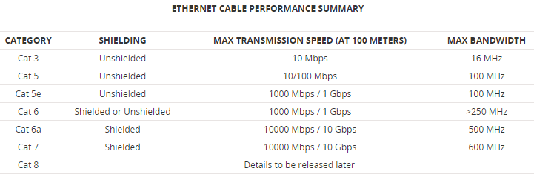
[1]

  - Analyze diagrams and tables for the TIA/EIA 568-A standard Ethernet cable.
The following table and diagrams display the color scheme and pinouts, as well as the function of the four pairs of wires used for the 568-A standard.
Note: In LAN installations using 100Base-T (100 Mb/s), only two pairs out of the four are used.
568-A 10/100/1000Base-TX Ethernet
Pin Number | Pair Number | Wire Color | 10Base-T Signal  100Base-TX Signal | 1000Base-T Signal
1 | 2 | White/Green | Transmit | BI_DA+
2 | 2 | Green | Transmit | BI_DA-
3 | 3 | White/Orange | Receive | BI_DB+
4 | 1 | Blue | Not Used | BI_DC+
5 | 1 | White/Blue | Not Used | BI_DC-
6 | 3 | Orange | Receive | BI_DB-
7 | 4 | White/Brown | Not Used | BI_DD+
8 | 4 | Brown | Not Used | BI_DD-

The following diagrams display how the wire color and pinouts align with an RJ-45 jack for the 568-A standard.
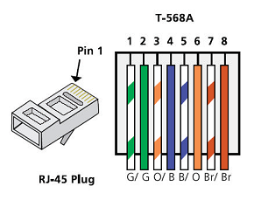
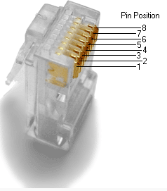
  - Analyze diagrams and tables for the TIA/EIA 568-B standard Ethernet cable.
The following table and diagram display the color scheme and pinouts for the 568-B standard.
568-B 10/100/1000-BaseTX Ethernet
Pin Number | Pair Number | Wire Color | 10Base-T Signal  100Base-TX Signal | 1000Base-T Signal
1 | 2 | White/Orange | Transmit | BI_DA+
2 | 2 | Orange | Transmit | BI_DA-
3 | 3 | White/Green | Receive | BI_DB+
4 | 1 | Blue | Not Used | BI_DC+
5 | 1 | White/Blue | Not Used | BI_DC-
6 | 3 | Green | Receive | BI_DB-
7 | 4 | White/Brown | Not Used | BI_DD+
8 | 4 | Brown | Not Used | BI_DD-
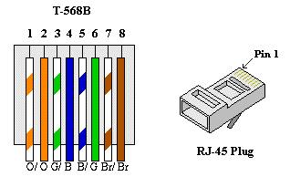

- Build an Ethernet Crossover Cable
A crossover cable has the second and third pairs on the RJ-45 connector at one end, reversed at the other end (refer to the table in Part 1, Step 2). The cable pinouts are the 568-A standard on one end and the 568-B standard on the other end. The two following diagrams illustrate this concept.
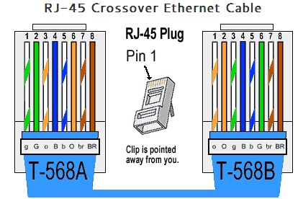
  - Build and terminate a TIA/EIA 568-A cable end.
    - Determine the cable length required. (Your instructor will let you know the cable length you should make.)
Note: If you were making a cable in a production environment, the general guideline is to add another 12 in. (30.48 cm) to the length.
    - Cut off a piece of cable to the desired length and using your wire stripper, remove 5.08 cm (2 in.) of the cable jacket from both ends.
    - Hold the four pairs of twisted cables tightly where the jacket was cut away. Reorganize the cable pairs into the order of the 568-A wiring standard. Refer to the diagrams, if necessary. Take as much care as possible to maintain the twists in the cable; this provides noise cancellation.
    - Flatten, straighten, and line up the wires using your thumb and forefinger.
    - Ensure that the cable wires are still in the correct order for the 568-A standard. Using your wire cutters, trim the four pairs in a straight line to within 1.25 to 1.9 cm (1/2 to 3/4 in.).
    - Place an RJ-45 connector on the end of your cable, with the prong on the underside pointing downward. Firmly insert the wires into the RJ-45 connector. All wires should be seen at the end of the connector in their proper positions. If the wires are not extending to the end of the connector, take the cable out, rearrange the wires as necessary, and reinsert the wires back into the RJ-45 connector.
    - If everything is correct, insert the RJ-45 connector with cable into the crimper. Crimp down hard enough to force the contacts on the RJ-45 connector through the insulation on the wires, thus completing the conducting path. See the following diagram for an example.
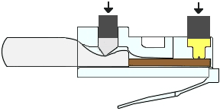
  - Build and terminate a TIA/EIA 568-B cable end.
Repeat steps 1a to 1g using the 568-B color wiring scheme for the other end.
- Test an Ethernet Crossover Cable
  - Test the cable.
Many cable testers will test for length and mapping of wires. If the cable tester has a wire map feature, it verifies which pins on one end of the cable are connected to which pins on the other end.
If your instructor has a cable tester, test the crossover cable for functionality. If it fails, check with your instructor first as to whether you should re-cable the ends and re-test.
  - Connect two PCs together via NICs using your Ethernet crossover cable.
    - Working with a lab partner, set your PC to one of the IP addresses shown in the Addressing Table (see page 1). For example, if your PC is PC-A, your IP address should be set to 192.168.10.1 with a 24-bit subnet mask. You partner’s IP address should be 192.168.10.2. The default gateway address can be left empty.
    - Using the crossover cable you made, connect the two PCs together via their NICs.
    - On the PC-A command prompt, ping the PC-B IP address.
Note: The Windows firewall may have to be temporarily disabled for pings to be successful. If the firewall is disabled, make sure you re-enable it at the conclusion of this lab.
    - Repeat the process and ping from PC-B to PC-A.
Assuming IP addressing and firewall are not issues, your pings should be successful if the cables were properly made.
Reflection
  - Which part of making cables did you find the most difficult?
The part I found most difficult was placing the paired wires correctly into the RJ45 connector. It was hard to keep them in the right order and to get them all the correct length so they actually made a connection.
  - Why do you have to learn how to make a cable if you can easily buy pre-made cables?
When carrying out installations of a network the cable maybe required to be different lengths, therefore having the ability to make a cable allows you to make the cable the correct length to suit your installation. Pre-made cables are best when in use in offices and the like for desktops etc.

Bibliography

[1]"Ethernet Cable: Types, Performance & Pinout - Cat 5, 5e, 6, 6a, 7, 8 etc", www.electronic-notes.com, 2019. [Online]. Available: https://www.electronics-notes.com/articles/connectivity/ethernet-ieee-802-3/cables-types-pinout-cat-5-5e-6.php. [Accessed: 26- Jun- 2019].

