THE UK LABOUR MARKET AND ONGOING CHALLENGES

Executive Summary
In this report, the labour market of the UK has been analysed in detail. It has been illustrated that the UK labour market has been suffering from several challenges like covid along with Brexit for the last few years. These challenges have directly impacted the employment sector of the UK. The rate of employment has largely reduced in the UK. This has kept a significant effect on the socio-economic sector of the UK. To get rid of such challenges, the HRM has to take several preventive strategies to obtain organisational goals. Especially to counter the covid situation, the remote work culture should be enhanced. In addition, several motivational and training programmes are needed to initiate in the organisation. The challenge of the HRM is to introduce sustainability in the case of employment. Besides, various learning sessions are needed to enhance the workplace to keep a proper working environment.

Table of Contents
Introduction 4
The current state of the UK labour market 4
Impact of covid on the UK labour market and its current state 5
Impact of Brexit on UK labour market and its current state 6
Emerging changes in HR strategies in the UK due to post-Brexit external environment 7
Emerging changes in HR strategies in the UK due to post covid external environment 9
Recommendation 10
Conclusion 11
Reference List 12
Appendix 14

Introduction
The labour market of the UK has been accounting for several challenges, especially in the field of employment, for the last few years. As the pandemic is prevalent globally, this situation is affecting the UK significantly in its socio-economic areas. As a result of this situation, the present UK labour market is suffering several factors caused by covid and Brexit. Due to covid, a lot of UK people have become jobless, which has directly impacted the financial stability of the UK government. Besides, various challenges are faced by the workers belonging to the European Union in the UK. Several rules and regulations are imposed by the UK government on workers in the UK.

The current state of the UK labour market
In this particular context, it is estimated by the Labour Force Survey that from February to April 2022, the general rate of employment has increased over the quarter. This rate of increment has taken a figure of 0.2% to 75.6% over the quarter (Office for the National Statistics, 2022). However, this rate is lower than the pre-pandemic situation in the UK. There is an increment in full-time employee number to a significant figure over the quarter. This is concluded as partly countervail by an undercut in the employee number who were serving in a part-time manner. The number of salaried employees for May 2022 is showing an increment up to 90000 on the modified April 2022 to a record of 29.6 million. The total number of working hours counted weekly has shown an increment of 12.2 million to 1.04 billion hours from February to April 2022 in comparison with the last quarter (Office for the National Statistics, 2022). Still, this figure is 7.6 million lower than in the pre-covid situation. The rate of unemployment for February to April 2022 has been reduced from 0.2% to 3.8% over the quarter (Office for the National Statistics, 2022). The rate of inactivity in the economic part decreased from 0.1% to 21.3% from February to April 2022. This type of reduction in economical functioning in comparison with the previous period of three months was effectively managed by those inactive economically as they were pupils. The number of vacancies from March to May 2022 increased to a new record of 1300000, which is significant in this situation (Office for the National Statics, 2022). The growth in the average gross pay was 6.8%. In addition, the growth in regular pay was 4.2% to April 2022 (Office for the National Statistics, 2022).

Impact of covid on the UK labour market and its current state
In this particular context, the covid-19 pandemic has had a significant impact on the labour market of the UK. The latest economic survey in the UK, as well as real-time, denotes, have pointed toward an effective reduction in the economic functioning of the UK. The starting evaluations in the case of other countries chalk out the proportions of the effects as far as the actual economy. Enhancement of social distance maintenance has also changed the way that individual’s function or their capacity to find employment. The collaborative effects have replaced not only the labour market of the UK but also the capability of measuring the situation. In this context, the framework of labour market statistics is introduced to clarify the significant concepts prevalent in the UK labour market. Such an approach has acceptance globally in addition by the International Labour Organisation. The number of people in the workplace has been reduced by 825000 between January to March 2020 and October to December 2020, while underemployment rose by nearly 400000. In addition, the number of financially inactive people rose by 327000 (House of Commons Library, 2022). The number of people demanding benefits regarding unemployment doubled between March to May 2020 (House of Commons Library, 2022). The workers who are young and old have lost their job more likely. It is illustrated that the age group between 16 to 24 has suffered from underemployment mostly, and the figure for unemployment took the form of 40% (House of Commons Library, 2022). A significant fall in the first covid lockdown was noticed in March 2020. Between January to March 2020, along with April to June 2020, the level of employment was reduced by 424000 (House of Commons Library, 2022). As per the data given, it is evaluated that there is an undercut in the level of employment from 76.3% to 75.7%, which is effectively significant (House of Commons Library, 2022). The level of employment continued to reduce all over the rest of 2020 and arrived at the lowest figure in November 2020to and January 2021. In this quarter, the rate of employment was 74.6% (House of Commons Library, 2022).
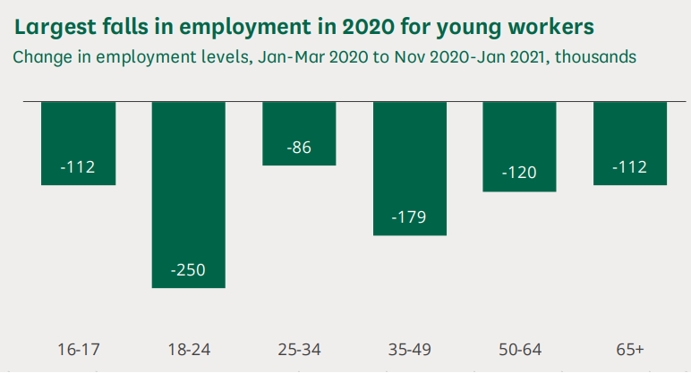

Figure 1: Fallings in employment in a pandemic situation
(Source: House of Commons Library, 2022)

Impact of Brexit on UK labour market and its current state
In this particular context, the impact of Brexit has been noticed far and wide throughout several sectors of the UK. Despite the previous study on the effect of Brexit on employment, a continuation has been noticed in the level of sharp growth of employment since the plebiscite to pull out of the European Union in 2016 (CIPD, 2022). The labour market stayed strong, and the job vacancy was still high when the employment growth was analysed in 2019. As per the Labour Market Outlook (LMO) report, the organisational shares reporting difficult vacancies took the form of growth from 56% in the report of 2017 to more than 61% organisation in 2019, which is significant. In addition, several organisations have taken the initiative to increase salaries. This includes both the freshers and existing employees. According to the LMO autumn 2019 report, it is illustrated that 59% of private organisations have increased the level of salary to reduce difficulties in the process of recruitment (CIPD, 2022). The tight market of labour seems to keep pressure in an upward direction on the wages for several employees. It has been noticed that Brexit has not bedewed the interest of the employees in case of employing EU expatriate workers. At the beginning of 2018, two-thirds of organisations decided that they had to continue recruiting nationals of the EU. Between October to December of 2019, the EU workforce has matched 7% of the complete workforce of the UK (Work Foundation, 2022). It has been declared by the Office of National Statics that the number of EU employees has increased in the last 20 years in the UK, but as per figure 2, this situation has paid off in the next half of 2016 (Work Foundation, 2022). In addition, it has levitated nearly 2.3 million over the last few years (Work Foundation, 2022). In addition to this situation, it has been illustrated that various new rules and regulations have been implemented by the UK government regarding the new immigrants from the EU. About 160000 EU employees have reached the UK over the last three years, which is 55% of the total current arrivals (Work Foundation, 2022). The employees who would not be allowed to go to the UK under the rules and regulations implemented on the EU employees are significantly centred around the hospitality, manufacturing and retail sector. It is illustrated that 25000 EU workers had returned to their homes during the covid situation as well as followed by the termination of the interaction period of Brexit (People Management, 2022). As per the opinion of the member of the Association of Independent Meat Suppliers, Tony Goodger, there are about 14000 vacancies in the UK which is a significant figure (People Management, 2022).

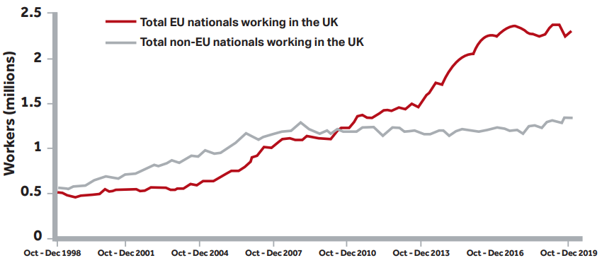
Figure 2: Labour Force Survey
(Source: Work Foundation, 2022)

Emerging changes in HR strategies in the UK due to post Brexit external environment
The impact of Brexit is variable depending upon the organisations. In this post-Brexit situation, several changes are needed to occur in the organisation to gain proper organisational profitability.
Awareness of business
In this particular context, Brown et al. (2019) opined that a potential awareness of the dealings of an organisation helps HRM to gain a strategic point of view. The HRM has to be intimated with the balance sheet of the organisation and various dealings with the organisation's functions. Apart from that, it is of paramount essence to make out how the hindrances are impacting the aptitude strategy of an organisation.
Improvement of communication
In this context, the employees belonging to the European Economic Area (EEA) and living in the UK up to the compilation of 2020 will be able to apply for the pre-settled and settled status (Gov.UK, 2022). This will provide them with the right to continue the functioning of their work in the UK. The HRM has to ensure communication with them frequently. In addition, the HRM has to support them to gain such status.
Access the impact of worker non-attendances from the UK
The HRM will help the EEA nationals who lived and functioned before January 2021 in the UK to analyse their non-attendance period from the UK (Gov.UK, 2022). Non-attendance of 6 months in any continuing 12-month period can break the period of the presidency of the UK. This will keep affecting a single's ability to achieve the status of the settlement.
Analysation of policies regarding employment
The HRM have to perform amending and reviewing the Brexit-related policies to make sure that they are amenable to the new system, which is related to immigration. In this particular context, Edwards et al. (2022) suggested that the policies related to diversity and inclusion must be considered, especially the policies related to the HRM section. It must be ensured by the HRM that there are no laws which offer discrimination in their recruitment approach.
Checking of sponsor licence needs
In the case of the HRM, who has not kept a sponsor licence earlier, should evaluate if this licence is needed now. Horak et al. (2019) opined that this licence would help the HRM under the new immigration system to recruit newly reached EEA along with non-EEA people. The HRM already has a sponsor licence and must verify its need to amend.
Monitoring UK employment rights
Presently the UK government has committed to preserving the employment rights which are still prevalent. In this context, the HRM should focus on government activity related to employment rights.

Figure 3: HR responsibilities in the workplace
(Source: Created by learner)

Emerging changes in HR strategies in the UK due to post covid external environment
In this particular context, several changes in the organisations are needed to consider what occurred due to covid-19. Performing a job is a significant factor specifying such constancy by its influence on the functioning of the whole organisation.
Enhancement of remote work culture
The interaction between the HRM strategies, performance of the job and the performance of the organisation is needed to be considered effective as employees are the most valuable resource of an organisation. A large number of organisations have shifted to the work-from-home (WFH) strategy to maintain covid restrictions. Iwashita (2021) opined that the management should focus to become more frank and open to continuing the WFH method of working. They have to shift the positions of the present organisation to a remote location for comfortable access to the employees. To maintain this working culture, the organisation has to modify and implement several policies of the organisation. Communication is another hindrance to maintaining a remote work culture. In this context, Terkamo‐Moisio et al. (2022) opined that it is the provocation of the HRM to secure the faith and confidence of all the employees with the help of proper communication methods. Apart from that, the employees are needed to evolve various capabilities to cooperate digitally. The HRM has to set out a unique way of setting organisational goals and detailed analysis of the employee system, which is perfect for the remote work culture.
Involving employees with work as a provocation
The employees suffer motivationless while working in a remote culture. In addition, it is also a drawback for the employees to maintain a fixed schedule always, especially in the case of cross-functional teams. The employees fail to remember the purpose of their work in the organisation. Therefore, Dundon and Rafferty (2018) opined that sustaining the ongoing organisational practice is a significant challenge for HRM in this post-pandemic situation. In this case, several communication strategies in the form of a coaching model can be considered by the HRM to keep the employees in line with the organisation. Training programme regularly to maintain motivation as well as retentiveness of the employees. In this context, Butterick and Charlwood (2021) opined that the HRM has to maintain the engagement of the employees properly. This includes flexibility and touches, frequently keeping with the employees. Meetings, information, learning sessions and updates can be delivered by the organisations regularly to maintain employee sustainability. The leader has to maintain the cooperation of the fragmented team and motivate them to be in line with the organisational practices.
[Refer to Appendix 1]
Enhancing Employee confidence and clutch affinity as a challenge
Amidst the covid situation, several organisations experienced a lot of turnovers, wage cuts and overdue leaves. The supreme level of mental stress and insecurity of the job have undercut the loyalty of the employees. In this particular context, the HRM keeps the responsibility to comply with this new work culture. After returning to their workplace, it is essential to relight the pre-covid working environment. Jacks (2021) opined that it is an essential duty of the HRM to arrange one-to-one meetings to take feedback about an individual's pandemic experience to analyse their physical and mental health. In addition, several norms regarding behavioural norms are needed to be thought about better.

Recommendation
Recommendation 1
Specific | To focus on sustaining appropriate work culture during the remote working process.
Measurable | This can be measured by analysing the reduction of conflict among the team leader and team members.
Achievable | This can be achieved by proceeding to a virtual meeting in a One-to-one pattern. This initiative will help the leader to understand employees individually.
Realistic | The employees will get motivation and enthusiasm to work properly.
Time-bounded | 1 year.

Table 1: Proper work culture
(Source: Created by learner)

Recommendation 2
Specific | To focus on implementing appropriate organisational behaviour.
Measurable | This can be measured by analysing the behaviour of the employees and their interaction with their colleagues.
Achievable | This can be achieved by evaluating regular check-ups of the mental as well as the physical condition of the employees.
Realistic | Evaluation of regular check-ups will facilitate in maintaining proper bonds among employees.
Time-bounded | 1 year.

Table 2: Sustaining proper organisational behaviour
(Source: Created by learner)

Conclusion
The UK labour market has faced several challenges during this pandemic for the last three years. The organisational goals are not being fulfilled properly in this context. The general rate of unemployment increased differently. The economic functioning of the UK has been hampered effectively along with the socio-economic condition. In addition, the contribution of Brexit has kept a significant figure in the field of employment in the UK. To face the various challenges, the HRM has to take several measures to tackle the situation in addition to gaining organisational profitability.

Reference List
Brown, R., Liñares-Zegarra, J. and Wilson, J.O., (2019). The (potential) impact of Brexit on UK SMEs: regional evidence and public policy implications. Regional Studies, 53(5), pp.761-770.
Butterick, M. and Charlwood, A., (2021). HRM and the COVID‐19 pandemic: How can we stop making a bad situation worse?. Human Resource Management Journal, 31(4), pp.847-856.
CIPD (2022). Brexit impact on workforce trend. Accessed from: https://www.cipd.co.uk/knowledge/brexit-hub/workforce-trends#gref [Accessed on:15.08.2022]
Dundon, T. and Rafferty, A., (2018). The (potential) demise of HRM?. Human Resource Management Journal, 28(3), pp.377-391.
Edwards, M.R., Leite, A.C., Randsley de Moura, G. and Marques, A.G., (2022). Let's talk about Brexit: intra-organizational communication, citizenship status, procedural justice, and job insecurity in a context of potential immigration threat. The International Journal of Human Resource Management, 33(5), pp.1037-1064.
Gov.UK (2022).Apply to the EU settlement scheme (Settled and pre-settled status. Accessed from: https://www.gov.uk/settled-status-eu-citizens-families/what-settled-and-presettled-status-means#:~:text=If%20you%20get%20settled%20status%2C%20any%20children%20born%20in%20the,it%20through%20their%20other%20parent. [Accessed on:15.08.2022]
Horak, S., Farndale, E., Brannen, M.Y. and Collings, D.G., (2019). International human resource management in an era of political nationalism. Thunderbird international business review, 61(3), pp.471-480.
House of Commons Library (2022). Coronavirus: Impact on the labour market. Accessed from: https://researchbriefings.files.parliament.uk/documents/CBP-8898/CBP-8898.pdf [Accessed on:15.08.2022]
Iwashita, H., (2021). The future of remote work in Japan: Covid-19's implications for international human resource management. Entrepreneurial Business and Economics Review, 9(4), pp.7-18.
Jacks, T., (2021). Research on Remote Work in the Era of COVID-19. Journal of Global Information Technology Management, 24(2), pp.93-97.
Office for the National Statistics (2022). Labour market overview,UK: June 2022.Accessed from: https://www.ons.gov.uk/employmentandlabourmarket/peopleinwork/employmentandemployeetypes/bulletins/uklabourmarket/june2022#:~:text=The%20UK%20employment%20rate%20increased,number%20of%20part%2Dtime%20employees [Accessed on:15.08.2022]
People Management (2022). The impact of Brexit on UK business so far. Accessed from: https://www.peoplemanagement.co.uk/article/1742010/impact-brexit-uk-businesses-so-far [Accessed on:15.08.2022]
Terkamo‐Moisio, A., Karki, S., Kangasniemi, M., Lammintakanen, J. and Häggman‐Laitila, A., (2022). Towards remote leadership in health care: Lessons learned from an integrative review. Journal of advanced nursing, 78(3), pp.595-608.
Work Foundation (2022). Post Brexit Labour Supply And Workforce Planning. Accessed from: https://www.lancaster.ac.uk/media/lancaster-university/content-assets/documents/lums/work-foundation/7097-LUni-WorkFoundation-Brexitv4.pdf [Accessed on:15.08.2022]

Appendix
Appendix 1: Coaching model
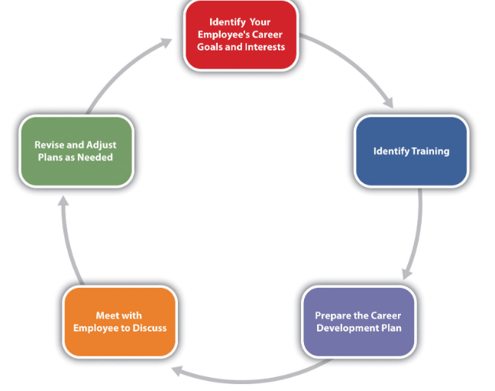
(Source: https://open.lib.umn.edu/humanresourcemanagement/chapter/8-4-designing-a-training-program/ )

