Nathan Doyle (P151450)
Ndoyle.151450@student.uwtsd.ac.uk
Advanced Processes and Materials
M6X00414

Contents

Abstract 2
List of Figures/Tables/Graphs 3
Introduction 4
Abrasive Water Jet Machining 5
Laser Beam Cutting 10
Table of Comparison 13
Conclusion 15
References 16

Abstract

This is a report that recommends a suitable, non-traditional manufacturing process for a company to consider using. Abrasive waterjet machining and Laser beam cutting are compared and contrasted with a traditional machining process such as CNC milling and all of advantages and disadvantages with regards to quality, surface quality, cost and tool wear are examined. The report suggests that abrasive waterjet cutting is an extremely modern process and has seen major advances in improvements in tighter tolerances and greater surface quality. The reports general findings show that abrasive waterjet cutting is a viable option for the company to use and can be a suitable replacement to CNC machining.

List of Figures/Tables/Graphs

Figure 1 Abrasive Waterjet cutting nozzle …………………………………………………… 5
Figure 2 Abrasive Waterjet cutting lag ………………………………………………………… 6
Figure 3 Abrasive Waterjet machining cost …………………………………………………. 7
Figure 4 Worn exit of Orifice plate ………………………………………………………………. 8
Figure 5 Worn drilling face cutter ……………………………………………………..………… 8
Figure 6 Types of Surface finish achieved with waterjet cutting …………..……… 9
Figure 7 Illustration of laser beam cutting …………….……………………………………. 10
Figure 8 Surface finish damage from CNC tool …………………………………..……….. 11
Figure 9 CNC milling guards ………………………………………………………………………... 12
Figure 10 Laser Beam cutting guards ……………………………………………………..…… 12

Table 1 Comparison table between three processes ……………………………………. 13

Introduction

The purpose of this report is to research two different types of Non-traditional manufacturing processes and compare the advantages and disadvantages of both with CNC milling. The company currently produces an aluminium helicopter cockpit floor using CNC milling and is recently looking to modernise and expand its business. The company wishes to improve its components surface finish quality and research processes that can cut to a specific tolerance of under 0.0127cm.
For the report I will be researching the benefits and problems associated with Abrasive Waterjet Machining and Laser beam cutting on many materials, especially aluminium. Due to the many specific properties of aluminium, it is important that both processes can cut the material efficiently, to the correct dimensions and without damaging the par. My research will highlight the many advantages and disadvantages of each process on a few different topics such as quality, safety, surface finish and cost. The points raised will be compared with the current CNC milling processes to highlight any improvements or drawbacks. I believe that a good understanding of the process on each topic will give a good indication on whether the process is suitable and viable for the company to consider. Throughout the report, I will be comparing several authors viewpoints on each topic and looking to analyse these opinions with the company requirements.
The report seeks to accomplish a viable and effective non tradition processes that would allow the company to replace its current traditional manufacturing processes.

Abrasive Water Jet Machining

Established as a Non-Traditional Machining process, this method involves the use of a pump that forces water through an orifice at high pressure to create a high velocity jet (Anwar, et al., 2018). The water is pumped between 20,000 to 80,000 PSI. A vacuum is generated that draws abrasive particles into the jet which cuts through a material. The purpose of the water is to create momentum and accelerate the abrasive material onto the workpiece (Chithirai Pon Selvan, et al., 2012). Jose, et al., (2012) states that the process has extensive applications within industry, particularly in producing profiles and argues that it can be used on a variety of hard materials such as titanium. Momber & Kovacevic, (2012) agrees by suggesting that abrasive waterjet cutting can be used on a variety of materials and in the automotive, chemical and construction industry. The extensive range of capabilities of the machinery is equivalent with CNC milling as suggested by Nozawa, et al., (2014) who informs that CNC milling is used in all aspects of metal work and manufacturing industries.
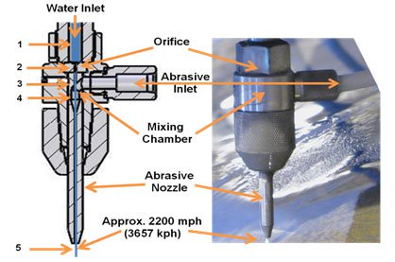

Figure 1, Abrasive Waterjet Cutting Nozzle, (Waterjet university 2019)

Quality
One of the biggest advantages of using abrasive waterjet cutting is the complete reduction in thermal deformation in the workpiece. Tosun, et al., (2013) asserts that this technology is beneficial for cutting materials that are thermally sensitive as high temperatures do not occur. Comparing this with CNC milling shows that thermal deformation is a major problem and will occur if the proper controls and measures are not in place. This includes applying the correct coolant and in the required location whilst cutting (Adrian & Vasile, 2015). In the case for using aluminium, Mujeeb, et al., (2014) claims that due to its malleable properties, aluminium can deform when localised heat is applied within a machine or outside, therefore it is essential that coolant is applied directly. This may come with an extra cost with the problem of recycling and cleaning the coolant. In my opinion, the process of reducing thermal damage on aluminium to maintain quality, incurs extra costs that needed to be considered when choosing between different machining processes.
A severe and challenging problem with using Abrasive Waterjet Cutting is the changing of the cutting gap. Zsolt, (2013) acknowledges that the form of the changing cutting kerf is a complex problem and usually appears as a wider gap at the lower surface and a narrower gap at the front surface. It presents itself as a taper that may produce a part going out of specification and can be a major issue with regards to quality. Thomas, (2013) adds that a taper is produced when high traverse speeds and thicker materials are used. The jets reduction in kinetic energy creates a taper and can be very difficult and costly to control. There is a clear contrast with CNC milling. Anon., (2019) suggests that CNC machines have automatic offsets programmed into their PLCs that control the kerf gap.
Tolerances are extremely important in manufacturing and it is important that a manufacturing process is able to achieve correct dimensions of a design brief. (Anon., 2019) states that todays waterjets are able to achieve a tolerance as small as 0.025mm compared to 1.5 over twenty years prior. Momber & Kovacevic, (2012) agrees with the abrasive waterjet tolerance by informing that these days the average tolreance is at 0.02mm but goes furthers and suggests that expensive versions can get the tolerance closer to 0.01mm. CNC milling goes even better than Abrasive Waterjet machining with an average tolerance of 0.013mm however this requires precision, high cost tooling (Antonelli, et al., 2016). In my view, abrasive water jet cutting satisfies the brief without requiring expenisve tooling, whilst being able to maintain a tolerance below the required dimension of 0.0127cm.

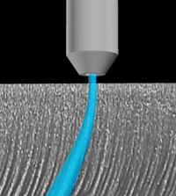

Figure 2- Abrasive Waterjet Cutting Lag, (Olsen, John H. 2012)

Cost
With regards to cost, abrasive material tends to be the largest financial burden as it can reach as much as 67% of the total operating cost. Mines, (2018) suggests that an abrasive material known as Garnet is extremely popular in the use of Waterjet cutting and prices vary from 10 – 40 cents per pound. With the typical usage of waterjet cutting being around one pound per minute, this process can be become expensive dependent on the type of material cut. In my opinion this would be a cheap method of cutting for the company due to the thin aluminium material used. Jai Aultrin, et al., (2012) adds that there are many cheaper varieties of abrasives that can be used which can give a similar quality finish. The type of abrasive choosen should reflect on the application of the material to be cut. Therefore this could be an option for the company to examine further as reducing the cost of the abrasives (which accounts for nearly 67% of the cost/hour), can significantly reduce the cost of the entire process. A limitation of this process is the reduction in the cutting speed with regards to material thickness. This means that it is a slower process compared to CNC milling which might suggest that you will achieve a reduction in parts per hour therefore a higher cost (Krajcarz, 2014). However, I believe that this will not be a substantial issue with regards to the manufacturing of the aluminium cockit floor due to its low thickness and soft metal properties.

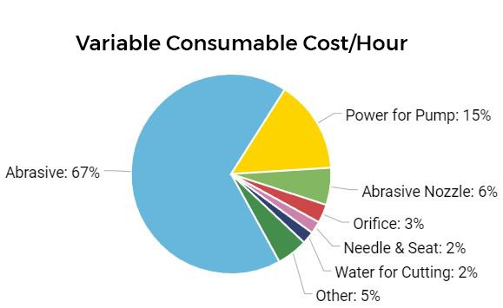

Figure 3-Abrasive waterjet machining cost, (Ward jet, 2017)

Tool Wear
A detriment to the milling process is wear on the cutting tool that has adverse effects to the entire production system. These include a substandard surface finish, increase costs for new tools and greater productivity cost (Badrinathan & Karunamoorthy, 2014). Liu, (2017) goes further and proposes that even with the advancement in CNC tools, they are unable to last when cutting high strength alloys and composites. An advantage of using Abrasive Waterjet Cutting over CNC milling is the consistency of the materials cut dimensions which are nearly always accurate due to the constant refreshing of abrasive material going through the nozzle (Korn, 2014). This does not create a worn tool which is often found with CNC milling. Laniel, et al.,(2017) agrees that tool wear is a regular occurrence with CNC milling however, disagrees that there is no tool wear with Abrasive Waterjet cutting. Laniel, et al.,(2017) explains that the abrasive water jet cutting uses nozzles and orifice plates that are prone to wear from the abrasive material that causes an increase in the diameter of the water jet. This affects the dimensions on the finished part.

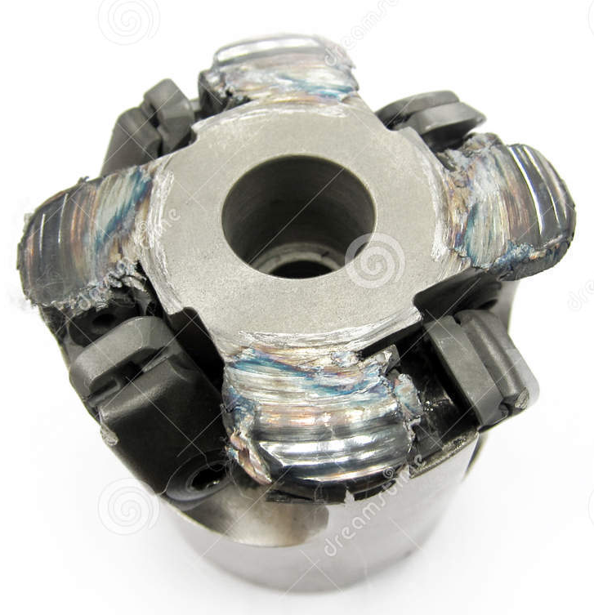
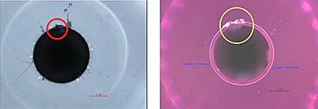

Figure 4- Worn exit of Orifice plate, (Bit Tooth Energy 2013) Figure 5- Worn Milling face cutter, (Dreams Time 2012)

Surface Finish
Several factors contribute to the surface finish and roughness when using Abrasive waterjet cutting. These include water pressure, abrasive material used and work feed rate (Arunkumar, et al., 2016). An increase in abrasive flow and water pressure especially, increase surface finish as there are a higher number of cutting edges per time applied. When the abrasive material first connects with the work piece, then the kinetic energy is high, creating a good surface finish however, a disadvantage is that as the abrasive jet cuts deeper the kinetic energy is reduced, and the cutting actions slows down. This does create an increase in the surface roughness (Chithirai Pon Selvan, et al., 2012). To counteract this, it is important to achieve the correct feed rate, abrasive material and water pressure. Due to the tools touching the part in CNC milling, marks are left by the tool that can create a poor surface finish therefore, as a result, the finish is measured in surface roughness. This is a drawback. Normally a second finishing machine is used after the CNC process that provides a better surface finish (Varotsis, 2019). In using Aluminium, Miles & Henning, (2013) noticed that striations in the surface finish appeared after the jet approached a thickness of 28 mm. Due to the dimensions of the cockpit door being below this. I don’t see this being a considerable issue and a high surface finish being maintained.
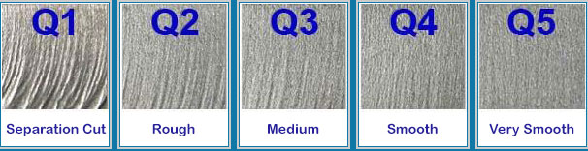
Figure 6, Types of surface finish achieved with waterjet cutting, (Waterjet cutting 2012)

Safety and Environment
One main advantage of waterjet cutting is the ability of being able to recycle the water and the abrasive garnet. This creates financial and environmental benefits to the process as very little water is used (Krajcarz, 2014). The process is beneficial to the environment and operators with the release of no hazardous fumes or UV radiation during the cutting stage. Due to the process being a cold cutting method, the risk of fire is very low which increases the safety risk to employees (Birtu & Avramescu, 2012). This is significantly different to CNC milling which has a real risk of fire. Anon., (2019) comments that due to toxic fumes, high temperatures and friction, any mechanical failure or sudden mistake can lead to a fire. Even though CNC poses many mechancial risks, abrasive Waterjet cutting can be very dangers if not used correctly. Olsen, (2008) says that the jet with its abrasive material can easily cut through hands and even get into your eyes which can extreme irration or loss of sight. It is important to wear PPE when in the vicinity of the machine.

Laser Beam Cutting

This is a type of Non-Traditional machining process that focuses a laser beam that melts and vaporises unwanted material from the main work piece (Dubey & Yadava, 2008). Once the high-powered beam vaporises the material leaving a kerf channel, the molten remains is blown away using an assist gas (Krishna & Kondayya, 2012). Nguyen, (2012) suggests that it is a thermal, non-contact process that can be used on several materials ranging from metals like aluminium, wood and plastics. Nguyen, (2012) goes on to say that laser beam machining has many applications similar to CNC machining that includes cutting, drilling and marking however, it also has the capability of engraving and texturing.

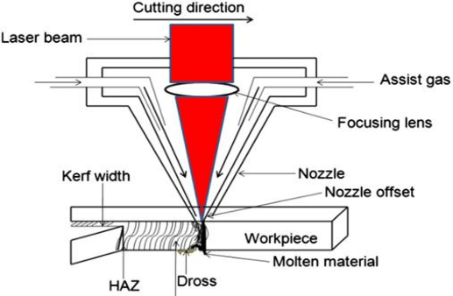

Figure 7, Illustration of the laser cutting process, (Kumar, Senthil 2015)
Cost
Even though the initial cost of the equipment will be higher than the CNC machine along with high energy costs, precision and quality tends to be high. According to Zheng, et al., (1996) a CNC controlled laser can cost approximatley $500,000 with an average energy cost between $100-$120 per hour and an average maintenance cost of $6000/year. If you compare this to the initial cost of a CNC machine being anything from $6000 - $300000 (Machines, 2018) and a running cost f 45$ per hour, you can see that the overall costs are much lower. This can be a disadvantage to using the laser cut technology, however this cost can gain back through its high quality cut (Kara & Anderberg, 2009). In my view, this initial and high energy cost may be too high for the company to rool out a programme of the laser cutting process compared to other non traditional processes that could deliver a similar quality.

Manufacturing
The laser beam cutting process allows for materials to be cut ranging from 3mm –25mm thickness and feeding rates between 0.3/4metres per minute (Laurentiu, et al., 2016). Even though there is a big range in material thickness that can be cut, Zheng, et al., (1996) observes that there is a limit to how thick a laser cutter can operate at without leaving thermal burns to the part. This is because it requires more time and energy to cut through thicker material. Wollenberger, (1998) notes that these Heat Affected zones lower the materials tolerance for cracking however this can be removed by heat treating the metal after cutting. This procedure of heat treating is currently used in the current manufacturing process for the cockpit floor.

Quality
From a quality aspect, laser beam cutting provides many advantages over CNC milling that need to be considered when deciding over a machining process. One benefit is the lack of touching mechanical parts due to the work piece not needing to be clamped or fixed when cutting (Abouzaid, 2014). This contrasts with CNC milling whereby the part needs to be clamped before the cutting process can resume which can be difficult to achieve. Hodges, (1994) agrees that this can be difficult to achieve as many things need to be considered such as reducing damage to work piece, avoiding deflection of part when cutting, stopping any rotation and provide support to the entire part. Failure to achieve this can affect the overall quality to the part.
Abouzaid, (2014) suggests the quality is maintained by the precise cutting and lack of thermal damage created by the laser. Wesman, (2012) reinforces the argument of cutting quality by stating that laser beam cutting produces cutting edges of the highest quality, with very narrow kerfs and with sharp defined edges. The cutting depth is also determined by the laser ability and this can be changed easily without any disruption to the manufacturing processes. Even though there is a lack of thermal damage created by the laser there are problems when it comes to cutting some aluminium (Anon., 2019) comments that sheet aluminium especially has high reflectivity which can allow the laser beam to get reflected back onto itself create significant damage to the tool and work piece. In my opinion this could prove to be costly and can cause a weakened floor to be placed into the cockpit. Another consideration proposed by Wollenberger, (1998) is the additional layer left on the surface of the cut material after the laser has been applied. This re-melted material is susceptible to small cracks which can progress into larger cracks and damage.
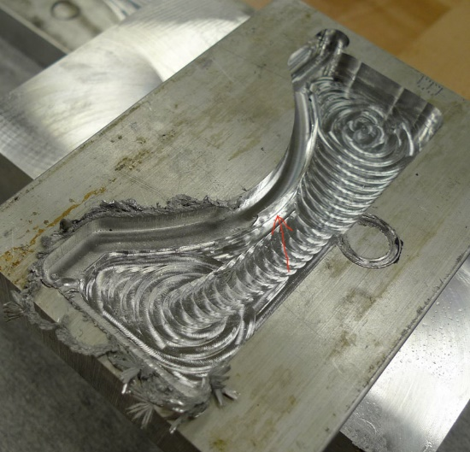

Figure 8, Surface finish damage from CNC tool, (Warfield 2018)
Safety and Environment
Due to the requirement of high-powered lasers with powers of over 100w, it is necessary to apply appropriate measures such as guards around the laser. Corder, et al., (1997) states that there must be a thick wall around the workpiece that is able to withdstand not only scattered radiation, but also a direct impact by the laser itself. This can be a disadvantage due to the higher than normal cost of extra reinforced guards. The extra procaution when it comes to guards, is simulated on CNC milling machining whereby harzards such as ejection of workpiece, chippings and unexpected motion, could lead to devastating injuries (Fridyland, 2006).
A major disdavantage shared with CNC milling and laser cutting is the release of harmful gases into the enviroment. Carnegie, (2019) reports that laser cuttings high temperatures cause all air surrounding the part to expand which releases harmful particles such as iron oxide, dust and chromium. stoney, (2018) points out that proper ventilation is essential when dealing with laser and CNC machine to reduce the chance of potential internal injuries.

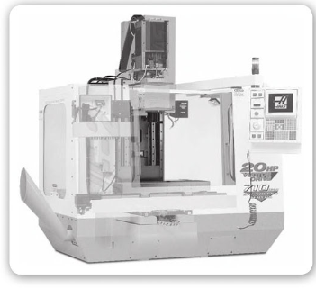

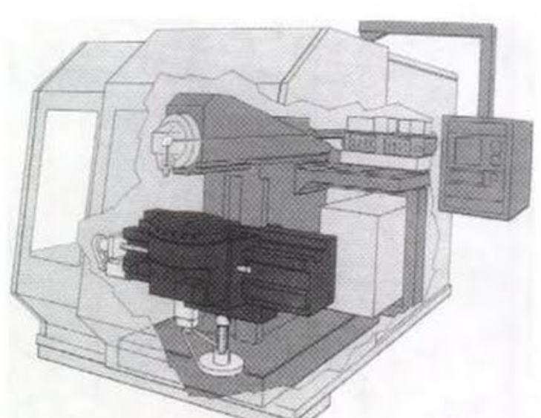

Figure 9, CNC milling machine guards, (Mattson, M 2009) Figure 10, Laser beam cutting guard, (Krar 2003)

Table of Comparison

This is a table summarising the key advantages and disadvantages of the three main manufacturing processes that are compared in this report.

Cutting Comparisons
 | Abrasive Waterjet Cutting | Laser Beam Cutting | CNC Milling
Thickness | 28mm before striations occur | Generally less than 7mm | Generally, under 20mm
Cutting Speed | Can be fast, depending on material thickness | Very fast cutting on thinner materials | Very fast
Precision Edge quality | Very Good | Excellent | Excellent
Heat affected Zones | None | Little Localised damage | Yes, requires huge amount of coolant
Part Damage | None | Heat can distort part | Can occur from clamping, tool or heat
Burr Formation | Minimal | Minimal | Yes, needs additional tools to remove burr
Hazardous Fumes | None | Yes, needs sophisticated extraction unit | Yes, requires extraction with additional filters
Set up | Very Fast set up | Fast set up | Very time-consuming set up
Process | Cold Cutting process | Thermal Process | Mechanical cutting process

From the above matrix you can see that all three cutting processes have benefits and drawbacks with the company’s specifications. Each area of the graph is colour code to with green, amber and red. With green being a good advantage, amber is a tolerated point and red is a disadvantage. From the table you can see that the process with the greater number of advantages is Abrasive waterjet cutting.

Conclusion

At the beginning of the report, the purpose was to find the company a Non tradition manufacturing process to modernise and improve surface quality. The two non-traditional process analysed were Abrasive waterjet cutting and Laser beam cutting, and their benefits and drawbacks were compared to the company’s current tradition process of CNC milling. Throughout the report, several different authors views were used via research to establish advantages and disadvantages of the three different processes. Areas of interest and examining in each process were their capabilities in quality, cost, surface quality and safety. A table of comparison that is colour coded is also used to highlight all the advantages and disadvantages raised within the comparative research.
From the data and research, it is clear that both of the non-traditional process have a variety of advantages over CNC milling that the company could adopted into their manufacturing programme. The research suggests however that the abrasive waterjet machining process, meets all of the company’s specification criteria with regards to tolerances and surface quality. Due to the processes ability to cut through thicker material, it would allow it to cut through the cockpits floor required thickness without the risk of leaving heat affected zones. From a safety viewpoint, the water cutting process does not produce any hazardous fumes that would require expensive extraction technology and filters. With areas from burr formation and an easy of set up being straightforward, the company would have minimum downtime modifying the manufacturing facilities machines from CNC milling to waterjet cutting. The research also determines that the cost of implementing laser beam machining would be considerable higher compared to Laser beam cutting.
I believe that this report succeeds in examining the both processes with CNC milling and it effectively highlights and provides all the necessary information for the company to decide on whether they should change to the recommended Non-traditional manufacturing process.

References

Abouzaid, A., 2014. Advanced laser beam cutting technology usage requirements on metal surfaces formed with automatic spinning. International Design Journal, 2(4), pp. 101-106.
Adrian, S. & Vasile, N., 2015. Monitoring and Control of Thermal Expansion Effect on Machining Process of Aluminium Alloy Parts. Applied Mechanics and Materials, Volume 809, pp. 33-38.
Anon., 2019. CNC Times. [Online]
Available at: https://www.cnctimes.com/editorial/fire-risks-in-a-cnc
[Accessed 7 april 2019].
Anon., 2019. Cutting Processes Laser Cutting. [Online]
Available at: https://www.twi-global.com/technical-knowledge/job-knowledge/cutting-processes-laser-cutting-052
[Accessed 4 march 2019].
Anon., 2019. ESAB KNOWLEDGE CENTRE. [Online]
Available at: https://www.esabna.com/us/en/education/blog/what-is-cutting-kerf.cfm
[Accessed 29 03 2019].
Anon., 2019. Waterjets.org. [Online]
Available at: https://waterjets.org/archive/getting-the-most/tips/waterjet-machining-tolerances/
[Accessed 11 april 2019].
Antonelli, D., Chiabert, P. & Afkhamaifar, A., 2016. Variational Analysis for CNC Milling Process. Science Direct, Volume 43, pp. 118-123.
Anwar, S. et al., 2018. Bibliometric analysis of abrasive water jet machining research. Journal of King Saud University - Engineering Sciences , pp. 2-3.
Arunkumar, K., Navaneethbalaji, M., Praveenkumar, G. & Venkatesan, R., 2016. Factors Affecting Surface Finish of Abrasive Waterjet Machining. International Journal of Modern Trends in Engineering and Research, pp. 859-860.
Badrinathan, K. S. & Karunamoorthy, L., 2014. Reducing Tool Wear in CNC End Milling Operation using Progressive Feed Rate. Applied Mechanics and Materials, Volume 592-594, pp. 716-723.
Birtu, C. & Avramescu, V., 2012. Abrasive Water Jet Cutting - Technique, Equipment, Performances. Revista de Tehnologii Neconventionale, 16(1), pp. 40-46.
Carnegie, M., 2019. The harmful side effects of laser cutting. [Online]
Available at: https://www.airsystems-inc.com/air-purification-news/air-impurities/the-harmful-side-effects-of-laser-cutting/
[Accessed 4 april 2019].
Chithirai Pon Selvan, M., Mohana Sundara Raju, N. & Sachidananda, H., 2012. Effects of process parameters on surface roughness in abrasive waterjet cutting of aluminium. Frontiers of Mechanical Engineering, 4(7), pp. 440-443.
Corder, D. et al., 1997. High Power Laser Beam Delivery Monitoring for Laser Safety. Optics and Lasers in Engineering , Volume 27, pp. 479-492.
Dubey, A. K. & Yadava, V., 2008. Laser Beam Machining-A Review. International Journal of Machine Tools and Manufacture , 48(6), pp. 609-628.
Fridyland, S., 2006. Getting CNC Machine Safety Right. Machinery and Equipment, 22(5), p. 30.
Hodges, B., 1994. CNC Part Programming Workbook. London: Palgrave.
Jai Aultrin, K., Dev Anand, M. & Jose, P. j., 2012. Modelling the cutting Process and Cutting Performance in Abrasive Water jet Machining Using Genetic-Fuzzy Approach. Procedia Engineering, Volume 38, pp. 4013-4020.
Jose, J. P., Anand, D. M. & Aultrin, J. K. S., 2012. Modelling the Cutting Process and Cutting Performance in Abrasive Waterjet Machining Using Genetic-Fuzzy Approach. International Conference on Modeling Optimization and Computing, Volume 38, pp. 4013-4020.
Kara, S. & Anderberg, S., 2009. Energy and Cost efficiency in CNC machining. Journal of Sustainable Manufacturing, Volume 7.
Korn, D., 2014. Setting the Stage for Sizeable Composites Work. Modern Machine Shop, 86(10), pp. 82-87.
Krajcarz, D., 2014. Comparison Metal Water Jet Cutting with Laser and Plasma Cutting. Science Direct, Volume 69, pp. 838-843.
Krishna, A. G. & Kondayya, D., 2012. An integrated evoloutionary approach for modelling and optimization of laser beam cutting process. Internations Journal of Advanced Manufacturing Technology, Volume 65, pp. 259-274.
Laniel, R., Bouchareb, O., Brient, A. & Miroir, M., 2017. Discrete elements model of an abrasive water-jet through the focal canon to the work piece. Science Direct, Volume 16, pp. 529-534.
Laurentiu, S. et al., 2016. Surface Roughness in Laser Beam Contour Cutting. Revista de tehnologii Neconventionale, 20(3), pp. 25-29.
Liu, H. -T., 2017. "7M" Advantage of Abrasive Waterjet for Machining Advanced Materials. Journal of Manufacturing and Materials Processing, Volume 1, p. 11.
Machines, C., 2018. Manufacturing Tomorrow. [Online]
Available at: https://www.manufacturingtomorrow.com/article/2018/12/2018-used-cnc-machine-price-average-cnc-machine-price/12676
[Accessed 9 april 2019].
Miles, P. & Henning, A., 2013. A Better Measurement of Abrasive Waterjet Cut Surface Finishes. Conference and Expo, pp. 1-10.
Mines, B., 2018. Waterjets.org. [Online]
Available at: https://waterjets.org/archive/waterjet-equipment/general/waterjet-abrasives/
[Accessed 7 april 2019].
Momber, A. W. & Kovacevic, R., 2012. Principles of Abrasive Waterjet Machining. 2nd ed. Duisburg: Springer Science and Buisness Media .
Mujeeb, A. et al., 2014. Thermal Deformation Analysis of Aluminium Heat Sink Using Electronic Speckle Pattern Interferometry. International Journal of Advances in Engineering and Technology, 7(2).
Nguyen, N.-T., 2012. Fabrication Technologies. 2nd ed. New York: William Andrew Applied Science Publishers.
Nozawa, R., Kawamura, H. & Kawamata, M., 2014. CNC Applications. IFAC Proceedings, 10(11), pp. 207-210.
Olsen, D. J. H., 2008. the fabricator.com. [Online]
Available at: https://www.thefabricator.com/article/waterjetcutting/safety-in-jet-cutting
[Accessed 7 april 2019].
stoney, C., 2018. Managing CNC Plasma Cutter Fumes. [Online]
Available at: https://stoneycnc.co.uk/cnc-plasma-cutter-fumes/
[Accessed 11 april 2019].
Thomas, D., 2013. Characterisation of aggregate notch cavity formation properties on abrasive waterjet cut surfaces. Journal of Manufacturing Processes, Volume 15, pp. 355-363.
Tosun, N., Dagtekin, I., Ozler, L. & Deniz, A., 2013. Abrasive Waterjet Cutting of Aluminium Alloys: Workpiece Surface Roughness. Applied Mechanics and Materials, Volume 404, pp. 3-9.
Varotsis, A. b., 2019. Surface Finishes For CNC Machining. [Online]
Available at: https://www.3dhubs.com/knowledge-base/surface-finishes-cnc-machinining
[Accessed 9 march 2019].
w, 2019. ESAB - What makes up the cost of Waterjet cutter. [Online]
Available at: https://www.esabna.com/us/en/education/blog/how-much-does-waterjet-cutting-cost.cfm
[Accessed 4 april 2019].
Wesman, K., 2012. Welding Process Handbook. 2nd ed. Cambridge: Woodhead.
Wollenberger, J., 1998. the fabricator.com. [Online]
Available at: https://www.thefabricator.com/article/lasercutting/the-challenges-of-laser-cutting-overcoming-some-common-obstacles
[Accessed 2 april 2019].
Zheng, H. Y. et al., 1996. Quality and Cost Comparisons Between Laser and Waterjet Cutting. Journal of Materials Processing Technology, Volume 62, pp. 294-298.
Zsolt, M., 2013. Energy Approach Of The Taper At Abrasive Waterjet Cutting. Production Processes and Systems, 6(1), pp. 89-96.

