Scott Ling 1810357 | DSP ACDA 5008 | December 16, 2020

The Simulation of DSP

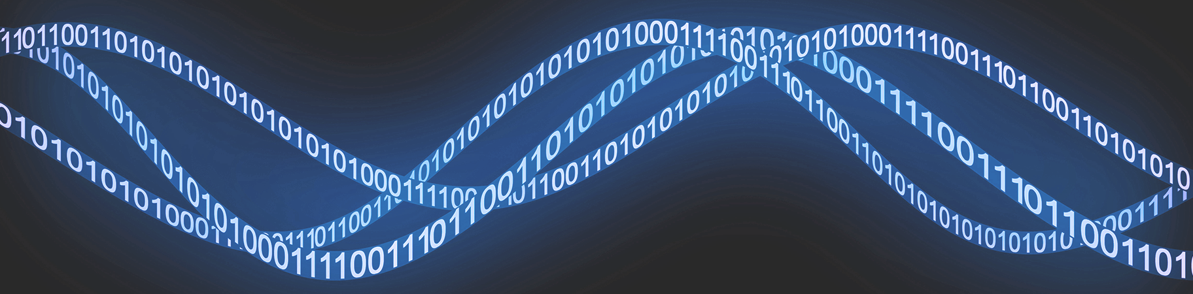

Contents
Introduction 1
1. Background research on Digital Signal Processing 2
1.1 Analogue to digital converter (ADCs) 2
1.2 Digital to analogue converter (DAC) 2
1.3 Converters 2
1.4 What is inside a DSP? 3
1.5 Digital Filters 3
2. Simulation modelling 4
2.1Amplitude Shift Key: 4
2.2 Phase Shift Key: 5
2.3 Quadrature Phase Shift Keying: 6
2.4 Quadrature Amplitude Modulation: 6
3. Results from the simulations 6
4. Discussion 8
5. Conclusion. 9
6. Table of figures. 9

Introduction
In this report the author will demonstrate a knowledge of the theoretical concepts of digital signal processing and digital communications systems. This will be achieved, by using simulation software to be able to be able to compare different systems.
The author will use simulation modelling software Simulink/Matlab, and will compare and analyze the performances and data between the different variants of; Amplitude shift Key (ASK), Phase shift Keying (PSK). The author will also research Quadrature Phase shift keying and Amplitude modulation (QPSK) additionally the additive white noise Gaussian (AWGN) will also be looked into.
Digital signal processors require the use of linear phase filtering these can be designed by the window design method or the optimal filter design. These will be implemented by the convolution method applying the filters impulse response and filter coefficients. [1]

Background research on Digital Signal Processing
Digital signal processers use every day signals and changes them through algorithms. The signals that can be used to achieve this can be: voice, audio, video, temperature, pressure or position that have been changed to digital format. The Digital Signal Processors has the ability to add, subtract, multiply and divide. A signal needs to be processed so information can be extracted and then be displayed, analyzed or changed over to another relevant signal for the user. By using Digital signal processors the information that has been processed can be displayed in a timely manner. [1]

Digital signal processors and algorithms are used to eliminate undesired from the data stream. Digital relays the information to the real-world through analogue to digital converters as well as digital to analogue converters.[1] [2]

1.1 Analogue to digital converter (ADCs)
Analogue to digital converters or ACDS for short, are used to convert data in digital circuits and allow them to respond with the real world and coding an analogue signal into binary form.
In the real world, a signal in analogue form will be continuously changing the values, this is caused by the signals that are received from different sources and sensors. An ACDS will take an image of the analogue voltage and will then produce this in the form of a digital code. [3]

1.2 Digital to analogue converter (DAC)
A digital to Analogue converter or DAC, are used to convert a binary digital signal from a computer into an electrical voltage. Using a DAC within DSP enables working with signals a lot easier when they are in a binary state. [4]

1.3 Converters
When converters are used within a DSP they will take a real world signal and turn this into binary format. The DSP will then transfer the processed digital data back into the application that it is being applied to in the real world.
The data that a DSP can produce can be used in multiple functions this can range from: Security cameras, Home audio and video compression. A signal can be compressed which will make the transmittance quicker and more efficient. The signals that are generated can be amplified or exploited, by doing this the quality could be improved or more information can be received. [2] [3] [4]

1.4 What is inside a DSP?
- Program Memory- This is the Program storage area that a DSP will use to process that data,
- Data Memory- This is the information storage area that needs to be processed,
- Compute Engine- This is where the math’s algorithms are processed, the compute engine will access the program that has been stored in the program memory thus extracting the data from the data memory,
- Input/output- This is the connection between the outside world and the DSP. This could be through serial ports, timers, host ports or external ports. [2][8]

1.5 Digital Filters
There is four main applications of Digital filters the list is as follows:
- Low-pass filter,
- High-pass filter,
- Band-pass filter,
- Band-reject filter.
A low-pass filter will allow low frequency signals to transfer through, though any frequencies that are above the chosen “low frequency” will not find it as easy to travel through. Low pass filters are rated at a certain “cutoff frequency”.[9][10]
A high-pass filter will allow signals to pass that are above its certain “cutoff frequency”.
Band-pass filters are used to the separate and remove certain frequencies that lie within a certain band or range of frequencies.[11]
Band-reject filter is used to stop the frequencies that lie in the area between the two defined frequency cut off points.[13]
Modulation is a process of converting data into radio waves by adding information to a carrier or electronic signal. A carrier signal has a steady waveform, this means it will have either a constant height or amplitude and frequency.
The carrier wave can be manipulated and information can be added by varying its amplitude (height of the wave), frequency (number of waves per selected timeframe), phase (where the phase is at any timeframe) or polarization (the orientation of the lines). The process of imposing an input signal onto a carrier wave is called modulation. Modulation changes the shape of the carrier wave to encode the data or information that you want to carry.
If the input signal’s height varies with the loudness of a given sound, this is then added to the carrier, by doing this it will increase the carrier’s amplitude corresponding to the input signal. This is known as amplitude modulation. [14]
There are 2 types of amplitude modulation, OOK (On-Off keying) and ASK (amplitude shift keying). Amplitude shift-keying represents the binary data in the form of variations in the amplitude of a signal. Any modulated signal has a high frequency carrier, when ASK is modulated, the binary signal gives a zero value for low input while the carrier output a high input. [1][2]
Frequency modulation (FM) is where the frequency of an input signal can be changed. If this input signal is added to the carrier wave, it will change the frequency of the carrier wave. Users can tweak the frequency to carry information. There any many types of FM, PSK (phase shift keying), QPSK (Quadrature phase shift keying) and BPSK (binary phase shift keying).
PSK systems use a differential method for encoding data onto the carrier wave, for example this can be achieved by making a change in phase equal to a 1 and no phase change equal to a 0, alternatively making a change by 90 degrees in one direction for a 1 and 90 degrees the other way for a 0, this retains the 180 degree phase reversal between 1 and 0 states.
QPSK is where 4 phase states are used each 90 degrees from the next, 2 bits are modulated simultaneously by choosing from the 4 states. It uses the same bandwidth as standard PSK but carries double the amount of information.
Quadrature amplitude modulation (QAM) is a combination of analog and digital modulation. It modulates the amplitude of the 2 carrier waves with the help of ASK in order to transmit 2 digital bit streams.
The 2 carrier waves remain out of phase by 90 degrees from each other, the modulated waves are then merged, the waveform produced is in the form of both PSK and ASK. [1][2][3] [5][9][11]

Simulation modelling

2.1Amplitude Shift Key:

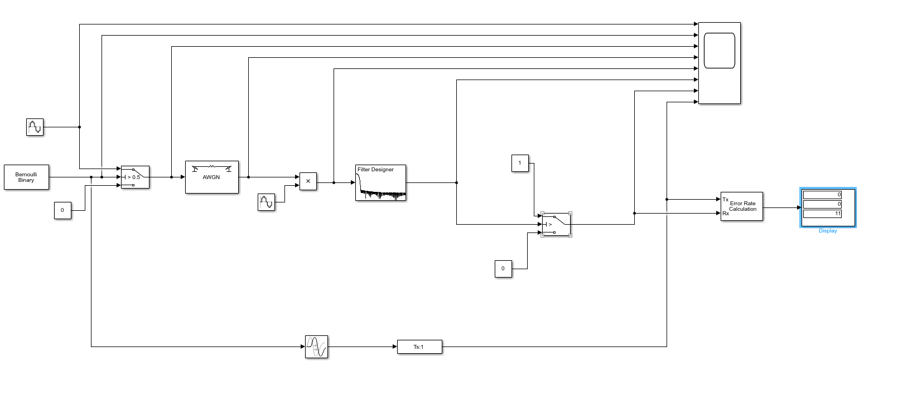
Figure 1- ASK Model
Figure one shows the design of the “ASK” Model in the simulation software. The components are:
- Bernoulli Binary Generator,
- Sine Wave Function x 2,
- Constant x 3,
- Switch x2,
- AWGN Channel,
- Product,
- Transport Delay,
- Signal specifications,
- Digital Filter Design,
- Scope,
- Error rate Calculator,
- Display.
The author designed the ASK modulation circuit within the simulation software. The Circuit is manipulated by changing the values in the AWGN by doing this the value of noise can be changed that the carrier receives.
The scope in the circuit design will show how the carrier waves react during the simulation. The error rate calculator at the end of the circuit will show the amount of errors that have been detected through the simulation.

2.2 Phase Shift Key:

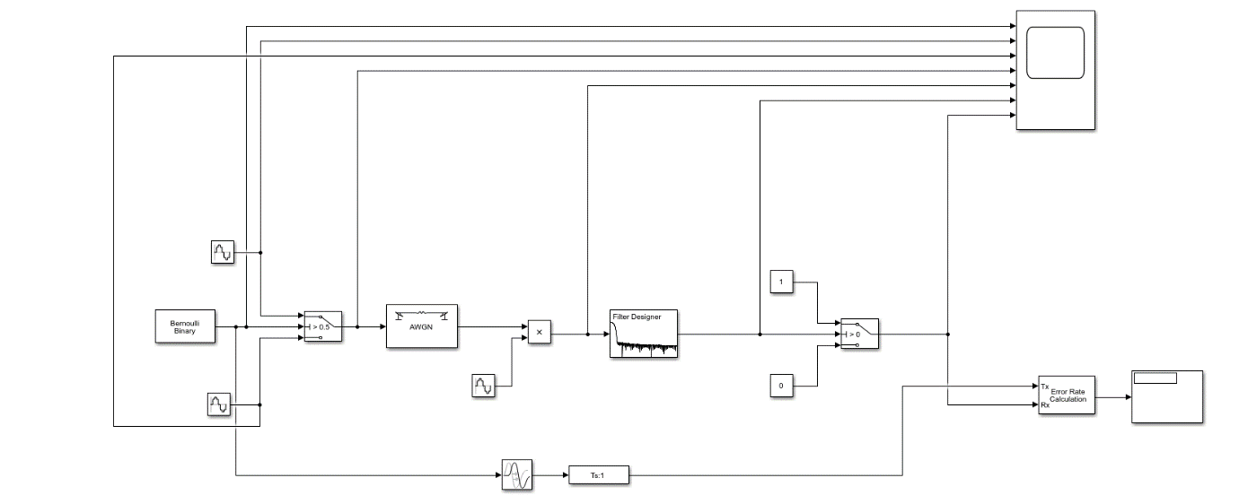

Figure 2- PSK Model

Figure 2 PSK
Figure two shows the design of the “PSK” Model in the simulation software.
The author designed the PSK modulation circuit within the simulation software. The PSK Circuit mirrors the ASK model.

2.3 Quadrature Phase Shift Keying:

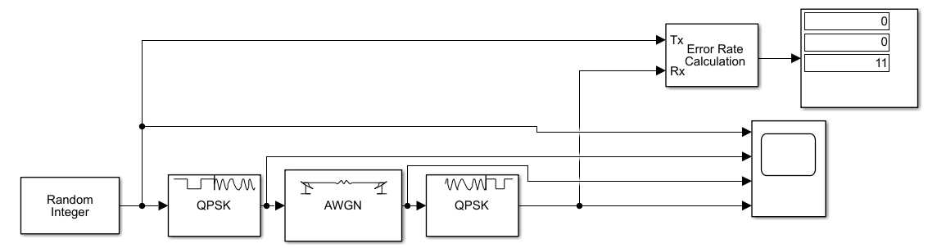

Figure 3-QPSK Model
In figure 3, the author has designed a Quadrature Phase shift Keying module (QPSK), the component that were used are:
- Random integer,
- Quadrature Phase shift key block x2,
- AWGN,
- Error Rate Calculator,
- Scope,
- Display.
The random integer block has been used to produce a series of data during the simulation. The scope was used to see the carrier wave along the simulation. The error rate calculation has been used to allow the author to record the bit error rate data of the QPSK system.

2.4 Quadrature Amplitude Modulation:
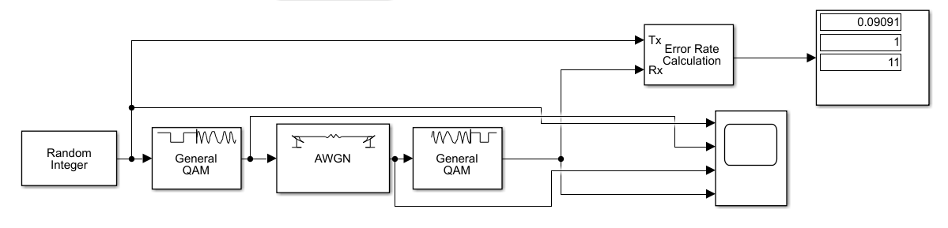
Figure 4-QAM Model
In figure 4, the author has designed a Quadrature Amplitude modulation (QAM), the component that were used are:
- Random integer,
- General QAM x2,
- AWGN,
- Error Rate Calculator,
- Scope,
- Display.
The random integer block has been used to produce a series of data during the simulation. The scope was used to see the carrier wave along the simulation. The error rate calculation has been used to allow the author to record the bit error rate data of the QAM module.

Results from the simulations

To be able to achieve the results for the simulation, the author selected 10 signal to noise ratio (SNR) values, these were run through the Additive white Gaussian noise (AWGN) block in the simulations program.
From the table below it can be seen the selected values that were used during simulation, the average of the simulations was then worked out to show the error rate that was given from the simulations. The table of results highlights at what point the simulations obtain a zero errors simulation with the chosen signal-to-noise ratio.

Figure 5- Table of failures percentages
SNR (DB) | ASK Modulation results | PSK Modulation results | QPSK Modulation results | QAM Modulation results
-100 | 0.5637 | 0.3636 | 0.7455 | 0.9273
-75 | 0.4182 | 0.399 | 0.8364 | 0.9454
-50 | 0.3091 | 0.4181 | 0.7636 | 0.8182
-40 | 0.5091 | 0.3818 | 0.7818 | 0.81
-20 | 0.3272 | 0.3636 | 0.7455 | 0.8727
-15 | 0.2182 | 0.3272 | 0.61 | 0.8
-10 | 0.2181 | 0.1454 | 0.5636 | 0.7454
0 | 0.0726 | 0 | 0.2182 | 0.3998
5 | 0 | 0 | 0 | 0.1818
10 | 0 | 0 | 0 | 0.0362

Figure 6-Graph of failures

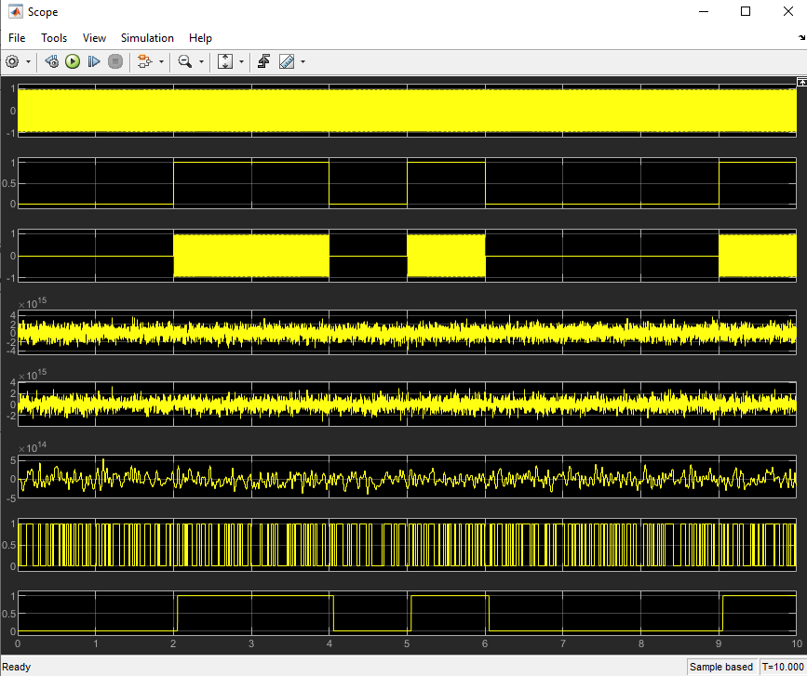

Figure 7-ASK Simulation 100DB

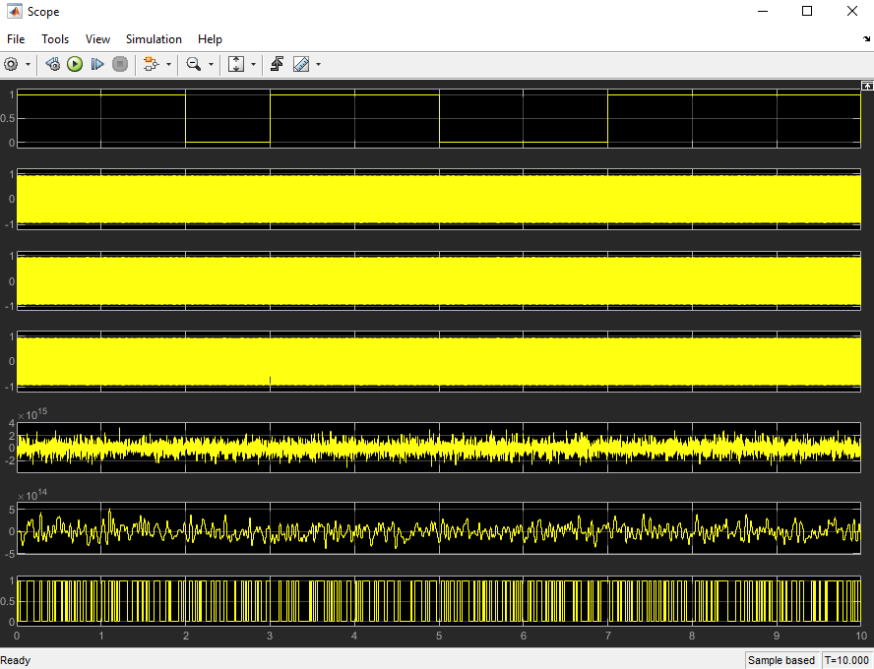
Figure 8 PSK Simulation 100DB
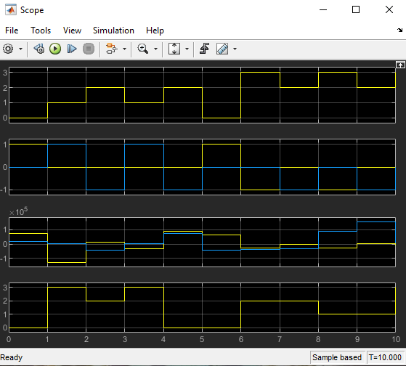

Figure 9- QPSK Simulation 100DB

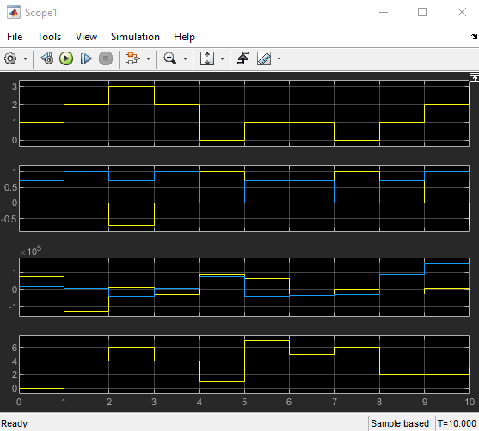

Figure 10-QAM Simulation 100DB

Discussion
There is a noticeable error rating on ASK simulation, with a negative “SNR” value there is a too much noise within the carrier wave and errors have occurred as a result of this.
The PSK simulation has a similar performance to the ASK however on the O SNR value there is no errors.
QPSK showed no errors at the positive five DB mark however the QAM still had errors at 10DB so further investigation would be needed to obtain a no error result.

Conclusion.
From the results obtained from the simulations it can be noted that the greater the data rate per simulation variant there is more interference from noise, the QPSK and QAM circuits have a higher error rate with the lower values.

The data that has been obtained from the simulations could have a variety of issues this would need further investigation by using different values and different timeframes. Further investigation into this could yield more errors or a more realistic average overall.

Table of figures.
Figure 1- ASK Model 5
Figure 2- PSK Model 6
Figure 3-QPSK Model 7
Figure 4-QAM Model 8
Figure 5- Table of failures percentages 9
Figure 6-Graph of failures 9
Figure 7-ASK Simulation 100DB 10
Figure 8 PSK Simulation 100DB 10
Figure 9- QPSK Simulation 100DB 11
Figure 10-QAM Simulation 100DB 11

References

[1] | "Beginners guide to DSP," Analog, [Online]. Available: https://www.analog.com/en/design-center/landing-pages/001/beginners-guide-to-dsp.html#. [Accessed 20 12 2020].
[2] | "Digital to Analogue converters," Components 101, [Online]. Available: https://components101.com/articles/digital-to-analog-converters-dac. [Accessed 18 12 2020].
[3] | S. direct, "Digital Signal Processor," Science direct, [Online]. Available: https://www.sciencedirect.com/topics/computer-science/digital-signal-processor. [Accessed 19 12 2020].
[4] | E. tutorial, "Analogue to Digital converter," Electronics tutorial, [Online]. Available: https://www.electronics-tutorials.ws/combination/analogue-to-digital-converter.html. [Accessed 19 12 2020].
[5] | S. direct, "Digital signal processing system," [Online]. Available: https://www.sciencedirect.com/topics/engineering/digital-signal-processing-system. [Accessed 20 12 2020].
[6] | M. Audio, Artist, Digital Signal Processing Front page cover. [Art]. 2020.
[7] | T. A. F. G. &. J. N. Omer Anjum, "EURASIP journal on Wireless Communications and Networking," State of the art baseband DSP platforms for software defined Radio, vol. 5, 2011.
[8] | Analog.com, "Design handbook," 1999. [Online]. Available: https://www.analog.com/media/en/training-seminars/design-handbooks/Technical-Tutorial-DDS/Section9.pdf. [Accessed 20 12 2020].
[9] | S. W. Smith, "Introduction to Digital filters," 1997-2011. [Online]. Available: http://www.dspguide.com/ch14/5.htm. [Accessed 21 12 2020].
[10] | T. R. Kuphaldt, Vol II Alternating Current, Design science License, https://www.allaboutcircuits.com/textbook/alternating-current/chpt-8/low-pass-filters/.
[11] | E. Tutorial, "Passive high pass filter," Electronics Tutorial, [Online]. Available: https://www.electronics-tutorials.ws/filter/filter_3.html. [Accessed 20 12 2020].
[12] | E. tutorials, "Passive band pass filter," [Online]. Available: https://www.electronics-tutorials.ws/filter/filter_4.html. [Accessed 22 12 2020].
[13] | E. Tutorials, "Band Stop Filter," [Online]. Available: https://www.electronics-tutorials.ws/filter/band-stop-filter.html. [Accessed 20 12 2020].
[14] | T. Target, "Polarization (wave polarization)," whatis.com, [Online]. Available: https://whatis.techtarget.com/definition/polarization-wave-polarization?_ga=2.196290092.1441646360.1608568477-2036785020.1608568477. [Accessed 19 12 2020].

