

Presentation and Slide Notes - Enabling and Supporting staff in a Hybrid Era
BMHR7014
Daniel Owen 2106804
900 Words
Slide 1 | Enabling and Supporting Staff in a Hybrid Era | Hybrid working the new flexible working trend, simply put it allowing you to work from home, but is it as simple as that? I will be taking you through the story of Implementing within Hywel Dda | 
Slide 2 | Introduction | Hywel Dda are in the process of moving clinical services closer to population bases within Carmarthen, Pembrokeshire, and Ceredigion to achieve this the plan is to move existing staff to Hybrid working | 
Slide 3 | Introduction | I have been asked to implement this within my teams, staff where positive about working from home, who isn’t? but the devil is in the detail is it just as simple as working from home? Or are there other challenges | 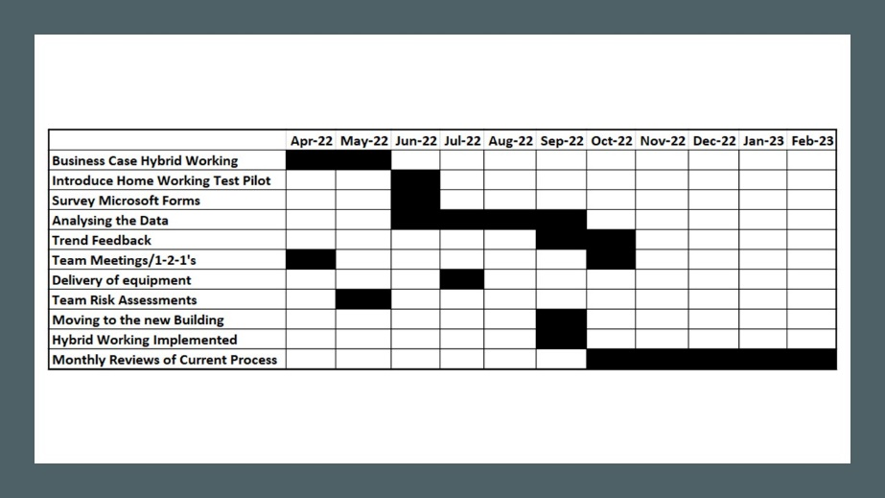
Slide 4 | Business Case | Aligning the project to a business case allowed me to secure additional funding to support the move to Hybrid, this also allowed me the tools to engage with my team recommended by the research paper | 
Slide 5 | Talk to your team | People want to solve problems, I provided my team with the challenge fist, if we moved to Hybrid how would you do it? This allowed the teams to provide their preferences ahead of the change and raise concerns. | 
Slide 6 | Test the water | I undertook a work from home test with my team first, this was to ensure we had the correct processes and systems in place to support them and continue with business as normal and understand any additional risk | 
Slide 7 | What do they really think? | I created a survey, 100% of staff completed it, asking them questions around the basis of Hybrid, Laptops/Software/What is Hybrid to them? This feedback allowed me to set a framework for the team to move to Hybrid working. | 
Slide 8 | What did the data say? | Staff wanted this, they had already read the polices and completed risk assessments ahead of Hybrid even taking place, the want was there, how to deliver it was the next question? | 
Slide 9 | The Good | Based on the survey they had the tools and hardware, they felt it provided them more freedom, 60%/40% is the preference, a better work life balance the main trend from the survey. | 
Slide 10 | The not so bad | Need for communication, coffee mornings, catch ups, staff wanted to ensure this happens so they can feel as part of a team. Daily catch ups allowed the Hybrid team to engage and support each other and the needs of new starters. | 
Slide 11 | The want for Hybrid Working | The teams will start with a 60% (3days office)/40% (2 days Home) but will review this with staff, this provides a greater work life balance to staff – this is also flexible on request | 
Slide 12 | Systems and Digital (R) | I recommend ensuring all the systems and digital requirements are in place ahead of hybrid working, that testing takes place also and champions identified to support the teams through hybrid working. | 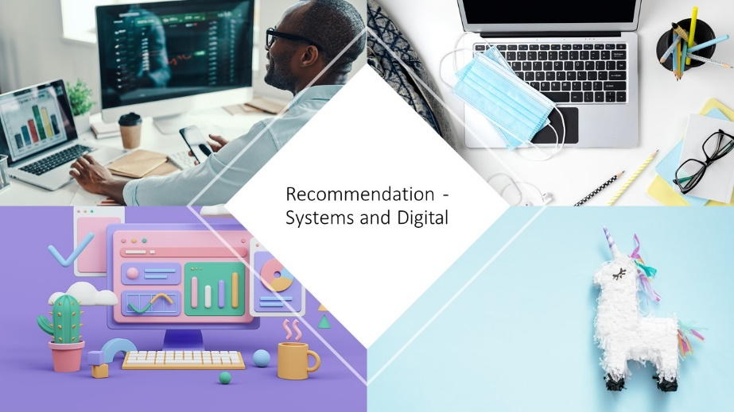
Slide 13 | Home Office Set Up (R) | I recommend providing Monitors/Desks/Chairs and other hardware to support the team moving to a Hybrid working function, to do this I have taken a list of hardware staff require to work from home and ensure this is in line with HSE | 
Slide 14 | The Social Stuff (R) | I recommend that daily catch ups along with 121’s and team meetings continue to take place to support staff, also virtual coffee drop ins to bring back the social element of work to allow staff to feel heard and supported. | 
Slide 15 | Development and Wellbeing | Ensuring staff have the correct access to support through development or wellbeing requirements is important, I will ensure this is discussed in 1-2-1’s and team meetings allowing any issues to be raised. | 
Slide 16 | Hybrid working plans (R) | I recommend the use of work plans to allow staff to know more detail about where and where they are working, this will allow staff to understand their workplans for the day a recommendation from the survey. | 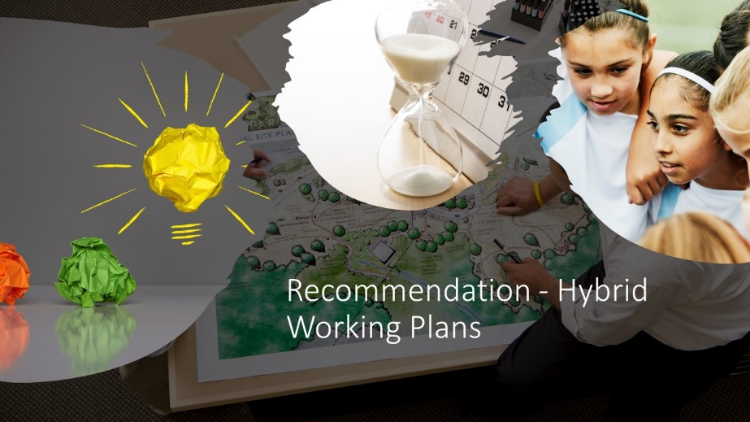
Slide 17 | Costs? | Hardware, Time, Engagement the costs of this project will be offset by the smaller footprint of the office space and the improvement to patient care locally and costs will be tracked through an implementation plan. | 
Slide 18 | Return on investment | Staff have reported feeling happier and more in control of their work/life balance, the reduction in space for staff will reduce estate costs, reviewing any qualitative benefits will also continue for a period of 3 months | 
Slide 19 | Wrap up | Hybrid working is still a new concept, understanding the benefits and negatives to staff and business will need to continue to be reviewed and changed, but Hybrid based on research and feedback is here to stay. | 
Slide 20 | The End? | It is not the end; I will continue to monitor hybrid team working to ensure the benefits to staff and that workloads are still managed effectively; staff will continue to be engaged to ensure this is future proofed. I will also share with other managers that are implementing. | 

References
Brand, A. (2022). Hybrid Working Needs Different Employee Engagement Methods. [online] HRreview. Available at: https://www.hrreview.co.uk/hr-news/hybrid-working-needs-different-employee-engagement-methods/141131 (Accessed 01 Sep. 2022).
Cameron, S. and Price, D. (2009). Business Research Methods : a Practical Approach. London: Chartered Institute of Personnel and Development, p.131.
Chamorro-Premuzic, T. (2022). The Challenges of Hybrid Work. [online] Forbes. Available at: https://www.forbes.com/sites/tomaspremuzic/2022/01/26/the-challenges-of-hybrid-work/?sh=1f989797286a (Accessed 26 Sep. 2022).
CIPD (2021). Planning for hybrid working. [online] CIPD. Available at: https://www.cipd.co.uk/knowledge/fundamentals/relations/flexible-working/planning-hybrid-working (Accessed 19 Sep. 2022).
Cleave, P. (2021). Advantages of Questionnaires in Online Research. [online] SmartSurvey. Available at: https://www.smartsurvey.co.uk/blog/advantages-of-questionnaires-in-online-research (Accessed 29 Sep. 2022).
Colombo, L. (2021). Council Post: Hybrid Working Models: Why Employees’ Well-Being Must Remain a Priority. [online] Forbes. Available at: https://www.forbes.com/sites/forbeshumanresourcescouncil/2021/12/06/hybrid-working-models-why-employees-well-being-must-remain-a-priority/?sh=42bf683d315b (Accessed 26 Sep. 2022).
Haas, M. (2022). 5 Challenges of Hybrid Work — and How to Overcome Them. [online] Harvard Business Review. Available at: https://hbr.org/2022/02/5-challenges-of-hybrid-work-and-how-to-overcome-them (Accessed 05 Sep. 2022).
Health and Safety Executive (n.d.). Managing Home workers’ Health and Safety - Overview - HSE. [online] www.hse.gov.uk. Available at: https://www.hse.gov.uk/home-working/employer/index.htm (Accessed 19 Sep. 2022).
HRRevolution. (2021). The pros and cons of hybrid working | HR Revolution. [online] Available at: https://hrrevolution.co.uk/the-pros-and-cons-of-hybrid-working/#:~:text=Cons%20of%20hybrid%20working%20Poor%20relationships%20Working%20from (Accessed 19 Sep. 2022).
Manu Bhatia (2019). A Complete Guide to Quantitative Research Methods - Atlan | Humans of Data. [online] Atlan | Humans of Data. Available at: https://humansofdata.atlan.com/2018/06/quantitative-research-methods/ (Accessed 19 Sep. 2022).
McKendrick, J. (2021). Business Leaders Are Changing Their Minds About Hybrid And Remote Work. [online] Forbes. Available at: https://www.forbes.com/sites/joemckendrick/2021/11/07/business-leaders-are-changing-their-minds-about-hybrid-and-remote-work/?sh=510090c8d4c8 (Accessed 19 Sep. 2022).
Microsoft (2022). Great Expectations: Making Hybrid Work. [online] 2022 Work Trend Index: Annual Report. Available at: https://clouddamcdnprodep.azureedge.net/gdc/gdc3Ps8ze/original (Accessed 19 Sep. 2022).
MindTools (2022). Hybrid Working: Finding the Right Mix of Remote and Office Working. [online] www.mindtools.com. Available at: https://www.mindtools.com/pages/article/hybrid-working.htm (Accessed 26 Sep. 2022).
Osbaldeston, A. (2021). 5 Reasons to Combine Qualitative and Quantitative Research. [online] www.questback.com. Available at: https://www.questback.com/blog/5-reasons-to-combine-qualitative-and-quantitative-research/ (Accessed 03 Sep. 2022).
Parrott, C. (2022). Best Practices for a Survey Introduction. [online] SurveyMonkey. Available at: https://www.surveymonkey.com/curiosity/survey_introduction (Accessed 19 Sep. 2022).
Penny, C. (2022). Hybrid Working in 2022: an Ultimate Guide for HR Leaders. [online] Sage Advice United Kingdom. Available at: https://www.sage.com/en-gb/blog/hybrid-working-hr-guide (Accessed 19 Sep. 2022).
Robson, D. (2021). The Digital Body Language Cues You Send – or don’t Send. [online] www.bbc.com. Available at: https://www.bbc.com/worklife/article/20210617-the-digital-body-language-cues-you-send-or-dont-send (Accessed 4 Sep. 2022).
Scribbr (2019). Research Methods | How to Collect and Analyze Data. [online] Scribbr. Available at: https://www.scribbr.com/category/methodology/ (Accessed 19 Sep. 2022).
Simpson, S. (2021). Writing a hybrid working policy: a guide for HR. [online] Personnel Today. Available at: https://www.personneltoday.com/hr/hybrid-working-policy-hr-guide/ (Accessed 19 Sep. 2022).
SMITH, C., SILVERSTONE, Y., WHITTALL, N., SHAW, D. and MCMILLAN, K. (2021). The Future of Work | Accenture. [online] www.accenture.com. Available at: https://www.accenture.com/us-en/insights/consulting/future-work (Accessed 19 Sep. 2022).
SurveyMonkey (2018). Open-Ended Vs Closed-Ended Questions | SurveyMonkey. [online] SurveyMonkey. Available at: https://www.surveymonkey.com/mp/comparing-closed-ended-and-open-ended-questions/ (Accessed 24 Sep. 2022).
Taylor, H., Florisson, R. and Hooper, D. (2021). Making Hybrid Inclusive - Key Priorities for Policymakers. [online] Available at: https://www.managers.org.uk/wp-content/uploads/2021/10/wf-cmi-making-hybrid-inclusive-policy-brief.pdf (Accessed 3 Sep. 2022).
Taylor, H., Florisson, R. and Hooper, D. (2021a). Making Hybrid Inclusive - a Guide for Employers. [online] Available at: https://www.managers.org.uk/wp-content/uploads/2021/10/wf-cmi-making-hybrid-inclusive-employer-guide.pdf (Accessed 5 Sep. 2022).
www.hr-inform.co.uk. (2021). Hybrid working - the benefits and drawbacks | CIPD HR-inform. [online] Available at: https://www.hr-inform.co.uk/news-article/hybrid-working-the-benefits-and-drawbacks (Accessed 19 Sep. 2022).

