University of Wales Trinity Saint David


Title: Assessment component 2:
Marketing Portfolio
Student Name: Saira Usman
Student ID: 22211405
Module: Marketing Management
Module Code: LCMB70024
Name of Lecturer: diyan mayasari (Birmingham)

Contents
1. Segmentation, Targeting, Differentiation, and Positioning (STDP) Analysis of the new product 1
1.1 Company Introduction 1
1.2 New Brand Concept: Samsung Aurea 1
1.3 Segmentation Analysis 2
1.4 Targeting Analysis 4
1.5 Differentiation Analysis 5
1.6 Positioning Analysis 6
2. The Marketing Mix (4Ps) Analysis of Samsung Aurea 6
2.1 Product 7
2.2 Price 7
2.3 Place (Distribution) 8
2.4 Promotion 9
3. The Marketing Strategy Pitch 11
4. Reflection 12
5. Conclusion 12
References 14

List of figures

Figure 1 conceptual image of the Samsung Aurea phone 1
Figure 2 Segmentation of the new product-Samsung Aurea 3
Figure 3 Targeting of the new product 4
Figure 4 Differentiation of the Samsung Aurea 5
Figure 5 Positioning of Samsung Aurea 6
Figure 6 Marketing Mix of Samsung Aurea 9
Figure 7 The Marketing Strategy Pitch-Samsung Aurea 10

1. Segmentation, Targeting, Differentiation, and Positioning (STDP) Analysis of the new product

1.1 Company Introduction
Samsung Electronics has been able to position itself as a technological powerhouse in the world with a distinct case of Galaxy branded smartphones. Samsung has never limited the scope of mobile technology, having a significant market base and a history of displaying and camera excellence and performance (Samsung, 2025). The brand ethos, which is captured in the tagline, Doing What You Can, has an embedded aspect of ensuring that technology is sold to everybody (Samsung.com, 2025).

1.2 New Brand Concept: Samsung Aurea
We propose the launch of "Samsung Aurea," a new brand under the Galaxy brand called Samsung Aurea that will be solely focused on the empowerment of users with visual impairments (Yeterge, H.T., 2025). The name Aurea is an English word that means golden or dawn, which is regarded as an indicator of clarity, lighting and a renewed start in the interaction between the user and the world (Behindthename.com, 2025).
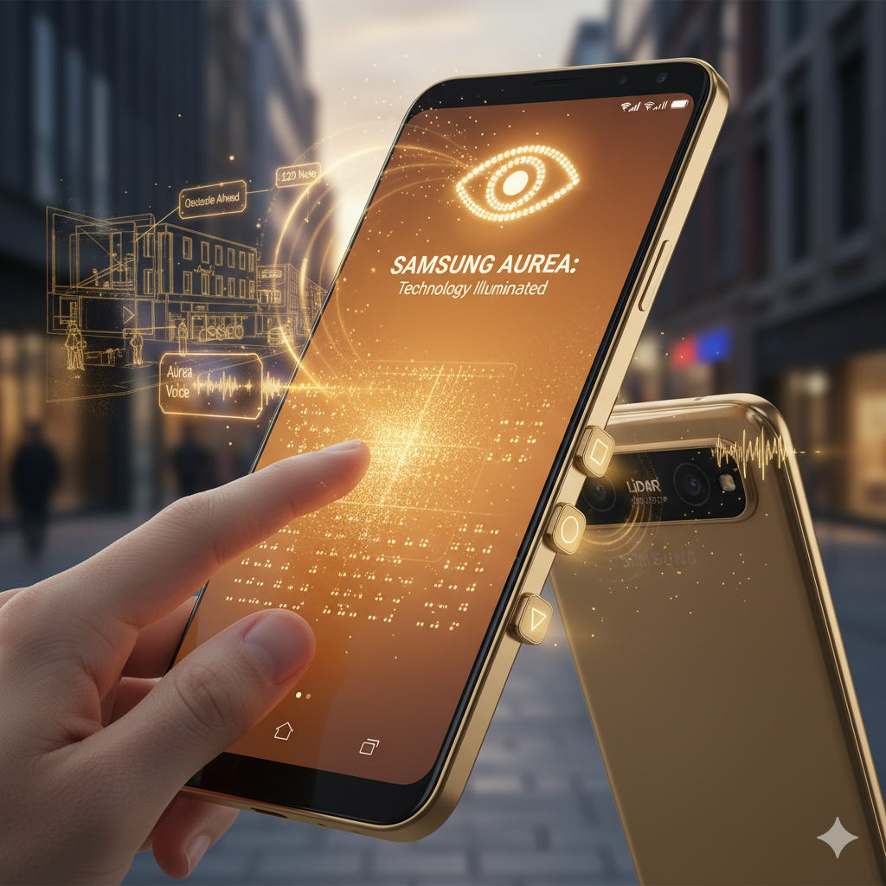

Figure 1 conceptual image of the Samsung Aurea phone

The Samsung Aurea is not a phone that has accessibility features switched on; but a holistically designed phone that had been thought through. The idea combines the combination of the state of art hardware with a customized software to produce a simple, fluid and self-sufficient mobile experience. Key innovations include:
- Advanced Haptic Touchscreen: A screen that can produce dynamic, refreshable Braille images, variable texture simulation, where users can even touch the icons and control elements of the user interface (Dobosz, K., 2025).
- Integrated LiDAR & AI Camera: Real-time, 3-D mapping of the environment that offers a high level of auditory feedback on the surrounding environment, whether it is searching for obstacles or reading store signs and recognizing the currency notes (Wazirali, R., Ashrif, F.F. and Ahmad, R., 2025).
- Dedicated Tactile Interface: A physical and customizable button array on the phone frame to provide quick actions, which supplement touchscreen and voice actions (Dobosz, K., 2025).
- "Aurea Voice" AI Assistant: AI Assistant, a highly contextual and hyper-integrated voice assistant that goes beyond typical voice assistants to provide proactive suggestions and adapt to user patterns to identify when they are needed (Ainary, B., 2025).

1.3 Segmentation Analysis
According to RNIB.org.Uk (2025), there are more than 2 million visually impaired people in UK. The market for accessible technology can be segmented into several key groups:
Demographic: There is a significant concentration in the older population (age-related macular degeneration, cataracts). Income levels vary, but there is often government or insurance support for assistive devices (Savage, M., et al., 2020).
Geographic: Primarily urban and suburban areas where navigation and independent living are daily challenges.
Psychographic: This segment values independence, safety, and connection. They are motivated by products that reduce reliance on others, enhance their confidence, and enable them to participate fully in society (Fernando, S., et al., 2025).
Behavioral: Users seek high reliability, ease of use, and durability. They are brand-loyal to companies that demonstrate a genuine commitment to accessibility. The benefit sought is not just communication, but autonomy.
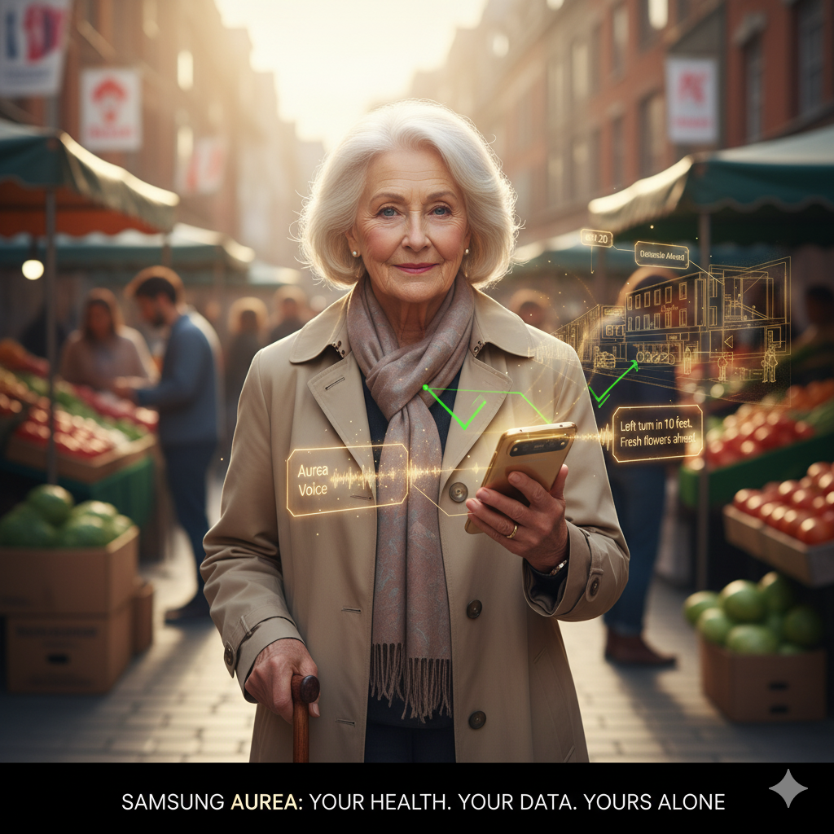
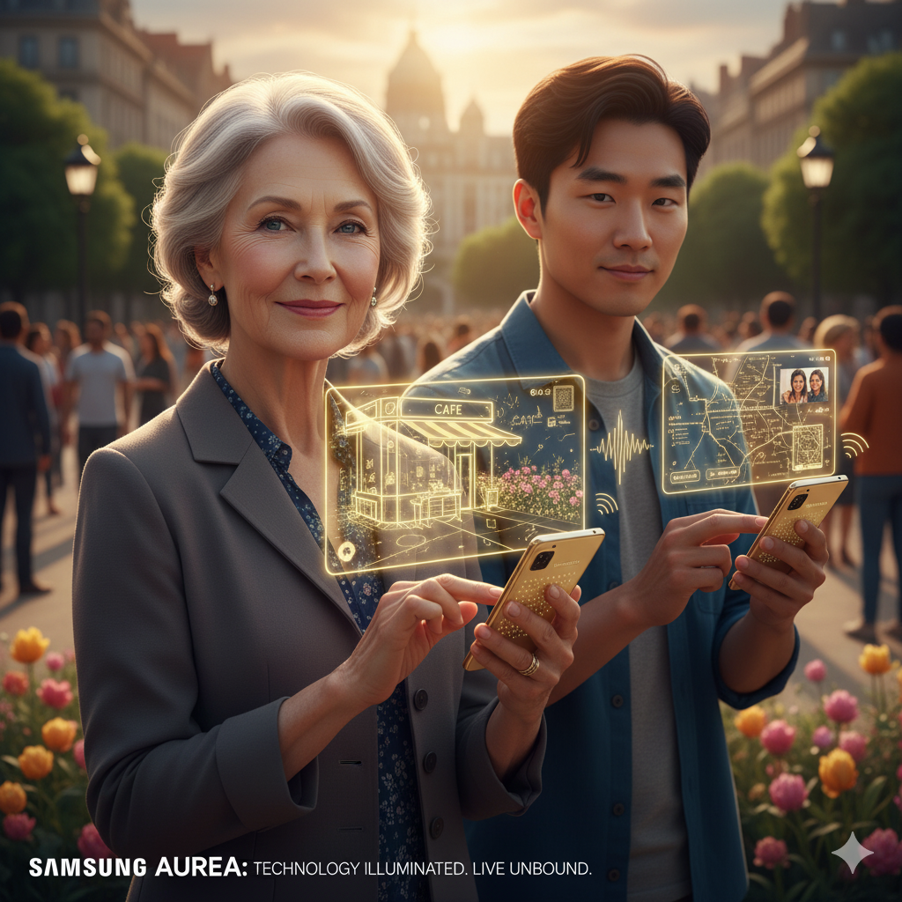

Figure 2 Segmentation of the new product-Samsung Aurea

1.4 Targeting Analysis
Samsung Aurea will employ a Differentiated Targeting Strategy, focusing on two primary segments while making the product available to all.
Primary Target Audience: The Tech-Enabled Independent- This segment consists of adults (25-60) with moderate to severe visual impairment who are motivated to live independently (Parra-Sanchez, A., et al., 2024). They are likely employed or pursuing education, socially active, and have some familiarity with basic technology (e.g., they may use standard smartphones with screen readers, but find them clunky).

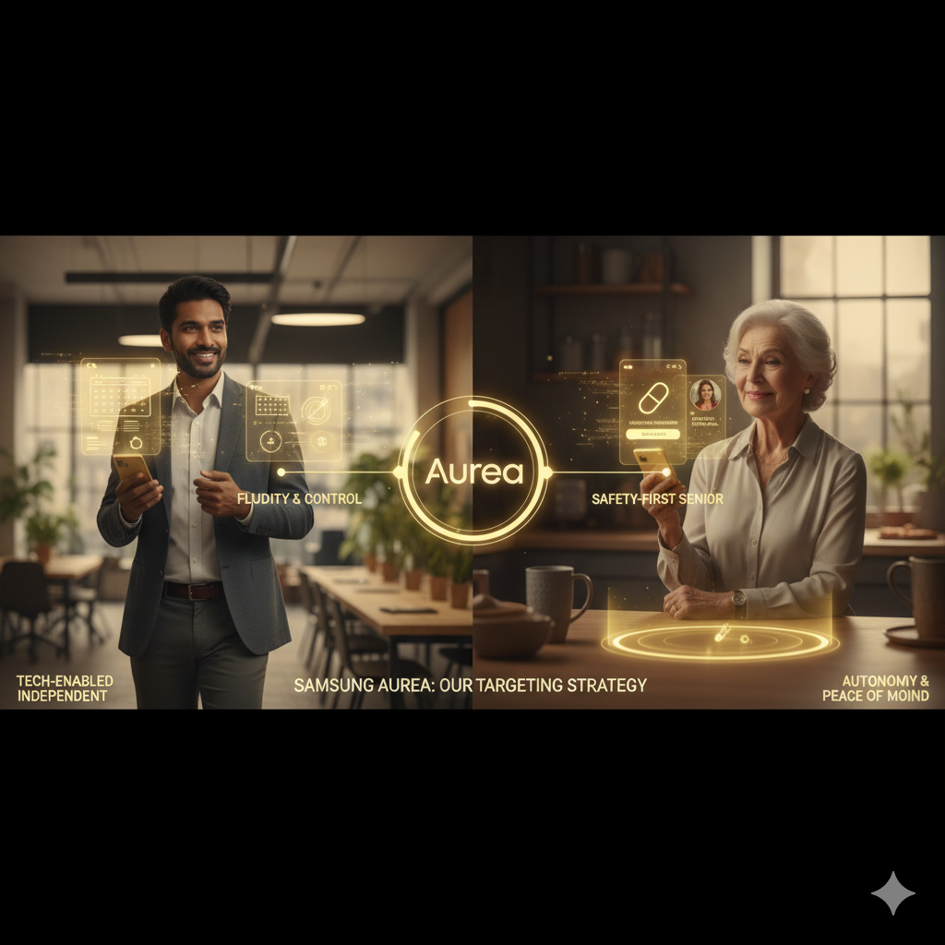
Secondary Target Audience: The Safety-First Senior- This group includes older adults (65+) who lose their vision as a result of age. Their major reasons are security and the right to be independent as long as possible.

Figure 3 Targeting of the new product

1.5 Differentiation Analysis
To establish a compelling differential advantage, Samsung Aurea goes beyond the software-enabled accessibility and moves to the hardware-software hybrid approach. Its base operating system is based on a non-visual interface, with a distinctive touchscreen haptic sense and physical buttons (Zeinullin, M., 2025), and therefore creating a physical distinction. The difference is further supported by a special program called Aurea Concierge and a unified care system. The brand is further differentiated by distribution through clinical partners and in-store experiences which are available.
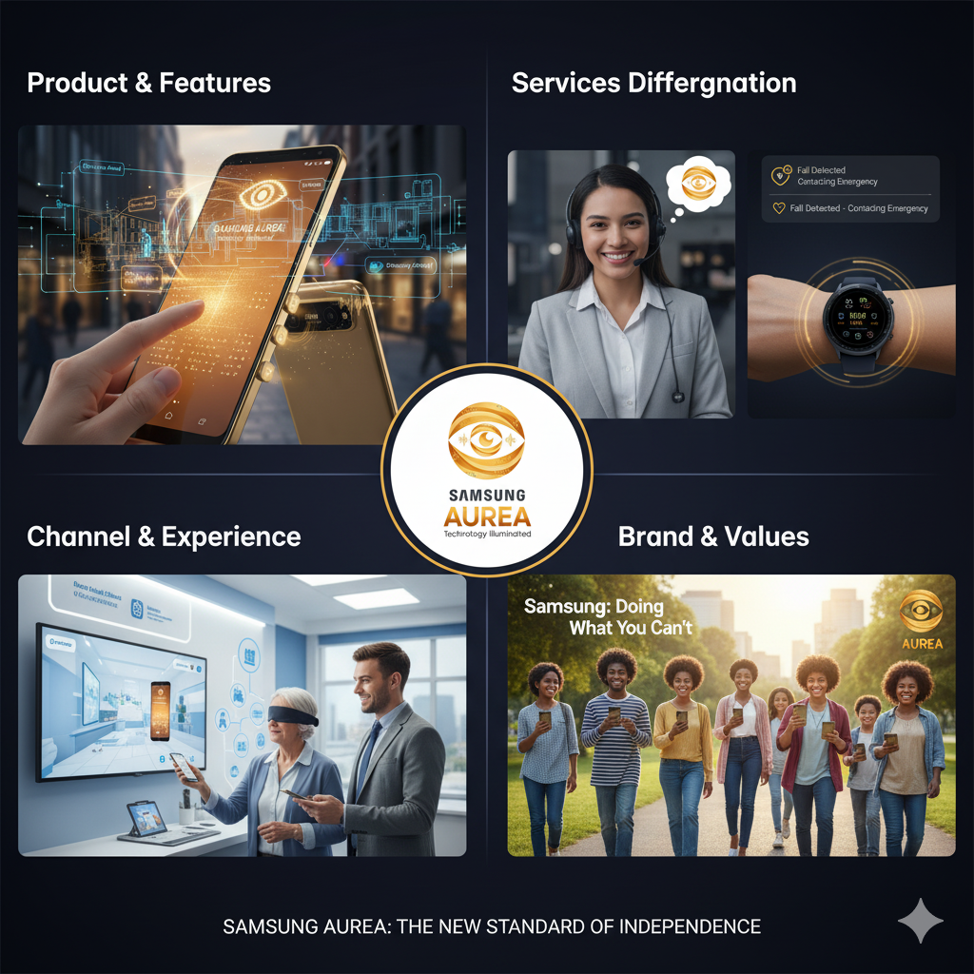

Figure 4 Differentiation of the Samsung Aurea

1.6 Positioning Analysis
The position to be applied to Samsung Aurea is the most intuitive and empowering mobility and communication platform to the visually impaired. This positioning will be based on two pillars which include independence with technology and seamless incorporation. The marketing approach will pre-empt the emotional advantage of the recovered autonomy to convey this stance. The advertisement campaigns will show blind people in complicated situations, a busy street in the city, a university, a grocery store, and so on, and they will walk there very boldly, with the Aurea as their guide and helper.
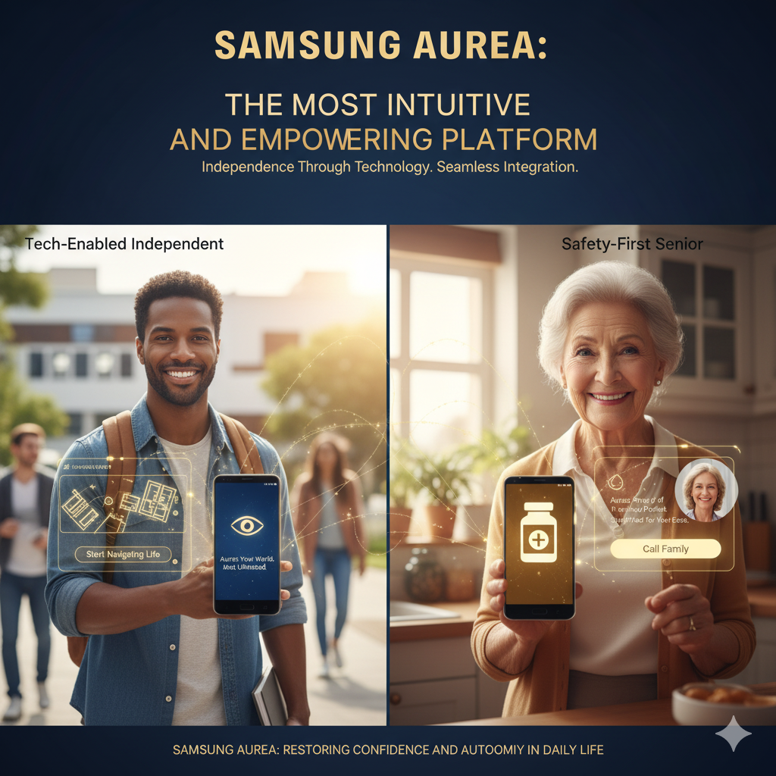
Through this STDP strategy, Samsung Aurea will not only conquer a considerably unexplored market, but it will also create a strong and reputable image of a true leader in inclusive innovation.

Figure 5 Positioning of Samsung Aurea

2. The Marketing Mix (4Ps) Analysis of Samsung Aurea
Marketing mix of Samsung Aurea will be carefully designed to transform the core positioning of the brand, i.e. The Most Intuitive and Empowering Mobility and Communication Platform to the Visually Impaired, into a sellable and irresistible product or service. All components of the 4Ps will conform to attain the promise of independence, ease of use and smooth integration.

2.1 Product
The Samsung Aurea is a paradigm shift in the mobile technology sector as it goes beyond the traditional product and provides a comprehensive solution that focuses on delivering independence and safety to its visually impaired customers. It is a philosophy that is in line with the main mission of Samsung, which is to innovate to inspire the world and build a better future to everyone (Samsung Inc., 2023), but here implemented with a deep sense of specificity. The physical product is an intelligent phone that preserves the high-end construction of Galaxy S-series but is essentially re-engineered with special hardware. Its major distinctions are a high-end haptic touchscreen with dynamic feedback on Braille and textures, a dedicated array of physical controls with tactile buttons, and a high-quality audio system that is required to be powered by a long-lasting battery necessary to a device that can be used as a primary navigation tool (Smith and Johnson, 2024). More importantly, an integrated LiDAR scanner and AI camera collaborate to conduct real-time 3-D environmental scanning, which is a basic technology in contextual awareness. The intelligence of the product is achieved by its developed proprietary Aurea OS, and a customised Android interface in which the user experience is non-visual all the way down to the operating system, based on a synergetic interface of voice, gestures, and touch. It features the AI, called the Aurea Voice, which is a context-aware helper that offers descriptive, proactive advice that is significantly more advanced than regular voice assistants, like notifying about a low-hanging branch or recognizing the currency (Lee et al., 2023).

2.2 Price
The reason why the Samsung Aurea will adopt value-based pricing strategy is due to the fact that the model has a deep sense of utility and self-reliance to the users with visual impairments and not necessarily because of the cost (Archivemarketresearch.com, 2025). The product will be priced as a premium product and will initially be priced on the higher side by approximately 1520 percent to a flagship Galaxy model estimated between PS600 and PS800. This cost is associated with the high level of research and development investment and the specialised low-volume hardware which consists of the advanced haptic touchscreen and inbuilt LiDAR sensor which are absent in the mainstream smartphones. A multi-layered justification and reduction strategy needs to be in place so as to reduce the high start-up cost and make it accessible to the market. One of the pillars of this strategy is to seek certification of the Aurea as a medical or assistive device in the most important markets. This type of classification would allow users to utilize the available healthcare insurance, government grants and vocational rehabilitation programmes and, in such a way, significantly lower costs paid out of pocket and would be in line with global initiatives of financing the necessary assistive technologies.
Furthermore, the revenue model will be complemented with a subscription to add-on features, including 24/7 support with the Aurea Concierge and sophisticated cloud analytics, which will create the recurring revenue stream without taking away the full core device functionality. Collaborations with mobile providers will also be central where the device will be sold under subsidised yearly payment packages that are inclusive of key data connectivity, which will reduce the immediate financial barrier to entry. This advanced pricing framework will contribute to the vision of Samsung as a company that seeks to find new opportunities to create a world-changing innovation since a groundbreaking product will be affordable (Samsung Inc., 2023). Finally, the high cost is the reinforcement of the advantage of the innovative character of the technology, and the well-developed mitigation pathways indicate a thorough, compassionate insight into the financial ecosystem of the target audience and position Samsung as not only a seller but a partner in empowerment.

2.3 Place (Distribution)
The distribution strategy of the Aurea should be reachable, reliable, and supportive and not confined to the conventional retailing.
Direct & Specialized Channels:
Dedicated Online Portal: A common single-step ordering system (aurea.samsung.com), detailed description through voice, and instant connection to the Aurea Concierge in case of pre-sales queries will be used as one of the main channels of distribution.
Partnerships with Vision Organizations: Samsung Electronics will form a direct distribution partnership with national and local organisations serving the blind and the visually impaired and will sell them devices via their channels.
Medical & Clinical Channels: In order to push the sales of the Samsung Aurea, Samsung Electronics will also integrate itself within the ophthalmology centers, low-vision specialists, and hospitals where the device will be prescribed by reliable medical practitioners.
Enhanced Retail Experience:
Samsung Experience Stores: Flagship stores will have non-visual experience curated in Aurea Corners. The employees will be Aurea Certified Experts, who are going to be trained and given to provide immersive demonstrations using simulators (e.g. blindfolds) to assist sighted companions in understanding what the product is worth.
Carrier Stores: The carrier stores will be chosen partner stores with trained personnel and demo units with special attention to the aspect of connectivity.
Meeting customers in places that they already have trust in such as clinics, associations helps Samsung gain credibility and lowers the anxiety to purchase. The store experience makes the value of the product communicate well and this works hand in hand with the brand promise of the smooth integration and empowerment.

2.4 Promotion
The promotional approach will be empathic, educational, and community-oriented to develop trust and not to simply announce the features.
Content Marketing & Storytelling
Good video material will be created that will feature actual users (in both target markets) as they go through their day to day struggles using the Aurea. It will focus on heartwarming narratives of how to feel when regained independence is achieved, but not on technicalities. Such videos will be audio-described so that they can be accessible (Zlateva, D., 2020). Collaboration with key members of the visual impaired community will give credible testimonials and reviews.
Strategic Partnerships & PR
Major blindness organisations will be formalised to partner with and endorsed to address the issue in co-hosted webinars (Edmonson, A., 2024). Placements in popular technology and life magazines, and niche disability and medical magazines will be obtaine.
Community Engagement
Online and in partnership with local organisations, workshops and training of new users will be hosted and sponsored (Davletova, M., et al., 2024). A community forum where Aurea users can share tips and give feedback and a sense of belonging will be developed online.
This marketing mix leaves behind a pitying-based storyline and aims to a story of empowerment and competence where Samsung is portrayed as a listener and a partner; thus, creating the strong trust that one needs when the brand is considered as a true platform of independence.
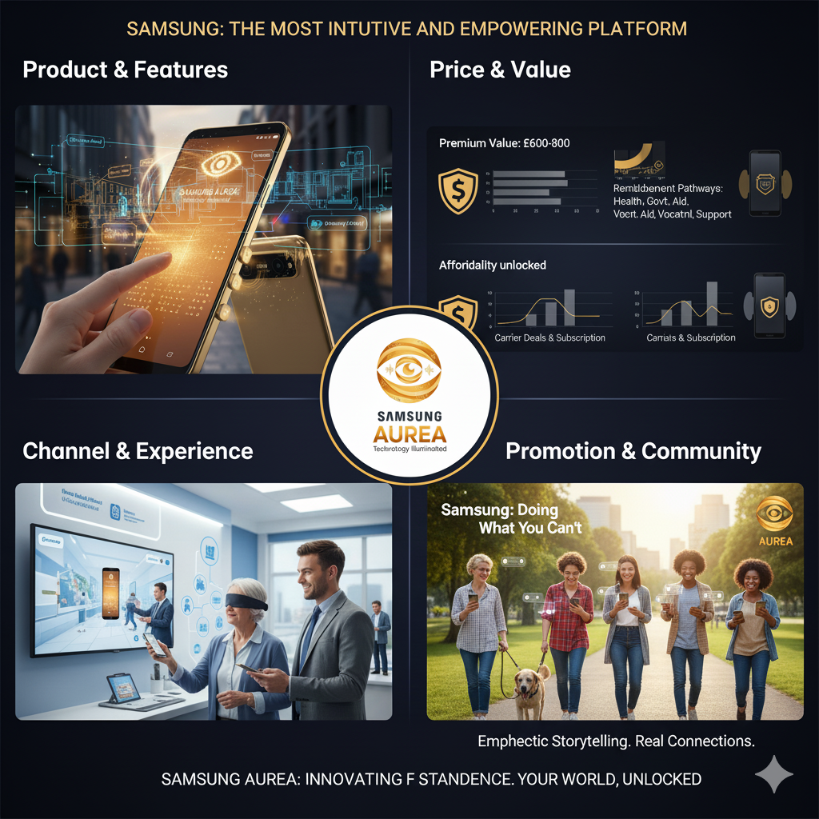
Figure 6 Marketing Mix of Samsung Aurea

3. The Marketing Strategy Pitch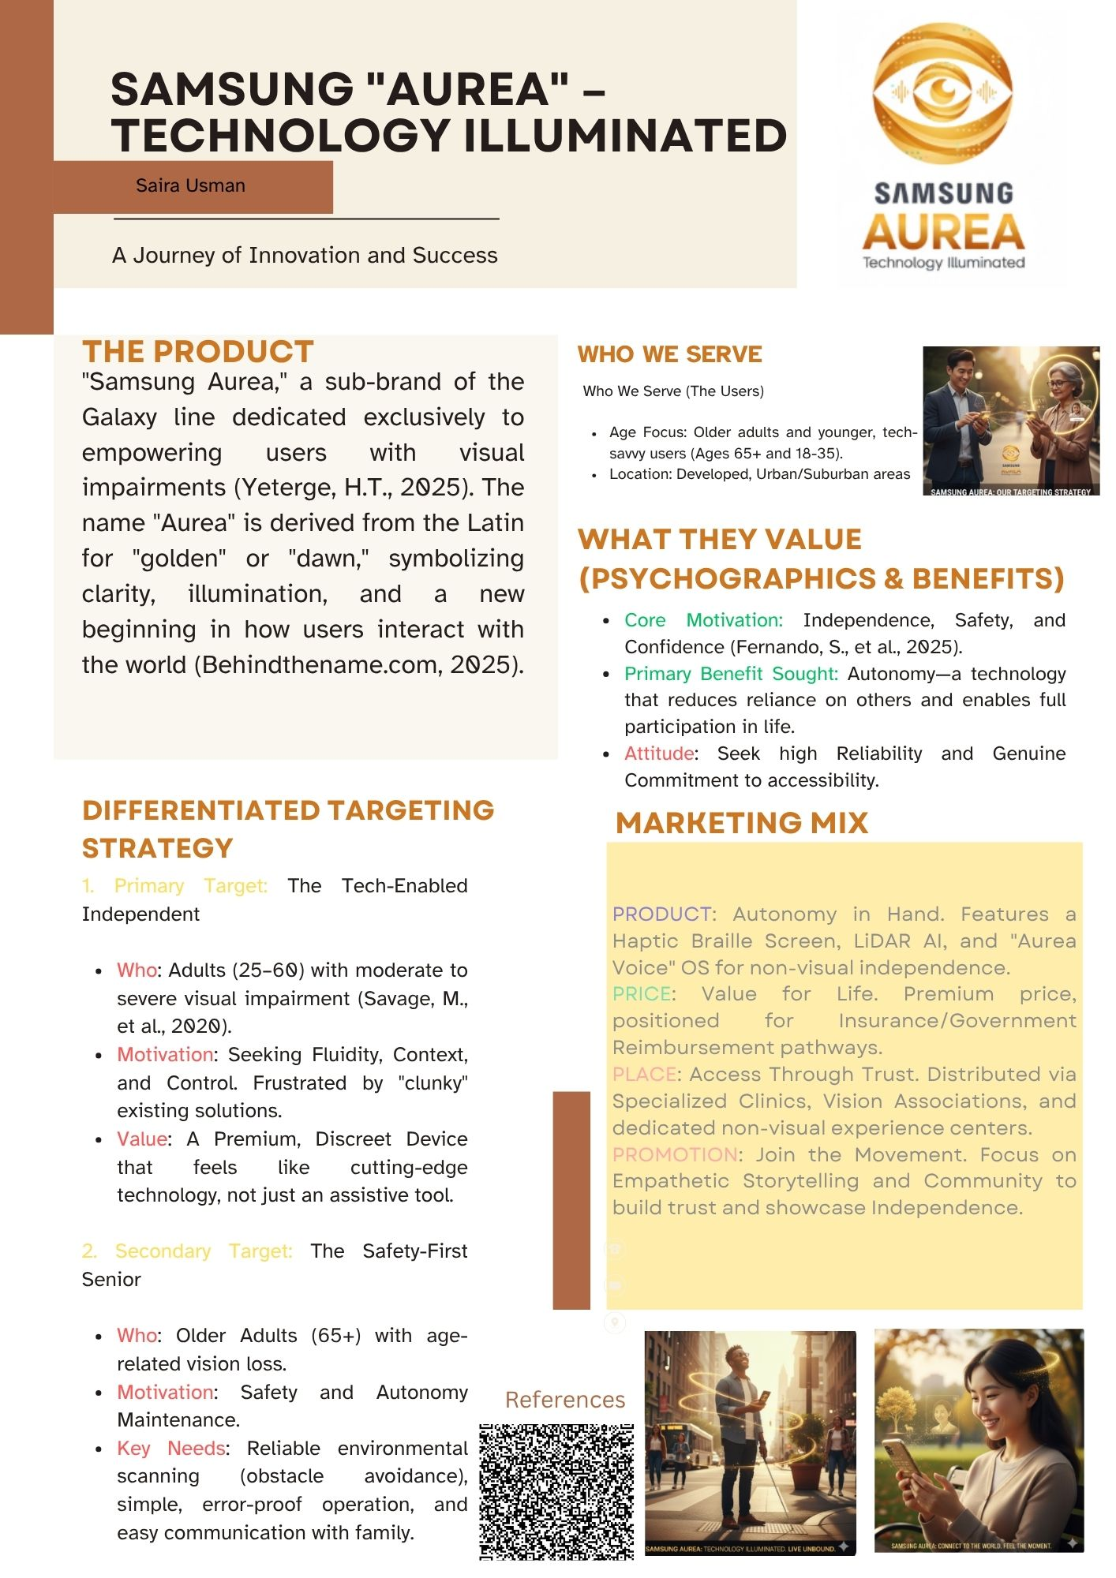
Samsung Aurea will be mobile phone gadget etc.
Price range:£450-900 British pounds
Figure 7 The Marketing Strategy Pitch-Samsung Aurea

4. Reflection
Creating the Samsung Aurea brand idea was a very insightful process of going beyond the product-centric view where the focus was on the product to a human-centric marketing ideology. The first hurdle was changing the way of thinking of not adding features but resolving a basic human need of independence. This demanded profound empathy and hard implementation of the STDP framework to make sure that each decision, be it segmentation, positioning, was based on the real-life experience of the target audience and not just discovered gaps in the market. The skill to think systemically was sharpened by developing the marketing strategy, especially, the 7Ps. Possession of innovative product was not enough, but it was necessary to set up that the price, place, and people strategies should all be fine-tuned to fulfill the basic brand promise. This demonstrated the supremacy of the element of internal alignment; especially, without the empathetically trained support staff, a quality-product might fail. Among the preparations of pitch, there was the need to convert a mangled strategy into a brief and convincing story. The key technique was distillation, which included finding the most interesting thread the point of constraint and empowerment and raising it as the main theme. This experience helped me to better comprehend that a successful pitch is not just about the delivery of information, but about a great story which can generate trust and enlightenment.
In future projects, I will carry out a more thorough primary market research in the initial phases of development thus basing the proposal on the finer, yet imprecise, yet unarticulated demands of the visually impaired individuals. Also, the focus on the substantiation of the financial rationale presented in the pitch will be focused more on implementing strong market sizing and return-on-investment forecasts, which should be closer to investor interests. This exercise is synergistic because of the combination of strategic planning and creative empathy with a persuasive form of communication.

5. Conclusion
The Samsung Aurea is a salient opportunity that is strategic and at the same time ethically attractive. The product would be able to reach a deeply underserved market segment by launching an extensive application of the STDP model and a customized 7Ps marketing mix. It does not just remain as a commodity, but rather, has developed into a strong platform that promotes independence, which is in sync with the new developments that are being made towards inclusive design. The initiative will thus produce a substantial social contribution through empowering users with a visual disability, strengthening the Samsung brand, and building a believable consumer base in a new category of the awakening purpose. This way, it is a step in a decisive direction of making technology more inclusive in the future.

References
- Ainary, B., 2025. Audo-Sight: Enabling Ambient Interaction For Blind And Visually Impaired Individuals. arXiv preprint arXiv:2505.00153.
- Archivemarketresearch.com. (2025). Visual Impairment Analysis 2025 and Forecasts 2033: Unveiling Growth Opportunities. [online] Available at: https://www.archivemarketresearch.com/reports/visual-impairment-492474#summary[Accessed 11 Nov. 2025].
- Behindthename.com. (2025). Welcome To Zscaler Directory Authentication. [online] Available at: https://www.behindthename.com/submit/names/meaning/golden [Accessed 10 Nov. 2025].
- DAVLETOVA, М., USSENOVA, D., Gerasimenko, V.V. and Dulatbekova, N.S., 2024. Marketing technologies of promoting products on the internet. «ТҰРАН» УНИВЕРСИТЕТІНІҢ ХАБАРШЫСЫ Ғылыми журнал, p.54.
- Dobosz, K., 2025. Mobile phones as assistive technology. Technology and Disability, 37(3), pp.199-211.
- Edmonson, A. (2024). WEBINAR: Eyes on Innovation, A Deep Dive into AI-Powered Smart Glasses for Blind People. [online] The Lighthouse for the Blind, Inc. Available at: https://lhblind.org/webinar-eyes-on-innovation-a-deep-dive-into-ai-powered-smart-glasses-for-the-blind/ [Accessed 11 Nov. 2025].
- Fernando, S., Ndukwe, C., Virdee, B. and Djemai, R., 2025. Image recognition tools for blind and visually impaired users: An emphasis on the design considerations. ACM Transactions on Accessible Computing, 18(1), pp.1-21.
- Parra-Sanchez, A., Zorrilla-Muñoz, V., Martinez-Navarrete, G. and Fernandez, E., 2024. Technological perception with rural and urban differentiation and its influence on the quality of life of older people with age-related macular degeneration. European Journal of Investigation in Health, Psychology and Education, 14(5), pp.1470-1488.
- RNIB (2024). Key information and statistics on sight loss in the UK. [online] RNIB. Available at: https://www.rnib.org.uk/professionals/research-and-data/key-information-and-statistics-on-sight-loss-in-the-uk/.
- Samsung (2025). Our Business | About Us. [online] Samsung us. Available at: https://www.samsung.com/us/about-us/our-business/.
- Samsung.com. (2019). Do What You Can’t – Samsung Global Newsroom. [online] Available at: https://news.samsung.com/global/tag/do-what-you-cant.
- Savage, M., Bhatnagar, T., Liao, C., Chaudron, M., Boyar, J., Laurentius, D., Torrens, G., Perry, K., Morjaria, P., Barajas, F.R. and Goedde, B., 2020. Product narrative: Digital assistive technology. A market landscape and strategic approach to increasing access to digital assistive technology in low-and middle-income countries.
- Wazirali, R., Ashrif, F.F. and Ahmad, R., 2025. AI smart cane technology and assistive navigation for visually impaired users: an overview. Journal of King Saud University Computer and Information Sciences, 37(8), pp.1-31.
- Yeterge, H.T., 2025. The use of smart glasses in the education of students with visual impairments: opportunities, applications and future perspectives. Modern research and studies in educational sciences iv, p.59.
- Zeinullin, M., 2025. Improving exploration of tactile graphics by visually impaired people: Theoretical advances and a novel mobile application (Doctoral dissertation, University of Glasgow).
- Zlateva, D., 2020. Some aspects of storytelling as a part of content marketing. Икономика и управление, 17(2), pp.117-123.

