 | UNIVERSITY OF WALES  TRINITY SAINT DAVID

Strategic Human Capital Report
Innovating New Working Practices and Breeding an Environment Where Talent May Grow

Programme: Master of Business Administration
Module: Human Capital Management (LCMB7023)
Assessment: Component 1: Individual Report
Lecturer: Eno Maycock (Birmingham)
Student name: Krupa Rambhai Bapodra
Student ID: 2610690
Submission date: 15 October 2026

Contents
Introduction 3
Task A Designing Innovative Working Practices 3
Traditional design and contemporary alternatives 3
Recommended operating model 5
Table 1 Work-practice design and evaluation 7
Task B Breeding an Environment Where Talent May Grow 7
What enables talent to flourish 7
NHSX talent growth strategy 8
Table 2 Talent ecosystem commitments 10
Task C Reflective Report 10
AI as a strategic HR decision-support tool 10
Reflective analysis and personal action plan 11
Conclusion 12
References 12

Introduction
NexSpace Health Systems (NHSX) has expanded to approximately 600 staff across the UK, India and the UAE. However, its work structures, inconsistent working arrangements and restricted career-development opportunities limit the innovation required in digital healthcare. This report recommends connected work practices that support timely decisions, experimentation, creativity and knowledge sharing while preserving clinical safety. Because NHSX operates in healthcare, employees must work on site; flexibility should therefore concern shift timing and coordination rather than working remotely. The recommendations are assessed against innovation, retention, wellbeing and healthcare product quality rather than attendance alone.

1. Task A: Designing Innovative Working Practices

Traditional design and contemporary alternatives
Traditional approaches to work design tend to be functionalist, to divide planning from doing, to centralize decisions in managerial levels, and to normalize work to ensure control and efficiency. These features can help with compliance, repeatability, and clear accountability – factors that are important in the world of clinical technology. But as each approval transcends functional lines, local knowledge is late and employees have little autonomy to experiment ideas. Research on job characteristics finds that meaningful task design and autonomy are related to motivation (Hackman and Oldham, 1976); more recent studies highlight that job characteristics also influence learning, health, and the ability to handle competing demands (Parker, 2014; Parker, Morgeson and Johns, 2017). The contemporary high-involvement work systems (HIWS) expand information, voice, and skills and decision authority, while high-performance work systems (HPWS) comprise selection, training, performance management, and rewards to foster ability, motivation and opportunity (AMO) (Appelbaum et al., 2000; Jiang et al., 2012). Coherent bundles rather than a one-size-fits-all checklist: there is some evidence, both from their own research and from the literature, that effects depend on strategic fit and implementation and that intensive performance systems can increase work pressure and/or negatively affect wellbeing if participation is symbolic (Combs et al., 2006; Boxall and Macky, 2009; Godard, 2004).
Technology should be designed alongside the social system in which it is used. Sociotechnical systems theory emphasises that work outcomes depend on the interaction between people, processes and technology, rather than technology alone (Trist and Bamforth, 1951). For NHSX, secure digital collaboration tools can reduce information bottlenecks by making decisions, evidence and lessons visible across functions and countries. Agile work design can organise this collaboration into small cross-functional teams that work in short learning cycles and use feedback to refine solutions (Rigby, Sutherland and Takeuchi, 2016; Cappelli and Tavis, 2018). In a healthcare setting, these practices must operate within clear clinical-safety, privacy and regulatory controls.
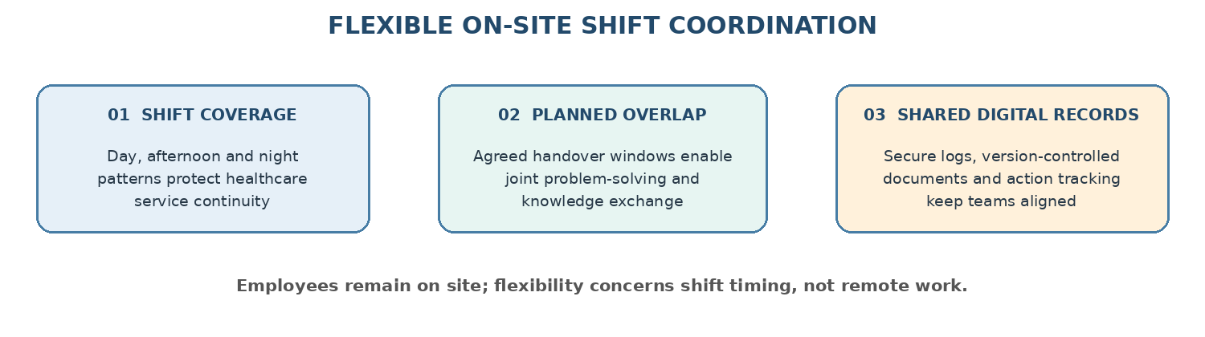
Figure 1. NHSX agile work design: on-site collaboration, flexible shifts and shared digital routines. Source: author’s synthesis of the recommended operating model.

Recommended operating model
NHSX should establish agile, cross-functional product teams of six to nine people drawn from engineering, clinical practice, product, data, security and customer implementation. Each team should own a clearly defined patient or provider problem, agree a quarterly outcome and maintain a small backlog of experiments. This directly addresses the first concern—slow decision-making and limited innovation—by bringing the knowledge needed for decisions into the same team and reducing hand-offs between functions. The product lead should coordinate priorities, while the clinical safety lead retains explicit authority over risk acceptance and release gates. Teams should review evidence, record decisions and failed tests, and share reusable learning in a searchable knowledge base every two weeks. Monthly communities of practice should spread useful knowledge between teams.
To address the second concern—limited experimentation and creativity—NHSX should use short, structured agile cycles in which staff can propose a test, state the expected learning, obtain a timely review and document the result. Psychological safety is an enabling condition: staff must be able to question assumptions, report mistakes and suggest alternatives without fear of humiliation, while remaining accountable for clinical standards (Edmondson, 1999; Edmondson, 2019). Experiments must be proportionate and approved through a light-touch process, with no relaxation of patient-safety, privacy or regulatory requirements. To address the third concern—weak knowledge sharing and collaboration—NHSX should introduce flexible on-site shift patterns with agreed overlap periods across day, afternoon and night teams. These arrangements should preserve service coverage while creating planned time for handovers, joint problem-solving and knowledge exchange. Secure digital collaboration tools, shared documentation, version control and clinical decision logs should support continuity across shifts and locations; they should complement, not replace, on-site teamwork.
The operating model should define decision rights and accountability. Teams may choose methods and sequence work within agreed boundaries, but clinical safety, patient privacy, regulatory compliance and financial limits remain subject to designated leadership approval. A short experiment proposal should identify the problem, proposed test, expected learning, risks and approval owner. Managers should facilitate inclusive discussion, remove avoidable barriers and evaluate outcomes and contribution quality rather than visible activity or hours. Digital tools should be selected after assessment of accessibility, privacy and security, and should not create excessive alerts or unnecessary meetings (Deci, Olafsen and Ryan, 2017; Kellogg, Valentine and Christin, 2020).
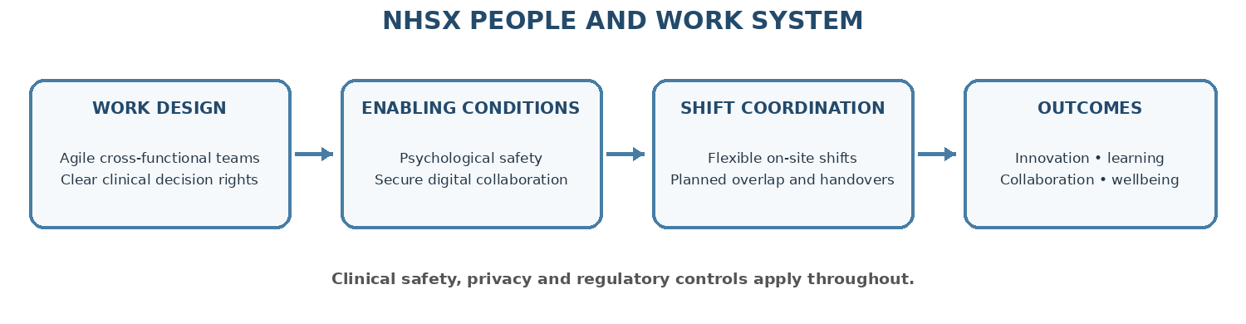
Figure 2. NHSX people and work system: recommended causal pathway. Source: author synthesis based on Trist and Bamforth (1951), Jiang et al. (2012) and Edmondson (1999).
The first six months should be a controlled pilot in two product groups, one UK-led and one internationally distributed. HR and product operations should establish baselines and review a balanced scorecard monthly: time from validated idea to decision, quality of experiments, reuse of knowledge, participation across functions and shifts, employee voice, regretted turnover, workload, wellbeing, and clinical quality or safety events. Workload and recovery indicators should be reviewed alongside output measures because high demands can deplete employees’ energy even when engagement is high (Bakker and Demerouti, 2017). Comparisons with similar non-pilot teams and staff interviews can help explain changes. Raw experiment counts should not be rewarded because they may encourage low-value tests or compromise safety. NHSX should scale only practices that improve learning and retention without harming safety, inclusion or wellbeing.
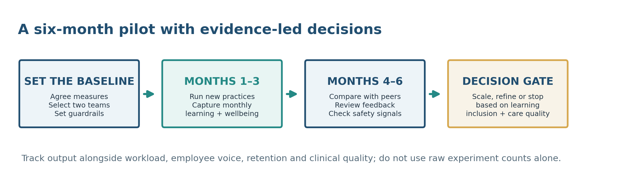
Figure 3. Six-month pilot and evidence-led scale decision. Source: author synthesis based on the NHSX report recommendations.

Table 1: Work-practice design and evaluation
Concern raised by NHSX | Recommended work design and how it works | Expected contribution and review measures
Slow decision-making and limited innovation | Agile cross-functional teams bring clinical, technical, product and data expertise into one team, reducing hand-offs and clarifying decision ownership. | Faster, better-informed decisions. Measures: decision-cycle time, decision quality and clinical-safety review quality.
Limited experimentation and creativity | Short agile learning cycles, a small experiment backlog, psychological safety and a proportionate approval process within clinical safeguards. | More constructive ideas, safe testing and learning from failed tests. Measures: experiment quality, documented learning, time from proposal to decision and safety events.
Weak knowledge sharing and collaboration | Flexible on-site shifts with planned overlap and handovers, supported by secure digital collaboration, shared records and monthly communities of practice. | Continuity across day, afternoon and night teams and greater knowledge reuse. Measures: handover quality, knowledge reuse, cross-shift participation and duplicate work.

2. Task B: Breeding an Environment Where Talent May Grow

What enables talent to flourish
Talent should be understood as the capacity to contribute and grow, rather than a quality possessed only by a small group labelled ‘high potential’. Exclusive systems can weaken fairness, narrow succession pools and reduce motivation among employees who are not selected. Research considers talent management at individual, team and organisational levels and recognises that talent is not necessarily scarce or exclusive (Gallardo-Gallardo, Thunnissen and Scullion, 2020; Meyers and van Woerkom, 2014; Thunnissen, Boselie and Fruytier, 2013). NHSX should provide all employees with access to core development while offering additional pathways in strategically important areas such as clinical AI, cybersecurity and product leadership.
A learning organisation creates shared direction, reflection and collective learning rather than relying on course attendance alone (Senge, 2006). This would address NHSX’s limited learning opportunities by embedding learning in everyday work through protected learning time, peer review, reflective retrospectives and opportunities to apply new skills. Psychological safety enables employees to ask questions, report mistakes and challenge assumptions, while clear accountability maintains standards (Edmondson, 1999; Edmondson, 2019). A growth mindset must be supported by feedback, time and stretch assignments rather than slogans alone (Dweck, 2006). Self-determination theory also suggests that autonomy, competence and relatedness support internal motivation; learning should therefore be supported and purposeful rather than experienced as a coercive extra demand (Ryan and Deci, 2000; Deci, Olafsen and Ryan, 2017).
Job crafting can support career development by helping employees adjust tasks, relationships or the meaning of their work to strengthen person–job fit (Wrzesniewski and Dutton, 2001; Rudolph et al., 2017). At NHSX, employees should discuss proposed changes with their managers so that development goals align with team capacity, patient safety and fair workload distribution. Career development should include lateral and expert pathways as well as promotion, because a relatively flat organisation cannot promote every capable employee. Regular career coaching can help employees identify next steps, find stretch assignments and review progress against transparent capability expectations.

NHSX talent growth strategy
NHSX should create a ‘learn, apply, share’ talent ecosystem with connected commitments. First, map current and future capabilities by role family, location and business priority using employee self-assessment and manager evidence. Publish clear skill profiles and career pathways for technical, clinical, product and people-leadership roles. This increases transparency without creating a single prestige ladder and helps direct development investment towards the human capital required by NHSX (Lepak and Snell, 1999). Second, hold quarterly growth conversations in which each employee agrees one capability goal, one assignment to apply it and the support required. Provide protected learning time, mentoring and stretch work with a named sponsor. Update the capability map annually as AI methods, clinical regulation and customer needs change; do not use it as a permanent ranking of employees.
Third, establish a blended learning offer as a core part of the learning-organisation approach. It should combine short evidence-based modules in AI assurance, clinical safety, data protection, inclusive collaboration and product discovery with peer-learning circles, cross-country mentoring and paid external credentials where relevant to a role. Employees should apply learning to a project and demonstrate the result to peers; feedback and opportunities to practise are essential for learning transfer. Fourth, launch a transparent internal opportunity marketplace for temporary projects, secondments and cross-functional rotations. Publish selection criteria, time commitments and manager-approval requirements, and monitor participation and outcomes by location and other lawful inclusion indicators to identify unequal access.
Fifth, connect career development with regular coaching. Managers should provide useful feedback, discuss career goals and help employees access stretch assignments, rotations and expert pathways. NHSX should also address wellbeing and high performance expectations explicitly. Clear, realistic priorities and agreed performance standards should be set with employees; managers should review workload, staffing, recovery time and competing demands so that high expectations do not become sustained overwork. Wellbeing pulse checks, confidential support routes and psychologically safe retrospectives should help identify pressure early. Performance reviews should reward patient and provider outcomes, knowledge sharing, prevention of safety failures and development of colleagues—not visibility or hours. Critical-role talent reviews should use evidence-based criteria, cross-country calibration and an appeal route. Retention interviews and aggregate employee feedback should inform changes to career pathways and workload while protecting privacy.
Implementation should be phased. In months 1–3, map skills, publish pathways and prepare managers to support growth and wellbeing. In months 4–6, pilot growth conversations, blended learning, coaching and the opportunity marketplace in two functions. In months 7–12, review the evidence and extend only effective components. Measures should include internal fill rates, learning participation by location and job family, demonstrated skills after learning, retention of critical capabilities, employee-reported growth opportunities, psychological safety, internal mobility and wellbeing. High course-completion rates alone do not prove capability; measures should be interpreted alongside employee feedback and evidence of applying skills. Targets should be co-created and reviewed using reliable data.
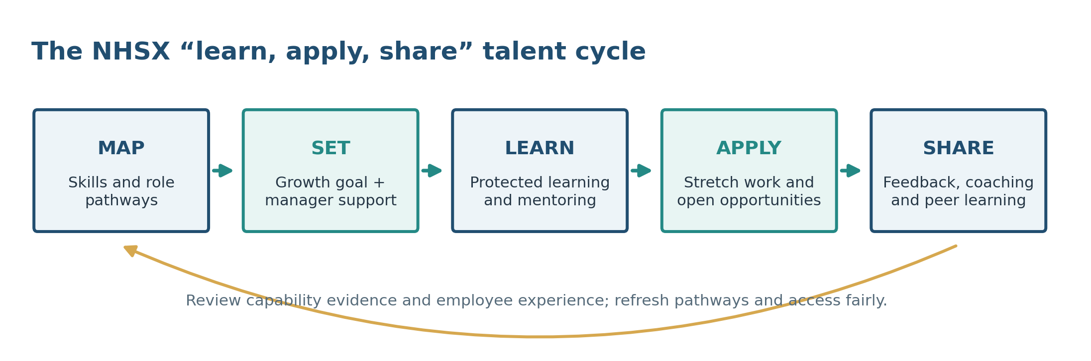
Figure 4. NHSX learn, apply and share talent-growth cycle. Source: author synthesis based on the NHSX talent strategy.

Table 2: Talent ecosystem commitments
Element | NHSX commitment | Evidence of progress
Visible pathways | Publish expert and leadership routes with skills and examples | Employee understanding of routes; internal mobility
Applied learning | Pair protected learning with stretch work, coaching and reflection | Demonstrated capability; project outcomes
Inclusive opportunity | Open project rotations with clear criteria and regional access | Participation and selection patterns; fairness pulse
Safe performance | Use coaching, voice and learning reviews with accountability | Psychological safety; wellbeing; critical-skill retention

3. Task C: Reflective Report

AI as a strategic HR decision-support tool
AI can help HR identify patterns in skills demand, summarise employee feedback, recommend learning content and model workforce scenarios. A systematic review describes applications of AI and advanced technologies across recruitment, learning, performance and workforce decisions, while highlighting the need for careful governance (Vrontis et al., 2022). These tools may help forecast skills gaps, but predictions are not fair or complete assessments of individuals. Historical data may reflect unequal access, automated summaries may miss context, and intrusive monitoring can damage trust. Claims about fairness should therefore be tested through measurement and independent review rather than accepted from vendors alone (Raghavan et al., 2020).
For NHSX, AI should support aggregate pattern-finding while consequential employment decisions remain human-led (Figure 5). This boundary allows HR to use tools for learning and workforce planning without treating a prediction as a complete assessment of a person.
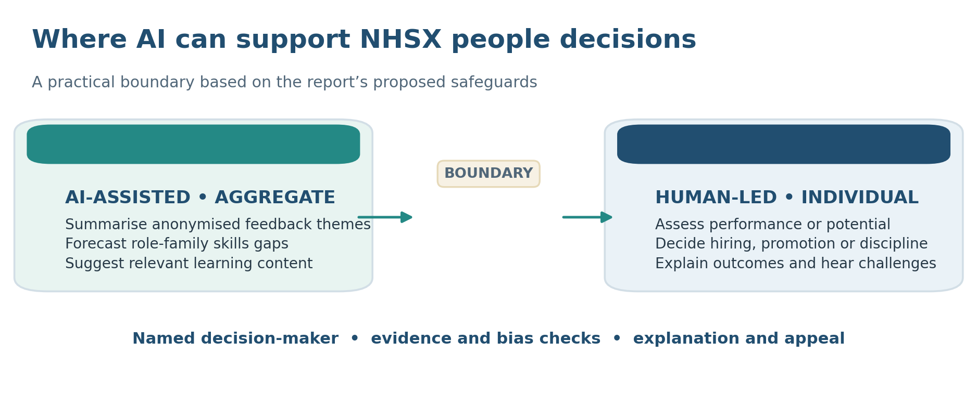
Figure 5. NHSX boundary between AI-assisted analysis and human-led people decisions. Source: author’s synthesis of the report recommendations.
AI must first be used to support low-risk decisions like anonymous theme analysis or skills gap forecasting, as this is where it can make the greatest impact for NHSX. Any decision made to an employee regarding an employment condition that has a material impact should have a documented basis, a named decision maker, an explanation that can be challenged by an employee, bias testing and monitoring and data minimisation. This aligns with responsible AI risk management principles, such as OECD values on human rights, transparency and accountability (NIST, 2023; NIST, 2024; OECD, 2019; Tambe, Cappelli and Yakubovich, 2019) and generative AI risk guidance (NIST, 2023; Tambe, Cappelli and Yakubovich, 2019). When meaning of illness, disability, caring responsibilities or conflict, empathy is still required, professional responsibility is not to treat a score as the person.
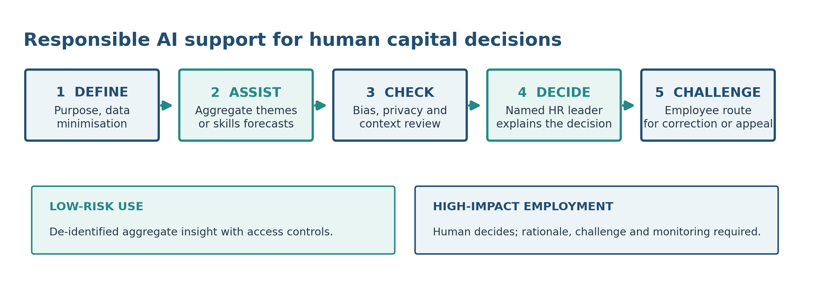
Figure 6. Human-accountable AI decision-support process for HR. Source: author synthesis based on NIST (2023, 2024), OECD (2019) and the report recommendations.

Reflective analysis and personal action plan
In preparing this report, I used AI in three ways. First, I used it to help locate and organise research on work design and working arrangements. This made it quicker to scan a large evidence base, but it also created a risk of treating a summary as evidence. I therefore checked the study design and limits of the cited research and adapted the recommendations to NHSX’s on-site healthcare context rather than assuming that remote or hybrid practices would transfer directly. Second, I used AI to compare practices for talent development and consider how learning, mobility and psychological safety connect. I then added safeguards relating to clinical safety, fair access across countries, workload and wellbeing. Third, I used AI feedback to improve clarity and structure. This helped readability, but it could not validate my personal reflection, institutional requirements or every citation. I remain responsible for the arguments, source accuracy and final decisions.
Over the next year, I will build three capabilities. Within three months, I will complete a recognised people-analytics course and practise checking data quality, bias and uncertainty using a small anonymised case. Within six months, I will take part in a team learning review and seek feedback from at least two colleagues on listening, constructive challenge and psychological safety. Within twelve months, I will design and complete a short skills-based workforce-planning project, share findings and recommendations with a manager, and document my learning in a reflective portfolio. I will review progress with a mentor every four weeks. This plan develops the technical, communication and ethical capabilities required for responsible HR practice.

Conclusion
NHSX’s investment in digital health and AI will create sustainable value only if it is supported by effective work design and fair talent development. Agile cross-functional teams can bring decision-making closer to the knowledge needed, while structured experimentation and psychological safety can strengthen creativity and learning. Flexible on-site shifts, planned handovers and shared digital routines can improve collaboration without relying on hybrid or remote work. A learning organisation, blended learning, career coaching, job crafting and explicit safeguards for wellbeing and high performance expectations can give employees clearer opportunities to grow. A staged pilot with balanced measures will help NHSX identify what works across its three-country workforce while protecting clinical quality, employee wellbeing and trust.

References
Appelbaum, E., Bailey, T., Berg, P. and Kalleberg, A.L. (2000) Manufacturing advantage: why high-performance work systems pay off. Ithaca, NY: Cornell University Press.
Bloom, N., Han, R. and Liang, J. (2024) ‘Hybrid working from home improves retention without damaging performance’, Nature, 630, pp. 920–925. doi: 10.1038/s41586-024-07500-2.
Boxall, P. and Macky, K. (2009) ‘Research and theory on high-performance work systems: progressing the high-involvement stream’, Human Resource Management Journal, 19(1), pp. 3–23. doi: 10.1111/j.1748-8583.2008.00082.x.
Deci, E.L., Olafsen, A.H. and Ryan, R.M. (2017) ‘Self-determination theory in work organizations: the state of a science’, Annual Review of Organizational Psychology and Organizational Behavior, 4, pp. 19–43. doi: 10.1146/annurev-orgpsych-032516-113108.
Dweck, C.S. (2006) Mindset: the new psychology of success. New York: Random House.
Edmondson, A. (1999) ‘Psychological safety and learning behavior in work teams’, Administrative Science Quarterly, 44(2), pp. 350–383. doi: 10.2307/2666999.
Gallardo-Gallardo, E., Thunnissen, M. and Scullion, H. (2020) ‘Talent management: context matters’, The International Journal of Human Resource Management, 31(4), pp. 457–473. doi: 10.1080/09585192.2019.1642645.
Godard, J. (2004) ‘A critical assessment of the high-performance paradigm’, British Journal of Industrial Relations, 42(2), pp. 349–378. doi: 10.1111/j.1467-8543.2004.00318.x.
Hackman, J.R. and Oldham, G.R. (1976) ‘Motivation through the design of work: test of a theory’, Organizational Behavior and Human Performance, 16(2), pp. 250–279. doi: 10.1016/0030-5073(76)90016-7.
Jiang, K., Lepak, D.P., Hu, J. and Baer, J.C. (2012) ‘How does human resource management influence organizational outcomes? A meta-analytic investigation of mediating mechanisms’, Academy of Management Journal, 55(6), pp. 1264–1294. doi: 10.5465/amj.2011.0088.
Katzenbach, J.R. and Smith, D.K. (1993) The wisdom of teams: creating the high-performance organization. Boston, MA: Harvard Business School Press.
Lepak, D.P. and Snell, S.A. (1999) ‘The human resource architecture: toward a theory of human capital allocation and development’, Academy of Management Review, 24(1), pp. 31–48. doi: 10.5465/amr.1999.1580439.
Meyers, M.C. and van Woerkom, M. (2014) ‘The influence of underlying philosophies on talent management: theory, implications for practice, and research agenda’, Journal of World Business, 49(2), pp. 192–203. doi: 10.1016/j.jwb.2013.11.003.
National Institute of Standards and Technology (NIST) (2023) Artificial intelligence risk management framework (AI RMF 1.0). NIST AI 100-1. Gaithersburg, MD: NIST. doi: 10.6028/NIST.AI.100-1.
NIST (2024) Artificial intelligence risk management framework: generative artificial intelligence profile. NIST AI 600-1. Gaithersburg, MD: NIST. doi: 10.6028/NIST.AI.600-1.
OECD (2019) Recommendation of the Council on Artificial Intelligence, OECD/LEGAL/0449. Paris: OECD.
Raghavan, M., Barocas, S., Kleinberg, J. and Levy, K. (2020) ‘Mitigating bias in algorithmic hiring: evaluating claims and practices’, in Proceedings of the 2020 Conference on Fairness, Accountability, and Transparency. New York: ACM, pp. 469–481. doi: 10.1145/3351095.3372828.
Rigby, D.K., Sutherland, J. and Takeuchi, H. (2016) ‘Embracing agile’, Harvard Business Review, 94(5), pp. 40–50.
Rudolph, C.W., Katz, I.M., Lavigne, K.N. and Zacher, H. (2017) ‘Job crafting: a meta-analysis of relationships with individual differences, job characteristics, and work outcomes’, Journal of Vocational Behavior, 102, pp. 112–138. doi: 10.1016/j.jvb.2017.05.008.
Ryan, R.M. and Deci, E.L. (2000) ‘Self-determination theory and the facilitation of intrinsic motivation, social development, and well-being’, American Psychologist, 55(1), pp. 68–78. doi: 10.1037/0003-066X.55.1.68.
Senge, P.M. (2006) The fifth discipline: the art and practice of the learning organization. Rev. edn. New York: Doubleday.
Tambe, P., Cappelli, P. and Yakubovich, V. (2019) ‘Artificial intelligence in human resources management: challenges and a path forward’, California Management Review, 61(4), pp. 15–42. doi: 10.1177/0008125619867910.
Thunnissen, M., Boselie, P. and Fruytier, B. (2013) ‘A review of talent management: “infancy or adolescence?”’, The International Journal of Human Resource Management, 24(9), pp. 1744–1761. doi: 10.1080/09585192.2013.777543.
Trist, E.L. and Bamforth, K.W. (1951) ‘Some social and psychological consequences of the longwall method of coal-getting’, Human Relations, 4(1), pp. 3–38. doi: 10.1177/001872675100400101.
Vrontis, D., Christofi, M., Pereira, V., Tarba, S., Makrides, A. and Trichina, E. (2022) ‘Artificial intelligence, robotics, advanced technologies and human resource management: a systematic review’, The International Journal of Human Resource Management, 33(6), pp. 1237–1266. doi: 10.1080/09585192.2020.1871398.
Wrzesniewski, A. and Dutton, J.E. (2001) ‘Crafting a job: revisioning employees as active crafters of their work’, Academy of Management Review, 26(2), pp. 179–201. doi: 10.5465/amr.2001.4378011.
Combs, J., Liu, Y., Hall, A. and Ketchen, D. (2006) ‘How much do high-performance work practices matter? A meta-analysis of their effects on organizational performance’, Personnel Psychology, 59(3), pp. 501–528. doi: 10.1111/j.1744-6570.2006.00045.x.
Edmondson, A.C. (2019) The fearless organization: creating psychological safety in the workplace for learning, innovation, and growth. Hoboken, NJ: Wiley.
Cappelli, P. and Tavis, A. (2018) ‘HR goes agile’, Harvard Business Review, 96(2), pp. 46–52.
Lepak, D.P., Takeuchi, R. and Snell, S.A. (2003) ‘Employment flexibility and firm performance: examining the interaction effects of employment mode, environmental dynamism, and technological intensity’, Journal of Management, 29(5), pp. 681–703. doi: 10.1016/S0149-2063(03)00032-X.
Parker, S.K. (2014) ‘Beyond motivation: job and work design for development, health, ambidexterity, and more’, Annual Review of Psychology, 65, pp. 661–691. doi: 10.1146/annurev-psych-010213-115208.
Parker, S.K., Morgeson, F.P. and Johns, G. (2017) ‘One hundred years of work design research: looking back and looking forward’, Journal of Applied Psychology, 102(3), pp. 403–420. doi: 10.1037/apl0000106.
Spreitzer, G.M., Cameron, L. and Garrett, L. (2017) ‘Alternative work arrangements: two images of the new world of work’, Annual Review of Organizational Psychology and Organizational Behavior, 4, pp. 473–499. doi: 10.1146/annurev-orgpsych-032516-113332.
Kellogg, K.C., Valentine, M.A. and Christin, A. (2020) ‘Algorithms at work: the new contested terrain of control’, Academy of Management Annals, 14(1), pp. 366–410. doi: 10.5465/annals.2018.0174.
Bakker, A.B. and Demerouti, E. (2017) ‘Job demands-resources theory: taking stock and looking forward’, Journal of Occupational Health Psychology, 22(3), pp. 273–285. doi: 10.1037/ocp0000056.

