

Postgraduate/Distance Learning
Assignment coversheet & feedback form

THIS SHEET MUST BE THE FIRST PAGE OF THE ASSIGNMENT YOU ARE SUBMITTING (DO NOT SEND AS A SEPARATE FILE)

For completion by the student:
Student Name: Hristina Ivanova Yadkova

Student University Email: 1808015@student.uwtsd.ac.uk
Module code: HPCA7027  Module title: Sacred Skies | Student ID number:  1808015 |  |  | Educational support needs:  Yes/No
Assignment title: Essay

Assignment due date: 05/05/2022
This assignment is for the 1st 2nd 3rd 4th X 5th 6th module of the degree
I confirm that this is my original work and that I have adhered to the University policy on plagiarism.
Signed: Hristina Ivanova Yadkova
Email submission:if you are submitting this form via email, please tick this box □
(as a substitute for your signature) to confirm that you agree to the above declaration.
Assignment Mark
1st Marker’s Provisional mark
2nd Marker’s/Moderator’s provisional mark
External Examiner’s mark (if relevant)
Final Mark

NB. All marks are provisional until confirmed by the Final Examination Board.

For completion by Marker 1 :
Comments:

Marker’s signature: |  |  | Date:
For completion by Marker 2/Moderator:

Comments:

Marker’s Signature: |  | Date:
External Examiner’s comments (if relevant)

External Examiner’s Signature: |  | Date:

Essay
Words counted: 4621 words
A Critical Examination of the Sky in Relation to the Penistaja Star Ceiling

- Introduction
The aim of this research is to critically examine the cultural expression or representation of the sky in a three-dimensional structure the Penistaja Star Ceiling represented the Navajo ritual rock art. The study aims to consider the origins and examine the significance of star ceilings covered with star symbols in relation to Navajo mythology. To explore some elements in mythology and ceremonial practices among the Navajo where the stars painted or stamped on the ceilings of sandstone rock shelters were used as protective symbols. This research work aimed to examine the origin, meaning, and traditional and cultural significance of the Penistaja Star Ceiling rock art in the context of perception of the sky among the Navajo people. The research project aims to seek an understanding of the star ceiling phenomena and comprehend the ritual practice of the star ceilings in the context of the Navajo mythology, their cultural frame, and cosmology.

- Methodology
The methodology applied to the research involved reading, researching, and examination of academic and non-academic sources and published literature, articles, and publications. The literature review involved analysing, evaluating, and summarizing scholarly literature, books, journals and articles about Star Ceilings in Native Americans and specifically the Penistaja star ceiling by the scholars' Von Del Chamberlain, Polly Schaafsma, Thomas Christian, Nancy C. Maryboy, Leland C. Wyman, Franc Newcomb, Gladys Reichard. The reviewed literature referred to research topics regarding Navajo mythology, cultural traditions, ceremonial practice and rituals among Navajos, philosophy and cosmology, and traditional art.
- The Sky as Celestial Mirror Represented in the Navajo Culture, Mythology and Ceremonial Practice
For the purpose of the research to examine the origin and the meaning of the Penistaja star ceiling was significant to explore and analyse the connection between the Navajo mythology, culture, ritual and ceremonial practice in relation to their cosmic and sky perception. In the study of religions, cults, and rituals of ancient times was found that the sky, the stars, the Sun, the Moon, and constellations have always been worshipped as deities; had a central role in shaping cosmogony and notions of cosmic order and heaven-earth relationship in establishing certain rules, rituals, and rhythms of the life of civilizations.
Gladys Reichard claimed that Navajo daily life was deeply determined by ritual, and real and mythical are not clearly differentiated. Reichard said their mythology is strongly bound to ritual practice; myth dictates social rules and actual behaviour, enlightening the ritualistic-empirical frame of Navajo social life.
According to Reichard, the deities in Navajo mythology and cult are represented as inanimate objects and personified beings with supernatural powers. The Navajo do not place these beings into a hierarchy, but the sun could be viewed as the superior among all deities. Some deities are portrayed by a simple expression of their powers which is almost strictly literary, while the rituals are an abstract manifestation. Various visible symbols represent others among deities. Some are described in detail but are also graphically depicted in sandpainting or imitated in ceremonies through costumes and masks.
Thomas Christian who described the Navajo myth of creation of sun, moon, and the stars suggested that the stars had significant meaning in the Navajo community's mythical, practical, and artistic life. The Navajo believed that their physical and spiritual survival depended on the stars and the stellar influence of daily life.
Christian considered that in Navajo as well as Puebloan and cultures, human souls are believed to be composed of stars during an abiding of the stars on earth. He referred to GrifﬁnPierce that the Navajo organized their physical surroundings as reflections of the skies. In their cultural perception and reflection, the skies are a model and template for how they should live on earth.
Matthews provided a valuable description of the Navajo oral traditions and rituals performed by Navajo priests who represented gods' characters in their dry and sand paintings, masks, ceremonies, chants, and dances performance. Navajo transmitted unchangeable in time by word-of-mouth generation after generation the rituals of their worship of the gods.
Nancy C. Maryboy said that sacred stories about Navajo cosmological and earthly origins crossed the centuries from generation to generation till the present day. Maryboy suggested that Navajo knowledge evolved from their traditions through a biological and metaphysical process; as a result, they developed consciousness and esoteric perception of light and the manifestation of their earthly life. According to Maryboy, the Navajos organized their star knowledge according to the central location they inhabited and main directions surrounded by the four sacred mountains. Maryboy pointed out that the cardinal directions, east, south, west and north, determined their cosmic stellar knowledge and observation from their geographical position in the four corners of the American southwest. She provided an example; the east was related to the place where the sun rose, determined by the equinox and solstice positions of the sun; the Navajos language related the evening with the area in which the sun goes down; the origin of all directions in the Navajo language had a clear association with cosmic processes:
Ha’aa’aah (east) means “where the sun comes up.” Shádi’ááh (south) means “as the sun travels with and for me.” E’e’aah (west) means “where the sun goes down.” Náhookòs (north) refers to the North Star (Náhookòs Bikò‘), and Náhookòs Bikà’ (Big Dipper) and Náhookòs Bi’áád (Cassiopeia) as they always rotate and revolve in the northern direction of the night sky.
Maryboy pointed out that the Navajo astronomy had an esoteric core, and Navajo star knowledge is based on a world view and cosmology based on a larger context of Navajo philosophy and world view. According to Maryboy, their perception included a holistic and ordered universe where everything is interconnected, and the universe was united and viewed as a whole where every fragment contains the entire universe. Maryboy claimed that the traditional Navajo astronomy had a highly spiritual foundation where every manifestation in the world was considered living and sacred. For the Navajos, the whole universe was a living and sacred organism, existing in permanent evolution and development, pointed out Maryboy. The author said that for the Navajo the human was a part of the integral universe, and every human activity was considered cosmic and influenced the relations in the university. The author viewed this unique Navajo cosmic perception in regard to modern quantum physics.
Maryboy suggested that the Navajo relationships with the stars had a personal element; they believed star constellations could heal body, mind and spirit and provide guidance and values. The author pointed out that many Navajo constellations were related to animals and natural elements such as Flash Lightning, the Sun, the Moon, and Thunder in the form of a Thunderbird. Maryboy said that the Navajo believed that the constellations were connected through vital energies and vibrations. Also, she pointed out that the stars were also associated with seasonal agricultural growth and animal life cycles such as birth and mating. Earthly life followed cosmic according to the Navajo sky observations, said Maryboy. According to the author, the cycles of the Sun and Moon determined calendar cycles, as well as the structural organisation and design order of the Navajos' home and hogan. The astronomical knowledge of the Navajo reflected their way of life and had a cosmic holistic world view, claimed Maryboy.
Von Del Chamberlain claimed that the need to interpret the surrounding world on the earth and the sky had been expressed in different ways: through language, stories, religion and ritual, arts and crafts, the sense and methods of measuring time, and even the ways we orient buildings.
Von Del Chamberlain suggested that the philosophical belief system and worldview of the Navajo included accents such as the number four, colour-direction orientation, features on a defined landscape, protection through rituals and ceremonies, and everything that was connected to the principles of harmony and balance, happiness, and long life. Von Del Chamberlain pointed out that the Navaho traditional world was framed with the boundaries of four sacred mountains that define the four directions, times of day, seasons, colours and gems, and the main topics in Navajo religion and philosophy.
Von Del Chamberlain pointed out that the Navahos believed the Holy People created the stars and put them up in the sky to give seasonal and day-night features for agricultural, hunting, and ritual practices. The Navajos identified the constellations; they grouped into male and female pairs, applying principles to harmony and balance and long and happy lives, suggested Von Del Chamberlain.
Von Del Chamberlain claimed that symbols represent a way of communication, whether they are shaped by words, language, ideas or abstract pictures. From ancient times simple images have been used to express information; whether depicted on walls of caves or cliffs, pictographs and petroglyphs might have been transmitted with certain information and ideas, pointed out Von Del Chamberlain. Franc Newcomb also suggested that the ancient people attempted to understand and articulate the movement of the sun, the moon, and the stars through legends and symbols.
Leland Wyman summarised that the Navaho Indian tribe was the largest group among the native Americans in the United States, numbering more than 110,000 members and is still one of the most rapidly growing ethnic groups in the USA. The author pointed out that the Navaho homeland lay in the Colorado Plateau country of northeastern Arizona's "four corners" region, northwestern New Mexico, southwestern Colorado, and southeastern Utah. According to Wyman, the Navajo Navaho religious philosophy viewed the universe as an organized, ordered, integrated system where all elements are connected and in the relationship between all components and as united, containing both good and evil, as complementary elements.
Wyman claimed that the ceremonial practice of Navajo included rituals for keeping dangerous and treats under control, exorcising ghosts, restoring harmony, healing disease, and securing immune power against future risks from the same supernatural influences. According to the author, the colours used in sandpaintings practice were red, yellow, and white sandstone, charcoal, and a few mixtures such as charcoal and white sand for blue, charcoal and red sand for brown, and red and white sand for pink. The same main colours were used in the star ceilings as well. Wyman pointed out that sandpaintings might have represented Navaho mythology; only a few were in traditional narrative characteristics, but the more had symbolic meaning.
- Origin of the Penistaja Star Ceiling
Determined by the aim of the study to investigate the Penistaha Star Ceiling phenomenon was essential to explore and reveal the origin of the Star Ceiling in a historical, mythological, and cultural frame of the Navajo. The Navajo Star Ceiling rock art underlaid on the culture and mythology of the Navajo and the Southwest Native Americans. In Navajo mythology, the sky had a significant influence on their life, and the Star Ceiling was a way to reflect this belief onto their ceremonial practice and rituals. The Penistaja Star Ceiling is a rock art formation found in the Navajo Nation in Arizona, was often used in traditional Navajo religious ceremonial and ritual practice, and was considered sacred to the tribe.
In their common article, "The Origin and Meaning of Navajo Star Ceilings,'' the scholars Von Del Chamberlain and Polly Schaafsma provided rich details and analysis regarding the Navajo's rock art and star ceilings. Von Del Chamberlain and Schaafsma studied sixty star ceilings in the Colorado Plateau and made numerous publications for their discoveries in the 60s, 70s, and 80s. Chamberlain and Schaafsma provided information that the star ceilings were found in the eighteenth century in different locations in the Colorado Plateau, which was the land of the Navajo people for centuries. Many were found in the Canyon de Chelly area in the upper Chinle drainage in north-eastern Arizona and in various other locations in north-western New Mexico, southern Colorado and south-eastern Utah. Chamberlain and Schaafsma also briefly gave the years of publications by other researchers such as Britt, De Harport, and Grant. Chamberlain and Schaafsma referred to Brit and Jett regarding the origin of the Navajo origin of the star ceilings, which they linked to oral traditions and ceremonial practices and the ritual rock art traditions of Navajos.
Chamberlain and Schaafsma described that the Penistaja star ceiling is situated in a deep rock shelter used as a watering place for animals located about 30 km in skirts of the town of Cuba, New Mexico. They provided a detailed description of the star ceiling which consists of various elements painted on multiple levels of the cave's roof, with different pictographs such as the usual for other star ceilings star-crosses in red and black. Still, single bars in black and red, black crosses, bird-like forms, black circular 'loops', double-barred crosses represent dragonflies, red triangular birds with voided centres, red figures of people and an animal that might symbolise a bear. Some depictions contain one or a few faded star-crossed, while others are complex and form large numbers or groups of stars.

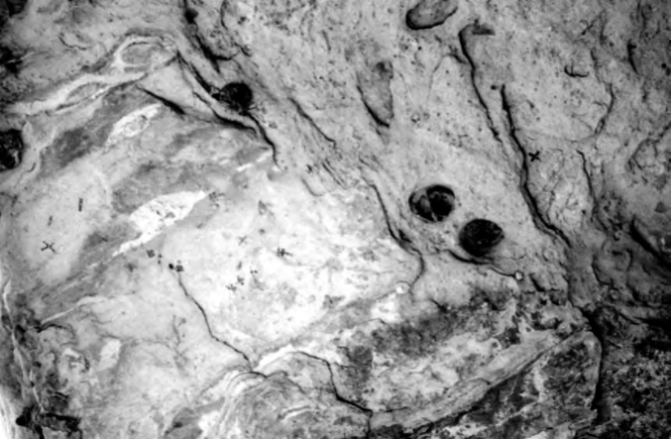
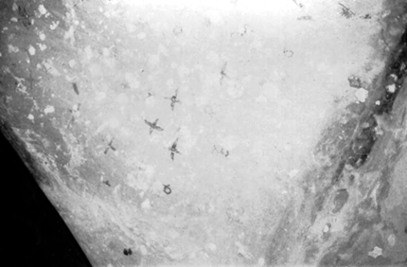
Fig. 2 The Penistaja Star Ceiling Photograph by the authors of The Origin and Meaning of Navajo Star Ceilings, Von Del Chamberlain and Polly Schaafsma

Fig. 1 The Penistaja Star Ceiling Photograph by the authors of The Origin and Meaning of Navajo Star Ceilings, Von Del Chamberlain and Polly Schaafsma

Thomas Christian suggested that the common view among scholars was that the star ceiling represented the star power as a protective way against rock falls among caves and cliff overhangs. However, he referred to Britt, claiming that exact star constellation patterns were depicted. Christian referred to Chamberlain and Schaafsma and their disagreement with that point of view because these patterns were not presented in other ceremonial artefacts of the Navajo.
Christian said that the star ceilings rock art found in the American Southwest was first described in the archaeological literature in 1951 and has generally been associated with the Navajo people due to the many other star ceilings found on traditional Navajo lands. However, Christian claimed that the suggestions this type of rock art characterized by its cruciform icons that represent stars was adopted and learned by the Navajo from their neighbour Puebloan people were questionable and probably speculations. Further, he suggested some doubts about the possible motivations for star ceilings creation and their use. Christian explored the star ceiling site research, the Navajo mythic narrative; the Spanish historical evidence; the cultural and mythical origin of star ceiling phenomena, and the main mythical-religious motives that founded the star ceiling practice and use.
Christian findings lead to some conclusions, such as the star ceiling appearance is older than firstly assumed by researchers, and the archaeological and mythic evidence confirmed that the Puebloan people guided the Navajos in the practice and use of Star ceilings. Also, the author suggested that the Native American mythology and the Spanish historical data could enlighten the origin and meaning of the star ceilings. According to Christian, these findings had important significance for Navajo and Puebloan Studies because they uncovered the mythological foundation of cultural iconography.

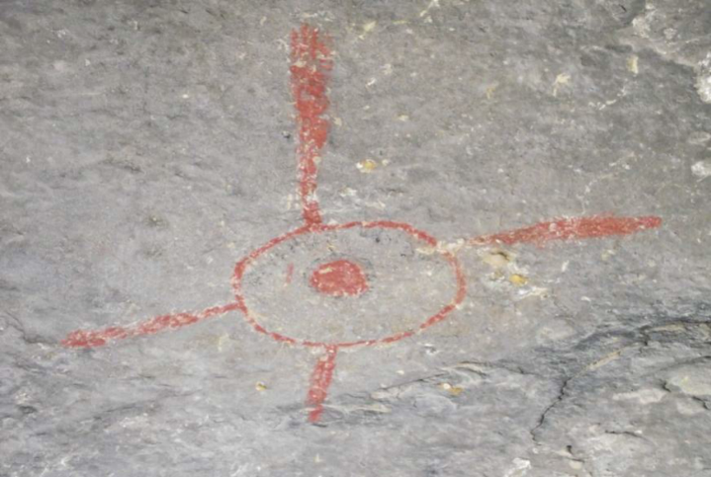
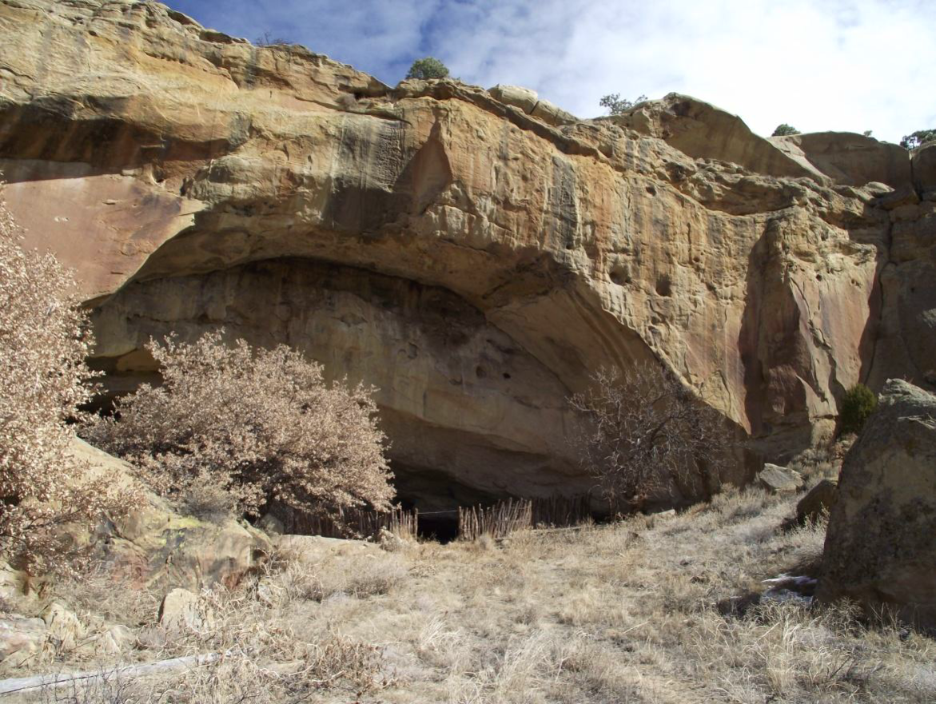
Fig. 4 “Sun” pictograph in cave located northwest of Pinestaja Photograph by the author of Under the Navajo Stars, Thomas Christian

Fig. 3 The Pinestaja Star Ceiling cave mouth. Photograph by the author of Under the Navajo Stars, Thomas Christian

- Meaning of the Penistaja Star Ceiling. Cultural Expression and Significance Representation of the Sky in the Penistaja Star Ceiling
For the purpose of the research was included this section concerning the meaning of the Penistaja Star Ceiling. The Navajo Star Ceiling rock art was based on the culture and mythology of the Navajo and the Southwest Native Americans. According to the myths and legends of the Navajo, the sky had a significant influence in their life, and the Star Ceiling is a way to reflect this belief onto their ceremonial practice and rituals.
Christian similarly assumed that the common view among scholars was that the star ceiling represented the star power as a protective way against rock falls among caves and cliff overhangs.
Von Del Chamberlain and Schaafsma summarised that the Star Ceilings are mostly situated in and around Canyon de Chelly, which was home and a place of refuge for Navajos during the 18th and the 19th centuries. During this time, the Navajos were under pressure from the invaders by various hostile groups, the authors pointed out. Von Del Chamberlain and Schaafsma hypothesised that these factors might have led to the development of protection rituals, including protection that might come from the stars, in the context of Navajos's beliefs. Von Del Chamberlain and Schaafsma suggested that this could explain the large number of star ceilings in that region. The authors referred to Newcomb, who suggested that the stars were significant symbols in Pueblo and Navajo cosmologies and took a special place as symbols in sand paintings, rituals, and ceremonial practice. Von Del Chamberlain and Schaafsma summarised that for the Navajo, star crosses had powerful abilities in exorcism rituals and represented sky forces, immortal force and power as stars have the power themselves.
Von Del Chamberlain and Schaafsma revealed in their work that the most precise figures were stamped in the fashion of the Navajo star ceilings. At least one of the crosses has a small voided centre like many Navajo crosses, and the situated nearby large boulder was also pecked with small sky symbols pointed out the authors. Von Del Chamberlain and Schaafsma described the depicted stars as simple crosses, a star with expanded points and a circular centre, spread-winged birds, and a star with a 'tail' that resembles a meteor or a comet are placed in the fashion of a star ceiling. The authors suggested that the star ceiling and the giant boulder painted with sky symbols represent historical evidence of the cultural coherency between Pueblo and Navajo star ceilings.
Christian pointed out that some scholars claimed that some of the depicted group of stars on the ceiling were images of the star constellations. The author referred to Britt, claiming that exact star constellation patterns were depicted. However, Christian referred to Chamberlain and Schaafsma and their disagreement with that point of view because these patterns were not presented in other ceremonial artefacts of the Navajo.
Von Del Chamberlain and Schaafsma assumed that Navajos adopted the practice of making star ceilings from Pueblos. The significance of the Penistaja and San Cristobal star ceilings referred to this conclusion as the clusters of star depictions had Pueblo origin, either pecked as petroglyphs or painted on the ceilings of rock shelters in the manner of Navajo Star Ceilings, the authors claimed.
For Von Del Chamberlain and Schaafsma the Navajo star ceilings style followed the ceremonial context of other Navajo rock art that was deeply affected by Pueblos in their coexistence with Navajos at the end of the 17th century. The Pueblo star ceilings were extremely rare, but the practice of painting, especially the stamping method by which stars were placed on sandstone overhangs and ceilings of rock shelters, spread amongst the Navajos. The authors dated the easternmost examples from the early 17th century during the Refugee Period, while those in Canyon de Chelly from the late 18th to early 18th centuries.
Von Del Chamberlain and Schaafsma related the Pueblo and the Navajo associations between birds, stars and war. The authors claimed that certain continuities of perceptions between Navajo and Pueblo concepts of stars, in general, are very close. In their mythology and ceremonial practice, for the Navajo people, stars were symbols of protection and power. The painted or stamped stars on the ceilings of sandstone rock shelters were per­ceived to have the power of protective magic and might have been placed on ceilings to protect shrines or for other protection reasons, suggested the authors. Von Del Chamberlain and Schaafsma said that the Navajos believed that the people and animals needed protection in some places against the harmful influences of ghosts and evil spirits. The authors supposed some purposes of the star ceilings and said that the Navajo practice of painted star ceilings might have 'made it safe' for them to be there. Also, contemporary Navajos believed that star-crossed keep the rock from falling, said the authors. Von Del Chamberlain and Schaafsma suggested that the ceilings might have been an element in ceremonies against the threat of enemies. The authors pointed out that the depictions of stars on ceilings might have been ceremonially linked to the mythological narrative of protection symbolism by Holy People as stars in the sky. Relating to the Navajo creation mythology, the Black God as the creator of the stars, along with the Holy People, put the stars with a purpose to guard and protect the sky and man, suggested the authors.
Christian claimed that for the Navajo tribe, the stars had a significant role in their mythical, practical, and artistic life, and even they believed their physically and spiritually survival was determined and dependent on the stars. According to Christian, the Navajo people perceived the stellar influence of the stars as an integral part of the Navajo psyche.
Von Del Chamberlain and Schaafsma considered a possible relationship between the star ceilings and the Navajo Evil Way ceremony rarely practised today, Great Star Chant. The Chant originated in the context of dangerous conflicts and in need to restore balance and harmony in uncertain and unsafe activities, revealed the authors. Von Del Chamberlain and Schaafsma described that the ceremony was practised for the divination of evil influences against evil powers in situations such as handling the dead, fear of the night and darkness, the powerful effects of the stars, and the presence of enemies. The authors mentioned an example of recent use of the ceremony for veterans returning from service in World War II. The protection against enemies performed by the Great Star Chant and this practice to combat the bad luck presented by a rockfall are similar to those suggested for the star ceilings, the authors claimed. Von Del Chamberlain and Schaafsma pointed out that the stars on the sandstone overheads were placed to prevent the rock from falling in the first place. The authors supposed that the stars also have served a more generalised protective function against outsiders and enemies.
The authors revealed that the singers in the Great Star Chant prayed for protection from the birds and the stars. For Von Del Chamberlain and Schaafsma the combination of symbols such as stars, birds, rock, danger, threat, war, and protection suggested that star ceilings might have been used in an early performance of ceremonies similar to, or related to, the Great Star Chant. The authors suggested that the stars were placed on ceilings sometimes as shot on star-tipped arrows like the Star People in the Navajo Great Star Myth, shooting their light arrows to make people safe from illnesses.
For Von Del Chamberlain and Schaafsma the concept of protective symbolism was presented in the contemporary Navajo belief that the stars hold the sky together; similarly, the power of the stars depicted on the star ceilings keep the rocks in place.

- Findings
The Navajo culture is steeped in mythology and has a rich history over the centuries. The Navajos adopted the Star Ceiling rock art from their neighbours, the Pueblos people. The Penistaja Star Ceiling formation originated and has been used in the context of the traditional Navajo religious ceremonial and ritual practice and was considered sacred to the tribe. Based on the researched sources and reviewed literature might be assumed that star ceilings were made in connection with mythological narratives, philosophy and ritual practices, which were performed to make these places safe for various kinds of use by the Navajo.
The placement of stars on ceilings might have been ceremonially related to the mythological placement of stars in the sky by the Holy People. This act had a great deal of protective symbolism for the Navajo. Referring to the Navajo mythology and their creation myth, their God, creator of the stars, and the Holy People have been ‘…instructed the stars to guard the sky and man’.

- Conclusion
This research aimed to critically examine the cultural expression or representation of the sky in a three-dimensional structure the Penistaja star ceiling represented the Navajo ritual rock art. The study considered and examined the origins and the significance of star ceilings covered with star symbols in relation to Navajo mythology. This research explored some elements in mythology and ceremonial practices among the Navajo, where the stars painted or stamped on the ceilings of sandstone rock shelters were used as protective symbols. This research work examined the origin, meaning, and traditional and cultural significance of the Penistaja star ceiling rock art in the context of perception of the sky among the Navajo people. The research project aimed to enlighten and seek an understanding of the star ceiling phenomena and comprehend the ritual practice of the star ceilings in the context of Navajo mythology, their cultural frame, and cosmology.

Bibliography
Christian, T. M. (2013). Under the Navajo Stars: The Intersection of Mythic Narratives, Archaeology, and Star Ceilings. ProQuest LLC.
Christian, T.M. (2014). The Night Sky, Psychological Projection, And Ancient Rock Art. A View Into The Human Psyche’, Jung Journal, 8.4 26-33.
Maryboy, Nancy C. (2008). A Collection of Curricula for the Starlab Navajo Skies Cylinder. A Guide to Navajo Astronomy. Indigenous Education Institute.
Matthews, W. (1886, October). Some Deities and Demons of the Navajo. The American Naturalist, 20(10), 841-850.
Newcomb, Franc Johnson. (1936). Navajo Symbols of the Sun. New Mexico Quarterly, 6 (4) 305-307.

Reichard, G. A. (1943). Good Characters in Myth: The Navaho Sun God. The Journal of American Folklore, 56(220), 141-143.
Von Del Chamberlain and Polly Schaafsma. (1990). The Origin and Meaning of Navajo Star Ceilings’ in Archeoastronomy in the 1990s. ed. by Clive Ruggles. Ocarina Books, School of Archaeological Studies. pp. 227-242.

Von Del Chamberlain, (2000). ‘Native American Astronomy: Traditions, Symbols, Ceremonies, Calendars, and Ruins’ in Astronomy Across Cultures: The History of Non-Western Astronomy, ed. by Helaine Selin, (Amherst Kluwer Academic Publishers, 2000) pp. 269-301.

Wyman, Leland C. (1970). Sandpaintings of the Navaho Shootingway and The Walcott Collection. Washington, Smitsonian Institution Press.

Gladys A. Reichard, ‘Good Characters in Myth: The Navaho Sun God’, The Journal of American Folklore, 56. 220 (1943), 141-143, (p. 141).
Reichard, ‘Good Characters in Myth: The Navaho Sun God’, p. 141.
Thomas M. Christian, Under The Navajo Stars: The Intersection Of Mythic Narratives, Archaeology, And Star Ceilings, (ProQuest LLC, 2013), p. 7
Thomas Christian, ‘The Night Sky, Psychological Projection, And Ancient Rock Art. A View Into The Human Psyche’, Jung Journal, 8.4 (2014), 26-33, (p. 28).
Christian, ‘The Night Sky’, p. 28.
Matthews, ‘Some Deities And Demons Of The Navajo’, p. 841.
Nancy C. Maryboy, A Guide to Navajo Astronomy, (Indigenous Education Institute, Science First/Starlab, 2008), p. 5.
Nancy C. Maryboy, A Guide to Navajo Astronomy, (Indigenous Education Institute, Science First/Starlab, 2008), p. 5.
Maryboy, A Guide to Navajo Astronomy, p. 6
Maryboy, A Guide to Navajo Astronomy, p. 6
Maryboy, A Guide to Navajo Astronomy, p. 6.
Maryboy, A Guide to Navajo Astronomy, pp. 6-7.
Von Del Chamberlain, ‘Native American Astronomy: Traditions, Symbols, Ceremonies, Calendars, and Ruins’ in Astronomy Across Cultures: The History of Non-Western Astronomy, ed. by Helaine Selin, (Amherst, Kluwer Academic Publishers, 2000) pp. 269-301 p. 269.
Von Del Chamberlain, ‘Native American Astronomy: Traditions, Symbols, Ceremonies, Calendars, and Ruins’ in Astronomy Across Cultures: The History of Non-Western Astronomy, ed. by Helaine Selin, (Amherst, Kluwer Academic Publishers, 2000) pp. 269-301 p. 277.
Von Del Chamberlain, ‘Native American Astronomy: Traditions, Symbols, Ceremonies, Calendars, and Ruins’ in Astronomy Across Cultures: The History of Non-Western Astronomy, ed. by Helaine Selin, (Amherst, Kluwer Academic Publishers, 2000) pp. 269-301 p. 279.
Von Del Chamberlain, ‘Native American Astronomy: Traditions, Symbols, Ceremonies, Calendars, and Ruins’ in Astronomy Across Cultures: The History of Non-Western Astronomy, ed. by Helaine Selin, (Amherst, Kluwer Academic Publishers, 2000) pp. 269-301 p. 280.
Franc Johnson Newcomb, ‘Navajo Symbols of the Sun’, New Mexico Quarterly 6, 4 (1936), 305-307, p. 306.
Leland C. Wyman, Sandpaintings of the Navaho Shootingway and The Walcott Collection, (Washington, Smitsonian Institution Press, 1970), p. 1.
Wyman, Sandpaintings of the Navaho Shootingway and The Walcott Collection, p. 2.
Wyman, Sandpaintings of the Navaho Shootingway and The Walcott Collection,p. 6.
Von Del Chamberlain and Polly Schaafsma, ‘The Origin and Meaning of Navajo Star Ceilings’, in Archeoastronomy in the 1990s., ed. by Clive Ruggles, (Ocarina Books, School of Archaeological Studies, 1990), pp. 227-242 p.229.
Von Del Chamberlain and Polly Schaafsma, ‘The Origin and Meaning of Navajo Star Ceilings’, in Archeoastronomy in the 1990s., ed. by Clive Ruggles, (Ocarina Books, School of Archaeological Studies, 1990), pp. 227-242 p.229.
Von Del Chamberlain and Polly Schaafsma, ‘The Origin and Meaning of Navajo Star Ceilings’, in Archeoastronomy in the 1990s., ed. by Clive Ruggles, (Ocarina Books, School of Archaeological Studies, 1990), pp. 227-242 pp.229-231.
Christian, Under The Navajo Stars, p. 8.
Christian, Under The Navajo Stars, p. 18.
Christian, Under The Navajo Stars, p.18.
Christian, Under The Navajo Stars, p. 8.
Von Del Chamberlain and Polly Schaafsma, ‘The Origin and Meaning of Navajo Star Ceilings’, in Archeoastronomy in the 1990s., ed. by Clive Ruggles, (Ocarina Books, School of Archaeological Studies, 1990), pp. 227-242 pp.237-238.
Von Del Chamberlain and Polly Schaafsma, ‘The Origin and Meaning of Navajo Star Ceilings’, in Archeoastronomy in the 1990s., ed. by Clive Ruggles, (Ocarina Books, School of Archaeological Studies, 1990), pp. 227-242 p.231.
Christian, Under The Navajo Stars, p. 8.
Von Del Chamberlain and Polly Schaafsma, ‘The Origin and Meaning of Navajo Star Ceilings’, in Archeoastronomy in the 1990s., ed. by Clive Ruggles, (Ocarina Books, School of Archaeological Studies, 1990), pp. 227-242 p.233.
Von Del Chamberlain and Polly Schaafsma, ‘The Origin and Meaning of Navajo Star Ceilings’, in Archeoastronomy in the 1990s., ed. by Clive Ruggles, (Ocarina Books, School of Archaeological Studies, 1990), pp. 227-242 p.234.
Von Del Chamberlain and Polly Schaafsma, ‘The Origin and Meaning of Navajo Star Ceilings’, in Archeoastronomy in the 1990s., ed. by Clive Ruggles, (Ocarina Books, School of Archaeological Studies, 1990), pp. 227-242 p.235.
Christian, Under The Navajo Stars, p. 7.
Von Del Chamberlain and Polly Schaafsma, ‘The Origin and Meaning of Navajo Star Ceilings’, in Archeoastronomy in the 1990s., ed. by Clive Ruggles, (Ocarina Books, School of Archaeological Studies, 1990), pp. 227-242 p.235.
Von Del Chamberlain and Polly Schaafsma, ‘The Origin and Meaning of Navajo Star Ceilings’, in Archeoastronomy in the 1990s., ed. by Clive Ruggles, (Ocarina Books, School of Archaeological Studies, 1990), pp. 227-242 p.235.
Von Del Chamberlain and Polly Schaafsma, ‘The Origin and Meaning of Navajo Star Ceilings’, in Archeoastronomy in the 1990s., ed. by Clive Ruggles, (Ocarina Books, School of Archaeological Studies, 1990), pp. 227-242 p.235.
Von Del Chamberlain and Polly Schaafsma, ‘The Origin and Meaning of Navajo Star Ceilings’, in Archeoastronomy in the 1990s., ed. by Clive Ruggles, (Ocarina Books, School of Archaeological Studies, 1990), pp. 227-242 p.231

