Assignment ECAD6007-C/Bridging 1
“A critical evaluation and the identification of next teaching and learning steps focusing on a case study of an individual learner or a group of learners, based on an observed critical incident”.

Introduction

What is it, to critically evaluate? Separately, Oxford Dictionaries define critical as, ‘expressing disapproval’ or ‘important’. Whereas evaluation is to ‘form an opinion of the quality of something after thinking about it carefully’ (OxfordLearnersDictionaries.com, 2020). However, when they are adjoined, this is a patient, holistic view, to be able to dissect research, literature and have a view point of both sides of the argument, to form a conscious and assertive set of findings based on a purposeful rational with clear evidence to support your theory. This paper will look to discuss the importance of personal, teacher reflection and the impact it can have on pedagogical techniques within the classroom. With the use of past and current literature, it will review the role of such techniques and the importance of teacher development and further education, surrounding ‘Donaldson’s Four Purposes and the new Curriculum for Wales’ based (Developing a vision for curriculum design - Hwb, 2020) on an observed critical incident. One focus of this paper will be looking at a critical incident and ‘how classroom observation can be used to aid and promote teacher learning and development’ (MacBeath, 2014). Tripp (2012) stated that ‘incidents happen, but critical incidents are produced by the way we look at a situation’. One must not think of a critical incident as a precise ‘thing’ to be found during an observation, but instead see incidents as significant and indicative of value to develop further research into reflective practice and create more thoughtful and analytical teachers.

Observation

The primary school in which the research would take place is based in a highly diverse and multi-cultural area of a large inner-city and has children from over 40 different countries. Their ethos is ‘Equity, Excitement and Education’ and they adhere to this within lessons and outside. When carrying out the observation, the researcher must be mindful of the ethics surrounding the research process within schools and the responsibility of privacy for participants. To ensure this, the researcher has followed BERA, ‘Individuals should be treated fairly, sensitively, and with dignity and freedom from prejudice, in recognition of both their rights and of differences arising from age, gender, sexuality, ethnicity, class, nationality, cultural identity, partnership status, faith, disability, political belief or any other significant characteristic’ (Ethical Guidelines for Educational Research, fourth edition (2018), 2020). The researcher would observe 4 lessons, in a year 1 (Foundation Phase) class with 27 pupils; 11 male and 16 females. Of these pupils, there were 10 different nationalities with varying levels of the English language. It should be noted that during the observation, Covid-19 restrictions had impacted upon the day-to-day running of schools and thus may have an impact on the ‘normality’ of a classroom due to schools following ‘proportionate control measures’ (Guidance for full opening: schools, 2020). The school is partly working with the new curriculum framework and has a ‘child-led’ approach to its teaching. However, as pupils have only recently come back to school, they are focusing the first few weeks on the health and wellbeing of pupils. They are building a trusting relationship with parents again and want them to know their children are safe. Therefore, the focus of most lessons is on the safety and happiness of children, rather than the teaching and learning.

Methodology

When conducting a field observation, one must assess which method is best to use. Referring to Cohen’s Research Methods in Education, it enables a better understanding of these and which would be the most appropriate to use in a school scenario; but more importantly, which would allow the collection of meaningful, valid and reliable data. Looking at our scenario and our purpose, the study is to observe and interpret a ‘critical incident’, review literature around this area and reflect on this and how it can improve further teacher education. Therefore, we must know the intimacies of what makes such an incident. A single, rare occurrence of behaviour may not seem important, but to an observer, such a stark moment, can give an insight and warrants further investigation (Cohen, Manion and Morrison, 2011). With these critical incidents, it may not be pupil behaviour but specific teacher attitudes or behaviours that draw attention of the observer and offer important insights (Flanagan, 1949).
Knowing that these incidents occur within a classroom at random, we can decide on which observation method would suit this study. We know that the data we want to collect will be qualitative, an incident of substance, not of number. We also know that the incident must be natural and not created; so, a structured observation, which would look to prove a pre-determined hypothesis is not feasible. Using an unstructured observation will give us a rich and holistic understanding of the scenario, where we can form a hypothesis because of the incident (Cohen, Manion and Morrison, 2011). It can be determined how structured or unstructured the observation is by referring to Flick (1998) and Cooper and Schindler (2001). Both believed that the nature of an observation could be considered across several dimensions, as seen in the figure below. By using this scale, our study very much leans towards unstructured and natural observation.
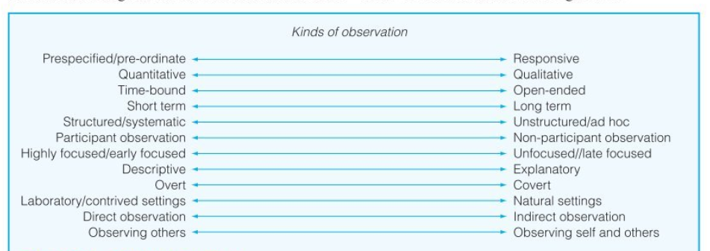
Figure 1: ‘Kinds of Observation’ scale (Cohen, Manion and Morrison, 2011).
In some situations, when confirming a hypothesis for example, it may be important for the creation of an artificial environment or pre-determined incidents to occur. But with our study it is important for a naturalistic and less intrusive when compared to an interview or recorded sessions. A benefit of placing an observer within this setting is that they can gain a true perspective of pupil behaviours and actions, whilst still maintain a level of detachment to study (Simpson and Tuson, 2003). Whereas Merriam (1998) sees this as a difficult role for the observer, to be on both sides of the study at once and states how time consuming this method can be. Not only does the observer have an active role, observing, within the group, but they also must spend more time writing up field notes after the session. When placing an observer directly into the environment, there must be a non-bias account of the incidents that aren’t affected by gender, race or age of participants (Kawulich, 2005) and practically place themselves in the right area to find a critical incident. All must be considered when conducting a natural, unstructured, and non-participant observation.

Four Purposes

The observation took place in a primary school in a highly deprived and multi-cultural area of Newport, with 25% of students receiving free school meals. Around 90% come from a minority ethnicity background with 26 different languages being spoken across the school. As around 85% of pupils receive support with English as an additional language, no Welsh is spoken at homes (Newport Primary Review and Catchment Area | School Guide, 2020).
For this observation, the study would take place in a year 1 group. This group was made up of 11 boys and 16 girls and 10 languages were spoken inside the classroom. The teacher was male, with 6 years of teaching experience and 2 female teaching assistants. The atmosphere of the classroom is a calm, safe and friendly environment where the teacher taught with the same demeanour. He never raised his voice during the observation, but still had respect and control of the classroom. There were no incidents of bad behaviour over the 2 days and whenever the class was becoming too loud or off task, the teacher would calm the pupils with a soft and respectful tone. This respectfulness could be seen around the class and school, as the new curriculum was being used and you could see Donaldson’s 4 purposes being focused on inside and outside of the classroom.
The incident happened during the introduction of the afternoon lesson linked to grid-referencing and programming. The teacher had the pupils sit in front of him on the floor, which was routine practice for him, and was explaining how ‘Bee-Bots’ worked. He wanted to use a practical example using 2 pupils and stickers to act as buttons with different functions. A 1st pupil volunteered to act as the ‘robot’, whilst the 2nd as a programmer. The teacher had the 1st pupil face the front of the class and the 2nd start to put stickers on the face of the 1st. When the 2nd pupil had stuck 3 stickers on, the children on the floor were starting the smile and laugh because they were enjoying the lesson and engaging with what the teacher was doing. However, the 1st pupil’s face changed, from a smiling and giggling student to a face that look anxious, apprehensive, and embarrassed. The teacher recognised this and stopped what he was doing and asked the pupil, “Are you still ok to be the robot?” with the pupil replying that they were “ok”, the teacher then followed up with “If at any point you aren’t happy or want to sit down, you just say” and then the lesson carried on and there weren’t any further incidents like that.
This small conversation between teacher and student may possibly have a big impact upon how the student approaches future education and how they interact with other teachers. From this incident, the observer could see all 4 of Donaldson’s purposes being drawn upon and how they apply in a real-world scenario, not just on paper. Especially, ‘Healthy and confident individuals’ (Donaldson, 2015), as a negative experience in a classroom at this early age could have a serious detrimental impact upon the pupil’s attitude towards learning.

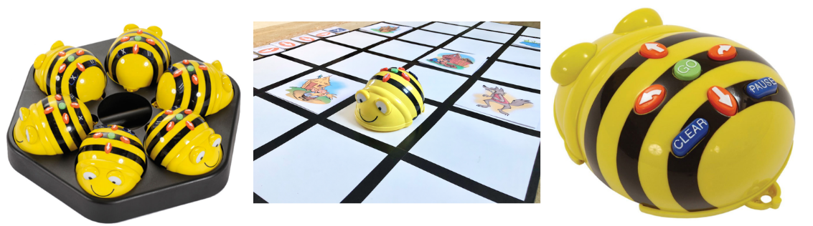

Image 1: Bee-Bot examples. (Bee-Bot - Bing images, 2020)

Literature Review

The purpose of this literature review is to provide context surrounding the found critical incident. By doing this, it can provide evidence to support certain strategies and show the value of further teacher education and reflection in the classroom. It is important to critique literature when reviewing as not all findings will support the findings from the critical incident. By doing this, one can find the key factors from literature and apply them.
As this critical incident was based around a student-teacher interaction and focusing on the well-being and happiness of the child in the classroom, this is where we will focus our literature research around. A teacher plays an important part of the child’s development during their school years. They undertake the role of more than just an educator, but as a mentor, role model, coach, and another parent figure. Within this role, they can create a classroom community which is a safe and healthy learning environment for the children. There have been many studies, Schreiber and Valle (2013) and Ciani et al. (2010), to show that creating this type of environment and building trust will assist children’s learning and motivation (Lash, 2008; Scully & Howell, 2008). This shows how important small critical incidents where a teacher intervenes and how it can benefit the child long-term as well as short. Much of this is based off Vygotsky (1978) sociocultural theory, where the human mind is developed from the pattern of social interactions in which individuals engage with significant others. The child gave a look within the observation of embarrassment after peers began to giggle, this made the child feel uncomfortable and it is why the teacher intervened. This is where the teacher is controlling that classroom dynamic and moulding the environment to ensure that every child is included and not feeling resentment from others. ‘Classroom communities have the power to create trusting relationships where everyone is valued’ (McInnes et al., 2015). The teacher is ensuring that this child is ok to participate, but it also creates trust between the student and teacher. It shows that it is a safe environment. Not only this, but the teacher is demonstrating the social skills that children will develop and wants them to reflect this behaviour within the classroom culture. Children can learn to support each other emotionally, allow for space and time when a child is upset, as in the incident and make them feel safe, valued and welcomed. Such a process will decrease stress and achievement in learning will increase (Whitington and McInnes, 2017).
The benefits for the student’s development in education, with a high-quality teacher-student relationship is a big factor in their school engagement, wellbeing, and academic success (Rooda et al. 2011). But there is also evidence to suggest that student-teacher relationships can affect a teacher both positively and negatively and have an affect on their impact in the classroom and further education. A study conducted by Spilt, Koomen and Thijs, (2011) suggested that further research into this area could give more information surrounding teacher wellbeing, not only is beneficial for the teacher but also have an impact upon student’s school success. It can then be a basis for improving this area in reflection and refining pedagogy and contribute to educational outcomes because good relationships between teachers and students are central to learning (Martin and Dowson, 2009).
‘Jones et al. (2008) proposed that both classroom teaching practices and teacher-student relationships contribute to the quality of the classroom’s instructional and emotional climates, which in turn impact children’s outcomes’ (Wang et al., 2020). Classroom climate, culture or community, all share the same principles, that they have an effect on children’s outcomes and the same with teacher-student relationships. This is an area that should be reflected on by educators as it will impact pupil’s during their entire school journey as well as how they see themselves in future life. Linking to Donaldson’s four purposes, this classroom culture of wellbeing impacts upon all four, which is why it is such an important area to focus on. It makes the learners ambitious and capable because they have been motivated and pushed the right way by the teacher, and from this classroom culture, they know that whatever they try, the teacher will be behind them supporting them. The teacher will push them to achieve all they can this starts from an early age an inspiring that self-belief in all pupils within the classroom. The reassurance from the teacher, even if they fail when they do try something, let’s them know that failing doesn’t matter, but if they want to learn and grow, sometimes they will have to fail. This is where the greatest learning will occur and the most important aspect to take away from this is to still be ambitious, even when they do. They will become creative contributors because they have been asked to do so at such a young age, they will be used to taking an active role in their life and making sure their voice is heard. A teacher can inspire students to stand up for what they believe in and by having a respectful classroom and valuing everyone’s opinion, they will be able to contribute to society in the future. This links to them becoming ethically, informed citizens. Giving everyone a fair voice, looking after others and being respectful about different cultures and beliefs. This classroom community can home in on individual differences and allow the children to ask questions and learn about each other in a safe environment. When they do leave school in the future, they will have an understanding and see how everyone has a part in this world. Finally, healthy and confident individuals; this can be seen clearly in the incident itself, where the teacher is checking on the pupil and taking the time to make sure that they are okay to continue. It is something that may not be seen as an important moment, but it really does show that this classroom community is lead by the teacher and will then spread amongst the pupils.
However, with all the benefits that comes from the observation and study of incidents, some studies and theorists have suggested that there is a gap between research and practice (Broekkamp and van Hout-Wolters, 2007). This study suggested that there were 4 main problems for the gap between research and practice within education. Firstly, education research yields only a few conclusive results; secondly, yielding only a few practical results; thirdly, practitioners believe that educational results and research are not conclusive or practical; and finally, practitioners make only little use of educational research. This reveals that even though many studies into education, how much of the research can be applied in practice? There is a large gap between both areas because of the questioning behind the research. Such as the results not being conclusive, therefore if time and money is spent looking further into something that new research has found, then it needs to show results. It needs to be worth all the effort and money and then be applied practically. Something that researchers may suggest, may not at all be applicable to practice and require further evidence to support its findings. What must be taken into account, is the perspective of the researcher and how it can impact upon the findings from the experiment. Is the quality of the research of a high standard, have results been looked at with a certain perspective to agree or disagree with the research hypothesis? There is also the question of whether there is enough research to cover both sides of the argument? For example, a researcher may conduct a study to find out something within the school context and be the first person to suggest a theory in that area. If there is no counter argument to oppose this, does it mean that all future research and practical application agree with the found theory? So, one must look upon current literature and see how studies may agree or disagree with each other.
Looking at practical results, there has been questions raised about how the research was conducted and results collected. If the study was undertaken in artificial settings, it calls into question the reliability, validity and practical application of the findings (Glaser, Lieberman, & Anderson, 1997; Nuthall, 2004). There will always be, in these circumstances an argument against the use of this research and if time and money would be more effective being used in other ways. Burkhardt and Schoenfeld (2003) suggest that this gap is widening further with future research because of the negative feelings towards previous literature. With a lack of practical and conclusive results from studies, there is always going to be a divide between educational research and practice until the validity of future studies can be proven. Thus when reviewing the literature to understand the critical incident from our study, it must be recommended that the findings and theories may not have the practical applications and outcomes shown in the studies.

Reflection/Evaluation & Next Steps

When carrying out the observation, I saw this moment as a critical incident because of the interpersonal relationship shared between teacher and pupil. It was a moment that could have just as easily not happened, and the lesson would have carried on. But the importance of such a small detail and act of kindness can have a lasting effect on this pupil, how they approach future education and how they conduct themselves in later life. For me, a moment like this is what teaching is about, not just the education of a pupil in maths or literacy, but the guidance shared from a role model to a student.
When looking at how I would approach a situation similar to this in the future, I would look at this as a positive impact and how it can affect the individual child, but also impact others by how they look at the situation. The way a teacher conducts themselves in a classroom will reverberate around the environment and undoubtedly rub off on the children. How they see you act; will determine how they act. Building this classroom community, I would aim to teach respect and kindness to all and about asking someone if they are alright, which can be so simple, can make the biggest of differences. It is vital for the pupil’s to have trust in their teacher; trust that they are being taught the right things but trust because that teacher is someone who they can talk to, share their doubts, feelings and any issues they may be going through. This may not be seen as that important at a young age, but during teenage years, it will be crucial students have someone outside the family home with whom they can share.
Teaching is a constant cycle of reflection, understanding and developing one’s own pedagogy. I believe this process will forever be ongoing and there will never be a point where you reach perfection, but you will be able to get to a level of teaching that is exceptional. Teaching in the modern day is not just the passing of knowledge to others, but as a role model in life, a coach, a guide, a therapist and sometimes a parent. Therefore, it is understandable that teachers will want to continue to develop, to be able to support their students in whatever way necessary. Referring to Gibb’s (1988) reflection model, they have laid out a 6-step process of how to discuss, analyse and adapt your approach to wherever this may be applied. Without the use of reflection, you could continue to make the same mistakes throughout your career and be failing the pupils you are teaching.
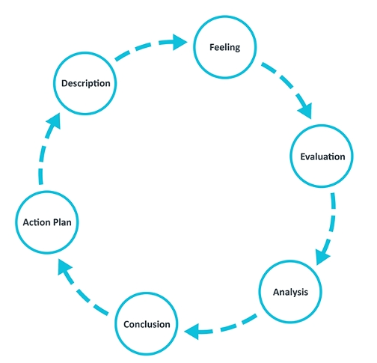

Figure 2: Gibbs Reflection Model (1988) Source: University of Edinburgh (2019:1)
Gibb’s model allows time for not only the description of the incident but also how you felt at that time. This is important because it can have impacted upon how you may have delt with the situation. When looking at the critical incident through this lens, you could question if this was a typical reaction of the teacher or a one off? But using these different steps, a teacher can continually learn to develop and become better, if they are honest with their reflection. I will use this progressing into my career as I want to always strive to better myself and improve the quality of my teaching for the pupils. I will keep a reflection journal which I can refer back to which will allow me to record my feelings at the time of specific incidents and how I will plan to address reoccurring incidents in the future.
For me, being a good teacher is about being open to change. Being able to be honest when something isn’t working and reflecting upon how you could change it in the future. I have spent 2 years as a Teaching Assistant prior to this course and found myself reflecting many times about different scenarios and what I would change. I will continue to do this throughout my career as a teacher to better myself and provide the best education and school environment possible.

Conclusion

Throughout this assignment, the constant theme of reflection and development has been echoed. Moving forward into a teaching career, it is important to continue this reflection to develop one’s own practice and be honest about weaknesses. To be as effective as possible, this cycle should be repeated through all their teaching years, not only for personal development, but as support and strategies for younger student-teachers in the future. By working together to, the teaching community can help bridge the gap found between research and practice and ensure that future studies and observation are fundamental in the improvement of pedagogical techniques.
Looking at the critical incident, it shows that not all reflection has to be based on negative scenarios as well. A reflection can be done over something that has had a positive impact upon a student’s learning or wellbeing. Being able to assess this and understanding why it is important can be vital to the improvement of future teachers and the steps they take in the classroom for creating an environment that best suits the learner. By creating this support network for other teachers and sharing concepts and approaches that work within the classroom, it can allow for greater strides forward in education and research.
Observations do play an important part in the furthering of reflection within the practice, but it is hard to give a full understanding of the context in which they happened. An interpretation from an observer may differ from the teacher or another and something may not be critical at all. The best reflection should be personal, honest and on-going. Effective reflection on the practice should be taught to allow teachers to reach their full potential and others by sharing their experiences over time.

Appendices

OBSERVATION / FIELD NOTES – Critical Incident 1
(Questions adapted from Fletcher Wood (2016)
29/09/2020, morning lesson, year group: 1
Lesson details:
This was a maths lesson on the Tuesday morning, taking place indoors whilst the weather was sunny outside. This covered the AoLE of Mathematics and Numeracy. It was a counting numbers lesson, working on 1 – 10. It was near the start of the Unit as this first month was more about well-being and settling in the pupils rather than teaching and learning being the focus. There are 27 pupils in the class, more girls than boys. As this school is in a very diverse area, there are many children from different countries and speak different languages. The children were all sat on the carpet on foam tiles with their names written on them. This is because they can clean the tiles as the carpet can’t be. Ability ranged from students only being able to count up to 3, and higher students were able to count to 100 and back down.
Classroom culture
The children were very well behaved, although some were distracted, focusing on myself, other things around the room rather than the teacher. But the teacher would correct them using a soft and calm tone. He never raised his voice. It was a calm and fun environment for the children this seemed like a regular routine as they knew what they were doing. Some children were sat up straight, legs crossed and focused on the teacher where-as some were more unsettled, led back, rocking side to side or turning around. But they did take part in the lesson. When the teacher started the counting through, the children would all take part. There were no real behaviour issues of children refusing to take part except for 1 child who was a select-mute.
Objectives
The teacher uses a mix of speaking and visual aids to help with their lesson objectives. They will talk through and demonstrate using the number pole how it works and then the child can see. This was important in this primary school as there were 10 different languages spoken in the class. The teacher would also refer to the maths corner if the children were stuck. Around the room for later in the lesson were different resources, such as white boards, number blocks and small sums.
Direction
The teacher would use a long pole with numbers taped to it. On the right of the pole, the numbers started at 0 and then worked up to the left 1,2,3 and so on. This way the children had a visual to use as well as the teacher saying the numbers as well to get them started. There was also a Maths corner with number charts pinned to the wall so the pupils could look and refer to that if they needed to. The teacher had stuck the numbers to the pole using velcro so he could remove certain ones if he wanted to. When the pupils had easily recalled 1-10 up and down, he removed the even numbers and asked the children to recall the missing numbers. He then questioned them further by asking how they knew what number was there, using bigger/smaller/larger/more/less words.
Access and challenge
The teacher and the 2 TAs would both count along with the numbers to make sure all the children could participate. They never picked on children to answer questions but let them raise their hands to see who would know the answers. The teacher knew who the higher and lower ability children were so would ask appropriate questions to challenge them. A higher-level pupil would be asked to count up through the missing digits where-as a lower ability student would be asked to simply count from 1-10. If the teacher felt the task was too easy, he would ask them to count backwards and explain why they knew a missing number was that number. This would develop the oracy skills.
Assessment
The teacher had obviously been working on counting numbers since the start of the year as most children were confident and loud counting from 1-10. When counting backwards there were a few more quieter children who would wait for their friends to start and then tail on the end of the number they were saying. This was the same when counting the missing numbers from the pole. But the teacher would challenge these students to answer questions as they would put their hands up before he had finished his question. He would go quickly through the beginning refresher task and then develop their knowledge on counting backwards by spending more time on this and starting from different numbers. You could see a difference in participation through noise at the end of the session to the beginning.
Specifics / Critical Incidents
In this class was one pupil who was deaf. They had to wear 2 hearing aids; the teacher had a microphone attached to his chest which would then feed directly to these hearing aids. This pupil was also Romanian, so there was the challenge of translation as well as hearing difficulty. This pupil didn’t have much speech and any words were more sounds that were very similar and hard to make out. You could see the pupil counting along with the class, attempting to sign the numbers but it was very difficult to hear if any clear numbers were being said. It raises the question of how do you check for learning and understanding with a pupil who cannot recall information in a lesson like this.

CRITICAL INCIDENT IDENTIFICATION RECORD

Details relevant to the research context.  Date/time.  Age/Stage of group.  People involved.  Contextual  information from field notes. | 29/09/2020, morning lesson approx. 10:00am.  Year 1 (ages 5/6) Early stages of Maths unit.  1 Teacher, 2 TAs and 27 pupils. (11 boys/16 girls)  Mathematics and Numeracy, counting numbers 1-10.  Children sat on floor in front of teacher who was using a wooden pole with circled numbers stuck to it using velcro.
What happened? A detailed decription of what you observed and what thoughts on pedagogy and practice occurred to you as a result, looking towards your research. | The pupils were being asked to count with the teacher at the start from 1-10. The teacher would hold the pole out in front so all the pupils could see, and he would start the counting as to give the pupils a prompt. He would move his finger along the pole to each number as he would count through. When he had done this a couple of times, he would then count backwards from 10-1 to the same with his finger. When he had felt the children has mastered this, he would start them counting from different numbers, backwards or forwards. The children were engaging with this and were happy to be very vocal when recalling numbers. At some points the teacher would ask a child to count by themselves, but only if they had put their hand up to volunteer. He then progressed this further by removing the even numbers on the pole and asked the children to count the missing numbers by themselves. He would then ask individuals who had raised their hands to say what the missing numbers were. He asked, ‘how they knew this?’ and get them to develop their oracy around maths by using words like ‘larger, smaller, bigger, more and less’. This was aimed more at the higher-level pupils as some of the lower level were struggling counting 1-10.  A critical incident for me was as this is only a verbal recall tasks, the pupil who was deaf, let’s call them ‘child X’, could only count along making sounds rather than saying the numbers. This was not their fault, but they with their disability, they could not talk properly. The child was still very engaged and did pay attention, although they would look to the TA for support sometimes who would sign the numbers along with them whilst saying them. Child X is still young so hasn’t learnt a lot of sign language yet. This moment stuck out for me because how does the teacher know that learning is taking place there? Is child X simply sounding along with the children even though engagement is high? Does the teacher want the engagement and participation from the student to be inclusive and then just check for understanding at different points with this pupil or does the teacher know enough about this student to know when there is clear understanding and recalling of knowledge happening?

OBSERVATION / FIELD NOTES – Critical Incident 2
(Questions adapted from Fletcher Wood (2016)
29/09/2020, afternoon session, year group: 1

Lesson details:

In the afternoon, the teacher uses this time as a ‘catch up’ session, where pupils can finish any independent tasks that they have been given from the start of the week. These tasks will be different each week but usually try to build FMS, literacy and numeracy or expressive arts depending on what the teacher feels they need to develop. This time is also allocated for some as provision time and they will play with whatever toys are put out that day. With Covid, the provision needs to be changed each day and deep cleaned and then isolated for 72 hours. During my 2 days, there was trains, Lego and animals out. The teacher will use this session to work with 1 or 2 groups, depending on the task and will use this time to carry out some formative assessment on the AolE whilst the other groups work independently or with a TA. In this lesson, the teacher was doing a formative assessment through questioning to see where children were with maths. He had a group around the table with him and he would ask them questions and get them to do tasks and then fill in a check box of what they could and could not do. He would then use this information later in the year when sorting the class into ability groups.

Classroom culture

This session is a bit more child led learning, rather than focusing on the teacher. The groups working with the teacher and TA will work nicely in their groups, discussing what they are working on. But the groups working independent are very chatty, they are learning through play and working with each other. This is important for their social and oracy development. The majority of children will play with friends or in groups on a table. There is a FMS table where children had to use plastic tweezers to pick up conkers and place in a bowl and other children were drawing faces or playing with trains. This is a nice time for the children where they are a bit more free with their learning and they can complete the tasks they are set in one area and then choose what they want to do next.

Objectives

The teacher at the start of the session would remind the pupil’s what their tasks were and where they were placed around the room. He would call out their names and to where they had to go in the groups. On the tables ready laid out was the pupil’s work, either new or half finished depending on where they were. If anyone were unsure, they could just remain on the carpet and ask. This is to make sure they are being independent and having their provision time.

Direction

The teacher at the start of the week will set out what tasks have to be completed, but he will also remind them of what tasks there are at the start of the afternoon session. He will read out what the groups are and where they have to go so, they know what area to stay in. During the lesson, even though the teacher is working with a specific group, he will often stand up and move around just to check the other children are where they are supposed to be and doing what their task is. A gentle reminder is a soft tone from him will correct the student if they have stopped doing their task or are interrupting somebody else. There are no behaviour issues in this class. There might be some louder talking but the teacher easily calms any issues.

Access and challenge

The teacher has a group working with him so he can keep them focused and also challenge them at the appropriate level so he can carry out his assessment. The groups working with the TAs tend to be the ones who need a little extra help with their tasks to get them finished. The independent groups will be challenged with their tasks but also having to do it on their own even though they can ask for support if they need it. All the children with have time to access the provision throughout the week so they can learn through play. As well-being is the focus of the first 4 weeks this year, it is important for the challenge not to be too high for pupils as you want them to enjoy and come to school as much as possible. They have missed 6 months of their reception year, so have missed a lot of crucial time in their development.

Assessment

The teacher uses a word document with a grid on each page with pupil’s name and competencies that the children will have do to through the year. This is set at Year 1 level, but he has also been using a reception level grid because they have missed so much time. This teacher is still getting to know these children, so the more information the better. Some of these competencies will be engaging with others, working in groups and on the maths assessment it is count 1-10, counting backwards, knowing evens and odds and so on. The teacher will use questioning and practical objects like blocks and tiles with holes in them to see how the children will add and make certain numbers. He can check off on the grid what they can do and what they need to develop.

Specifics / Critical Incidents

As this was a provision lesson, children could work independently and would usually work with friends and in groups. But I did notice one child, ‘child Y’ playing by themselves or doing tasks on their own. They did have friends as I had noticed them playing earlier with other children. But this child was a select mute, she would not speak to teachers, TAs or other children, not that I could observe at least. When I spoke to the teacher about child Y, he said that they have spoken sometimes but not very often. He wasn’t worried about this though and said he had come across children like this before and thought it best to let them develop at their own pace. The child was engaging in lessons as much as they could and didn’t’ seem to be struggling in any other areas.

CRITICAL INCIDENT IDENTIFICATION RECORD

Details relevant to the research context.  Date/time.  Age/Stage of group.  People involved.  Contextual  information from field notes. | 29/09/2020, afternoon session, approx 113:00-14:30pm.  Year 1 (ages 5/6) Provision and small maths group.  1 Teacher, 2 TAs and 27 pupils. (11 boys/16 girls)  Provision, expressive arts, mathematics and numeracy, counting numbers 1-10.  Groups spead across the room. 1 with Teacher, 2 with TAs and 2 working independent.
What happened? A detailed decription of what you observed and what thoughts on pedagogy and practice occurred to you as a result, looking towards your research. | During this provision lesson, I noticed child Y spending most of their provision time on their own. This is time when they could be working in groups or playing with friends. But child Y would either go and read a book away in the corner on their own or be drawing on the small white boards. I did find this interesting because this child was choosing for some reason to isolate themselves and was happy to do tasks. If other children came and talked to them they would nod or shake their head, and engage with them, so it wasn’t a case of them wanting complete isolation, but more preferring to be own their own working. This child was also a select mute so it stood out to me as I wondered what could be causing this child’s behaviour and if the teacher should be addressing it more. The teacher will know more about family background and has spent more time observing this child so I can only go from what they say. But I would be intrigued to see if this behaviour was normal at home as well as in school.

OBSERVATION / FIELD NOTES – Critical Incident 3
(Questions adapted from Fletcher Wood (2016)
30/09/2020, morning lesson, year group: 1

Lesson details:

The children come into the classroom between 8:30 and 9:00am. They are given an open time as to try and reduce the number of parents coming in at one time. The children come into the classroom and hang their coats and bags up, wash their hands and then take their whiteboards out from their draws. They will sit on their foam tiles on the carpet and practice writing their numbers or alphabet. This is a regular morning routine as all the children did this without asking or being told what to do. Once all the class was in, the teacher asked them to put their things away and he then took the register. After this he had them all stand up and he found a Joe Wicks morning PE lesson for them do to. He said that this will wake them up some more, get them moving and switch on their minds for learning. That morning was going to be a phonics lesson, and the teacher would split the pupil’s into groups; 1 group with him, 1 with a TA, 2 groups working independent and 2 children with 1 TA. Of the 2 children working with the TA, 1 was deaf and struggled to speak and the other was struggling with their learning and the school were in the process of getting a statement put in place for them. I wanted to observe this particular TA and these 2 pupils because I wanted to see how a phonics lesson would work with a child who was nearly completely deaf and struggled to produce any speech.
Classroom culture

It was good to see a regular morning routine in place for the children. It helps them settle in and they know what to expect. It can be daunting for a child to come into school because of many reasons, but this helps them feel comfortable and is crucial for their well-being. All the children would engage in this morning exercise and they were all smiling from it. It builds a positive environment for the day and can help improve any poor attitudes that might have come from home. When they have settled back down from doing the video, the teacher would explain what was going to happen that day and then split the children up into their groups. With the 2 pupils who work with the TA, they know this routine and it is normal for them to work in a small pair rather than a group. This is to make sure their needs are being met by giving them that 1-1 time that is crucial for their development. They go into a smaller side room and can work in quiet there without the noise and distraction around them.

Objectives

The teacher will use a lot of hand signals with his talking at the front of the class to help with understanding for the children who don’t have perfect English. He explains that there are resources around the room for the independent group, points to where he will be working with his group and the other group working with the TA. The teacher can carry out any formative assessment with his group at the back of the room then on his table. It gives him a chance to rotate groups and work with different pupils throughout the day.
Direction

There wasn’t any work as a class at the start of this lesson. There is usually a little introduction into what they are doing and some work together as a big group, but this morning he just said what they were doing and split them up into their smaller groups. I asked later about this and he said it was because they have done this many times, they know the routine of the lesson and it gives him more time to work closely with pupils and observe them. With the TA I was observing, she used lots of different resources to help with her teaching. She had to phonics cards with the letter ‘D’ on it as that’s the sounds they would be working on, but she also had a box of objects beginning with D so they could practice their sounding.

Access and challenge

The TA was only working with the 1 letter because this was an appropriate level of learning for these children. It would be hard for them to grasp and recall the sounding of D if they were doing too many at once. By only working with 1 letter, it allows them more time to grasp what the sound is on it’s own or with different words. They would practice pronouncing D by itself and then move on to the objects in the box. These objects were toys mainly, dinosaur, doll, dog, dolphin and other things beginning with D. This was a way to challenge them by picking harder words depending on how easy or hard they were finding it. The TA would also sign the word to them as she was saying it. This was crucial for the one pupil who was deaf as they will need to learn sign as they grow up.

Assessment

The TA would assess the children by listening to their responses and would then know if there was understanding there. She could go back through the different toys and ask them to recall the name of it. This was a basic assessment method but was important for tracking these pupil’s progression. With the deaf pupil, sounding back the word was extremely difficult and although they could pronounce the single D, they struggled for anything that sounded different no matter what the toy was. The sign language was extremely important to check for understanding with this pupil, as they could sign the word back to the TA even if they couldn’t pronounce it properly. The pupil could sign dog, doll, dinosaur and the TA knew that he was understanding and engaging in the lesson. The child would point to other objects around the room that began with D to show that he knew the sound and what other words began with D.

Specifics / Critical Incidents

The critical incident hear was the signing of the word along with using the toy and saying the word. This gives 3 different methods of learning for the child who does need that extra help. The TA speaking, using a visual tool like a doll and also signing the action. It was showing how modern teaching is more than just standing at the front of a class and reading words and waiting for a pupil to recall. It was about adapting their pedagogy and being inclusive. The school pushes equity and this was equity in action. The teacher and TA will have planned this out from the start of the year and are making sure hey are giving every pupil a fair chance to learn. They have overcome barriers along with this pupil to allow them the best opportunity.

CRITICAL INCIDENT IDENTIFICATION RECORD

Details relevant to the research context.  Date/time.  Age/Stage of group.  People involved.  Contextual  information from field notes. | 30/09/2020, morning lesson approx. 10:00am.  Year 1 (ages 5/6) Phonics.  1 Teacher, 2 TAs and 27 pupils. (11 boys/16 girls)  Observed 1 TA and 2 pupils.  Literacy and Communication  2 children working in a side room with the TA practicing phonics using multiple resources.
What happened? A detailed decription of what you observed and what thoughts on pedagogy and practice occurred to you as a result, looking towards your research. | I went into the side room where the TA and 2 pupils were working. 1 pupil is deaf and struggles with any speech, so the TA has to sign and use a microphone that is attached to her shirt. But this doesn’t always work as the pupil’s hearing is really bad. There is also the barrier of English not being their first language. This child has to try and either interpret sign, hear the English, translate it in their head, think of the answer, translate in back to English and then try to speak it or sign it. The other pupil does not have a statement or any diagnoses, but there are traits, so the school is investigating further. But as this student is struggling, it is better for them to have this 1-1 time.  The TA was going to be working on the letter D today. They had phonics cards of the letter D and also a box of visual aids. These were mostly different toys that began with the letter D. There was also a small book which was the Sign Language Dictionary. If there were any words the TA was unsure of, they could refer to that. The TA spent the first 5 minutes pronouncing the letter D using the visual card, getting the pupils to sound it back which they were both able to do. She then would say how to write it, “go around the loop, up to the top and back down” whilst doing the action with her hand. The pupils were engaging and following along but as there were no tools for writing with, it was hard to know whether they would actually be able to do this.  She then moved on the using the objects in the box, the toys. There were dolls, dinosaurs, dolphins, ducks, deer and so on. The TA would pick up a toy, say its name and also sign the word. This was crucial for the pupil who was deaf as he would have to learn sign through his life. The pupil could not pronounce any long words, but by using sign, they could show there was understanding. They were able to sign the words back when being shown the toy. The TA would then ask the pupil to find a specific toy, and she would sign it and the deaf pupil could do this. This showed clear understanding and learning had taken place. They had not only learnt how to say D, and things that begin with D, but also different sign words for them.

OBSERVATION / FIELD NOTES – Critical Incident 4
(Questions adapted from Fletcher Wood (2016)
30/09/2020, afternoon lesson, year group: 1

Lesson details:

This afternoon session was going to be a catch-up lesson again, for children to finish off whatever tasks they had to do and for the teacher to finish working with some groups from yesterday. It was hitting the AoLE of Science and Technology and Humanities, hitting cross-curriculum connection, using ‘Bee-Bots’, which is the start of programming and mapping skills. These robots had 7 buttons on the top; go, clear, pause, forward, left, right and back; you input what you what the robot to do and it moves there. The teacher had worked with 2 groups yesterday, so still had some groups to work with today. At the start of the lesson he just wanted to go over again how the robot’s mind works and said that it will only do what you tell it to do. For this he used a demonstration with 2 participants and some stickers as buttons. This was just to show the pupils that the robot can only do what you tell it do to and was a visual demonstration rather than just telling them which might have been difficult to understand.
Classroom culture

The pupils were calm and quiet whilst this demonstration took place. They were engaged and did laugh, answer questions and ask them which is what the teacher wanted. He wanted it to be fun and entertaining for them but that was to ensure it had their focus and attention so they would understand what was being said. The children do like working with the ‘Bee-Bots’ as it is different and fun for them, it is like playing with a toy if they were at home. So, the idea of playing with a toy in school is just as fun, even though they are doing it for education purposes.

Objectives
The objective of this lesson was to understand how to program basic input data in robots, and the start of grid referencing. Moving forward in the year, this will be used for using laptops and I-pads and not only being able to use them, but understand how they are using them and what is going on inside the technology. With the role in humanities, it can be used for reading maps, learning a compass and grid referencing on a larger scale. The children would have to learn how with a robot mind, you must clear data and input new data to start again and how limited to robot is. They had used these before, but it was now moving to the next level of understanding and learning rather than just playing with them.

Direction

The teacher picked one volunteer at first to explain the difference between a human mind and a robot mind. He asked the pupil to go and pick up a book from the back of the room and bring it back, he then made the point of how the child thought for himself to make his own way there, pick a book and then bring it back. He said if it was a robot, he would have to input every detail of the task so they understood and got it right. He then asked for another volunteer to be the ‘robot’ and used stickers as control buttons which someone else decided what they would do. The teacher was using constant hand signals and some sign language to go along with his talking so they could all understand what was being said. When he would be working with a small group, they would have a fold away map of a town from a bird’s eye view and have to make the robot go to certain places.

Access and challenge

The teacher was working directly with the group working with the bee-bots, so everyone would be able to access the work. There were no real issues with accessing the work and it was simple and a straightforward task. The teacher would remind pupils of the instructions and would build up the task through the lesson. They would start of having to move the bee-bot forward 3 times or back, then add in a turn and so on. Once they had mastered this and knew how to clear and enter new instructions, the teacher would bring out another map and this one had specific shops and places the bots could go to. This time, the bee-bots would start at the end of the street and would have to go to certain shops on the map. This raised the level of challenge for pupils but could also be made easier or harder. If the teacher wanted to make the task harder, he could make the pupil get the bee-bot to 2 or 3 shops in 1 turn, rather than just 1.

Assessment

The teacher could assess pupils by how quickly they progressed through the tasks with the bee-bot, he could visually see how they entered the commands into the bee-bots and how hard he was having to make the task. Questioning alongside this will give him a better understanding of how much a pupil knows. If there was clear learning taking place, the pupil could recall how to program the bee-bots and how to explain it to others.

Specifics / Critical Incidents

The critical incident in this lesson that stood out was when the teacher was asking for volunteers to take part in the demo at the start. The teacher asked for 1 pupil to act as his robot and 1 pupil did volunteer for it. The teacher then started to stick small, circular stickers on their face to act as buttons. As he put them on, he would write what the buttons did on the white board. As he was sticking more on, the pupils on the floor were getting excited and did start laughing, but this was because they were enjoying the lesson, not laughing at the pupil at the front. But the teacher did notice this and did see the pupil’s enthusiasm start the diminish; he then proceeded to stop what he as doing and ask if the pupil was still ok to take part or if she wanted to swap. The pupil did carry on, but it was that small, 15 second period, which stuck out as a really critical moment for the teacher as well as the teacher.

CRITICAL INCIDENT IDENTIFICATION RECORD

Details relevant to the research context.  Date/time.  Age/Stage of group.  People involved.  Contextual  information from field notes. | 30/09/2020, afternoon lesson approx. 14:00pm.  Year 1 (ages 5/6) Science and Technology.  1 Teacher, 2 TAs and 27 pupils. (11 boys/16 girls)  Inputting data/programming ‘Bee-bots’ with commands.  Class sat on their foam tiles around the teacher who was picking pupil’s to demonstrate what he was teaching.
What happened? A detailed decription of what you observed and what thoughts on pedagogy and practice occurred to you as a result, looking towards your research. | The teacher was doing his lesson on how to input data on the bee-bots using the buttons on top. He was describing how the robot can only do what it is told and the buttons are limited to what commands have already be programmed into their microchips. He wanted a volunteer to take part in a demonstration of how simple programming works. One pupil put their hand up to take part as the robot and another pupil volunteered to be the programmer. The teacher was using small stickers which would act as buttons and the 2nd pupil had to stick these buttons on the 1st pupil’s face. The teacher would then write down on the board what the buttons did; walk forward, stop, turn around, spin. This was a fun lesson and the children sitting on the carpet were all paying attention and engaging as it was fun to see their classmates pretending to be a robot. As the 2nd pupil was putting the stickers onto the face on the 1st pupil, the pupils on the floor did start giggling and were becoming a bit louder because they were getting excited. I was watching the 1st pupil’s face closely and it did seem they were becoming quite self-conscious about what was happening. The teacher did notice this as well, so he stopped what was happening for the moment, and asked the pupil if they were ok, and if they were still happy to take part in the demonstration or if they wanted to sit back down. The pupil turned to the teacher and shook their head saying they were ok. The teacher then carried on with the lesson but was reassured that the pupil was ok and if they weren’t happy at any point they could say. This was a crucial moment for me as the teacher took into account the child’s well-being first above their learning. It holds true to what the school believe in were they have a child-led approach and want their children to be happy and safe in school.

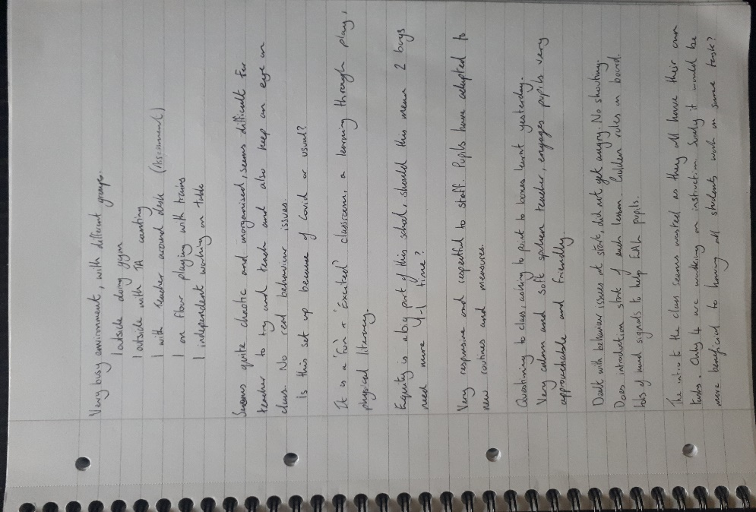
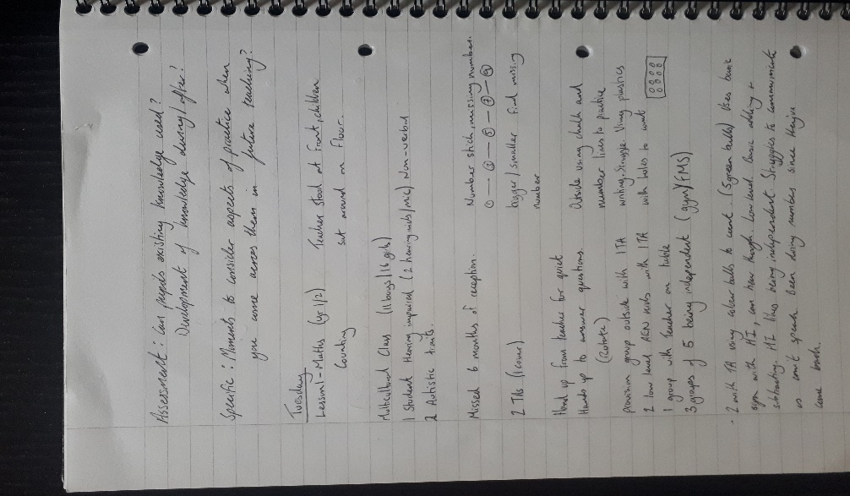

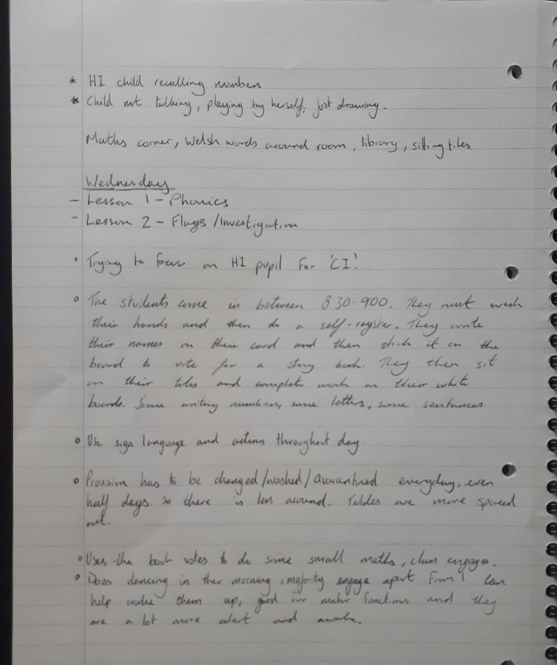

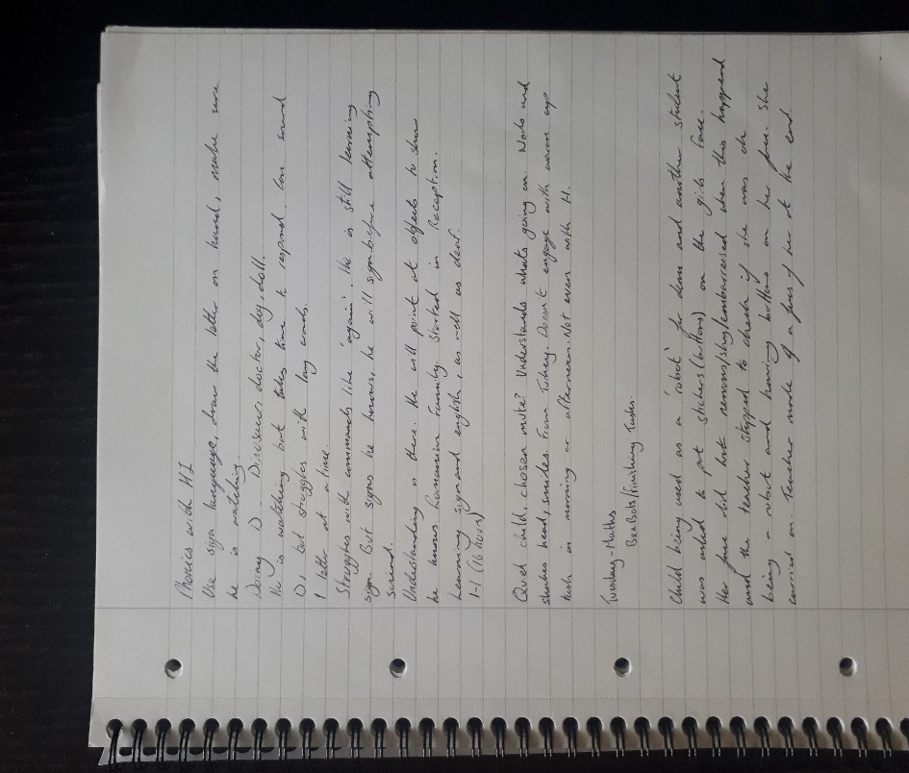

Reference List
Bera.ac.uk. 2020. Ethical Guidelines For Educational Research, Fourth Edition (2018). [online] Available at: <https://www.bera.ac.uk/publication/ethical-guidelines-for-educational-research-2018-online#participants> [Accessed 7 October 2020].
Bing.com. 2020. Bee-Bot - Bing Images. [online] Available at: <https://www.bing.com/images/search?q=Bee-Bot%20&qs=n&form=QBIR&sp=-1&pq=bee-bot%20&sc=8-8&cvid=037810C7449244F6AE0482B613ED5794&first=1&scenario=ImageBasicHover> [Accessed 11 October 2020].
Burkhardt, H., & Schoenfeld, A. H. (2003). Improving educational research: Toward a more useful, more influential, and better-funded enterprise. Educational Researcher, 32(9), 3 – 14.
Broekkamp, H. and van Hout-Wolters, B., 2007. The gap between educational research and practice: A literature review, symposium, and questionnaire. Educational Research and Evaluation, 13(3), pp.203-220.
Cohen, L., Manion, L. and Morrison, K., 2011. Research Methods In Education. 7th ed. Abingdon: Routledge.
Cooper, D. C. and Schindler, P. S. (2001) Business Research Methods (seventh edition). Cited in L. Cohen, Research Methods in Education. Abingdon: Routledge.
Donaldson, G., 2015. Successful Futures: Independent Review Of Curriculum And Assessment Arrangements In Wales. Scarlet Design International Ltd.
Flanagan, J. (1949) Critical requirements: a new approach to employee evaluation. Cited in L. Cohen, Research Methods in Education. Abingdon: Routledge.
Flick, U. (1998) An Introduction to Qualitative Research. Cited in L. Cohen, Research Methods in Education. Abingdon: Routledge.
Glaser, R., Lieberman, A., & Anderson, R. (1997). ‘‘The Vision Thing’’: Educational research and AERA in the 21st century part 3: Perspectives on the research-practice relationship. Educational Researcher, 26(7), 24 – 25.
GOV.UK. 2020. Guidance For Full Opening: Schools. [online] Available at: <https://www.gov.uk/government/publications/actions-for-schools-during-the-coronavirus-outbreak/guidance-for-full-opening-schools> [Accessed 7 October 2020].
Hwb.gov.wales. 2020. Developing A Vision For Curriculum Design - Hwb. [online] Available at: <https://hwb.gov.wales/curriculum-for-wales/designing-your-curriculum/developing-a-vision-for-curriculum-design/#curriculum-design-and-the-four-purposes> [Accessed 6 October 2020]
Kawulich, B. B. (2005) Participant Observation as a data-collection method. Cited in L. Cohen, Research Methods in Education. Abingdon: Routledge.
MacBeath, J., 2014. Education And Schooling. Abingdon: Routledge, p.209.
Martin, A. J., & Dowson, M. (2009). Interpersonal relationships, motivation, engagement, and achievement: Yields for theory, current issues, and educational practice. Review of Educational Research, 79, 327-365.
Merriam, S. B. (1998) Qualitative Research and Case Study Applications in Education. Cited in L. Cohen, Research Methods in Education. Abingdon: Routledge.
Lash, M. (2008). Classroom community and peer culture in kindergarten. Early Childhood Education Journal, 36(1), 33–38.
Oxfordlearnersdictionaries.com. 2020. Critical Adjective - Definition, Pictures, Pronunciation And Usage Notes | Oxford Advanced Learner's Dictionary At Oxfordlearnersdictionaries.Com. [online] Available at: <https://www.oxfordlearnersdictionaries.com/definition/english/critical?q=critical> [Accessed 6 October 2020].
Schoolguide.co.uk. 2020. Newport Primary Review And Catchment Area | School Guide. [online] Available at: <https://www.schoolguide.co.uk/schools/cp-school-newport> [Accessed 11 October 2020].
Scully, P., & Howell, J. (2008). Using rituals and traditions to create classroom community for children, teachers and parents. Early Childhood Education Journal, 36(3), 261–266.
Simpson, M. and Tuson, J. (2003) Using Observations in Small-Scale Research: A Beginner’s Guide. Cited in L. Cohen, Research Methods in Education. Abingdon: Routledge.
Tripp, D., 2012. Critical Incidents In Teaching. Abingdon: Routledge, p.8.
The University of Edinburgh. 2020. Gibbs' Reflective Cycle. [online] Available at: <https://www.ed.ac.uk/reflection/reflectors-toolkit/reflecting-on-experience/gibbs-reflective-cycle> [Accessed 25 October 2020].
Vygotsky, L. S. (1978). Mind in society: The development of higher psychological processes. Boston, MA: Harvard University Press.
Wang, M., L. Degol, J., Amemiya, J., Parr, A. and Guo, J., 2020. Classroom climate and children’s academic and psychological wellbeing: A systematic review and meta-analysis. Developmental Review, 57, p.100912.
Whitington, V. and McInnes, E., 2017. Developing a ‘Classroom as Community’ Approach to Supporting Young Children's Wellbeing. Australasian Journal of Early Childhood, 42(4), pp.22-29.

