Evidence-based Practice

Evidence-based practice (AC 1.1)
Evidence-based practice is used as an approach towards decision-making that uses a combination of best available, current, valid, and relevant evidence, which is used to review and analyse, to ensure that good decision-making is accomplished through critical appraisal. This will increase the chances of an agreeable outcome. People professionals are often involved in solving complex organisational problems and need to understand 'what works' to influence key organisational outcomes (CIPD,2023a). Whilst always factoring in that management experience can be subject to bias and errors, decisions that are made solely on these can lead decision-makers down the route of 'fads' (CIPD,2016a).
People professionals use critical thinking to successfully examine the information and form a judgment with an ability for critical thought and reflection on the arguments, ideas, and viewpoints of others. Critical analysis can also assist you in making constructive decisions by fairly analysing the evidence, identifying its strengths and weaknesses, and looking through all supporting documentation to arrive at a reasonable conclusion that can be put into practice. Making a mistake in HR can lead to issues and can be costly if you rely on your judgment. (Paul and Elder, 2019) imply that a ‘critical thinker will reflect on ideas rather than just passively accept them’.
One example of Evidence-based practice could be the decision to investigate the reasons why there is a decrease in employee productivity and well-being, which has significantly resulted in a higher turnover of staff. For instance, the 'Six Steps' process which is commonly followed are, Asking, Acquiring, Appraising, Applying, Assessing. (CIPD,2021a). The ‘Six Step’ process can help address the root causes of high staff turnover, it can identify and implement strategies that have been supported by research. Employers may adopt a more stable and happier workforce by prioritising professional development, work environment, mentorship, and feedback mechanisms. In essence, this could lower turnover rates and enhance organisational effectiveness overall which will increase the likelihood of a favourable outcome.
Furthermore, 'The four sources of evidence' process is also a strategy that is generally used, each of which contains data of different types, including combing specific expertise, internal organisation data, stakeholder values and concerns, and academic research. Together, 'The four sources of evidence', create a thorough and impartial method of decision-making, people professionals can create judgements that are more likely to be sustainable and successful by utilising all four sources to help them make well-informed and practical choices.
‘Profession map’ is another tactic that can be employed to encourage effective decision-making inside a company, this allows us the ability to adapt to changing conditions and make sure that our work us based on solid ideas even with their sometimes being a clear lack of rules or answers. The profession map values are, Principles-led –going beyond policy and process to do what's right, evidence-based – using a range of evidence and expertise to make decisions and outcomes-driven – focusing on work which creates value for people and organisations. (CIPD, 2024). Examples of the core and specialist knowledge areas that are required from a people practice professional to support the needs of the organisation they are part of, are listed in the Profession Map provided by CIPD (CIPD,2021). The Profession Map sets the international standard for our profession, developed in consultation with 20,000 people professionals, CIPD members, employers, and academics. Starting with our purpose and values. (CIPD, 2024).
Employee feedback and recommendations on a variety of organisational difficulties, such as ineffective procedures and people’s behaviours like a lack of employee well-being, are another major benefit of group decision-making for this technique.

Analysis tools and methods (AC 1.2)

There are several approaches to analysing an organisation to find issues, challenges, and opportunities. Among the most popular techniques is, the SWOT Analysis Tool. The SWOT analysis tool is a widely used technique for assessing an organisation, providing a complete overview of the organisation's current position, strengths, and weaknesses as well as its external opportunities and threats. Carrying out and using a SWOT analysis is part of the core knowledge on enabling change in our Profession Map. (CIPD, 2024). By performing a SWOT analysis, organisations can take advantage of opportunities and obtain a competitive edge by recognising and applying their strengths. Organisations can also discover areas of vulnerability, such as outdated technology and ineffective practices. (CIPD Factsheets, 2024) indicate that it requires a ‘team effort and can't be done effectively by just one person’. By using SWOT analysis, organisations can improve overall performance by identifying flaws which can lead to ideas of decision making, development and improvement. However, it is notable that similarly, both, PESTLE and SWOT analyses are encouraged to be repeated and updated to be effective, suggesting that one ideology alone is not effective (CIPD,2020a).
The method of interview analysis is an added helpful took that companies can use to discover opportunities, issues, and challenges. This approach could be used to assess an organisations high staff turnover rate. Managers within a company conduct exit interviews to receive input from departing employees about their reasons for leaving. Additionally, people professionals might discover organisational issues such as outdated policies through interviews. This would be an example of a qualitative method rather than a quantitative method. People’s thoughts, feelings and experiences are deeply captured by this kind of method. Quantitative approaches, on the other hand, concentrate on numerical data that may be statistically examined to find trends. Interviews are an effective method for qualitative research, which aims to comprehend human behaviour, and experiences at a deeper level rather than counting and measuring them.
People professionals can successfully assess ideas through critical thinking and employees who feel dissatisfied can express these feelings in focused group interviews where they can identify some laws and regulations that are not being followed correctly, this can then assist the implementation within an organisation. A particular piece of law that sets out requirements for the execution of specific jobs and procedures is the Employment Rights Act of 1996. The purpose of the Employment Rights Act of 1996 is to protect employees from unwarranted treatment.

Critical thinking (AC 1.3)

Critical thinking is having the capacity to reason logically and clearly about any given scenario. It entails deferring judgment until all the information is gathered, fairly and impartially, evaluating the evidence, and then reaching a well-reasoned decision. Howlett (CIPD, 2019) develops this idea further, stating that ‘three factors make a critical thinker: critiquing the ideas, opinions, and arguments of others; how arguments and opinions are constructed; and identifying when others are using these’.
The process of critical thinking is built upon a foundation of four principles, Objective rational thinking entails assessing data and reasoning free from bias, individual opinions, and emotional influence. A well-reasoned argument uses logic, clarity and supporting evidence to persuade or educate its audience. Making observations and scrutinising the legitimacy of sources and rationality of evidence is examining the validity of sources and evidence and determining how accurate and trustworthy the information you encounter is. Awareness of bias is crucial for creating more equal and fair situations in the workplace. You must be aware of your own and others' conscious and unconscious biases, this awareness can lead to more deliberate unbiased decision-making. For instance, you can use critical thinking when making a recruitment decision, particularly when it's a tight call. Using critical thinking techniques will help you make a more thoughtful and fair hiring decision even when the choice is not immediately obvious.

Decision-making approaches (AC 1.4)

Several decision-making procedures can be applied, depending on the circumstances. De Bono's six thinking hats technique promotes diversity in viewpoints to improve problem-solving and decision-making processes. By representing each 'hat' as a distinct way of thinking, individuals can investigate different aspects of a topic. Here is a summary of each hat and its associated thinking style. The White Hat calls for information known or needed. ‘The facts, just the facts.’ The Yellow Hat symbolizes brightness and optimism. Under this hat, you explore the positives and probe for value and benefit. The black hat Risks, difficulties, Problems – The risk management Hat, is probably the most powerful Hat; a problem however if overused; spots difficulties where things might go wrong, why something may not work, inherently an action hat with the intent to point out issues of risk with intent to overcome them. The Red Hat signifies feelings, hunches, and intuition. When using this hat, you can express emotions and feelings and share fears, likes, dislikes, loves, and hates. The Green Hat focuses on creativity, the possibilities, alternatives, and new ideas. It's an opportunity to express new concepts and new perceptions. The Blue Hat is used to manage the thinking process. It's the control mechanism that ensures the Six Thinking Hats guidelines are observed. (De Bono Group, 2019-2029). When evaluating staff members individually, for example, organisations can study problems in-depth, avoiding limiting their thoughts and promoting a complete approach to problem-solving. By wearing each hat in the correct order and ensuring that all viewpoints are taken into consideration, this approach produces more effective balanced results, including improvements for the employee, for instance, the organisation can introduce a performance management system to evaluate and improve employee performance.
Another approach to critical thinking is Kepner and Tregoe's Model, it is an orderly approach to problem-solving and decision-making. In organisational settings, it emphasises rational methods for problem discovery, leading to positive results. These four steps are, Situation Appraisal – identify concerns and outline the priorities, Problem Analysis – describe the exact problem or issue by identifying and evaluating the causes, Decision Analysis – identify and evaluate alternatives by performing a risk analysis for each and then make a final decision, Potential Problem Analysis – evaluate the final decision for risk and identify the contingencies and preventive actions necessary to minimize that risk. (By the Mind Tools Content Team, 2024).
Furthermore, the Force field analysis tool a decision-making method developed by Kurt Lewin, which investigates the variables that impact a situation in organisational change. For example, there has been a decision to implement an employee training and development scheme. In this instance, the force field analysis can help organisations to visualise and create well-informed plans for applying change. By undertaking the five steps, assigning ratings, describing your strategy or change proposal, identifying forces for and against change, analysing and application. The tool is useful for making decisions by analysing the forces for and against a change, and for communicating the reasoning behind your decision. (By the Mind Tools Content Team, 2024). This could be used to develop the most appropriate way to apply a successful employee training and development scheme.

Ethical perspectives (AC 1.5)

Decision-making can be influenced by diverse ethical viewpoints in several ways. Due to its importance in embracing moral principles like honesty and integrity, the Utilitarianism Theory is an ethical perspective that can have an overall impact on decision-making. Moral judgment is informed by an understanding of utilitarianism theory since it enables people professionals to review a situation before acting. For example, in healthcare utilitarianism would encourage spending money on medical procedures that help the greatest number of patients, even if doing so means that some patients may not receive the best care. (Armstrong, 2012) suggests that ‘ethics is concerned with what is morally acceptable to the larger community, denoting the basic principles of a Utilitarianism approach to ethics, which centres on what is best for most people’.
Another ethical perspective is the 'Equity Theory'. In the 1960’s, J. Stacey Adams, a workplace, and behavioural psychologist, created a particular idea that assessing the equal distribution of resources is the main objective of the equity theory. In accordance with the equity theory, for individual awards to be maximised, structures are frequently created which can divide resources fairly among group members. This then makes people highly motivated to uphold equality when dealing with coworkers because the see value in being treated fairly.
Deontological theory specifically focuses on the ethical framework that emphasises the value of abiding moral laws or responsibilities. It is frequently linked to the philosopher Immanuel Kant, which contains two main propositions: (a) one should follow the principle that what is right for one person is right for everyone, and thus you must do others as you would be done by; and (b) in the words of Rawls(197: 183): 'We must treat persons solely as ends and not in any way as means'. (Armstrong & Taylor, 2020). According to Deontological ethics, certain actions are fundamentally good or bad. For instance, deontological ethics holds that speaking with the truth is a moral responsibility regardless of the consequences, according to this viewpoint, following moral guidelines comes before weighing the possible outcomes.
The eight ethical lenses have been established by CIPD to help people professionals navigate moral challenges at work. These lenses offer an organised method for making moral decisions ensuring multiple perspectives are considered. The ethical lenses include Fairness, Merit, Markets, Democracy and Well-Being, as well as, Rights and Duties, Character, and Handling Down. By using these lenses, people professionals can analyse ethical issues whilst considering a variety of viewpoints to make judgments that are both morally sound and well-rounded.

Financial and non-financial performance (AC 3.1)

Financial and Non-financial performance indicators can be used to evaluate the overall success of the business. Organisations can measure performance by using financial and non-financial methods, under what is called 'controlled performance' (2019:6) and whilst the values alone can indicate the current position, for them to tell a story, they must be analysed further.
An organisation's financial performance can be identified as the evaluation of how well it uses its resources to produce profits and add value to its stakeholders. Organisations can calculate the amount of money made from operations as well as the gross and net profit margins to see how well the company is turning revenue into profit. For example, people professionals’ asses the entire revenue of the company and its expenses to calculate revenue generation. Expenses are incurred in several ways, including salary for staff members, professional training, and resource upgrades, therefore the organisation's financial income is determined by a positive revenue rate. Return on investment is another way to assess an organisation's financial performance.
The term 'Non-financial Performance' describes the measurements and statistics used to review an organisation's operation such as monitoring employee satisfaction rates, training, and development. A method that peoples professionals might use to assess an organisation's non-financial success is customer satisfaction. This can be used to collect feedback in a way that facilitates the identification of low customer satisfaction employee questionnaires. High employee satisfaction levels can be a sign of an effective management style and a positive work environment, both of which can eventually help an organisation succeed. Using critical thinking means that the data collected is properly assessed and a choice is made.

Adding value and measuring impact (AC 3.2)

Effective use of employee potential is the key to creating value. Creating value for the organisation, and its employees is the main goal of effective people management methods. Value creation can be established by an employee’s sense of purpose or by their income and development. Long-term effects include long-lasting adjustments like improved organisational culture or increased competitiveness in the market. Positive impacts support organisational objectives like improved talent.
An organisation can benefit greatly from people practices in multiple ways such as ongoing learning and development initiatives to improve employee performance, abilities, and flexibility, which directly boosts the creative and innovative capacity of the company. By investing in training and development, organisations may increase employee happiness and retention as well as the capacities of their workforce. This raises the workforce's general capacity, improving performance and giving a competitive edge whilst it provides the company archive its long-term strategic objectives by improving its overall human capital management. Human capital symbolises the human element of the organisation; it provides the intelligence, skills and capabilities needed for long-term survival (Armstrong, 2012).
Return on investment is a measuring tool that assesses how profitable or efficient an investment is. It calculates the return on investment on the amount of capital invested. For example, comparing the costs of training to the improvement in performance measures to determine the training programmes' return on investment. Furthermore, employee surveys use both quantitative and qualitative tools to assess the effects of people's practices like satisfaction and engagement scores. Engagement and happiness with employees are common topics of survey questions.
The Cost-Benefit approach is quite simple to use when determining where to move forward with a project in cost-benefit analysis. Organisations utilise this tool by lists of the expenses for the project and then calculate the expected benefits. (By the Mind Tools Content Team, 2024). Indicate that you can ‘carry out an analysis using only financial costs and benefits. However, you may decide to include intangible items within the analysis. As you must estimate the value of these items, this inevitably brings more subjectivity into the process’.
Combining these techniques allows organisations to assess the regard and effect of their people practices in a comprehensive method, ensuring that HR efforts successfully support the achievement of strategic goals and improve overall business performance.

Word Count - 2844

Equality, Diversity, and Inclusion Salary Data

- Gender type

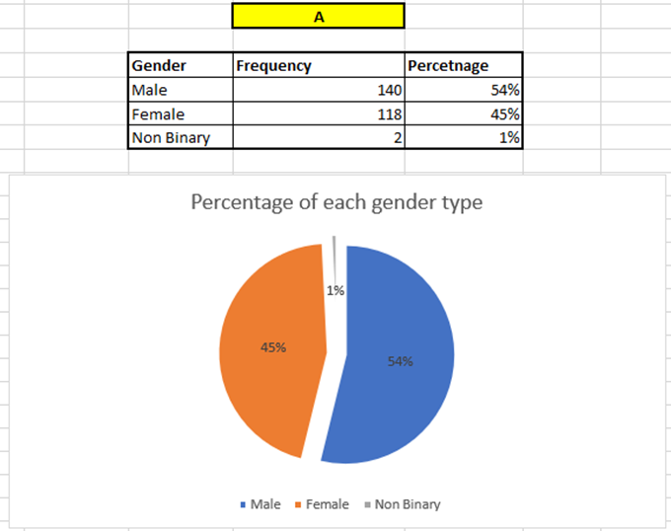

Based on the data provided, it signifies that there is a comparable distribution of male and female employees, with 54 per cent of men and 45 per cent of women. However, it is significant to mention that there is only 1 per cent of employees who identify as non-binary in the workplace. To help reduce involuntary bias, awareness of gender issues and promote a respectful and understanding culture inside the organisation, it would be beneficial to support and encourage female and non-binary engagement. This can entail recurring training courses on gender equality, unconscious bias, and the value of diversity in leadership to all staff members. The risk element of this recommendation is that employees may oppose to new training proposals, particularly if they believe they are not required or will interfere with their daily routine. While also anticipating the training program administration, scheduling, and planning expenses.

- Ethnicity as a percentage per team

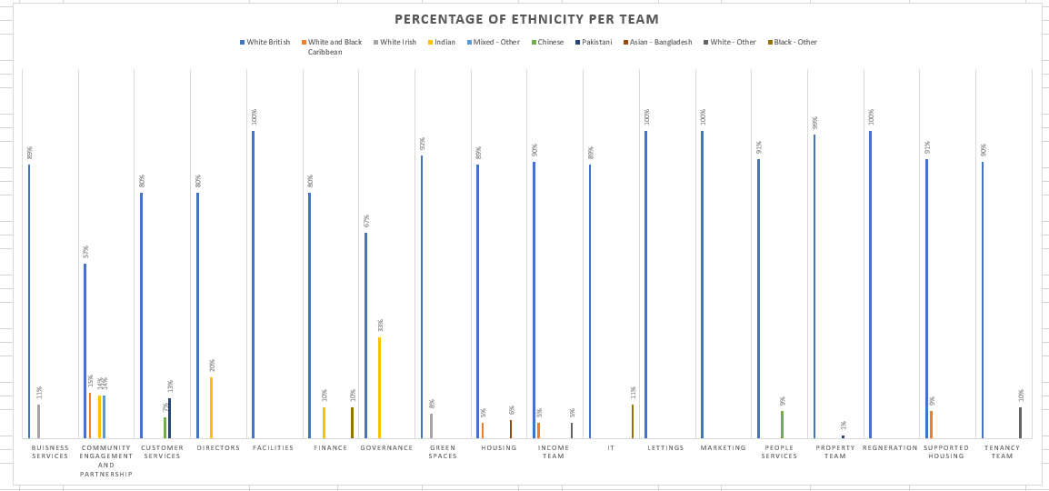

Chart B represents the percentages of ethnicity per team across the organisation. Departments having a high proportion of white British employees include Facilities, Lettings, Marketing and Regeneration, where 100 per cent of staff are white British only. There is very little representation from other ethnic groups in the departments. Although there is some diversity, most employees in departments like finance, governance, IT and customer services are primarily white British. Only a few departments have representation from a particular ethnic group. For instance, just 20 per cent of the Directors department and 14 per cent of the Community Engagement and Partnership department employ Indian employees. Other groups such as white and black Caribbean are only 15 per cent in Community Engagement and Partnership and 9 per cent in Supported Housing. Moreover, there are several ethnic groups represented in the Community Engagement and Partnership department, which shows the highest level of diversity, whilst the data shows that there is a sizable percentage of Indian employees, 33 per cent in the Governance department which demonstrates diversity.
It may be determined to adopt focused recruitment strategies to attract a larger pool of applicants. Reviewing recruitment practices to eliminate bias and discrimination. This could include how and where employers recruit new workers, whether the images and language used in recruitment materials are inclusive, line manager interview practices and the approach of recruiters working on employers' behalf. (CIPD Factsheet, 2014). Additionally, conducting frequent employee surveys to learn about their experiences and thoughts on how inclusive the workplace is. By implementing these recommendations, the organisation may be able to foster a more diverse and inclusive workplace which will enhance innovation and improve employee retention.

(C) Disability percentage as an organisational whole and by teams
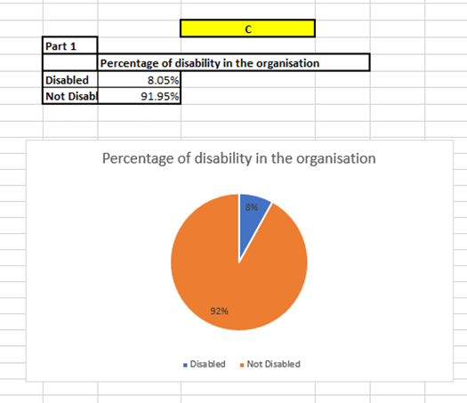

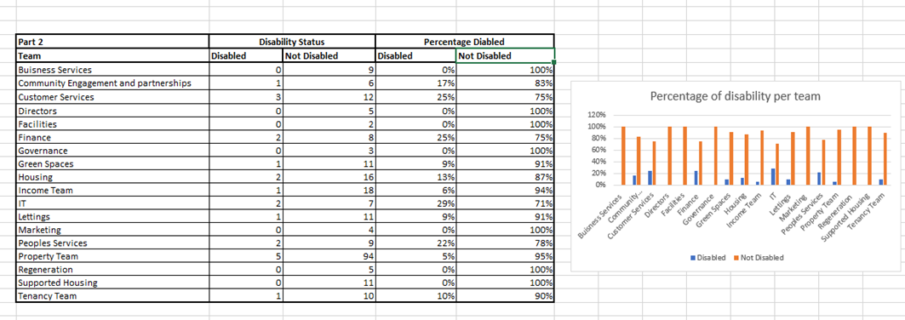

According to the data supplied, 8.05 per cent of the organisation's employees identify as disabled emphasizing a significant gap. Ensure that the organisation's dedication to diversity is highlighted in the job recruitment advert to encourage applications from people with disabilities and to confirm that all parts of the physical workplace, such as entrances, restrooms, workspaces, and common areas, are fully accessible by conducting an audit. This strategy not only promotes the success and well-being of employees with disabilities but also strengthens the organisation's general inclusion and diversity. Businesses that aren't inclusive – and don't support people with disabilities and long-term health conditions – risk their wider reputation as an employer and business, as well as legal action if they fail to comply with equalities law. (CIPD, Factsheet 2024).
Furthermore, Line managers need to know how to sensitively navigate conversations about disability and health conditions with employees and understand what they need to do to arrange and implement adjustments. (CIPD, Factsheet 2024)

- Salary differences across genders

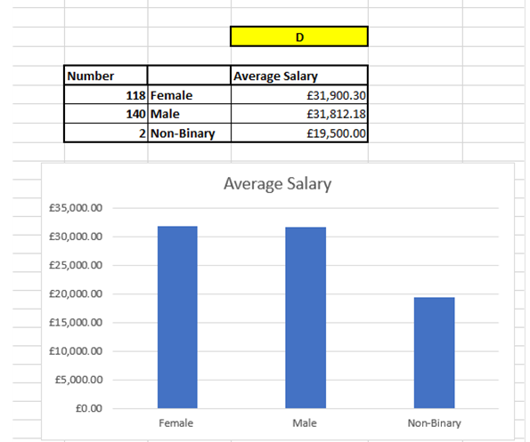

The data demonstrates the average pay for different gender groups within the organisation. The average pay for non-binary employees is £19,000.00, which is substantially less than the pay for male employees (£31,812.18) and female employees (£31,900.30). Particularly for the non-binary category, there are notable differences. The CIPD define the gender pay gap as "a measure of labour market or workplace disadvantage, expressed in terms of a comparison between men's and women's average (median) hourly rates of pay. It's about pay, but also about other factors." (CIPD, Factsheet, 2024).
In a job advertisement, an organisation can emphasise their commitment to inclusion and wage equity, ensuring that hiring tactics are designed to draw in a varied talent pool, which includes non-binary individuals. (CIPD, Factsheet, 2024) suggests that ‘at an organisational level, promoting gender equality is part of being a good employer, one that strives to achieve fairness. Being open about gender pay gap and how you're tackling it increases employee confidence in you as an employer and in your pay and reward processes’.

- Overall average salary paid by the organisation

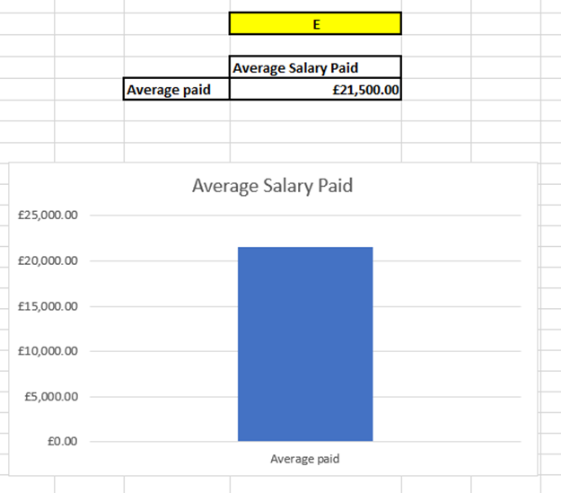

Based on the provided data, it indicates an average salary of £21,500. Surveys could be conducted to find out whether present employees are satisfied with their pay. This can reveal whether the average wage they currently receive satisfies their requirements and aspirations. Additionally, the organisation can look to provide opportunities for career growth and a defined path for promotions as retention strategies. Reviewing salaries regularly to ensure they reflect the changing nature of the market as well as the employee's increasing expertise and contributions. The organisation can guarantee that the average pay paid is fair, competitive and in line with the company's financial resources and objectives by putting these guidelines into practice.

Hybrid working practices.

According to the survey data, a substantial percentage of employees prefer to work from home occasionally. Out of 169 replies, 112 employees completely agree and 57 agree that working from home is a good option. Most people view hybrid working habits as beneficial to work-life balance. There were 247 responses, 261 of which, completely agree and 86 agree. The data shows that many employees miss cooperating with colleagues in the office. The percentage of employees who strongly feel that they miss in-person interactions at work is 94 entirely disagree and 155 disagree with the assertion that they miss workplace connection. 102 people strongly disagree, feeling unsupported at work. This suggests that enhancing workplace assistance programmes is required. There are many different views about whether working remotely is challenging; the data provided reveals that 101 employees were undecided.

Recommendations

Recommendations based on evaluation could be to implement a support system to provide reliable support solutions for staff members who are on-site and those who work remotely. For example, planning frequent in-person and online team-building activities is also another advantage which can encourage engagement and communication among the workforces. The benefits of this would be increased productivity and contentment and it would boost morale and team bonding among the workforce, whilst the risk implications could be that the system must have support resources invested in it, taking into consideration that this may encounter opposition from employees who work remotely. The financial implications of this are the possible expenditures for support infrastructure and training and the expenses linked to planning recurring team-building exercises. Hybrid working is a form of flexible working where workers spend some of their time working remotely (usually, but not necessarily, from home) and some in the employer's workspace. (CIPD, Factsheet 2019). Many organisations use hybrid working arrangements and research has consistently found that employees value and desire flexible work, including opportunities to work in a hybrid way. (CIPD, Factsheet 2019). It would be useful to review and modify hybrid work policies regularly in response to employee input to make sure that they continue to meet the changes in employee demands. For instance, this could adapt work procedures to the preferences of the employees, which may increase retention. The risk element would mean that this would need cautious management to balance the many needs of the workforce. Hybrid work has the potential to support inclusion and fairness by opening the labour market to employees who cannot work in traditional office-based roles. But, if poorly managed, it could also worsen existing inequalities and create new 'in and out' groups. (CIPD, Factsheet 2019). There would be minimal direct expenses, mostly associated with the administrative adjustments. By taking care of these issues, the company may promote more engaged employees, increase in employee happiness, and encourage efficient hybrid working methods.

Word Count - 1373

Bibliography
Armstrong, M & Taylor, S (2021). Human Resource Management Practice: A Guide to the Theory and Practice of People. 12th ed. London: Kogan Page.

Armstrong, M & Taylor, S. (2020). Armstrong's Handbook of Human Resource Management Practice. 15th ed. London: Kogan Page

Briner R. (2019). - HR People + Strategy - The Basics of Evidence-Based Practice. [Online]. Cullen Scholefield. Available at: https://cullenscholefield.com/wp-content/uploads/2020/07/Briner%202019%20The-Basics-of-Evidence-Base [Accessed 29 May 2024].

By the Mind Tools Content Team. (2024). Cost-Benefit Analysis. [Online]. MindTools. Available at: https://www.mindtools.com/a7jgr0w/cost-benefit-analysis [Accessed 14 June 2024].

By the Mind Tools Content Team. (2024). The Kepner-Tregoe Matrix. [Online]. MindTools. Available at: https://www.mindtools.com/atznth6/the-kepner-tregoe-matrix [Accessed 29 May 2024].

By the Mind Tools Content Team. (2024). Force Field Analysis. [Online]. MindTools. Available at: https://www.mindtools.com/a23ewmr/force-field-analysis [Accessed 29 May 2024].

CIPD. (2024). Disability equality at work. [Online]. CIPD.org. Last Updated: 2024. Available at: https://www.cipd.org/uk/views-and-insights/cipd-viewpoint/disability-work [Accessed 5 June 2024].

CIPD. (2015). Ethical decision-making: Eight perspectives on workplace dilemmas. [Online]. CIPD.org. Last Updated: August 2015. Available at: https://www.cipd.org/globalassets/media/comms/the-people-profession/profession-map-pdfs/ethical-deci [Accessed 29 May 2024].

CIPD. (2024). Gender pay gap reporting. [Online]. CIPD.org. Last Updated: 14 February 2024. Available at: https://www.cipd.org/uk/knowledge/guides/what-is-the-gender-pay-gap/?gad_source=1&gclid=EAIaIQobChMI [Accessed 9 June 2024].

CIPD. (2019). Hybrid working: Guidance for people professionals. [Online]. CIPD.org. Last Updated: February 2019. Available at: https://www.cipd.org/uk/knowledge/guides/planning-hybrid-working/ [Accessed 5 June 2024].

CIPD. (2024). Race inclusion in the workplace. [Online]. CIPD.org. Last Updated: 2024. Available at: https://www.cipd.org/uk/views-and-insights/cipd-viewpoint/race-inclusion-in-the-workplace/ [Accessed 9 June 2024].

CIPD. (2024). SWOT analysis. [Online]. CIPD factsheets.org. Last Updated: March 2024. Available at: https://www.cipd.org/en/knowledge/factsheets/swot-analysis-factsheet/ [Accessed 29 May 2024].

CIPD. (2024). The Profession Map, Professional values and purpose. [Online]. CIPD.org. Available at: https://www.cipd.org/uk/the-people-profession/the-profession-map/explore-the-profession-map/professi [Accessed 29 May 2024].

De Bono. (2019). Six Thinking Hats. [Online]. The De Bono Group. Available at: https://www.debonogroup.com/services/core-programs/six-thinking-hats/ [Accessed 29 May 2024].

LawBite. (2022). The Employment Rights Act 1996. [Online]. LawBite. Last Updated: December 2022. Available at: https://www.lawbite.co.uk/resources/blog/the-employment-rights-act-1996 [Accessed 29 May 2024].

Taylor S and Woodhams C. (Sept 2022). CIPD Studying Human Resource Management. A Guide to the Study, Context and Practice of HR. 3rd ed. London: Kogan Page.

Waite K, Beevers K, Small N, Tomlinson K, Hussain S. (2021). People Practice: A Complete Guide. 15th ed. London: Kogan Page.

