I confirm that I have not used any AI tools in the research and creation of this assignment. I confirm that I have not presented any AI generated materials as my own work. I confirm I have copies of my drafts, notes, and other resources I used, which I may be asked to provide in evidence.

Ethical considerations of the Little Albert experiment.
Here in the 1920s ethical guidelines don’t really exist yet but experiments that happened in our time shaped the guidelines for the future. (Olsen, K. 2025)
John B. Watson and Rosalie Raynor conducted this study to prove that emotions can be learned instead of inherited. While their study does demonstrate classical conditioning, it will in future years raise major ethical concerns.
First, Little Albert’s mother was not fully informed of what Watson and Raynor’s experiment intended to do with Albert. By failing to gain consent Watson and Raynor have violated Little Albert’s right to withdraw. There is also a question of Little Alberts age and his inability to consent to participating in this experiment.
Second, there has been no attempt to decondition Little Alberts fear responses since the experiment has ended. Possibly leaving Little Albert with life-long effects caused by Watson and Raynor. (Fitzpatrick, n.d.)
Third, Watson and Raynor’s experiment caused a considerable amount of mental and emotional harm to Little Albert. This coupled with a lack of transparency likely compromised Little Albert’s safety and well-being. (“Little Albert Experiment: An Analysis of Ethical Boundaries and Psychological Implications” n.d.)
The Little Albert experiment is a landmark study in psychology, but will also be a reminder to people in the future of the importance of why ethical guidelines will be developed (Gross, 2020). The deliberate induction of fear in an infant, the failure to decondition the foibas learned and the lack of informed consent are clear violations of the ethical guidelines of the future.

Conclusion
So, step into the 1920s – a time when psychology is alive with new ideas about the mind, behaviour and what it means to be human. From Freud’s theories to the rise of behaviourism, our era will reshape how we understand ourselves. Discover the roots of psychology, explore the 1920s and see how it all begins.
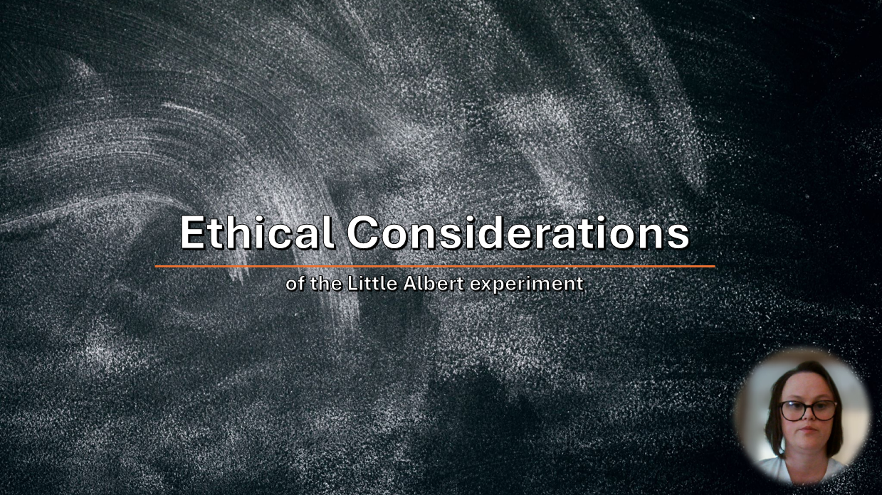
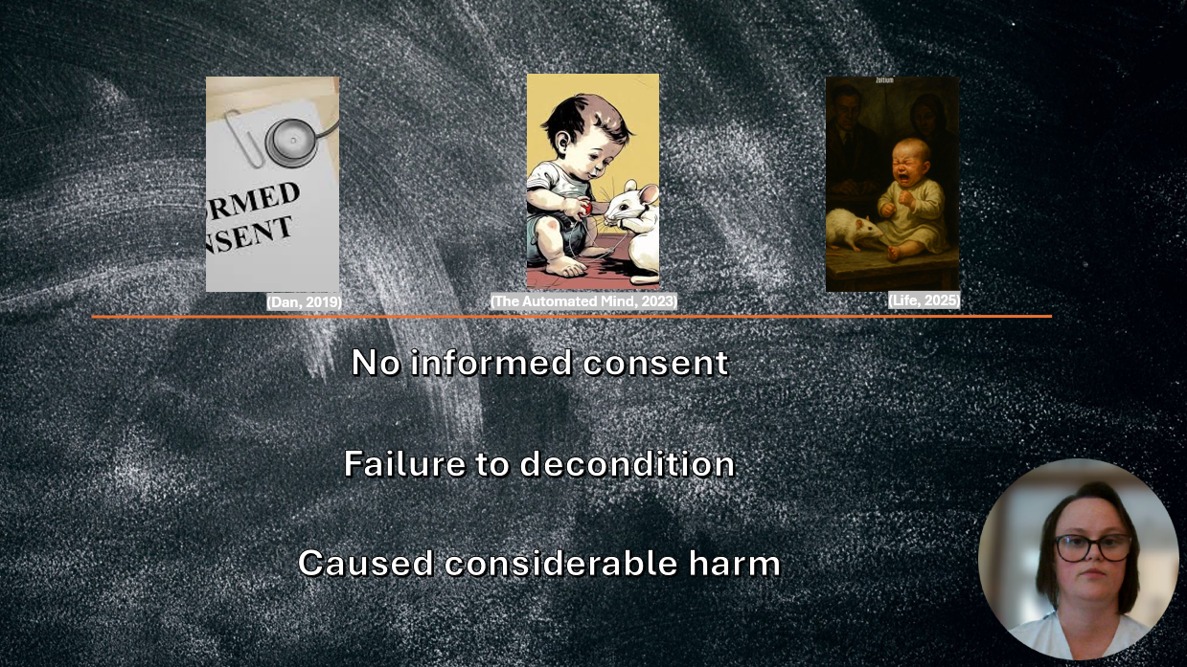
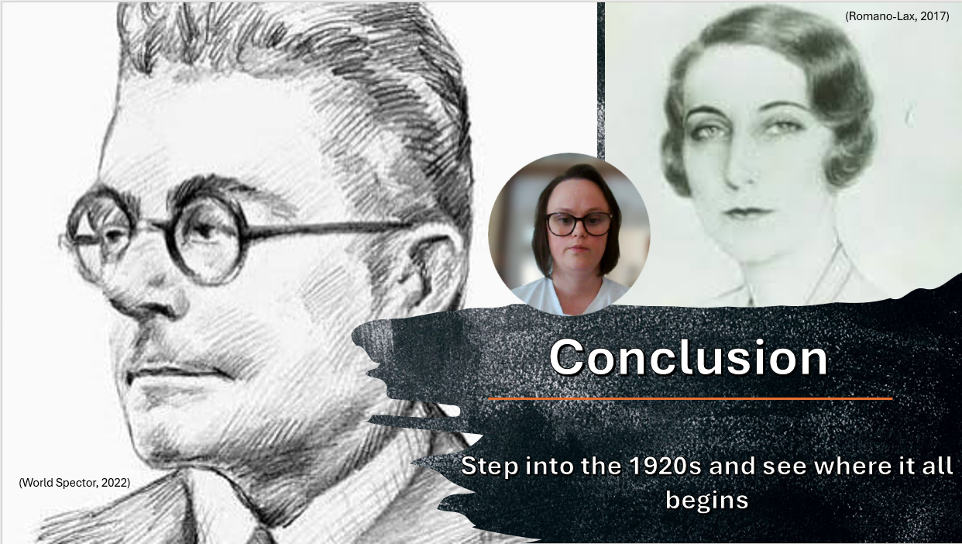
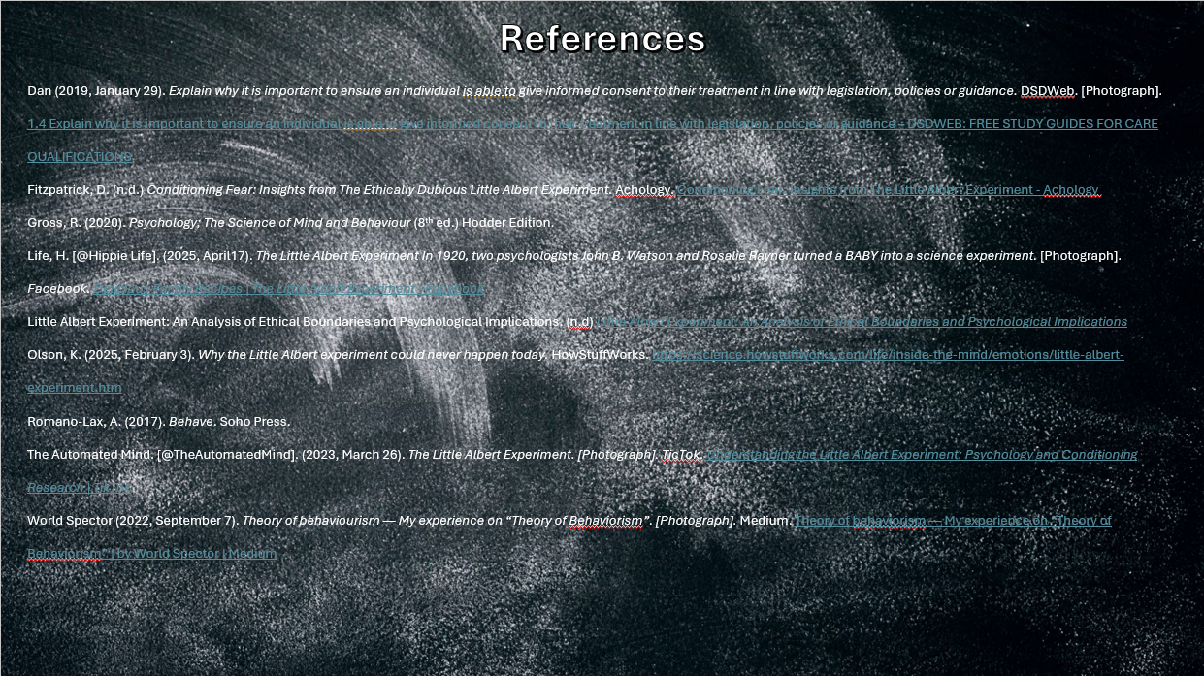

Reference List
Dan (2019, January 29). Explain why it is important to ensure an individual is able to give informed consent to their treatment in line with legislation, policies or guidance. DSDWeb. [Photograph]. 1.4 Explain why it is important to ensure an individual is able to give informed consent to their treatment in line with legislation, policies or guidance – DSDWEB: FREE STUDY GUIDES FOR CARE QUALIFICATIONS
Fitzpatrick, D. (n.d.) Conditioning Fear: Insights from The Ethically Dubious Little Albert Experiment. Achology. Conditioning Fear: Insights from The Little Albert Experiment - Achology
Gross, R. (2020). Psychology; The Science of Mind and Behaviour (8th ed.) Hodder Edition.
Life, H. [@Hippie Life]. (2025, April17). The Little Albert Experiment
In 1920, two psychologists John B. Watson and Rosalie Rayner turned a BABY into a science experiment. [Photograph]. Facebook. Delicious Family Recipes | The Little Albert Experiment | Facebook
Little Albert Experiment: An Analysis of Ethical Boundaries and Psychological Implications. (n.d) Little Albert Experiment: An Analysis of Ethical Boundaries and Psychological Implications
Olson, K. (2025, February 3). Why the Little Albert experiment could never happen today. HowStuffWorks. https://science.howstuffworks.com/life/inside-the-mind/emotions/little-albert-experiment.htm
Romano-Lax, A. (2017). Behave. Soho Press.
The Automated Mind. [@TheAutomatedMind]. (2023, March 26). The Little Albert Experiment. [Photograph]. TicTok. Understanding the Little Albert Experiment: Psychology and Conditioning Research | TikTok
World Spector (2022, September 7). Theory of behaviorism — My experience on “Theory of Behaviorism”. [Photograph]. Medium. Theory of behaviorism — My experience on “Theory of Behaviorism” | by World Spector | Medium

