Business intelligenge
and
its impact to the business
report
Milena Adzhemova
ID: 2129045
Lecturer: Xavier Matieni

Contents

Introduction: Business Intelligence and its importance for the business 2
BI trends, Tools and Applications are the future for the business 2
Business Intelligent Trends 3
Business Intelligent Tools 4
Business Intelligence Applications 4
How BI trends can help to make timely and effective decisions: 5
Data governance 5
Artificial Intelligence 5
Cloud Based BI 5
Self Service BI 5
Data Storytelling 6
Data storytelling includes 3 main elements - raw data, visual representations, and the overarching narrative. All of them work in coordination to represent a meaningful, impactful message to the audience. (Gülen, 2023) 6
Conclusion: 7
References: 8

Introduction: Business Intelligence and its importance for the business

Business offer product or service in according to someone needs or wishes. Business activities could be written on paper or using electronic media and these records became data. Analysing and mining this data with special tools and techniques can show how the business operate.
According to Maheshwari (2014) BI contains tools and systems for data collecting, analysis, and data visualisation to support in decision making in any industry. Data mining uses statistical and machine learning technics, such as artificial neural networks, regression, cluster analysis, decision trees and many other. Nevertheless, these tools have some limitations like lack of advanced analytics capabilities and static information.
The main drive of Business Intelligence approaches is that its gives knowledge for effective and timely decisions.

BI trends, Tools and Applications are the future for the business

The growing data nowadays make the BI specialist’s job very crucial. He has to be able to see a wider view with more dimensions and variables to consider from many angles. At the same time the solving problem has to be enough big and valuable, because to prepare the data for meaning and other analyses needs time, execute with the exploration of patterns, and to be deep enough to involve with the data. (Maheshwari, 2014)

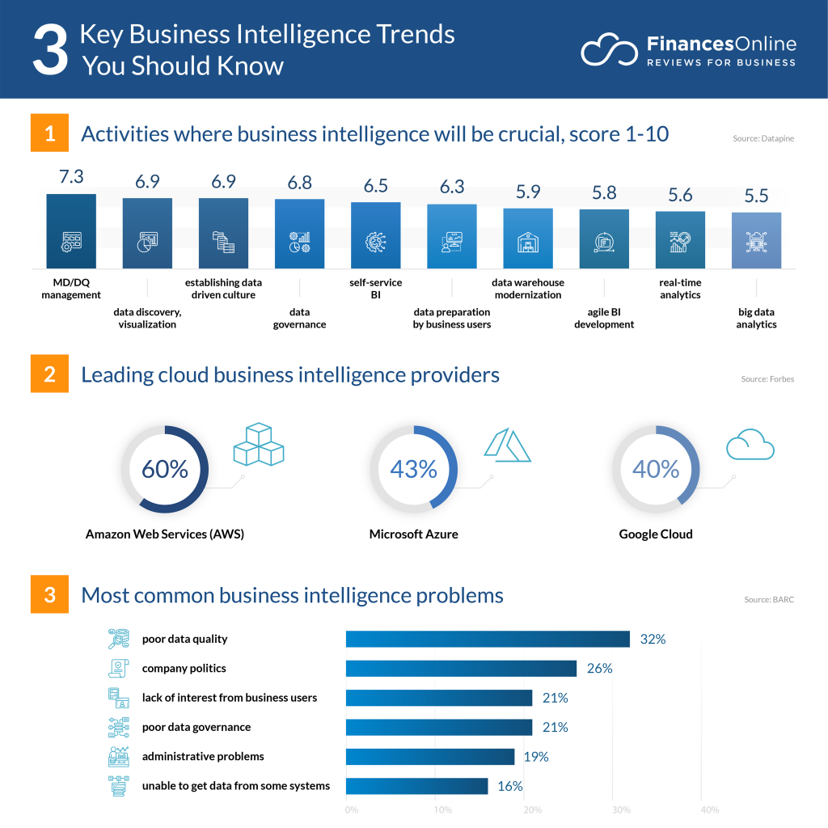s.financesonline.com

Business Intelligent Trends
BI trends are important for the business. Not so long time ago only big and wealth corporation could afford this kind of software. Now cloud computing delivered inexpensive data analysis tools that ushered small businesses into the BI revolution. Here will be mentioned a few of BI trends: Storytelling, Data governance, Voice activated assistance, Connected Clouds, Self-service BI, Artificial Intelligence, Data Security, Data Discovery, etc.

Business Intelligent Tools
BI tools are necessary in all commerce and utilities. A manager needs access to BI implements to have up to date metrics about business performance. The business has to be known inside with its operations to develop with more efficient practises.

Business Intelligence Applications
Maheshwari, (2014) says in his book that the business exists to serve the customer and if the customer is delighted, he will come back again. BI applications can affect many aspects of the market. In this report will stop only on two areas, which are nearest to our retail corporation - customer relationship management and retail.
Customer Relationship Management
- To maximise the return on marketing campaigns
- To develop customer retention. It is more difficult and expensive to gain new customers, instead to retain current customers.
- To maximise the value of the consumer.
- To recognize and pleased high value customers with loyalty programmes, with consideration and better service
- To manage brand image. Blogs and social media can give feedback with customers opinions and suggestions.
Retail
- To meet customers expectations with quality goods in cost-effective manner
In our retail online shop ‘With Love for You’, knowing the customer shopping patterns we could organize our inventory, products and layout. This can be done with club cards for our shop, where we can see their customers interests, favourites, habits and to offer to them more accurate to their need’s products. Example for this kind of cards are Tesco Club Card, Nectar card, Lidl Pass app. Amazon Prime is a different way to show customers attention. It is more about involving in Amazon Prime community with their Alexa, Prime Video, Music, Books, and fast and free delivery. We must use AI for orders and customer support.
The reasons BI trends, tools, and applications are going to be the future for businesses are that they provide based on data decision-making, improved customer experience, increased efficiency, cost savings and competitive advantages.

How BI trends can help to make timely and effective decisions:

Data governance
Data governance figures the sturdy basis upon which organization-wide data management happens. It enables companies to harness the power of technologies, processes, and people involved in the management of data assets to deliver complete, trustworthy, secure, and understandable data.

Artificial Intelligence
AI systems are machine learning models. They execute language-related tasks, which are built on developed patterns and knowledge. Artificial intelligence brings in text production, answering questions and generating images, code, and music. AI is a solution of automatic data analyses.
Benefits of AI are data-driven decision-making, better customer service, increase profit, predict future trends, ethical consideration, and governance. There are also limitations in AI using – limited understanding of context, Bias, lack of creativity and common sense, can be manipulated.
Reliance on LLMs could lead to laziness in the people lazy and they do not be interested to learn technical skills.
The BI future will have generative AI playing a key role, as the ease of use it offers.

Cloud Based BI
It is a procedure of transferring data into actionable insights in a cloud environment. Cloud Based Bi give information to the corporations for data based without costs for physical software.
Examples for Data BI are applications as Customer Relationship Management and Data Clauds as Google Cloud.

Self Service BI
According to BARS, 2021 self service is in the wish list for many companies from long time. This technology is a timely intervention, and it is top main concern for many businesses. (Anthony, 2023)
it empowers users to filter, sort, and analyse corporate data without necessarily having technical data analytic skills.
SSBI (self-service business intelligence) manage increasingly succeeding the traditional BI tools. The rise of self-service BI has spelled a waning significance of data scientists in the BI process. SSBI can bring more analytics than data scientists.

Data Storytelling
Data Storytelling is convincing way to communicate insights and results from data analysis.
It is art form that present quantitative information with tale context and in this way engage audiences in a exiting way. Data storytelling is not just numbers and charts; it involves a gorgeous blend of data analysis, domain knowledge, and effective communication.

Data storytelling includes 3 main elements - raw data, visual representations, and the overarching narrative. All of them work in coordination to represent a meaningful, impactful message to the audience. (Gülen, 2023)
Examples of data storytelling are Fry Universe, Animated sport result, We fill fine, and more.
Visme.co, (n.d.) explained that on https://youtu.be/4pymfPHQ6SA

Conclusion:

‘According to an IDC prediction, by 2024, organizations with efficient BI tools and technologies will be at a significant advantage, with five times more reaction time to capitalize on new opportunities.’(Kaur, 2023)
It is really sad, when the small, but even big and profitable companies lose their business, because they did not adapt to the new digital environment. The World is changed and only Apocalypses can stop the technology progress!
Nonetheless, it is necessary we to be aware of the limitation of BI trends, tools and applications and the Ethical requirements. Limited understanding, Bias, easy for manipulating system can cause serious problems in the company and to lead to leaks of money or clients. It is important with this big wave of innovation do not lose us as a human race.

References:

Anil Maheshwari (2014) Business Intelligence and Data Mining. New York: Business Expert Press. Available at: https://search-ebscohost-com.ezproxy.uwtsd.ac.uk/login.aspx?direct=true&db=nlebk&AN=935070&site=ehost-live (Accessed: 1 December 2023).
Ian H. Witten, Eibe Frank and Mark A. Hall (2011) Data Mining : Practical Machine Learning Tools and Techniques. Burlington, MA: Morgan Kaufmann (The Morgan Kaufmann Series in Data Management Systems). Available at: https://search-ebscohost-com.ezproxy.uwtsd.ac.uk/login.aspx?direct=true&db=nlebk&AN=351343&site=ehost-live (Accessed: 1 December 2023).
The Future of Business Intelligence (BI) in 2024, Available at: Future of Business Intelligence (BI) for 2023 (selecthub.com) (Accessed: 1 December 2023).
11 Business Intelligence Trends for 2023: Latest Predictions You Should Be Thinking About Available at: https://s.financesonline.com/uploads/2019/12/business-intelligence-trends-1024x1024.png (Accessed: 1 December 2023).
Visme.co (n.d.)Five Data Storytelling Tips to Improve Your Charts and Graphs, Available at: Five Data Storytelling Tips to Improve Your Charts and Graphs - YouTube (Accessed: 2 December 2023).
Gülen (2023), Available at: Kerem Gülen - Dataconomy (Accessed: 2 December 2023).

