

University of Wales Trinity Saint David
School of Engineering

Combined Advanced Vehicle Dynamics
AWD Torque Vectoring (ACHA6003)

Taylor Winter
Automotive Engineering
1901843

02/03/2022

Table of Contents
Figures ii
1 Introduction iii
2 Torque Vectoring Systems iv
2.1 Torque Vectoring Using a Differential iv
2.2 Torque Vectoring Using Brakes iv
2.3 Limited Slip Differential iv
3 Base Vehicle Specification v
4 Models and Calculations vi
4.1 Lump mass model vi
4.2 Longitudinal Centre of Gravity Position vi
4.3 Moment of Inertia vii
4.4 Position of Inertial Conjugate vii
4.5 Dynamic Index vii
4.6 Mechanical Torque Path to Front Wheels viii
4.7 Potential Yaw Rate Increase viii
4.8 Clutch Pack Torque Capacity ix
4.9 Potential Longitudinal Acceleration Improvements ix
5 Discussion xi
5.1 AWD Systems xii
6 Summary xii
7 Bibliography xiv
7.1 Figures xv
7.2 Equations xv

Figures
Figure 1: Ferrari FF. iii
Figure 2: Ferrari FF AWD System. v
Figure 3: Driveline Layout Comparison. v
Figure 4: Lump Mass Model. vi
Figure 5: Mechanical Torque Path. viii
Figure 6: Dynamic Index Comparison. xiii

Equation 1: Centre of Gravity from the Front. vi
Equation 2: Centre of Gravity from Rear. vi
Equation 3: Engine Position. vi
Equation 4: Moment of Inertia. vii
Equation 5: Distance from the Centre of Gravity to the Inertial Conjugate vii
Equation 6: Inertial Conjugate. vii
Equation 7: Dynamic Index. vii
Equation 8: Circumference. viii
Equation 9: Time. viii
Equation 10: Yaw Rate. viii
Equation 11: Axial Force. ix
Equation 12: Clutch Torque Capacity. ix
Equation 13: Transmitted Torque. ix
Equation 14: Pressure. ix
Equation 15:Uniform Pressure Torque. ix
Equation 16: Uniform Wear Torque. ix
Equation 17: Turning Moment. ix
Equation 18: Drive Force Rear. x
Equation 19: Drive Force Front. x
Equation 20: Potential Acceleration Increase. x
Equation 21: Force on a Slope. x
Equation 22: Acceleration. x

1 Introduction

The Ferrari FF is the first four-wheel drive Ferrari. This vehicle is being analysed due to the all-wheel drive systems, enabling, and understanding of the effects on vehicle dynamics and potential control strategies from the torque vectoring system. With the addition of a front-wheel-drive transmission that can handle 20% of the engines total torque output, there are no sacrifices to the speed of the vehicle due to no additional weight, as it is 50% lighter than a traditional four-wheel drive. It is also fitted with two gear boxes, meaning there is a totally separate gearbox connected to the V-12 engine. The front gearbox is a two-speed, and the rear is a seven-speed.
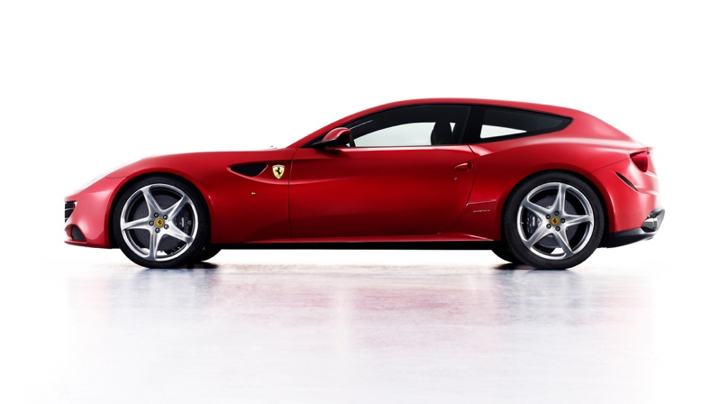
Figure 1: Ferrari FF.
With 53% of the weight over the rear, the FF retains a sporty layout. Although the layout is unusual, the “front first is geared six percent longer than rear second, and front second is geared six percent longer than rear fourth (reverse is geared the same). So, the front transmission’s first gear covers the rear’s first and second, and its second gear covers the rear’s third and fourth.” (Austin, 2011). However, this system doesn’t work past fourth gear.

“To Ferrari, rear-wheel drive is always the most desired configuration except in extreme cases where the car is struggling for traction. Conventional permanent 4-wheel-drive systems are just a waste of mass and energy for most of the time. Ferrari designed its 4RM to be a part-time 4WD system. In other words, in normal running conditions the FF is purely rear-wheel drive. Only when it struggles for traction the front wheels will be engaged quickly for very short moments to sort things out.” (Autozine, 2011). This is due to the torque vectoring system that has been implemented.

There are many other systems fitted such as a power transfer unit (PTU), which transmits torque from the rear axle, taking power directly from the crankshaft. As well as an integrated hydraulic control system. Two separate multi-plate clutches, that can be seen in the next section as figure two. The clutches work completely separately, controlling the front wheels independently.

2 Torque Vectoring Systems

A torque Vectoring system is a system used to improve steering response and handling
by improving grip for a vehicle in wet or slippery conditions, or when driving at a considerable speed. “In simple terms, torque vectoring is a computer-controlled system that controls how much power your car’s engine or motors send to each individual wheel.” (Hirons, 2022). This means that a vehicle with a torque vectoring system will have better overall control due to the improved grip, therefore, the vehicle can accelerate quicker as well as being safe. This also means that when power is redistributed to the slower wheel, the vehicle is able to corner much easier, therefore increasing the yaw rate.

Torque vectoring systems may vary in the way that they work, but overall, they will have the same outcome. The different methods include:
- Torque vectoring using a differential
- Torque vectoring using brakes

Although there are many positives to this, there are a few negatives. For most drivers, they will not benefit from this expensive system as it will not be used for a ‘normal’ drive. “Unless you drive down muddy country roads or you drive a car enthusiastically, you won’t really feel the benefit of torque vectoring. As a result, it’s not worth buying a car just for the technology unless you plan to make use of it.” (Hirons, 2022).

2.1 Torque Vectoring Using a Differential

Different types of differentials can be used for different effects; however, they all work in a similar way. Using a differential allows the power and torque from the engine to be redistributed between the wheels, however the torque in each driveshaft is the same and torque can’t be supplied. “Typical differential-based torque vectoring systems combine an open differential with a pack of multi-plate clutches on either side, together with sensors measuring the wheel speed, pitch, and the yaw of the car.” (Shah, 2020). This can be done with either a normal open differential or an open differential with viscous coupling.

2.2 Torque Vectoring Using Brakes

Torque vectoring using brakes is normally used when using a differential is too expensive for the vehicle or for when there is not enough space. For example, the Volkswagen GTI. Using the brakes works by stopping the wheels from spinning from the brakes themselves. “This allows more power to be sent to the wheels that still have grip, improving a car’s ability to accelerate on slippery roads or accelerate out of tight corners.” (Hirons, 2022).

2.3 Limited Slip Differential

Although using a limited slip differential (LSD) is similar to an open slip differential, it works in a slightly different way. This is the system used in the FF. The most common types of LSDs used are usually Eaton locker, G rotor pump and Hydratrack. An LSD is another way to improve steering by altering the contact patch via torque redistribution. Limited slip differentials can work across axle (front or rear) or interaxle (between the front and rear). They’re also speed dependent therefor; force is proportional to changes in rotational speed, as well as drive torque dependent.

“An LSD is primarily a mechanical, reactive system that works in specific circumstances to limit the slip being experienced by a particular wheel, such as when accelerating or braking through a sharp corner.” (Shah, 2020). To increase torque at the contact patch, the slip must be increased; therefore, increasing speed and force as a result. The difference from open slip is that engine power cannot be redistributed, therefore, the slower wheel will not receive more power so the yaw rate will not be increased. Figure one below shows the torque vectoring system used on the Ferrari FF.

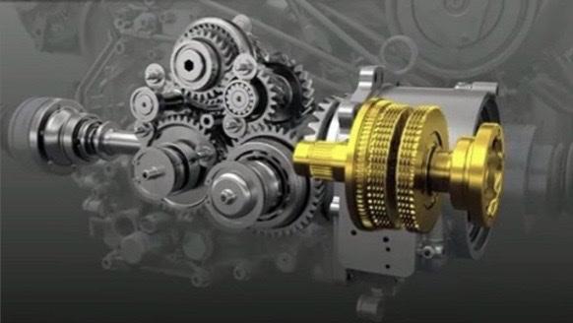
Figure 2: Ferrari FF AWD System.

3 Base Vehicle Specification

The mass distribution of the FF is perfect for a vehicle of its type, “the company's patented four-wheel-drive system, called 4RM. The Italian automaker claims it is 50 percent lighter than a conventional 4WD system, allowing the FF to have a near perfect weight distribution (53 percent over the rear axle).” (Raynal, 2011).

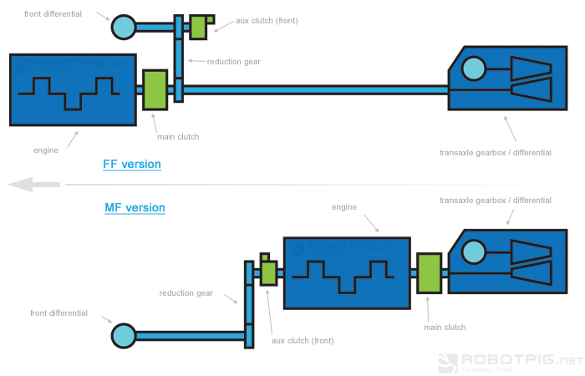
Figure 3: Driveline Layout Comparison.
Figure three above shows the driveline layout of the Ferrari FF compared to a mid-engine vehicle. This set up is used to incorporate the four-wheel-drive system, including the second gearbox in a way that the vehicle can still have a decent mass distribution when compared to other sporty cars of a similar style.

4 Models and Calculations

4.1 Lump mass model

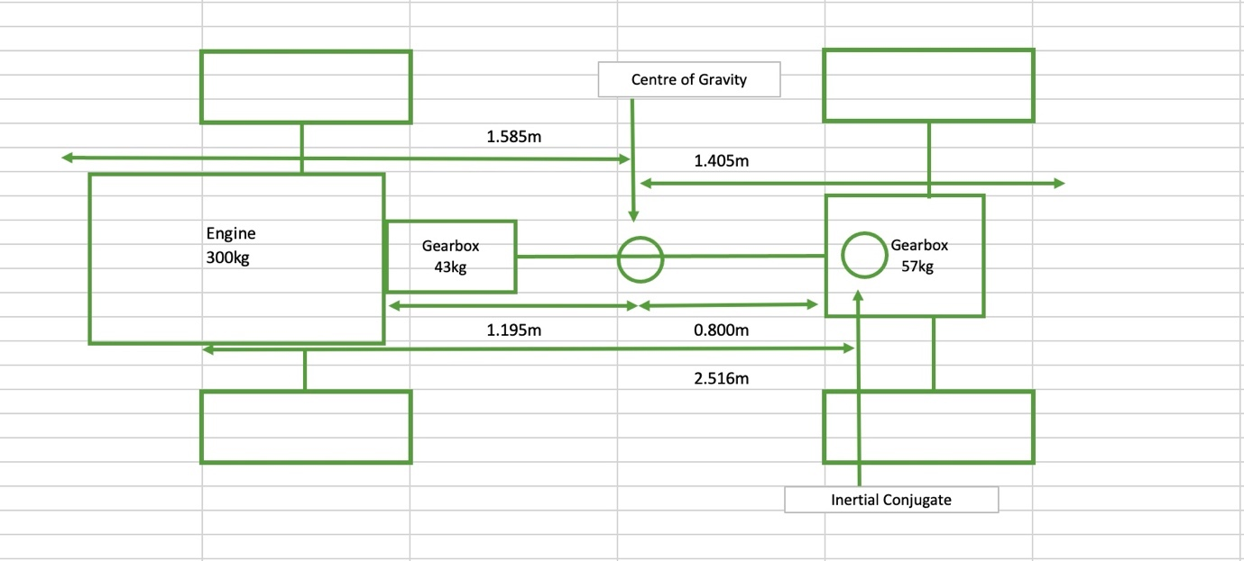
Figure 4: Lump Mass Model.
Figure three above shows the lump mass model of the FF, showing all of the masses and distances from centre of gravity, including the location of inertial conjugate. All massed on the lump mass model should add up to the kerb mass:
$$Masses=Engine+Gearbox+Gearbox2+Chassis$$
$$Masses=300+43+57+1480$$
$$Masses=Kerb Mass=1880kg$$

4.2 Longitudinal Centre of Gravity Position

The centre of gravity from both front and rear is calculated using equation one and two below:
$$CofG from Front=Wheel base×Weight Distribution Rear$$
Equation 1: Centre of Gravity from the Front.
$$CofG from Front=1.585m$$

$$CofG from Rear=Wheel base ×Weight Distibution Front$$
Equation 2: Centre of Gravity from Rear.
$$CofG from Rear=1.405m$$

$$Engine Position=\frac{(m1×r1)+(m3×r3)+(m4×r4)+(m5×r5)}{m1+m2+m3+m4+m5}$$
Equation 3: Engine Position.
$$Engine Position=1.195m$$

4.3 Moment of Inertia

Moment of inertia can be calculated using equation four below, where m1 is the mass of the front chassis, m2 is the mass of the engine and the gearbox, m3 is the mass of the rear gearbox and m4 is the mass of the rear chassis. R1 and r2 is the distance from the front chassis to the centre of gravity and the distance from the front chassis and gearbox to the centre of gravity respectively. D3 and d4 are the distances from the front wheel.

$$I_{zz}=\left(m1×{r1}^{2}\right)+\left(m2×{r2}^{2}\right)+{\left(m3×(1-r1+d3\right)}^{2}+{\left(m4×(1-r1+d4\right)}^{2}$$
Equation 4: Moment of Inertia.
$$I_{zz}=2773.218/m^{2}$$

4.4 Position of Inertial Conjugate

For the position of inertial conjugate first the distance from the centre of gravity to the inertial conjugate need to be calculated via:
$$K=√\frac{I_{zz}}{m}$$
Equation 5: Distance from the Centre of Gravity to the Inertial Conjugate
$$K=1.215$$

From this the inertial conjugation can be calculated where a is the distance from the front of the car to the centre of gravity (1.585m).

$$C=\frac{K^{2}}{a}$$
Equation 6: Inertial Conjugate.
$$C=0.931m$$

So, the point of inertial conjugate is 0.924m after the centre of gravity, this can be seen in the lump mass model in figure four in the previous section.

4.5 Dynamic Index

From the inertia the dynamic index is calculated via:

$$DI=\frac{Inertia }{Mass × CofG Rear × CofG Front }$$
Equation 7: Dynamic Index.
$$DI=0.662$$

As DI is below one this means that the distance between the centre of gravity and the point of inertial conjugate (0.931m) is smaller than the distance between the centre of gravity and the rear of the car (1.405m). Therefore, the point of inertial conjugate is inside of the car, this can be seen below in figure five. The effect of this is that the rear of the car will more outwards, therefore inertial effects will add to the rear tyre slip angle. A low dynamic index also indicates that the feel of the car will be pretty light.

4.6 Mechanical Torque Path to Front Wheels
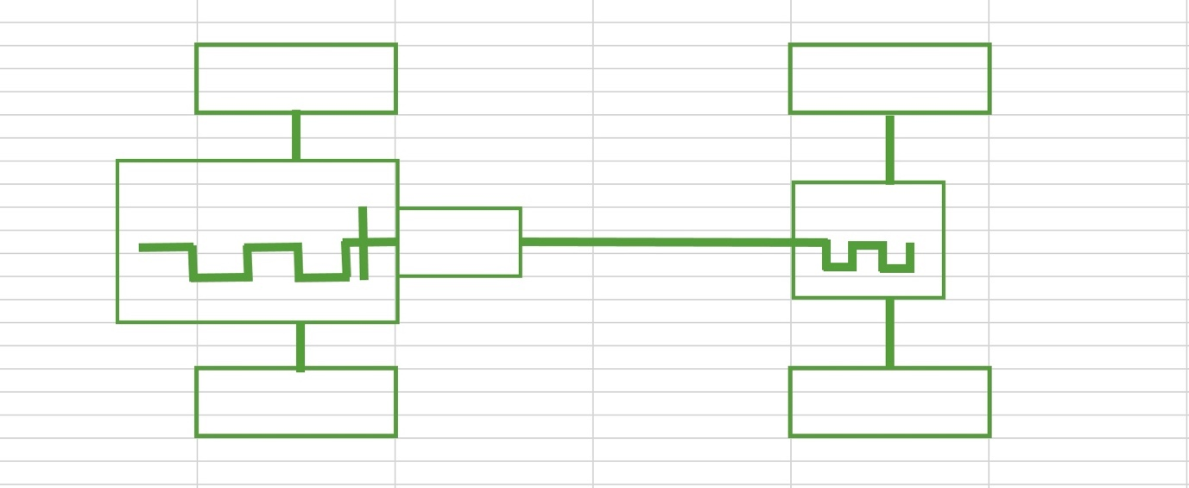
Figure 5: Mechanical Torque Path.
Figure five above shows the mechanical torque path, with the thick green lines showing the path that the torque would take to the front wheels (from right to left). Mechanical torque is the torque that is transferred through the mechanical components, such as the gearbox, travelling through the drive shaft to the wheels.

4.7 Potential Yaw Rate Increase

To calculate yaw rate the circumference of a corner needs to be found:
$$C=πD$$
Equation 8: Circumference.
$$C=62.832m$$

Then the time can be found using the acceleration already found:
$$t=\frac{c}{a}$$
Equation 9: Time.
$$t=7.016s$$

Therefore, the yaw rate can be calculated using:
$$yaw rate=\frac{360°}{t}$$
Equation 10: Yaw Rate.
$$yaw rate = 51.314 degree/sec$$

The potential yaw rate increase is:
$$yaw rate increase = 83.267 degree/sec$$

The original yaw rate would have a better effect of vehicle handling. A lower yaw rate means that a vehicle is less likely to understeer or oversteer, therefore yaw rate sensors are uses to combat the effects of increased yaw rate.

4.8 Clutch Pack Torque Capacity

Equation six below shows how the axial force is calculated which can then be used to calculate the clutch torque capacity.

$$W=\frac{T_{max}×2}{2n×μ×(r_{2}+r_{1})}$$
Equation 11: Axial Force.
$$W=609.821N$$

$$T_{c}=(2×\frac{2}{3}×μ×W×(\frac{{r_{2}}^{3}-{r_{1}}^{3}}{{r_{2}}^{2}-{r_{1}}^{2}}))×4$$
Equation 12: Clutch Torque Capacity.
$$T_{c}=362.408Nm$$

$$T_{t}=2π×μ×\int_{r_{1}}^{r_{2}}{p×{{(r}_{2}-r_{1})}^{2}}$$
Equation 13: Transmitted Torque.
$$T_{t}=31.362Nm$$

The transmitted torque is the torque lost. Where:
$$P=\frac{W}{π×({r_{2}}^{2}-{r_{1}}^{2})}$$
Equation 14: Pressure.
$$P=23108.594Pa$$

$$T=\frac{2}{3}×μ×W×\frac{{r_{2}}^{3}-{r_{1}}^{3}}{{r_{2}}^{2}-{r_{1}}^{2}}$$
Equation 15:Uniform Pressure Torque.
$$T=45.301NM$$

The uniform pressure torque is the torque calculated with the assumption that the pressure is constant.

$$T=\frac{μ×W×(r_{2}+r_{1}}{2}$$
Equation 16: Uniform Wear Torque.
$$T=42.688Nm$$

The uniform wear torque is the torque calculated with the assumption that the wear is constant.

4.9 Potential Longitudinal Acceleration Improvements

$$M_{t}=T_{max}×front ratio$$
Equation 17: Turning Moment.
$$M_{t}=321.010Nm$$

$$F=\frac{80\%T_{engine}×(r_{gear}×r_{final})×W_{distribution}}{r_{tyre}}$$
Equation 18: Drive Force Rear.
$$F=\frac{20\%T_{engine}×(r_{gear}×r_{final})×W_{distribution}}{r_{tyre}}$$
Equation 19: Drive Force Front.
Using 3.4 as the first gear ratio and 4.38 as the final drive axle ratio. (CarandDriver, 2020).Therefore, the maximum drive force experienced by the rear gearbox is:
$$F=8489.378N$$

$$a=\frac{F}{m}$$
Equation 20: Potential Acceleration Increase.
And the potential acceleration increase at the rear gearbox is:
$$a=4.516m/s^{2}$$

For the front gearbox the maximum drive force is:
$$F=1995.004N$$

And therefore, the potential acceleration increase at the front is:
$$a=1.061m/s^{2}$$

For the total potential longitudinal acceleration improvement, the front and rear are added together. Resulting in the improvement of:
$$a=5.577m/s^{2}$$
When calculating the effects of different surfaces $μ$ determines the surface. Using the equation:

$$F=μ×m×g×sin(θ)$$
Equation 21: Force on a Slope.
For the purpose of this equation the angle that has been used is 20. Using:
$$F=ma$$
Equation 22: Acceleration.
The acceleration can be found. When accelerating on ice ($μ=0.1$) the acceleration is 0.896m/s², on snow ($μ=0.4)$ the acceleration is 3.583m/s² and for standard tarmac ($μ=1$) the acceleration is 8.956m/s². This shows that the less traction is available due to the surface of the road, the less force is exerted by the car, therefore the lower the acceleration will be.

5 Discussion

For vehicle dynamic improvement there are two main points to consider:
- Control algorithms
- Sensors

Both of these will have a significant effect on how a vehicle handles, regarding straight line, cornering and on-limit lane change manoeuvres.

Control algorithms is the term used for different drive setting; the most common types are:
- Sports mode
- Eco mode
- Comfort mode
- Snow mode

For example, “In sports mode, the throttle will become more responsive, meaning the car accelerates more readily. In addition, more fuel is introduced into the engine to increase the available power, the steering gets heavier, and the suspension will stiffen.” (Simm, 2019).

For eco mode, the car is affectively slowed down to reduce fuel use. “Eco mode is designed to reduce fuel consumption and improve the car’s efficiency. To achieve this, the amount of fuel allowed into the engine is often reduced, and some of the engine cylinders may be shut down. The throttle response often reduces to help the driver use less fuel and improve mileage capabilities, but this can make the car feel slower.” (Simm, 2019).

The different control algorithms may also affect the likelihood of over or understeer. As understeer is more likely on front wheel drive and oversteer is therefore more likely on rear wheel drive.

Yaw rate is also something that can greatly affect the vehicle dynamics overall. Therefore, yaw rate sensors are used. “A Yaw Rate Sensor (or rotational speed sensor) measures a vehicle’s angular velocity about its vertical axis in degrees or radians per second in order to determine the orientation of the vehicle as it hard-corners or threatens to roll-over. The yaw rate sensor is a key component in a vehicle’s stability control or electronic stability control system designed to provide motorists with increased safety, security, and control even in the most difficult driving conditions.” (Standardbrand, 2020). Yaw rate sensors are used to compare the yaw rate felt by a vehicle to the expected yaw rate. By comparing these the sensor can identify if the vehicle will be under-steering or over-steering, and therefore identify an action to correct this. The corrections that may occur are reducing acceleration or applying the brakes. It also “helps the ESP control unit to determine the current driving-dynamic state of the car. For this purpose, it must be placed close to the vehicle's centre of gravity.” (Seat, 2020).

Electronic stability programme (ESP) is another commonly used safety system. “Electronic Stability Programme (ESP) is a computerized safety technology present in all modern cars. It is designed to improve a vehicle’s stability by detecting and reducing loss of traction, thus preventing the tyres from skidding uncontrollably. When the stability control programme detects a loss of steering control, it automatically applies individual brakes to help ‘steer’ the vehicle where the driver intended it to go.” (Totalcarcontrol, 2020). ESPs are very important in vehicles as they are known to reduce fatal accidents by 25%. (Totalcarcontrol, 2020). When understeer is encountered, the intended vehicle track is compared with the actual track by the steering wheel angle, and the acceleration will stop. The brakes will then be applied to the opposite side at the rear to bring the vehicle back to the intended track. For example, if a vehicle is travelling around a left turn and begins to veer to the right, the left rear brake will be applied to turn the vehicle back to the left turn. For oversteer, again the steering wheel angle are compared, acceleration is stopped but this time the front opposite brake will be applied.

Anti-lock braking systems (ABS) is used in all modern cars as one of the ways to keep drivers and pedestrians safe. “The anti-lock braking system is designed to stop your car from skidding when you brake sharply. If a car is travelling at speed when the driver brakes hard, the wheels could lock. This can cause the car to lose traction and the driver to lose control of the steering. ABS makes this less likely to happen.” (AA, 2020). ABS is more affective depending on the surface of the road, such as dry, solid road surfaces like tarmac.

5.1 AWD Systems

AWD systems interact with ESP and ABS different to a rear-wheel drive or a front-wheel drive would. “The FF also had ABS/EBD, the anti-lock braking system which intervenes individually on all four wheels. The ESC also intervenes during braking on all four wheels independently. The E-diff, on the other hand, distributes torque to both the rear wheels while the race-derived F1 Trac traction control system manages the torque to the rear axle.” (Ferrari, 2011). ESP for AWD is very helpful however, when travelling at low speeds this is often disabled by people off-roading.

6 Summary

To summarise, the Ferrari FF is not a great performance car, and the all-wheel drive system is a strange choice, causing more limitations than enhancements. The two-gearbox system is a great idea, however the fact that it doesn’t work past fourth gear is less than ideal for a vehicle of this spec, often with fast drives in mind. With an improved acceleration of 5.577m/s² there are some advantages, although the increase in yaw rate from 51.314 degree/sec to 83.267 degree/sec is slightly off putting, leading to a much higher chance of the ESP kicking in.

The feel of the car is also something that may not be expected when compared to other performance cars. Having a light feel compared to most with a dynamic index of 0.662, compared to those in figure six below. The dynamic index of the vehicles seen below is much higher than that of the FF meaning it will have a much lighter feel to those cars competing on the market.

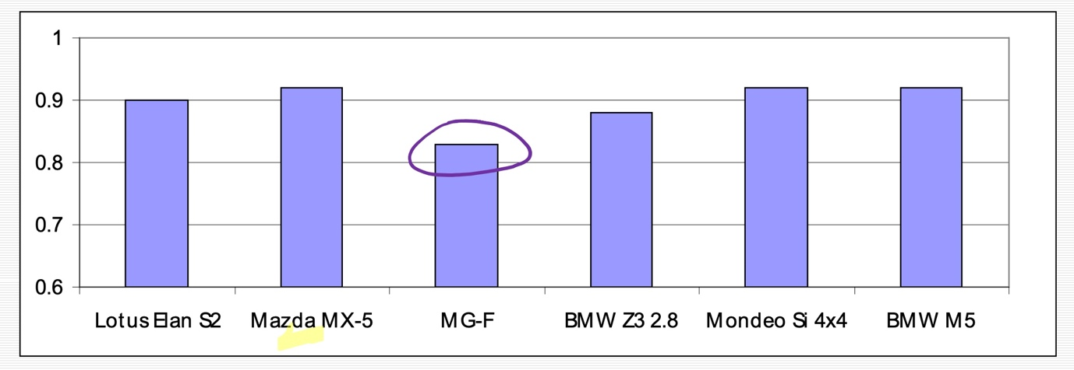
Figure 6: Dynamic Index Comparison.
So, in conclusion the FF was not what it was expected to be.

7 Bibliography
AA, 2020. The AA. [Online]
Available at: https://www.theaa.com/driving-advice/service-repair/anti-lock-brakes
[Accessed 19 March 2022].

Austin, M., 2011. Car and Driver. [Online]
Available at: https://www.caranddriver.com/news/a18736603/funky-four-explaining-the-ferrari-ffs-two-gearbox-four-wheel-drive-system/
[Accessed 3 March 2022].

Autozine, 2011. Autozine. [Online]
Available at: https://www.autozine.org/Archive/Ferrari/old/FF.html
[Accessed 16 March 2022].

CarandDriver, 2020. Car and Driver. [Online]
Available at: https://www.caranddriver.com/ferrari/ff/specs
[Accessed 16 March 2022].

Ferrari, 2011. Ferrari. [Online]
Available at: N/A
[Accessed 19 March 2022].

Hirons, R., 2022. carwow. [Online]
Available at: https://www.carwow.co.uk/guides/glossary/what-is-torque-vectoring#gref
[Accessed 1 March 2022].

Raynal, W., 2011. Autoweek. [Online]
Available at: https://www.autoweek.com/news/a1987126/ferrari-ff-technology-focused-performance-less-weight/
[Accessed 12 March 2022].

Seat, 2020. Seat. [Online]
Available at: https://www.seat.com/car-terms/y/yaw-rate-sensor.html
[Accessed 19 March 2022].

Shah, V., 2020. CarExpert. [Online]
Available at: https://www.carexpert.com.au/car-news/torque-vectoring-explained
[Accessed 1 March 2022].

Shen, D. & Chen, S., 2012. Science Direct. [Online]
Available at: https://www.sciencedirect.com/topics/computer-science/control-algorithm
[Accessed 19 March 2022].

Simm, L., 2019. Stone Acre. [Online]
Available at: https://www.stoneacre.co.uk/blog/drive-modes
[Accessed 19 March 2022].

Standardbrand, 2020. Standardbrand. [Online]
Available at: https://www.standardbrand.com/en/products/sensors/sensors/yaw-rate-sensors
[Accessed 19 March 2022].
Totalcarcontrol, 2020. Total Car Control. [Online]
Available at: https://www.total-car-control.co.uk/car-tips/esp-explained/
[Accessed 19 March 2022].

x-engineer, 2022. x-engineer. [Online]
Available at: https://x-engineer.org/calculate-clutch-torque/
[Accessed 18 March 2022].

7.1 Figures

Figure 1: Ferrari FF. Available at:
https://www.motorauthority.com/news/1054126_ferrari-ff-hit-or-miss

Figure 2: Ferrari FF AWD System. Available at:
https://www.dailymotion.com/video/xhgyuc

Figure 3: Driveline Layout Comparison. Available at:
https://robotpig.net/__automotive/ferrari_ff.php?page=4

Figure 4: Lump Mass Model.

Figure 5: Mechanical Torque Path.

Figure 6: Dynamic Index Comparison. Mark Sandford, 2022. Available on lecture 3, slide 8.

7.2 Equations

Equation 1: Centre of Gravity from Front.

Equation 2: Centre of Gravity from Front.

Equation 3: Engine Position.

Equation 4: Moment of Inertia.

Equation 5: Distance from Centre of Gravity to Inertial Conjugate.

Equation 6: Inertial Conjugate.

Equation 7: Dynamic Index.

Equation 8: Circumference.

Equation 9: Time.

Equation 10: Yaw Rate.

Equation 11: Axial Force.

Equation 12: Clutch Torque Capacity.

Equation 13: Transmitted Torque.

Equation 14: Pressure.

Equation 15: Uniform Pressure Torque.

Equation 16: Uniform Wear Torque.

Equation 17: Turning Moment.

Equation 18: Drive Force Rear.

Equation 19: Drive Force Front.

Equation 20: Potential Acceleration Increase.

Equation 21: Force on a Slop.

Equation 22: Acceleration.

