Negative Externalities of Alcohol consumption

Sally Hocking

2103459

BMSP

Negative Externalities of Alcohol Consumption

For this report I will be researching the damaging impacts of the alcohol industry on wider third parties as negative externalities. This includes effects on demand for public services, the impact on the economy, and public health implications. Negative externalities include added costs and pressure to the NHS, strain on police and other public services, and damage to public property such as vandalism and littering of cans/ broken glass.

Negative externalities are defined by Oxford Learner's Dictionary (accessed 2024) as “a consequence of an industrial or commercial activity that affects other people or things without this being reflected in market prices''. When looking into the alcohol industry within the UK specifically, negative externalities include excess cost to the NHS from drink related injuries, directly or indirectly, costs of public services such as police, ambulance, fire brigade and services by the council. These come as a result of people acting dangerously when under the influence of alcohol, being more likely to become violent or lack spatial awareness, causing injury to themselves and or others and damage to their surrounding environment.

Before The 1920s drinking was attributed to crime, corruption and many of the social issues of the time in America. From 1920-1933 there was an 18th Amendment to the U.S. Constitution which led to a complete and absolute ban on the manufacture, transportation and sale of intoxicating liquors, when with the passage of the Volstead Act went into effect. (Onion, 2023). The public response was to make their own and this developed into a black market trade involving the Mafia. The sudden surge in unregulated alcohol production (a.k.a. bootlegging), gang activity and organized crime resulted in the 1933 abolition of the prohibition. (Onion, 2023)

While the UK has never had its own alcohol prohibition, the UK public responded to the American Prohibition with a campaign “rob you of your beer” to fight back on any UK alcohol restrictions. Leaflets were printed and posted from 1922-1926 with anti-american themes - labeling them as “aliens coming over to interfere with British liberties” (“Rob You of Your Beer”: The British Fight Against Prohibition, n.d.) there were fears that there would be increased taxes, unemployment due to less sales and concerns that alcohol may be criminalized.

A temperance movement was attempted in the UK in the 1930s by temperance societies who began a public campaign against alcohol. Alcohol was believed by these people to be the cause of society's misery, leading to “ poverty, child neglect, immorality and economic decline.” They wanted to change the culture around drinking to have a more sober, if not completely sober society, for the betterment of the communities. Drinking chocolate was promoted as an alternative to drinking alcohol “this is one of the reasons why so many of the great chocolate barons were Quakers, such as Cadbury, and Fry, besides Rowntree.” (Temperance Movement - the Rowntree Society, 2017).

In Spite of all these movements, in the 21st century Alcohol remains very much a key part of Britain's social scenes. Alcohol is in almost all social celebrations or events, and is seen as a way to relax and unwind after a hard day's work. Even when there have been economic uncertainties and buyers are more conscious of spending, alcohol is not a product that loses sales, in some instances, sales even increase due to society's stress leading to more drinking.

Drink Driving

Drink driving is a major concern and broadens the reach of negative externalities to the wider public. Between 2010 - 2020 there was an annual average of 41,737 convictions for drunk driving. From 1979 - 2020 there was an annual average of 546 reported deaths in the uk from drunk driving incidents (Gov.uk, July 2023). In the year 2020, of the 28,171 drunk driving convictions, 81.2% of convicted drivers were male (Salmon, 2024). The numbers are alarmingly high, especially when these numbers are after the public is well informed about the great costs of drunk driving, legally and psychologically. Many drivers' perception of their drunken state is dangerously inaccurate while making a decision on how to get home after a night of drinking.

In 1987, Due to the high numbers of drunk driving incidents and damage to society and communities, a new law called ‘The Landmark Road Safety Act’ was introduced in the UK. From this point onwards it has been illegal to drive or attempt to drive with a blood alcohol level of “over 80mg of alcohol per 100ml of blood” (Department for transport, 2017) In Scotland this limit has further reduced from December 2014 to 50mg of alcohol per 100 milliliters of blood, much like many other European countries (Alcohol Focus Scotland, n.d). The sentence for being convicted of driving or attempting to drive while above the legal limit is a 1 year driving ban,unlimited fine and 6 months in prison. There is a 3 year driving ban if you are convicted twice in 10 years (Gov.UK)

Alcohol Unit Guidelines

The likelihood of anyone who is actively drunk knowing their blood alcohol levels is very low so the UK government has issued warning labels on all alcohol cans and bottles to highlight the unit content of alcohol and advise on how many units are safe to consume (shown below). UK Government and NHS guidelines suggest adults consume no more than 14 units per week. This is not to suggest that 14 units in one day once a week is in any way safe or advisable. Research shows alcohol has a stronger effect on women and can increase fertility issues in both men and women when used in excess (Van Heertum & Rossi, 2017). If planning to drive, no more than 3 units for men and no more than 2 for women (Drink-drive Limits: Everything You Need to Know | RAC Drive, 2023)

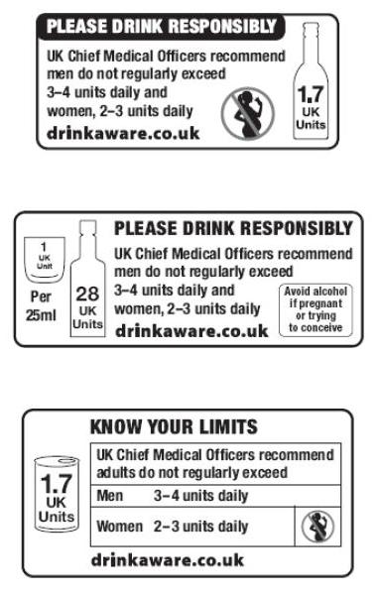
(Image 1. Brooks, J, 2015)

It is estimated that alcohol costs the NHS £3.5 billion per year in England and costs an estimated £21 billion per year to society. (Alcohol Treatment Services - Committees - UK Parliament, n.d.) These new labeling currently remain as only guidelines in the UK, however you are unlikely to find alcohol for sale without the labeling, and it has been credited for the reduction in drinking in younger generations since its introduction. It seems people are making more informed decisions when the risks are clearly stated on the bottle, and as a result, take more precaution. (Wen, 2024)

The price of alcohol has increased with higher alcohol tax and a minimum cost per unit which means bars and pubs must charge at least 50 pence per unit - 10ml of pure alcohol (Uk, 2020). This makes drinking less price competitive and less affordable to be overused. The standard uk measure shot of shot must cost at least £1.25 per single shot, most bars charge more to rising costs of overheads. As alcohol is available in shops and supermarkets, no longer just off licenses, it's more affordable to buy bottles than to go on a night out around pubs.

Alcohol Under 18 years of age

In attempt to curb antisocial behavior in young people while under the influence alcohol, and with better understanding the long term harm of alcohol on developing brains,
The UK Parliament introduced a new law in 1923 to ban the sale of Alcohol to anyone under the age of 18. The restriction was imposed by MP Nancy Astor known as “the fairy godmother’ (Takayanagi, M, 2020) who delivered her speech to a very opposed board of MPs to push for change. She had concerns about the damaging impact of alcohol consumption for young people and the negative effects on students in school and at home. The petition to ban sales of alcohol to anyone under the age of 18 was signed by 116,000 teachers and educators who shared the belief that it was harmful for young people (Takayanagi, M, 2020). Before this law was passed, children as young as 14 could drink beer in pubs and bars, and those who were 16 could also purchase spirits. Amendments were made to allow young people ages 16+ (but below the legal age limit to buy alcohol) to have a drink in a pub or bar when also having a meal, and accompanied by an adult. The drink options are limited to one beer, wine or cider (Excluding northern Ireland) (drinkaware, n.d)

In England, Scotland and Wales, it’s not illegal to allow your own children from ages of five to seventeen to drink alcohol in the privacy of your own home. However, it is highly discouraged as the dangers of alcohol to cognitive health and liver function are far higher in children due to them being much smaller and needing much less to get drunk. Risks include alcohol poisoning, which can be fatal, and permanent brain damage (drinkaware, n.d)

In Britain especially there is definitely a culture of underage drinking being seen as “a rite of passage” and a way to gain social connections through shared experiences. Sneaking a bottle of vodka to a party will gain you a lot of respect and appreciation from peers who will also try to do the same, making it a bit of a social game and status symbol. If you bring the alcohol, you have the power of influence for the night. This is less of a cultural norm in America as you must be 21 not 18 to drink, so it's even less accessible, and not as socially integrated in norms and celebrations.

Public Disturbances

Those who are loud when drunk tend to cause a lot of public nuisance for those around them, often using foul language in public settings, after leaving the bars/ pubs. Although not necessarily posing a threat, living in a rowdy area with loud drunks and poor behavioral management can negatively affect your chances of selling your home if you ever do plan to move, or lower the house sale value. Research suggests “vandalism is the crime that has the biggest impact on property values.” (Trattou, 2023) On the other hand, living by a bar may increase your home's value in some instances, but it depends greatly on the nature of the establishment, and the audience it attracts. Having rowdy bars near you may increase police presence in the area which is off putting to potential buyers. Managing the drunk and disorderly on a saturday night also puts strain on the local police force who have less resources to deal with other incidents such as burglaries, harassment and domestic violence reports. Alcohol is never a cause nor excuse for domestic violence but it does play a role in many more violent reports. Violent outburst may also come because of a lack of alcohol for someone who relies on it, and this being a trigger point for violence. (Uk, 2021)

Alcohol and the Economy

The UK alcohol industry accounts for a large proportion of UK revenue from exports and tax. In a HMRC Alcohol Strategy report (March, 2016) the report claims the UK was the “fourth biggest exporter of beer in the European Union (EU) and Scotch whisky exports were worth £3.9 billion in 2014.” However, the crime rate associated with drinking was “estimated to cost between 1.3 and 2.7% of the UK annual GDP (£21-£52 billion)” in 2016, according to a 2016 Public Health England report. (Dr Burton,R. Et.al, 2016)

The diagram below shows statistics for Duty receipts in Million GBP for different forms of alcohol. The diagram shows that while beer duties have remained relatively consistent, wine duties have increased as well as spirits. 2021-2022 has a duty receipts increase of £6,452 million from 2000-2001 which had a total of £6664 Million.

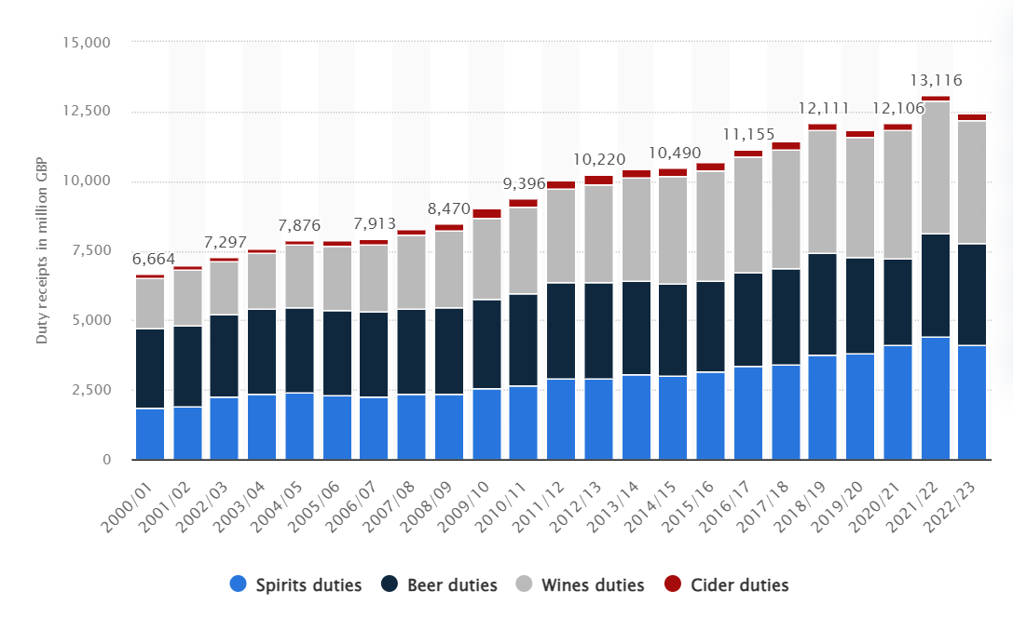

(Statista, 2023)

Cultural Shifts

The UK has seen many improvements since making it illegal to sell alcohol to anyone under the age of 18 and increasing the tax on alcohol. There are lower rates of social issues caused by young people who are under the influence, and socially it is becoming more the norm to drink less. Younger generations are developing a ‘coffee culture’, preferring to go out for coffee with a friend than go to the pub (Ballard, 2024) More information about drink awareness has made it harder to feel good about overdrinking. Knowing the harm you are causing yourself makes it less enjoyable to drink in excess on the regular, and people are preferring to invest in more meaningful memorable experiences, with less alcohol. With alcohol being more expensive than previous years, and average income not increasing to match daily expenses, alcohol is becoming more of a luxury and less affordable. Coffee shops have replaced the bars as the ‘third place’.
‘The third place’ is a concept from a 1989 book, The Great Good Place, by sociologist Ray Oldenberg. It is the idea that humans achieve work-life balance by having home, work, and ‘a third place’ to socialize and have fun outside of these two spaces. The point is “facilitate social interaction outside of the people you live or work with and encourage “public relaxation.” (Libby, K, 2023 )It has become more socially trendy to meet up for brunch and coffee than to go to a bar, with drinking seen as more of a weekend treat. (Libby, K, 2023)

Conclusion

Changes in attitudes around drink and increased culture of health and wellness has seen more people switch to brunch and coffee over pints after work. Drink awareness has been one of the most effective campaigns against drink related social costs and issues. Now that awareness is high about the long term damages of alcohol, and the ease at which you can exceed 14 units a week, people are more conscious to make better health decisions. This, and the price of alcohol increasing so it's more of a luxury than a regular affordable habit, has reduced the UK drink culture slightly. Alcohol being illegal to sell below the age of 18 means that once you turn 18, the excitement and novelty soon wears off and after a few times of overdrinking, its becomes far less appealing to keep up regularly

Alcohol Focus Scotland.(Accessed 25 March 2024).Alcohol driving limit | How many units of alcohol to drive. https://www.alcohol-focus-scotland.org.uk/alcohol-information/drink-and-the-driver/

Alcohol treatment services - Committees - UK Parliament. (Accessed 25 March 2024) https://committees.parliament.uk/work/7257/alcohol-treatment-services

Ballard, S. (2024, January 25). Brewing History: The rise of coffee culture in the United Kingdom | Aguri. Aguri. https://aguriworld.co.uk/blog/brewing-history-the-rise-of-coffee-culture-in-the-united-kingdom/

Brooks, J. (2015, July 28). Alcohol label designs revealed for “responsible drinking” push. Packaging News. [Image] https://d3hjf51r9j54j7.cloudfront.net/wp-content/uploads/sites/7/2011/08/19/alcohol-label-designs-revealed-for-responsible-drinking-pledge/portman-layouts-mn.jpg

Brooks, J. (2015, July 28). Alcohol label designs revealed for “responsible drinking” push. Packaging News. https://www.packagingnews.co.uk/news/alcohol-label-designs-revealed-for-responsible-drinking-pledge-19-08-2011

Department for Transport. (2017, October 6). Life-saving drink drive law turns 50. GOV.UK. https://www.gov.uk/government/news/life-saving-drink-drive-law-turns-50

Dr Burton,R., Henn,C., Lavoie,D., O’Connor,R., Perkins,C., Sweeney,K., Greaves,F., Ferguson,B., Beynon,C., Belloni, A., Musto, V., Professor Marsden,J., Professor Sheron, N., Wolff, A., and staff at PHE. (December, 2016).The Public Health Burden of Alcohol and the Effectiveness and Cost-Effectiveness of Alcohol Control Policies An evidence review. Public Health England. https://assets.publishing.service.gov.uk/government/uploads/system/uploads/attachment_data/file/733108/alcohol_public_health_burden_evidence_review_update_2018.pdf

Drink-drive limits: everything you need to know | RAC Drive. (2023, May 4) https://www.rac.co.uk/drive/advice/legal/drink-drive-limits-everything-you-need-to-know/

Excessive alcohol use and risks to women’s health | CDC. (n.d.). https://www.cdc.gov/alcohol/fact-sheets/womens-health.htm

Gov.UK.(2023, July 27). Reported drinking and driving: data tables.GOV.UK. https://www.gov.uk/government/statistical-data-sets/reported-drinking-and-driving-ras51

Gov.UK. (2021, May 20). Criminal justice system statistics quarterly: December 2020. GOV.UK. https://www.gov.uk/government/statistics/criminal-justice-system-statistics-quarterly-december-2020

Gov.UK.(2014, December 5).Drink-driving penalties. GOV.UK. https://www.gov.uk/drink-driving-penalties

IAS. (2023, June 5). Violence and crime - Institute of Alcohol Studies. Institute of Alcohol Studies. https://www.ias.org.uk/factsheet/violence-and-crime/

Libby, K (2023, August 2). How to manage your mental health in the summer. [Video]. TODAY.com. https://www.today.com/life/inspiration/third-place-meaning-rcna94279
Onion, A. (2023, April 24). Prohibition: Years, Amendment and Definition - HISTORY. HISTORY. https://www.history.com/topics/roaring-twenties/prohibition

Oxford Learners Dictionary.(accessed March 25 2024).externality noun - Definition, pictures, pronunciation and usage notes | Oxford Advanced Learner’s Dictionary at OxfordLearnersDictionaries.com. (n.d.). https://www.oxfordlearnersdictionaries.com/definition/english/externality

“Rob you of your beer”: The British fight against prohibition. (n.d.). https://warwick.ac.uk/services/library/mrc/archives_online/exhibitions/prohibition/

Statista. (2023, October 11). Alcohol duty tax receipts in the UK 2000-2023. https://www.statista.com/statistics/284336/united-kingdom-hmrc-tax-receipts-alcohol-duties-by-type/

Salmon, C. (2024, March 22). UK drink driving statistics - updated 2024. Quittance Legal Services. https://www.quittance.co.uk/uk-drink-driving-statistics

Takayanagi, M., (2020) “Astor the Fairy Godmother: The Intoxicating Liquor Act 1923”, Open Library of Humanities 6(2), 13. doi: https://doi.org/10.16995/olh.567

Temperance movement research guide | Sheffield City Council. (n.d.). https://www.sheffield.gov.uk/libraries-archives/access-archives-local-studies-library/research-guides/temperance-movement

Temperance Movement - the Rowntree Society. (2017, December 1). The Rowntree Society. https://www.rowntreesociety.org.uk/explore-rowntree-history/rowntree-a-z/temperance-movement/

The law on alcohol and under 18s | Drinkaware. (n.d.). Drinkaware. https://www.drinkaware.co.uk/facts/information-about-alcohol/alcohol-and-the-law/the-law-on-alcohol-and-under-18s

Trattou, R. (2023, August 14). Does location impact the value of your home? James Douglas Sales & Lettings. https://james-douglas.co.uk/does-location-impact-the-value-of-your-home/

Uk, A. C. (2021, November 14). Alcohol and domestic abuse. Alcohol Change UK. https://alcoholchange.org.uk/alcohol-facts/fact-sheets/alcohol-and-domestic-abuse

Uk, A. C. (2020, March 5). Minimum price for alcohol in Wales – what does it mean for you? Alcohol Change UK. https://alcoholchange.org.uk/policy/policy-insights/minimum-price-for-alcohol-in-wales-what-does-it-mean-for-you

Uk Parliament. (Accessed 25 March, 2024) Intoxicating Liquor (Sale to persons under 18) Act. (n.d.). UK Parliament. https://www.parliament.uk/about/living-heritage/transformingsociety/electionsvoting/womenvote/parliamentary-collections/nancy-astor/intoxicating-liquors-act/

Van Heertum, K., & Rossi, B. V. (2017). Alcohol and fertility: how much is too much? Fertility Research and Practice, 3(1). https://doi.org/10.1186/s40738-017-0037-x

Wen, L. S. (2024, February 6). Young people are drinking less. But one group is undoing those gains. Washington Post. https://www.washingtonpost.com/opinions/2024/02/06/alcohol-young-people-women-health/

Women and Alcohol | National Institute on Alcohol Abuse and Alcoholism (NIAAA). (n.d.). https://www.niaaa.nih.gov/publications/brochures-and-fact-sheets/women-and-alcohol

