Electronics System Design (ACDA6002)
Assignment 1
BNG Electrical & Electronic Engineering Course
UWTSD
By Krzysztof Matela
Student ID: 1804424

Page Index:
- Introduction
- WebDAQ 904
- Ventus W830
- AcuRite 01024M Pro
- Data Loggers Comparison
- Sensors Comparison
  - Temperature Comparison
  - Humidity Comparison
  - Wave Height Comparison
  - Wind Speed Comparison
  - Wind Direction Comparison
  - Sunlight Brightness Comparison
  - GPS
  - GPS Comparison
- Storage Memory
- Microcontroller Choice
  - MSSP (SPI and I2C interface)
  - USB
  - EUSART (RS-232)
- Power Supply
- Casing
- System Block Diagram
- Circuit Schematic Diagram
- PCB Design
- Future Improvements
- Cost
- References
- Appendix

- Introduction
This document contains a description of a design for marine weather data logger to be used by forecasters to aid their predictions. The device is intended to be portable and adaptable for any vessels. It will be powered by a battery and it is expected to gather following data over 7 days and store it on a non-volatile memory which can be read and cleared when connected to a computer via USB:
- Temperature
- Humidity
- Wave height
- Wind speed
- Wind direction
- Sunlight brightness
- GPS position
The document contains first look into existing data loggers for potential weather applications and then shows a comparison of their features and benefits. Next sections cover potential sensors for the temperature, humidity, wave height, wind speed and direction, sunlight brightness, and GPS position.
- WebDAQ 904
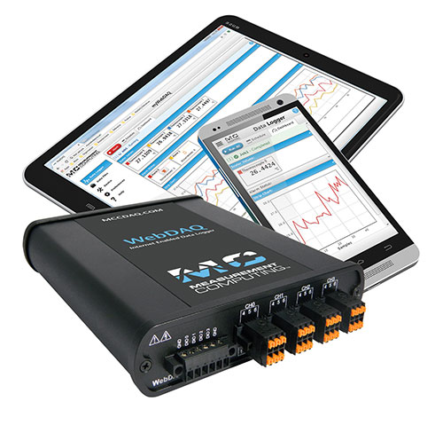
The WebDAQ 904 is a universal stand-alone data logger with internet access designed with Wi-Fi for remote monitoring and control and it contains enough intelligence to remove need for computer or software. It uses web servers, protected with passwords, to allow user to manipulate configurations, data log, update digital outputs or even send notifications when alarms are triggered. User can access data logs in real time using web browser and storage is virtually unlimited as the user can store data on either internal memory flash or configure it to use FTP servers as the remote storage location. The stored data can be extracted for Excel and MATLAB to use. The analog inputs have ADC resolution for up to 24-bits and are configurable for different input modes for voltage, current, thermocouples, RTD (4-wire and 2-wire), resistance and bridge-based sensors (half-and full-bridge, and other powered load cells) which supports voltages up to ±60V. Also, it has 4 isolated digital I/O ports for triggers and alarms [1].
- Ventus W830
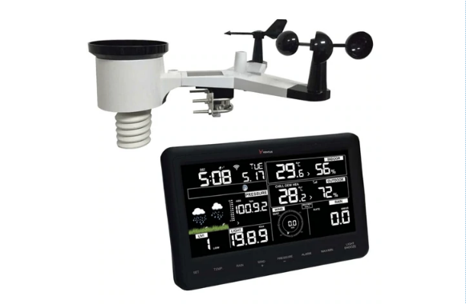
Ventus W830 is a weather station designed for remote monitoring. It uploads data to online services such as: Weather Underground, Weather Cloud and UK MetOffice WoW which are available for free while user also has an option to use his own web server. The outdoor unit has solar powered rechargeable batteries and solar powered capacitor to extend battery life even further. This package comes with sensors such as: Wind Cups, Wind Vane, Rain Funnel, and UV sensor as well as indoor console with high contrast that can show charts and figures. The device can measure indoor and outdoor temperatures, humidity, rain fall, wind speed, light Lux, UV levels and air pressure [2].
- AcuRite 01024M Pro
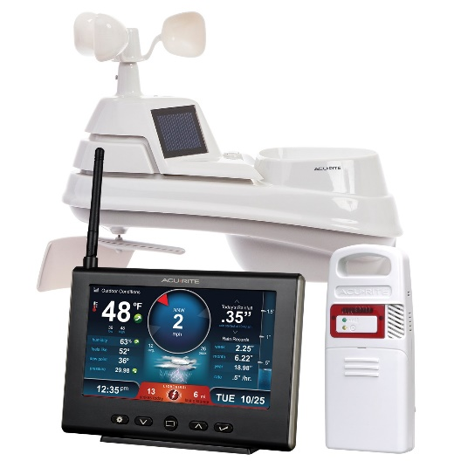
AcuRite 01024M Pro is a weather station for home use that tracks weather conditions and display them on a HD display. The sensors have the ability to monitor indoor and outdoor temperatures and humidity, wind speed, wind direction, rainfall, and lightning data. The console allows easy switch between outdoor weather, indoor condition and daily records for each reading which includes lightning strike counter with weekly and monthly totals. The devices have an option to set up alarms for each measurement it takes and it is capable of storing data up to 1 year of weekly and monthly occurrences. The console has automatically updated clock for daylight saving time and includes calibration option for different environments [3].
- Data loggers Comparison
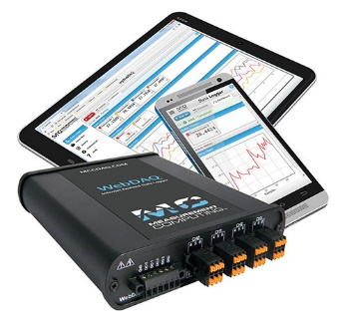 | 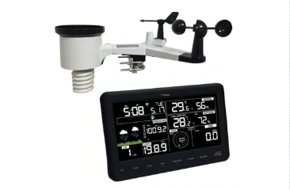 | 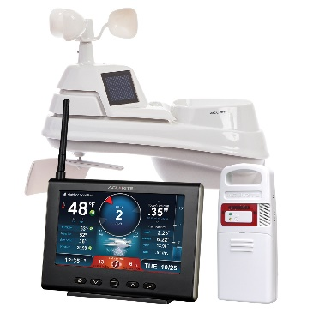
WebDAQ 904 | Ventus W830 | AcuRite 01024M Pro
Features:  - Four 24-bit analog inputs  - Voltages up to ±60V  - 100 S/s/ch sample rate, max  - Voltage and current excitation  - Four isolated DIO for triggers and alarms  - Log data to internal or mapped network storage  - Share folders to view files over a local network  - Export data to csv, UFF, or binary for use in other application  - Alarm and event notification  - Easy, flexible task scheduling  - Configurable read/write access  - No driver software to install  - Built-in web server  - Remote monitoring and control  - Wi-Fi support | Features:  - Digital display  - Solar and battery powered  - Sensors for:  * Outdoor temperature and humidity  * Rain measurements  * Wind speed  * Wind direction  * Wind chill  * UV sensor  * Daylight sensor  * Air pressure  - Graphs for data  - External sensor calibration  - Wi-Fi support  - Web services support  - Rechargeable battery  - Weather forecasting | Features:  - Digital display  - 5-in-1 weather sensor:  * Outdoor temperature and humidity  * Wind speed  * Wind direction  * Rain measurements  * Wireless  * 4 AA Alkaline batteries  - Indoor display:  * Indoor temperature and humidity  * Data reporting  * 5V AC adapter  - Lightning detector  - Graphs for data
Cons:  - Needs sensors  - Needs power supply  - Very expensive | Cons:  - Needs constant Wi-Fi connection  - Can attract a lightning strike during installation | Cons:  - No internet  - Cannot add more sensors  - Data for 1 year period

- Sensors Comparison
  - Temperature Comparison
LM35 Temperature sensor {1} | DM-310 RTD sensor {2} | SHT21 Temperature and humidity IC {3}
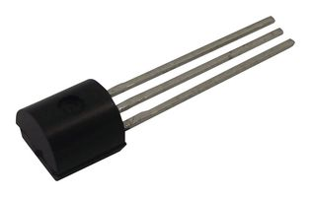 | 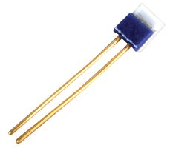 | 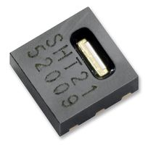
Features:  - Linear output (+10mV/°C)  - Range -55°C to 150°C  - Cheap  - Operates from 4V to 30V  - Low current drain at 60μA | Features:  - Linear output  - Range -50°C to 500°C  - Cheap  - Fundamental interval 385Ω  - For surface application | Features:  - 14bit resolution (0.01°C per bit)  - Range -40°C to 125°C  - I²C interface  - Operates between 2.1V to 3.6V  - Includes humidity sensor

  - Humidity Comparison
HCZ-D5-A Humidity sensor {4} | HIH-4000-001 Humidity sensor {5} | SHT21 Temperature and humidity IC {3}
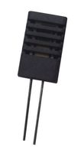 | 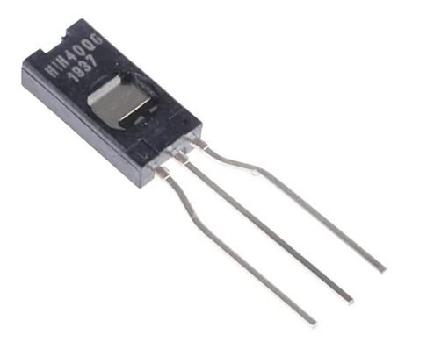
Features:  - Operating frequency range 0.5kHz to 2kHz  - Humidity range 20%RH to 90%RH  - Operating temperature range 0°C to 60°C  - Operates using impedance | Features:  - Operates from 4V to 5.8V  - Operating temperature -40°C to 85°C  - Humidity range 0%RH to 90%RH  - Analog output | Features:  - 12bit resolution (0.04%RH per bit)  - Operates between 2.1V to 3.6V  - I²C interface  - Includes temperature sensor

  - Wave Height Comparison
XMLG010D71 Pressure sensor {6} | MMA8451 Accelerometer {7} | 28015 Ultrasonic distance sensor {8}
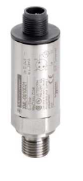 | 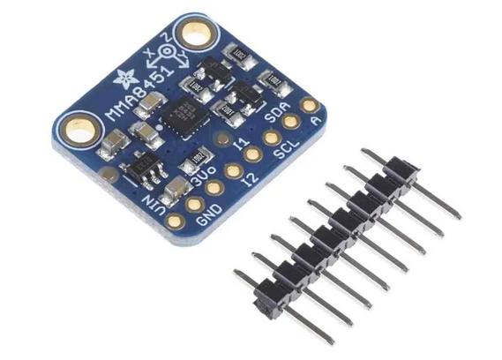 | 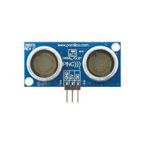
Features:  - Analog output  - Pressure setting range 0 to 10 bar  - Operates at 24V  - IP67 protection | Features:  - Operates from 1.95V to 3.6V  - I2C interface  - 14bit resolution  - Needs a buoy | Features:  - Range 2cm to 3m  - Operates at 5V  - Communicates using pulses

  - Wind Speed Comparison
SKU:SEN0483 Cup anemometer {9} | SEN-15901 Wind station {10} | 1405-PK-021 Ultrasonic sensor {11}
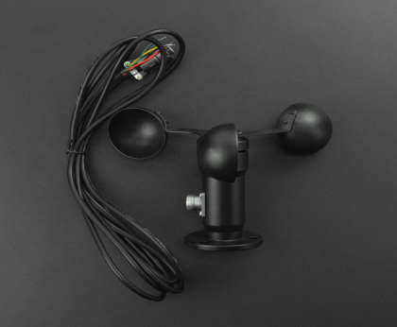 | 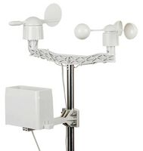 | 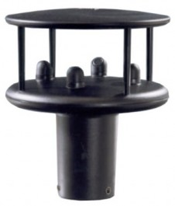
Features:  - Measuring range 0~32.4m/s  - Accuracy: ±0.3m/s  - Operates from 7V to 24V  - RS485 communication protocol  - Cable for long distance transmission | Features:  - Analog output  - Wind speed of 2.4km/h gives output every second  - Includes wind direction sensor  - Includes rain gauge  - Mechanical | Features:  - RS232, RS422, and RS485 compatible interface  - Range 0 to 60m/s  - Accuracy ±2% @12m/s  - Resolution 0.01m/s  - Includes wind direction sensor  - Solid state

  - Wind Direction Comparison
024A Wind direction sensor {12} | SEN-15901 Wind station {10} | 1405-PK-021 Ultrasonic sensor {11}
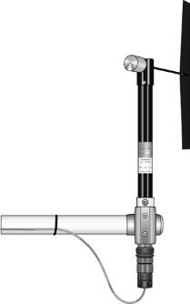
Features:  - Analog output  - Range 0 to 360°  - Resolution 0.5°  - Accuracy ±5°  - Needs dedicated data logger | Features:  - Analog output  - Range 0 to 360°C  - Resolution 22.5°  - Includes wind speed sensor  - Includes rain gauge  - Mechanical | Features:  - RS232, RS422, and RS485 compatible interface  - Range 0 to 360°  - Resolution 1°  - Accuracy ±2% @12m/s  - Includes wind speed sensor  - Solid state

  - Sunlight Brightness Comparison
SFH 213 IR and visible light photodiode {13} | NORPS-12 Light dependent resistor {14} | SI1133-AA00-GMR {15}
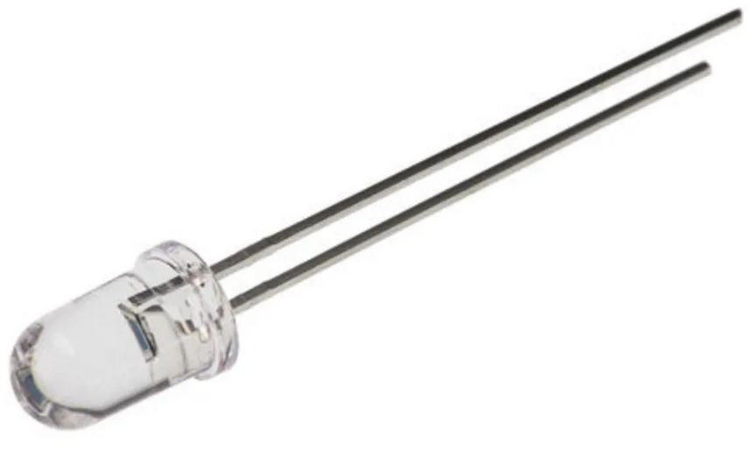 | 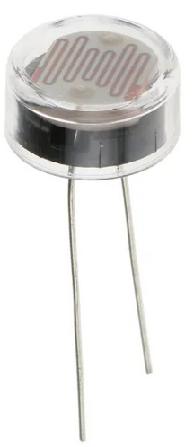 | 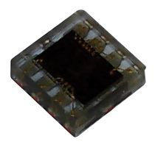
Features:  - Analog output  - Infrared and visible light  - minimum 1000lx | Features:  - Analog output  - Up to 250V  - Light resistance range 5.4kΩ to 12.6kΩ  - Dark resistance 1MΩ | Features:  - I2C interface  - Operates at 1.62V to 3.6V  - Resolution 100mlx  - Light level up to 128klx

  - GPS
Global Positioning System (GPS) is a satellite-based navigation system that was originally designed for military and became accessible for civilian use in 1980s. It uses number of satellites that rotate earth twice a day. Each satellite can transmit unique signal and its orbital parameters that GPS, along with trilateration, use to calculate users’ position. The users’ location is found by measuring time delay between transmit and receive. To calculate longitude and latitude GPS needs to lock to at least 3 satellites while locking onto 4 or more satellites allows calculating 3D location (longitude, latitude, and altitude). There are more satellite navigation systems such as: GLONASS built by Russian; Galileo made by European Space Agency; BeiDou created by China; and they are all classified as Global Navigation Satellite System (GNSS) [4].

  - GPS Comparison
TEL0094 Receiver Module {16} | GPS-622F GPS Receiver {17} | Adafruit 746 GPS Module {18}
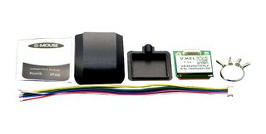 | 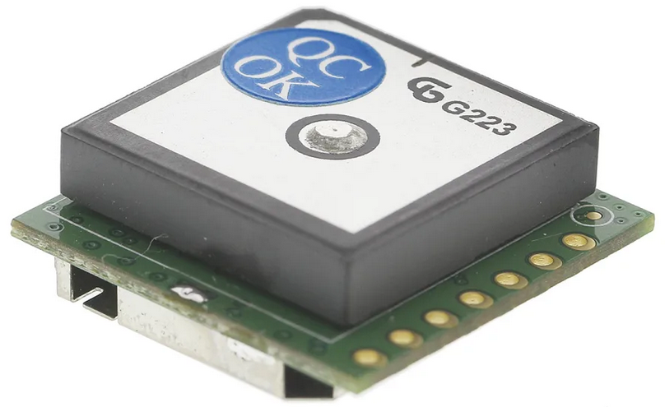 | 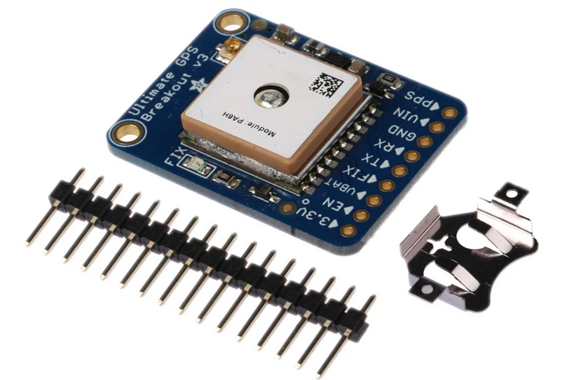
Features:  - Operates at 3.3V and 5V  - 56 channels  - 10Hz updates  - Sensitivity -161dBm  - RS232 interface | Features:  - Operates at 2.7V to 5.5V (typ. 3.3V)  - 68 channels  - 20Hz updates  - Sensitivity -165dBm  - RS232 interface | Features:  - Operates at 5V  - 66 channels  - 10Hz updates  - Sensitivity -165 dBm  - RS232 interface

- Storage Memory
To help with decision for the amount data storage required, a following table has been made that describes how often data will be taken:
 | Temperature |  | Humidity |  | Wave Height |  | Wind Speed |  | Wind Direction |  | Latitude |  | Longitude
Time | Temp-msb | Temp-lsb | Humi-msb | Humi-lsb | Wave-msb | Wave-lsb | Speed-msb | Speed-lsb | Direc-msb | Direc-lsb | Lati-msb | Lati-lsb | Long-msb | Long-lsb
0 | X | X | X | X | X | X | X | X | X | X | X | X | X | X
1s |  |  |  |  | X | X
2s |  |  |  |  | X | X
3s |  |  |  |  | X | X
4s |  |  |  |  | X | X
5s |  |  |  |  | X | X
… | … | … | … | … | … | … | … | … | … | … | … | … | … | …
60s | X | X | X | X | X | X | X | X | X | X | X | X | X | X
61s |  |  |  |  | X | X
62s |  |  |  |  | X | X
63s |  |  |  |  | X | X
64s |  |  |  |  | X | X
65s |  |  |  |  | X | X
… | … | … | … | … | … | … | … | … | … | … | … | … | … | …
Temperature, humidity, wind speed, wind direction, longitude and latitude data will be measured and stored every minute, while wave height data will be measured and saved every second.

Formula for temperature:
$$7 Days*24 Hours*60 Minutes*2 Bytes=7*24*60*2=20160 Bytes$$
Formula for humidity:
$$7 Days*24 Hours*60 Minutes*2 Bytes=7*24*60*2=20160 Bytes$$
Formula for wave height:
$$7 Days*24 Hours*60 Minutes*60 Seconds*2 Bytes=7*24*60*60*2=1209600 Bytes$$
Formula for wind speed:
$$7 Days*24 Hours*60 Minutes*2 Bytes=7*24*60*2=20160 Bytes$$
Formula for wind direction:
$$7 Days*24 Hours*60 Minutes*2 Bytes=7*24*60*2=20160 Bytes$$
Formula for latitude:
$$7 Days*24 Hours*60 Minutes*2 Bytes=7*24*60*2=20160 Bytes$$
Formula for longitude:
$$7 Days*24 Hours*60 Minutes*2 Bytes=7*24*60*2=20160 Bytes$$
That gives a total of:
$$1330560 Bytes$$
In kiloBytes:
$${1330560}/{1024}≈1299 kB$$
In MegaBytes:
$${1299.375}/{1024}≈1.27MB$$
Since the system requires at minimum, 1.27MB of storage memory, the choice for storage memory is Verbatim MicroSDHC Card class 10 with 32GB of storage which is way more than required but it is very cheap {19}.
- Microcontroller Choice
The PIC needs to be able to communicated with SD card using SPI interface; I2C interface to communicate with temperature and humidity sensor and sunlight sensor; RS232 to communicate with ultrasonic wind sensor and GPS module; and lastly 2 digital ports – one for LED and 1 for distance sensor.
  - MSSP (SPI and I2C interface)
Master Synchronous Serial Port (MSSP) module is required to communicate with SPI and I2C devices – in this case, an SD card. SPI was introduced by Motorola to communicate between ICs and I2C was made by Philips for communication between chips [5] [6]. SPI bus is a synchronous serial data communication bus that operates in Full-Duplex mode – meaning that data can go in both directions at the same time. Device’s communication is in a master/slave environment and master is the one to initiate communication. A slave device is controlled by a Chip Select which is also known as Slave Select ($\overline{SS}$). SPI is made out of 4 wires:
    - Serial Clock (SCK)
    - Serial Data Out (SDO)
    - Serial Data IN (SDI)
    - Slave Select ($\overline{SS}$)
In event where multiple SPI devices are present, each SCK, SDO, and SDI are connected together while each device has their own unique SS pins [7].
I2C, unlike SPI, only uses 2 wires as a bus where slave addressing is sent first in the same line as data. The communication is Half-Duplex – data going in one direction at the time. Also, any slave can take control of the bus if the master relinquishes the control [8]. The 2 wires in I2C are:
    - Serial Clock Line (SCL)
    - Serial Data Line (SDA)
  - USB
Universal Serial Bus (USB) was introduced in 1995 with main goal to simplify the connection between computer and peripherals. USB 1 had options for low speed (1.5Mb/s) and full speed (12Mb/s) and it was sufficient enough for keyboards, mouses and some external memory drives (thumb drives). In version 2, USB give hi-speed transfer up to 480Mb/s and is more suitable for serious data transfer for devices such as optical drives or external hard drives. Version 3 add another two shielded twisted pair cables that give Full-Duplex communication and speed up to 4.8Gb/s while version 3.1 can go in speed up to 10Gb/s and also increased power output from 5V@2A to 5A at either 12V or 20V. USB 1 and 2 are configured as Half-Duplex Master/Slave with 4-wires [9]:
    - Vbus (+5V)
    - D+
    - D-
    - Ground (GND)
While Vbus gives a constant voltage between 4.40V to 5.25V, the D+ and D- data lines operate at 3.3V [10].
  - EUSART (RS-232)
Enhanced Universal Synchronous Asynchronous Receiver Transmitter (EUSART) Module is a peripheral for serial I/O communication and it contains clock generators, shift registers, and data buffers required to do input or output of serial data transfer independent of device program execution. EUSART is also known as Serial Communication Interface and can be configured as either Full-Duplex or Half-Duplex [11].
The RS-232 refers to electrical signalling scheme that uses voltages of both polarities (+ and -) to signal 1 and 0. When signalling starts, the transmitter rests at logic 1 and it change to 0 which is then followed by 8 data bits and ends with extra 1 or 2 trailing stop bits. The 8 bits data can sometimes by 7-bits long with 1 parity bit. The transmitter and receiver must have the same baud rate (e.g., 9600 bits/s).
  - PIC Choice
- Power Supply
The power supply for the 7-day period is defined by a sum of maximum currents for each component:
Sensor | Current
Temperature and Humidity | 300μA
Wave Height | 30mA
Wind Speed and Direction | 5.5mA
Sunlight Sensor | 4.5mA
GPS Module | 70mA
Total | 110.3mA
Total for a single day | 2.6472A
Total for 7-day run | 18.5304A
Therefore, a choice for battery is 2x parallel 12V TSB18 {20} with each having 17.0Ah capacity.

- Casing
The choice for casing is: Peli 1150 {21} with the size of 111 x 232 x 192mm. It has IP67 rating and is fully waterproof.
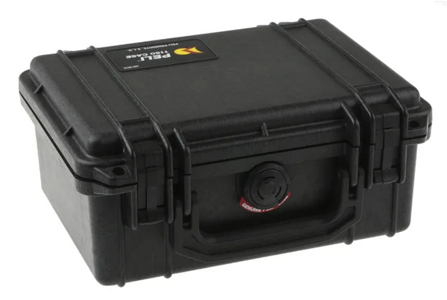
- System Block Diagram
Diagram is made out of microcontroller in the middle with sensors going into the PIC and USB and memory card going both in and out of the PIC.

- Circuit Schematic Diagram
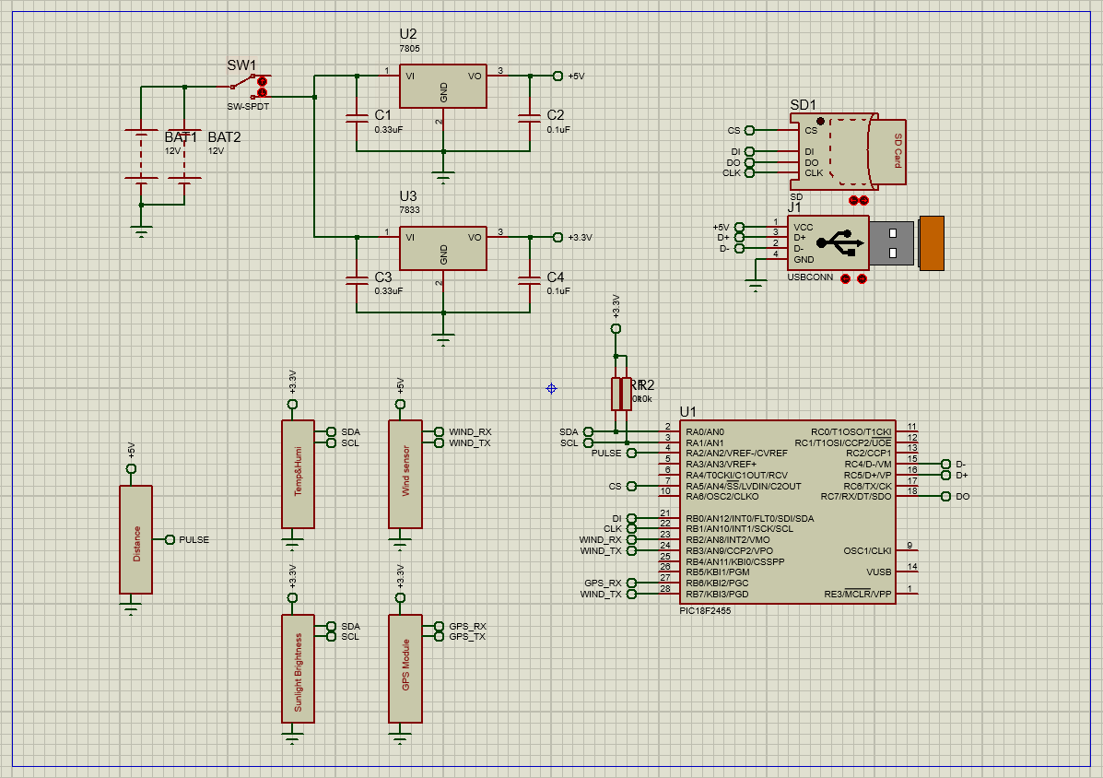
From top-left, circuit shows a couple of batteries connect in parallel that will give 2x the current output to keep system running for 7-days. Battery output is then fed to a couple of voltage regulators placed in parallel; one for +3.3V to power PIC, temperature and humidity sensor, sunlight sensor, and GPS module; one for +5V to power distance sensor and wind sensor. Temperature and humidity sensors are I2C meaning that they need pull up resistors which also will be bit batched to free dedicated pins for memory card and USB to use at maximum speed. Wind sensor and GPS module also have their pins bit batched.

- PCB Design
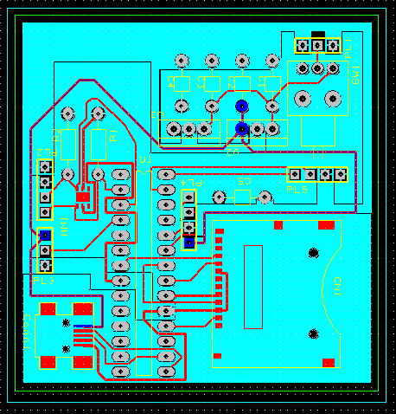

3D View:
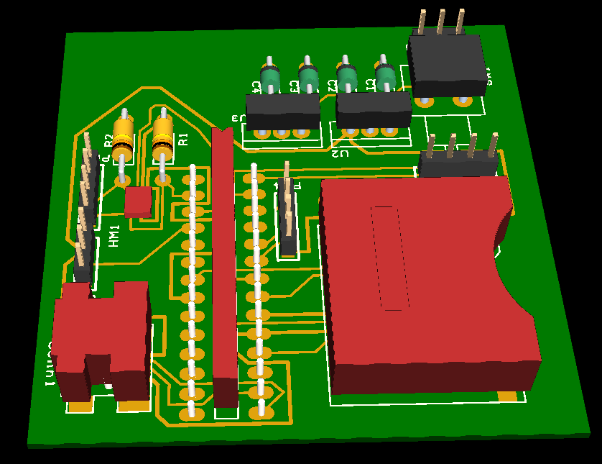

Design Rule Check:
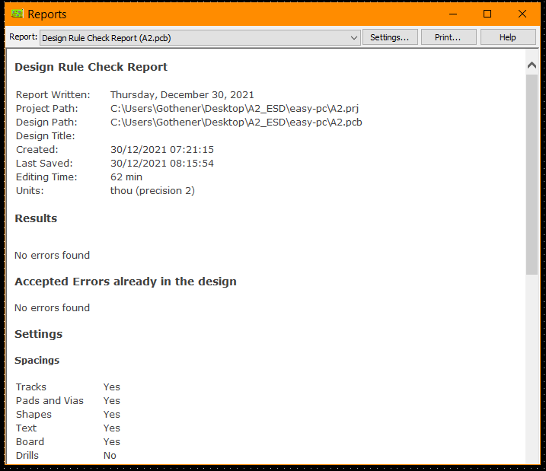
Connectivity Check:
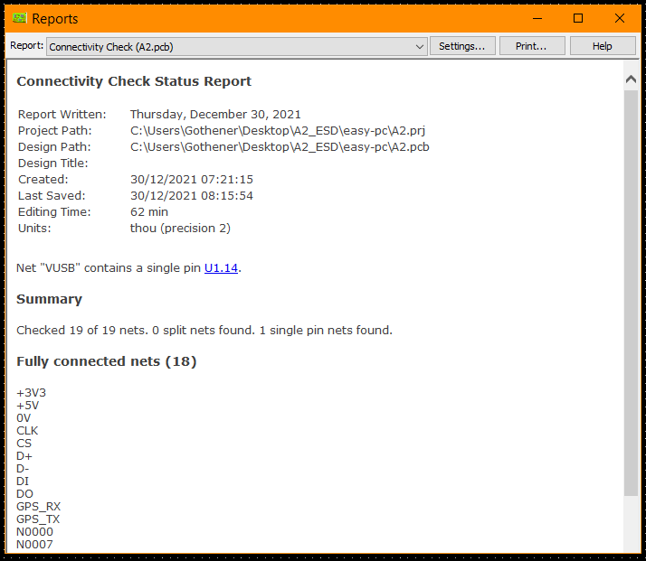
- Future Improvements
First improvement could be to add internet access and backup data online as this would protect data against catastrophic system failure and a web server give extra ease by being remotely accessible. Another improvement could be to add rain gauge and lightning detector as a feature for storm heavy regions. Additionally, the system could benefit from internal circuit that could recharge the batteries while in box.
- Cost
SHT21 Temperature and Humidity sensor | £6.45
28015 Distance sensor | £27.99
1405-PK-021 Wind sensor | £1098.00
SI1133-AA00-GMR Sunlight sensor | £1.91
GPS-622F GPS module | £32.45
Verbatim SD card 32GB | £9.79
USB Socket type C | £3.08
PIC18F2455-I/SP | £7.27
PCB Printing (JLCPCB) | £1.48
SD Card Slot | £2.08
Total | £1190.50

- References
[1] MC Measurement Computing TM. WebDAQ 904 Datasheet. URL: https://www.measurementsystems.co.uk/docs/mc/DS-WebDAQ-904.pdf. Accessed: 27/12/21

[2] Weather Spares. Ventus W830 Weather Station. URL: https://weatherspares.co.uk/collections/ventus/products/ventus-w830-weather-station-wifi-internet-colour-forecast. Accessed: 27/12/21

[3] Amazon. AcuRite 01024M Pro. URL: https://www.amazon.com/AcuRite-01024M-Lightning-Detector-Temperature/dp/B01MF7HK97?th=1. Accessed: 27/12/21

[4] Garmin Ltd. About GPS. URL: https://www.garmin.com/en-US/aboutgps/. Accessed: 27/12/21

[5] P. Horowitz, W. H. (2015). ”The Art of Electronics”, Third Edition. Cambridge University Press. Chapter 14.7.1 SPI. Page 1032

[6] P. Horowitz, W. H. (2015). ”The Art of Electronics”, Third Edition. Cambridge University Press. Chapter 14.7.2 I2C 2-wire interface (“TWI”). Page 1034

[7] Microchip Technology Inc. PIC18F2455 Datasheet. Chapter 19.3 SPI Mode. Page 195

[8] Microchip Technology Inc. PIC18F2455 Datasheet. Chapter 19.4 I2C Mode. Page 204

[9] P. Horowitz, W. H. (2015). ”The Art of Electronics”, Third Edition. Cambridge University Press. Chapter 14.7.3 USB. Page 1042

[10] Murphy R. Cypress. USB 101: An Introduction to Universal Serial Bus 2.0. Chapter 5 Physical Interface. Page 7

[11] Microchip Technology Inc. PIC18F2455 Datasheet. Chapter 20 Enhanced Universal Synchronous Receiver Transmitter (EUSART). Page 235

- Appendix
{1} LM35 Datasheet. URL: https://www.ti.com/lit/ds/symlink/lm35.pdf. Accessed: 27/12/21

{2} DM-310 Datasheet. URL: https://www.farnell.com/datasheets/1918818.pdf. Accessed: 27/12/21

{3} SHT21 Datasheet. URL: https://www.farnell.com/datasheets/2307648.pdf. Accessed: 27/12/21

{4} HCZ-D5-A Datasheet. URL: https://www.farnell.com/datasheets/2865737.pdf. Accessed: 27/12/21

{5} HIH-4000-001 Datasheet. URL: https://docs.rs-online.com/53cc/0900766b8138b8e7.pdf. Accessed: 27/12/21

{6} XMLG010D71 Datasheet. URL: https://docs.rs-online.com/87a2/0900766b815c825f.pdf. Accessed: 27/12/21

{7} MMA8451 Datasheet. URL: https://docs.rs-online.com/8f5f/0900766b814beed7.pdf. Accessed: 27/12/21

{8} 28015 Datasheet. URL: https://docs.rs-online.com/ca69/0900766b81382974.pdf. Accessed: 27/12/21

{9} SKU:SEN0483 Datasheet. URL: https://wiki.dfrobot.com/RS485_Wind_Speed_Transmitter_SKU_SEN0483. Accessed: 27/12/21

{10} SEN-15901 Datasheet and Manual. URL: https://cpc.farnell.com/sparkfun-electronics/sen-15901/weather-meter-kit/dp/MK00988. Accessed: 27/12/21

{11} 1405-PK-021 Datasheet. URL: https://www.omniinstruments.co.uk/fileuploader/download/download/?d=0&file=custom%2Fupload%2FFile-1468488142.pdf. Accessed: 27/12/21

{12} 024A Datasheet. URL: https://s.campbellsci.com/documents/eu/product-brochures/b_024a.pdf. Accessed: 27/12/21

{13} SFH 213 Datasheet. URL: https://docs.rs-online.com/f594/0900766b814f568d.pdf. Accessed: 27/12/21

{14} NORPS-12 Datasheet. URL: https://docs.rs-online.com/7c8b/0900766b8156674b.pdf. Accessed: 27/12/21
{15} SI1133-AA00-GMR Datasheet. URL: https://www.farnell.com/datasheets/2311618.pdf. Accessed: 27/12/21

{16} TEL0064 Datasheet. URL: https://www.farnell.com/datasheets/3216226.pdf. Accessed: 27/12/21

{17} GPS-622F Datasheet. URL: https://docs.rs-online.com/1cff/0900766b81470a8a.pdf. Accessed: 27/12/21

{18} Adafruit 746 Datasheet. URL: https://docs.rs-online.com/c562/0900766b814beeb7.pdf. Accessed: 27/12/21

{19} Verbatim Micro SD Card. URL: https://uk.rs-online.com/web/p/micro-sd-cards/8775553. Accessed: 27/12/21

{20} TSB18 Battery. URL: https://www.tlc-direct.co.uk/Products/TSB18.html. Accessed: 27/12/21

{21} Peli 1150 Case. URL: https://peliproducts.co.uk/1150-protector-case. Accessed: 27/12/21

