Name: Shaymaa Al Abbasi

knowledge and information management at tesco

Student ID number: 1817837
Module code: BMSW5106
Module title: Knowledge and Information Management Skills for the Workplace
Lecturer name: Vajira Balasuriya
Task title: Knowledge and Information Management of Tesco
Submission date: March 26th2021

Contents
Introduction 2
The importance of Information system 2
The importance of the information systems for Tesco 2
Information systems implemented by Tesco 3
The objectives of Tesco’s data system 5
Knowledge management challenges 6
Enterprise Resource Planning 7
ERP elements in Tesco 7
ERP Advantageous, disadvantageous and limitation. 8
Porter's Five Forces 9
Porter’s generic strategies in Tesco and the influence of the IS/IT on each force 9
The limitation of Porters five forces in Tesco 11
Recommendation 11
Conclusion 12
References 13

Introduction
The aim of this report is to examine the importance of the significant data collection system in Tesco. Also, the study will be focusing on the provided information system by Tesco and detail the stages of the data collection, transforming as well as the productions of the system. Additionally, this study will be looking into the possible difficulties in organizing data and analyse the long-term technical strategy implemented by Tesco. Further, the purpose of this report is to present and examine the approaches of knowledge management with reference to Porter’s generic model and the implementation of enterprise resource planning systems for Tesco.
The following section will be dissecting the information management and highlighting the importance of the information system in Tesco in complete depth.

The importance of Information system
Information system is stream handling systems dependent on computers information and incorporated with different methodology to give data in an ideal and successful way to help dynamic and other administration capacities (Berisha - Shaqiri, 2014). Also, management information system is vital inside associations, both private and public, business, and non‐commercial they should try to set up an administration data framework unit in their associations so sufficient data can be put at the removal of their administration (Adeoti‐Adekeye,1997).

The importance of the information systems for Tesco
Directors in a large organization like Tesco present need to oversee masses of data, convert that data into information, inspecting the information and making decisions inciting the achievement of business objections. For an association like Tesco, information is a huge resource as money, equipment, and work. It is principal for the perseverance of the endeavour. Additionally, at the administrative level, decisions can be made by analysing the information on bargains, benefits, customer's choice, etc. This information should be given to the head of the organization. Little and enormous, this data is amassed on the activities at the operational, data levels and are transported off the more raised levels. This cycle is motorized with the ascent of information systems. By and by, as information frameworks are placed in each level, it has become the commitment of these systems to gather/measure the data that is gone into the structures at the operational, data levels and the data is sent into the systems at the organization level. The commitment of the structures at the leader level is to research the data that is gotten from the under levels and help the chiefs in unique (Tesco, 2017).
Further, Tesco IS observably recognizing the customers' motivation with the data melded through the Tesco club account plot. This is a pivotal estimation to the accomplishment into the degree of applying the data of the customer is concerned. By taking apart data of their customers in an irregular plan, Tesco keeps prudently made care on advantage similarly as incident record to evaluate the theories of customers in the arrangement, the assessment proportion of resources used similarly as the extra benefits and assessment of new customers made. This procedure has invigorated more customers' relationship in the business consequently training more demands for the consequences of the business. Tesco IS look at their client by social affair them into different, numerous sections blend similarly as stages in agreement in with factors, for example rule, regard, repeat, lifestyles, restricted time responsiveness, sneak past rates, coupons' reclamation, lead among others have has been used by Tesco as a technique to achieve a productive system of market division in the running of the business (Payne and Frow, 2005).
Lowe et al.’s (2012) work on organisational identity and capability development in internationalization about transference, splicing and enhanced imitation in Tesco’s US market entry shows that Tesco depends on quantitative/hard information which is defined as the estimation of information as tallies or numbers where each dataset has an extraordinary mathematical worth related with it (Cramer, 2003) and qualitative/soft data that is defined as clear-cut information and information that can be masterminded into classes dependent on actual characteristics, sex, tones, or anything that doesn't have a number related with it (Bryman and Burgess, 2002). They used this knowledge to cover the whole expectancy of the services were assembled from various sources.
The main aim of collecting the hard and soft information in the above exploration shows that Tesco relied upon this information to make data from gathered information and change this data into a legitimate high ground that can be assessed as achievement in the business. Likewise, to make, share and apply information to accomplish their crucial and operational goals inclusively and methodically. Further, it upheld to add to expand the productivity and adequacy of the procedure from one viewpoint and to enhance and change the nature of rivalry on the other.

Information systems implemented by Tesco
Tesco implemented subsystems to collect data to observe their different types of marketing such as online and in-store shopping, level of customer services as well as the demand for their products. Within an instructive organisational environment like Tesco, managers should consider the input, process and output and choose destinations, substance, techniques, and evaluation (Mitra, 2008). The input of data is generally the objectives and encapsulated substance that managers put in while the processes are the techniques for the transport of a substance. Outputs are the eventual outcome of organisational information sources and association those ought to be studied reliant on objections (Salam, 2015).
A basic information system at Tesco is:
- Input includes staff, offices, PCs, charging machines and self-checkout machines.
- Process includes selling products, offering advice to clients, Limit, and Stock control.
- Output incorporates consumer loyalty, items sold, and profits made.
For example, Tesco Input transforming resources are staff, offices like PCs, charging machines. Change measure includes selling merchandise, offering guidance to clients, Limit, and Stock control. In the present time programming and PC guarantees that stock is consistently ready to move on the floor. Tesco actualized such innovation set up. When staff examine items on the shelves, this illuminates the stock regulator that a certain shelf is coming up short on a specific item and stock is then given to the floor. Progressed stock administration programming will likewise alarm the stock regulator of when new stock should be requested and what amount ought to be requested (Figure1). This guarantees that racks are in every case all around supplied and that the store is running productively. This can be a perplexing capacity inside a business yet having to make instruments and gear accessible to make the work that a lot simpler and with a significant degree of exactness.
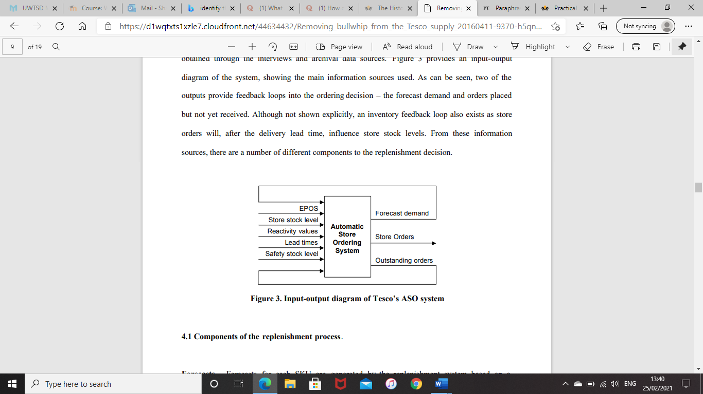
Figure 1: Input-output diagram of Tesco’s system
Source: Potter and Disney (2010)
Also, Tesco implemented the Big Data to measure their structured and unstructured data to measure their products life cycle (Figure 2). Structured data incorporates exchanges, log information, and bookkeeping pages. External information for media organizations commonly incorporates web-based media, sound, photographs, and video, all unstructured information, while inward information incorporates log information, exchanges, and messages (Arasu and Garcia-Molina, 2003). Unstructured information, including video, sound, email, research, online media feeds, and the sky is the limit from there, which address 80% of all enormous Information will be a test from which to extricate significant business information (Blumberg and Atre, 2003).
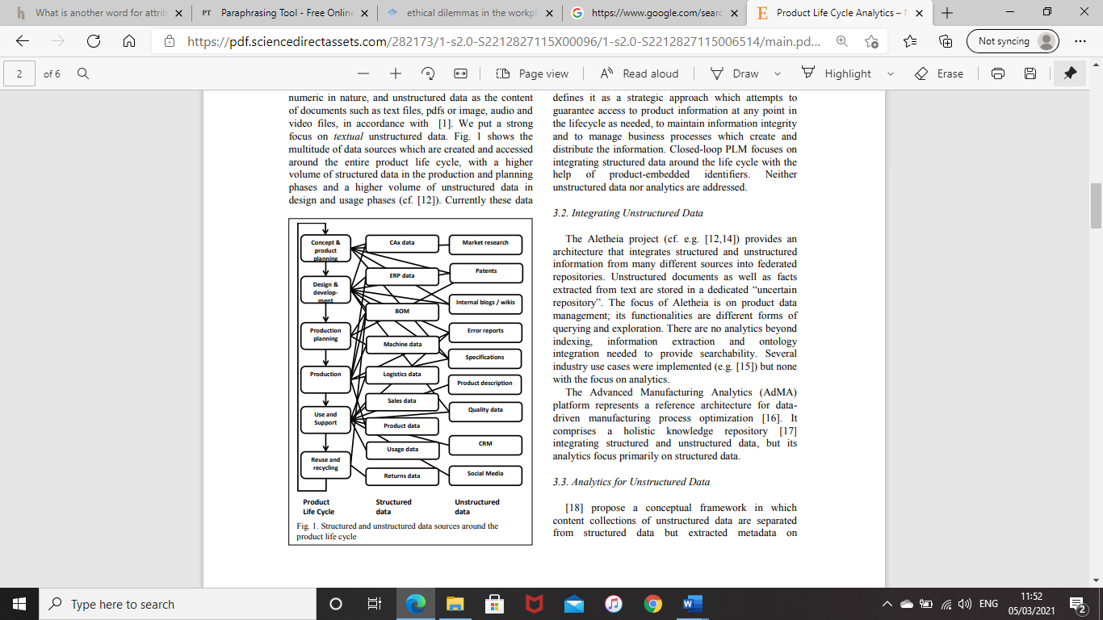
Figure 2: Structured and unstructured data sources around the product life cycle
Source: Kassner et al, (2015)
Measuring the structured/unstructured data have its own advantages and disadvantages to Tesco as it gives great chance to the company to understand what their customers think of their certain services and help the organisation to make better and quicker decision. However, the downside of it, Tesco would face some challenges such as, dealing huge volume of information through their channels comes in various lingos and certainly would require translation as well as diverse articulation styles.

The objectives of Tesco’s data system
Tesco’s data system is made of components that cooperate to meet data objectives. Components of a data system incorporate equipment, programming, liveware, systems, organization, and information. Every component plays out a particular objective to help an association to meet its objectives. Data frameworks fluctuate across the association order in accordance with the variety in data needs. Tesco's data system upholds working together with suppliers, and this guarantees the privilege and ideal supplies. Tesco's data frameworks permit the organization to flawlessly speak with the suppliers. Therefore, the organization fulfils client needs on time since things don't leave stock. Teaming up with representatives builds their profitability. Data frameworks upgrade cooperation with representatives accordingly expanding their profitability. For example, Tesco IS giving the company the chance to observe the minimum spending for an average household so they can hit two birds in one stone by watching what’s in demands and in same time they do this by reducing costs and offering more in store bargains. Tesco are meaning to build up an easier web-based shopping experience, so when they succeed in doing so, they may pull in a lot more shoppers which will assist them with accomplishing their objectivities.

Knowledge management challenges
Knowledge Acquisition, Retention and Transfer.
knowledge acquisition is the cycle used to characterize the principles and ontologies needed for an information-based framework whereas Information Retention and Transfer procedure are a way to deal with lessening this danger. The knowledge Acquisition, Retention and Transfer system is an essential way to deal with the danger of the deficiency of basic information and features need zones and subjects for information maintenance action (Lainema and Lainema, 2007).
Tesco uses Clubcard as knowledge acquisition. Loyalty card market knowledge can be mined and deciphered by statistical surveying organizations by giving data past that accumulated by more conventional statistical surveying overviews. The power of Clubcard information identifies with experiences into explicit purchaser specialties, and real purchasing practices, just as how explicit item classes and providers are performing. This empowers numerous retailers and their suppliers to recognize who is purchasing items, yet additionally different items that buyers are probably going to buy (Donnelly et al., 2015). However, Tesco’s acquisition knowledge should be under a consistent survey and exchanged to meet the corporate necessity of the data.
Further, Tesco might face some challenges within their KA. For instance, some research show that more than half of customers engagement of loyalty program individuals are not active. Despite these clients do settle on the decision to join, numerous never draw in or quit after a couple of months. Therefore, Tesco should use information to acquire bits of knowledge into client conduct and interests to tailor encounters, offers, and messages to a crowd of people of one. In addition, if brands only compensate their loyal customers when purchasing from them, most of their regulars would lose interest in shopping from them as the expectation of the regular customers to get compensated for non-transactional condition such as taking a review or cooperating on informal communities and in this case, Tesco should consider planning loyalty activities that form enthusiastic association.
Information retention and transfer is a more extensive view. Tesco can utilize information maintenance and move from numerous points. Some execute substitution arranging methods that include documentation of occupation jobs and ID of representatives who can substitute during present moment opening. Others use progression arranging procedures to recognize basic administration positions and key entertainers who could be created for influential positions. Notwithstanding, a few organizations take a more extensive perspective on information maintenance and move, zeroing in on the relationship with representatives for the duration of their life cycle at the organization. However, Tesco may stand up to troubles in planning speed, data understanding, data quality, discernment, and exception treatment of tremendous data. KR and KT are very crucial to any organisation as some challenges might accrue for KR and KT such as losing key knowledgeable employees for various reasons and in such case, company has to replace them with new staff, and this will consume time and effort to train and develop them. Also, some information might get misplaced or hard to find or in some cases gets hacked.
Moreover, Tesco could face some common challenges transferring the knowledge such us,
- Various perspectives on expresses of information,
- Impediments of Data and Correspondence Advancements
- The utilization of visual portrayals to move information
- Deficient data

Enterprise Resource Planning
Enterprise Resource Planning (ERP) system is a customary term for a consolidated endeavour figuring system. It is a changed packaged software-based system that handles a large portion of an enterprise's information structures necessities. It is an item designing that supports the movement of information among all limits inside an endeavour. It sits on a commonplace informational collection and is maintained by a single improvement environment. ERP structures are shaped to help a business’s measurement (Watson and Schneider, 1999).

ERP elements in Tesco
- HR: it is extremely crucial to deal with the labour force inside the association, HR ERP component should have the choice to manage the full scope of labour force the executives, the best component Tesco need from a HR fragment is finance programming. HR part automates portions including instalments for the hourly laborers just as burdening them to save time on to actually enter their timesheets.
- CRM: (CRM) ERP empowers Tesco to screen the whole of their clients' data inside their ERP game plan. One of the essential vocations of a CRM is pursuing the historical backdrop of Tesco's customers, with this data nearby, Tesco can suggest extra purchases through deliberately pitching or selling or endeavour to sell them a relevant thing/administration when they're for the most part not as responsible to buy.
- Supply Chain Management: this component of the ERP framework is exceptionally fundamental in Tesco. Tesco needs the best SCM features to have the alternative to smooth out their creation organization and that starts by get-together consistent data to empower them to screen their store organization, so they can find and fix issues as they happen, rather than holding up until they get the data every day or all the more thereafter, it moreover makes insightful assessment possible. The SCM portion with the guide of persistent data can help with demand masterminding, so Tesco can make an approved careful creation plan that fulfils a need yet doesn't outperform it.

- Financial the board: this fragment that oversees data from the sum of the other ERP parts. Tesco utilizes this segment inside their stores and analyses the aggregate of their money related data, including bank liabilities, obligation claims, costs, monetary plans, and gauges. It reveals encounters into the association's spending, so they can discover advantage examples and periods of shockingly high spending. By then they can adequately use that data by changing whatever cycles are causing lower advantages or high spend, so the association can help their advantages while decreasing expenses.

ERP Advantageous, disadvantageous and limitation.
Tesco benefits from ERP as it:
- Boosts the process of effectiveness
- Control the cost of IT.
- Information security and quality
- Improve coordinated effort and work processes
- Normalize business measure
- improve SCM
On the other hand, there are some potential challenges to the ERP in Tesco, and they are:
- Training inadequacy: Capacities, experience, work, and ideal utilization of resources are key inside an amassing action. Without these components, it is difficult for Tesco to have the organization's movement run successfully. Along these lines, a genuine planning in ERP is essential to make the system work suitably and Insufficient preparing may prompt misusing of the innovation by staff, which brings about the deficiency of important data.
- Costly Framework: carrying out ERP is a costly programming alone and setting up the item additionally can be incredibly extravagant as well.
- Level of Customization - The customization of ERP plan is limited, and it may inundate the changing of the total of the ERP programming foundation. Versatility of the game plan is absolutely dependent upon the brand of writing computer programs being utilized Porter’s five forces

Porter's Five Forces
The Five forces model, Michael E. Doorman, his model was to perceives five genuine forces that shape every industry and chooses an industry's weaknesses and characteristics. Five powers examinations are typically used to perceive an industry's plan to choose corporate strategy. It very well may be applied to any section of the economy to fathom the level of competition inside the business and improve an organization's drawn-out profitability (Grundy, 2006).

Porter’s generic strategies in Tesco and the influence of the IS/IT on each force
- Industry rivalry
The UK staple market is fundamental overpowered by few competitors, including four huge brands of Tesco, Asda, Sainsbury's, and Safeway that have a slice of the pie of 70% and little chains of Somerfield, Waitrose, and Budgens with a further 10%. Throughout the latest 30 years. Example, Tesco can rely on the IS/IT to watch and investigate the competitive rivalry within the sector, such as Industry development rate, item contrasts, brand personality, exchanging costs, industry responsibility, brand character, exchanging costs, capital prerequisite, government strategy, industry productivity, stage in the business life cycle.
- The threat of new entrants
New participants in retail brings improvement, better methodologies for completing things and put possible weight on Tesco through bringing down the value rate, diminishing costs, and offering new advantage suggestions to the shoppers.
Tesco gives a wide scope of offers and rebate coupons to pull in more clients over their rivals. Tesco likewise reports selective online offers which drives monstrous traffic to their site and be serious among the opponents. Further, Tesco can tackle this challenge to assesses the threat of new entrant by relying on their IS/IT and launch a survey to innovate new items and departments to help them to build economies of scale so it can bring down the fixed expense per unit and so forth. Therefore, New entrants are less inclined to enter a unique industry where the firmed players like Tesco continues to characterize the norms routinely.
- Bargaining power of buyers,
Buyers are as often as possible want more for less. They generally request buy the accessible offers and save money. This put the weight on Tesco efficiency as time goes on. The more humble and even more great the customer base are of Tesco the higher the dealing force of the buyers and higher their ability to search for extending cutoff points and offers.
Tesco's Clubcard gives Clubcard points which persuade consumers to spend more at Tesco. Not just that, the purchasing propensities for each club card holder was put away in a brought together information base, where the client might utilize it across any branch or on the web. As an insurgency in the retail business, Tesco dispatched the android and iPhone application with broad highlights that made the existence of the client's simpler and expanded the benefit of Tesco over its rivals among the business.
- Bargaining power of suppliers,
Tesco buy their unrefined material from different suppliers. Suppliers in a common position can lessen the edges that Tesco can get available. The amazing suppliers in purchaser organizations territory use their orchestrating capacity to remove more extravagant expenses from the associations in the retail field.
Enormous retail like Tesco defeats other suppliers’ power by overwhelming the providers with colossal volume of orders. So, the supplier will have an exceptionally minimal benefit because of the volume of request. It is hard for the suppliers of this sort to get a major benefit for everything. However, they procure a bigger net benefit. Also, Tesco can conquer the power of supplier by utilizing their own marking and item.
- Threat of substitutes
It is the ease of access of various items that consumers could purchase from other stores. The competitive construction of an industry is subverted when there are substitute products free that offer reasonably close benefits facilitate at a cheap price.
Example, spread and margarine, wine and beer, tea and coffee are for the most part exemplary instances of substitute items. They are a danger to productivity since they set a limit for the costs that Tesco can charge for their items and administrations.
Tesco gives its wide scope of items expressly on their own site, while the moderate sites like mysupermarket.co.uk prompts the checkout of Tesco as they permit choosing items through them. In spite of the fact that Tesco permits these middle sites to get to the part of its data IS, the system is to expand the turnover. Tesco decreases the costs by a bargain price dependent on the purchasing propensities for online clients. So, these sites, who lets the clients to think about the costs, establish a connection that the costs of Tesco are the cheapest.
Also, observing the social media to gain a better picture of their customers think of their essential brans over the others as well as see customers’ comparison between their own brands pricing and quality over other supermarkets’ such as Tesco’s own butter to Asda’s essential brand of butter and so on.

The limitation of Porters five forces in Tesco
Adelakun (2020) concluded that there are limitations of Porters five forces analyses just any other models within the business literature. This model is too general analytical framework as it believes in a work of a classic, perfectly established business sector. The model accepts a generally static market structure. Moreover, as Tesco applying the utilization of this model within their industry, consequently this doesn't consider vital coalitions, electronic connecting of data-information system of all organizations along a worth chain and so forth. Also, vulnerability to subjectivity is another issue could confront Tesco with the five powers model. As the framework progresses the distinctive verification of emotional data. For undeveloped labour force, wellsprings of these abstract data might be established simply on records, tattle, or shallow insights. Further, another disservice of the five powers model is that it is essentially hard to apply generally to relationship with a colossal course of action of things or those working in various undertakings and markets like Tesco. The design is more sensible for a firm working in a singular industry or market or to an assistant and a specific line of business.

Recommendation
It is essential for Tesco to unmistakably impart the need and advantages of the IS/IT usage with the staff, so they comprehend the value and need and give their help. Also, it’s truly vital to conclude whether to upgrade or update IS in the company and set a deadline for the implementation. Further, appropriate preparing must be given to the workers during the stage of the implementation and observing the progression and choose on the correct implementation strategy for the frameworks to lower the risk of failing the needs of the necessities and prerequisites and business interest and size.

Conclusion
Tesco benefited by both the IS/IT and the transaction-processing systems. Utilizing these mechanized frameworks supports Tesco run productively by assisting with stock renewal and dissecting marketing projections and help Tesco acquiring incomes worth Billions of pounds. Further, Tesco has accomplished their objectivities by executing the latest technology and following the latest patterns. This is the inspiration driving why it realized the board information systems as they are valuable in finishing the business measures. At last, Tesco has achieved improvement by executing these frameworks to diminished manual force, brought together all the frameworks across their stores, decreased expenses in spending on qualified work and make huge profits.

References
- Adeoti‐Adekeye, W.B., 1997. The importance of management information systems. Library Review.. The importance of management information systems. Library Review.
- Adelakun, A., 2020. Should Porters Five Forces have value in Businesses today. Computing for Business (BSC) Aston University Birmingham.
- Arasu, A. and Garcia-Molina, H., 2003, June. Extracting structured data from web pages. In Proceedings of the 2003 ACM SIGMOD international conference on Management of data (pp. 337-348).
- Berisha-Shaqiri, A., 2014. Management Information System and Decision-Making. Academic Journal of Interdisciplinary Studies, 3(2), p.19.
- Blumberg, R. and Atre, S., 2003. The problem with unstructured data. Dm Review, 13(42-49), p.62.
- Bryman, A. and Burgess, B. eds., 2002. Analyzing qualitative data. Routledge.
- Cramer, D., 2003. Advanced quantitative data analysis. McGraw-Hill Education (UK).
- Donnelly, C., Simmons, G., Armstrong, G. and Fearne, A., 2015. Digital loyalty card ‘big data’and small business marketing: Formal versus informal or complementary?. International Small Business Journal, 33(4), pp.422-442.
- Grundy, T., 2006. Rethinking and reinventing Michael Porter's five forces model. Strategic Change, 15(5), pp.213-229.
- Kassner, L., Gröger, C., Mitschang, B. and Westkämper, E., 2015. Product life cycle analytics–next generation data analytics on structured and unstructured data. Procedia CIRP, 33, pp.35-40.
- Lainema, T. and Lainema, K., 2007. Advancing acquisition of business know-how: Critical learning elements. Journal of Research on Technology in Education, 40(2), pp.183-198.
- Lowe, M., George, G. and Alexy, O., 2012. Organizational identity and capability development in internationalization: transference, splicing and enhanced imitation in Tesco's US market entry. Journal of Economic Geography, 12(5), pp.1021-1054.
- Mitra, A., 2008. A survey of recent patents on radio frequency identification systems and applications. Recent Patents on Electrical & Electronic Engineering (Formerly Recent Patents on Electrical Engineering), 1(1), pp.40-46.
- Payne, A. and Frow, P., 2005. A strategic framework for customer relationship management. Journal of marketing, 69(4), pp.167-176.
- Salam, A., 2015. Input, Process and Output: system approach in education to assure the quality and excellence in performance. Bangladesh Journal of Medical Science, 14(1), pp.1-2.
- Tesco, 2017. Interim Results 2017/18. Available from https://www.tescoplc.com/news/news-releases/2017/interim-results-201718 [Accessed on 5 February 2021].
- Watson, E.E. and Schneider, H., 1999. Using ERP systems in education. Communications of the Association for Information Systems, 1(1), p.9.

