
Student Name:
Student ID:

Module Name: Marketing Management
Module Code: LCMB7024
Programme: Master of Business Administration

Lecturer’s Name: Laila Maazouz, Dian Mayasari
Assignment Title: Assessment component 1: Marketing Environment Analysis

A Critical Analysis of the Macro Marketing Environment and Strategic Responses in Subscription Video Streaming Industry: A Comparison of Netflix as Pioneer and Disney+ as Follower

Work Count:

Table of Contents
1. Introduction 2
2. Task 1: Critical Analysis of the Macro Marketing Environment 3
2.1 Macro Marketing Environment 3
2.2 Analysis of Macro Factor 1: Technological 4
2.2.1 Impact on the Pioneer Organisation: Netflix 4
2.2.2 Impact on the Follower Organisation: Disney+ 5
2.3 Analysis of Macro Factor 2: Economic 6
2.3.1 Impact on the Pioneer Organisation: Netflix 6
2.3.2 Impact on the Follower Organisation: Disney+ 6
3. Task 2: Strategic Responses of Pioneering and Follower Organisations 7
3.1 Pioneering Organisation’s Strategic Responses: Netflix 7
3.2 Follower Organisation’s Strategic Responses, Disney+ 9
4. Conclusion 10
5. References 12

1. Introduction
The present report is a critical analysis of the subscription video streaming industry through the lens of strategic marketing management that treats Netflix as the leader and Disney+ as the follower in this market. This investigates the effects of external macro environmental factors in determining competitive position and strategic choice at a marketplace. Netflix started streaming in 2007, and Disney released Disney+ in November 2019, which creates the pioneer and follower relationship justifiable in the framework of subscription streaming, but not the entertainment industry (Netflix, 2016; Disney, 2019).
The video streaming subscription business is vast, competitive and maturing. Netflix had over 325 million paid memberships in Q4 2025, and Disney+ had 132 million subscribers in fiscal Q4 2025, notable scale on each side but also a persistent difference in the maturity of platform and reach into the market (Netflix, 2026; Disney, 2025a). The market in the UK, where 68% of households had at least one subscription video on demand service in Q1 2025 with industry revenue of £4.37 billion in 2024, is proving commercially important but not as reliant on early-stage consumer subscriber growth (Ofcom, 2025). Content differentiation, platform ability, pricing structure, and customer retention are strategic determinants of rivalry in this industry.
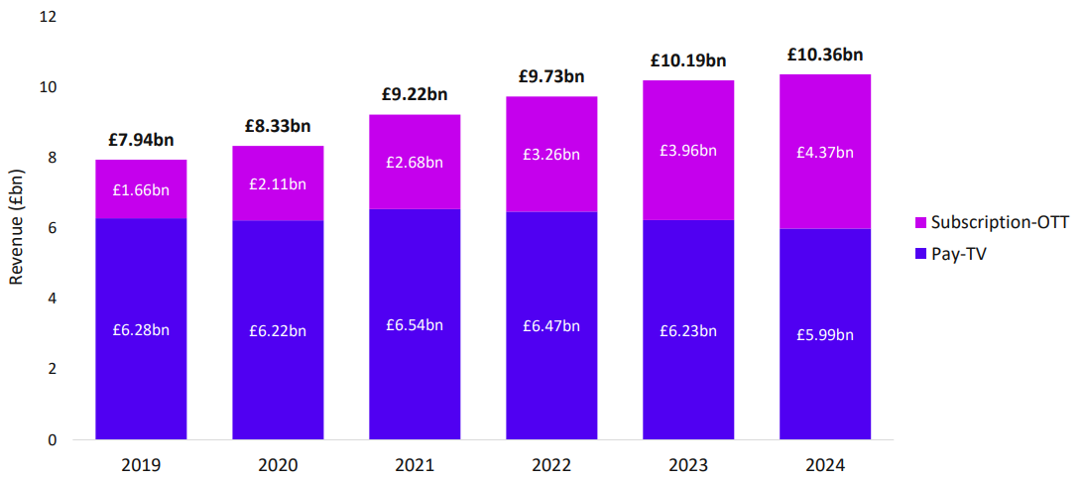
Figure 1: Revenue of Subscription-OTT
(Source: Ofcom, 2025)
The analysis of the macro marketing environment is therefore a critical requirement due to the fact that strategic decisions are more influenced by external forces instead of the mere growth in the audience. This report will analyze the Technological and Economic forces that are influencing Netflix and Disney+ and then discuss the strategic response of the two companies based on Porter's Generic Strategies.

2. Task 1: Critical Analysis of the Macro Marketing Environment

2.1 Macro Marketing Environment
This application of the PESTLE framework as a macro-environmental analysis tool is due to its ability to determine the overall market pressures that are external to an organisation that determine market conditions, consumer behaviour, investment priorities and competitive strategy (Qadri and Tariq 2025). Technological and Economic factors are the most strategic in the case of subscription video streaming, thus they are given priority over other macro influences (Lotz and Eklund 2024). The central focus is on technological pressure because competition relies on the quality of the platform, recommendation algorithm, the ability to advertise, the provision of content, and personalisation based on data (Yang, 2025). With the world anticipated to have USD 416.8 billion in the video streaming industry by the year 2030, technological changes are worth the strain (Grand View Research, 2025). Economics also play a key role since the readiness of consumers to use multiple subscriptions is becoming more sensitive to price, with 47% of consumers reporting that they spend too much on streaming services and 41% that content is not worth the price (Deloitte, 2025). These two aspects are thus the most pertinent since they directly influence competition, retention, monetisation, and positioning in a maturing streaming market.
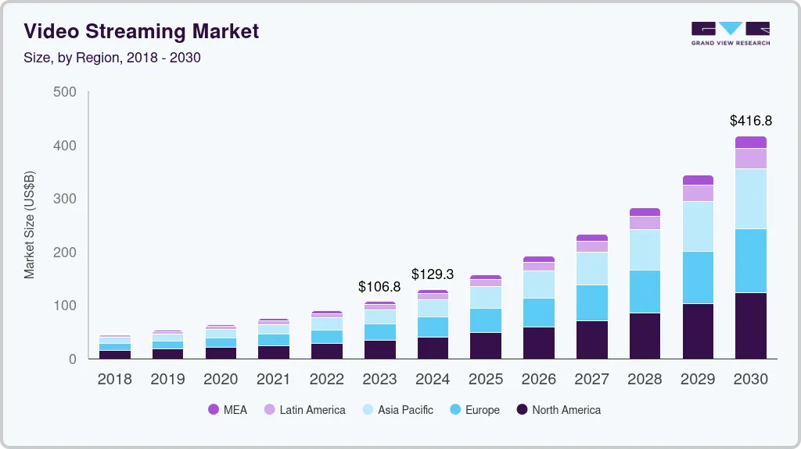
Figure 2: Video Streaming Market
(Source: Grand View Research, 2025)

2.2 Analysis of Macro Factor 1: Technological

2.2.1 Impact on the Pioneer Organisation: Netflix
In the case of Netflix, the Technological factor is primarily an opportunity, but it also poses pressure to maintain an advantage (Nelsa et al., 2025). The reason is that subscription streaming is currently competing with platform performance rather than content. In May 2025, the proportion of television watching, according to streaming, reached 44.8 percent in the US, which means that the competitive strength has shifted decisively to digitally delivered viewing conditions (Nielsen, 2025) [Refer to Appendix]. Its streaming service was introduced in 2007, providing the company with a significant first-mover platform capability, algorithmic learning, and user data accumulation (Netflix, 2016). Even that technological advantage remains commercially desirable. At the end of 2025, Netflix had more than 325 million paid memberships, revenue was up 16% to $45.0 billion and operating margin rose to 29.5% which points to scale and technological maturity as still supporting monetisation and efficiency (Netflix, 2026). This argument is also supported by consumer outcomes. According to Ofcom, 83 percent of Netflix subscribers rated the service as satisfying, the highest in the survey of the leading SVoD sites, implying that the quality of recommendations, usability and platform consistency continue to be competitive advantages (Ofcom, 2025). Nonetheless, this advantage is getting more difficult to hold on because streaming technology is no longer that rare, so Netflix has to continue renewing its platform edge.
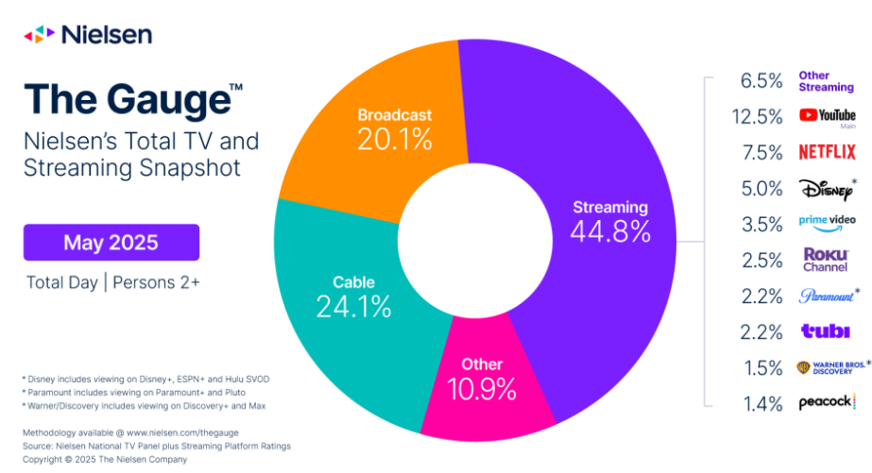
Figure 3: Streaming Industry Snapshot
(Source: Nielsen, 2025)

2.2.2 Impact on the Follower Organisation: Disney+
In the case of Disney+, the Technological factor is an opportunity as well as a threat. The potential opportunity is in the further growth of streaming-based viewing in the US which offers well-invested platforms space to increase digital interactions and monetisation (Nielsen, 2025). However, it poses a greater risk to Disney+ since the platform was launched in 2019, at the time, when the platform standards, expectations of the user, and streaming habits were already molded by the previous competitors (Disney, 2019). Disney+ has already attained a big scale, achieving 132 million subscribers in fiscal Q4 2025, and 196 million Disney+ and Hulu subscriptions combined, which nevertheless places it in a smaller standalone position compared to Netflix (Disney, 2025a). That is important because small scale impairs data collection and technological lag reduction becomes harder. This pressure is also evident in the cost base of Disney. According to its 2025 annual report, the growth in depreciation and amortisation is partially due to increased investment in technology assets, indicating that platform capability is an expensive competitive investment, but not an entry investment (Disney, 2025b). Moreover, since January 2025, Nielsen has been moving Disney+, Hulu, and ESPN+ under one Disney Streaming brand, implying that Disney technological reaction will become less about the potential of Disney+ as an independent force (Nielsen, 2025a). Disney+ thus is weaker than Netflix in platform maturity and monetisation design, but it is equally flexible given that Disney can integrate technology investment and strong intellectual property and bundle based platform integration. The market position implication is that Disney+ is technologically relevant, but it has not translated technologically relevancy into technological leadership.

2.3 Analysis of Macro Factor 2: Economic

2.3.1 Impact on the Pioneer Organisation: Netflix
In the case of Netflix, the Economic factor is a threat as well as an opportunity. The potential threat is increased price sensitivity and a fragile desire to continue paying to receive various services (Liu et al., 2026). In a study, 47 percent of US consumers reported that they pay too much to stream services, 41 percent thought that SVoD content does not justify the cost, and the amount that people spend on four paid streaming services increased from $61 to $69 per month on average (Deloitte, 2025). It implies that even the market leader will be subjected to stricter value-inspections in a more established subscription economy. Investor disappointment also occurred as Reuters reported when Netflix revenue outlook could not retain the high expectations, indicating that scale does not shield the company against pressure to perform in the economy (Reuters, 2025). However, the same environment opens opportunities as well. According to Deloitte, 54% of SVoD subscribers have taken at least one ad-supported product now, and the market average price of an ad-supported product tier is around $9 per month, which is near $10, consumers consider acceptable (Deloitte, 2025). This helps Netflix to monetise in a more flexible way than their smaller competitors. The competitive advantage implication is that Netflix is still more economically resilient, although the advantage has shifted to monetisation quality and pricing discipline instead of subscriber volume.

2.3.2 Impact on the Follower Organisation: Disney+
In the case of Disney+, the economic factor is particularly significant since the follower should demonstrate that scale can be turned into profit. This threat is more significant due to the price-sensitive consumers who tend to churn (Zhang, 2025). Deloitte reported that 39% of customers had already canceled one paid SVoD within the past six months, and 60% indicated that an increase in price by $5 was likely to make them cancel their favourite service (Deloitte, 2025). The pressure is considerable to Disney+, whose economic stand is at a disadvantage compared to Netflix. According to Ofcom revenue data, Disney+ earned £482 million in UK SVoD revenue in 2024, compared with £1.854 billion by Netflix, reflecting a significantly smaller revenue foundation in a mature market (Ofcom, 2025). It was also reported by Reuters that Disney increased the price of the US Disney+ once again in 2025, which highlights the conflict between monetisation and retention (Reuters, 2025a). Nevertheless, Disney demonstrates flexibility as well. Its Direct-to-Consumer operating income increased by 143 million in fiscal 2024 to 1.327 billion in fiscal 2025 which indicates a far stricter economic response (Disney, 2025a). The market position implication is that Disney+ is not as strong as Netflix in terms of revenue and market penetration, although the improving profitability is evidence that having follower status does not necessarily imply strategic weakness.
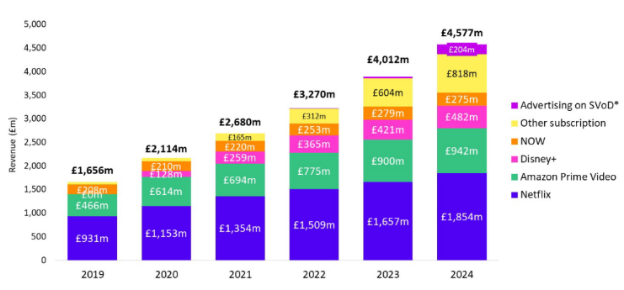
Figure 4: SVoD Revenue Comparison of Netflix and Disney in UK
(Source: Ofcom, 2025)

3. Task 2: Strategic Responses of Pioneering and Follower Organisations

3.1 Pioneering Organisation’s Strategic Responses: Netflix
The response of Netflix to Technological and Economic pressures as analyzed in Task 1 can be analyzed through Porter's Generic Strategies as they identify the various types of cost leadership, broad differentiation, cost focus and differentiation focus (Porter, 1985). The best classification in the case of Netflix is broad differentiation, since its strategic response is constructed around the provision of unique value to a mass global market through platform quality, precision of recommendations, wide content selection, and a more flexible monetisation instead of low price.
This reaction is very applicable to the technological challenge. Since streaming technology has become a primary area of competition, Netflix has been attempting to guard competitive advantage by enhancing the user experience beyond just increasing access. The platform scale built over a long time is significant here. Netflix has 301.6 million memberships at the end of 2024, US$39.0 billion of revenue, US$10.4 billion of operating income and a 27% operating margin, indicating that the platform maturity and data-driven personalisation continue to bring commercial returns (Netflix, 2025). The same distinction is reflected in customer outcomes. Ofcom discovered that 83 percent of Netflix subscribers were satisfied with the service, the greatest among the principal SVoD providers it surveyed (Ofcom, 2025). This implies that the technological response as applied by Netflix is not only functional. It reinforces the perceived value and retention.
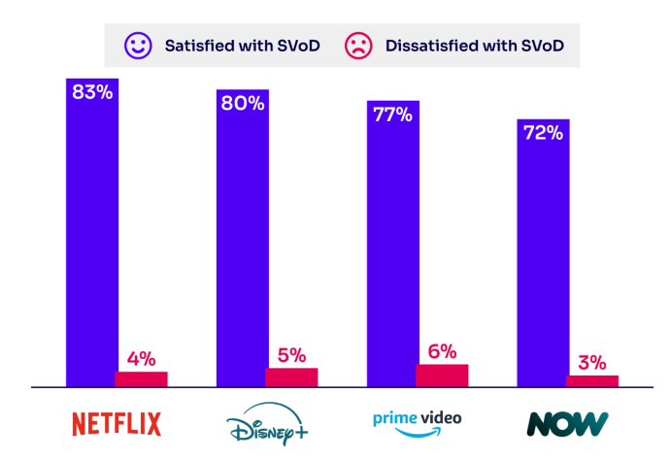
Figure 5: Satisfaction rate of customers with Netflix
(Source: Ofcom, 2025)
The reaction to the economic problem is much more complicated in the case of Netflix, as streaming markets have become more price receptive. Deloitte discovered that 47 percent of US consumers think they are overpaying on streaming services and 54 percent of the SVoD subscribers are subscribers to one of the ad-supported streaming services (Deloitte, 2025). Netflix has also reacted by making things affordable without foregoing differentiation. Reuters noted that Netflix's ad-based subscription had 94 million subscribers by May 2025, indicating that ad-supported is no longer a foregone conclusion when it comes to responding to pressure on values as a strategy but a core feature (Reuters, 2025b). The reason behind this is that Netflix can guard revenue but can still adapt to the fluctuating consumer willingness to pay.
Nevertheless, the plan is efficient but under pressure. Amazon also integrated advertising to Prime Video, and Peacock also changed pricing, and tier structure, indicating that competitors are reacting to the same financial pressures in a similar fashion (Reuters, 2023; Reuters, 2025c). The pioneer advantage possessed by Netflix thus still is as powerful but is now less defended through early entry and more through the capacity of the firm to do broad differentiation better than competitors that have ever gained more capability in the same field.

3.2 Follower Organisation’s Strategic Responses, Disney+
Differentiation is also the most appropriate approach to evaluating the strategic response of Disney+ to the Technological and Economic challenges presented in Task 1. Disney+ is responding to external pressure by exclusive franchise content, family-value brand and bundle-based integration of ecosystems, particularly between Disney+, Hulu, and ESPN+, and not through the maturity of any single platform.
This reaction is seen most where technological challenge is concerned. The strategy of Disney+ has been reactive, as its entry in 2019 came after streaming norms were already established by other competitors (Disney, 2019). The integration of multi-service functionality to disaggregate digital responsiveness at Disney to Disney+, Hulu, and ESPN+ beginning in January 2025 represents the increasing significance (Nielsen, 2025). This is a strategic move as it enables Disney to counterbalance the lack of maturity in standalone platforms with the maturity of the ecosystem. Disney announced 132 million Disney plus subscribers and 196 million Disney plus and Hulu subscriptions combined in fiscal Q4 2025 and also recorded increased depreciation and amortisation part of which is attributed to investment in technology assets, reflecting that competitiveness yet again only requires costly technological upgrades (Disney, 2025a; Disney, 2025b).
The responses to the financial crisis are more powerful. Disney+ is more vulnerable than Netflix to price-sensitive customers, but it has been responsive by balancing price increases with enhanced monetisation. In 2025, Disney raised US Disney+ prices once more to enhance the profitability of streaming (Reuters, 2025a). More crucially, its Direct-to-Consumer operating income increased as compared to US$143 million in fiscal 2024 to US$1.327 billion in fiscal 2025, which is a sign of a better disciplined economy (Disney, 2025a). Examples in the industry demonstrate that this response is also strategic. HBO Max started raising its prices to all US levels in October 2025 as the cost of content increased and subscriber growth decelerated, and Apple TV+ raised its price to US$12.99 in the US in August 2025 as it faltered to narrow the scale gap with larger competitors (Reuters, 2025d; Reuters, 2025e). Disney+ thus continues to be weaker than Netflix in platform-based differentiation, and its IP-based and bundle-based broad differentiation has become a more effective method to maintain competitiveness as the technology and economy pressures.

4. Conclusion
The conclusion of this report is that subscription video streaming is an older and more strategically challenging market where competitive success is less about the mere growth of subscribers and more about the responsiveness of firms to external change. The analysis revealed that the most crucial forces that influence the rivalry, retention, monetisation, and market position are Technological and Economic factors. The opportunity is provided by the quality of platforms, the ability to recommend, and delivery performance, but competition also increases due to the ease with which the advantages of a type of technological change can be copied. This pressure is further worsened by the economic conditions as price sensitivity and subscription fatigue have rendered perceived value to be a core aspect of competitive performance.
In this environment, Netflix is the superior firm since it transformed early entry into maturity of the platform, scale and more flexible monetisation. Its reaction can be described as wide differentiation created based on platform quality, customer experience, and value flexibility made possible through advertisements. Disney+ is still the follower, but it is not strategically weak. Its differentiated reaction, grounded more on franchise content, bundle integration and enhancing profitability has fortified its stance despite still lagging behind Netflix in platform-based benefit. The broader conclusion is that environmental scanning and responsive marketing is necessary. With the streaming market maturing, companies that can more effectively change digital capability, pricing and value delivery as compared to their competitors are better placed to remain competitive in the long run.

5. References
Deloitte (2025) 2025 Digital Media Trends, Deloitte. Available at: https://www.deloitte.com/us/en/insights/industry/technology/digital-media-trends-consumption-habits-survey/2025.html (Accessed: 24 March 2026).
Disney (2019) Disney+ launches today and a new era of Disney entertainment begins, The Walt Disney Company. Available at: https://thewaltdisneycompany.com/news/disney-launches-today-and-a-new-era-of-disney-entertainment-begins/ (Accessed: 24 March 2026).
Disney (2025a) The Walt Disney Company Reports Fourth Quarter and Full Year Earnings for Fiscal 2025, The Walt Disney Company. Available at: https://investors.thewaltdisneycompany.com/files/doc_events/2025/11/q4-fy25-earnings.pdf (Accessed: 24 March 2026).
Disney (2025b) Fiscal Year 2025 Annual Financial Report, The Walt Disney Company. Available at: https://investors.thewaltdisneycompany.com/files/doc_financials/2025/ar/2025-Annual-Report.pdf (Accessed: 24 March 2026).
Grand View Research (2025) Video Streaming Market Size and Share, Industry Report, 2030, Grand View Research. Available at: https://www.grandviewresearch.com/industry-analysis/video-streaming-market (Accessed: 24 March 2026).
Liu, X., Zhou, B., Qi, W. and Wang, J. (2026) Service pricing and charging strategy for video platforms considering consumer preferences. International Transactions in Operational Research, 33(1), pp.567-602.
Lotz, A.D. and Eklund, O. (2024) Beyond Netflix: Ownership and content strategies among non-US-based video streaming services. International Journal of Cultural Studies, 27(1), pp.119-140.
Nelsa, P., Paradita, A.X., Hermawan, F.F., Ghifari, M.Y. and Lubis, M. (2025) Netflix's Digital Transformation Strategy: A Systematic Review of Challenges and Risk Mitigation Approaches. JIPI (Jurnal Ilmiah Penelitian dan Pembelajaran Informatika), 10(2), pp.1133-1143.
Netflix (2016) Netflix is now available around the world, Netflix. Available at: https://about.netflix.com/en/news/netflix-is-now-available-around-the-world (Accessed: 24 March 2026).
Netflix (2025) Form 10 K 2024, Netflix. Available at: https://www.sec.gov/Archives/edgar/data/1065280/000106528025000044/nflx-20241231.htm (Accessed: 24 March 2026).
Netflix (2026) Final Q4 2025 Shareholder Letter, Netflix. Available at: https://s22.q4cdn.com/959853165/files/doc_financials/2025/q4/FINAL-Q4-25-Shareholder-Letter.pdf (Accessed: 24 March 2026).
Nielsen (2025) Streaming Reaches Historic TV Milestone, Eclipses Combined Broadcast and Cable Viewing for First Time, Nielsen. Available at: https://www.nielsen.com/news-center/2025/streaming-reaches-historic-tv-milestone-eclipses-combined-broadcast-and-cable-viewing-for-first-time/ (Accessed: 24 March 2026).
Nielsen (2025a) The Gauge: FOX’s Successful Cross Platform Super Bowl Strategy Drives a Huge Day in Television Viewing, Nielsen. Available at: https://www.nielsen.com/news-center/2025/the-gauge-foxs-successful-cross-platform-super-bowl-strategy-drives-a-huge-day-in-television-viewing/ (Accessed: 24 March 2026).
Ofcom (2025) Media Nations 2025 UK Report, Ofcom. Available at: https://www.ofcom.org.uk/siteassets/resources/documents/research-and-data/multi-sector/media-nations/2025/media-nations-2025-uk-report.pdf?v=401287 (Accessed: 24 March 2026).
Porter, M.E. (1985) Competitive Advantage: Creating and Sustaining Superior Performance. New York: Free Press.
Qadri, A.U. and Tariq, M. (2025) SWOT and PESTLE Analyses in Strategic Business Planning. International Journal of Modern Research in Management, 2(01), pp.34-44.
Reuters (2023) Amazon to roll out ads on Prime Video in 2024, Reuters. Available at: https://www.reuters.com/business/media-telecom/amazon-starts-ads-prime-video-2024-2023-09-22/ (Accessed: 24 March 2026).
Reuters (2025) Netflix slumps as revenue forecast disappoints lofty investor expectations, Reuters. Available at: https://www.reuters.com/business/media-telecom/netflix-slumps-revenue-forecast-disappoints-lofty-investor-expectations-2025-10-22/? (Accessed: 24 March 2026).
Reuters (2025a) Disney+ to raise subscription prices for fourth consecutive year, Reuters. Available at: https://www.reuters.com/business/media-telecom/disney-raise-subscription-prices-fourth-consecutive-year-2025-09-23/? (Accessed: 24 March 2026).
Reuters (2025b) Netflix says ad supported service has 94 million subscribers, Reuters. Available at: https://www.reuters.com/technology/netflix-says-ad-supported-service-has-94-million-subscribers-2025-05-14/ (Accessed: 24 March 2026).
Reuters (2025c) Comcast’s Peacock to raise streaming prices next week and introduce new streamlined tier, Reuters. Available at: https://www.reuters.com/business/media-telecom/comcasts-peacock-raise-streaming-prices-next-week-introduce-new-streamlined-tier-2025-07-17/ (Accessed: 24 March 2026).
Reuters (2025d) HBO Max hikes prices in US for second time in less than 18 months, Reuters. Available at: https://www.reuters.com/business/media-telecom/hbo-max-hikes-prices-us-second-time-less-than-18-months-2025-10-21/ (Accessed: 24 March 2026).
Reuters (2025e) Apple boosts subscription price for TV+ to $12.99, Reuters. Available at: https://www.reuters.com/business/media-telecom/apple-boosts-subscription-price-tv-1299-2025-08-21/ (Accessed: 24 March 2026).
Yang, Q. (2025) Application of Recommendation System Technology and Architecture in Video Streaming Platforms.
Zhang, A., (2025) Pricing Strategy Dynamics of Streaming Giants and Their Impacts on Consumer Decision-Making Behaviors. Finance & Economics, 1(6).

