Cover Page
Module Name: Managing Projects in the Workplace
Module Code: BMSW5104
Student Name: Luigi Stefan Butoi
Student Number: 1816330
Lecturer: Daminabo Pokubo

Table of Content:
1. Introduction………………………………………….……………………………….2
2. Main Body:
- Project outline / description / scope based of the project…………….……2
- Stakeholder analysis……………………………………………………….….2
- Work Breakdown Structure (WBS)………………………………………….. 3
- Costs/resources………………………………………………………….……..5
- Project Schedule / Gantt Chart……………………………………………….6
- Project network………………………………………………………………….6
- Risk Assessment…………………………………………………………….…7
3. Conclusion……………………………………………………………………..….....8
4. References………………………………………………………………………..….9

Introduction:
This report will be focused on the development of a project management plan that will help a pharmaceutical business retry to introduce a new product to the market after a failure in the past. The project management plan will include a project outline, scope based of the project, stakeholder analysis, work breakdown structure, costs and resources, project schedule (Gantt chart), project network and risk assessment. A project is a short-term endeavour performed to develop a one-of-a-kind product, service, or outcome. The scope of the project comprises all of the work that is necessary, as well as merely the work that is required. Project Time Management refers to the length, order, and interdependence of project operations. Project Human Resources: project team members' roles, duties, and performance. Project Communications Management entails the gathering, dissemination, and application of project-related data McAlister, D.T., (2006). Project management plans are a very good way of planning and organising the start to finish process of any kind of project which will help the project manager to analyse and identify any weaknesses in the project process and fix them.
Main Body:
1). Project outline / description / scope based of the project
After a previous attempt in launching a new multivitamin product on the market, the pharmaceutical company requires a new project management plan in order to give this product a second try and launch on the market successfully. Without a project management plan, the product cannot be launched successfully due to lack of organisation and data stored and analysed into a well organised plan. Individuals must have prior experience and on-the-job training in order to be considered for these positions. Formal project management education, on the other hand, is in great demand due to the potential benefit it may provide Duncan, W., R., (1993). This project is focused on the achievement of the desired sales target, gain traction with the desired customers, hospitals, and stores, with the lead of the pharmaceutical company gaining dominance in a very competitive market with boosted profits compared to previous attempts. The competitive market is making the launch of a new product very difficult, the multivitamin product needs to have something that other products on the market do not have in order to gain attention from customers and stores, so in order to achieve these targets, the project needs to be focused on a good method of marketing, manufacturing of the actual product but also the organisation of the management team that will be in charge of this new product launch. In order to achieve these desired profits, the product must lower the manufacturing costs to a level where quality is still competitive and up to standards, in order to do this, the multivitamins themselves can remain the same within the specified standards and ingredients but the packaging can be changed to lower manufacturing costs, for example use recycled materials to produce the multivitamins containers, this will also give the brand a good environmental impact and reputation when advertised.
2). Stakeholder analysis
Clarkson, M. (1995) defines stakeholders as ‘persons or groups that have, or claim, ownership, rights, or interests in a corporation and its activities, past, present, or future.’ He categorizes them as primary stakeholders, who are essential to the survival and wellbeing of the organization. The stakeholders are divided into two categories: internal stakeholders and external stakeholders.
- Internal stakeholders are very important to any organisation because these stakeholders determine the end result of a products and the process of production. Employees, management, project team and accountants are part of internal stakeholders, so in order to determine the importance, interest, and influence of these stakeholders the following table has been created.
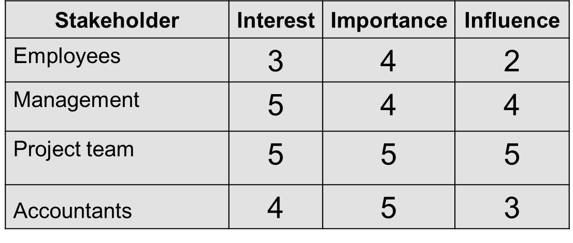
- External stakeholders have an important role and a high influence towards the launch of a new product because based on these external factors the product will be successful or not. The following table shows the levels of importance and influence from the external stakeholders.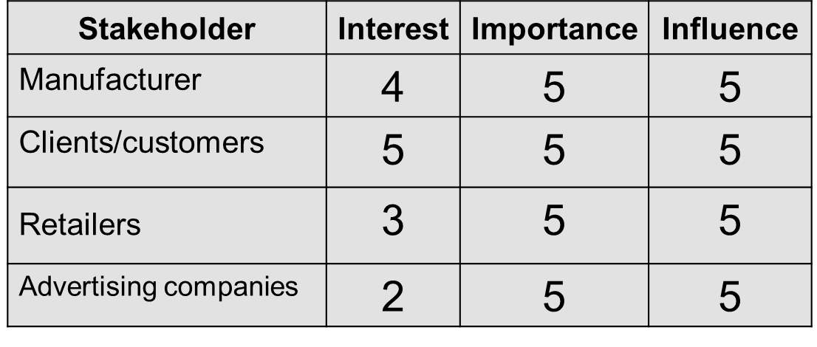
Based on the tables above we can identify the fact that internal and external stakeholders have a different approach to the product, the internals ones have a higher interest in producing the product and launching it because they have an expected outcome and desired profits from it but with a relatively lower influence than the external ones because there is not much they can do to improve the product launch. The external stakeholders, however, have a lower interest in the new product due to the very competitive market in which similar products are already launched and gaining profits, but the importance and the influence of these stakeholders is very high for this new multivitamin product because they can make the difference in making, marketing / promoting, and selling this new product into the market.
3). Work Breakdown Structure (WBS)
The Work Breakdown Structure, or WBS, is an important component of a project's lifespan and timetable. The WBS, which is an important aspect of project planning, starts with a hierarchy of activities and levels that assist outline how the project will flow within the project manager's planned timeframe. Any project's success depends on the use of a WBS to define where the project will begin, what stages, levels, and tasks will be first, second, third, and so on, as well as the project's duration. Skipping the WBS might result in delays, muddled tasking, and project overruns. The WBS also aids in defining the project's details as described in the project scope Devi, T.R. and Reddy, V.S., (2012).
The work breakdown structure for the multivitamin product is very complex and requires a detailed visual graph which simplifies the categories and steps which the project will undertake for the launch of the new product.

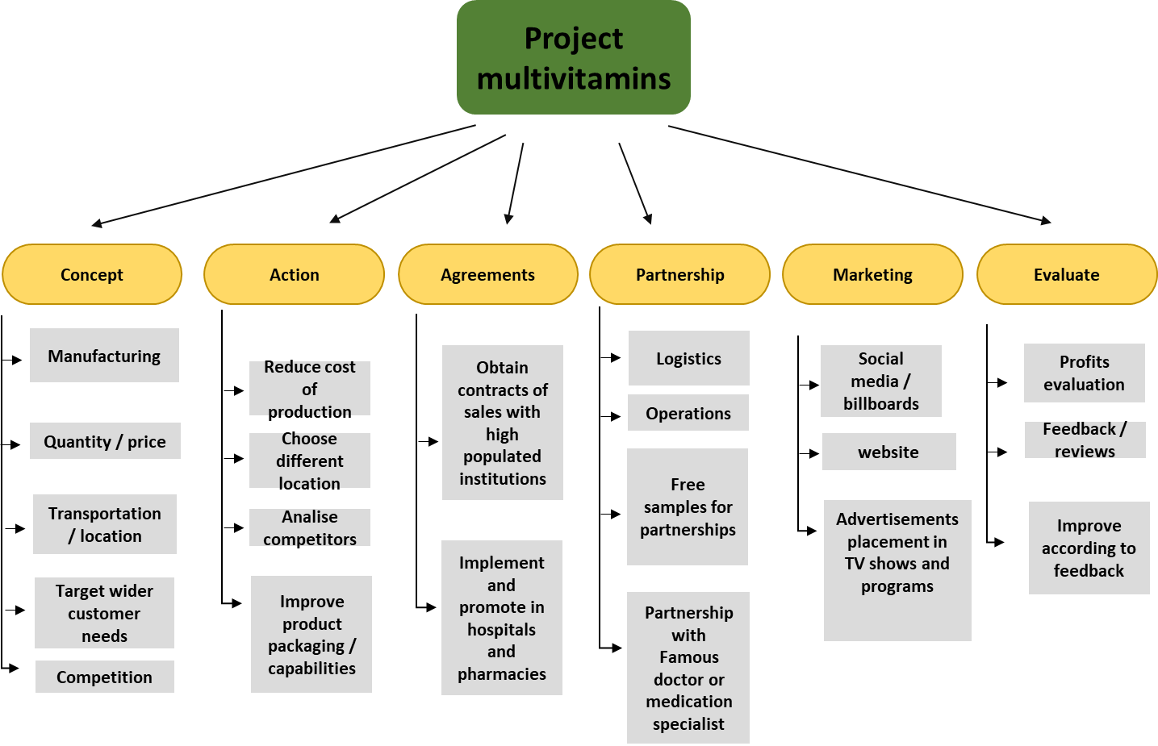
There are six steps from start to finish of the project which will cover all the work that needs to be done in order to make the new multivitamin product successful in this competitive market.
- The Concept of the product is focused on the manufacturing of the product and what quantities it should have, the market needs to be evaluated and determine a good quantity, and target wider customer needs which other competitors cannot do. At this stage transportation of the product and location of the production is also determined targeting a place where transport costs are lower and rent/warehouse prices are lower too.
- Action is the second stage of the project, where action is taken to identify and rectify the things that did not work well in the previous attempt in launching this product into the market. The cost of production can be reduced by improving the packaging with recycled materials, choose a different location where the product is launched if needed, analyse the competitors, and evaluate what things go well with their products.
- Agreements is the stage within the project where the business obtains different contracts of sales with high populated institutions like hospitals and pharmacies in order to sell and promote this product. The agreements are very important because they offer good marketing and sales towards the business, making the brand well known and expand quickly due to the high flow of customers and patients in these institutions which might have the high demand for these multivitamins.
- Partnerships is the process in which the business can expand even more beyond the usual places where multivitamins are sold, for example, in this current times, online influencers on different social media accounts like Facebook, TikTok and YouTube can gain more sales due to their high number of followers which might find this product useful and try it. Also, free samples are also a good marketing strategy offering the customers the opportunity to try the new product without spending money, and when the customer needs are achieved it can result in more sales and spread of awareness about this product.
- Marketing stage can be expanded through different advertisements targeting all kinds of customers, via TV advertising, billboards, website, and social media. The most effective marketing method in the past few years has been social media where the platforms expand daily and gain more users, the chances of finding the right customers are higher on social media.
- Evaluation is the last step in this project where the organisation evaluates all the data collected throughout the other stages and improve the actions and product accordingly. Data collection, feedback and reviews are very important for any new product in a competitive market because if good feedback and reviews are received, most of the customers tend to go for the higher rated product even if price is a bit higher than other competitor products, but this feedback give the assurance of quality and meet the customer requirements.
4). Costs/resources
Costs for the development of process descriptions, the creation of Project management manuals, and the establishment of project management processes within organisations, as well as consultancy fees, operating costs for PM-related processes, governance costs, and the costs of operating a project portfolio board, are all examples of organisational costs Lappe, M. and Spang, K., (2014).
After some research, average costs of launching a new product at a small scale into the market can average between £50.000 and £200.000 depending on the area, if the product is launched international or national, how much advertising is required, manufacturing costs, etc. these numbers can not be predicted exactly because the different actions need to be taken accordingly while the project is put in place so costs can stay low or they can increase to a certain maximum point which the company is willing to spend. The following table shows an approximate cost analysis for launching the new multivitamin product with a total of £50.000 and also the number of days these actions need to be in place.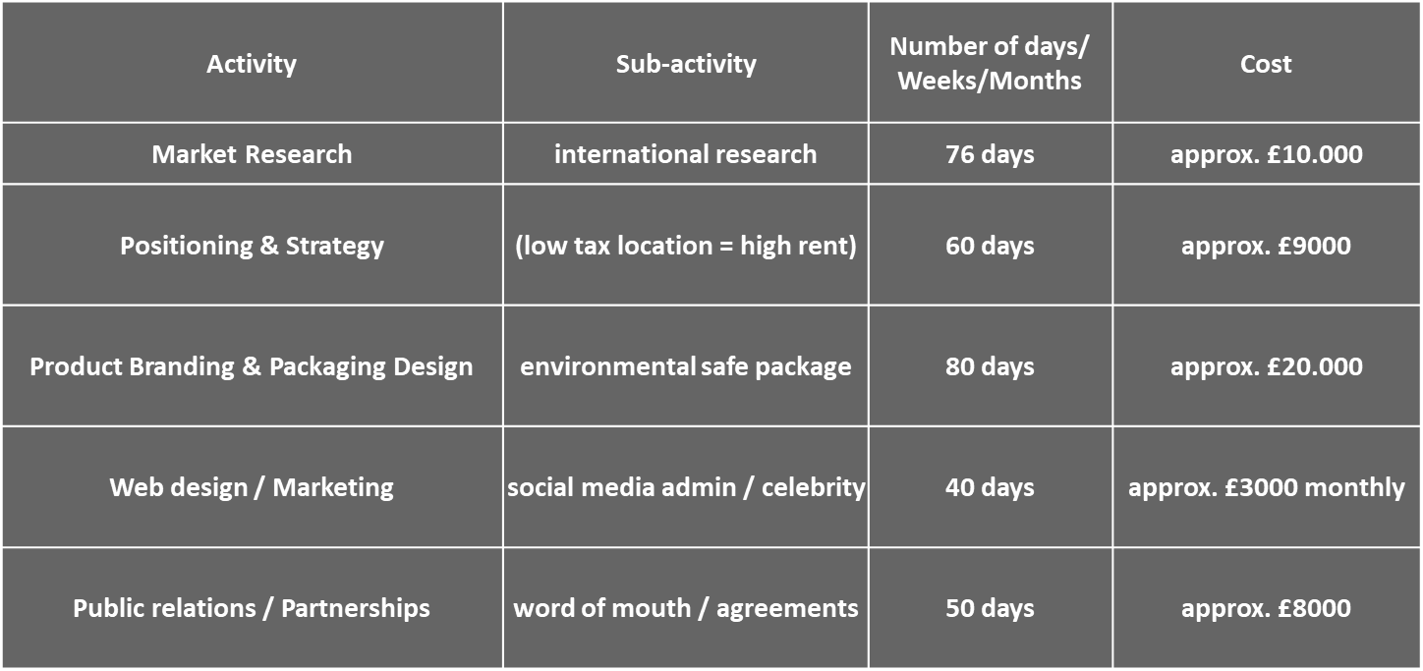
5). Project Schedule / Gantt Chart
The project schedule is a very important stage in any project management plan, this schedule helps to identify how long each task will take in order to achieve the project goal and what dates to expect for the finalising of the separate stages. In order to accurately represent this project schedule, Gantt chart should be used. “A Gantt chart is a popular sort of bar chart that shows the progress of a project. The start and completion dates of a project's endpoint and summarizing parts are depicted using Gantt charts” Gantt, H., (2015). The prominence of Gantt charts in project management appears to have sparked its adoption in other fields, particularly when showing scheduling information is critical. In some situations, these are a comeback to formerly popular applications.
The following Gantt chart illustrated the time periods each step will take for the multivitamin product launch:
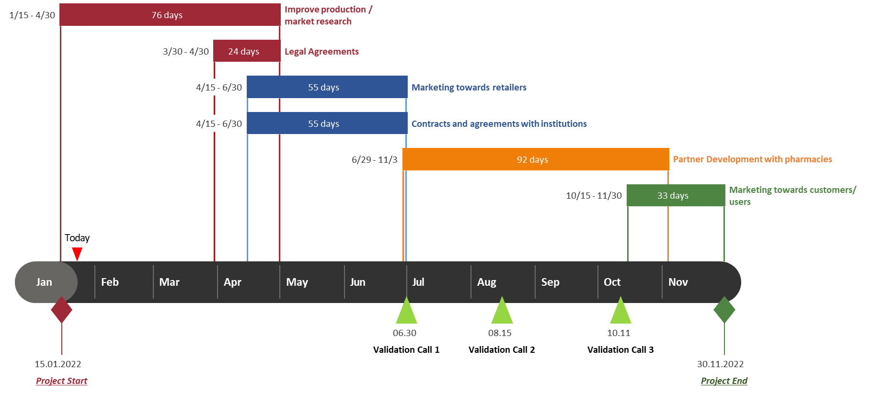

6). Project network
Project managers are occasionally confronted with projects with which they have no prior expertise. As a result, the inputs to a network analysis (i.e., activity periods and precedence’s) would be uncertain McCahon, C.S. and Lee, E.S., (1988). Project network consists of all the activities within the project management plan and what is the actual order of these activities that need to be completed in order to achieve the project outcome. Project network usually helps in organising the tasks in order and makes the project a lot easier to understand and put in action. The following project network diagram shows the order of the actions that need to be taken throughout this project for launching the new multivitamin product.
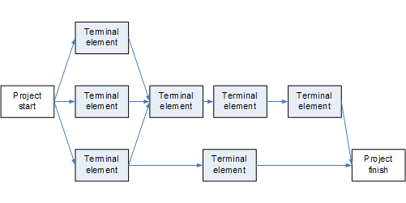
Improve production
Market research
Legal Agreements
Marketing towards retailers
Contracts and agreement with institutions
Partner development
Marketing towards customers

7). Risk Assessment
Risk management is a method for identifying, evaluating, managing, and communicating risk. It is concerned with resolving the tensions that arise from pursuing possibilities on the one hand and avoiding losses, mishaps, and disasters on the other Aven, T. and Vinnem, J.E. (2007). There are a variety of risks associated with launching a new product, including commercial risks where the product does not comply with local rules or health warnings, legal, environmental, and regulatory risks where the product does not meet the appropriate safety standards for local authorities, such as chemicals used in packaging, different plastic materials, or the age group to which the multivitamins can be administered. Manufacturing and the production phase of the product, as well as, most crucially, marketing risks, where the product may not obtain the desired attention from consumers and associations, are examples of technical and operational hazards. In order to overcome these risks, the project management team need to focus on how to prevent those risks and if they do occur, how to achieve a better result by changing the tactics, taking for example the commercial risk where the product might not meet the local rules and laws, this can be fixed by delivering the product to a different location if the product can not be modified in order to comply with those laws. Different risk assessment approaches, such as fishbone diagrams and risk score matrixes, can be used to reduce these risks. The following matrix shows a number of risks for the multivitamin project and the importance and likelihood of happening.
Risk | Importance  Impact | Likelihood  Probability
Collaborators uncooperative | H | M
Transportation prices too high | L | M
Influencers refuse the partnership | H | L
Multivitamins cause allergic reactions | H | M
Hospitals refuse to promote | M | L
Manufacturing failure / supply shortage | H | L
Negative feedback received | H | L
Customer satisfaction / needs not met | H | L

Conclusion
People frequently refer to any work they must do as a "project." Projects are defined in a very precise way. A set of activities or labour to be completed cannot be labelled a project if it does not fit the precise criteria. You must first have a project in order to apply the project management strategies provided in this book. A project is a collection of distinct, interconnected operations with a single aim or purpose that must be completed on time, on budget, and according to specifications Wysocki, R.K., (2011). A very unpredictable environment is being created by rapid and dramatic changes in customer needs, market, technology, and competition behaviour. Businesses in a competitive position confront new market problems, which can have a substantial impact on their financial status. It is critical to improve the firm's capacity to deal with these issues as economic patterns shift in order to fulfil corporate objectives in such complicated scenarios. Organizations that are unable to adjust to these developments may lose their competitive advantages Singh, D., et al. (2012). In order to succeed with launching a new product, a good project is required to organise and keep track of all the processes needed for the launch and collect all the necessary data in order to be analysed and transformed into information which can be useful to determine what is going wrong with the product and what is going well.
The multivitamin product should be a successful product even though there is a very competitive market, the strategy presented in this project should improve the new product launch with a positive profit gain and dominance in the pharmaceutical industry. There will be multiple risks and challenges in order to achieve this goal, however, with good planning and organising management team the project has a high potential of succeeding.

References:
- Aven, T. and Vinnem, J.E. (2007), Risk Management: With Applications from the Offshore Petroleum Industry. London: Springer.
- Clarkson MBE. 1995. A stakeholder framework for analysing and evaluating corporate social performance. Academy of Management Review 20(1): 92–117.
- Devi, T.R. and Reddy, V.S., 2012. Work breakdown structure of the project. Int J Eng Res Appl, 2(2), pp.683-686.
- Duncan, W.R. (1993). The process of project management. Project Management Journal, 24 (3), 5-10.
- Gantt, H., 2015. Gantt chart.
- Lappe, M. and Spang, K., 2014. Investments in project management are profitable: A case study-based analysis of the relationship between the costs and benefits of project management. International Journal of Project Management, 32(4), pp.603-612.
- McAlister, D.T., 2006. The project management plan: Improving team process and performance. Marketing Education Review, 16(1), pp.97-103.
- McCahon, C.S. and Lee, E.S., 1988. Project network analysis with fuzzy activity times. Computers & Mathematics with applications, 15(10), pp.829-838.
- Singh, D., Oberoi, J.S. and Ahuja, I.S. (2012) “A conceptual examination of impact of dynamic capabilities in managing strategic flexibility in manufacturing sector”, International Journal of Business Continuity and Risk Management,Vol. 3 No. 3, pp 187- 205.
- Wysocki, R.K., 2011. Effective project management: traditional, agile, extreme. John Wiley & Sons.

