DATA HANDLING AND BUSINESS INTELLIGENCE

Student name: Marian Cosmin Vilaia

Student number: 2113634
Module Code: LCBB5000
Lecturer : Eric Osei

Supermarket Sales Data Analysis
Introduction
Data is one of the elements that are crucial in numerous sectors across the globe. The volume of data that is accessible combined with the availability of various tools to assess the data makes the possession of data analysis skills important in the 21st century (Sheng et al., 2019). According to Araz et al. (2020), data handling, an element of data analysis, involves the process of collecting, assessing, recording, and presenting data in a format that is easy to comprehend among various target audiences. Businesses in the 21st century regularly deal with big data due to a large number of individuals across the globe and the various variables that characterize consumers (Sheng et al., 2019). Data analysis has therefore proven to be a critical element among businesses whose desire is to make informed decisions. A supermarket is an example of a business enterprise that requires data analysis skills due to the high level of data and competition associated with the industry (Lin et al., 2021). An assessment of how data analysis skills can be applied in supermarkets aids in revealing how data analysis facilitates the process of making informed business decisions.
Data visualisation is a process of presenting information in a visual format. According to Waskom (2021), data visualisation makes it easy for the target audience to comprehend and interpret information. Sievert (2020) states that a dashboard entails a deliberate collection of various data visualisations organized on a single screen. Visualisations contained in a dashboard may include charts, graphs, and gauges (Waskom, 2021). A data visualisation dashboard aids in providing a snapshot of the target data in a visual format. Sievert (2020) also reveals that users of data visualisation dashboards receive tailored information, which is easy to comprehend resulting in fast and informed decisions. Enterprises commonly use data visualisation dashboards to display their key performance indicators (KPIs) (Ajah &Nweke, 2019). Data visualisation dashboards are powerful tools that businesses have used to leverage their data so that they can obtain better and desired business outcomes.
Supermarket Data Visualisation Dashboard
The first data visualisation dashboard involved presenting the supermarket’s invoice identification number (ID) per sale. The dataset contained 1000 unique invoice IDs and therefore a line graph stood out as the most appropriate data visualisation tool for the task. To present the supermarket’s line graph displaying the unit price per invoice ID, three steps were undertaken. The first step involved placing the variables invoice ID and unit price in a separate sheet and selecting them. The second step involved clicking on the insert tab and navigating to the insert line or area chart menu and clicking on the option. The final step involved naming the chart and the labels. Appendix 1 provides a screenshot associated with the line graph. Executing the three steps above produces the following chart.

The second data visualisation dashboard involved presenting the gross margin percentage per product. A pivot chart helped visualize the relationship between the two variables. Three steps facilitated the production of the pivot chart depicting the relationship between both variables. The first step involved clicking the insert tab, navigating to the pivot chart menu, and clicking on the pivot chart option. The second step involved selecting and appropriately inserting variables in the rows and values boxes. The final step involved naming the chart and both axis. Appendix 2 provides screenshots associated with the pivot chart. Executing the three steps listed above produces the pivot chart presented below.

The third data visualisation dashboard involved presenting the cost of goods sold (COGS) per product line. A pivot chart stood out as the most appropriate data visualisation tool to execute the task. Three steps facilitated the production of a pivot chart displaying the COGS per product line in Excel. The first step involved clicking the insert tab, navigating to the pivot chart menu, and clicking on the pivot chart option. The second step involved selecting and appropriately inserting both variables in the rows and values boxes. The final step involved naming the chart and axes. Appendix 3 provides screenshots associated with the pivot chart.

The final data visualisation tool involved a presentation of the supermarket’s product per customer ratings. A pie chart stood out as the most appropriate data visualisation tool to visualize the average customer rating per product. Four steps were executed in excel so that the pie chart could be generated. The first step involved clicking the insert tab, navigating to the pivot chart menu, and clicking on the pivot chart option. The second step involved selecting and appropriately inserting both variables in the rows and values boxes. The third step involved generating the averages of the product lines using the value field option. The final step involved highlighting entries in both columns, clicking on the insert tab, selecting the pie chart option to generate the diagram, and finally modifying the pie chart. Appendix 4 provides screenshots associated with the pivot chart. Executing the steps named above produces the pie chart presented below.

Supermarket’s Assessment
Determining the most profitable product line is one of the most crucial elements of any enterprise. An enterprise gets to receive numerous benefits by determining the most profitable enterprise. According to Stone et al., (2020), resource allocation and strategic planning are the top benefits that an enterprise gets to realize by determining the most profitable product line. Kabeyi (2019) also adds that an enterprise gets to focus on the products that are currently generating the highest revenue and develop short or long-term goals that are associated with the product. Research by George et al. (2019) provides a different view by indicating that enterprises that have mastered their most profitable product line obtain a competitive advantage in the industry and make fast decisions concerning their products. Enterprises that have adequate knowledge of their most profitable product line are associated with improved performances, rigid plans, and significantly larger profits.
An assessment of the most profitable product line was necessary for the supermarket’s management to make informed decisions. A pivot chart stood out as the most appropriate data visualisation tool that would effectively determine the most profitable product line. According to Lee et al., (2020), the ability to customize a pivot chart to meet specific needs makes it a widely used data visualisation tool. A pivot chart enabled the visual to present the total unit price for each product. The pivot chart below displays the supermarket’s total unit price per product line.

An assessment of the pivot chart reveals that fashion accessories were the most profitable product line in the supermarket. Fashion accessories were associated with sales of $10173.75. The second best-performing product line was food and beverages which was associated with sales of $9745.54. The sports and travel product line was the third most profitable product line and was associated with sales of $9460.88. The ranks of the other product lines in terms of their profitability were electronic accessories, home and lifestyle, health and beauty products respectively.
Determining the supermarket’s branch that performed better was the second task of assessing the supermarket’s performance. The research relied on the sales recorded by the supermarket in all of their branches to compare its performance across all three branches. A pie chart helped visualize sales recorded by each branch. An assessment of the pie chart revealed that all three branches were in positive competition. All branches contributed towards almost the same amount of sales. Branch A accounted for approximately 34% of the supermarket’s sales and was associated with total sales of $18625.49. Branch C was the second-best performing branch and accounted for approximately 33% of the supermarket’s sales by being associated with sales of $18567.76. Branch B ranked third in terms of its performance and contributed to 33% of the supermarket’s total sales by being associated with sales of $18478.88. The pie chart presented below reveals that there were slight differences in the sales recorded by the supermarket’s branches.

Gender plays a significant role in understanding consumers in a particular industry. According to a study by Shiel et al. (2020), gender had a significant impact on consumption patterns and the processing of marketing information received from various sources. Rahman et al. (2020) indicate that gender has a significant impact on an individual’s taste, and decision-making. Men tend to have different tastes and consumption habits when compared to women and therefore enterprises have to tailor their advertisements and products based on a particular gender. Rahman et al. (2020) conclude by indicating that understanding your consumer base based on gender plays a critical role in determining and formulating marketing and advertising strategies. However, it is important to consider other factors that influence consumer behaviour other than gender before rolling out the advertisement or marketing strategies.
An assessment of the supermarket’s sales performance by gender played an important role in understanding its customer base. A bar chart aided in understanding the total amount of sales contributed by each gender. An assessment of the supermarket’s sales by gender revealed that males highly contributed towards the supermarket’s success when compared to females. Males were accountable for $27984.89 in sales made by the supermarket while females were accountable for $27687.24 in sales. However, the assessment reveals that the difference between both genders is slight. The supermarket should therefore consider both genders when laying out strategies involving their products. The assessment also reveals that there is a chance of females accounting for a large proportion of the company’s sales in the future if the organisation incorporates the right strategies.

Measures of central tendency are statistical measures that aid in determining the typical or central value of a dataset. There exist three measures of central tendency that are popularly used (Bhandari, 2022). The mean, median, and mode are the three popularly used measures of central tendency (Bhandari, 2022). All three measures provide different information regarding the middle value of a dataset. Measures of dispersion are statistical measures that aid in describing the extent to which a dataset is scattered (Mishra et al., 2019). Several popularly used measures of dispersion aid in providing different perspectives regarding the extent to which a dataset is distributed. According to Mishra et al. (2019), the range, variance, and standard deviation are the commonly used measures of dispersion.
The final step involves an analysis of the customer’s ratings using some of the measures of dispersion and central tendency. The assessment was important in understanding the perception that the customers had regarding the supermarket. The mode, median, and mean were the measures of central tendency used in the research. The range and standard deviation were the measures of dispersion used in the analysis. The analysis revealed that the mean customer rating was 6.9727, which implies that the average supermarket rating was 6.9727 since all customer ratings helped in obtaining the mean. The median customer rating was 7 which implies that when the customer ratings are arranged from the lowest rating to the highest rating, a customer rating of 7 will be in the middle. The mode customer rating was 6 which implies that the majority of the customers believed that the supermarket deserved a customer rating of 6. The standard deviation was 1.71858 which is close to 0 and therefore the customer ratings regarding the supermarket were distributed around 6.9727 which was the average value. The sample variance was 2.953518 which is close to 0 and therefore the customer ratings were associated with less variability by being closely distributed around the mean.
The assessment reveals that the supermarket is associated with excellent performance across all its branches. Both the volume of sales recorded and the customer’s rating of the supermarket revealed that the supermarket was associated with a decent performance. Males form the larger segment of consumers who have contributed towards the supermarket’s success when compared to females. Fashion accessories, food and beverages are the top two product lines that produced the highest sales and received the highest customer ratings. However, the food and beverages product line was associated with the highest cost before its introduction in the market while fashion accessories ranked third and fourth in terms of the total cost before its introduction to the market. Despite almost all branches recording almost the same amount of sales, Branch A contributed towards the largest proportion of sales recorded by the supermarket. The management needs to strive at developing new strategies that will result in recording increased sales across its various branches and higher customer ratings across all branches.

Reference List
Ajah, I.A. and Nweke, H.F., 2019. Big data and business analytics: Trends, platforms, success factors and applications. Big Data and Cognitive Computing, 3(2), p.32. https://www.mdpi.com/2504-2289/3/2/32/pdf
Araz, O.M., Choi, T.M., Olson, D.L. and Salman, F.S., 2020. Data analytics for operational risk management. Decis. Sci., 51(6), pp.1316-1319. https://www.researchgate.net/profile/Om-Araz/publication/339938737_Data_Analytics_for_Operational_Risk_Management/links/5e9379fa4585150839d958e3/Data-Analytics-for-Operational-Risk-Management.pdf
Bhandari, P., 2022. Central Tendency | Understanding the Mean, Median & Mode. Scribbr. https://www.scribbr.com/statistics/central-tendency/
George, B., Walker, R.M. and Monster, J., 2019. Does strategic planning improve organizational performance? A meta‐analysis. Public Administration Review, 79(6), pp.810-819. https://onlinelibrary.wiley.com/doi/pdf/10.1111/puar.13104
Kabeyi, M., 2019. Organizational strategic planning, implementation and evaluation with analysis of challenges and benefits. International Journal of Applied Research and Studies, 5(6), pp.27-32. Organizational-strategic-planning-implementation-and-evaluation-with-analysis-of-challenges-and-benefits-for-profit-and-nonprofit-organizations.pdf (researchgate.net)
Lee, B., Choe, E.K., Isenberg, P., Marriott, K. and Stasko, J., 2020. Reaching broader audiences with data visualization. IEEE Computer Graphics and Applications, 40(2), pp.82-90. https://hal.inria.fr/hal-02459678/document
Lin, R.H., Chuang, W.W., Chuang, C.L. and Chang, W.S., 2021. Applied big data analysis to build customer product recommendation model. Sustainability, 13(9), p.4985. https://www.mdpi.com/2071-1050/13/9/4985/pdf
Mishra, P., Pandey, C.M., Singh, U., Gupta, A., Sahu, C. and Keshri, A., 2019. Descriptive statistics and normality tests for statistical data. Annals of cardiac anaesthesia, 22(1), p.67. Descriptive Statistics and Normality Tests for Statistical Data - PMC (nih.gov)
Rahman, O., Fung, B.C. and Chen, Z., 2020. Young Chinese consumers’ choice between product-related and sustainable cues—The Effects of Gender Differences and Consumer Innovativeness. Sustainability, 12(9), p.3818. https://www.mdpi.com/2071-1050/12/9/3818/pdf
Sheng, J., Amankwah-Amoah, J. and Wang, X., 2019. Technology in the 21st century: New challenges and opportunities. Technological Forecasting and Social Change, 143, pp.321-335. https://kar.kent.ac.uk/67252/1/TFSCjune2018R%26R2-Clean%20version%20X2.pdf
Shiel, C., do Paço, A. and Alves, H., 2020. Generativity, sustainable development and green consumer behaviour. Journal of Cleaner Production, 245, p.118865. http://eprints.bournemouth.ac.uk/33045/1/JCP%20Generativity%20Revised%20manuscript%20clean_02.10.pdf
Sievert, C., 2020. Interactive web-based data visualization with R, plotly, and shiny. CRC Press. https://books.google.com/books?hl=en&lr=&id=7zPNDwAAQBAJ&oi=fnd&pg=PT9&dq=data+visualization&ots=ezNeVgc-di&sig=mM3f4usSS3lf3gglNYLH9nIK-eI
Stone, R.J., Cox, A. and Gavin, M., 2020. Human resource management. John Wiley & Sons. https://books.google.com/books?hl=en&lr=&id=uCIgEAAAQBAJ&oi=fnd&pg=PR13&dq=Profitability+in+terms+of+Resource+allocation+and+strategic+planning&ots=PJMQVw3QE1&sig=Zqss3ouYg-_Dst4vdEadN0t6M34
Waskom, M.L., 2021. Seaborn: statistical data visualization. Journal of Open Source Software, 6(60), p.3021. https://joss.theoj.org/papers/10.21105/joss.03021.pdf

Appendix 1: Invoice ID per Sale Screenshot
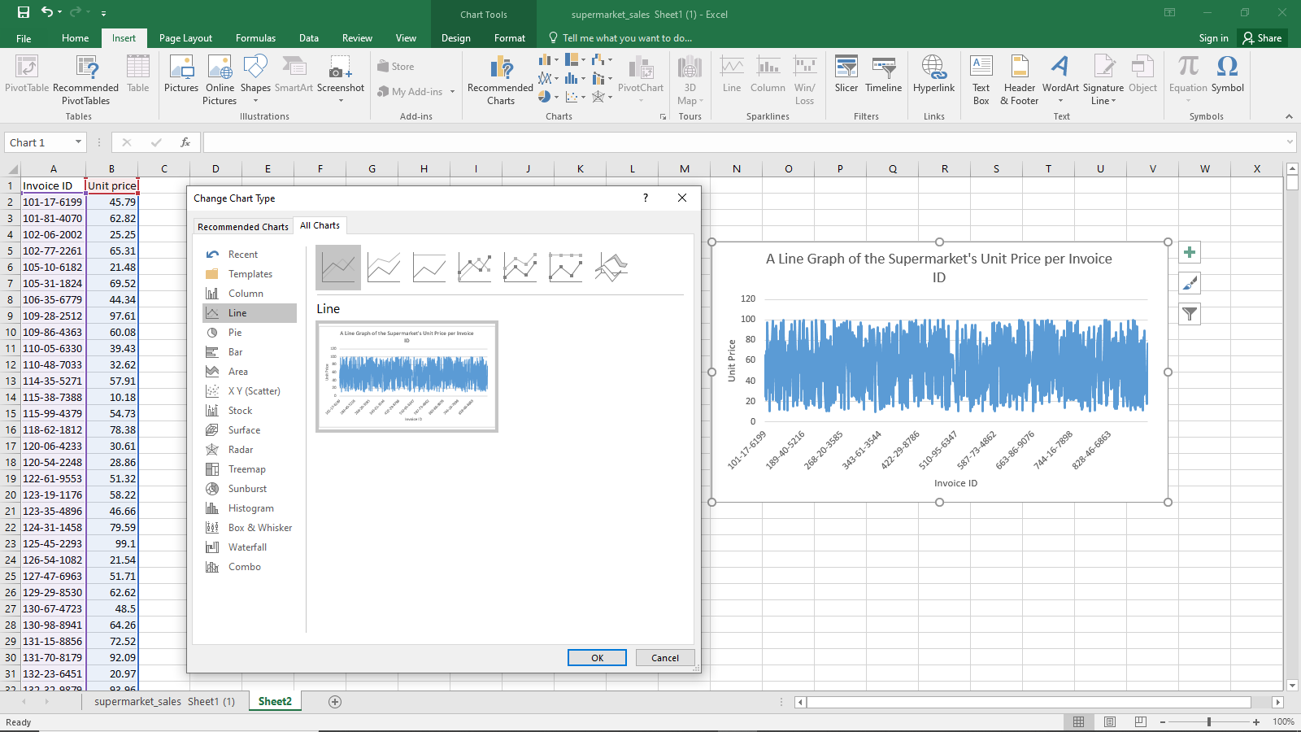
Appendix 2: Gross Margin Percentage per Product Screenshots
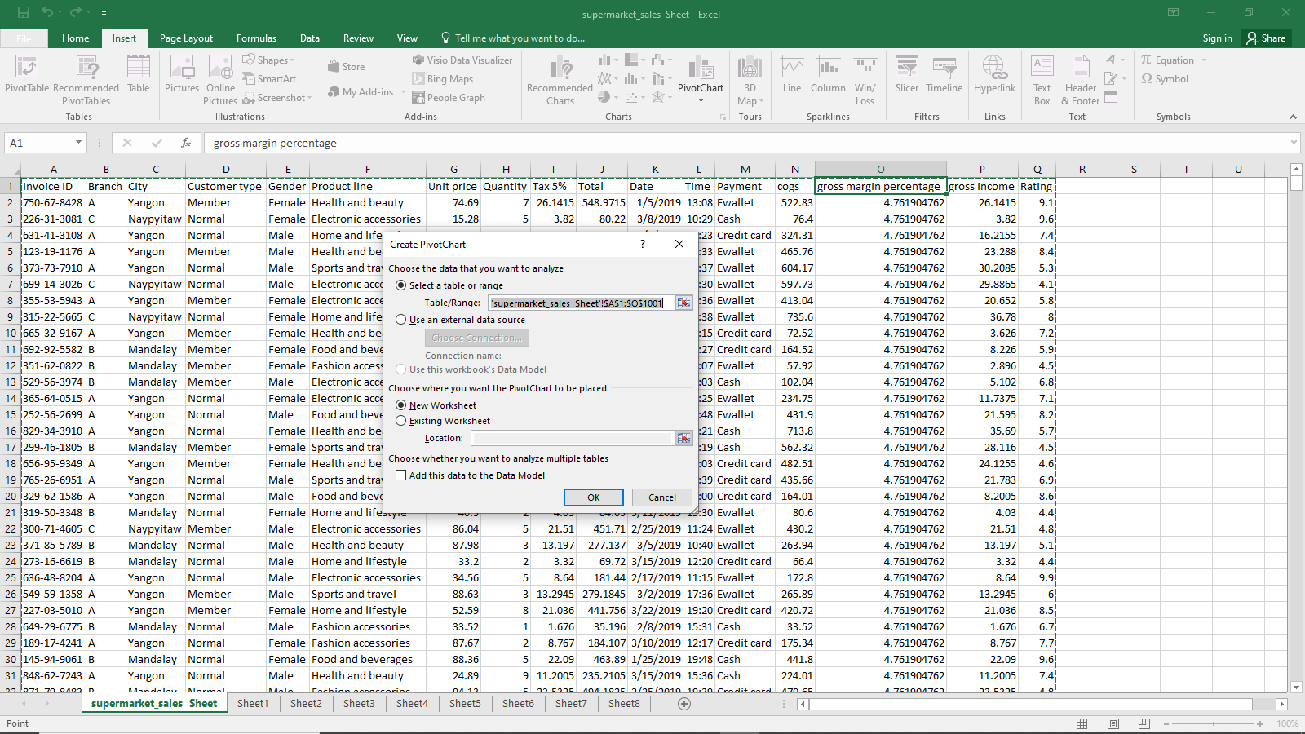
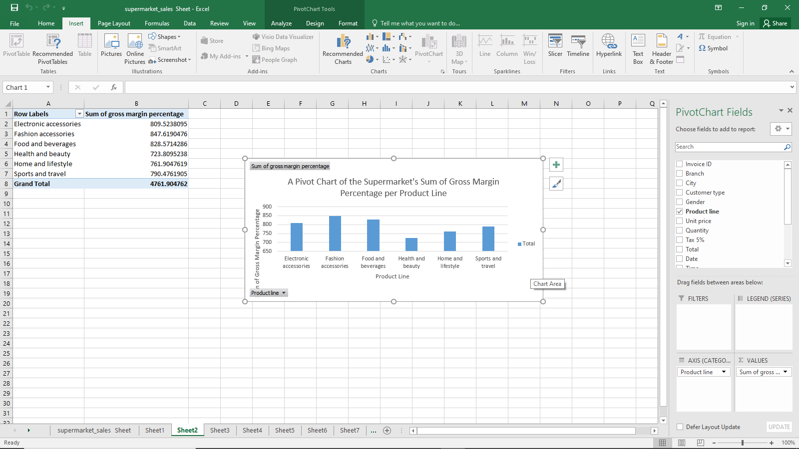
Appendix 3: COGS per Product Line Screenshots

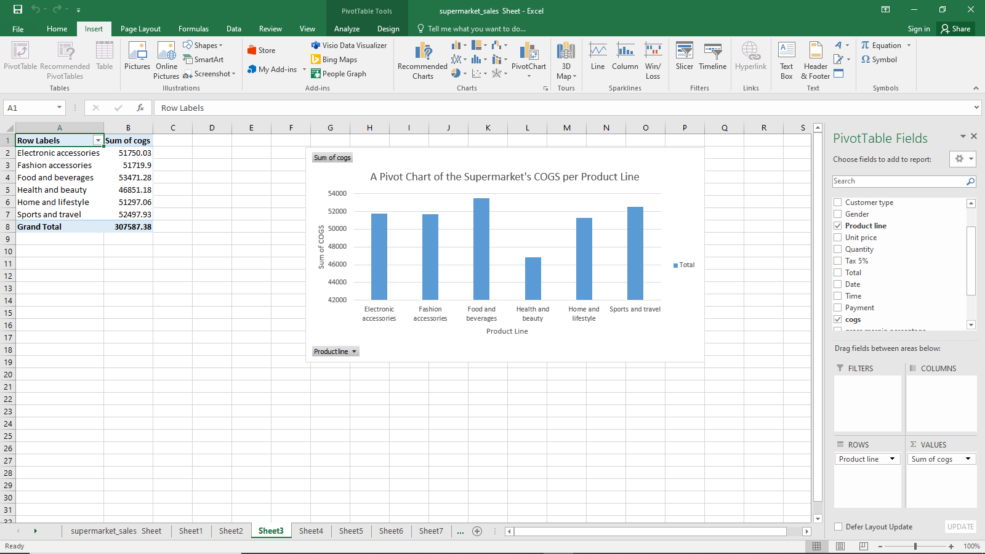
Appendix 4: Product per Customer rating Screenshots
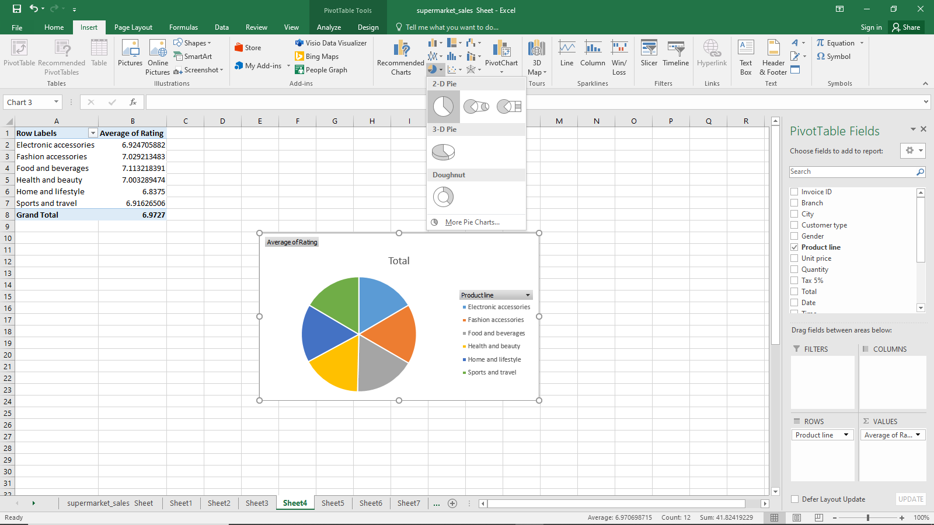

DATA HANDLING AND BUSINESS INTELLIGENCE

Student name : Marian Cosmin Vilaia

Student number :2113634
Module : LCBB5000
Lecturer : Eric Osei

SPSS and Data Mining
SPSS
The Statistical Package for the Social Sciences (SPSS) is a statistical software used for data analysis. The International Business Machine Corporation (IBM) developed the software to facilitate various activities that surround data analysis (High, 2012). SPSS has grown to become a popular software that is widely used in the 21st century with both the business and education sector incorporating the use of the software (Al-Imam, 2019). According to George and Mallery (2019), the software is widely used to conduct academic and market research due to its various capabilities that appeal to a wide range of audiences. However, it is also important to note the software has several limitations despite the high level of praise that has been associated with the software (Stehlik-Barry & Babinec, 2017). An assessment of both the advantages and disadvantages associated with the software use play a significant role in deeply understanding the software.
Benefits of Using SPSS
SPSS is associated with numerous benefits when compared to its disadvantages. The major benefit associated with SPSS is that it is easy to use. SPSS is associated with a user-friendly interface that is easy to use if the user is following text or video instructions (George & Mallery, 2019). The images in appendix 1 show how it is easy to navigate through the software due to its user-friendly interface. The software can perform various types of data analysis when compared to other statistical software in the market. According to Pituch and Stevens (2015), SPSS can perform Non-parametric tests, factor analysis, survival analysis, and structural equation modelling which Excel cannot execute. SPSS also possesses the capability of integration with open-source software. Morgan et al. (2019) indicate that the integration feature allows its users to import and export data to open-source software and take advantage of the powerful data analysis tools available in the language while still using SPSS. The software also allows its users to document the steps involved during the analysis, which is an important feature, especially in studies that may require replication in the future (George & Mallery, 2019). Users can document the steps involved during the analysis using syntax, viewer, notes, and the output window.
Disadvantages of Using SPSS
SPSS is associated with several disadvantages despite its numerous benefits. The first disadvantage involves the high cost associated with the software. SPSS is a commercial software that requires its users to have a licence before they can use it which makes it hard for individuals and small enterprises to enjoy the benefits of using the software (Pituch & Stevens, 2015). According to Amazon’s website, the cost of a 12-month SPSS licence for two computers is $145 (Amazon, 2023). SPSS is also associated with limited capabilities when compared to other statistical software, an element that has seen a rise in competition in the statistical software industry (Garson, 2019). R software can perform data analysis tasks such as machine learning, big data analysis, customization and automation that SPSS cannot execute (Garson, 2019). Advanced data engineers have also complained of the software’s inability to handle large data files, an element that is critical in a century associated with big data. According to Garson, (2019), SPSS can handle a maximum of 32,767 variables and 2 billion cases.
Data Mining
Data mining involves the process of extracting and discovering patterns and relationships from large datasets. Data mining involves six steps that form the data mining cycle. The first stage is the problem definition stage, which involves a clear definition of the objective of the project. According to Wood (2020), during the first stage, the organization identifies the goals it intends to achieve by mining the data. The second stage involves gathering the data. The second stage involves determining available sources, determining methods of gathering the data, and channels that will store the data (Al-Shamiri, 2021). The third step involves cleaning the data. During the third step, an inspection of the data occurs to determine its accuracy, completion status, and consistency (Wu et al., 2021). Identification of outliers and mistakes occurs during the third stage. Once the first three steps are completed, the data is, therefore, ready for analysis.
The final three steps in data mining involve dealing with the data. The fourth step involves performing the actual data analysis using various data analysis techniques. Wu et al. (2021) state that techniques such as statistical analysis and machine learning aid in searching for any trends, relationships, associations, and patterns. The fifth step involves an interpretation of the results obtained from the analysis. Data analysts use the fifth step to discuss how the results of the analysis relate to the business problem or research question (Wood, 2020). The final step involves presenting the results of the analysis using various techniques such as reports, dashboards, or models so that the readers can make informed decisions (Al-Shamiri, 2021). Executing all of the six data mining steps has been critical in various industries that deal with big data in the current era.
Benefits of Data Mining Cycles
Data mining cycles are associated with various benefits. Numerous businesses are familiar with data mining since it helps them to execute almost all of their tasks. Large corporations such as Standard Chartered use data mining to learn about their consumer’s interests, detect fraudulent activity, and filter spam messages (Jain, 2021). Yoseph et al. (2020) list customer segmentation as a data mining cycle that aids in breaking down patterns and determining existing or new connections from the information. Amazon UK is an example of a corporation that has benefited from customer segmentation. According to the summary by Gopal and MohdNawi (2021), Churn prediction is a data mining cycle that uses customer data to determine which customers are most likely to stop using a product or service. BT is one of the leading internet service providers that rely on churn predictions to make decisions about their customers. Market basket analysis is a data mining cycle that determines products that consumers regularly purchase together and provides recommendations for complementary products (Jain, 2021). Amazon UK is an example of an online retailer in the UK that relies on market basket analysis. Ptak-Chmielewska (2019) explains how credit risk analysis is a data mining cycle that aids in determining credit-worthy individuals by assessing the probability of potential borrowers defaulting. Standard Chartered is a bank in the UK that relies on credit risk analysis to manage its lending portfolio. Numerous sectors have applied various data mining cycles that have helped them make informed decisions in the current century characterized by big data.
Data mining is an important element in the current century characterized by big data. Data analysts need to follow and execute all of the six steps so that they provide a concrete and precise interpretation of the data they are dealing with. Data analysts should also familiarize themselves with various statistical software that is in the market so that they can easily perform the analysis. Data analysts should learn about the advantages and disadvantages associated with various statistical software so that they can make easy and fast decisions when dealing with a particular type of dataset.

Reference List
Al-Imam, A., 2019. A Gateway Towards Machine Learning: Predictive Analytics and Neural Networks in IBM-SPSS (SPSS v. 24). Retrieved January, 3, p.2019. Pharma-terrorism (researchgate.net)
Al-Shamiri, A.Y.R., 2021. Artificial intelligence and pattern recognition using data mining algorithms. International Journal of Computer Science & Network Security, 21(7), pp.221-232. https://www.academia.edu/download/84266431/20210726.pdf
Amazon., 2023. T IBM SPSS Statistics Grad Pack Standard V28.0 12 Month License for 2 Computers. Amazon.com: IBM SPSS Statistics Grad Pack Standard V28.0 12 Month License for 2 Computers
Garson, G.D., 2019. Multilevel Modeling: Applications in STATA®, IBM® SPSS®, SAS®, R, & HLMTM. Sage Publications. https://books.google.com/books?hl=en&lr=&id=jWemDwAAQBAJ&oi=fnd&pg=PP1&dq=IBM+SPSS+versus+R+studio&ots=1MZ0mkJeKz&sig=PlGYFEkCdVLzWzJiewqc3a2Zy1E
George, D. and Mallery, P., 2019. IBM SPSS statistics 26 step by step: A simple guide and reference. Routledge. http://ndl.ethernet.edu.et/bitstream/123456789/28322/1/Darren%20George_2016.pdf
Gopal, P. and MohdNawi, N.B., 2021, December. A Survey on Customer Churn Prediction using Machine Learning and data mining Techniques in E-commerce. In 2021 IEEE Asia-Pacific Conference on Computer Science and Data Engineering (CSDE) (pp. 1-8). IEEE. https://ieeexplore.ieee.org/abstract/document/9718460/
High, R., 2012. The era of cognitive systems: An inside look at IBM Watson and how it works. IBM Corporation, Redbooks, 1, p.16. https://www.academia.edu/download/52854673/Red_book_ibm_watson.pdf
Jain, A., 2021. SPAM Filtering Using Artificial Intelligence. Artificial Intelligence and Data Mining Approaches in Security Frameworks, pp.261-291. https://sci-hub.hkvisa.net/10.1002/9781119760429.ch15
Morgan, G.A., Barrett, K.C., Leech, N.L. and Gloeckner, G.W., 2019. IBM SPSS for introductory statistics: Use and interpretation: Use and interpretation. Routledge. https://www.taylorfrancis.com/books/mono/10.4324/9780429287657/ibm-spss-introductory-statistics-use-interpretation-george-morgan-nancy-leech-gene-gloeckner-karen-barrett
Pituch, K.A. and Stevens, J.P., 2015. Applied multivariate statistics for the social sciences: Analyses with SAS and IBM’s SPSS. Routledge. https://sci-hub.hkvisa.net/10.4324/9781315814919
Ptak-Chmielewska, A., 2019. Predicting micro-enterprise failures using data mining techniques. Journal of Risk and Financial Management, 12(1), p.30. https://www.mdpi.com/1911-8074/12/1/30/pdf
Shatri, Z.G., 2020. Advantages and disadvantages of using information technology in learning process of students. Journal of Turkish Science Education, 17(3), pp.420-428. https://www.tused.org/index.php/tused/article/download/1099/633/
Stehlik-Barry, K. and Babinec, A.J., 2017. Data analysis with IBM SPSS statistics. Packt Publishing Ltd. https://books.google.com/books?hl=en&lr=&id=-JlGDwAAQBAJ&oi=fnd&pg=PP1&dq=Limitations+of+IBM+SPSS+&ots=pqWi_wMaiM&sig=NIpKYkQ-TMvzqpLx18j2Wp8JIpc
Wood, D.A., 2020. Combined cycle gas turbine power output prediction and data mining with optimized data matching algorithm. SN Applied Sciences, 2(3), p.441. https://link.springer.com/article/10.1007/s42452-020-2249-7
Wu, W.T., Li, Y.J., Feng, A.Z., Li, L., Huang, T., Xu, A.D. and Lyu, J., 2021. Data mining in clinical big data: the frequently used databases, steps, and methodological models. Military Medical Research, 8, pp.1-12. https://link.springer.com/article/10.1186/s40779-021-00338-z
Yoseph, F., Ahamed Hassain Malim, N.H., Heikkilä, M., Brezulianu, A., Geman, O. and Paskhal Rostam, N.A., 2020. The impact of big data market segmentation using data mining and clustering techniques. Journal of Intelligent & Fuzzy Systems, 38(5), pp.6159-6173. The impact of big data market segmentation using data mining and clustering techniques - IOS Press

Appendix 1: SPSS Navigation Menu Screenshots


