University of Wales Trinity Saint David

Assessment Title: Liberty Stadium Report
Course: Accounting

Module: Global Business Environment
Student Name: Brychan John
Student Number: 1706823
Assessment 2

Lecturer: Sandra Dettmer
Submission Date: 5th April 2018

1 Introduction

1.1 Report Remit

This report covers a PEST analysis of the Liberty Stadium, a stadium which is run by Swansea City AFC after they bought the company from The City and County of Swansea. I will also cover how different areas of the stadium could be improved by using the PEST analysis.

1.2 Stadium Background

The Liberty Stadium is run by Swansea City AFC after they bought the company from The City and County of Swansea in 2018. The stadium holds both rugby and football matches, with The Ospreys and Swansea City AFC respectively, as well as concerts which attracts many fans from all across the country and beyond.

2. PEST

2.1 Political

The first PEST point I will discuss is Political. This is an important area that the stadium must follow in order to comply with government standards. One of these factors is the minimum wage, which all business must follow in the UK.

“Workers must be at least school leaving age (last Friday in June of the school year they turn 16) to get the National Minimum Wage. They must be 25 or over to get the National Living Wage.” [1]

They must follow this statement as law, otherwise they may face legal action from the victims, i.e. the employees they would not have been paying enough.

Another political value is that Britain has recently voted to leave the UK, therefore fans of both the rugby and the football, home and away fans, will have trouble reaching the stadium from outside the UK.

“Post-Brexit system will allow EU citizens to enter freely, but to work they will need to comply with new immigration restrictions.” [2]

This will cause damage to the profits of the Liberty Stadium as they will not be making as much profit as they are now. This point is unavoidable, and is up to parliament to decide on immigration restrictions and travel laws.

2.2 Economic

The second factor I will cover is Economic effects. These effects can vary from being beneficial to the stadium to not helping them at all. As they can vary so much, it is impossible to determine the issues the stadium will have on the economic front in the near future.

One of these factors is unemployment. Even though unemployment percentage in the UK is dropping, it is still fairly high.

“UK unemployment fell by 3,000 to 1.44 million in the three months to November, official figures show.
The number of those in work increased sharply and wages rose at their fastest rate in almost a year, the Office for National Statistics said.
That leaves the UK's unemployment rate at a four-decade low of 4.3%.” [3]
This is an issue for the stadium as some of the fans that they want to bring in may not be able to afford the ticket prices as they are not earning enough money to buy them. They are unable to lower the ticket prices as it would be a bad business decision as they won’t be making as much profit as they usually would.
Another factor would be inflation rates. As people are earning more money, the stadium is able to increase its prices, but some people may not be able to afford these new prices. The inflation rate is dropping in the UK but in November 2017, it was at a six year high.

“The UK's inflation rate has fallen for the first time since June, mainly because of the impact of air fares.
The inflation rate dipped to 3% in December, down from November's rate of 3.1% - a six-year high.” [4]
This shows that an increase in prices is viable, although may drive away some customers that cannot afford it.
2.3 Social
The third factor i will discuss is the Social effects of the liberty stadium. There are many demographics that visit the stadium, from super fans to casual family visitors. The stadium has to adapt to this, as they would not want a drunk football hooligan to be seated with a family with young children. This is why they have implemented Family Stands, situated in the LG Stand, whereas the affectionately known “Nutters Corner” is situated in the top left of the eteach Stand, the closest seats to the away supporters during football matches.
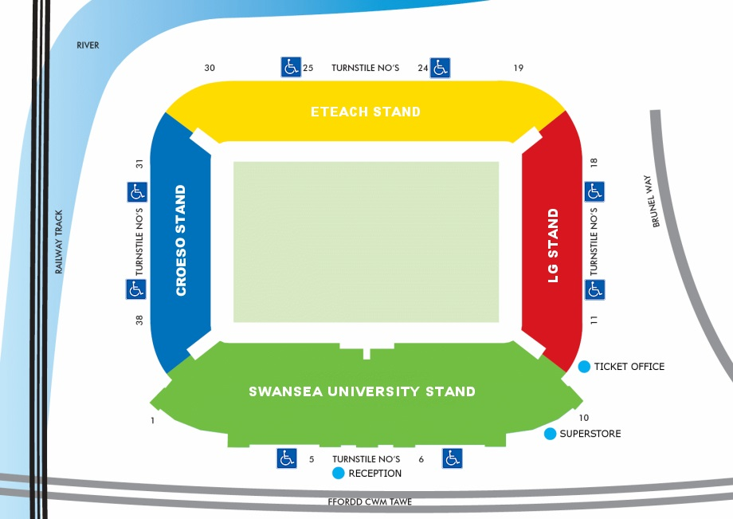
Fig 2.1

Another demographic would be disabled visitors. The stadium has many disabled visitors therefore it needs many entrances for the disabled and seats for the disabled. As shown above, every stand has two disabled entrances and plenty of disabled seating areas.
“26 spaces for wheelchair away supporters are available in the North Stand at the front of the upper tier. There is a lift on the concourse of this stand to help disabled fans gain access.” [5]
2.4 Technological
The last factor I will discuss is Technological effects. There has been an rapid increase of developments in technology in recent memory. Within the last ten years, we have achieved more in the technology field than in the last one hundred years. From 4K televisions to self-driving cars, the Liberty Stadium has got a lot of enhancements to make to keep up with the times. The Liberty Stadium has two large screens in opposite corners of the stadium, these screens will have to be updated every few years to keep up with the latest technological advancements.

“Rugby fans will be receptive to your brand’s message, both in the Liberty Stadium and broadcast on live TV. LED Mega Screen and perimeter advertising has a proven track record of delivering high impact campaigns and benefits to your brand response.” [6]

They may also need to accomodate for driverless cars if the idea becomes a reality, by having different spaces for these cars to safely maneuver into. They may also have direct routes from the motorway or train station to try and attract more fans to the stadium.

3. Suggestions

I believe that there are many improvements that can be made to the stadium regarding my PEST analysis. The first of which would be to try and offer cheaper tickets for less sought after seats in the stadium. This would allow more fans to come in and potentially fill seats that may have been empty.

Another suggestion would be to offer part-time jobs to the unemployed, this would drop the unemployment rate down and offer much more credibility to the stadium for its hard work to help this issue.

My final suggestion would be to try and attract more demographics to the stadium, such as the elderly. Offering the elderly heavily discounted tickets or even free tickets would greatly increase the profit of the company as they would buy more things inside the stadium. This would also help the elderly who may be lonely to socialise with others that are in the same situation as them.

