Report Title: Developing Professional Practice

Name: Deborah Marshall

Date: 14/11/2018

Word count (max: 2600 words)

I declare that this assignment is my own work and that any information obtained from books and other sources have been appropriately referenced.

Signed.......D Marshall.................................. Date........14/11/2018..................




CDSM INTERACTIVE SOLUTIONS
Developing Professional Practice





Prepared by - Deborah Marshall, Head of HR

Executive summary

The aim of this report is to look at the role the HR Professional plays in the business, the CIPD profession map breaks down the professional areas and behaviours that an HR professional should look to have or be working too. The report also looks at group dynamics, setting up a working group with a good structure and how to handle conflict when it arises.

The report details a recent project and the highs and lows that can be taken from it. With the final section looking at what I need to improve on the recent self-assessment has allowed me to pull together a PDP so that I can focus on improving my skill set over the next 6 months.
.

Contents
Activity 1 5
What it means to be an HR Professional 5
CIPD Profession Map 5
The Eight Behaviours 6
The Ten Professional Areas 6
The Four Bands 7
Activity 2 9
Group Dynamics and Conflict Resolution 9
Tuckman theory – (forming, storming, norming, performing and mourning) 9
Conflict Management 10
Activity 3 11
Project Management and Problem-Solving 11
Self-Assessment and PDP 12
Behaviour 13
Professional Areas 13
Referencing 14

Activity 1

What it means to be an HR Professional
A Human Resource (HR) professional should be able to interact and talk the same language as their employees. It is imperative that they have a good knowledge of HR processes, laws and be able to confidently communicate these back to the business. All HR personnel should be professional at all times, they should have excellent listening and communication skills.
The Chartered Institute of Personnel and Development (CIPD 2018) released a document that sets out “Code of professional conduct” each HR Professionals has a responsibility to uphold and maintain these standards and behaviours regardless of the size of the business or wherever they are in their career.
The obligations of an HR professional are grouped into these four areas:-
- Professional Competence and Behaviour
- Ethical Standards and Integrity
- A representative of the Profession
- Stewardship

CIPD Profession Map
The CIPD profession map gives a framework of the behaviours and knowledge that an HR or Learning Development (LD) professional should possess, or should be at least be working too to provide excellent HR practices within their company. The profession map gives an overview of the areas of the business an HR professional will be working in and what they need to understand to fulfill their job.
The profession map below (CIPD 2013) is made up of ten professional areas (centre out), eight behaviours (outer edge) and the four bands of professional competencies (figure 1).
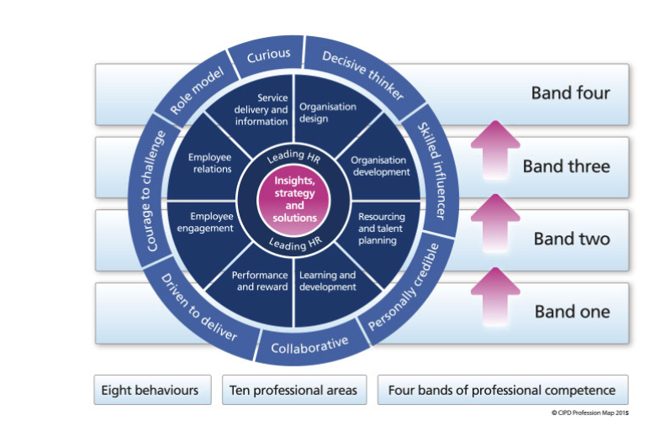
Figure 1 CIPD Profession Map

The Eight Behaviours
These outer circle of the above diagram represents the behaviours that are relevant to the role of the HR practitioner within a business (figure 2).
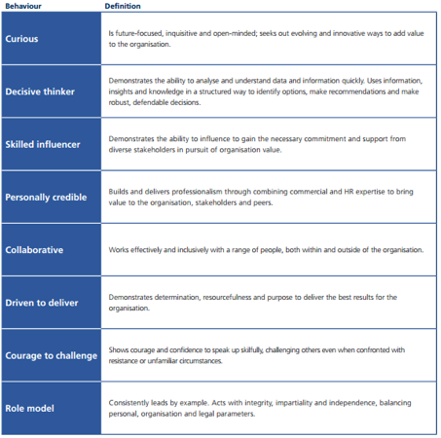
Figure 2, the competencies described by the CIPD’s HR Professional Map

The Ten Professional Areas
The professional areas describe what an HR Professional needs to be doing and also what they should know. (Arhire 2014)
There are three areas that really interest me in this section:-
Resourcing and talent planning – By ensuring that the company has the right talent in place or how you go about securing new talent for the company. This section helps focus the HR professional to identify trends or needs of the company, it helps them to think about what skills sets will be needed for the future. It also covers the process from advertising, application right the way through to selection and then onboarding new starters and then finally the different exit strategies.
Performance and reward – A company need to have good pay and rewards, this professional area works hand in hand with talent planning, this professional section breaks down the basic pay and rewards, it looks at staff benefits. It takes a company through reviewing of its existing rewards and schemes, analysing this information, gaining feedback from management teams, through to executing rewards and benefits schemes to individual or teams.
Employee engagement – By ensuring that a company has strong connections with all its staff members, by having these connections allow the company to strengthen. If employs are happy and appreciated this shows in their work. This section focusses the HR professional through the stages of research, engagement, planning, embedding practices through to embedding key messages and values back into the business.

The Four Bands
The four bands of professional breaks down the different stages that an HR Professional will go through during their working life within the HR sector. Figure 4 (Arhire 2014) provides an overview of the competencies, behaviours and professional areas that an individual should bring to their company.
The bands focus on the following key area:
- Relationship with client
- Focus on activity
- Where time is spent
- The service offered to clients
- Measurement and results
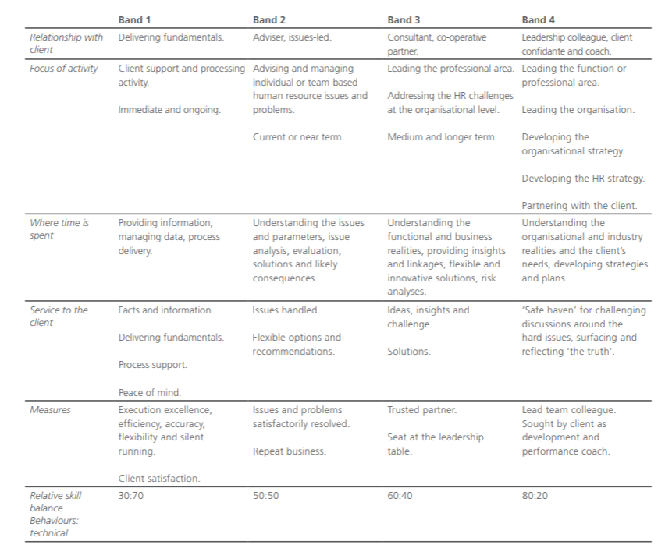
Figure 3 – The professional bands

Activity 2

Group Dynamics and Conflict Resolution

Group dynamics is how a group works together, for a company it is really important to fully understand what type of individuals are needed to make a group successful, so it is important to understand what might hinder this group and also what will motivate them, the aim is to create a happy workforce to achieve results.
As a company, we have found it key to have a manager involved as they will manage the behaviour of the group and keep the individuals focussed on achieving their goals.

Tuckman theory – (forming, storming, norming, performing and mourning)
Tuckman in 1965 (Tuckman 1965) developed a theory to help a group to keep focussed whilst working through their objectives, the aim of this tool is to allow self-evaluation and encourage the group to work more effectively together. Initially there were 4 stages, however, a final step was added to end the journey to complete it.
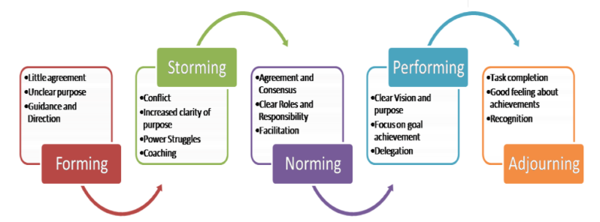
Figure 4 Team Development stages (Hilary 2015)
Each of the stages reflects behaviours for the group and what their tasks they should be focused on Figure 7:-
- Forming – the group is keen but will be immature at this stage, they will need guidance
- Storming – the group will have disagreements, there could be tension or hostility as they test the boundaries
- Norming – the group start sharing, leadership is defined, they are comfortable in their roles and they are starting to trust each other
- Performing – the group have become an effective team, they are performing well, there is openness and helpfulness to solve problems
- Mourning/Adjourning– the group is dismantled as the tasks are completed. There will be sadness as the project comes to end. There should also be a sense of achievement and pride in the work they have done.
This is a theory we have applied to groups in the past, it has worked really well for us.

Conflict Management
With any groups working together conflict naturally happens, so it is important to resolve any issues quickly as possible to allow the group to focus on their set objectives.
That's why models of conflict resolution are so important, we have used Active Listening skill models and Thomas-Kilmanns theory to help manage conflict within the organisation.

Active Listening
Active listening is a great technique that allows us to help and understand what an individual is trying to say, it opens up the conversations and allows them to express themselves so that they can get their point across clearly. This technique focuses on facts and feelings, it helps to reduce any tensions and looks at ways to break down any barriers and allow any conflicts to be resolved.
Below are active listening skills that we have used as a company to resolve issues that have come up within a group:-
- Listen, be attentive, put time aside to listen to the individual or group members, summarise back at the end to ensure you have heard correctly
- Ask open-ended questions – such as ‘What do you think’, or ‘Tell me more’, if you need more information ask for further explanations.
- Ask probing questions, such as ‘Have you asked the team what their concerns are?’
- Request clarification, double check to see that you have fully understood
- Paraphrase – do a recap, don’t assume you have fully understood
- Be attuned to and reflect feelings, pick up on their feelings are they feeling frustrated in this situation
- Summarise – give an overview of the items that have been raised, check that you have fully understood what they are saying

Thomas Kilmann Model of conflict resolution
The Thomas-Kilmann model was designed by Kenneth Thomas and Ralph Kilmann (TKI). This model displays 5 conflict management styles based on the two dimensions - assertiveness and cooperativeness.
Assertiveness – stand up for what you believe in, avoid being overaggressive when getting your point across, try to remain calm.
Cooperativeness – is a trait of the individual, it is how you interact and engage with others.
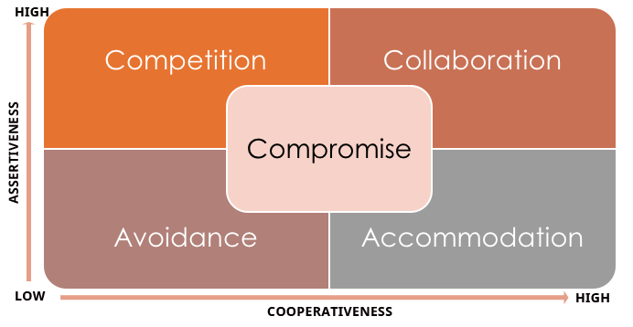
Figure 5 TKI Model (Ascenditur 2017)
There are 5 conflict management styles , below is a summary of these:-
- Competing – as an individual you are assertive, competitive and usually have the last word in an argument or try to win an argument. You are not worried about others emotions and you feel that your opinion is correct and you are not open to discussing it.
- Accommodating – as an individual, you are not assertive but likely to be cooperative. You will probably give up your opinion to allow overs to have their way.
- Avoiding ,- as an individual, you will avoid dealing with an issue at it happens and look to resolve at a later date, sidestepping the situation, hoping it goes away.
- Compromising – this individual is happy to split the difference if it means the issue will be resolved quicker, they are happy if both sides get something out of it.
- Collaborating –if the two parties are in disagreement they should work together to find a solution that will fully satisfy all their needs, they should find a solution and then move forward from there.
After completing the survey myself (Evidence 6) it has identified that I need to work on two areas Compromising and Competing. I have added these to my PDP so that I can reassess where I am in six months’ time.

Activity 3

Project Management and Problem-Solving
Middle of May this year, I was handed a contract from the MD that both he and the Welsh Government has signed the company to take over a support desk from an existing supplier of theirs that they have served notice on. The timeframe was tight the company needed to set up a new phone / online support desk by the first week of June. Due to the tight deadlines this project needed to be handled in a disciplined way to keep on schedule. First thing was to pull together a working group, this needed to consist of individuals who had experience in this area already, so the Support Manager and IT technician were invited to be involved in the planning and delivering of the project. These two teams already work closely together, so I knew I had a good team who would stay focused and be able to deliver the project. The contract set out that if we didn’t deliver on time there be consequences / financial penalties.
After an initial briefing I provided the group with the details of the project and set some objectives, the first meeting involved brainstorming (figure 6 below) to understand fully what was needed to fulfill the project. The team met and then brainstormed a defined list of tasks that needed to happen. The tasks were then assigned to specific team member so that they could take ownership of them. I created a Gantt chart (evidence 3) that was shared with the team via google documents, this set out the order of tasks and the deadlines the group needed to work too. By sharing on google documents meant we can use it as a working document, as all updates happened in one place. A private channel in our internal messaging Slack was created, this allowed us to share notes and update each other instantly. Project costs were calculated and delivered to the MD for signoff (evidence 4). This method of handling a project worked well and I would apply to future projects.
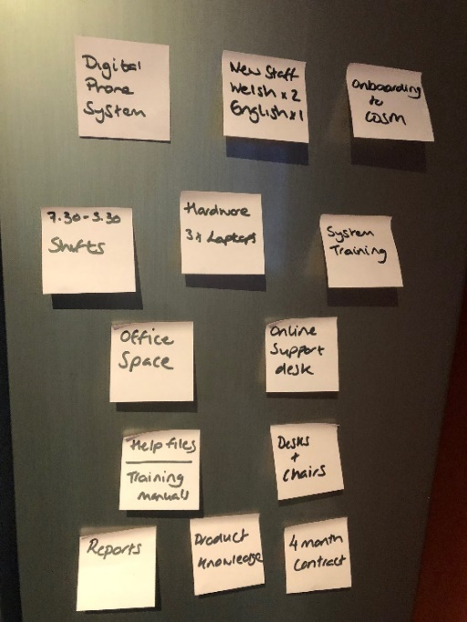
Figure 6 – Brainstorming (evidence 5)
We knew there would be issues because there were only three weeks to set everything up. The first obstacle was moving from an analog phone system to a new digital one. Two quotes were needed as well as reassurances that the phone system would be in place for the 31st of May (evidence 8 and 11).
The MD who never usually gets involved with the buying anything, asked his son to quote for the phone system, however, this was a more expensive option. So I had to compare costs and present these back to him, only by doing this I was able to show a saving of £3000 over a 3 year period to go with my preferred supplier. By using this approach I knew that this was the only way I would get him on board and allow me to move on with ordering the phone system.
The contract stated that we need to employ one English and two Welsh speakers, adverts were placed on English and Welsh job sites, however, we didn’t have any applications for the bilingual role. So I took to social media and asked existing employees to share the job advert to their friends. This did indeed help us to find one Welsh speaker. After having no more applications for the Welsh role I looked internally to see if we could restructure departments for the 4 months period. We did already have a Welsh speaker on the IT team so I moved them into the new team.
The project did need managing very tightly in order for us to meet our objectives and deadlines. Being a small team helped us to achieve this, but it also meant that no one could take their eye off the ball. The team remained positive at all stages, it did require people to work extra hours. It has helped to build my confidence, I was able to negotiate the best deals for the business in order for me to meet the set budgets. My persuasion skills were used to influence the MD to look at the bigger picture of costs savings for the company rather than just handing the business to his son.

Self-Assessment and PDP
The CIPD provides HR professionals with a continuing professional development (CPD) map so that you can identify your own strengths or weakness. This map allows you to quickly assess yourself against the CPD profession map once completed it allows you to identify areas you need to develop in, in order for you to become a better HR professional.
I recently completed my own assessment (evidence 2) and from the report, I choose to concentrate on these sections, behaviour - Courage to challenge and then two professional areas - Resourcing and talent planning and Performance and Reward.
The assessment shows that I have existing strengths, however, there are gaps that need addressing to become more competent in the role. I have chosen to include these weaknesses on my PDP so I will continue to work on them over the next six months (evidence 1).
During my assessment I also completed the Honey & Mumford – Learning styles questionnaire (evidence 9), this allowed me to see my preferred learning style. My strongest style is Theorist closely followed by Reflector, which I can relate to as I do like to work through things step by step, I am a perfectionist at heart so I will need to absorb and have a full understanding before I put into practice anything new. These learning styles will be used whilst I develop my HR skills over the next six months
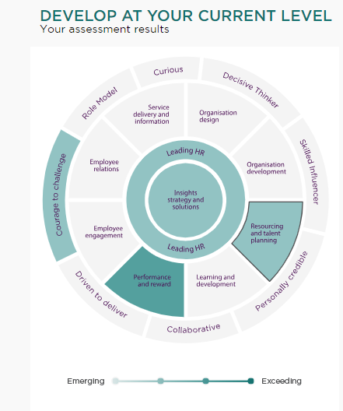
Figure 7 – My CPD Map
Below is an overview of the sections I have now chosen to focus on.

Behaviour

Courage to challenge
I chose this behaviour as I wanted to become more confident to challenge others within the organisation. Being an HR professional there are often conversations that are unpleasant so I want to build on my confidence so that it shows when having these conversations.

Professional Areas

Performance and reward
I wanted to check where I was sitting on the scale as I have been working on Performance and Reward, after having done a recent report for the business on how we attract new talent. The report looked at our pay structure and existing benefits/reward packages. My findings were then presented to the senior management team to look at how we can become a more appealing employer in the marketplace. After taking this review I was pleased to see that I was exceeding in this area.

Resourcing and talent planning
The company is growing so it’s important that the company secures the correct individuals for the role, the assessment showed me that there are a couple of areas for us to focus on. I will carry on researching the external market as we need to access talent with specialised skills set. Succession planning is also critical as we grow we need to backfill in the business.

Referencing
Arhire, H. (2014) CIPD’s Competencies. [Image] Accessed at: https://ciprianarhire.files.wordpress.com/2014/05/competencies.png [Accessed 13th of November. 2018]
Arhire, H. (2014) The HR Profession [Blog] The Future of Work is here. Accessed at: https://ciprianarhire.wordpress.com/2014/05/01/the-hr-profession/ [Accessed 13th of November. 2018]
Arhire, H. (2014) The Professional Bands [Image] Accessed at: https://ciprianarhire.files.wordpress.com/2014/05/prof-map.png [Accessed 13th of November. 2018]
Ascenditur. (2017) Managing Workplace Conflicts [Blog] The Thomas Kilmann Conflict Mode Instrument (TKI) for addressing conflicts. Accessed at: http://ascenditur.no/blog/2017/04/30/managing-workplace-conflicts/ [Accessed 14th of November. 2018]
CIPD. (2013) The 2013 Profession Map [Online]. Accessed at: https://www.cipd.co.uk/learn/career/profession-map/2013-profession-map [Accessed 13th of November. 2018]
CIPD. (2018) - Code of Professional Conduct. [Online]. Accessed at: https://www.cipd.co.uk/Images/code-of-professional-conduct_tcm18-14510.pdf [Accessed 13th of November. 2018]
Hilary, M. (2015) Team Work - Tuckman's Way. [Image] Accessed at: http://margarethillary.com/team-work/ [Accessed 13th of November. 2018]
QualityGurus. (2016) Tuckman's Stages of Team Development [Video] Retrieved from the YouTube Website: www.youtube.com/watch?v=uOCz1gOmg30 [Accessed 13th of November 2018]
Tuckman, B. (1965) Developmental sequence in small groups, Psychological Bulletin, 63(6), 384–399.
Taylor,S. & Woodham, C.J. (2016) Studying Human Resource Management, 2nd or Ed. , CIPD:London

Appendix’s
Evidence 1 – PDP
Evidence 2 - MY CIPD Map Review.docx
Evidence 3 - HWB UM Support Gantt.xlsx
Evidence 4 - Project_Budget_HWB_Support_Desk.xls
Evidence 5 - Brainstorming.JPG
Evidence 6 - TKI Survey.PDF
Evidence 7 - Thomas PPA Assessment results.PDF
Evidence 9 - Learning Styles Questionnaire.PDF

