

Work Based learning
  - Recycling at Neath Library
Rhian Peto | Work Based Learning | Date 24/05/19
Words 2,878

Title
Reflection of a work- based learning project undertaken at Neath Library and exploring present recycling efforts at Neath library with the aim to include recommendations.
Introduction
The report will firstly provide background information about Neath library . Secondly, highlight and reflect upon current recycling practices at the setting . The report will include a project created and trialed by the researcher . The researcher created recycling signage (poster) in order to explore if this could support future recycling efforts .Finally the report provides recommendations in which the library service can contribute to a long term sustainable future (Appendix 1)
The Researcher
The Researcher is a part- time worker at the library and Environmental student, this topic was chosen to explore the current recycling practices at the library. Library staff are interested in the content of this report and to view any recommendations highlighted . library staff supported the researcher throughout the assignment by providing information, and awarded study time to complete the work .
1. Background Information
Neath library was opened in 1905 and is located opposite Victoria Gardens within walking distance of the main shopping area and can be accessed via bus, walk ,train and cycling ,although parking outside of the building can be difficult due to yellow road markings (Appendix 2)
There are approximately thirteen staff members this includes full and part time staff; this does not include visiting stakeholders .In addition, members of the public attend workshops at the library for example, IT assistance, welsh, reading and coloring groups. In addition the public can access newspapers, bus time tables and other information displayed on public boards. Plus the library welcomes volunteers up to five at a time these include Duke of Edinburgh and Welsh Baccalaureate.
The library is spread over two floors, including a separate annex ( junior/children’s section). The main building (first Floor) : Music Room and main library room i.e. (books and video). Floor two :Reference library, computer room and Archive room, there are also a number of offices and group rooms located on the second floor, plus staff room and toilets.
The library is the hub of the community and is open Monday to Saturday ,closed bank holidays (Appendix 3). Approximately five hundred visitors access the library on a daily basis, library users are a mixture of all ages from birth to age hundred, the library welcomes and supports diversity and equality of members.
2. Present Recycling
The library is part of Neath Port Talbot Council Education and Lifelong department. The library follows Neath Council waste strategies. Currently, the council work to support the Welsh Assembly Collections i.e. Blue Print (Kerbside recycling), plus The Municipal waste plan part one .(npt.gov 2019). Neath libraries role is to support the council’s efforts, it does this by providing recycling bags and information on the recycling scheme. (Appendix 4). The Department for Environment and Rural Affairs (DEFRA) illustrates that local Authorities i.e. council have a duty to keep land clear of litter and refuse and follow the Code of practice of litter and refuse (Gov UK 2019)
Currently Neath Councils recycling rate is at 60 percent. (The wave 2018), compared to City and County Of Swansea at 63 percent. (Welsh government 2019). Neath Council has been given a target of 64 percent to achieve by 2020 and 70 per cent by 2025 however, in order to achieve targets by 2020 this would need to be improved significantly. (The Wave 2019). In contrast, Williams firstly points out that that the control of litter and waste will benefit both the environment and economy ,and secondly many businesses today do not regard waste management as a key part of business strategy and may not even measure waste costs. Williams (2005). It does appear in this case Neath Council are making an effort to meet targets the 60 percent average is low compared to other councils, it is clear there is a way to go, however it is important to remember these figures were reported in 2018 , these figures may have changed i.e. increased or decreased.(Appendix 1a)
The council encourages staff to recycle as much waste as possible and support energy usage at the library, this includes recycling items such as out of date stock i.e. books, in addition items which fall under kerbside recycling (plastic, paper, cans and foils)as illustrated in the NPT councils recycling guide.(npt.gov.uk 2019). It appears the reuse of materials is positive, plus some old stock is sold onto the public .There are bins located in the main library buildings (staff and public), located in the staff room are specific boxes for staff recycling i.e. food items (Appendix 4). Members of the public are able to collect food recycling bags ,from observation food bags are taken daily and in large quantities, these are then restocked by staff.
It certainly appears the council are encouraging staff/departments in its employ to recycle and raises awareness of recycling i.e. the public yet more could still be achieved, from personal observation the public ask for extra food bags when visiting the library, this could be due to many reasons i.e. not having enough bags in the home, or an increase in food consumption leading to an increase in food waste, The 2000Waste Strategy illustrates that waste should be put to good use through composting and recycling and then using this, an example fuel ,this could support the councils other departments such as transport and support company vehicles. (Department of Environment 2000)

3. The Researchers Project (April –May 2019)
The researcher created recycling signage i.e. poster in order to explore if signage could support current recycling efforts .The researchers aims was to:
1 .Observe staff reactions
2. Raise awareness of recycling and reuse of products
3. Prompt discussion on current efforts
Permission was sought from the senior librarian to place this sign in staff areas only i.e. staff room, plus staff members were informed of the project, although some staff members may not be in the building all at once, On reflection the researcher felt the project would aim to illustrate signage would be effective enough to use throughout the library, in reality, this was only a small scale university project and may not have the desired effect.
Poster Design (Appendix 1)
The sign was designed on PowerPoint and illustrated a globe with recycling signature, the globe was green in color with yellow writing, the poster was laminated, the table below highlights feedback on Coloring, font and wording .

Design- (colour, wording) | Feedback
Colouring | Some staff could not read the wording due to the yellow colour
Font | The font size was enlarged to 44, although this could have been increased. Some staff mentioned the wording was visible, yet some had trouble from a distance to read the wording, up close it was manageable.

The Image (Globe with recycling signatures)

Image -Globe in Green | Feedback
This image was picked to highlight that recycling is a global effort as well as local effort | Staff felt the globe was appropriate for the poster , although some staff felt a superhero cape would have been a nice addition.

Reflection
On reflection, the poster was rushed and more time could have been awarded to its design especially font size,. The researcher felt additional imagery could have been added i.e. depicting wildlife and the environment, an example turtles caught in netting or chewing plastic ,this additional imagery may have increased awareness and generated greater response, if this project was to be repeated in the future additional imagery and greater emphasis would be placed on the design/image ,plus different fonts would be used with larger writing .
Yet the poster did prompt conversation informally around the staff room table (four to six staff),out of the staff present some asked who had placed the poster and asked what the poster signified, this then prompted the conversation on what staff did at home to recycle, discussion then moved onto plastic fibers in food items such as tea bags i.e. these do not degrade the bag is left. Some staff mentioned the issue of plastic has increased with some staff composting food items at home and saving rain water for the garden ,one staff member mentioned she was concerned for the planet and wanted to contribute to personal recycling at work and at home.
The poster is still visible, hence more reactions can be observed, and time will tell if this poster will remain up in the staff room. There was no response from the public as the posters were not displayed in public areas. Presently(May 2019) two posters are still visible in the staff room, one has been taken down. It appears the library staff are happy to keep the posters up and continue supporting the recycling effort, yet the posters look bland compared to professional recycling posters. Overall the researcher felt the poster would be enough to support the small scale project ,yet was disappointed in the number of people who viewed the posters, yet the project may support future enquires into this area (signage) and in reality was worthwhile.

Recommendations
From personal observation the library could purchase marked recycling bins including (paper only), these marked bins illustrate which items can be recycled, this would support the libraries efforts and could be easier to use. The researcher observed these types of marked bins at the library in the University of Wales St David’s Trinity Swansea, these bins are easier to use and enhance the professional setting (, Appendix4). The use of notices in the main Neath library building i.e. formal recycling signage would be an advantage to the library, this could encourage members of the public to take ownership of their recycling,. It is important to remember not everyone will want to recycle, it can be an effort to sort rubbish into marked bins, signage could initially be started as a trial and undertaken inexpensively i.e. printing signs from the computer and placing at locations so users and staff can view, however, permission would need to be approved by senior management or committees for this to transit. (Appendix 6)

In addition, staff use refillable water bottles, the library could benefit from a water fountain as observed at the University of Wales St David’s Trinity Swansea (plugged), although water is freely available for staff to use( Neath library) .In addition members of the public would be able to access this facility, in a building of this type where the public could spend long hours these fountains would support the public experience at the library, however with council budgets this type of equipment could incur costs and may not be deemed necessary ( Appendix 5 ) . In terms of energy usage the library building uses electricity daily i.e. lights, computers, the building is old and therefore some equipment reflects the age of the building, if in the future the library was to be modernized timer lights could be used i.e. switch on when you walk into a room, however when the library is closed lights and computers are switched off to save energy, plus the heating is controlled to come on /off at certain times , in some departments the heating is switched off during the summer and autumn months.

The library could consider purchasing battery recycling bins, although this would incur a cost i.e. disposal, yet it appears there are not many of these battery bins locally, some members of the public have asked if the library operates this service, it could be argued the libraries role is to provide education/books services for the public and is not a recycling centre, surely a library setting is not expected to tackle the issue of recycling for the borough of Neath , as illustrated the library undertakes and contributes to waste management with staff dedicated to this task.

Long Term prospects

It is important to remember that the library is part of Neath Council, it is likely in the future with budgets library services may be under scrutiny, although library services i.e. community branches have been under review and may have possibly faced closures ,public opinion was sought via questionnaires. General feedback from the public highlighted that local branches were the hub of the community and services supported the wellbeing of residents, with the introduction of the future Generations Wellbeing act these closures would be in contrast to the act. In addition, if the United Kingdom leaves the European Union, how will future services be affected? Yet the control of litter and waste will benefit both the environment and economy to support well being of the public.(npt.gov.uk 2019)

It is difficult to predict and plan for the future (local services), or even if councils will still operate in their own entity, merger options could apply to some counties. In addition, the decrease of support from the European Union (EU) will take some adjustment, even though Britain will still have to honour legislations that have been agreed with the EU. Recently The Prime Minister Theresa May has issued a statement stepping down from her role as Prime Minister, more uncertainty arises who will be the next party leader for the conservatives, and this departure will have a knock- on effect for leaving the EU .(The Express 2019).

Everett illustrates, The Environment for Food and Rural affairs committee have already carried our pre -legislative scrutiny of the draft environment and governance. Everett( 2019) .Evans points out that global governance does not set rules, frameworks or social contract which require a response, global policies exist in order to create situations in which institutions can follow there is no political global party in which to enforce law. Evans (2012) .It is difficult to predict the United Kingdom future yet Britain was not always part of the EU and did manage to succeed pre and post Second World War. It could be argued has the Brexit departure been heightened unnecessarily? Additional support for Britain could be the United Nations (UN). The UN supports countries to work together in order to provide security and protect citizen’s human rights, it could be argued Britain can still fall back on the ‘security blanket’ of the UN.

In the near future recycling efforts by the council would be expected to continue. The council are required to meet targets, as highlighted the future of council services are yet to be seen, although it could be argued some type of recycling will exist. The library could see some services being automated and the use of Information Technology installed, example (Computerised checkouts i.e.Tesco) or even the introduction of service robots to assist staff. Leathley reports that the use of robots is increasing and are prominent in areas of manufacturing, warehouse automation, farming and some medical services, although the use of robotic assistant in care homes or medical settings only represent a small scale of the market, yet if service robots can extend into medial settings why not education settings surely this would enhance and support public services. The imagery of robots are enhanced through the use of the media i.e. animation characters, example Star Wars ,leatherly (2019) .In a future world the creation of the fictional robot 'Wall- E' ,who in the Disney Pixar film was created to support the environment( by disposing of litter people left behind) could indeed one day manifest, in all reality these service robots are already in settings, hence an environmental 'Wall -E' could already be an idea (imdb.com 2019 ) (Appendix 7)

Reference List /Bibliography
Department for Environment, Food and Rural affairs(2019). https://www.gov.uk/government/organisations/department-for-environment-food-rural-affairs(Accessed: 11th June 2019)
Department of the Environment, Transport and the regions (2000) Waste Strategy 2000 England and Wales part 1. London:crown
Evans,J. (2012) Environmental Governance.Oxford:Routledge
Everett (2019)”Conservation News “British Wildlife 30 (4 ):223.
The Express Newspaper (2019) Conservative leadership election: How is the next Tory leader and prime minister elected.[ONLINE].Available at https:// www.telegraph.co.uk/politics/0/conservative-party-tory-leadership-leader-election-candidates/Accessed: 28th May 2019)
Government UK (2019) Litter and Refuse responsibilities to keep land clear .Available at: http://www.gov.uk/guidance/litter-and-refuse-council-responsibilities-to-keep-land-clear Accessed: 11th June 2019)
Idmb (2019) Wall-e .Available at https://www.imdb.com/title/tt0910970 Accessed 24.5.19)
Leatherly, B(2019)”Meet your new colleagues” Health and Safety at work June 2019 :22-25
Neath Port Talbot County Borough Council (2019). Available at: https:// www.npt.gov.uk/1422, (Accessed: 11th June 2019)
Neath Port Talbot County Borough Council 2019 Recycling and Waste. Available at https:// www.npt.gov.uk/1422(Accessed: 11th June 2019)
The Wave (2019) Council Issue new black bin limit. Available at: http:// www.thewave.co.uk/news/local/neath-residents-new-black-bag-limits/ (Accessed: 11th June 2019)
Welsh Government (2019) My recycling Wales. Available at: http:// https://myrecyclingwales.org.uk/local_authorities/swansea (Accessed 11th June (2019)
Williams, P. T. (2005) Waste Treatment and Disposal.Sussex: John Wiley and sons

Appendix
1 Signage devised for the project places in the staff room

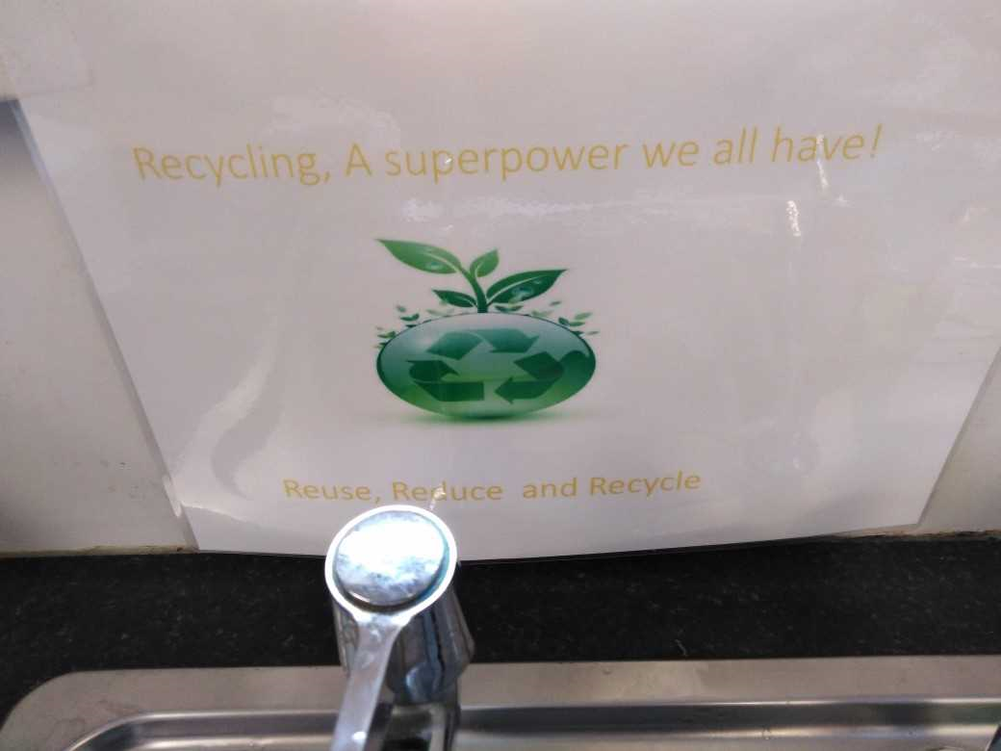

(1a)Targets Swansea Council
Ref( myrecyclingwlaes.com 2019)
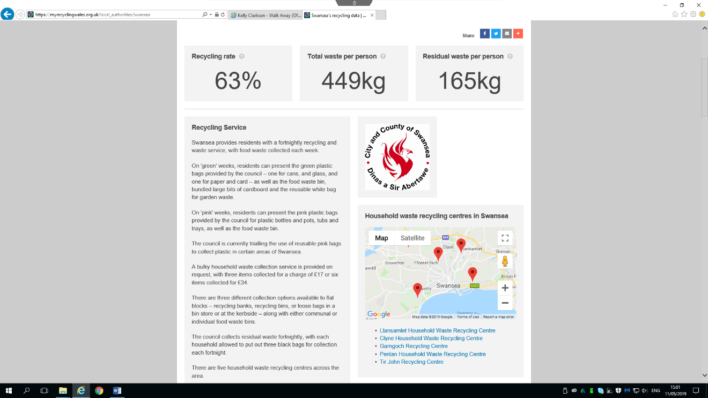

Neath Council
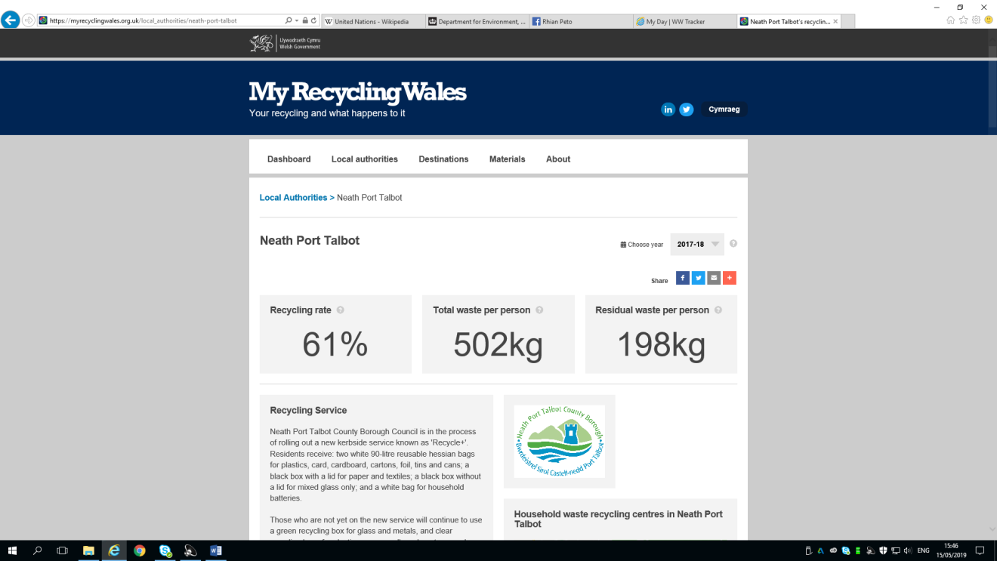

2. Main Neath Library building – children’s section is separate connected via walkway

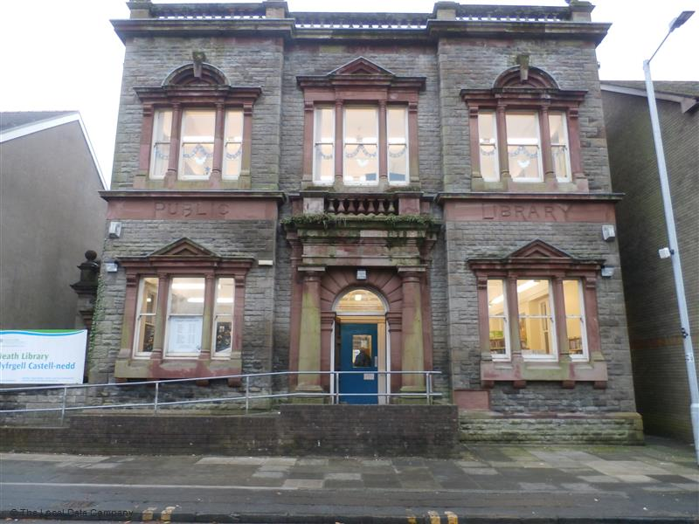Ref (NPT.gov.uk 2019)

3 .Neath Library opening times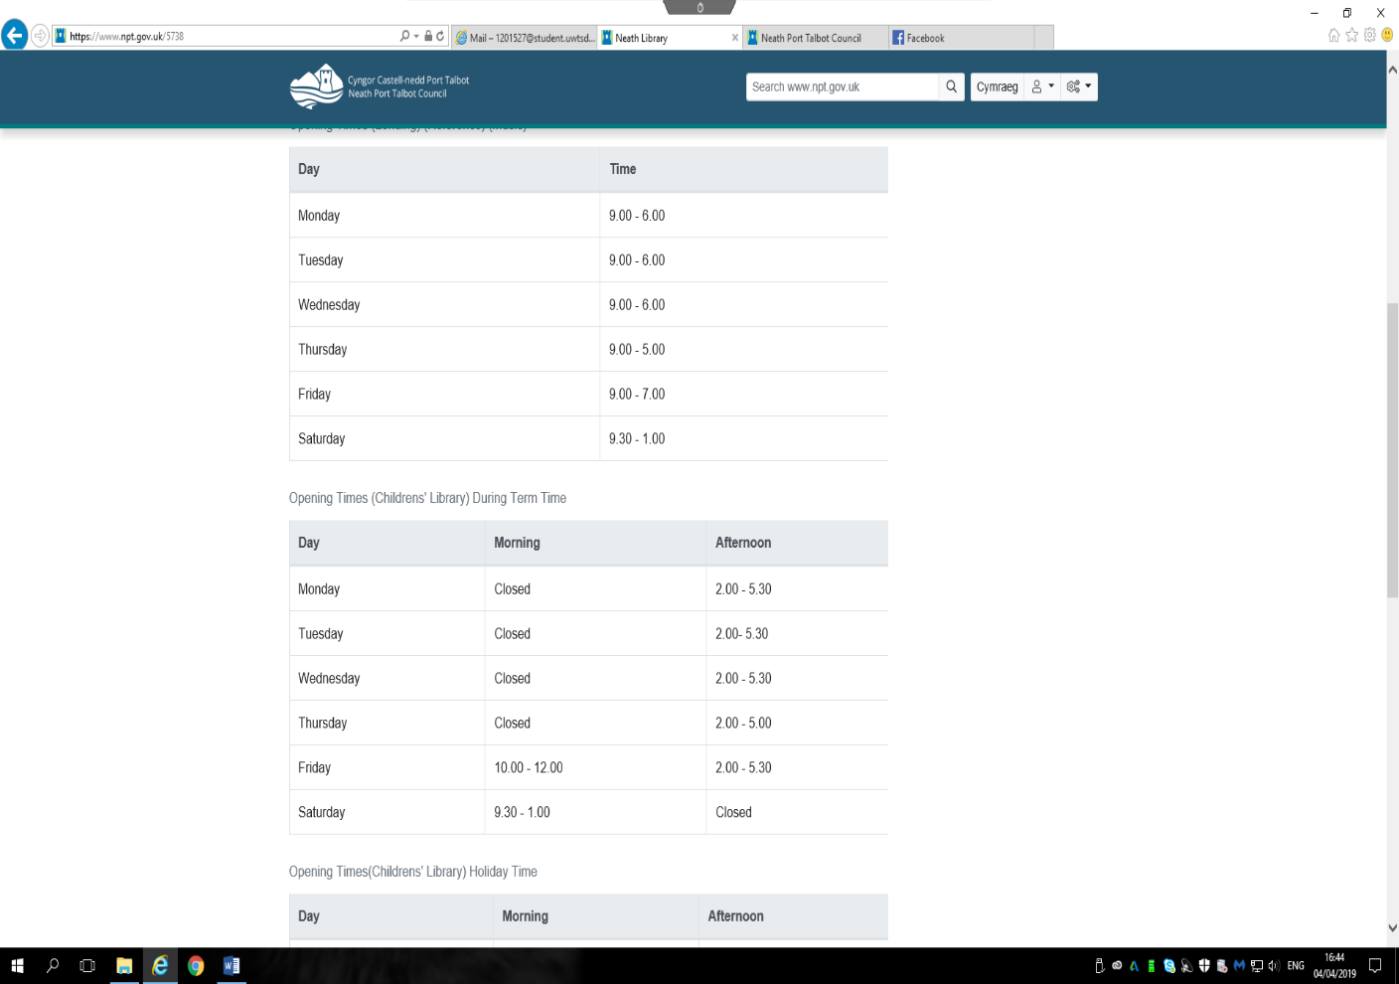
ref (npt.gov.uk 2019)

4. Staff Room Recycling Efforts i.e. Bins and Signage poster from Neath Port Talbot Council
.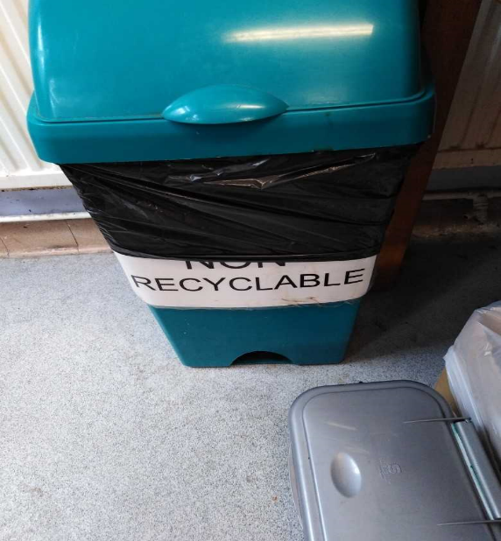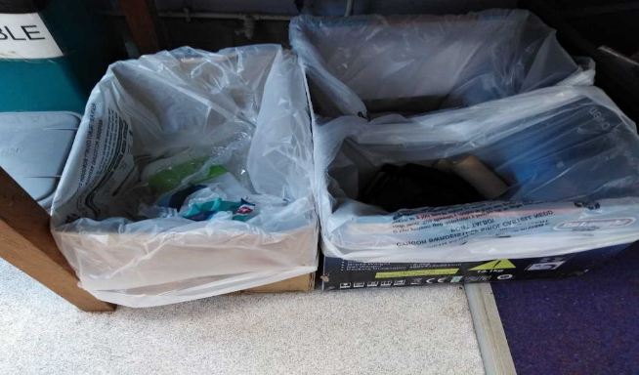
Signage in staff room (NPT 2019)
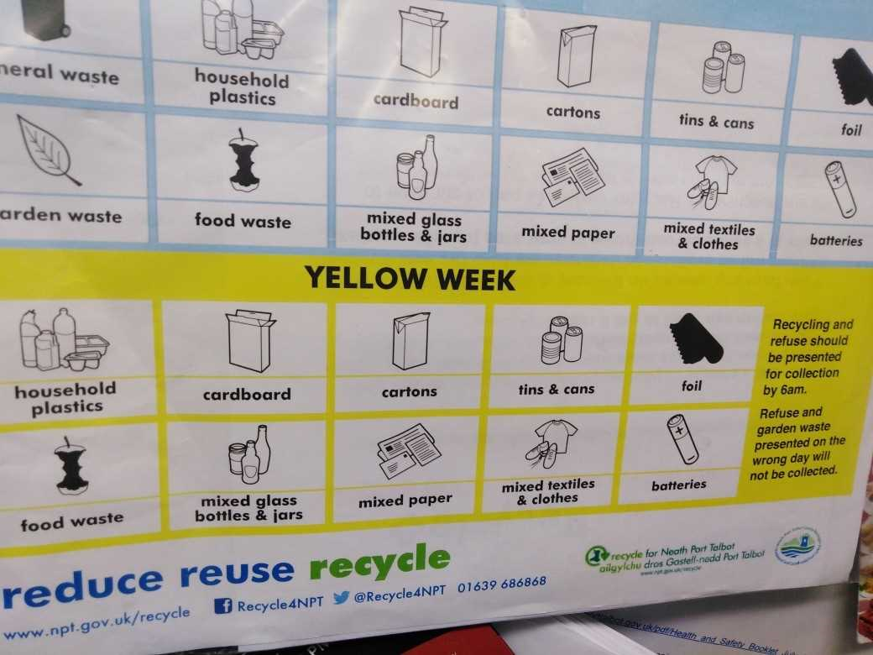

5. University Marked Recycling Bins (UWTSD 2019)
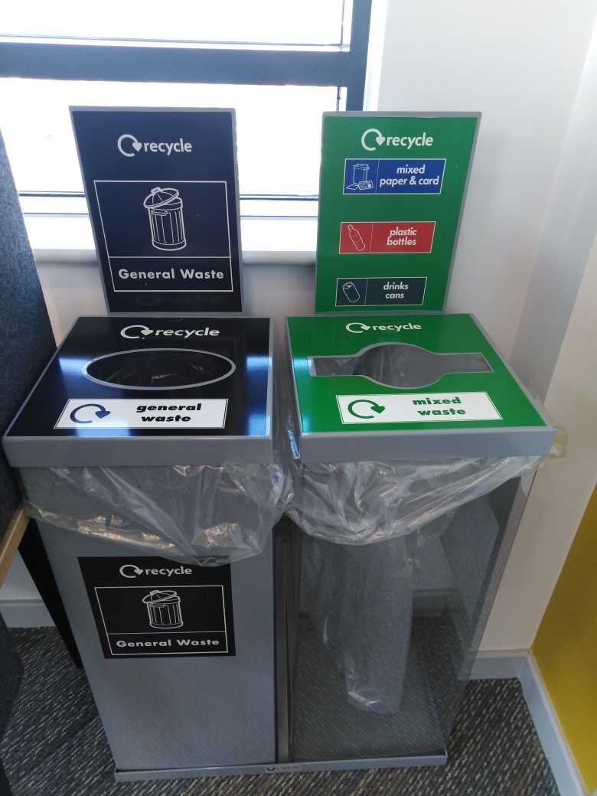

6 Water Fountain( UWTSD 2019)
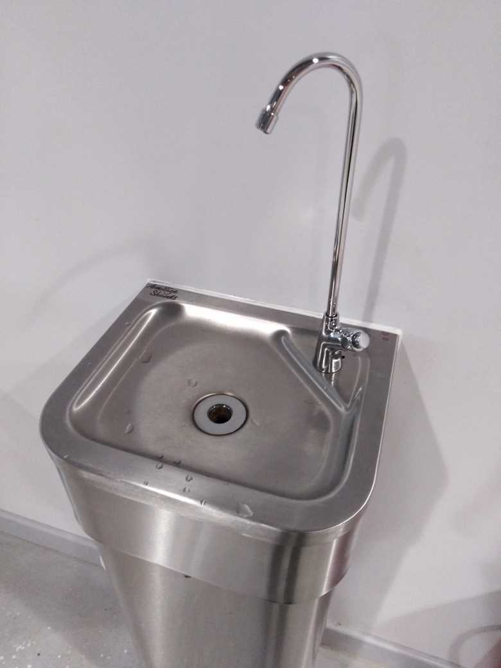

4a. Paper Bin University (UWTSD 2019)
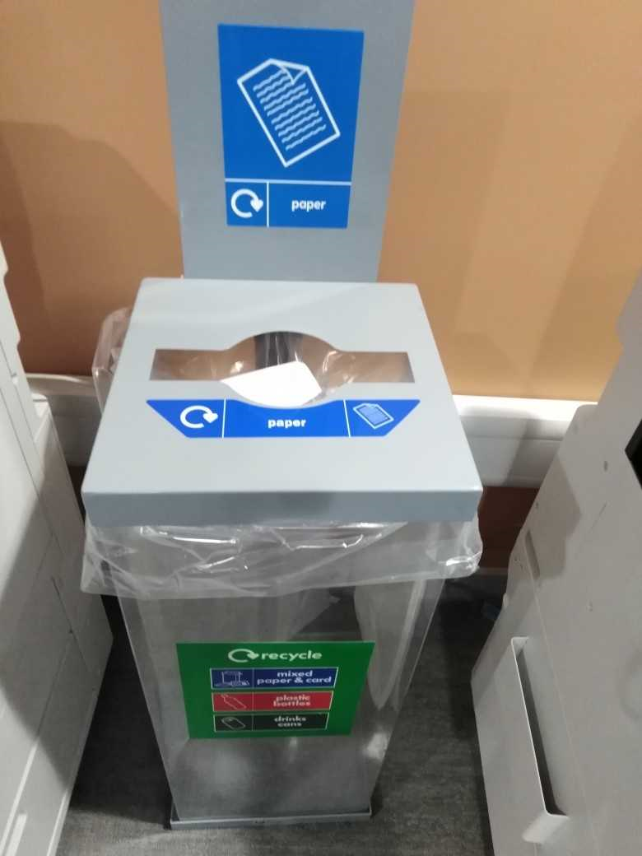

6. Images could be placed around the library such as these signs

Ref (123rf.com 2019)


7 WALL .E Ref rotoscopers .comrotoscopers.com

