Improvement of an HR priority area
Assignment 1

Human Resource Management BMMB7007
Improvement of an HR priority area
Ning Nie 2106243

Executive summary
Alibaba is one of the largest internet companies in China, facing fierce challenges not only in the field of e-commerce, cloud computing but also as an employer which hired the most employee in the industry. However, its employer brand is precarious, and its position as an employer has fallen to the second. Hence a report is needed to figure out the existing problems in the given 6 six areas of HRM, and to decide what to be done next to stay competitive.
Alibaba did pretty good with the employee’s satisfaction and well-being since the executives have been taking action and carrying out reforms. The weakness of Alibaba’s human resources management is the selection process. According to the wide discussion on the internet and several HR managers, some of the staff from Alibaba’s human resources treated the candidates and interviewees in an inappropriate way during recruitment.
After using Harvard Model, how these misbehave would impact Alibaba’s stakeholders’ interests and corresponding solutions are found out:
- Inappropriate practice during recruitment lead to understaffing, overwork, which deteriorates employees' health and wellbeing.
- Inappropriate practice during recruitment caused public disgust, damaging the employer brand and the employer competitivity.
And the corresponding solutions are to modify the selection process and improve HR’s psychological resilience. If these solutions are difficult to achieve, there are supplementary solutions to prevent stakeholders’ interests from being affected.

Contents
Executive summary 3
Introduction 6
1. Overview of Alibaba 6
2. Main Discussion 7
a) HRM circumstances of Alibaba 7
b) Analysing using cases and Harvard Model 8
c) From HRM policies choices to HR outcomes 9
d) From HR outcomes to Long-term Consequences 9
e) From Long-term Consequences to stakeholder interest 10
f) From Long-term Consequences to Situation Factors, thus to the stakeholders’ interest 10
3. Conclusions 11
4. Recommendations 12
a) Systemic reasons and their solutions 12
b) Personal reasons and their solutions 13
c) Alternatives 14

Introduction
Alibaba is a multinational technology company founded by Jack Ma. Around 1994 he went to the USA, where he first knew about the internet and noticed that there is little information about Chinese goods on the internet (Lei, 2016). So, after he returned, he began his business with his 17 friends. After a series of entrepreneurship, Jack Ma established Alibaba in 1999. The company went through a lot of difficult times, such as the Internet Bubble (though not listed in Nasdaq, the collapse made Investors stop follow-up investment plans), SARS, fraud (more than 1,000 fraud cases in both 2009 and 2010 was found after which two executives resigned (BBC News, 2011)). And now it has become one of the biggest internet companies in China (RecordTrend, 2021). But that won't ensure the top competitivity as an employer; Alibaba is losing to ByteDance in Talent Acquisition (Tong, 2021). As ByteDance is seeking a position in e-commerce (Yu, S. and Horwitz, J., 2021) the disadvantage could lead to a significant loss in Alibaba’s main business, damaging stakeholders’ interest, such as share prices.
The report aims at looking for the next move in Human Resource Management of Alibaba, starting with a glance at all 6 areas, and then evaluating the HR area that needs improving. After the evaluation, conclusions will be drawn and recommendations will be given.

- Overview of Alibaba
Alibaba is the 18th in the "Top 500 Chinese Enterprises in 2021", and one of the two largest internet technology companies in China, with a market value of US$252.573 billion and 251,462 full-time employees.
Alibaba's employee count and growth rate are shown in the chart below. The number of employees increased significantly in 2015 and 2021, respectively, due to the company's expansion after listing on the NYSE and the acquisition of Sun Art Retail.
Figure 1
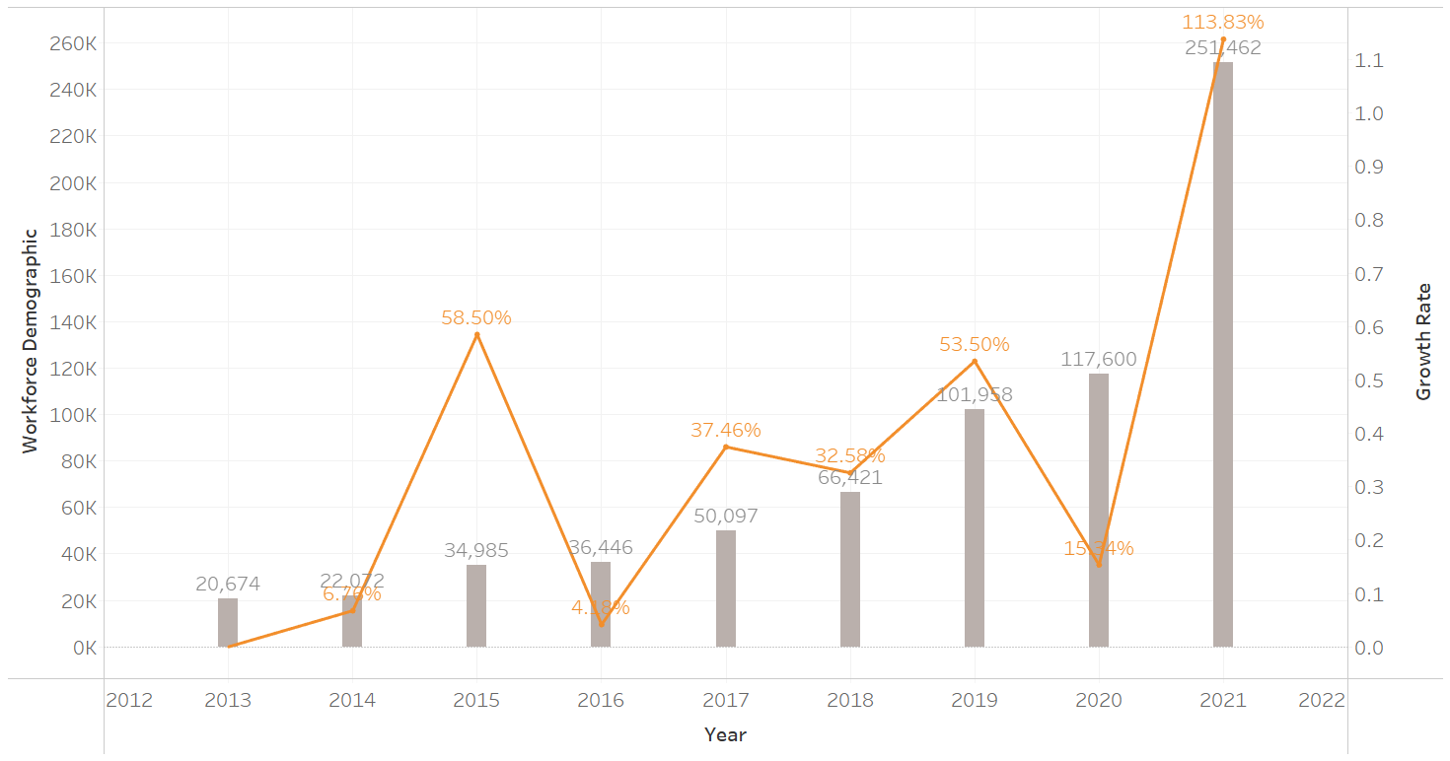
(ir.Alibaba.com, 2021)
Human Resource Management plays a vital part in building a foundation for competitive advantage (Offstein, E.H., Gnyawali, D.R. and Cobb, A.T., 2005). Technology is the foundation for Internet companies to build all kinds of moats. So, as an Internet company, Alibaba must pay attention to how to attract talents, retain talents, and make full use of talents to develop new technologies.
- Main Discussion
  - HRM circumstances of Alibaba
The appropriate human resources management strategy ensure that fresh blood will continuously flow into Alibaba, and enable Alibaba to compete against other tech giants and to expand the global market when the domestic policy and the international situation are favourable.
Alibaba has developed a consummate Human Resources Management system to support its hundreds of thousands of employees and millions of applicants and candidates. Many areas of Alibaba’s human resources management are updated since Savio Kwan, who worked at General Electric for 15 years, firstly sorted out the company's organizational structure and values as Alibaba’s new COO in 2000.
The culture of Alibaba, represented by its core value ‘Six Vein Spirit Sword’ got renewed in 2019, after a series of thorough discussions between the leaders and employees around the globe (Gabbie, F., Sovanna, F., 2019). KPI, the quantifiable measure of performance which was introduced and modified by Savio Kwan in 2000, swept the internet start-ups in China. And despite the general dislike of KPI, Alibaba has been on the list of the best employers for many years in a row.
And in the areas of equality, diversity and equity, Alibaba has also put in a lot of effort, such as supporting UN Women flagship programmes – ‘Making Every Woman and Girl Count’ and Buy from Women’, the various helps in the employment of disabled persons (Alibaba Foundation, 2019). Though an employee of Alibaba was publicly accused of sexual assault by his subordinates in August 2021, Alibaba quickly responded by dismissing the employee and setting up the Work Environment Committee which report directly to the board of directors (Reuters, 2021).
In conclusion, everyone in Alibaba is well taken care of. According to the report published by a recruitment platform Dajie.com, Alibaba, surpassing Huawei and ByteDance, is the company with the highest employee satisfaction among the post-95s generation (People.cn, 2019).
However, those above are not the whole story of human resource management at Alibaba. In September 2016, a question was put up in Zhihu (Chinese Quora) asking Why Alibaba's HR is different from that of other Internet companies? (Zhihu, 2016) It has received 441 answers so far, and most of them are criticism of the interviewer of Alibaba. Another similar question is Why is Alibaba’s HR so arrogant? It was published in March 2017 and receive 711 answers so far, and some of them got 10s thousand upvotes (Zhihu, 2017).
It is strange that so many people are dissatisfied with Alibaba’s HR, even considering the scale of Alibaba’s annual campus recruitment and social recruitment. At first glance, these cases are the sign that many talents are lost and the employer branding is ruined. And we will see what other potential effects these misbehaving recruiters and the complaints against them would have by analysing some of the cases and the Harvard Model.

  - Analysing using cases and Harvard Model
One answer with 16,889 upvotes is about a call from Alibaba’s interviewer (Niu, 2021). A few years ago, Ali's interviewer called the answerer at 10:30 in the middle of the night and asked him to interview. And many of the comments shared their experience of getting called by Alibaba’s interviewer after work hours or weekends, and they related that to Alibaba’s customs of working overtime.
Another answer (Ju, 2021) is about the conversation between the answerer and an interviewer from Alibaba. The answerer regarded that offer as humiliation, not for the low salary or low rank of the job, but for the interview itself, which is full of the interviewer’s criticism and sarcasm. This answer got 10,066 upvotes and 891 comments, many shared the same experiences and some suggest that Alibaba’s interviewer is using Pick-Up Artist techniques.
According to Harvard Model, HRM policies choices will influence HR outcomes directly and influence Long-term Consequences indirectly, thus stakeholder interest will be affected; for a big company like Alibaba, the Situation Factors would be affected and consequently put an effect on stakeholders’ interest.

  - From HRM policies choices to HR outcomes
Internally, the inappropriate practice during recruitment may limit the number of employees employed, which in consequence, either the HR increase the number of interviewees and interview more, either the departments suffer from understaffing.
And externally, the inappropriate practices during recruitment are reported to the HR department of Alibaba and posted on the internet, causing a wide range of discussion, like these two questions above. Though this affects no stakeholder of Alibaba, it is the cause of other long-term consequences listed below.

  - From HR outcomes to Long-term Consequences
On the one hand, Understaffing causes overwork of individual employees. Though it is passion and commitment that grant Alibaba’s achievement today, it is not a glorious thing to let employees work overtime, let alone worshipping overtime.
In April 2019, Jack Ma’s speech in an internal communication leaked, and his view that 996 (working from 9 to 9, 6 days a week) is a blessing (compared with those poorly run companies) caused people's rage and criticism on the internet. After that speech, Alibaba was regarded as a representative of 996 work cultures. Though new core values released half a year later replaced passion and commitment with live seriously, work happily may be the compensation of that speech, making employers work 996 did harm Alibaba’s brand.
On the other hand, in the discussion about the inappropriate practices during recruitment, many perceive the interviewers’ arrogance as gaslighting and even regarding gaslighting as part of Alibaba’s unspoken rules and culture.

  - From Long-term Consequences to stakeholder interest
Overwork of individual employees is not only bad for employer brand but also bad for employees’ health and wellbeing, which lead to sudden death in cases. According to research published on the lancet, employees who work long hours have a higher risk of stroke than those working standard hours (Kivimäki et al., 2015, p.1739-1746). As for death from overwork, or in Japanese, Karoshi, was a serious problem in Japan, and raised much attention in China, since cases of sudden death continue to occur in the internet industry.
And as a result of the worse employer brand, according to a report TALENT MOBILITY IN CHINA 2021 published by Maimai Data Research Institute (2021), ByteDance had the highest net inflow of talents from China's new economy companies in 2020, and Alibaba is the second. Alibaba is losing its edge in the race for the best talent, which can be fatal as ByteDance is trying to capture share from Alibaba in e-commerce (Tong, 2021).

  - From Long-term Consequences to Situation Factors, thus to the stakeholders’ interest
As Jack Ma’s speech brought 996 to light, the question that does 996 schedules comply with labour law has become a public concern. Fortunately for the employer, the Supreme People’s Court and Ministry of Human Resources and Social Security of the PRC released some typical cases of labour and personnel disputes (2021), one of which define the 996 schedule as a serious violation of the law regarding extended working hours.
As government tighten up the registration, the company will either pay employees overtime, or let employees leave work at regular hours, and both will make the industry or just Alibaba less competitive.

- Conclusions
In conclusion, firstly, the problematic selection process may cause understaffing and will exacerbate the problem of overtime, which is bad for employees’ health and wellbeing. Secondly, the misbehave of interviewers and overtime culture as people perceive it will both provoke resentment and harm the employer brand, making Alibaba less competitive as an employer.
The figure below illustrates the direct and indirect influence the problem in selection would have.
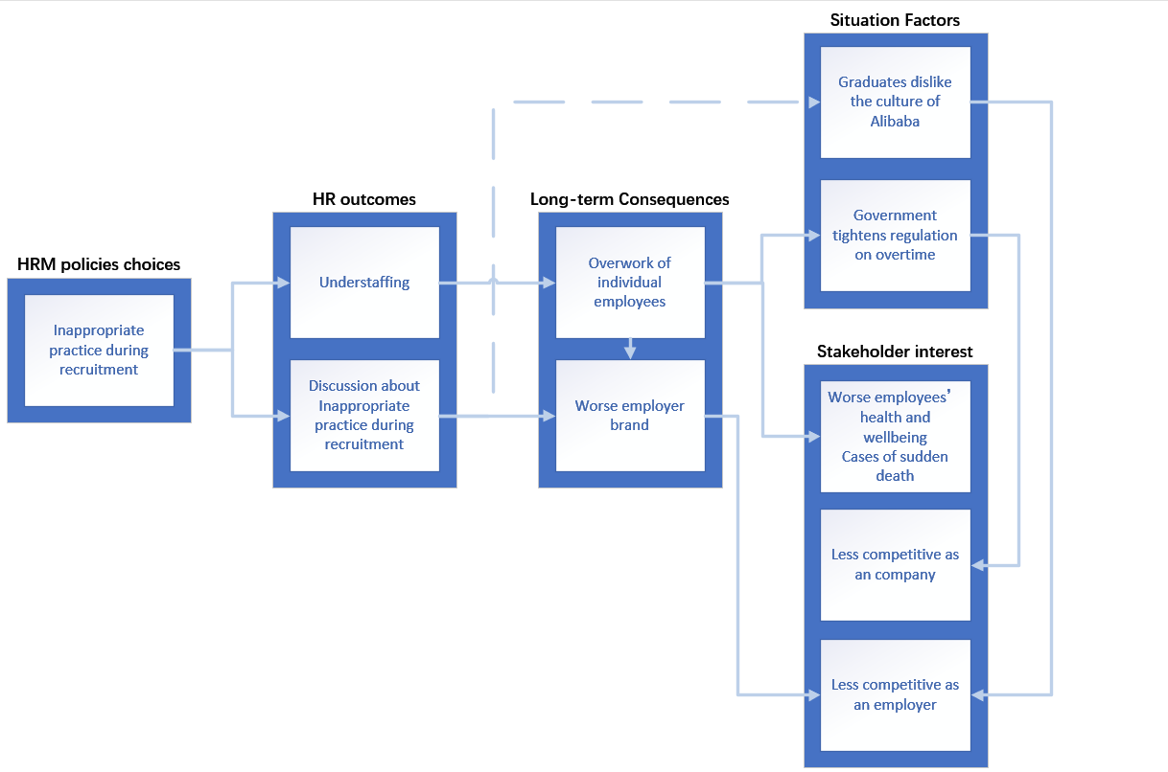

- Recommendations
The reasons behind the wide range of misbehaviour of Alibaba’s HR can be divided into systemic ones and personal ones.

  - Systemic reasons and their solutions
The systemic reasons are apparent. Firstly, Alibaba has a significantly larger number of onboarding staff (MaiMai Data Institute, 2021). The figure below shows the change in the number of employees of top e-commerce companies last year, and the leftmost company on the horizontal axis is Alibaba. The cyan line represents the number of employees newly hired, the blue line represents the number of net inflow employees, and the yellow line represents the number of resigned employees. As the figure shows, the number of newly hired employees of Alibaba is eight times higher than other companies.
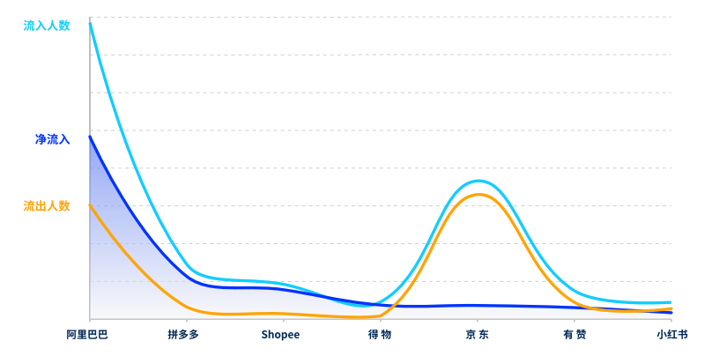
Even if Alibaba have 4 times larger HR department, HR has to cope with 2 times more interviewees than the average tech giant. With a significantly larger amount of work to be done, it is difficult for interviewers to stay in the right mood all the time. And calling interviewees in the middle of the night is understandable, though wrong. Secondly, the selection process is specially designed to let the interviewers estimate the interviewees’ value, to pick those who share a similar value with Alibaba. This means HR is given the right to veto the interviewees even the frontline managers approve the interviewee.
The huge number of interviewees and the power to veto them combined, make some of Alibaba’s HR behave indifferently and show no empathy.
A simple solution to the HR workload problem is to expand the HR team, so they can handle the huge number of candidates and interviewees. Or the manager could outsource selection and recruitment. But since Alibaba applies a unique selection program which includes a separate HR interview (in which the interviewers can veto the interviewee) to evaluate the interviewees’ value, HR outsourcing maybe not economy as expected (Klaas, McClendon and Gainey, 2001, p.125), and it may be compatible with the solution to the veto right problem mentioned below.
As for the veto right, since it is very important to evaluate the similarity of values between the interviewee and Alibaba, and the job can only be done by HR, we can apply grading systems to interviews, replacing absolute veto powers with a high weighting of the grading system.

  - Personal reasons and their solutions
And apart from the systemic problems, two types of HR are more likely to appear inappropriately when interviewing.
- Those who are arrogant or indifferent by nature.
- Those who are more prone to emotional problems under pressure.
And to prevent these two types of HR from being arrogant or indifferent with candidates, we can promote HR’s psychological resilience by training courses or Cognitive–Behavioural Therapy (Padesky and Mooney, 2012, p.283) or transfer them to positions that suit them, such as performance management, which require less interpersonal communication.
And to optimize the experience between candidates and HR on the phone, Alibaba can build up a telephone interview system, which will record the interview and text the candidates for feedback, and include the feedback into the HR’s KPI.

  - Alternatives
If the measures above are invalid for various reasons or not getting the expected result, supplementary measures can be taken to block the HR choices from really influencing stake interests.
For example, the HR department can increase the number of interviewees and interview more to recruit enough staff in case of understaffing. And HR department could encourage Internal Reference to prevent Alibaba’s competitivity as an employer from the influences of public disgust and worse employer brand.

References

Lei, M. (2016) official Documentary about Jack Ma [video]. Available at: https://www.youtube.com/watch?v=bU5ze-EwFg8 (Accessed 21 March 2022).
BBC News (2011) Alibaba executives resign after rise in fraud cases. [news] Available at: https://www.bbc.com/news/business-12521833 (Accessed 21 March 2022).
Tong, C. (2021) Douyin and Kuaishou besiege Alibaba's e-commerce business. Available at: https://36kr.com/p/1277504050217216 (Accessed: 21 March 2022).
Yu, S. and Horwitz, J. (2021). Analysis: Alibaba’s e-commerce empire under threat from Douyin, Pinduoduo. [online] Available at: https://www.reuters.com/technology/alibabas-e-commerce-empire-under-threat-douyin-pinduoduo-2021-12-08/ (Accessed: 21 March 2022).
Offstein, E.H., Gnyawali, D.R. and Cobb, A.T. (2005) ‘A strategic human resource perspective of firm competitive behavior’, Human Resource Management Review, 15(4), pp.305–318.
Gabbie, F. and Sovanna, F. (2019) ‘Alibaba Unveils Six New Company Values for the Digital Era’, Bloomberg, 10th September. Available at: https://www.bloomberg.com/press-releases/2019-09-10/alibaba-unveils-six-new-company-values-for-the-digital-era (Accessed: 21 March 2022).
Alibaba Foundation (2019) Alibaba Disability Support Report. Available at: http://www.alijijinhui.org/file/download/id/82e396817e37b40026f68cb5f6d0dade (Accessed: 21 March 2022)
Reuters (2021) Alibaba to set up committee to probe sexual harassment complaints. Available at: https://www.reuters.com/business/retail-consumer/alibaba-set-up-committee-probe-sexual-harassment-complaints-2021-08-12/ (Accessed: 21 March 2022)
People.cn (2019) Post-95 job search survey: programmers are the most popular occupation. Available at: http://society.people.com.cn/n1/2019/0910/c1008-31345265.html (Accessed: 21 March 2022)
Zhihu (2016) Why Alibaba's HR is different from that of other Internet companies? Available at: https://www.zhihu.com/question/50617632 (Accessed: 21 March 2022)
Zhihu (2017) Why are Alibaba’s HR so arrogant? Available at: https://www.zhihu.com/question/57131318 (Accessed: 21 March 2022).
Niu (2021) [Zhihu] 13 August. Available at: https://www.zhihu.com/question/57131318/answer/2057241837 (Accessed: 21 March 2022).
Ju (2021) [Zhihu] 09 August. Available at: https://www.zhihu.com/question/57131318/answer/1205985451 (Accessed: 21 March 2022).
MaiMai Data Institute (2021) Talent Mobility in China 2021. Available at: http://www.199it.com/archives/1217886.html (Accessed: 21 March 2022).
Kivimäki et al, (2015) ‘Long working hours and risk of coronary heart disease and stroke: a systematic review and meta-analysis of published and unpublished data for 603 838 individuals’, The Lancet, 386(10005), pp.1739-1746.
DOI: 10.1016/s0140-6736(15)60295-1
Supreme People’s Court and Ministry of Human Resources and Social Security of the PRC (2021) Typical Cases of Labour And Personnel Disputes. Available at: https://www.court.gov.cn/zixun-xiangqing-319151.html (Accessed: 21 March 2022).
Klaas, B., McClendon, J. and Gainey, T. (2001) ‘Outsourcing HR: The Impact of Organizational Characteristics’, Human Resource Management, 40(2), pp.125-138.
Padesky, C. and Mooney, K. (2012) ‘Strengths-Based Cognitive-Behavioural Therapy: A Four-Step Model to Build Resilience’ Clinical Psychology & Psychotherapy, 19(4), pp.283-290.

