Student name: Nathan Davies
Student Number: 1706135
Degree: Electrical and Electronic Engineering
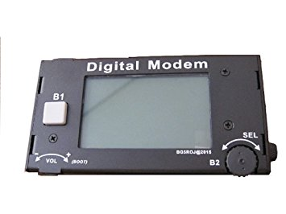
Preferred Lecturer: Prof Ian Wells
Word count: 4134
Research Project Proposal
Hardware and software implementation of a PSK Digital Modem
Table of Contents
Introduction/Background Research 1
Research and Development Methods 5
Risk and Analysis 7
Project Planning 8
References 11
Bibliography 12

Table of Figures
Figure 1: PSK waveform 2
Figure 2: BPSK Constellation diagram 2
Figure 3: QPSK Constellation diagram 3
Figure 4: Research Methods Wall 5
Figure 5: Gantt chart Checkpoints 9
Figure 6: Gantt chart stage 1 9
Figure 7: Gantt chart stage 2 9

Introduction / Background Research
Introduction
The premise of this first section is to give a brief explanation of what the research project is going to be and to give some background information on what the topic is and some of the theories behind the project. This background information will contain a literature review of what research is being done in this subject currently and certain knowledge needed for this project. The background information will also include aims and objectives that will be met at the end of the whole project.
Giving the project a working title
The title of the project will be, Hardware and software implementation of a PSK Digital Modem.
Background Information
To start off this literature review we must first ask the question, what is a digital modem and how does it work? A digital modem Is any type of modem used for synchronous transmission of data over circuit-switched digital lines[1]. The way these digital modems work is by using advanced digital modulation techniques for changing data frames from a network into a format suitable for transmission over a digital signal such as an integrated services digital network (ISDN for short) line[1]. An ISDN is the original high-speed internet service, this sparked the high-speed internet development between service providers during the 1990’s and, of course revolutionized the internet[5]. Just like the dial up method before this, ISDN utilizes a phone line connection[5]. It also set the standards for telephone data services[5]. These modems have two different systems within them which are modulation and demodulation. The modulation on the sending modem modulates the data into a signal that is compatible with the phone line, and the receiving modem demodulates the signal back into digital data which then can be transmitted wirelessly[9].
The next question that must be asked to gain further knowledge in this project would be, what digital modulation will be used in this project and how does it work. A digital modulation in essence is the process of changing one or more properties within a continuing wave, this wave is called the carrier wave[6]. Digital modulation is most used in radio systems with the most common types being frequency modulation(FM) and amplitude modulation(AM)[6]. Most of the waves found being used in digital systems will be sine waves. These sine waves or sinusoidal waves are mathematical waves that describe a smooth periodic oscillation[4]. The reason why sine waves are useful is because when an modulated sine wave is added to another sine wave is retains its normal wave shape it is the only periodic waveform that will retain its shape[4]. This allows the wave to be transmitted through the atmosphere without degrading or losing any data embedded in the wave. The type of modulation that will be used in this project will be phase-shift-keying modulation (PSK for short), this type of modulation was chosen by the lecturer overseeing the project. The way this type of modulation works is by changing the phase of the carrier wave[2].
Another key feature within modulation and demodulation would be a filter module. This is a module that is used to filter out gaussian noise form a signal to produce a smooth signal with no added data. Gaussian noise or white noise is natural noise that is added into a signal naturally. This can be from internal hardware noise or by atmospheric noise from other waves being transmitted through the atmosphere. This filter design is normally done using a FIR compiler module available in libraries found in Simulink[10].
With phase-shift-keying modulation there are many different types of modulation to choose from to create this device and accomplish a PSK modulation system[10]. The way in which these are chosen between depends on upon the modulation scheme and the angular separation change between the outputs[10]. In this report only two types will be discussed these subtypes would be Binary-phase-shift-keying and quadrature-phase-shift-keying the decision for which subtype will be used will come after giving some background research on both subtypes. Starting off with binary-phase-shift-keying (BPSK) this is the simplest form of phase-shift-keying[2]. This form uses two phases which are separated by 180 degrees[2] these two phases represent binary 0 and 1. This can been seen in figures 1 and 2. This form of modulation is regarded as the most robust digital modulation technique and is mainly used for long distance wireless communication[8]. This is due to its 180 degree phasing between constellation points hence why it can withstand severe channel fading[8]. This technique is used in various standards some being satellite, cable modems, WLAN 11a and cellular systems[8].
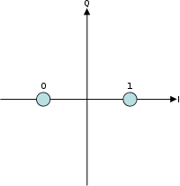
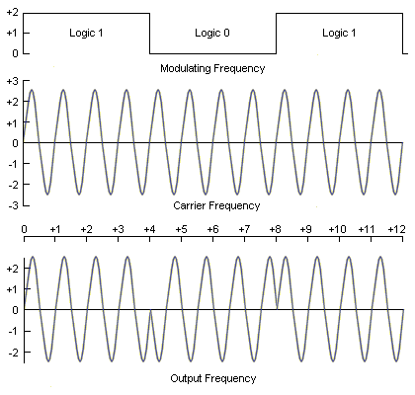

Figure 2 shows the constellation points for PSK modulation
Figure 1 shows the waveform of PSK modulation

Quadrate phase-shift-keying (QPSK) works as follows unlike BPSK which uses two constellation points QPSK uses four points equipage around a circle[2]. Because QPSK has four points this means it can encode two bits per symbol were as BPSK could only encode one[2]. This is to reduce bit rate error, meaning error correction such as Gray coding can be used[2]. This also shows that QPSK can be used to either double the data rate compared to BPSK while maintain the same bandwidth of the signal, or maintain the data-rate of BPSK while having the bandwidth of the signal[2]. This also means that this form of modulation can undergo channel fading and phase changes just like BPSK but more frequently and on a higher level[2]. The constellation diagram for QPSK can be seen in figure3.
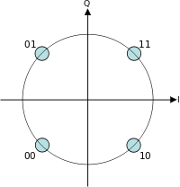
Figure 3 this figure shows the constellation diagram for QPSk modulation
Making the decision on which form of phase-shift-keying to use was fairly straight forward. This is because as QPSK can transmit at twice the data rate of BPSk while maintain the same bandwidth, there is an engineering penalty which is QPSK transmitters and receivers are more complicated and cost more to create[2]. This factor as well as the fact that this will be a fairly small project, meaning high bitrates and complicated error correction isn’t really needed for the project, which has led me to decide that BPSK will be more useful for this project.
Another key research topic will be on radio frequencies and how there generated. A radio frequency refers to the rate of oscillation of electromagnetic radio waves in between 3kHZ and 300GHZ[3]. This range of frequencies is called the frequency band and is used for most communications and broadcasting systems[3]. The way this whole process works is by oscillating current a number of times and then transmitting this signal off a conductor[3]. This is then transmitted into empty space as electromagnetic radio waves[3]. The way in which radio frequencies are sent and received is through a phenomenon called the skin effect[3]. This process is where radio frequency current latches itself and flows through the surface of the conductors rather than passing through the conductor like it does with non-conducting solids[3]. This effect is the basis of which radio technology is based upon[3].
The radio band mentioned early which is a range of frequencies between 3KHZ and 300GHZ is divided up these sections are then assigned to different technology industries[3]. These industries can range anyway from radio stations, military communications and cv radios to recreational use for radio controlled toys. An example of one of these sections in use would be the range of 30-300MHZ this band is used for FM radio, tv broadcasting and amateur radio[3], as can be seen this band is used for broadcasting. More demanding broadcasting which needs more bandwidth to transmit large amounts of data is transmitted at ultra-high frequencies[3]. Industries that use this band are high data using ones such as mobile phones, wireless LAN’s, Bluetooth and land radio[3].
Research project premise
The premise of this project is to design and construct a working PSK digital modem that focuses on the efficiency of the modulation and demodulation, as well as the development of different recovery systems such as clock and carrier recovery. After the completion of the device a number of test will be conducted to gauge the efficiency of all the systems present within the device.

Aims and Objectivise
The one aim for this assignment will be to create a working PSK digital modem that will successfully adapt digital signals from one transmission to another. To complete this aim a number of objectives will be set so that progress on the aim can be shown, this list of objectives can be found below:
- Create a critical literature review on PSK Digital Modems
- Create a working PSK system using the program Simulink
- Create working subsystems that will help the efficiency of the PSK system e.g clock recovery or carrier recovery systems
- Evaluate the final product for its usability
- If the project is being completed on time with no delays create a working hardware prototype of the system.

Conclusion
In conclusion to this section, the basic knowledge to do which the topic and some related topics has been outlined in the research. The premise behind the project has also been discussed in this case the efficiency of the device will be the overall factor of the project and will be tested thoroughly at the completion of the device. Another thing that was achieved in this section was the deduction of the overall aim of the project and five objectives that will be met to show that the project was a success. As was decided previously the overall aim of the project will be co design and create a working PSK digital modem using the software Simulink.

Research and Development Methods
Introduction
In this section the type of research method that will be used throughout this project will be determined and, an explanation of why these research methods were chosen will accompany each section. The way that this will be determined is by using a methodology wall seen in figure4. Using this wall always for an easier time in determining which methodologies are suited for which project. Also within this section the risks and ethical issues to do with this project will be determined along with ways in which to prevent these issues or lessen the impact of them on the project and people involved with the project.
Research Methods Used
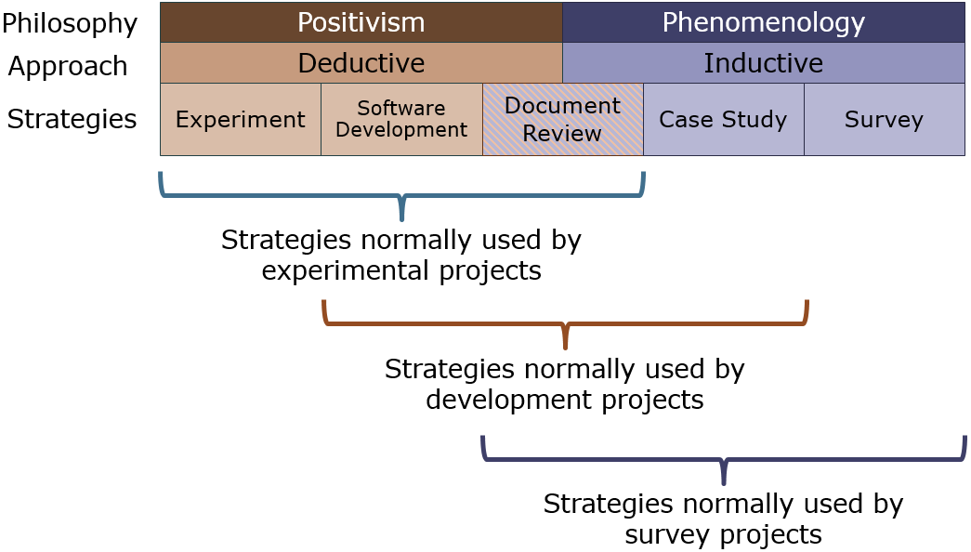
Figure 4 Methods Wall
The philosophy that has been determined for this project is the Positivism philosophy. This is because this type of project requires the design, creation and observation of a system and piece of hardware created in the real world. This philosophy was also chosen because of the type of experiments needed to deduce whether the project is a success or not, these experiments are observations about the system to determine if the final product does the job it is intended to do or not and whether it can perform as efficient as other products of a similar nature.
The approach that was determined for this project is the deductive approach, this approach normally follows a positivism philosophy but there are some factors which influenced this decision. This approach requires there to be a theory or a hypothesis, in this case the project is the design and creation of a digital modem using the PSK modulation/demodulation theory. This approach is mostly a scientific approach meaning that lots of quantitative data will be collected and that this project will be moving from theory into practical while collecting data along the way. This approach is great for this project as it relies on researching a wealth of literature to collect data, seen as this is a project to create something which has been researched thoroughly in the past there will be a lot of literature to review.
The three strategies selected for this project are Case study, Software development and Document review. These three strategies are the most commonly used one’s in development projects which this project is. Case study was chosen as this project is all about the development of a software, which is to create a PSK digital modem through the use of software and hardware and by also comparing the product at different stages to a readily available one on the market. Software development was chosen because the whole project revolves around using Simulink to create a PSK modulation/demodulation software that will act as the backbone of the whole system and be the bulk of the project research and construction. Document review was chosen because it is used to collect most of the research information for the literature review. This is used to collect information such as main theories within the field, who the most famous researches in the field are, identify the positives and negatives within the field and this research provides a starting point in which you can compare your own results too.
Software Development Methodology
There are a few development methods that have been identified which could be used in this project, but the one chosen to be used in this project is Feature Driven Development Methodology (FDD). In essence FDD is a practical agile modelling process that combines a number of industry standards into a single process and mixes them with what specifications the client wants the software to have. The reason this methodology is the right chose for this project Is because it a practical process and its purpose is to produce working software time and time again. FDD has five processes to follow to make a working software these are:
- Developing an overall model
- Building the feature list
- Planning by feature
- Designing by feature
- Building by feature
From analysing these processes and comparing them to the project, these processes bring a big advantage to the project. This is because these processes allow the user to carefully plan out what is going to happen within the project. This method also encourages the user to do regular builds meaning that the project will constantly be growing and changing, this also allows the user to easily find errors within the project and easily record progress. These features are very useful for this type of project as it allows the user to constantly keep up with errors within the project.
Not many problems should arise from using this method as it fits the project quite well. But if problems do arise they can be combatted by thinking them out logically and planning them out, which is what this method is based upon.
Conclusion
In conclusion to this section, what methodologies for research and software development have been discussed. The research methods that have been agreed on are positivism philosophy, deductive approach and experimental, software development and document review strategies. This philosophy was chosen as the project is mainly based on the creation of piece of software from scratch while observing test results from different stages during the development. This approach was chosen as this project is mainly based on using modulation and demodulation theory and that this approach relies on a lot of research to be done, and because this topic has been around for a long time there will be a wealth of report and experiments to refer to during the development of this project. The three strategies where chosen because they are the most commonly found in development projects as well as having their own unique connections to the project, more information regarding the decision of these methods can be found in the research methods section of the report. Another thing that was discussed within this section is what development method will be used in the project. The method that was decided on was feature driven development methodology (FDD). This is because of the way the method plans things out nicely and allows for regular test builds to fix problems and record progress.
Risk and Analysis
Introduction
This section of the report will highlight all the risks that will be associated with the project and certain steps to either prevent or lessen the impact these risks have on the project and people working on the project. This section will also highlight some of the ethical issues which will affect this project as well as steps to prevent or lessen the effect of these issues.
Within this project there are many risks related to this project. Most of these risks are common risks in projects which relate to time and resource management. But some of these risks relate more to this type of project which is the design and creation of a software and or piece of hardware. The risks identified within this project have been listed below:
- Time management
- Resource availability and management
- Not meeting the requirements of the specification
- Not having enough knowledge on the topic
- Software constraints
- Not having access to certain software
- Incompatible hardware
- Defective hardware
- Burns and shocks from soldering or testing hardware

To combat the first issue on this list a Gantt chart creating in Microsoft project will be created, to allow for efficient time management and to record delays and or early finishes in project checkpoints. The second risks on the list resource availability and management this can also be combatted by using a Gantt chart. This can also be done by using the Gantt chart to record what resources are needed and what times and days there available at. Not meeting the requirements of the specification is one of the risks that is affected by other risks. This risk is affected by time management, resource availability and management, not having enough knowledge on the topic and many other hardware related risks. To combat this risk making sure these other risks are completed on time and all resources are being managed efficiently will help reduce the impact that this risk has on the whole project. The fourth risk on the list can be combated by doing more research on the topic and other topics which might be needed for this project. This can also be combated by using summer break to learn new skills and do extra research that might be needed to complete the project. Software constraints is one of the unavoidable risks on the list, this is because if the software your using can do a certain task that is needed to complete the project then that software is useless to the project. This also means a new software is needed to complete the project which means money might be spent on another software. The sixth risk on the list can be combated by using the Gantt chart again. This is so the times and dates at which the software is available can be recorded, this is so project work won’t clash with other lectures. The seventh and eighth risks can be combated in the same way, this is by researching parts toughly to find out which hardware is compatible then ordering the parts. Another way is to just tell the supplier the hardware was defective to get replacements or to order new hardware from the same supplier or a different one. The last risk can be prevented by being careful when soldering or handling powered electronics. If burns do happen during soldering applying cold water to the area will alleviate pain or a burn ointment could be applied if any is available.
Resource Planning
Introduction
In this section of the report the resources needed for completing this project will be outlined in Microsoft project. A Gantt chart for this project will also be created in Microsoft project to show the intended course in which the project will be completed in showing start dates and end dates for all checkpoints as well as the duration of each checkpoint and their predecessor checkpoints.
Resources required
To successfully complete this project with little time delays and high efficiency, these resources will be required:
- PC/Laptop – to be used to create and simulate the PSK system
- Simulink program – to be used to create the PSK system with along with its subsystems
- Microsoft package – to be used to write up and document the progress of the project
- Hardware accessibility – to be used to create a physical prototype of the system
- IEEE journals – to be used to conduct research on the subject and relating subjects
- Library Books – to be used to conduct research on the subject and relating subjects
- Staff Help – to be used for insight on what to do next or help with certain aspects of the project
Project Planning
To manage time efficiently and make sure all steps of the project are recorded a Gantt chart will be constructed figures 5-7. The Gantt chart has been divided into two sections, these sections are called specification requirements and implementation. The specification requirements section contains steps that will be completed at the start of next year, this means such things as background research, identifying existing or new aims and objectivise and write ups for the literature review and methodologies. The implementation part of the Gantt chart contains the more practical part of the project, containing steps such as designing the modulation / demodulation system, designing any subsystems that will be needed as well as the testing and simulation of these systems. This section also contains building the system using hardware in the real world, conducting experiments to get results for comparisons and the final evaluation write up for the whole project.
Figure 5 This figure shows the checkpoint in the project

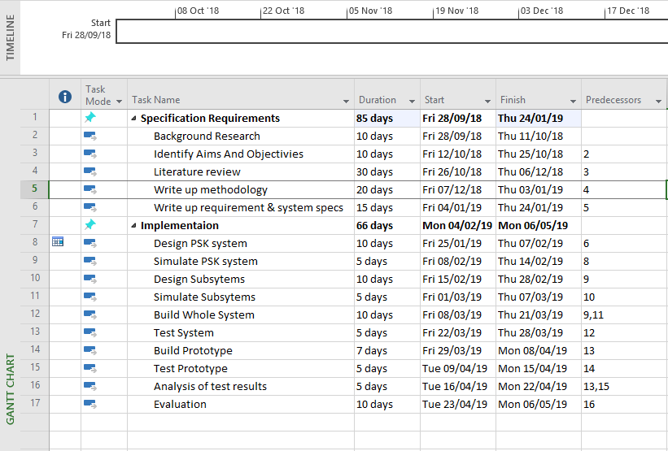
Figure 5 This figure shows the checkpoints that will be met while developing the project

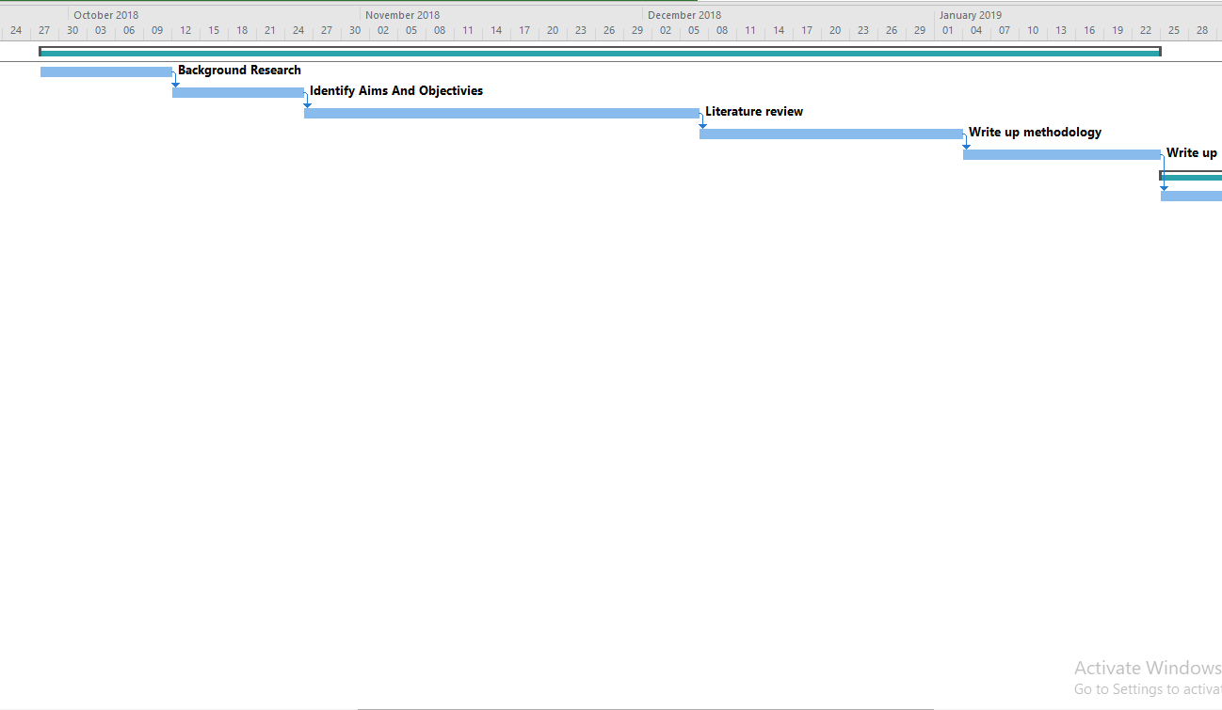

Figure 7 This figure shows stage two of the Gantt chart

Figure 6 This figure shows stage one of the Gantt chart

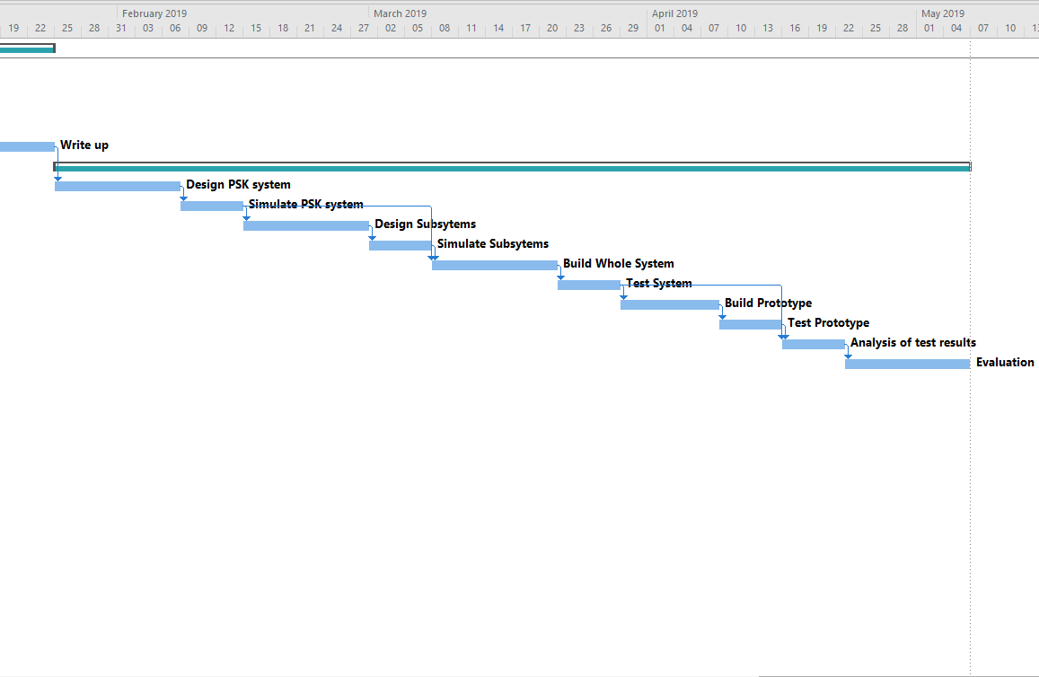

Conclusion
In conclusion to this section all resources that might be needed have been listed in this section. But this is just a temporary list as a placeholder, as during next year possibly during the research process for the literature review, new resources might be brought to light that will be essential to the project. If this does happen hopefully with the help of the overseeing lecturer these resources can be obtained without causing much delay to the project. Another point that is subject to change would be the dates within the Gantt chart found in figure5. As these dates have not been discussed yet these dates are placeholders, these dates are subject to change. Holidays such as Christmas and Easter have also not been included into this Gantt chart as the term dates for these have not been set in stone yet.

References

[1] | T. N. Encyclopedia, “Digital Modem,” The Network Encyclopedia, [Online]. Available: http://www.thenetworkencyclopedia.com/entry/digital-modem/.
[2] | Wikipedia, “Phase-shift-keying,” Wikipedia, [Online]. Available: https://en.wikipedia.org/wiki/Phase-shift_keying.
[3] | Technopedia, “Radio Frequency,” Technopedia, [Online]. Available: https://www.techopedia.com/definition/5083/radio-frequency-rf.
[4] | Wikipedia, “Sine Wave,” Wikipedia, [Online]. Available: https://en.wikipedia.org/wiki/Sine_wave.
[5] | What is my ip address, “What is ISDN,” What is my ip address, [Online]. Available: https://whatismyipaddress.com/isdn.
[6] | Wikipedia, “Digital Modulation,” Wikipedia, [Online]. Available: https://en.wikipedia.org/wiki/Modulation#Digital_modulation_methods.
[7] | G. H. Dave Collins, “CW mode for the nue-psk digital modem,” TAPR Digital communications conference, 2011.
[8] | RF wireless world, “BPSK-Binary phase shift keying,” RF wirless world, [Online]. Available: http://www.rfwireless-world.com/Terminology/BPSK.html.
[9] | M. Brian, “How modems work,” How stuff works, [Online]. Available: https://computer.howstuffworks.com/modem.htm.
[10] | K. A. A. Kumar, “A low power implementation of PSK modems in FPGA with reconfigurable filter and digital NCO using PR for SDR and CR applications,” Green Technologies (ICGT), Trivandrum, India, 2012.

Bibliography

[1] | T. N. Encyclopedia, “Digital Modem,” The Network Encyclopedia, [Online]. Available: http://www.thenetworkencyclopedia.com/entry/digital-modem/.
[2] | Wikipedia, “Phase-shift-keying,” Wikipedia, [Online]. Available: https://en.wikipedia.org/wiki/Phase-shift_keying.
[3] | Technopedia, “Radio Frequency,” Technopedia, [Online]. Available: https://www.techopedia.com/definition/5083/radio-frequency-rf.
[4] | Wikipedia, “Sine Wave,” Wikipedia, [Online]. Available: https://en.wikipedia.org/wiki/Sine_wave.
[5] | What is my ip address, “What is ISDN,” What is my ip address, [Online]. Available: https://whatismyipaddress.com/isdn.
[6] | Wikipedia, “Digital Modulation,” Wikipedia, [Online]. Available: https://en.wikipedia.org/wiki/Modulation#Digital_modulation_methods.
[7] | G. H. Dave Collins, “CW mode for the nue-psk digital modem,” TAPR Digital communications conference, 2011.
[8] | RF wireless world, “BPSK-Binary phase shift keying,” RF wirless world, [Online]. Available: http://www.rfwireless-world.com/Terminology/BPSK.html.
[9] | M. Brian, “How modems work,” How stuff works, [Online]. Available: https://computer.howstuffworks.com/modem.htm.
[10] | K. A. A. Kumar, “A low power implementation of PSK modems in FPGA with reconfigurable filter and digital NCO using PR for SDR and CR applications,” Green Technologies (ICGT), Trivandrum, India, 2012.
[11] | E. F. O. J. T. E. R. Cofer, “Shaped PSK in a digital modem with direct digital synthesis,” in Military Communications Conference, Monterey, CA, USA, USA, 1990.
[12] | R. C. I.R. Corden, “A high speed DSP PSK modem for real time digital speech transmission,” in Telecommunications, 1989. Second IEE National Conference, York, UK, 1989.
[13] | M. G. S. Maslamani, “Digital demodulation by a non-coherent differential PSK modem,” Electronics Letters, vol. 26, no. 24, pp. 2028-2029, 1990.

