University of Wales Trinity Saint David
School of Engineering



Approaches to Innovation and Organisational Change
Joe Shankland
2317772
BEng Mechanical Engineering
12/05/2025

Management, Sustainability and Innovation
ACMA5007

Executive Summary

This report analyses the organisational change process undertaken by TATA Steel in its transition from traditional Blast Furnace Steelmaking to the more sustainable Electric Arc Furnace method. Using Kotter’s 8-Step Change Model and Lewin’s Force Field Analysis, the report evaluates the challenges, barriers, and successes experienced by TATA Steel during this transition, with a focus on change management and organisational communication. Initially, TATA Steel failed to create a sufficient sense of urgency among its workforce. The lack of accessible and informative communication around the need for low-carbon steel and the capabilities of EAF technology led to anxiety, and resistance. This was further compounded by a management reorganisation that left many departments without permanent leadership, making top-down communication ineffective and challenging information flow. The report analyses Kotter’s model for its heavy reliance on formal leadership, which can be misaligned with TATA’s strong working culture. It highlights the missed opportunity to use informal leaders within departments to support and cascade the change message. Despite initial gaps, the establishment of a Change Committee and community forums helped restore some engagement by creating platforms for dialogue between the organisation and its stakeholders. While the long-term goal of carbon reduction was explained, intermediate milestones were poorly communicated. A specific example includes the early closure of the Coke Ovens, which resulted in unexpected financial strain due to coke import needs. This decision-making gap could have been avoided through input from operational engineers. Momentum was regained by small milestones, such as progress updates published via internal newsletters and video series. This communication built credibility and helped re-engage staff. Relocating engineers from soon-to-be redundant roles into change-related project teams also boosted morale and demonstrated a commitment to job retention. Union resistance posed a significant barrier due to job losses and led to industrial action threats. It took several months to resolve through negotiated agreements focused on long-term industry sustainability. To ensure the longevity of change, the report underscores the importance of embedding new processes into standard operations. TATA’s Management of Change procedure plays a central role in assessing and updating procedures, training, and maintenance documentation to align with the new production method. Overall, while the transition encountered significant resistance and miscommunication, TATA Steel’s adaptive responses and structured change strategies provided a foundation for successful transformation. Recommendations include enhancing early-stage communication, involving informal leaders, and co-creating visions with the workforce.

Contents
Executive Summary 2
Introduction 4
Main Findings 5
Lewin’s Force Field Analysis 5
Driving Forces 6
Resistive Forces 6
Kotter’s 8 Steps for Leading Change 7
Step 1 – Create a Sense of Urgency 7
Step 2 – Build a Guiding Coalition 7
Step 3 – Form a Strategic Vision and Initiatives 8
Step 4 – Enlist a Volunteer Army 8
Step 5 – Enable Action by Removing Barriers 8
Step 6 – Generate Short-Term Wins 8
Step 7 - Sustain Acceleration 9
Step 8 – Institute Change 9
Herzberg’s Motivation Model 10
Hygiene Factors 10
Motivation Factors 10
Conclusion 11
Bibliography 12

Introduction

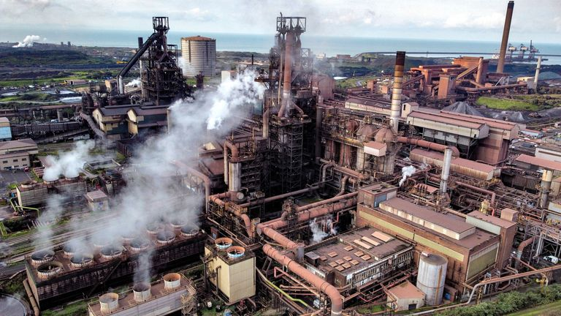
TATA Steel is a Multinational Steelmaking Company which operates in 26 countries and produces around 30 million tons annually. Until recently, the Port Talbot Site in South Wales was the largest Steel Producer in the UK. However, in September 2023, TATA Steel announced that they would be transitioning from Blast Furnace Steel Production to Electric Arc Steel Production. This transition was driven by a promise of £500 million from the Government with the goal of reducing the UK’s Carbon emissions. The transition however, was accompanied by 3,000 job losses, with 2,800 of them being from the Port Talbot site. These jobs came as Port Talbot’s Heavy End was shut, and other areas mothballed until the completion of the Electric Arc Furnace, which has a proposed completion date in 2027.
Figure 1 – TATA Steel’s Port Talbot Heavy End
This transition created the need for a massive organisational restructure, which would affect every member of the organisation, at every level of management and included not only thousands of job losses but also thousands of job changes. One example of this was in the Asset Integrity Teams in Central Engineering, with the majority of machinery that would be used on site having to change, the function of the Asset Integrity Teams would also have to change. This change came in the shape of a reorganisation, affecting the numbers and roles of those in the team.

Main Findings

In the modern world, change is essential for any business or organisation. Change ensures that a company is able to adapt to any problems it may face whether internal or external. Many factors may force change upon a company for it to survive, for example, competition from rival companies in the same sector, innovative technologies that render the current technology obsolete, or political and social pressures. However, for a change to be properly executed in a company, the proper analysis and management tools must be used, such as Kotter’s 8-Step Change Model, or Lewin’s Force Field Analysis. To first analyse the change, Lewin’s Force Field Analysis will identify both the driving and resistive forces in the system, which allows us to see which areas must be focused on and managed correctly.

Lewin’s Force Field Analysis

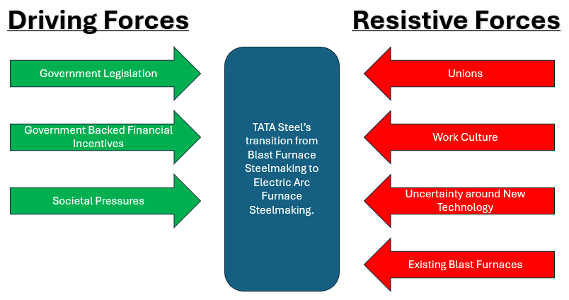
Lewin’s Force Field Analysis is a framework for understanding the forces of change in an organisation. Being able to identify these forces means organisations can plan to implement effective change strategies in their management. While the simplistic approach is commended by many, this is also one of the model’s greatest critiques, with some suggesting that the model is outdated for today’s fast paced environment (By, 2005). In the case of TATA Steel’s transition from Blast Furnace Steelmaking to Electric Arc Furnace Steelmaking, we can see the equilibrium of forces below, in Figure 1. Figure 1 shows that the majority of the driving forces are environmental factors, however, the weight of the factors is further increased by the governmental backing. The resistive forces are mainly from the workforce and the surrounding culture of steelmaking in Port Talbot which has impacted the area for over a century.
Figure 2 – Lewin’s Force Field Analysis of TATA Steel’s Proposed Change

Driving Forces

Government Legislation – The largest driving behind the change of furnaces in TATA Steel Port Talbot UK Government Climate Legislation. The UK Government signed the 2008 Climate Change Act, committing to cut emissions 80% from 1990 levels by 2050. However, in 2019, the UK government updated this to 100% from 1990 levels, making the UK net zero by 2050. In 2020, the UK Steel Industry was responsible for over 25% of the country’s greenhouse gas emissions, making it the largest industrial emitter in the UK, followed by the Chemicals Industry, at 19%(Griffin and Hammond, 2021). This meant steelmaking became a key target for emission cuts.
Government Financial Incentives – In 2023, the UK Government and TATA Steel announced proposals to invest £1.25 billion to enable greener steel production in Port Talbot, via an Electric Arc Furnace. As part of this investment, the government pledged a £500 million grant to support the transition.
Societal Pressures – In response to the looming global threat of climate change, societal expectations demand large companies such as TATA Steel take stronger climate action. This is not only reflected in the domestic market, but in the industrial market TATA Steel supply to. Evidenced by growing demand for TATA Steel’s low-CO2 Steel.

Resistive Forces

Unions – One of the largest resistive forces to TATA Steel’s proposed change was from the Trade Unions closely tied to the company. The Unions, representing much of the workforce, strongly oppose changes threatening large-scale job losses. While not always successful, trade unions have the support of the workforce and may propose alternatives or even threaten strikes, which could seriously impact TATA.
Culture and History – Port Talbot has been producing steel since the turn of the 20th Century. Strategic connections by rail and sea helped the industry thrive. While the process has changed with developments like BOS steelmaking and new mills, the workforce and culture have largely remained unchanged. The Steelworks has employed thousands—at one point nearly 20,000—including multiple generations, many staying from apprenticeship to retirement. The proposed change will not only threaten the livelihood of many workers, but will require extensive retraining for those who remain. This may result in some being replaced by more skilled workers.
Uncertainty – In the first six months, employees were only told nearly 3,000 jobs could be lost in the green transition. This lack of information and vague proposal caused confusion and uncertainty within the workforce, making it more difficult to understand and agree to the changes.
Misinformation – At the time, there wasn’t a lot of information surrounding the EAF method of Steelmaking, as it wasn’t widely used at scale. It became common belief that because of its lack of use, EAF Steelmaking must not be able to produce the same qualities of Steel as traditional Blast Furnace Steelmaking. While not explicitly true, this became a massive concern for the workforce and local community. This fueled concerns that TATA Steel would not be able to provide the quality of Steel for food packaging or the automotive industry, key contracts for the company.

Kotter’s 8 Steps for Leading Change

After the need for change has been analysed, and the largest resistive forces have been identified, the change needs to be managed moving forward. While there are many methods of managing change, one of the most common and effective methods is to use Kotter’s 8 Steps for Leading Change. However, Kotter’s method has been critiqued for being too linear and top down, which for many modern organisations, might not be adequate to manage the type of changes they experience. TATA Steel also has its own Management of Change procedure, which assesses the impacts of the change as well as the process which should be taken to ensure that the change is well integrated into the business. This is often completed by multiple levels of management and needs the contributions of Engineers that will be working with the change, as well as those higher up to approve any new procedures.

Step 1 – Create a Sense of Urgency

Creating a sense of urgency when experiencing change is important to inspire people to act by helping them understand the risks of not changing. An effective way of doing this is by educating the organisation on the opportunities that change can bring, as well as the risks of not changing. While this is important, the model lacks information on creating urgency without incidentally creating fear or anxiety (OCM Solution, 2019). In the context of TATA Steel’s change to EAF Steelmaking, urgency could be built by highlighting the importance of low carbon steel for downstream businesses and educating the organisation on the quality of the product from EAF Steelmaking, previously identified as a resistive force in Lewin’s Force Field Analysis. TATA Steel was unsuccessful in both, as there was no information about the importance or quality of low carbon steel. During this period, a company-wide reorganisation of management left some departments without permanent management. This made the top-down method of communication ineffective and left many workers uninformed. The lack of supporting education created fear and anxiety, leading to resistance.

Step 2 – Build a Guiding Coalition

To manage change effectively, strong leadership is crucial. It increases credibility and helps overcome resistance by answering questions and educating the organisation. However, this model focuses more on formal leaders (Warrilow, 2023), which is not always suitable for organisations with strong working cultures like TATA Steel. This can be mitigated by identifying leaders throughout departments to ensure most of the workforce has a leadership example. TATA failed to place strong leadership roles in each department due to urgent reorganisation. Some departments became disconnected. However, those with strong leadership were well informed and had opportunities to engage with the change. For example, TATA created a Change Committee that included workforce and community voices. This committee was key in establishing a community forum, often held in local rugby clubs(Npt.gov.uk, 2023).

Step 3 – Form a Strategic Vision and Initiatives

Forming a strategic vision helps guide decision making and ensures actions align with long-term goals. It also helps everyone understand the final objective, often by creating clear milestones. TATA Steel was clear about reducing carbon emissions but unclear on the intermediate steps. For instance, the closure date of the Coke Ovens was moved earlier than planned, impacting operations and requiring imported coke, which had financial consequences(Evans, 2024). This could have been avoided if the vision had incorporated input from operational staff, such as engineers in the Coke Ovens and Blast Furnaces, who may have foreseen this overlap. However, the model’s emphasis on leadership (CIPD HELP, 2024) can result in overlooking solutions from lower levels.

Step 4 – Enlist a Volunteer Army

While leadership is important, securing majority workforce support is also crucial. One method is encouraging ideas that support the change and recognising contributors. At TATA Steel, engineers from areas facing job losses were relocated to project teams. This not only saved jobs but also gained support by involving experienced workers in the change process.

Step 5 – Enable Action by Removing Barriers

Removing barriers streamlines the process. Barriers can be processes, people, or mindsets. TATA removed the physical barrier of Blast Furnaces by planning their 2024 closure. They also reduced uncertainty by holding community forums to educate stakeholders. However, unions remained a major barrier, fighting to retain 2,800 jobs. Their influence allowed them to threaten industrial action, posing financial and reputational risks. It took months to resolve, with the first multi-union plan proposed in November 2023 and an agreement reached in July 2024 after TATA agreed to negotiate for long-term industry sustainability (The Guardian, 2024).

Step 6 – Generate Short-Term Wins

Being able to communicate that change is creating wins is an effective method of gaining momentum and recruiting more of the workforce to understand its benefits. This can be done by setting monthly goals and celebrating when they are achieved, such as signing contracts for project work and highlighting where money is being spent to initiate the change. TATA accomplished this using an internal newsletter and intranet. These were used to publish milestones and advertise the ongoing change. The internal newsletter ‘Steel Matters’, shown in Figure 3, and the video series ‘SteelCast’, shown in Figure 4, detailed the process and interviewed those involved.

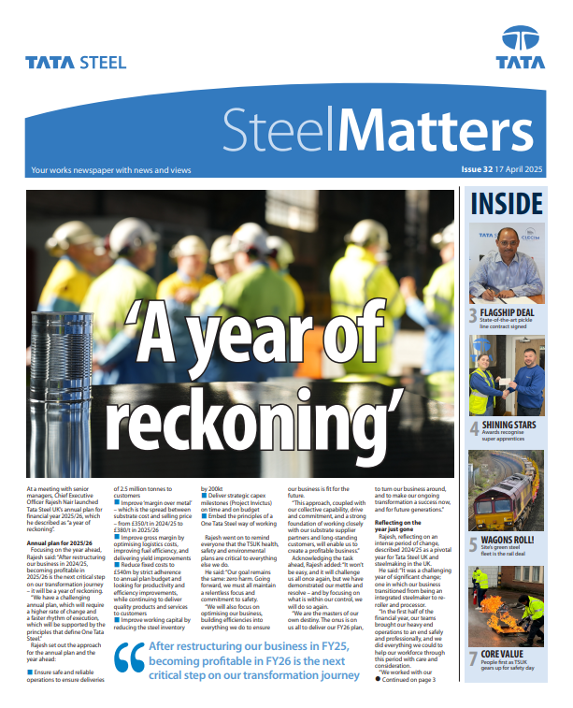

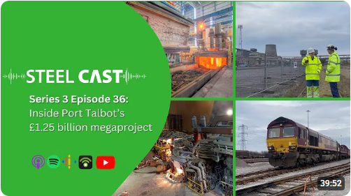

Figure 4 – TATA Steel’s ‘SteelCast’ Video Series
Figure 3 – TATA Steel’s ‘Steel Matters’ Newsletter

Step 7 - Sustain Acceleration

Once change has been initiated, it is important that it is sustained to avoid a loss of momentum. Project delays and miscommunication can cause stagnation if not addressed. For example, miscommunication between TATA and the Unions meant that from November 2023 to July 2024, there was no agreed process to progress the transition, leaving the workforce confused about the future. This also affected some work areas not directly involved in the change, leading to stagnation. However, TATA maintained momentum by regularly updating the organisation through ‘Steel Matters’ and ‘SteelCast’. This helped avoid issues of misinformation and exclusion.

Step 8 – Institute Change

Finally, after change takes place, it must be integrated into standard procedures. This can include updating hiring practices to reflect a workforce trained in new procedures or providing training for new hires to ensure compliance and support cultural change. TATA’s Management of Change process helps assess the impact of changes and determine what adjustments are needed. For example, it reviews maintenance plans and data storage to ensure accuracy and alignment with new procedures.

Herzberg’s Motivation Model

Herzberg’s Motivation Model suggests that there are two main factors that contribute to job satisfaction and dissatisfaction, Motivators and Hygiene Factors (Herzberg, 1964). Motivators are intrinsic and cause satisfaction, such as Meaningful and Challenging Work, Opportunities for Growth, and Recognition for Accomplishment. Hygiene Factors however, are factors that cause dissatisfaction when not present, such as Competitive Pay, Job Security, and Working Conditions. While this motivation method has been critiqued for having a rigid separation between Hygiene and Motivation Factors (Locke, 1976), it is still very commonly used to assess motivation, and ensure that the necessary factors are in place.

Hygiene Factors

Being able to provide Hygiene Factors to an organisation is important to avoid dissatisfaction, which unfortunately TATA weren’t able to provide. This is most notably made clear with Job Security after they announced nearly 3000 job losses and failed to explain the number, leaving a large portion of the workforce unsure about their future (Thomas, 2023).

Motivation Factors

Providing Motivating Factors reduces competition in the job market as it increases employee happiness throughout the organisation, while TATA weren’t able to provide the whole workforce with Motivating Factors, they did provide it well for the on site engineers. This was done by providing Engineers from the works areas which would be affected by the job losses, with the opportunity to move to the projects teams. The projects work can be seen as more rewarding as it allows the Engineers to have a contribution to the change occurring and the future of the business.

Conclusion

In conclusion, TATA weren’t able to manage change according to the Kotter’s 8 Steps Plan, however they were able to motivate change in other ways. We can see TATA’s management of change failures throughout the 8 Step Process, but the majority of problems stem from the miscommunication of the change and the new technology to the workforce and surrounding community. If this resistive force had been identified prior to the change, such as seen in Lewin’s Force Field Analysis and in Figure 1, TATA would have been able to strategically managed this area by improving their communication. While there was a good attempt at this by holding forums, these came far too late, with the first being an online webinar on the 31st of July (Tata Steel UK, 2024). By that point, the resistance created from miscommunication had grown in the nine months since the initial announcement, compounded by the Unions, which was also an issue that TATA ignored for too long, by rejecting their proposed solutions. In terms of motivation, while TATA was able to provide this for some of the workforce, the lack of Hygiene Factors to support this was the ultimate downfall. This lack of Job Security and Communication is what ultimately led to the demotivation of the workforce, making the transition more difficult for the business.

Bibliography

By, Rune. (2005). Organizational Change Management: A Critical Review. Journal of Change Management. 5. 369-380. 10.1080/14697010500359250.
CIPD HELP (2024). Kotter’s 8-Step Model of Change Management. [online] CIPD HELP. Available at: https://cipdhelp.co.uk/kotters-8-step-model-of-change-management.
Community Trade Union. (2023). Community and GMB reveal multi-union plan for Tata Steel | Community Trade Union. [online] Available at: https://community-tu.org/community-and-gmb-reveal-multi-union-plan-for-tata-steel/.
Davies, R. (2024). Tata cancels early closure of Port Talbot furnaces after Unite calls off strike. The Guardian. [online] 1 Jul. Available at: https://www.theguardian.com/business/article/2024/jul/01/port-talbot-steelworks-unite-union-calls-off-strike-fresh-talks
Evans, F. (2024). Tata Steel: Port Talbot coke ovens closing amid stability fear. BBC News. [online] 18 Mar. Available at: https://www.bbc.co.uk/news/uk-wales-68600179.
Farrow, J. (1997). Management of change: technological developments and human resource issues in the information sector. Journal of Managerial Psychology, 12(5), pp.319–324. doi:https://doi.org/10.1108/02683949710183513.
Griffin, P.W. and Hammond, G.P. (2021). The Prospects for ‘Green Steel’ Making in a net-zero economy: a UK Perspective. Global Transitions, 3(1), pp.72–86. doi:https://doi.org/10.1016/j.glt.2021.03.001.
Hallin, A., Lindell, E., Jonsson, B. and Uhlin, A. (2022). Digital transformation and power relations. Interpretative repertoires of digitalization in the Swedish steel industry. Scandinavian Journal of Management, 38(1), p.101183. doi:https://doi.org/10.1016/j.scaman.2021.101183.
Herzberg, F.. (1964). The motivation-hygiene concept and problems of manpower. Behavioral Concepts in Management. 26. 33-40.
Jabri, M. and Pounder, J.S. (2001). The management of change: a narrative perspective on management development. Journal of Management Development, 20(8), pp.682–691. doi:https://doi.org/10.1108/02621710110401400.
Kansal, S. and Chandani, A. (2014). Effective Management of Change During Merger and Acquisition. Procedia Economics and Finance, 11, pp.208–217. doi:https://doi.org/10.1016/s2212-5671(14)00189-0.
Kotter, J. (2025). The 8 steps for leading change. [online] Kotter. Available at: https://www.kotterinc.com/methodology/8-steps/.
Locke, Edwin. (1976). The Nature and Causes of Job Satisfaction. The handbook of industrial and organizational psychology. 31.
Mullins, L.J. (2016). Management and organisational behaviour. 11th ed. Harlow: Ft Prentice Hall.
Npt.gov.uk. (2023). Article - Neath Port Talbot Council. [online] Available at: https://www.npt.gov.uk/council/newsroom/press-releases/article/?id=7306 [Accessed 11 May 2025].
OCM Solution (2019). Is John Kotter’s 8-Step Change Model Still Relevant? Is It Worth Using? Pros & Cons – OCM Solution Blog. [online] www.ocmsolution.com. Available at: https://www.ocmsolution.com/john-kotter-change-model/.
Parry, S. (2011). History of the Steel Industry in the Port Talbot Area 1900-1988. [online] Available at: https://etheses.whiterose.ac.uk/id/eprint/2591/1/parrystephen.pdf [Accessed 24 Mar. 2025].
Siddiqui, S. (2017). A CRITICAL REVIEW OF CHANGE MANAGEMENT STRATEGIES AND MODELS. International Journal of Advanced Research, [online] 5(4), pp.670–676. doi:https://doi.org/10.21474/ijar01/3862.
Siegal, W., Church, A.H., Javitch, M., Waclawski, J., Burd, S., Bazigos, M., Yang, T., Anderson‐Rudolph, K. and Warner Burke, W. (1996). Understanding the management of change. Journal of Organizational Change Management, 9(6), pp.54–80. doi:https://doi.org/10.1108/09534819610150521.
Silva, L.V., Anholon, R., Rampasso, I.S., Silva, D., Quelhas, O.L.G., Leal Filho, W. and Santa-Eulalia, L.A. (2019). Critical analysis of organizational change process: evidences from a steel company. Business Process Management Journal, ahead-of-print(ahead-of-print). doi:https://doi.org/10.1108/bpmj-05-2019-0199.
Tata Steel UK. (2024). Planning process. [online] Available at: https://www.tatasteeluk.com/green-steel-future/planning.
TATA Steel Communication Centre (2025) ‘Steel Matters’. TATA Steel UK. Unpublished
Tata Steel UK (2025). SteelCast S3 E36: Step inside Port Talbot’s £1.25 billion megaproject. [online] YouTube. Available at: https://www.youtube.com/watch?v=_UzTSsqu_m4 [Accessed 11 May 2025].
Thomas, H. (2023). Port Talbot: Steelworkers frightened by Tata job loss reports - BBC News. BBC News. [online] 14 Sep. Available at: https://www.bbc.com/news/uk-wales-66813992.amp [Accessed 7 May 2025].
Warrilow, S. (2023). Where Kotter’s 8 Steps Model Gets it Wrong. [online] www.strategies-for-managing-change.com. Available at: https://www.strategies-for-managing-change.com/where-kotters-8-steps-model-gets-it-wrong.html.

