Student Name: Nicu Lazar  Student ID: 2235532  Module Title: Foreign Languages & Cultural Awareness  Module code: BMIH5003  Lecturer: Heidi Prosser  Date: 09/02/2024 | 
ASSIGNMENT 1: PORTFOLIO
(4 Components)

Component 1: Professional Reflection (500 words +/- 10%)

Weighting: 25%
Cultural diversity often leads to misunderstanding which reflects in terms of language barrier and misinterpretation of cultural norms. Language barriers and communication styles have a significant impact on the performance of the organization's workforce (Ramlan.,2018). The hospitality industry which is a rapidly growing sector involves challenges related to cultural dissimilarities. According to the study, the implementation of technologies within the hospitality industry also requires in-depth insight into the cultural differences in regard to successfully incorporating technical advancement (Jung et al., 2018). This statement indicates the significance of understanding the cultural aspects of foreign beliefs. I personally experienced the event of misinterpretation in my early years of working as an F&B employee at Ritz London. I still remember the incident that almost took my job when I served the wrong order to the guest because of a misunderstanding. The customer was Indian and she ordered veg food however, as she focused on not including non-veg in her order I interpreted she wanted non-veg dishes. Therefore, I pointed out the non-veg dishes from the menu card and she accepted my recommendation. The climax of the story was when the order was served to her and she found all the non-veg dishes on the table.
After that the lady panicked and started to shout which was something difficult for me to handle therefore, my manager came to deal with the situation. When the manager got to know about the problem he was furious at me which was obvious from his expression. He politely handled the situation as the lady was saying that it was infuriating because this could affect her cultural beliefs. I was not aware that serving the incorrect order could be such a serious matter which could affect someone's beliefs. The dining hall of the hotel's restaurant was silently gazing toward us which was quite obvious but I remained speechless until my manager made me understand what was the problem. The episode made me realize that cultural awareness and language barriers can provoke someone's personal beliefs or practices. The cultural and language differences can be understood by the cultural awareness that the individual can develop in regard to understanding and relating to foreign cultures (Zohirjonovna, 2022). Through cultural awareness, not only the cultural norms but also the relationship between the language and culture can be explored. As the culture develops or forms the language thus, the language is the source to explain the cultural needs. The incident that took place with the lady was due to the cultural differences we have and the language barrier created more difficulties in understanding each other. I interpret the keywords from her sentences rather than understanding the context or meaning of her words. I was unaware that serving her the non-veg food can be such a great mistake and it could hurt her set of beliefs or norms. This made me understand that what was not a major thing for me really means to her and this was due to the different cultural backgrounds we belong to.
References:
Jung, T.H., Lee, H., Chung, N. and tom Dieck, M.C. (2018). Cross-cultural differences in adopting mobile augmented reality at cultural heritage tourism sites. International Journal of Contemporary Hospitality Management, [online] 30(3), pp.1621–1645. doi:https://doi.org/10.1108/ijchm-02-2017-0084.
Ramlan, S., Abashah, A., Samah, I., Rashid, I. and Radzi, W.N.W.M., 2018. The impact of language barrier and communication style in organizational culture on expatriate’s working performance. Management Science Letters, 8(6), pp.659-666.
Zohirjonovna, G.Z. (2022). THE RELATIONSHIP BETWEEN CULTURE AND LANGUAGE. SCIENTIFIC ASPECTS AND TRENDS IN THE FIELD OF SCIENTIFIC RESEARCH, [online] 1(4), pp.30–33. Available at: https://interonconf.org/index.php/pol/article/view/406 [Accessed 2 Feb. 2024].
Component 2: Training Plan (500 words +/- 10%)

Weighting: 25%

Identified cultural misunderstanding (in a few words) :
The misunderstanding is caused because of the unexplained or undefined cultural norms by the natives to the foreigners which creates confusion while communicating (Korkut, et al., 2018). The misunderstanding of culture could be seen in the form of language barriers or misconceptions related to the norms. Furthermore, often individuals misinterpret the body language or gestures of others. For instance, European countries prefer a firm grip while greeting whereas in terms of Asian countries lighter touch is preferred. This highlights the dissimilarity of cultural aspects in terms of minor gestures or non-verbal communication. The cultural misunderstanding is because of the dissimilar beliefs and values people have developed through their culture. Moreover, the changes in the cultural aspects are often due to globalization which creates misunderstandings among the different cultural background individuals (Tarasenko, 2018).
Training plan (Why/What//Who/Where/When):
The basic aim associated with the training process is to enhance the abilities and skills of the individuals in regard to preparing them for the competitive work environment. The hotel training programs or workshops incorporate language training sessions as well because the recruits are not prepared for the industry's technicalities. The educational institutes do not provide language teachings to the graduates thus, they are not prepared to work in a competitive environment (USHAKOV et al., 2020). Apart from the competitiveness the hotel staff is required to have a strong grip on languages as the hospitality sector involves tourists who belong to dissimilar cultural and language backgrounds. In regard to enhancing the employee's skills and for the productive progress of the hotel, F&B training workshops are planned by the business analysts of the hotel. These workshops have the essential intention of progressing as a unit which will aid the growth of individuals along with achieving the hotel's goals to compete in the highly competitive hospitality industry.
The training plan will include the 5W model to create the blueprint of the session therefore it will contain the fruitful objectives related to the efficient hotel personnel training. The employees will be trained about all the hotel-related polices along with the associated position training. These training sessions will incorporate housekeeping, administration, restaurant management, and other tasks that are associated with the hotel's progress. Language and communication skills along with customer services are the indirect factors that influence customer satisfaction thus, the training will include these aspects as well.
Training is for entire hotel personnel although the job description is the key factor for the training workshop. However, it will include receptionist, housekeeping staff, restaurant management staff, and hotel management workforce. Training workshops will be flexible in regard to delivering the core objectives of training the language or communication sessions can be conducted outside the hotel premises. However, the tasks such as housekeeping or food serving will be trained on the job site. Training the new employee along with the already employed individuals is required therefore, the training workshops will be conducted after recruiting the employees and after that on the basis of requirement. The hotel management will evaluate the work performance of the staff members and then conduct the workshop if required.
References:
Korkut, P., Dolmaci, M. and Karaca, B. (2018). A Study on Communication Breakdowns: Sources of Misunderstanding in a Cross-Cultural Setting. Eurasian Journal of Educational Research, [online] 18(78), pp.139–158. Available at: https://dergipark.org.tr/en/pub/ejer/issue/42563/512866.
Tarasenko, Т. and Kulykova, L., 2018. The ways of overcoming misunderstanding in cross-cultural communication. Naukoviy visnyk Melitopolskoho derzhavnoho pedahohichnoho universitetu imeni Bohdana Hmelnitskoho. Seria: Pedahohika, 2(21), pp.40-44.
USHAKOV, R.N., KRYUKOVA, E.M., KHETAGUROVA, V.S., MUKHOMOROVA, I.V. and ZELENOV, V.V. (2020). Efficiency of Hotel Management. Training of Specialists in Hotel Industry Field. Journal of Environmental Management and Tourism, 11(2), p.388. doi:https://doi.org/10.14505//jemt.11.2(42).17.
Component 3: Student Self-Reflection (500 words +/- 10%)

Weighting: 25%
Kolb's reflective model is referred to as the experiential learning cycle which incorporates four elements that include, concrete experiments, critical reflective observation, abstract conceptualization, and active experimentation (Morris, 2019). These factors signify that the individual learns through gaining experience from active participation. However, in association with to model I experienced that cultural awareness and the language barriers are directly linked to each other thus, I have to improve my cultural awareness. Through the means of active involvement in the training and workshops which are designed to spread cultural awareness, I can improve myself and clear the misconceptions regarding different cultures. Through experiencing concrete examples of how the cultural difference plays a vital role in the personal and professional life I will be able to implement the understandings within my occupation. The process of experiencing through the training session will enhance my ability to reflect on those teachings within my life and work context (Kolb.,2018). Hospitality industry is based on the verbal and non-verbal communication through which the employees and customers interact to transmit their stances. Therefore, the fundamental principle for the hotel employees to succeed in their jobs is to improve their communication skills that is what I have experienced through my journey while creating this portfolio. Experiential learning is seen as the fundamental principle to incorporate it with theoretical learning so that the hospitality and tourism industry can attain the desired objectives (Yang, et al., 2021). This highlights my perspective that the experiential learning along with the theoretical learning can enhance my ability to perform as the progressive hotel employee. Apart from just being a fruitful hotel staff it will aid me to progress in my life through learning and experiencing dissimilar cultural norms and the languages associated with those cultures. Initially, when I stepped into the hospitality industry I was not aware of the importance cultural differences have within the industry to progress. The impact and influence dissimilar cultural backgrounds portray on the hotel management signifies that the cultural awareness is the essential factor to accomplish the desired goals of the hotel development and growth. Experiencing and understanding the different cultural aspects are fruitful in terms of enhancing my knowledge. Along with my self-grooming, I also learned to work in the competitive industry prolifically and learned how I can pave my way toward the successful career opportunities in the future as well. Through the means of learning various languages, I can interact and engage with the people who belong to dissimilar cultural backgrounds which will enhance my knowledge, abilities, and skills. Throughout the journey, I experienced that cultural dissimilarity is not something that should be avoided or left unnoticed because the hospitality industry deals with the customers who do not belong to a single cultural background. Therefore, the customer satisfaction which is the core aim of businesses requires to understand their customer's needs to provide them with excellent customer services.
References:
Kolb, A. and Kolb, D., 2018. Eight important things to know about the experiential learning cycle. Australian educational leader, 40(3), pp.8-14.
Morris, T.H. (2019). Experiential Learning – a Systematic Review and Revision of Kolb’s Model. Interactive Learning Environments, 28(8), pp.1–14. doi:https://doi.org/10.1080/10494820.2019.1570279.
Yang, C.Y., Xie, D. and Wong, J.W.C. (2021). CHALLENGES AND BENEFITS OF EXPERIENTIAL LEARNING: THE CASE OF OVERSEAS EXCHANGE PROGRAMS. Advanced Education, (19), pp.79–88. doi:https://doi.org/10.20535/2410-8286.239232.
Component 4: Training Presentation (6 Slides)

Weighting: 25%
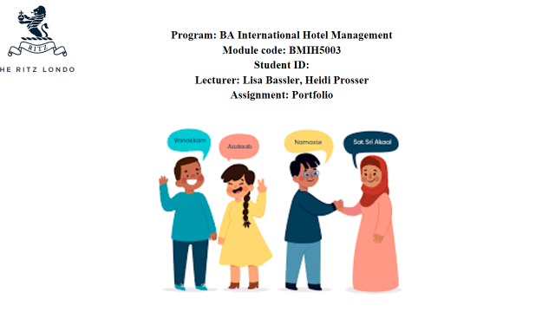
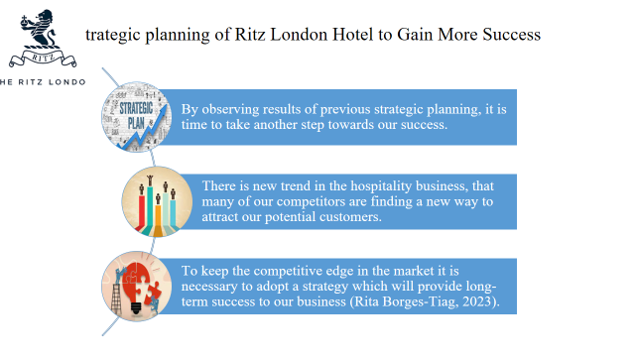
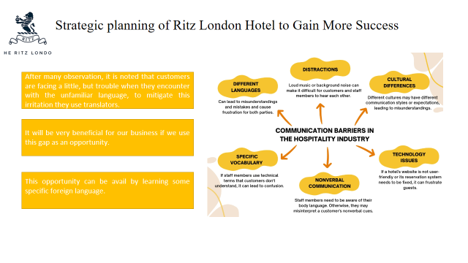
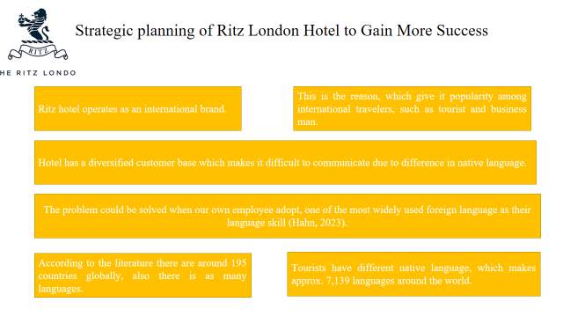
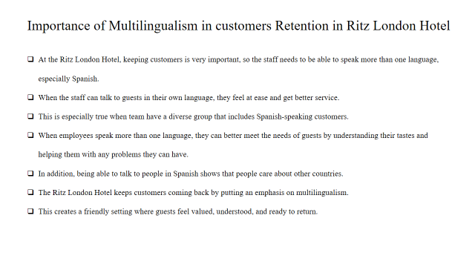
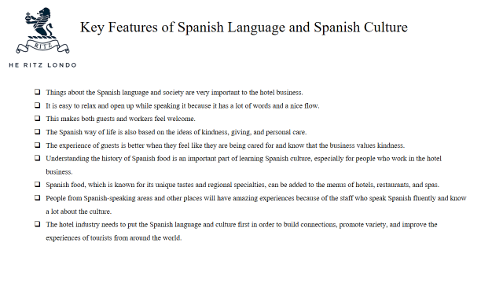
References (no screenshots):
Bastianes, M., 2023. Multilingualism, diversity, and performing arts. A home for Spanish language theatre in post-Brexit gentrified London. International Journal of Cultural Policy, pp.1-15.
Benzehaf, B., 2023. Multilingualism and its role in identity construction: a study of English students’ perceptions. International Journal of Multilingualism, 20(3), pp.1145-1163.
Hahn, T., 2023. The Restaurant as a Medium (Connect/Disconnect) On Culinary Temples and Porous Spaces. Food-Media-Senses: Interdisciplinary Approaches, 100, p.55.
Mariani, M.M., Borghi, M. and Okumus, F., 2020. Unravelling the effects of cultural differences in the online appraisal of hospitality and tourism services. International Journal of Hospitality Management, 90, p.102606.
Rita, P., Borges-Tiago, M.T. and Caetano, J., 2023. The theory-practice research gains from big data: evidence from hospitality loyalty programs. International Journal of Contemporary Hospitality Management.
Tesseur, W., 2022. Linguistic hospitality and listening through interpreters: critical reflections and recommendations on linguistic power relationships in multilingual research.
Zhang, Z., 2023. Computational Technologies for Construction of Business Korean Translation Corpus Based on Association Rules Mining. ACM Transactions on Asian and Low-Resource Language Information Processing.

