

Programme: BSc CLOUD COMPUTING
Module: Cloud Computing Architecture
Module code: ACCA5025
Lecturer: Suneth Fernando
Assignment Title: Assignment 2: Practical

Student: Ivo Ivanov/2111853
02/05/2023
Table of Contents
Additional Exercise: 2
Explain the resources associate with a VM, such as virtual hard drives 2
How VMs are created and managed. 3
vNets and network security groups 4
Benefits of using vNets and NSGs: 5
Visual representation of vNets: 5
vNet is connected to the internet and to another vNet. 6
visual representations of NSGs 9
Example of Network Security Group with 2 VMs. 10
Here is an example of how NSGs can be configured for two VMs in Azure: 11

Additional Exercise:
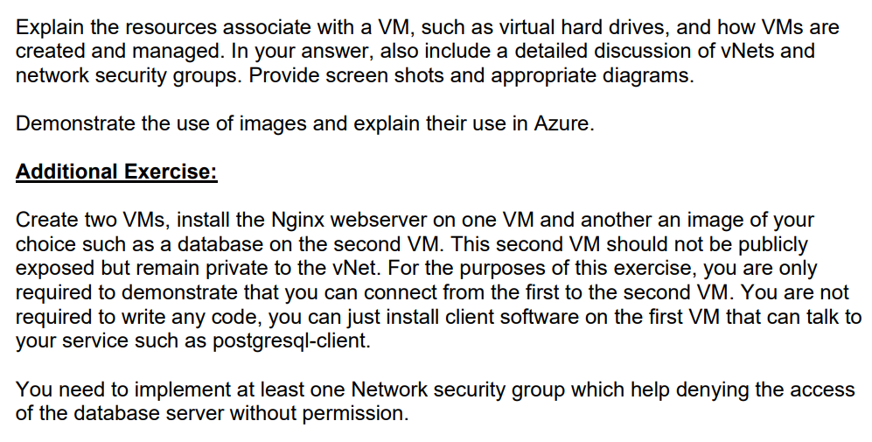

Explain the resources associate with a VM, such as virtual hard drives
In the context of virtualization, a virtual machine (VM) is a software emulation of a physical computer system, which means that it needs certain resources to function properly. These resources are allocated to the VM by the hypervisor, the software layer that manages and controls the virtual environment.
- Virtual Hard Drive (VHD)
One of the resources associated with a VM is the virtual hard drive (VHD). This is a file that emulates a physical hard drive and contains the operating system, applications, and data that the VM needs to function. The VHD is stored on the host machine's physical hard drive but appears to the VM as if it were a physical hard drive attached to the VM.
The size of the virtual hard drive can be set during the creation of the VM and can be increased later if needed. Virtual hard drives can also be dynamically allocated, meaning that the file size will grow as the VM uses more storage space, or they can be fixed-size, meaning that the file size is set at the time of creation and does not change.
In addition to virtual hard drives, VMs also require other resources such as CPU, memory, and network connectivity. The hypervisor allocates these resources to the VM based on the VM's configuration and the host machine's available resources. These resources can also be adjusted dynamically to meet changing workload demands.
- Network interfaces: Network interfaces (NICs) are the devices that connect a VM to a network. A VM can have multiple NICs, each of which can be connected to a different network.
- Storage accounts: Storage accounts are the containers that store the VHDs and other files for a VM. Storage accounts can be used to store data for multiple VMs.
- Network security groups (NSGs): NSGs are the security controls that you can use to control access to a VM. An NSG can have a set of rules that allow or deny traffic to a VM.
VMs can be created and managed in the Azure portal, the Azure CLI, or the Azure Resource Manager (ARM) templates.
To create a VM in the Azure portal, follow these steps:
- Go to the Azure portal.
- Click the Create a resource button.
- Search for virtual machine and click the Create button.
- On the Basics tab, enter the following information:
  - Subscription: Select the subscription that you want to use.
  - Resource group: Select or create a resource group.
  - Name: Enter a name for the VM.
  - Location: Select the location where you want to create the VM.
  - VM size: Select the size of the VM.
- On the Image tab, select the operating system image that you want to use.
- On the Disks tab, select the type and size of the VHDs that you want to use.
- On the Network tab, select the network that you want to connect the VM to.
- On the Security tab, select the NSGs that you want to apply to the VM.
- On the Review + create tab, review the settings and click the Create button.
To manage a VM in the Azure portal, you can use the following features:
- Overview: The overview page provides a summary of the VM's settings, such as the name, size, and status.
- Settings: The settings page allows you to change the VM's settings, such as the operating system, network, and security.
- Diagnostics: The diagnostics page allows you to view the VM's logs and performance data.
- Extensions: The extensions page allows you to install extensions on the VM. Extensions are software components that can be installed on a VM to add functionality, such as monitoring or load balancing.
- Health: The health page provides information about the VM's health, such as the status of the VM's components.
- Backups: The backups page allows you to create and manage backups of the VM.
- Delete: The delete page allows you to delete the VM.
Here are some additional details about vNets and NSGs:
- vNets: A vNet is a virtual network that you can create in Azure. It is similar to a traditional network, but it is virtualized and hosted in the cloud. You can use vNets to isolate your resources and to control access to them.
- NSGs: An NSG is a collection of rules that you can use to control access to a VM. An NSG can have a set of rules that allow or deny traffic to a VM.
. and destination IP addresses, protocols, and ports, and can be associated with subnets or individua

How VMs are created and managed.
Virtual Machines (VMs) are created and managed through a software layer called a hypervisor. The hypervisor is responsible for creating and managing the virtual environment where the VMs run. There are two types of hypervisors: Type 1 and Type 2.

Type 1 hypervisors, also known as bare-metal hypervisors, run directly on the host machine's hardware. They provide direct access to the physical resources of the host machine, such as the CPU, memory, and storage, and allocate these resources to the VMs. Examples of Type 1 hypervisors include VMware ESXi, Microsoft Hyper-V, and Citrix XenServer.
Type 2 hypervisors, on the other hand, run on top of an existing operating system (OS) installed on the host machine. They are also known as hosted hypervisors. Type 2 hypervisors are less efficient than Type 1 hypervisors because they have to share the physical resources of the host machine with the host OS. Examples of Type 2 hypervisors include Oracle VirtualBox and VMware Workstation.
To create a VM, the user must first install the hypervisor software on the host machine. Then, they can use the hypervisor's management interface to create a new VM. The management interface typically provides options for configuring the VM's hardware resources, such as CPU, memory, and storage. The user can also specify the operating system and other software that will be installed on the VM.
Once the VM is created, it can be started, stopped, and managed using the hypervisor's management interface. The user can also use the management interface to monitor the VM's resource usage, adjust its hardware resources, and create or delete virtual devices such as virtual hard drives or virtual network interfaces.
Overall, creating and managing VMs requires some technical knowledge of the hypervisor software and the underlying hardware resources. However, with the help of modern hypervisor management tools and intuitive interfaces, the process has become more user-friendly and accessible to a wider range of users.

vNets and network security groups
vNets, short for virtual networks, are an important component of virtualization that allow virtual machines (VMs) to communicate with each other and with external networks. A vNet is a virtual network that is created and managed within a hypervisor's network stack. It is isolated from the physical network infrastructure, which means that all communication between VMs within the same vNet is confined to the virtual environment.
Virtual networks (vNets) are logical networks that you can create in Azure. They are similar to traditional networks, but they are virtualized and hosted in the cloud. You can use vNets to isolate your resources and to control access to them.
Network security groups (NSGs) are collections of rules that you can use to control access to a VM. An NSG can have a set of rules that allow or deny traffic to a VM.
vNets
A vNet is a logical network that you can create in Azure. It is similar to a traditional network, but it is virtualized and hosted in the cloud. You can use vNets to isolate your resources and to control access to them.
When you create a vNet, you must specify the following information:
- Name: The name of the vNet.
- Location: The location where you want to create the vNet.
- Address space: The IP address range that you want to use for the vNet.
You can also specify the following optional information:
- DNS servers: The DNS servers that you want to use for the vNet.
- Gateway: The gateway that you want to use for the vNet.
- Subnets: The subnets that you want to create in the vNet.
NSGs
An NSG is a collection of rules that you can use to control access to a VM. An NSG can have a set of rules that allow or deny traffic to a VM.
When you create an NSG, you must specify the following information:
- Name: The name of the NSG.
- vNet: The vNet that the NSG is associated with.
- Rules: The rules that you want to create for the NSG.

A rule can have the following properties:
- Priority: The priority of the rule. Rules with a lower priority are processed before rules with a higher priority.
- Direction: The direction of the rule. Valid directions are inbound and outbound.
- Protocol: The protocol of the rule. Valid protocols are TCP, UDP, and ICMP.
- Source: The source IP address or range of IP addresses for the rule.
- Destination: The destination IP address or range of IP addresses for the rule.
- Ports: The ports for the rule. If you specify a range of ports, you must separate the ports with a hyphen (-).

Benefits of using vNets and NSGs:
1. Isolation: vNets allow VMs to communicate with each other without exposing them to the outside world. This can improve security by limiting the attack surface of the VMs.
2. Segmentation: vNets can be segmented into multiple subnets, which can be used to organize VMs by function or security requirements.
3. Flexibility: vNets can be easily reconfigured and adapted to changing workload requirements, such as adding or removing VMs.
4. Control: You can use NSGs to control access to your VMs. This can help to prevent unauthorized access to your resources.
5. Scalability: You can easily scale your vNets and NSGs as your needs change. This can help you to save money on your Azure costs.

In addition to vNets, another important network-related feature of virtualization is the network security group (NSG). An NSG is a security group that is used to filter network traffic to and from virtual machines. It is a software-defined firewall that can be used to control access to and from VMs based on IP addresses, protocols, and ports.

Overall, vNets and NSGs are important network-related features of virtualization that help to improve security and flexibility in virtual environments. They allow VMs to communicate with each other and with external networks in a secure and flexible manner, while also providing granular control over network traffic. and destination IP addresses, protocols, and ports, and can be associated with subnets or individual VM network interfaces. and destination IP addresses, protocols, and ports, and can be associated with subnets or individual VM network interfaces.

Visual representation of vNets:
A vNet is represented as a virtual network diagram that shows the subnets and the virtual machines connected to each subnet. The diagram may also show the virtual routers and switches that connect the subnets, as well as the virtual network interfaces of the virtual machines.
Here is an example of a simple virtual network diagram that includes a vNet with two subnets and three virtual machines:

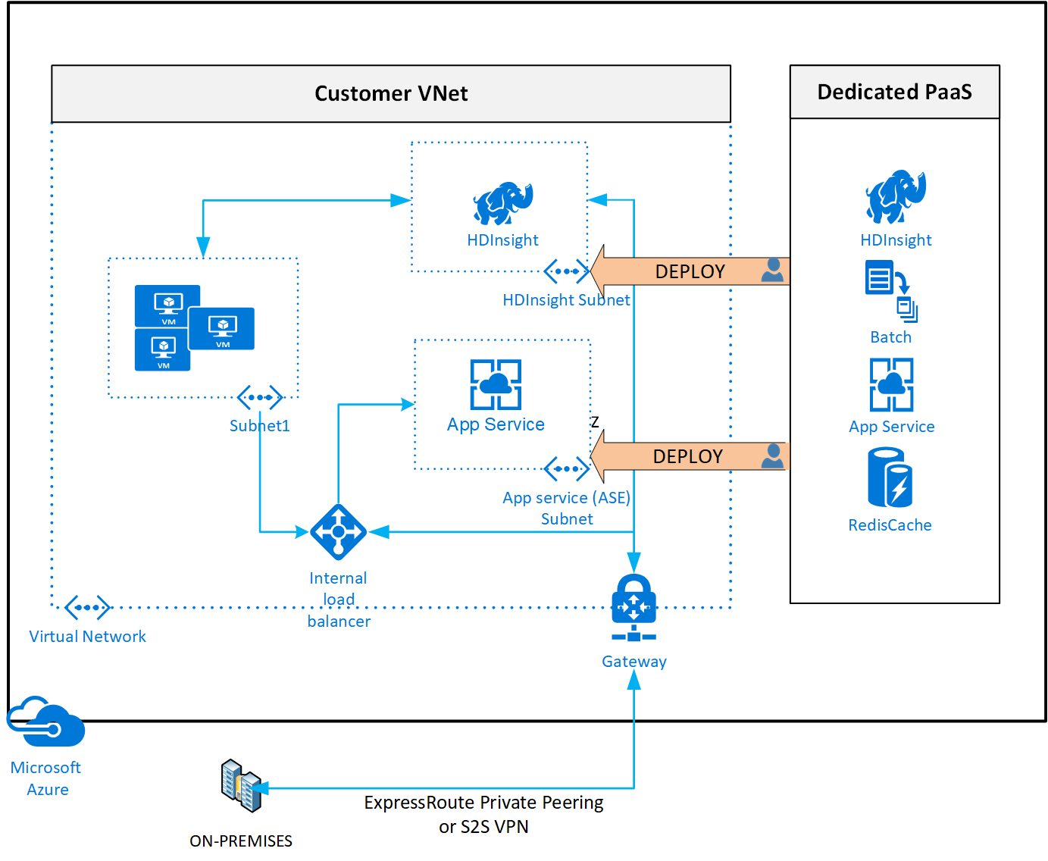

vNet is connected to the internet and to another vNet.
The vNet is a logical network that you can create in Azure. It is similar to a traditional network, but it is virtualized and hosted in the cloud. You can use vNets to isolate your resources and to control access to them.
A vNet can have multiple subnets. A subnet is a smaller logical network within a vNet. You can use subnets to group resources together and to control access to them. and destination IP addresses, protocols, and ports, and can be associated with subnets or individual VM network interfaces.
A vNet can be connected to the internet or to other vNets. When you connect a vNet to the internet, you can access resources in the vNet from the internet. When you connect a vNet to another vNet, you can access resources in the other vNet from the vNet.

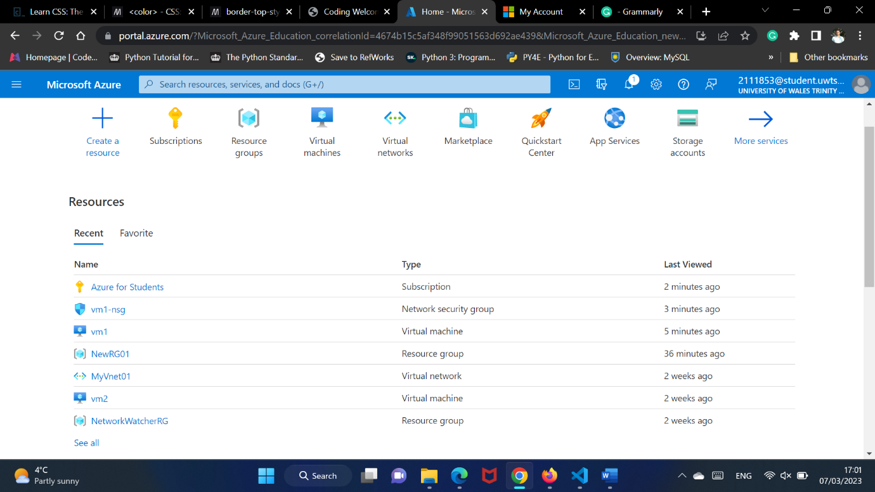

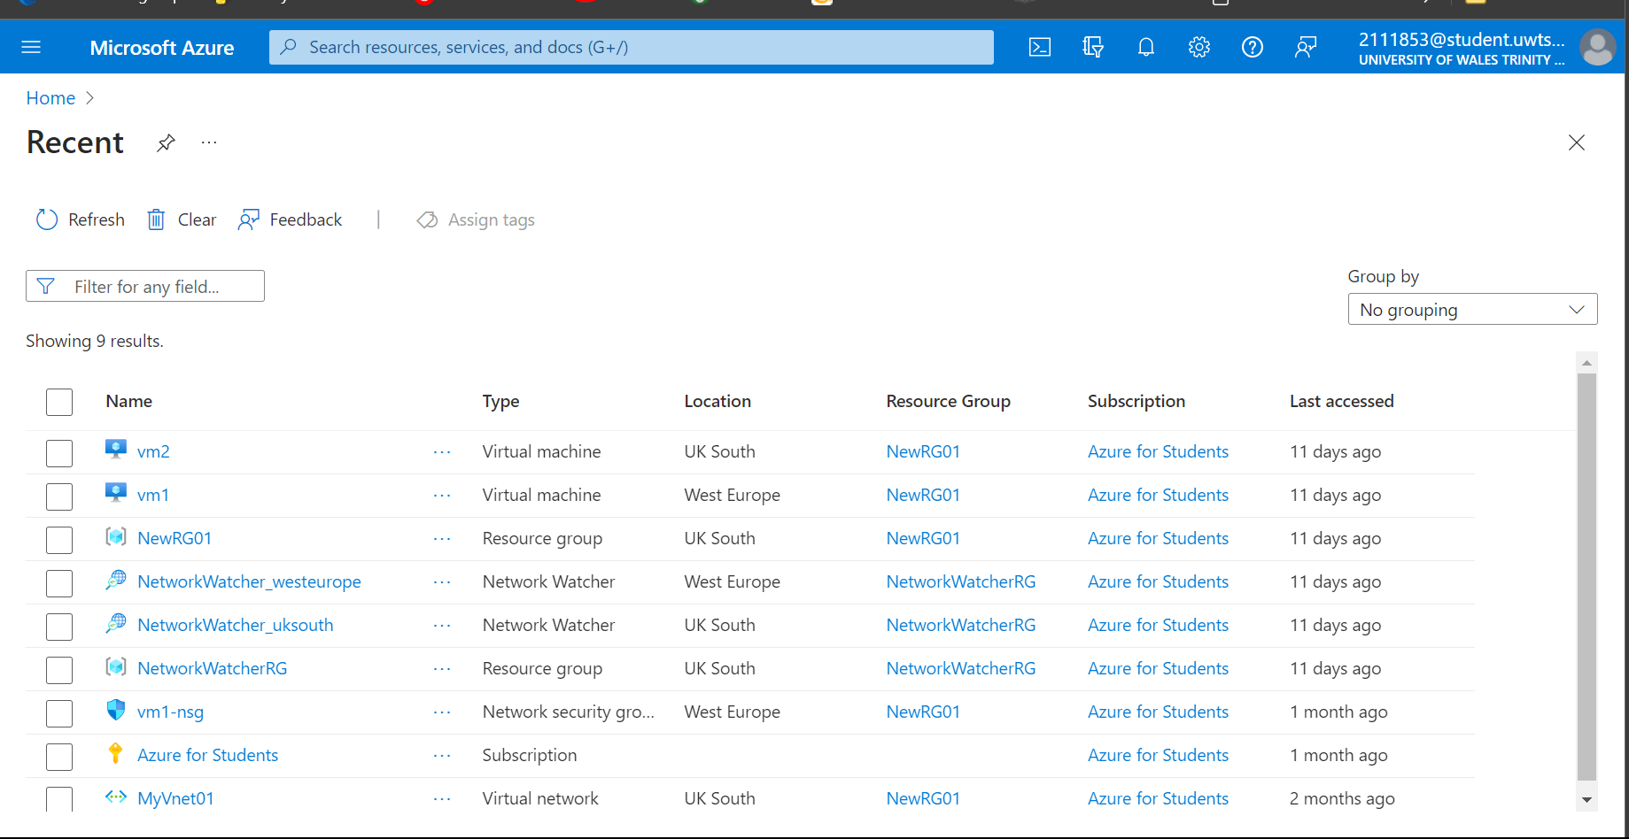

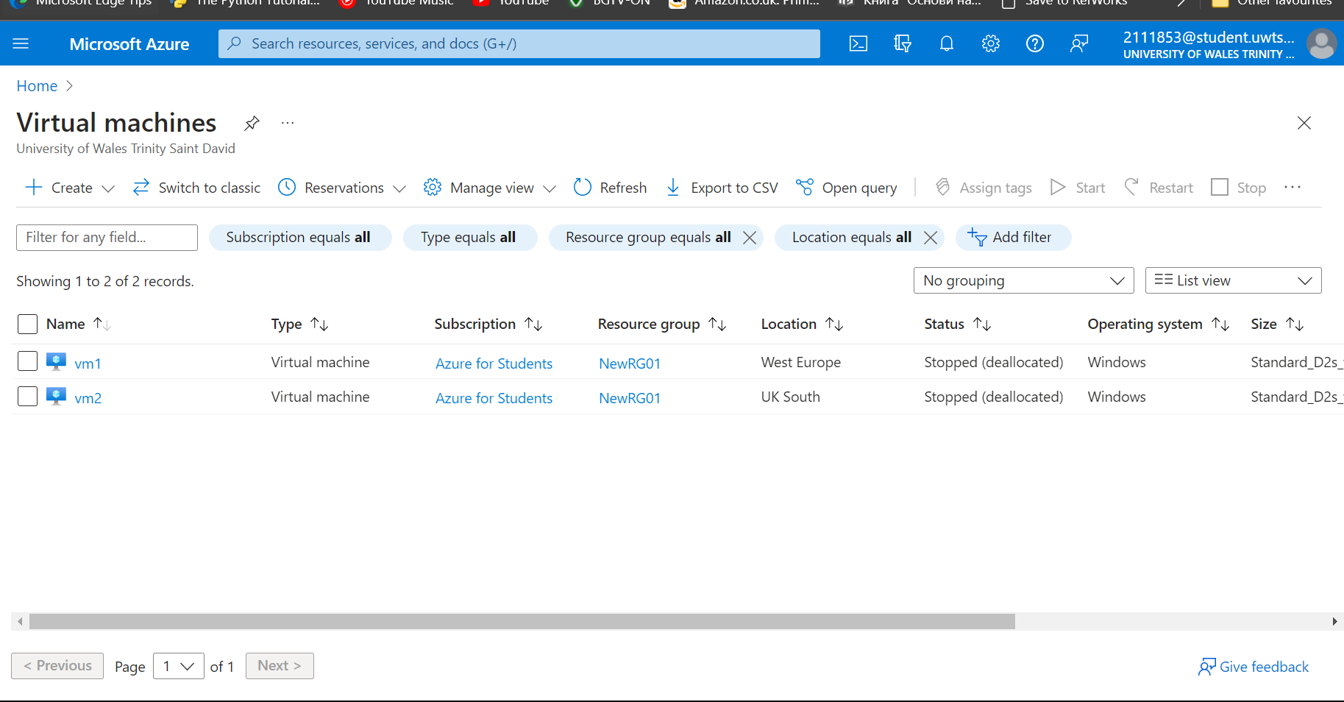

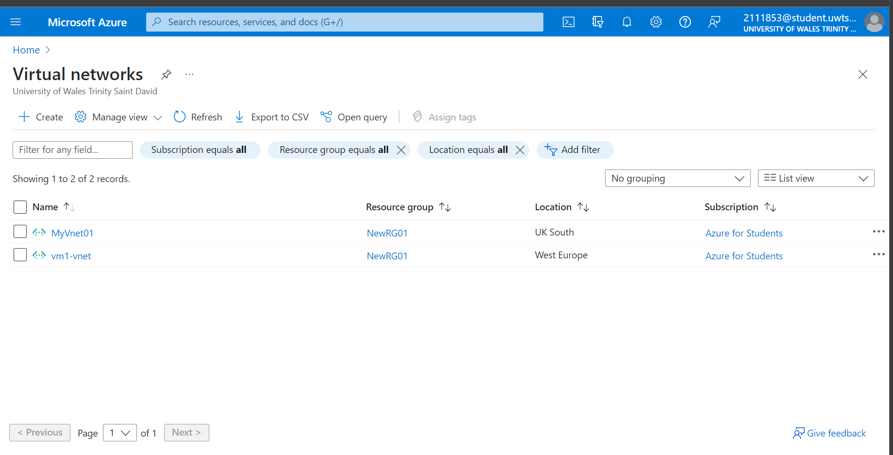

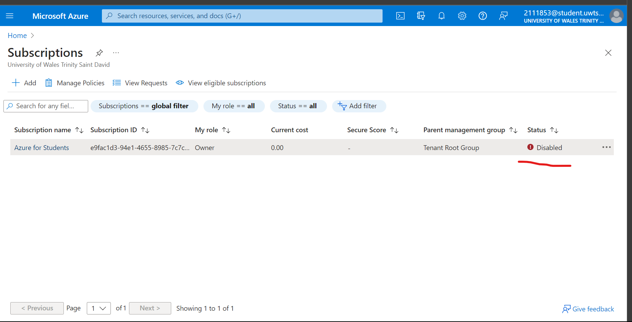
Unfortunately my subscriptions expired and I could not proceed!
and destination IP addresses, protocols, and ports, and can be associated with subnets or individual VM network interfaces. and destination IP addresses, protocols, and ports, and can be associated with subnets or individual VM network interfaces.

visual representations of NSGs
here is an example of an NSG rule table that allows traffic from a specific IP address to a virtual machine:
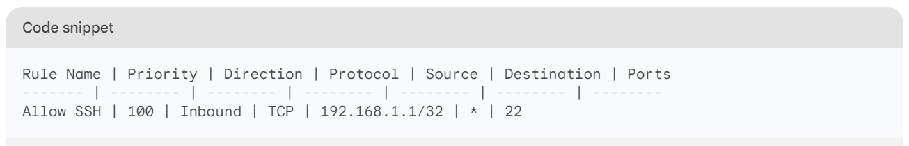
This rule allows inbound TCP traffic on port 22 from the IP address 192.168.1.1 to the virtual machine. The priority of the rule is 100, which means that it will be processed before any other rules in the table.
Here is a breakdown of the rule properties:
- Rule Name: This is a user-defined name for the rule.
- Priority: This is the order in which the rules in the table will be processed. Rules with a lower priority will be processed before rules with a higher priority.
- Direction: This specifies whether the rule applies to inbound or outbound traffic.
- Protocol: This specifies the protocol for the rule. Valid protocols include TCP, UDP, and ICMP.
- Source: This specifies the source IP address or range of IP addresses for the rule.
- Destination: This specifies the destination IP address or range of IP addresses for the rule.
- Ports: This specifies the ports for the rule. If you specify a range of ports, you must separate the ports with a hyphen (-).
You can create NSG rules in the Azure portal, Azure CLI, or Azure Resource Manager templates.

Example of Network Security Group with 2 VMs.
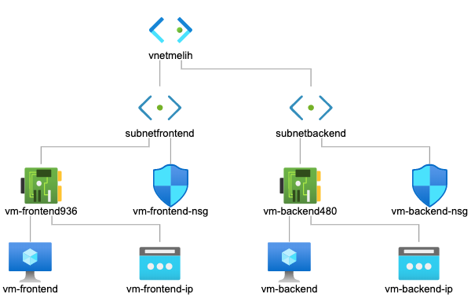

Here is an example of how NSGs can be configured for two VMs in Azure:
You may manage network traffic to and from your Azure virtual machines (VMs) using a Network Security Group (NSG), one of Azure's security features. NSGs can be connected to subnets or specific VM network interfaces, and they can be used to filter traffic based on source and destination IP addresses, protocols, and ports. and destination IP addresses, protocols, and ports, and can be associated with subnets or individual VM network interfaces. and destination IP addresses, protocols, and ports, and can be associated with subnets or individual VM network

- Create two VMs: VM1 and VM2.
- Create two NSGs: NSG1 and NSG2.
- Associate NSG1 with VM1's network interface, and associate NSG2 with VM2's network interface.
- Configure NSG1 to allow incoming traffic on port 80 and deny all other incoming traffic.
- Configure NSG2 to allow incoming traffic on port 443 and deny all other incoming traffic.
With this configuration, incoming traffic on port 80 will be allowed only to VM1, and incoming traffic on port 443 will be allowed only to VM2. All other incoming traffic will be denied for both VMs.

