Travel Blog
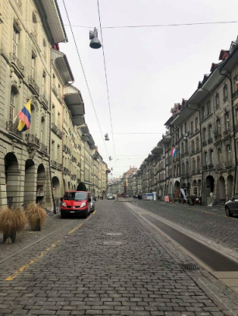
This travel blog will involve my free day excursion in Switzerland. My group and I had a rough idea on how we would have liked to spend our free day in Switzerland but we were not 100% sure. Whilst we were in Switzerland, James Wilson from Switzerland Travel Centre was kind enough to give us tips on what to do and how to make the most of our free day opportunity. After speaking with James, we decided for our free day we would visit Bern, the capital city of Switzerland, which is what we had originally planned, but James helped us to finalise our itinerary and gave us a couple of extra ideas to add in.
Bern is a beautiful, old city in Switzerland; it is quite historic with many old and memorial buildings. It was quite busy, but we expected that due to it being the capital city. We departed Camping Jungfrau at 10:30 to get the train from Lauterbrunnen to Bern, with a changeover at Interlaken OST using our interail passes. Our plan was once we arrived to get some lunch, visit the Bear Museum, Albert Einstein’s Museum and then visit the zoo before departing back to Lauterbrunnen.
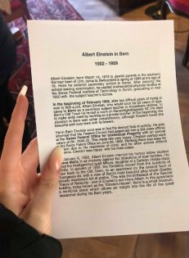
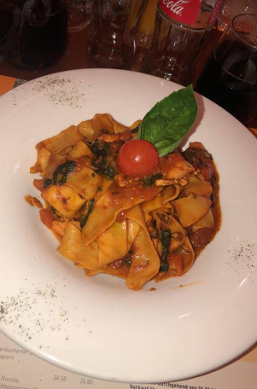
Once we arrived, we found a sit in Italian restaurant called Pizzeria, where we had a lovely sit down meal. It took us a while to find it as the maps on our smart phone were not working very well. Whilst we were eating our lunch, it was discussed by our University group chat that the Bear Museum was closed due to them being in hibernation, which interrupted with our plans. We were slightly annoyed at this as there was nothing advertised on social media when we were looking stating it may be closed, if we had knew this information we could have arranged something else to ensure we made the most of our day, although we did not let this spoil it.
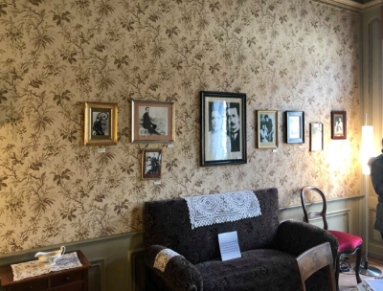
After we had finished our lunch, we got the directions up on our phones to make our way to the Albert Einstein Museum. It was quite hard to find due to no public directions and it also looked like an ordinary house. Once we got there, the lady working on the reception was very kind, and we also had a student deal where it only cost us around 6 Swiss Francs, whereas it would usually cost about 12 Swiss Francs. I personally found the museum interesting and discovered that it was where Einstein came up with his theory of relativity. There was two parts to the museum, a film where it explains his life and also a room with a timeline of his life on the walls. We spent approximately 1 hour in the museum before leaving the museum to depart to the zoo.
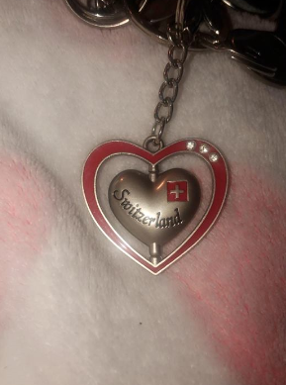
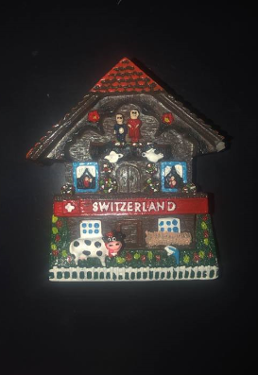
Before departing for the zoo, we noticed some shops so decided to take a visit to some local shops and purchased some lovely traditional souvenirs, including some key rings and magnets to take home for my family and friends.

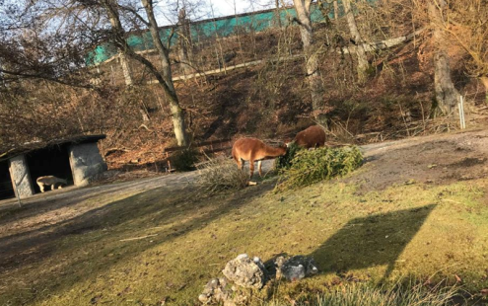
After leaving the museum, we went to catch bus 19 to get to the zoo, which was approximately a 5 minute journey. We only had about 45 minutes to spend in the zoo, as we had to get the bus back to Bern station for 16:45 to depart back to Lauterbrunnen. We walked around the zoo and seen some animals including goats, donkeys, pigs, meerkats and rabbits. We did not have enough time to see the other animals as we had to catch our bus. The zoo was very family orientated as they had many parks and play areas located around the area.
Overall, I had a wonderful experience in Bern with even better company. As Switzerland is not a destination I would have chosen to visit, I consider myself extremely lucky to have had the opportunity to experience the attractions that I did in Bern. Discovering the life of Albert Einstein and getting to visit the zoo was the best way to spend our educational free day, although we were disappointed about the Bear Museum, we still had a wonderful day.

