TASK 3 – WRITTEN REPORT

Table of Contents
Introduction 2
Importance of social media tools 2
Role of social media tools in recruiting staffs 3
Advantages and disadvantages of social media tools 4
Conclusion 5
References 6

Introduction
Social media tools like Facebook and LinkedIn play a vital role in recruitment of employees in organisations. Through these tools the job advertisements regarding vacant posts are provided which can help the employers to recruit and hire the right talents to the company. These tools are known for helping the companies to hire the candidates who are suitable for job positions based on their merits or experiences. This study will discuss the importance of social media tools. It will also analyse the role of social media tools like Facebook and LinkedIn to hire staff. Furthermore, this report will evaluate the pros and cons of these social media tools.

Importance of social media tools
The social media tools help in maintaining a consistent online presence and to increase the efficiency of team work by scheduling job posts at the most convenient time. These tools help in increasing the brand management for resolving issues quickly. The brand awareness of any content gets enhanced by these social media tools. The targeted audiences can be discovered with these tools. These tools provide a deep audience insight for making informed decisions in marketing. There is an improvement in customer support by these social media tools (Leidner, Gonzalez and Koch, 2020). The streamlining of faster responses is by these tools. The customer base is developed by these tools which enables a business to make good profits. The multiple social media accounts can be managed by these tools. The communication gap can be bridged with these tools that make a business process successful. To generate leads and useful information social media tools can be used. The better customer relationships can be managed by using these tools. The team celebration is increased by these tools in business (Zhang and Chen, 2023).
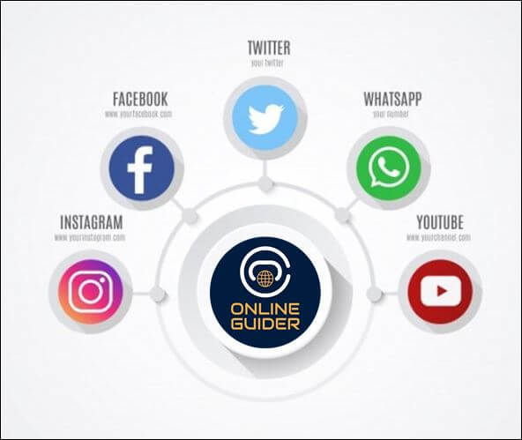
Fig 1: Showing social media tools
(Source: Zhang and Chen, 2023)

Role of social media tools in recruiting staffs
The two most important social media tools for hiring staff in business are LinkedIn and Facebook. This Facebook helps to find potential candidates by posting job advertisements. The candidate who will be perfect to get that specific job position based on merits and capabilities will have a high chance of getting selected. Facebook posts the job advertisements and job roles and by this the candidates reach is gained. This tool can attract, engage the top talents for the job roles as per abilities. 81% of job seekers use Facebook to get connected with their employers. A strong company page is developed by a business in Facebook where various candidates post their job needs (Varadaraj and Al Wadi, 2021). As per that the employer checks their merit and experiences and hires them for interviews through this tool. This tool provides the company's logo, job roles and responsibilities, salary, and this helps all the candidates to find their suitable job positions based on talents, skills, and expertise. The new job opening alerts are also posted by Facebook to find the right talents in the business. Another vital tool to recruit staff in business is via Linkedin. The recruiters by using this Linkedin application as a social media tool shares their job vacancies to over 500 million professionals to make it visible to attract the right staff to the business. Linkedin displays the ads and emails to all those potential candidates whose skills and knowledge are matching with the job role (Hysa, Karasek and Zdonek, 2021). The job description is posted on the page of Linkedin through which it can reach a broader audience. Later from them the responses can be gotten for the recruiters of the companies. Hence it can be said that both Facebook and Linkedin help the recruiters in companies to hire qualified appropriate staff in their company and to make best profits.

Advantages and disadvantages of social media tools
The advantages and disadvantages of Facebook are -
The billions of potential customers can be reached by Facebook. The marketing expenses are lowered in a business using Facebook. The specific audiences can be targeted using this tool. This tool helps in gaining an in-depth audience insight. The business brand loyalty can be developed using Facebook. The website traffic gets enhanced using Facebook. This tool helps to reach people by phones only. This tool helps in generating the business leads. This allowed a two-way communication among customers and business. Facebook helps in social connection building among people. The recruiters use Facebook to gather email ids of candidates to give them daily job post alerts. This tool helps a business to post product related content to reach targeted customers and to gain a broad customer base (Black and van Esch, 2020).
On the other hand, setting up and running a Facebook page requires a lot of time so a staff is required who can manage the page and create engaging content to attract more customers. Sometimes a staff member does not have the right skills to create good content that can hamper business productivity. It is costly and it is also open to negative feedback. This can lead to addiction and is susceptible to different scamming. This publishes private personal information of people and is easier to hack (Iskandar, Pahrijal and Kurniawan, 2023).
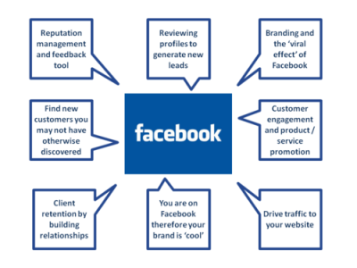
Fig 2: Showing pros of Facebook
(Source: Iskandar, Pahrijal and Kurniawan, 2023)
The advantages and disadvantages of Linkedin are -
This increases the professional relationship and networking among people. This provides various job openings and opportunities for candidates. The learning opportunity can be gained with insight management by this Linkedin. This helps in skill promotion and knowledge demonstration to get high chances of employment. This gives options for professional branding (Cartwright, Liu and Raddats, 2021). This helps in job endorsements, recommendations, event listing and boost up the job visibility. On the other hand, this enables a competition for job search. This has spam and unsolicited messages and it's very expensive and time consuming. Here, the personalisation features are limited. It possesses a risk of identity theft, incomplete profile challenge and tons of spam messages.

Conclusion
Hence it can be concluded from the above report that both Facebook and Linkedin helps in employment, connectivity, customer insights, skill, and knowledge promotion. The social media tools help in boosting business sales and the pros and cons of these tools of Facebook and Linkedin are discussed in this study.

References
Black, J.S. and van Esch, P., (2020). AI-enabled recruiting: What is it and how should a manager use it?. Business Horizons, 63(2), pp.215-226.
Cartwright, S., Liu, H. and Raddats, C., (2021). Strategic use of social media within business-to-business (B2B) marketing: A systematic literature review. Industrial Marketing Management, 97, pp.35-58.
Hysa, B., Karasek, A. and Zdonek, I., (2021). Social media usage by different generations as a tool for sustainable tourism marketing in society 5.0 idea. Sustainability, 13(3), p.1018.
Iskandar, Y., Pahrijal, R. and Kurniawan, K., (2023). Sustainable HR Practices in Indonesian MSMEs from a Social Entrepreneurship Perspective: Training, Recruitment, Employee Engagement, Social Impact of Local Communities. International Journal of Business, Law, and Education, 4(2), pp.904-925.
Leidner, D.E., Gonzalez, E. and Koch, H., (2020). An affordance perspective of enterprise social media and organizational socialization. In Strategic information management (pp. 364-402). Routledge.
Varadaraj, A. and Al Wadi, B.M., (2021). A study on contribution of digital human resource management towards organizational performance.
Zhang, J. and Chen, Z., (2023). Exploring human resource management digital transformation in the digital age. Journal of the Knowledge Economy, pp.1-17.

