

Assignment For Procurement Process (ACBA4026)

HNC / HND / BSc Quantity Surveying
Lecturer – Dr. Deborah Hughes

Bibek Khatri
Student Id – 2503477

Contents
1.0. Introduction 1
2.0. Procurement Process 1
3.0 Types of Procurement Process 1
3.1. Traditional (Design bid build) 2
3.2. Design and build (D&B) 3
3.3. Management Contract 3
4.0. Proper procurement process 4
4.1 Single Point of Responsibility 5
4.2. Cost Certainty and Risk Reduction 5
4.3. Time Efficiency (Faster Project Delivery) 5
4.4. Improved Coordination and Communication 6
4.5. Lower Disputes and Better Risk Management 6
4.6. Growing Industry Interest and Evidence of Effectiveness 6
5.0. Appropriate Tender Process 6
6.0 Conclusion 7
7.0. References 7

1.0. Introduction
A new construction training centre in Swansea, SA1, offers a great opportunity to enhance local skills. The funding is now in place, and the next step will be to look at feasibility and the best way to procure the project. The chosen method will influence cost, schedule, risks, success and sustainability. The assignment considers the three main procurement options, their advantages and disadvantages, and recommends the best one for staying on budget. It also recommends the most appropriate tendering strategy to match that selection.

2.0. Procurement Process
Procurement is the process of acquiring the goods and services necessary to complete a construction project. This includes the selection of contractors, consultants and suppliers, management of contracts and tracking of the supply chain. A good procurement plan helps make sure the project is completed on schedule, within budget and safely. So, in a nutshell procurement is about making sure whatever the project needs to be a success (Procurementhub.co.uk,2024).
There are several key steps in the procurement process. Here are the main stages
- Needs Identification & Planning
- Selection and sourcing of vendors
- Handling purchase orders and contracts
- Receipt and quality control
- Processing of invoices and payment
- Supplier relationship management and performance management (Commerce Edge, 2024).

3.0 Types of Procurement Process
Money for the new centre of excellence for construction training is already in place. The next step is selecting the optimal procurement method. For this, we will go through the three most common procurement options and choose the one that best suits this project. These are given below.

3.1. Traditional (Design bid build)
This is still a popular way of tendering procurement process. This is the best place for the next situation.
- If the design is well evolved
- If you have a good idea of what you want your project to look and feel like
- When you want to work with an architect to bring your vision to life and make your ideas a reality
- If you value having a voice in what is being designed and built for you more than getting it done as fast as possible
For the person who loves details However, the traditional approach might be the best option here (Bahar, 2020).
Advantages
- You have a personal connection with the person or group doing the design.
- You remain the owner of the project.
- If you feel confident to select other experts and various professional consultants.
- Tender process allows you to select your builders on the basis of lowest price, best quality or a combination of the two that suits you best.
- There is clearer guidance for building contractors, and their pricing should better reflect the actual work.
When you design and build you have to decide on your budget before you know how the project will turn out. One of the reasons why more complex projects are usually selected for traditional procurement (Bahar, 2020).
Disadvantages
- You may have to deal with more people directly (unless you engage your architect as project manager)
- Less certainty on cost, instead of getting one quote at the outset for the entire project, you will get separate bills for each stage of the project.
- Planning permission can take a long time and waiting to run the tender process until you have planning can add weeks onto the project length (Bahar, 2020).

3.2. Design and build (D&B)
Design and build have become the main alternative to traditional procurement for developers and new build projects. Pros and cons of it are:
Advantages
- One company manages all aspects of your project delivery.
- You can probably estimate the costs better, although you may not know the exact amount at the start.
- Your builder can plan the build while the design is still being developed and can start work as soon as planning permission and building regulations are approved.
- Getting contractors involved early could make projects easier to build. Architects are not always interested in practical construction, and contractors prefer simple and standard parts that are easy to assemble (Bahar, 2020).
Disadvantages
- Passing the responsibility to another party means giving up some control. If you are not involved on a close level the finished project may not be to your expectations.
- Most contractors want to stay within their original quote, yet they need to make a profit as well. They may cut quality to deal with delays or extra costs, by using cheaper materials or spending less time on the project.
- Reduced flexibility, since project details are determined upfront. As the project moves forward, the chances to make changes diminish. Some of the benefits of design and build can be lost if the planning authority requires major changes.
Your choices are limited as fewer building contractors are capable of full design and build and you might not get your preferred contractor (Bahar, 2020).

3.3. Management Contract
A management contract is a contract whereby a third party, a management company, runs a project, function or department on your behalf. They might do something like marketing or bookkeeping, for example. This method has similar pros and cons in construction industry as in other industries.
Advantages
- (Saves time and resources) Management contracting allows the contractor to get involved early so design and construction can proceed in tandem. This leads to fewer delays and less administrative effort for the client.
- (Shares knowledge) The management contractor offers specialist knowledge to manage the trade packages well, leading to better buildability and less technical risk.
- (Saves money) Early cost planning and competitive bidding for each work package can achieve better value and less risk of costly changes later.
Disadvantages
- (Loss of control) The management contractor takes over the handling and management of trade packages so the client does not have direct control over selection of subcontractors and daily site decisions.
- (Harm reputation) If the trade contractors do not perform well, the client may still be blamed for delays or quality problems even though the management contractor is responsible for delivery.
- (Conflict of interest) The management contractor may be biased toward some subcontractors with whom they have a history of working together, resulting in less competition.
Management contracts are a tried and tested way to share the workload especially if you do not have enough time or resources in a certain area. The management company is paid a fixed fee, so costs are transparent from the start and tasks are completed to a high standard (Thompson, 2019).

4.0. Proper procurement process
I've worked on construction projects before, but this is the biggest one I've managed. Having looked at the three most common procurement methods, I feel that Design and Build is the best option for this project which is the building of a new centre of excellence for construction training.
Design and Build is one of the most effective methods of procuring construction projects. It generally provides a single point of accountability, increased certainty on cost and schedule, reduced risk and a more streamlined process. It is now the most popular method, used in more than half of UK construction projects. The reasons for choosing Design and Build are as follows (CIOB, 2022).

4.1 Single Point of Responsibility
One contractor does the design and the construction, and the client has one company to be held accountable.
- Minimises conflicts between the designer and the contractor.
- Decreases client work and facilitates risk division.
- Enhances communication and decision making (CIOB, 2022).

4.2. Cost Certainty and Risk Reduction
With D&B you get cost certainty sooner because the contractor is in charge of design and can make sure the plans can actually be built.
Advantages
- Budget certainty comes earlier in the process.
- Significant reduction in risks of cost overruns and variations
Reduction in design error claims as the design is owned by the contractor (CIOB, 2022).

4.3. Time Efficiency (Faster Project Delivery)
D&B allows for earlier start of work because design and construction may occur concurrently.
Advantages
- Reduced overall project timelines.
- Integrated teams for faster decision-making.
- More efficient handling of design changes (CIOB, 2022).

4.4. Improved Coordination and Communication
D&B gets designers and contractors involved early, which helps keep the project more cohesive.
Results
- Less communication gaps.
- Better problem solving and teamwork.
- Improved buildability and more feasible design solutions (CIOB, 2022).

4.5. Lower Disputes and Better Risk Management
When one party is responsible for the entire project, there are fewer disagreements about design errors or construction problems.
- More certain contractual responsibility
- Less adversarial relationships than in traditional procurement (CIOB, 2022)

4.6. Growing Industry Interest and Evidence of Effectiveness
Surveys indicate D&B is now the prevalent method of procurement in the UK, with over half of all projects. “That shows the industry has strong confidence in the approach.” The increase in the application from 2019 to 2022 shows its real benefits and its fit with modern construction methods (CIOB, 2022).

5.0. Appropriate Tender Process
After studying the reports, evidence and market data, selective tendering is the best option for quality and reliability. This method is to pre-qualify only skilled contractors and invite bids. The effects of selective tendering are:
- Only pre-approved contractors are invited, so only high quality and capable bidders participate.
- Reduces the possibility of bids from unsuitable and inexperienced suppliers.
- Time is saved in evaluation as the bidder pool is smaller and already filtered.
This method is good for maintaining standards and fair competition. The main tendering methods in the UK are one of the main tendering methods and is welcomed for balancing competition and quality control Procurement Hub says that selective tendering is suitable when the project requires suppliers with proven experience or specialist capability and is a good way of ensuring quality and minimising risk (Procurement Hub, 2024).
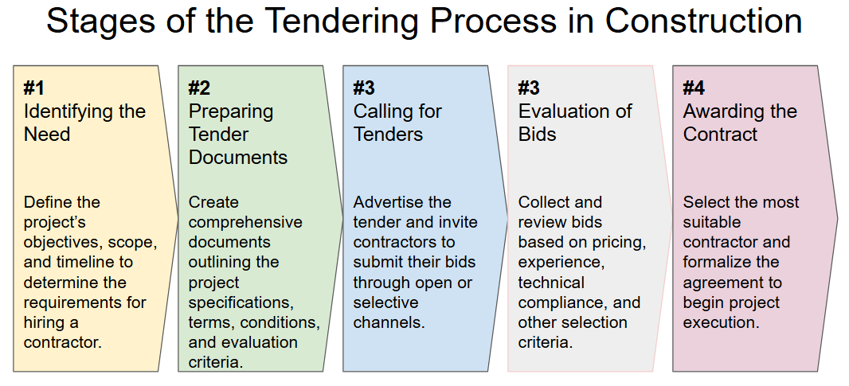
Stage of the tendering process in construction (Planyard.com, 2026)

6.0 Conclusion
In summary good procurement and tendering are the keys to realising value, quality and risk control in UK construction. Selective tendering is a balanced and reliable method, as it allows the client to invite tenders only from pre-qualified and capable contractors. This leads to better quality and reduces the risk of hiring inappropriate bidders. When used with the Design and Build method, which provides single point responsibility, faster delivery and better cost certainty, clients get a more efficient and collaborative process (Myprojectestimating, 2025).
The use of selective tendering and the Design and Build method for a new centre of excellence for construction training offers better project outcomes and better control over contractor skills and project delivery.

7.0. References
- Procurementhub.co.uk. (2024). What is Procurement in Construction? | Procurement Hub. [online] Available at: https://www.procurementhub.co.uk/news/what-is-procurement-in-construction/. (Accessed date; 13/02/2026)
- Commerce Edge. (2024). The Procurement Cycle in 6 Steps. [online] Available at: https://commerce-edge.com/tools-tips/the-procurement-cycle-in-6-steps/. (Accessed date; 13/02/2026)
- Bahar, U. (2020). Traditional Procurement vs Design & Build: Which One is Better? [online] Urbanist Architecture - London Architects. Available at: https://urbanistarchitecture.co.uk/traditional-vs-design-and-build/.
- Thompson, J. (2019). Advantages and Disadvantages of Management Contracts. [online] Chron.com. Available at: https://smallbusiness.chron.com/advantages-disadvantages-management-contracts-18886.html.
- CIOB (2022). Design and build procurement route. [online] www.designingbuildings.co.uk. Available at: https://www.designingbuildings.co.uk/Design_and_build_procurement_route.
- Procurement Hub (2024). Types of Tendering in Construction | Procurement Hub. [online] Procurementhub.co.uk. Available at: https://www.procurementhub.co.uk/news/types-of-tendering-in-construction/.
- Myprojectestimating (2025). Construction Tender Process Explained: UK Guide. [online] My Project Estimating. Available at: https://myprojectestimating.co.uk/construction-tender-process-uk-guide/.
- Planyard.com. (2026). Available at: https://planyard.com/wp-content/uploads/2025/01/image-1.png [Accessed 27 Mar. 2026].

