International Business Report
Mexico’s Automotive Manufacturing Industry and a Critical Evaluation of Volkswagen de México
Module: LCMB7034 International Business Concepts

Programme | Master of Business Administration
Module | International Business Concepts
Module code | (LCMB7034)
Lecturer | Dr Robert Ejike Udeogu
Student name | Asif Mahmud Emon
Student ID | 2439438
Word count | 5398
Submission date | 20 March 2026

Table of Contents
Section 1: International Business Report 1
1. Introduction to the report 1
2. Industry and country overview 1
3. Porter’s Diamond analysis of industry competitiveness 6
4. Critical evaluation of Volkswagen de México 9
5. Conclusion to the report 14
Section 2: Reflective account using Gibbs’ reflective cycle 16
Reference 19

Section 1: International Business Report

1. Introduction to the report
The automotive manufacturing sector of Mexico provides a firm foundation of an international business report, as it combines cross-border production, foreign multinational manufacturers and regional trade integration. It is strategically significant to the Mexican economy, North American value chains and current debates on nearshoring, rules of origin and industrial resilience. This report discusses the Mexican industry and contends that its international competitiveness lies on a combination of geographic proximity to the United States, accumulation of supplier capabilities, trade integration and enduring foreign investment rather than on cheap labour alone. It then evaluates Volkswagen de México as a foreign multinational operating in that environment.

2. Industry and country overview
Mexico is among the most significant manufacturing sites of the automotive industry in the world and one of the clearest illustrations of an export-oriented industrial cluster constructed through long-term foreign direct investment, supplier development and trade integration. According to the International Trade Administration (2026), Mexico is the seventh-largest passenger vehicle manufacturer in the world, the fifth-largest producer of heavy vehicles and the top exporter of tractor trucks. The sector is therefore strategically important not only because of output volume but because it anchors employment, suppliers and export activity.
The industry size can be observed in terms of output and depth of the ecosystem. According to Trade.gov, in 2024, there were 37 manufacturing plants of light vehicles in Mexico, in 12 states, owned by 13 major companies, and a very large parts industry comprised of over 2,100 firms and with a highly multi-tiered supplier structure (International Trade Administration, 2026). According to Data Mexico, also, the motor vehicle manufacturing industry received US$7.55 billion in foreign direct investment in January to September 2024, with a further US 2.3 billion in motor vehicle parts manufacturing (Data Mexico, 2026a; 2026b). This assembly and parts capacity is one of the reasons why Mexico is a good platform to manufacture. It lowers the cost of transaction, promotes just in time production and the country is made resilient compared to being just a low-cost assembly location, which is largely dependent on imported inputs.
The industry's scope is broad. It encompasses mass market passenger automobiles, pickup trucks, commercial automobiles, engines, transmissions and components. The location of plants is also important strategically. The northern states are advantaged with geographical closeness to the United States and border logistics whereas central and western clusters are advantaged with accrued supplier networks, labour pools, universities and highway infrastructure. According to Trade.gov, large original equipment manufacturers are located in such regions as Puebla, Guanajuato, Aguascalientes, Nuevo Leon and Coahuila, the automotive capability is concentrated and networked (International Trade Administration, 2026). This has led to Mexico not only having a national market but also a number of subnational industrial systems with varying assembly, components and logistics strengths.
There is much domestic market but the strategic logic of the industry is highly export oriented. This is important to business analysis since the Mexican firms are not only placed against the domestic demand but also against the needs of the North American market. According to Trade.gov, in 2024, 79.7 percent of vehicle exports were to the United States, with Canada and Germany contributing to the top three destinations of the total export being 91.7 percent (International Trade Administration, 2026). Such a trend produces opportunity and dependency. The opportunity is in the availability of a big neighbouring market within USMCA regulations. It is dependent on the concentrated exposure to changes in trade policy, regional content regulation, cyclical demand and political mood in the U.S.
The industry is highly multinational in terms of its competitive structure. Some of the major assemblers are General Motors, Ford, Stellantis, Volkswagen, Audi, Toyota, Nissan, BMW, Mercedes Benz, Honda, Hyundai, Kia and Mazda (International Trade Administration, 2026). Mexico, strictly speaking, has significant domestic automotive companies in such niches as parts, heavy vehicles and distribution, whereas the light vehicle assembly sector is controlled by foreign multinationals. This implies that relative positioning is not to be viewed as a struggle between strong domestic champions and foreign entrants rather it is a struggle among the various foreign business models entrenched in Mexico. There are those companies that use Mexico as a base of exportation, others as a base of exportation and domestic market and others integrating the local production with vast import-based brands.
These differences in positioning are highlighted by recent sales data. According to AMIA and INEGI data for January to November 2025, Nissan is the market leader in Mexico with 248,017 units sold, followed by General Motors with 169,309, Volkswagen Group with 154,681 and Toyota with 105,021 (AMIA, 2025). Nissan and GM benefit from scale and dealer reach, while Volkswagen combines meaningful domestic presence with an export-oriented production base rather than simple volume leadership.
VW Mexico holds a particularly fascinating position in this scenery. According to the company, in 2024, its Puebla vehicle plant manufactured 382,312 vehicles and the Volkswagen Group brands sold 177,261 vehicles in the Mexican market in the same year, which is why the Group is the third largest multi brand corporate seller in Mexico (Volkswagen de Mexico, 2026). This reveals a dual role. Volkswagen is a domestic market competitor who is also an exporter of manufacturing. The dual role is also a strategic value as it diffuses the risk of demand sources and enables learning on product, marketing and operations. Simultaneously, it makes the situation complicated as the company should be able to stay competitive in the market with local consumers and also address the requirements of cross border production networks in terms of cost, quality and rules of origin.
Altogether, the Mexican automotive market is huge, external and institutionally important. It has no ability to lower its competitiveness to cheap labour. Instead, it is a result of a cumulative industrial structure whereby trade agreements, supplier concentration, logistics, engineering capacity, foreign capital and regional concentration interplay. The following section employs Porters Diamond to understand how this industrial pattern has turned into a globally competitive one and its weaknesses.

Table 1. Relative positioning of selected competitors in Mexico
Firm | Core strategic role | Market strength | Manufacturing profile | Key positioning insight
Nissan | Domestic leader with deep local presence | Highest domestic volume | Strong Aguascalientes and Mexico footprint | Combines scale, distribution reach and local embeddedness
General Motors | Broad portfolio multinational | Strong volume and brand spread | Large export and assembly base | Benefits from scale and wide market coverage
Volkswagen Group | Multi brand competitor with historic legitimacy | Strong but not dominant | Puebla manufacturing plus multi brand sales | Balances export manufacturing with domestic brand depth
Toyota | Operationally disciplined Japanese rival | Growing and credible | Important assembly and sourcing role | Competes through quality, efficiency and trust
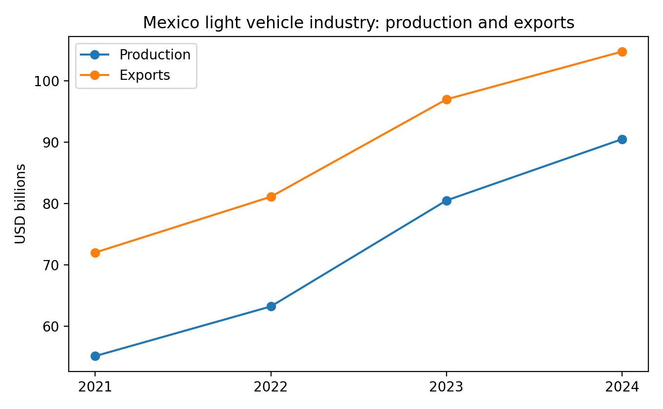
Figure 1. Mexico light vehicle production and exports, 2021 to 2024
Source: International Trade Administration (2026).
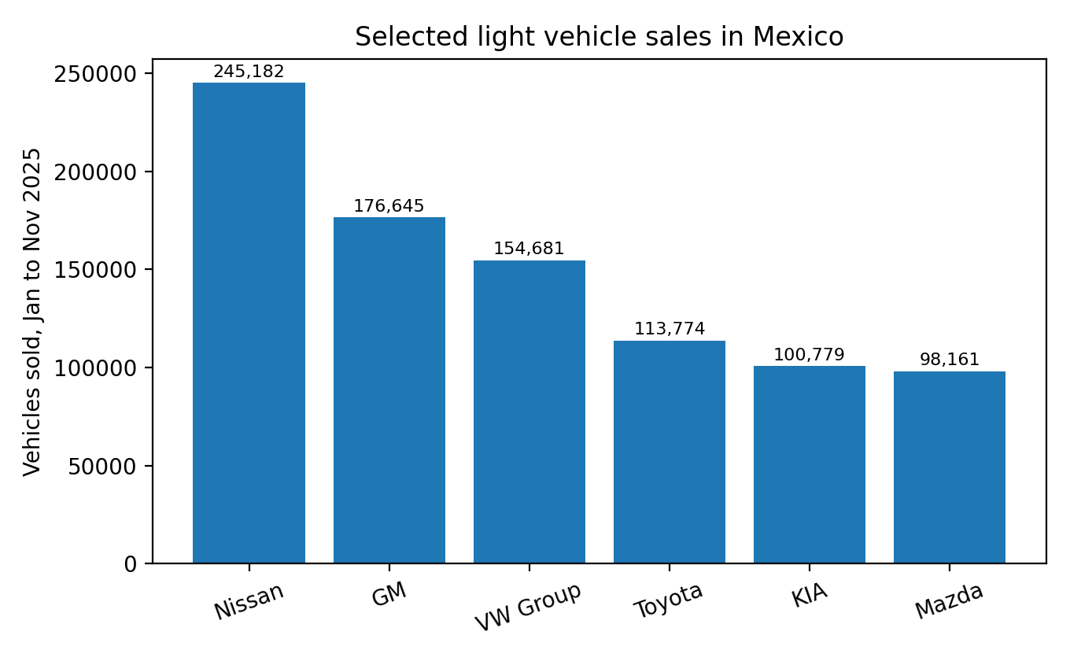
Figure 2. Selected light vehicle sales in Mexico, January to November 2025
Source: AMIA (2025).

3. Porter’s Diamond analysis of industry competitiveness
Porter’s Diamond can still be used to analyse why certain locations in a country become internationally competitive in a particular sector, but it should be employed with discipline. Brouthers, Brouthers and Ensign (1997) show that national competitive advantage can vary by context, while Rugman and Verbeke (1993) argue that Porter’s single-country model underestimates the role of regional integration and multinational networks. That caution is particularly relevant to Mexico.
Mexican competitiveness is significantly due to factor conditions. The nation has a huge manufacturing workforce, engineering and technical capacity, well-established industrial corridors and logistical access to the United States. The advantage is not cheap labour alone but the combination of labour, infrastructure, accumulated know-how and proximity to major export markets. That supports cost efficiency and scale, but also creates exposure to labour, infrastructure and policy constraints.
The demand situation is less clear. The domestic market size and the increasing middle class in Mexico are substantial, yet the industry is shaped heavily by regional export demand, especially from the United States. This means competitiveness depends less on local consumption alone and more on the ability to serve demanding external markets through quality, timing and compliance. The benefit is scale and discipline; the fragility is dependence on external demand cycles and policy shifts.
One of the strongest things about Mexico is related and supporting industries. Final assembly is facilitated by the big auto-parts industry in the country, logistics, steel and plastics and specialised suppliers. Supplier density helps firms meet rules-of-origin thresholds and reduce coordination costs, though reliance on imported higher-value inputs in some segments still limits autonomy. The ecosystem therefore supports competitiveness, but uneven localisation remains a constraint.
The competitiveness is also enhanced by firm strategy, structure and rivalry. Mexico has a high concentration of assemblers that are globally competent that compete on price, quality, delivery speed, product mix and market coverage. Competition among Nissan, GM, Volkswagen, Toyota, Kia, Mazda and others in the domestic market helps to strengthen performance pressure, whereas competition on export contracts, model assignments and capacity with suppliers helps to strengthen the manufacturing side. This type of competition is constructive in that it forces companies to invest in local adaptation and process improvement. However, the height of competition also implies the industry is prone to the margin squeeze, labour strain and political influence when companies are interested in protection or incentives.
The Mexican case revolves around government as a clear extension of the diamond. Trade policy, export promotion, FDI openness and industrial regulation have helped Mexico attract multinational investment and link production to the United States and Canada. Recent USMCA review discussions and wider tariff changes show that policy can reinforce competitiveness through regional integration while also increasing exposure to regulatory uncertainty.
Competitiveness is also determined by chance events and external shocks. The strategic environment has changed due to the pandemic, semiconductor shortages, and the emergence of Chinese EV manufacturers as well as the presence of geopolitical conflict and tension. The attractiveness of Mexico has been partly augmented due to the fact that companies pursue supply chain resilience and nearshoring resources. Meanwhile the government of Mexico increased tariffs on Chinese and other Asian vehicles up to 50 percent in 2025 in a bid to safeguard local employment and manufacturing, Reuters (2025b). That action brings out a critical conflict. Mexico would like to be open to investment and also protect strategic capabilities and manufacturing capabilities and align itself with the North American political pressure. This is opportunity to some companies; it is sourcing and partnership problems to others.
In general, Porters diamond can be used to understand the global competitiveness of the Mexican automotive industry, however, a regionally extended reading is the most convincing. The benefit enjoyed by Mexico is as a result of developed industrial factors, well-established supplier networks, stiff multinational competition and trade combined access to North America. Competitiveness in the industry is not due to Mexico being a peripheral low-cost location but as a result of it turning into a strategically central location in a regional production system. The boundaries of such competitiveness include overreliance on exports, sensitivity to policies and the fact that an increase in regional content might put weaker suppliers or less localised assemblers at risk.
Table 2. Summary application of Porter’s Diamond to Mexico’s automotive industry
Diamond dimension | Evidence in the Mexican case | Critical implication
Factor conditions | Large manufacturing base, technical labour, clustered plants and suppliers | Strong created advantage, but quality varies by region and infrastructure corridor
Demand conditions | Domestic market matters, but export demand from North America is decisive | Diamond works best when read through regional rather than purely national demand
Related/supporting industries | Deep parts ecosystem, logistics and engineering services | Supplier density strengthens localisation and resilience under rules of origin
Rivalry and strategy | Dense multinational rivalry in domestic and export segments | Competition improves efficiency but can compress margins and intensify political pressure
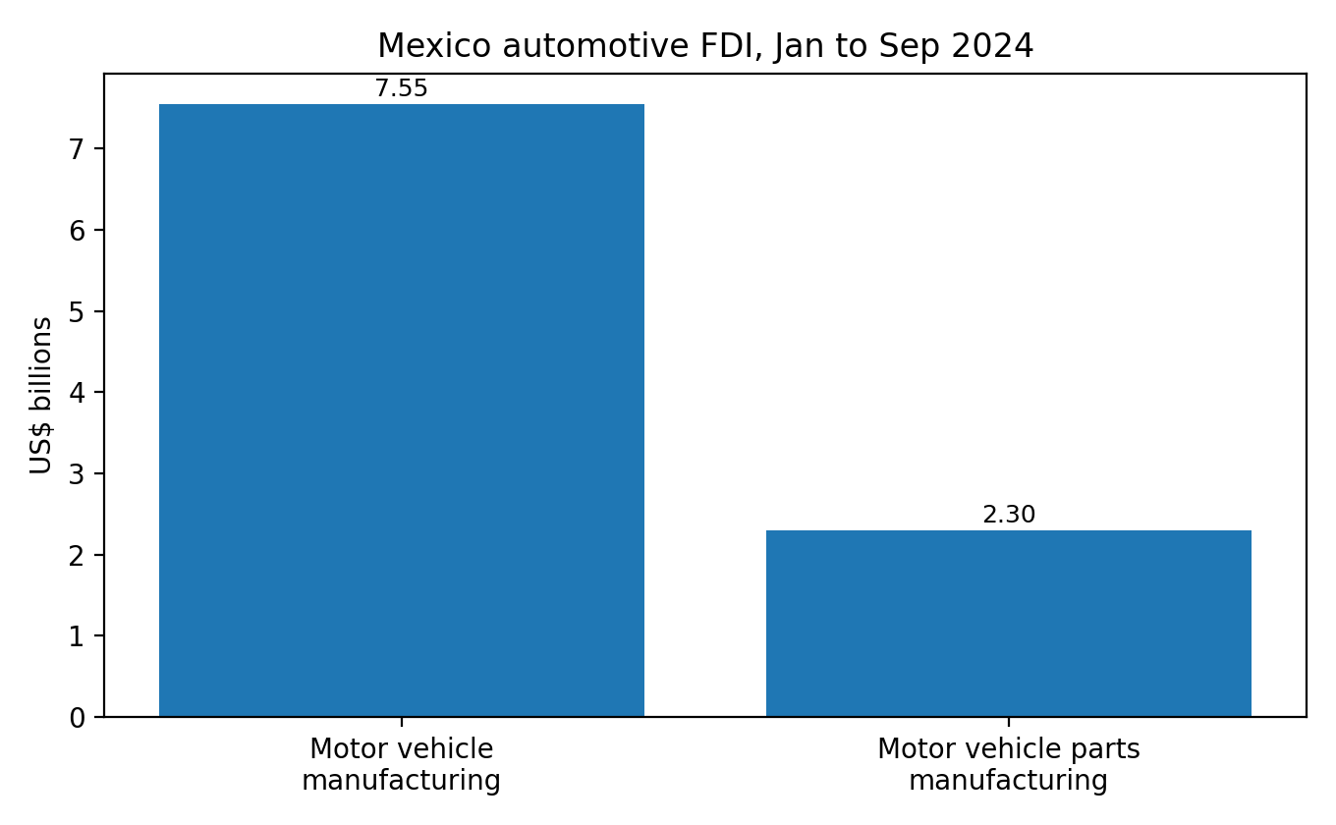
Figure 3. Mexico automotive FDI, January to September 2024
Source: Data México (2026a; 2026b).

4. Critical evaluation of Volkswagen de México
Volkswagen de Mexico is a perfect focal company as it represents the opportunities and risks of doing business in the automotive industry of Mexico. The company is a blend of strong historical embeddedness and relevance in the modern strategic context. Volkswagen has been in operation in Mexico over decades and Puebla plant is one of the flagship plants of the company outside Germany. The company thus enjoys experience, supplier networks, brand name and local credibility that new entrants do not necessarily enjoy. Simultaneously, the company has to work in the environment, which is influenced by trade politics, cost pressure, environmental transition and technological competition. In this part, the general appeal of the Mexican market to Volkswagen is assessed using a hybrid approach to PESTLE and CAGE.
Politically, Mexico is widely appealing to an automotive multinational since the state is deeply interested in maintaining the export revenue, employment and investment base in the industry. Political attractiveness is however not equal to certainty. The most significant concern of Volkswagen is the relationship between North American regional politics and Mexican domestic policy. Reuters indicated that U.S. and Mexican leaders would start bilateral USMCA review talks in March 2026, specifically with attention to external sourcing and North American content retention (Reuters, 2026a). This is both a threat and an opportunity: tighter origin rules would raise sourcing costs, yet Volkswagen’s established manufacturing base gives it more room to localise than many entrants.
Mexico is structurally desirable in terms of economic factors, albeit volatile. The nation is a blend of comparatively affordable labour expenses and manufacturing expertise, location closeness to the United States and a pool of suppliers. These are long-lasting conditions compared to short-term cost arbitrage. Also, the FDI inflows in the industry reflect that investors continue to consider Mexico as a serious long term production platform (Data Mexico, 2026a; 2026b). In the case of Volkswagen, the basic economic rationale is that Puebla enables the company to produce efficiently within an industrial geography of North America without having to incur the entire cost base of German or U.S. manufacturing. However, macro attractiveness is checked by the changes in the exchange rates, inflationary pressures, transport bottlenecks, and reliance on the U.S. demand. The greater the concentration in the export demand, the greater the exposure of the firm to external Mexico shocks.
The second dimension of the economy is the domestic market. The Mexican corporate information page of Volkswagen de Mexico (Volkswagen de Mexico, 2026) stated that 177, 261 vehicles sold in Mexico in 2024, and Volkswagen Group was ranked as the third largest multi brand dealer. This implies that Mexico is not just a manufacturing point, it is also a significant demand point. January-November 2025 AMIA data reveal a robust presence of Volkswagen Group in the market at 154, 681 units, but trails Nissan and General Motors (AMIA, 2025). The domestic market is thus favouring volume, brand learning and dealer network depth. Nevertheless, the domestic market of Volkswagen is threatened by solid Japanese and U.S. competition and the appearance of Chinese brands and price competition. Attractiveness of the market is thus high but disputed. It is not a question of demand but can Volkswagen maintain differentiation and pricing power.
Of particular importance are legal and regulatory factors. The closest legal framework is USMCA. Rules of origin, labour value content, customs procedures and dispute mechanisms shape the viability of Mexican operations for firms exporting northwards. Reuters reported in October 2025 that Mexican auto executives expected a complex outlook ahead of the USMCA review, particularly amid scrutiny of Asian content in parts and pressure for higher regional content requirements (Reuters, 2025c). For Volkswagen, this means sourcing strategy, supplier upgrading and compliance discipline are as important as market access itself.
The legal and policy environment is also demonstrated by the tariff increments on cars produced in China and other Asian nations in Mexico in 2025. According to Reuters, the tariffs on imports of the same were increased to up to 50 percent to save the local industry and employment (Reuters, 2025b). This might seem favourable to a manufacturer that is already located in Mexico. Increased barriers to imported Asian vehicles will eliminate direct price competition and make local assembly more appealing. However, the action is more complex. Car makers rely on the components and technology alliances of global sources. When the policy becomes too hardened, companies might have access to sourcing limitations or increased input prices. The disadvantage is that the protection measures only give Volkswagen an advantage when they enhance production in the country without compromising on component flexibility.
The history of cultural factors is not always taken seriously when manufacturing is analysed since the industry appears to be cost and logistics oriented. That would be a mistake here. The CAGE framework by Ghemawat also serves to remind us that cultural distance also plays a role in managerial communication, organisational routine, consumer perception and institutional trust despite the high levels of formal trade integration (Ghemawat, 2001). Cultural factors in the case of Volkswagen work in three levels. First, the organisational culture within an organisation has to tie a German parent company with Mexican plants, managers and suppliers. Second, the brand has to address the Mexican consumers in a manner that will be locally relevant. Third, the company should be legitimate among the workers, communities and authorities. The fact that Volkswagen has a rich history of association with the Mexican mobility culture, particularly the Beetle, is a significant strength of the company. The 70 years campaign in Mexico by the company is not that of nostalgic branding, but is a sign of intense symbolic embeddedness in the local market ( Volkswagen Mexico, 2025).
Meanwhile, cultural embeddedness should not be romanticised. The framework by Hofstede is frequently employed to juxtapose national cultures, however, other researchers like McSweeney (2002) caution about simplistic national stereotypes. Because of this reason, the most justifiable conclusion is not that German and Mexican cultures are compatible or incompatible in a deterministic manner, but that cross cultural management should be done by the local autonomy, clear communication, and awareness of the institutional context. The company has a long history in Mexico, which is an advantage since it provides Volkswagen with an organisational memory and relationship capital. That benefit should however be vigorously sustained by labour relation, management development and local involvement and not taken as a preponderance.
The future of Volkswagen in Mexico is increasingly shaped by technological and environmental factors. The industry around the world is being electrified, software integrated and subjected to tighter sustainability expectations. Mexico’s current automotive strength has been built largely through internal-combustion manufacturing, and although hybrid and electric production is growing, it remains relatively limited (International Trade Administration, 2026). This poses a strategic dilemma for Volkswagen: it must continue leveraging traditional manufacturing strengths while preparing plants, suppliers and skills for a different technological future.
The competitive forces also influence the future of Volkswagen. Nissan continues to be a rather competitive force in Mexico because of local manufacturing presence, dealer network and size in local sales. Toyota fights on the perceptions of quality and operational efficiency whereas General Motors is a combination of scale and breadth of portfolio. In the meantime, the Chinese brands have added pressure in the market, especially the prices and the product features. The law against the Asian imports can slow down some of that pressure, but not the bigger strategic challenge. Volkswagen has no alternative but to compete on other than legacy. It requires efficiency in the processes, relevance of the products, localisation, resilience of supply and clarity of the brand.
The internal capabilities of Volkswagen indicate that it is in a good position to react. This is evidenced by the fact that the Puebla plant (382,312 vehicles in 2024) exhibits a high level of scale (Volkswagen de Mexico, 2026). The company also belongs to a broader group structure which can cross brand the technology, purchasing power, product development and financing capabilities. This is important since the multinational performance in a complex market is not solely based on attractiveness of the country but also on specific benefits of the firm. The group capabilities of Volkswagen minimise risk through cross brand learning and economies of scale. Nonetheless, firm specific benefits may be lost when strategic focus is lost or when the firm miscalculates the local change. The market in Mexico is dynamic and the past presence can only be useful when it is coupled with the current flexibility.
There is need therefore to make a balanced judgement. The Mexican market will continue to be appealing to Volkswagen due to the benefits it has in export platforms, strong industrial ecosystems, local market relevance and extensive local base. These strengths cannot be cancelled by political and legal uncertainty, but increase the price of complacency. The further localisation, development of suppliers, the strict adherence to the regional trade regulations, the attentive labour and relations with the community, and the mindful positioning towards technological shift are the most probable sources of the future success of Volkswagen de Mexico. On the other hand, overreliance on the U.S. demand, underinvestment in the next generation capabilities and inability to react decisively to policy and competitive changes are the biggest risks. As concisely discussed, Mexico remains a good strategic point of Volkswagen, but it is not an automatic appeal. The success of an institution is not only determined by its operational efficiency but also by its active management.
Table 3. PESTLE style assessment of Volkswagen de México in the Mexican market
Factor | Opportunity for Volkswagen | Risk for Volkswagen | Overall judgement
Political | Government interest in retaining auto investment and jobs | USMCA review and regional trade politics create uncertainty | Attractive but policy sensitive
Economic | Competitive manufacturing base with export access and local demand | Dependence on U.S. demand and macro volatility | Structurally strong, cyclically exposed
Legal | Trade rules can reward localised producers | Rules of origin, labour and compliance costs may rise | Compliance capability is a strategic asset
Cultural | Long historic presence and local brand legitimacy | Consumer preferences and labour relations still require adaptation | Embedded advantage, not guaranteed loyalty
Technological | Potential to upgrade plants and suppliers for future mobility | Slow ecosystem transition could reduce future relevance | Requires active investment and capability renewal

5. Conclusion to the report
It has been revealed in the report that the Mexico automotive manufacturing industry is globally competitive due to its integration of mass production, high density of suppliers, long term foreign investment and conferred access to the North American markets. This competitiveness can be explained by Porters Diamond especially based on the conditions that have been created, the related industries and high competition among multinational firms, but the Mexican case would be more appropriate in terms of a regionally extended variant of the model. The low-cost labour is not the only strength of the industry. It is based on the accumulation of production system which integrates the plants, suppliers, logistics corridors and trade institutions. VW Mexico shows how successful and challenging it is to work in this system. The company enjoys such scale, historical embeddedness, brand legitimacy and group level capabilities that make Mexico an attractive production and sales base. Nevertheless, its future performance is pegged on its ability to manage dynamics of review of USMCA, local compliance needs, technological change and increased competition. The Mexican market is hence still appealing, though not passively. It hands out rewards to those firms that are able to match multinational capabilities to local institutional realities. In the case of Volkswagen, it will imply going further towards localisation, cushioning strategic flexibility and getting the Mexican platform prepared to enter the next stage of automotive competition.

Section 2: Reflective account using Gibbs’ reflective cycle
I chose the automotive manufacturing industry in Mexico because it provided a better fit to the assignment than a more familiar but less analytically rich subject. The task required an industry and country overview, a Porter’s Diamond analysis and a critical assessment of one foreign multinational through political, economic, legal and cultural factors. During the planning phase, I realised that this would work best in a sector with clear public information, relevant theory and live policy tensions. Mexico’s automotive industry satisfied those requirements.
The reflective cycle developed by Gibbs also enabled me to plan the process. The task during the description stage was not merely to summarise an industry but make an argument concerning national competitiveness and firm specific success. I was initially inclined to believe that the assignment would easily turn out to be descriptive since the automotive industry produces vast amounts of factual data. I had the risk of gathering production and sales data without developing a logical line of analysis. It was beneficial to realise that the risk was identified at an early stage since it influenced my approach to reading sources. Rather than inquiring about the latest numbers, I started asking, what did those numbers say about the industry structure and the place of Volkswagen in it.
Triangulation was one of the most helpful elements in the research process. My sources were academic literature to frame the concepts, official and quasi official sources of information in the industry, and the current news reporting sources to track policy developments. The academic literature (Porter, Rugman and Verbeke, Brouthers and Ghemawat) assisted me in choosing the way to utilise theory not in a mechanical manner. Specifically, the criticism of the Diamond formulated by Porter was significant as the case of Mexico cannot be entirely reduced to a purely national paradigm. In the absence of that important literature, I could have subjected the diamond to checklist. The current operating data required in the country and company sections was found in official and industry sources like Trade.gov, Data Mexico, AMIA and Volkswagen de Mexico. Then Reuters assisted in relating the analysis to the ongoing events, particularly USMCA review and tariff policy.
In the assessment phase of the reflection, I believe that the distinction between the industry attractiveness and company success was one of the strongest aspects of my process. Initially, I had the temptation to believe that since Mexico is a good manufacturing destination, Volkswagen would automatically be placed well. Additional reading revealed that this would be too naive. A place may be appealing, yet subject firms to market dependence concentration, regulatory friction as well as technological uncertainty. The realisation enhanced the report since it guided me to define success as contingent. The opportunities of Volkswagen lie in its localisation, compliance, supply chains and technological transition, rather than in the fact that the company has already established a plant in Puebla.
The other significant lesson was related to evidence selection. Lots of materials were written about the automotive industry of Mexico generally, but not all of them were equally helpful in this assignment. I discovered that there were materials that were full of descriptive information but not much in strategic relevance. Others were up to date, but too limited. Consequently, I was forced to be more selective. The sources with scale to significance, i.e. export shares, GDP contribution, FDI inflows or market shares, were the most valuable. These statistics helped me to substantiate my statements concerning financial significance and competitive rank. They also enabled the production of tables and graphs that helped in the argument rather than just beautifying the report.
Some of the frameworks were also limited by the analysis stage. Gibbs does not just ask us to reflect on what worked but why. Porters Diamond came in handy since it gave a perfect framework of thinking competitiveness, but it was not quite ideal in itself. Multinational production systems and regional trade rules strongly influence the Mexican automotive industry; thus I needed to alter the model by clearly addressing the issues of government, chance, and regional integration. On the same note, there was a need to do cultural analysis since the brief requested it, yet I could not generalise culture to mere national characteristics. The critique on Hofstede by McSweeney made me realise that culture is something you have to be cautious about. This compelled me to approach culture as a practical organisational concept, including legitimacy, communication and local embeddedness, as opposed to a national stereotypes list.
Another lesson learnt in the process was that the current policy developments can greatly alter the tone of an assignment. In March 2026, the discussions on the USMCA review and the 2025 tariff on some imports of Asian goods made the report even more up to date and challenging simultaneously. They enhanced the assignment since they enabled greater critical discourse of political and legal risk. They however also needed to be judged since such developments are still developing and the ultimate impact is yet to be experienced. One of the difficulties mentioned in the level 7 assessment criteria is to write when the information is not complete. I thus attempted to be modest. Rather than forecasting one effect, I concentrated on realistic strategic implications to Volkswagen and how uncertainty itself impacts on business decisions.
To sum up, the process enhanced my knowledge on the process of transitioning between research collection and analytic writing. I have learned that the key to effective international business reporting lies in the ability to be disciplined in selecting the topic, critical in applying theory, triangulation of sources and readiness to live with uncertainty instead of denying it. To further enhance this piece of work, I would analyse the subnational variation within Mexico in more depth, specifically the variations between the states of Puebla, Guanajuato and the northern border. I would also make a more explicit comparison of Volkswagen with one of its immediate competitors like Nissan or Toyota at plant level and not primarily at market and strategic level. The steps that I will take in future assignments would then be to start with a previous source mapping phase, distinguish descriptive evidence and analytical evidence more effectively, and theory to influence the direction of reading earlier than to apply it when the data is already obtained.

Reference
AMIA (2025) Reporte de venta de vehículos ligeros nuevos por marca en noviembre de 2025. Available at: https://amia.com.mx/wp-content/uploads/2025/12/031225.pdf (Accessed: 8 March 2026).
Brouthers, K.D., Brouthers, L.E. and Ensign, P.C. (1997) ‘Explaining national competitive advantage for a small European country: a test of three versions of Porter’s diamond’, International Business Review, 6(1), pp. 53-67.
Data México (2026a) Motor vehicle manufacturing: wages, production, investment, opportunities and complexity. Available at: https://www.economia.gob.mx/datamexico/en/profile/industry/motor-vehicle-manufacturing (Accessed: 8 March 2026).
Data México (2026b) Motor vehicle parts manufacturing: wages, production, investment, opportunities and complexity. Available at: https://www.economia.gob.mx/datamexico/en/profile/industry/motor-vehicle-parts-manufacturing (Accessed: 8 March 2026).
Ghemawat, P. (2001) ‘Distance still matters: the hard reality of global expansion’, Harvard Business Review, 79(8), pp. 137-147.
Gibbs, G. (1988) Learning by doing: a guide to teaching and learning methods. Oxford: Further Education Unit, Oxford Polytechnic.
International Trade Administration (2026) Mexico: automotive industry. Available at: https://www.trade.gov/country-commercial-guides/mexico-automotive-industry (Accessed: 8 March 2026).
McSweeney, B. (2002) ‘Hofstede’s model of national cultural differences and their consequences: a triumph of faith, a failure of analysis’, Human Relations, 55(1), pp. 89-118.
Porter, M.E. (1990) The competitive advantage of nations. New York: Free Press.
Reuters (2025b) ‘Mexico to raise tariffs on cars from China to 50%’, 10 September. Available at: https://www.reuters.com/business/autos-transportation/mexico-raise-tariffs-cars-china-50-2025-09-10/ (Accessed: 8 March 2026).
Reuters (2025c) ‘Mexico auto industry warns of complex outlook ahead of USMCA review’, 2 October. Available at: https://www.reuters.com/business/autos-transportation/mexico-auto-industry-warns-complex-outlook-ahead-usmca-review-2025-10-02/ (Accessed: 8 March 2026).
Reuters (2026a) ‘US, Mexico to launch review process of USMCA trade pact week of March 16’, 5 March. Available at: https://www.reuters.com/world/americas/us-mexico-launch-review-process-usmca-trade-pact-week-march-16-2026-03-05/ (Accessed: 8 March 2026).
Rugman, A.M. and Verbeke, A. (1993) ‘Foreign subsidiaries and multinational strategic management: an extension and correction of Porter’s single diamond framework’, Management International Review, 33(2), pp. 71-84.
Volkswagen de México (2026) Información corporativa. Available at: https://www.vw.com.mx/es/informacion-corporativa.html (Accessed: 8 March 2026).
Volkswagen Group (2025) Annual report 2024. Available at: https://www.volkswagen-group.com/en/publications/more/annual-report-2024-2931 (Accessed: 8 March 2026).
Volkswagen México (2025) Volkswagen México gana Effie® de Plata 2025. Available at: https://www.vw.com.mx/es/experiencia/cultura/volkswagen-premio-maximo-70-anos-2025.html (Accessed: 8 March 2026).

