Module name: LCBB5000 – Data Handling and Business Intelligence
Assignment: Component 2 – Part 1,Written report

Student name: Ana Moldovanu
Student ID: 2130326
Module tutor: Zahra Mohammadnazari

Table of Contents
Introduction 3
Part 1 4
A. Statistical information regarding GreenMed Healthcare 4
B. Microsoft Excel use 18
C. SPSS use 20
Conclusion 23
References 24

Introduction

This report is going to analyse the use of Microsoft Excel and SPSS tools in order to improve the data analytics of a company. The report will present proof that the two programs are considered as advantages for a company to use and that they make the activity of the company more efficient.
SPSS is a comprehensive set of software applications used for analyzing scientific data relating to the social sciences. It provides a range of modeling environments, from the simplest to the most intricate, that operate at high speeds (Aljandali, 2016). The data generated from the use of SPSS is utilized for a variety of purposes, including but not limited to surveys, market research, and data mining. In 1968, SPSS Inc. first released SPSS, a software package that is widely used in the social sciences for statistical analysis. The ownership of SPSS was transferred to IBM in 2009. One of the reasons why SPSS has gained popularity is due to its user-friendly interface, straightforward command language, and thorough documentation. A wide range of organizations including government agencies, educational institutions, market research firms, survey companies as well as health researchers and data miners make use of it to analyze survey data (Bala, 2016).
A component of Microsoft's suite of business software programmes is the Excel spreadsheet application. Those who utilize Microsoft Excel have the ability to manipulate, organize, and calculate data within a spreadsheet. Data Analysts and other users can simplify the examination of information by utilizing tools such as Excel to organize data when it is updated or modified. Microsoft Office and Office 365 packages come with Excel, which is compatible with other Office programs. Excel, a spreadsheet application, can be used on different devices, including Windows, macOS, Android, and Ios (NYU, 2021).

Part 1

Statistical information regarding GreenMed Healthcare

The data set provided in Microsoft Excel and transposed in SPSS offers the values for the processing time for each tool used by GreenMed Healthcare. Microsoft Excel is using the exact processing time for each period of time from the 01st of January till the 19th of February for the data analytics to be processed by the company whereas the SPSS is using values (1 for Under 1, 2 for over 1, 3 for over 2, 4 for over 3, 5 for over 4) for each processing time as to correlate the data analytics.

Figure 1 – SPSS variable view
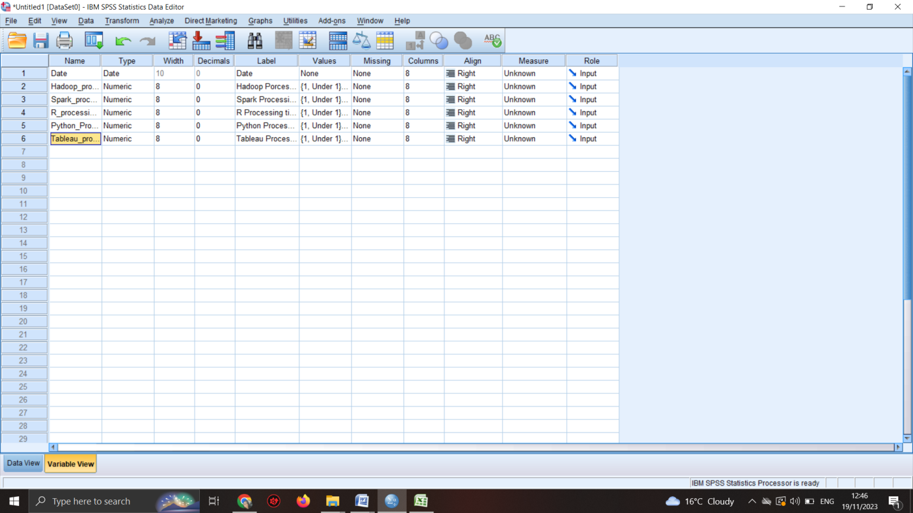

The variable view in SPSS is showing the variables used for the data set which are the 6 platforms and tools used by the company and the dates they were used for. The 6 tools have each 5 values attributed as follows: for processing time under 1 the value is 1, for processing time over 1 the value is 2, for processing time over 2 the value is 3, for processing time over 3, the value is 4, for processing time over 4, the value is 5 (Aljandali, 2016).
Figure 2 – SPSS data view
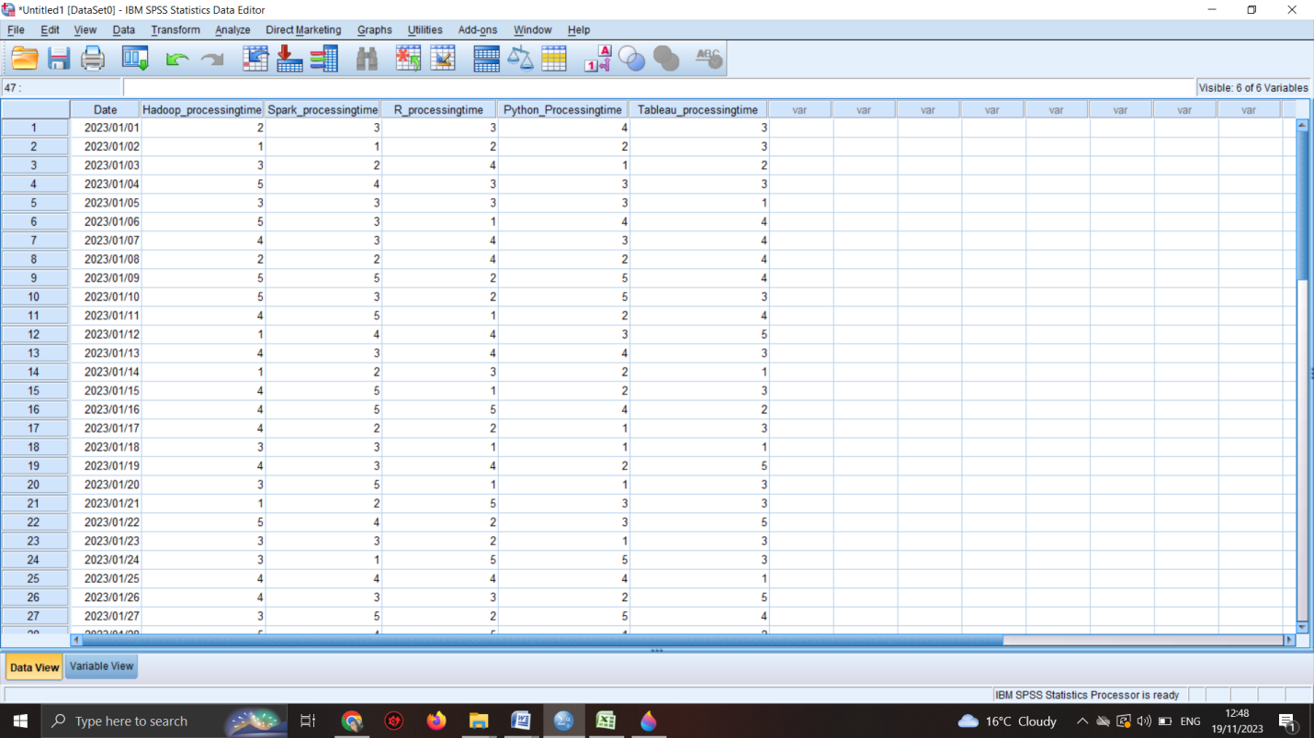

The data view in SPSS shows the values given for each platform with the help of which all of the calculations required can be done. For answering the 6 questions SPSS program was used. The results are given below.

Figure 3 – What is the mean processing time when using Hadoop?

Descriptive Statistics
 | N | Minimum | Maximum | Mean
Hadoop Porcessing Time | 50 | 1 | 5 | 3.20
Date | 50 | 2023/01/01 | 2023/02/19 | 2023/01/25
Valid N (listwise) | 50

The mean processing time when using Hadoop in the given period of time is 3,20. Medium value as the values are from under 1 to over 4. Hadoop is a useful tool according to the mean provided by SPSS.

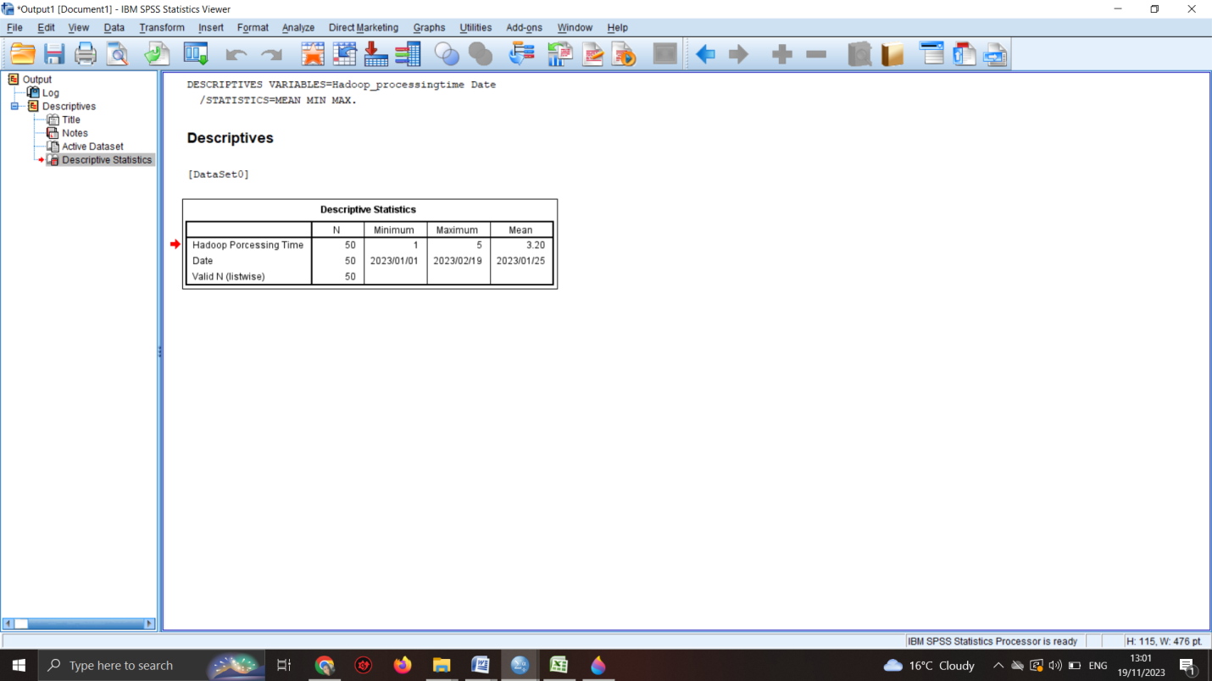

Figure 4 – What is the median processing time when using Spark?
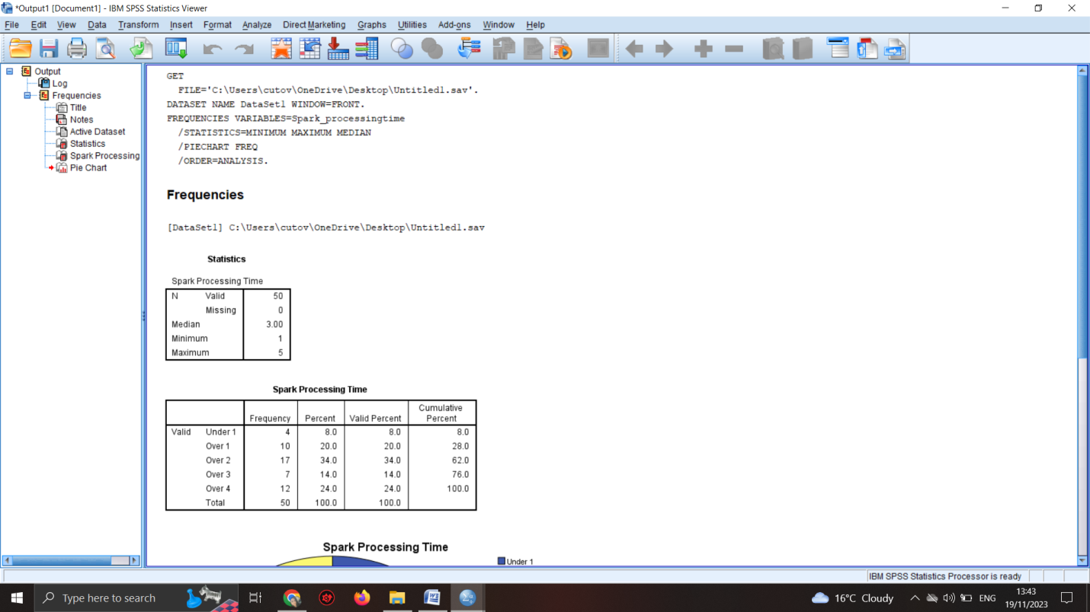
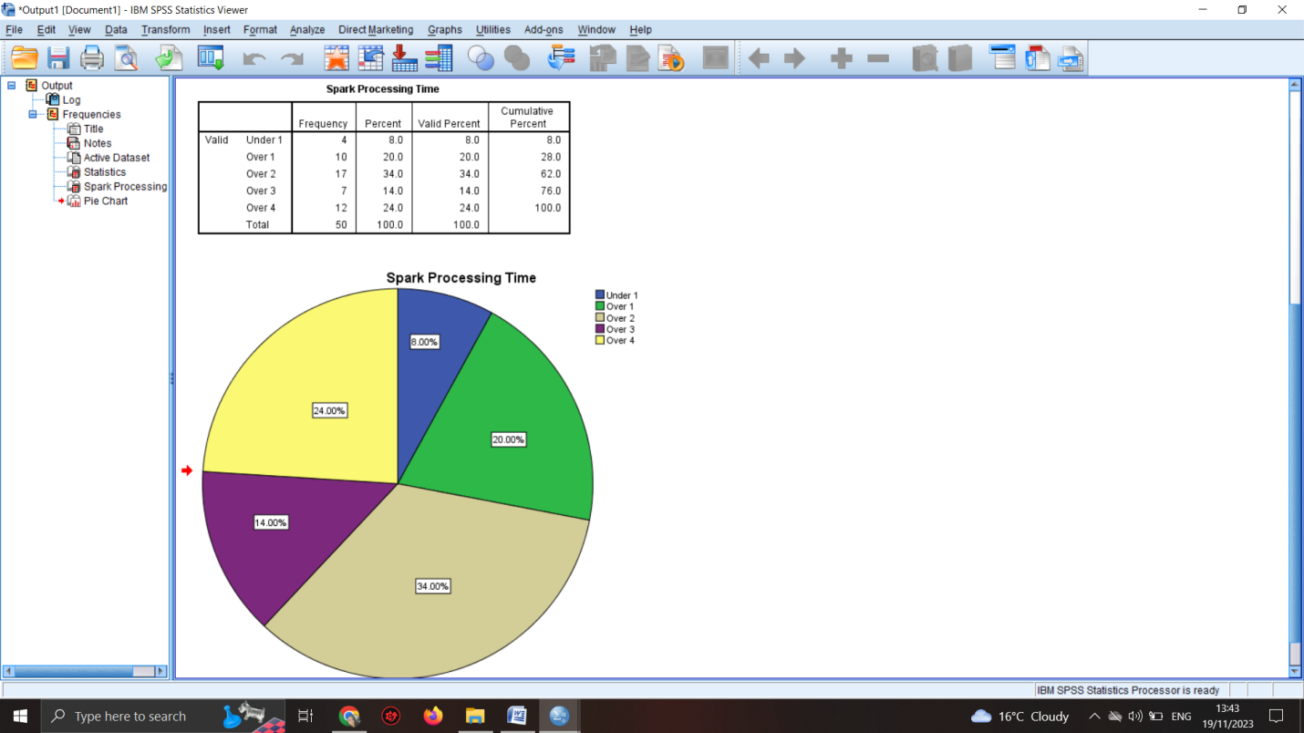

Statistics
Spark Processing Time
N | Valid | 50
N | Missing | 0
Median |  | 3.00
Minimum |  | 1
Maximum |  | 5

Spark Processing Time
 |  | Frequency | Percent | Valid Percent | Cumulative Percent
Valid | Under 1 | 4 | 8.0 | 8.0 | 8.0
Valid | Over 1 | 10 | 20.0 | 20.0 | 28.0
Valid | Over 2 | 17 | 34.0 | 34.0 | 62.0
Valid | Over 3 | 7 | 14.0 | 14.0 | 76.0
Valid | Over 4 | 12 | 24.0 | 24.0 | 100.0
Valid | Total | 50 | 100.0 | 100.0

When sorting an odd number of values, the median is established as the value situated at the midpoint. In the case of an even number of values, it is determined as the average of the two central values after they have been sorted (Aljandali, 2016). Quantitative variables are the only ones that can be calculated using means. Ordinal variables, on the other hand, can be computed with medians. However, there is often a multitude of ties (values that appear more than once) in ordinal variables (Arkkelin, 2014).
The median for the Spark processing time is 3 average, which is in between the given values of 1 to 5. This means that Spark is a useful tool for GreenMed Healthcare also and can be used to analyse the data analytics for patients.

Figure 5 – On which date did R have the highest processing time

Statistics
 |  | R Processing time | Date
N | Valid | 50 | 50
N | Missing | 0 | 0
Mean |  | 3.14 | 2023/01/25
Median |  | 3.00 | 2023/01/25
Skewness |  | -.156 | .000
Std. Error of Skewness |  | .337 | .337
Minimum |  | 1 | 2023/01/01
Maximum |  | 5 | 2023/02/19
Sum |  | 157 | 8040525 00:00:00

R Processing time
 |  | Frequency | Percent | Valid Percent | Cumulative Percent
Valid | Under 1 | 7 | 14.0 | 14.0 | 14.0
Valid | Over 1 | 9 | 18.0 | 18.0 | 32.0
Valid | Over 2 | 13 | 26.0 | 26.0 | 58.0
Valid | Over 3 | 12 | 24.0 | 24.0 | 82.0
Valid | Over 4 | 9 | 18.0 | 18.0 | 100.0
Valid | Total | 50 | 100.0 | 100.0
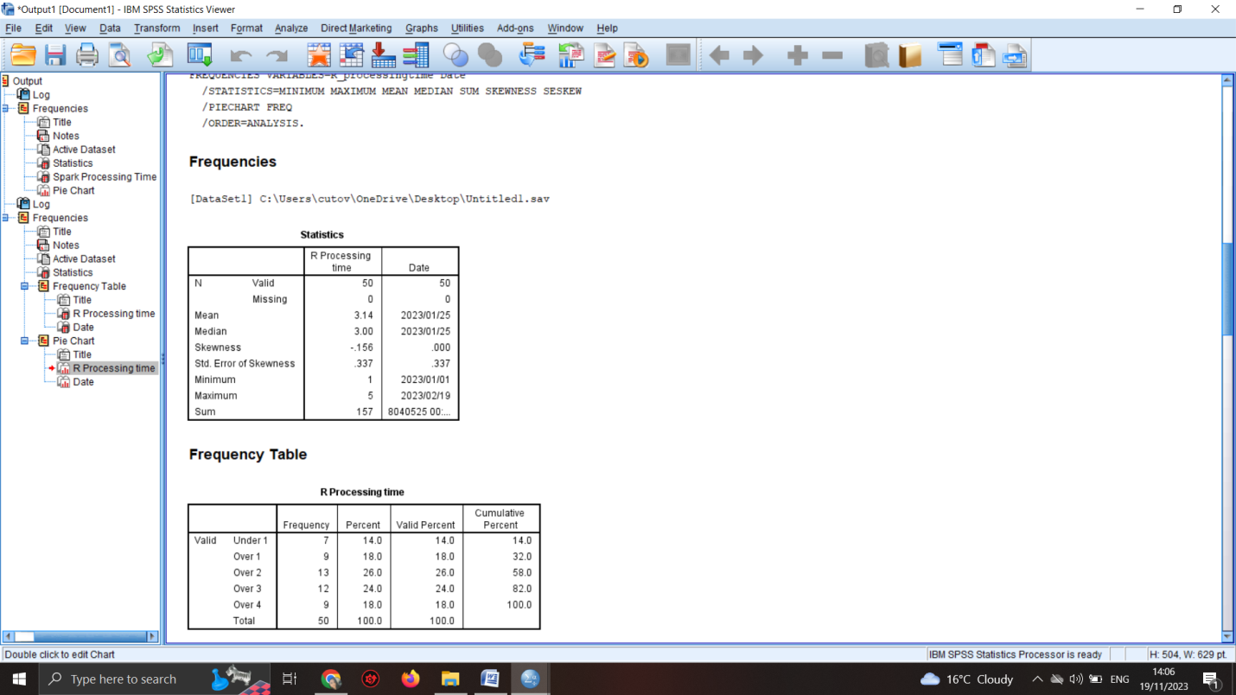
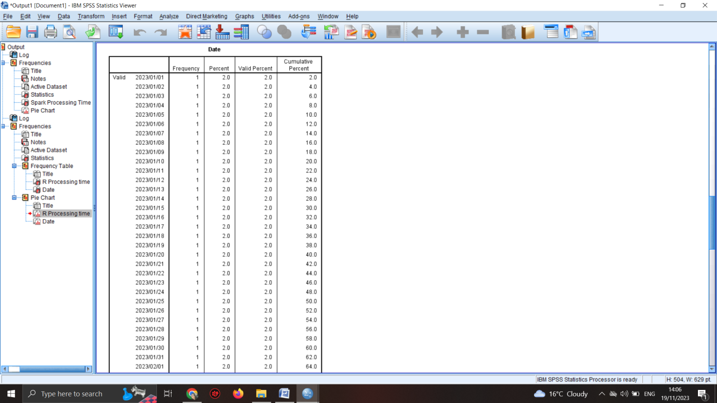
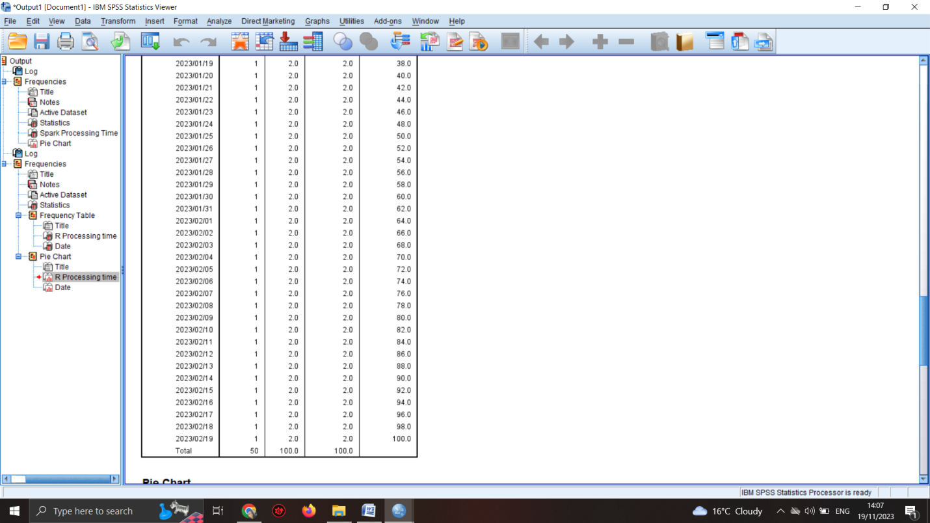
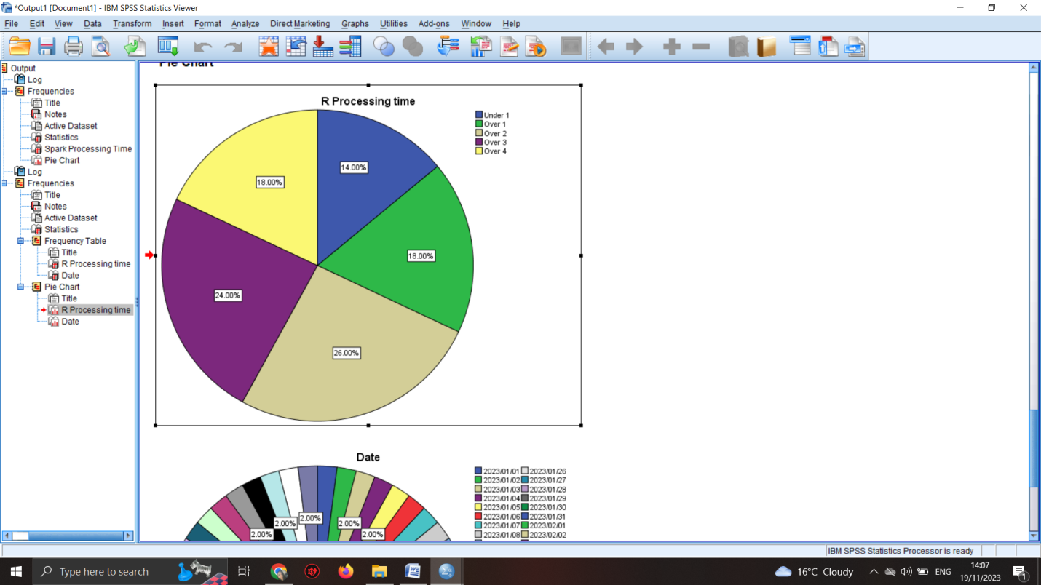
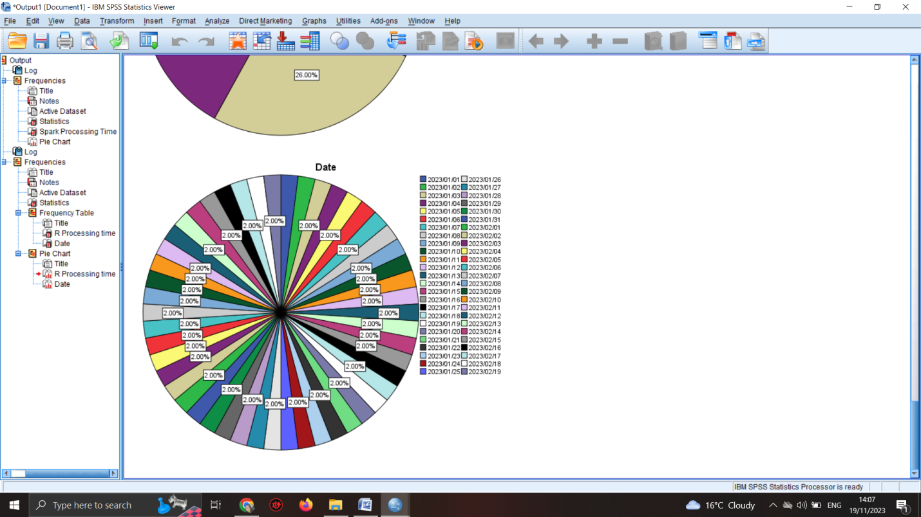

The processing dates have similar percentages for all dates which suggests that the program was used on a regular basis and it is being considered as fit for the company (Niño-Zarazúa, 2012).

Figure 6 - What is the standard deviation for processing time when using Python

Descriptive Statistics
 | N | Minimum | Maximum | Std. Deviation
Python Processing Time | 50 | 1 | 5 | 1.346
Valid N (listwise) | 50

The square root of the variance is known as the standard deviation, which is a method used to assess the distribution of a set of observations. The greater the standard deviation, the more dispersed the observations are throughout the range. The standard deviation for the processing time of Python is 1,34 which is lower than the other programs and tools used by the company (Lambert & Frye, 2022).
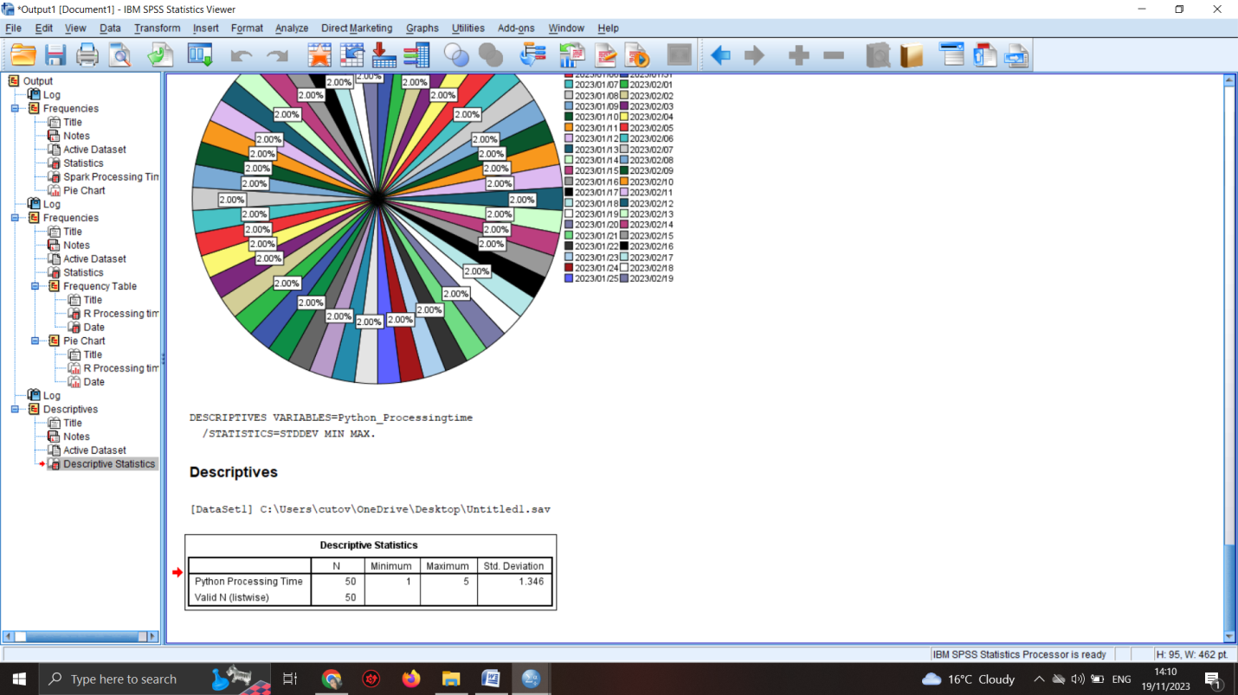

Figure 7 – Which tool or platform had the lowest average processing time across the data set?
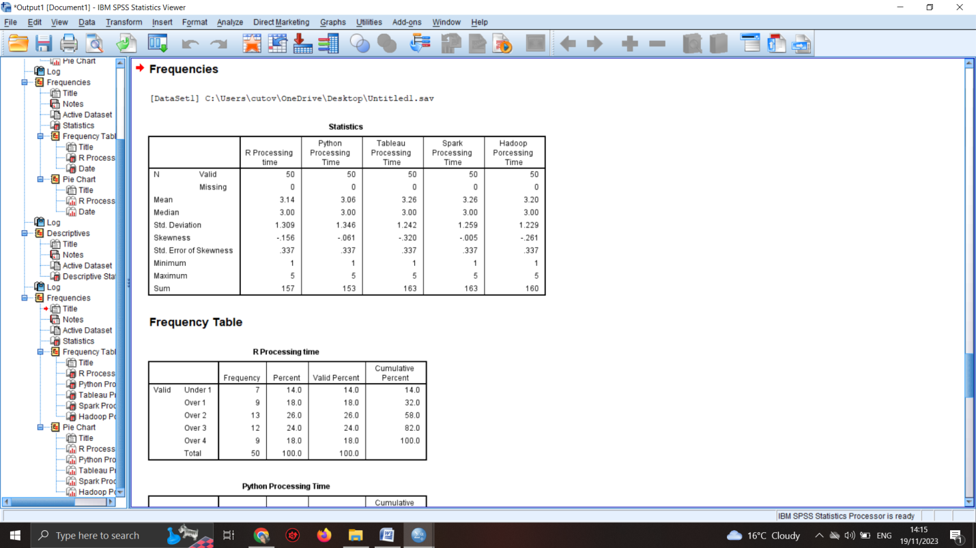
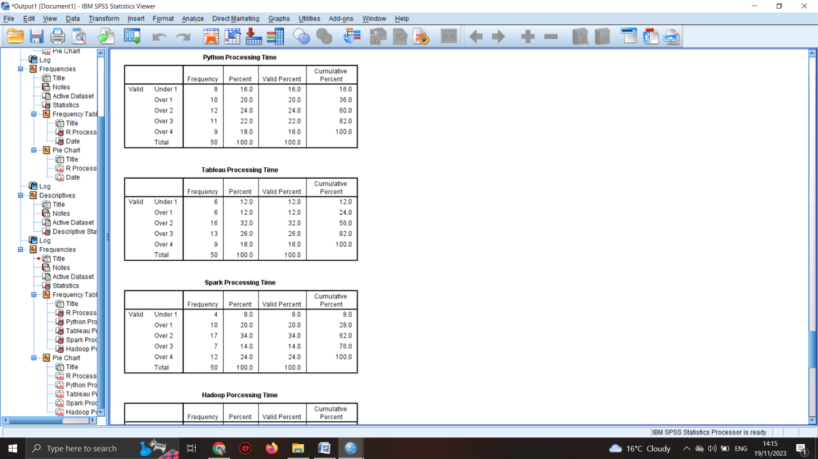
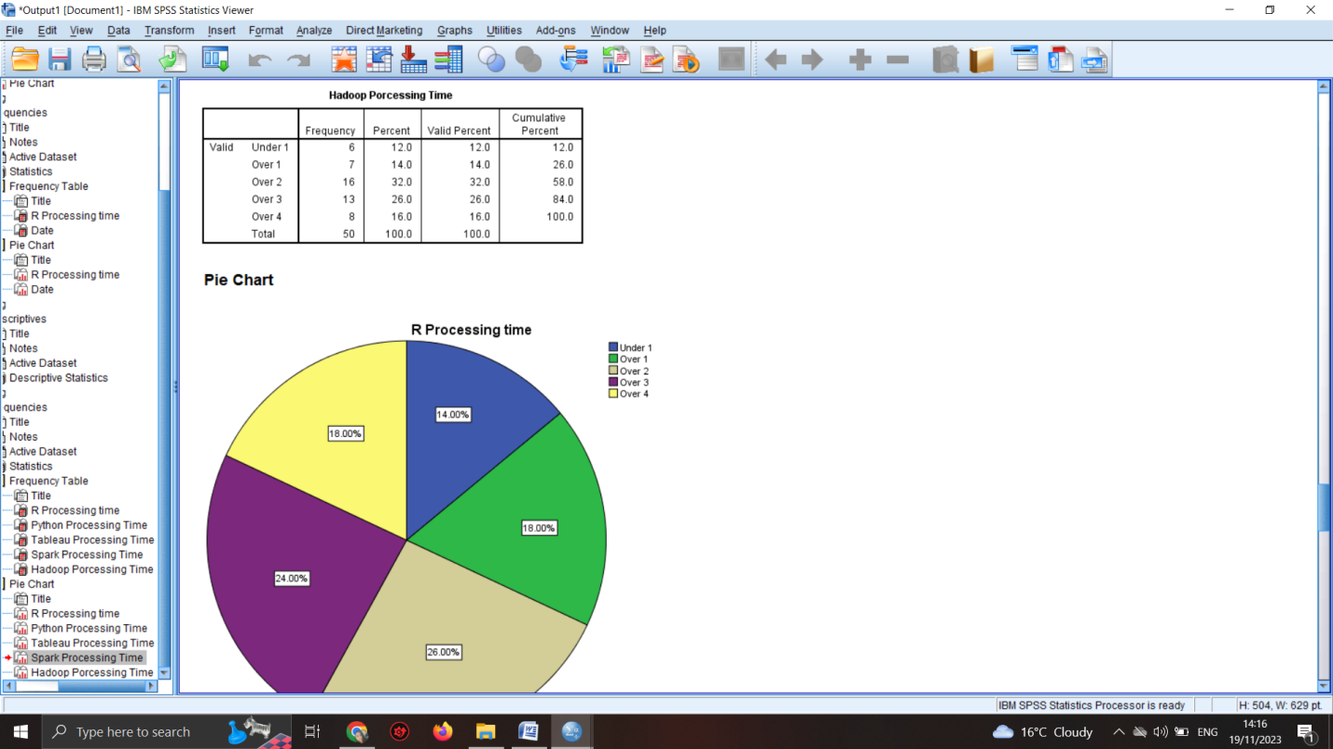
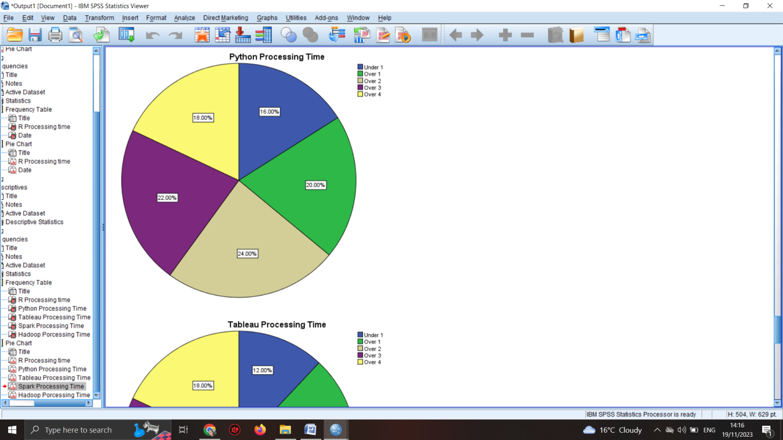
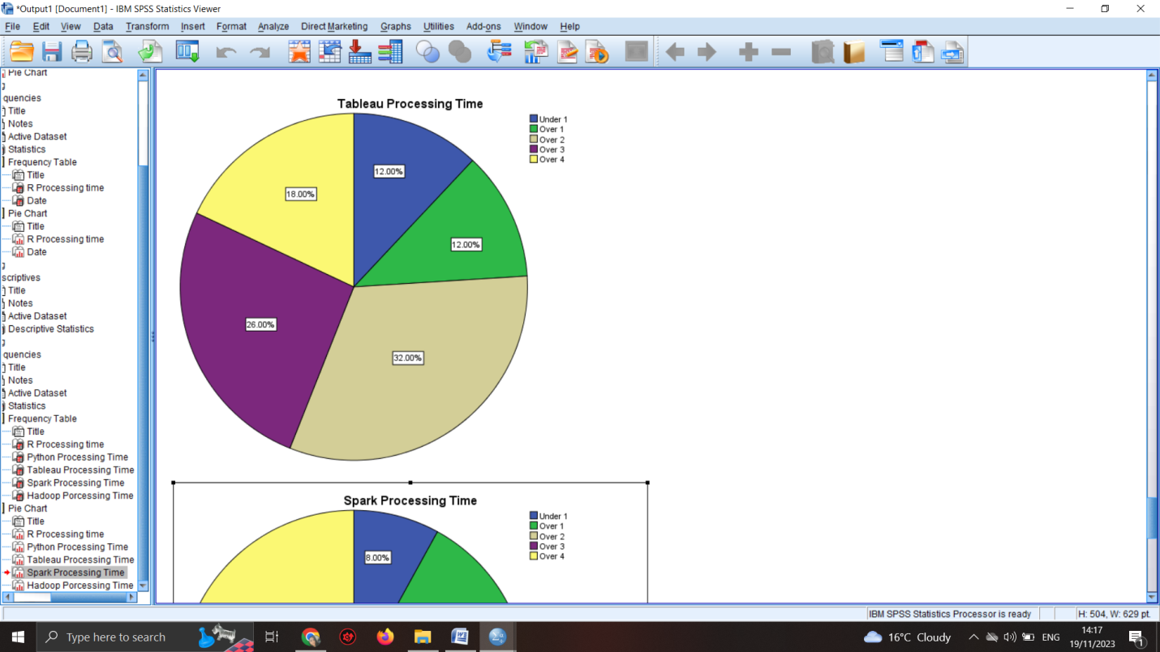
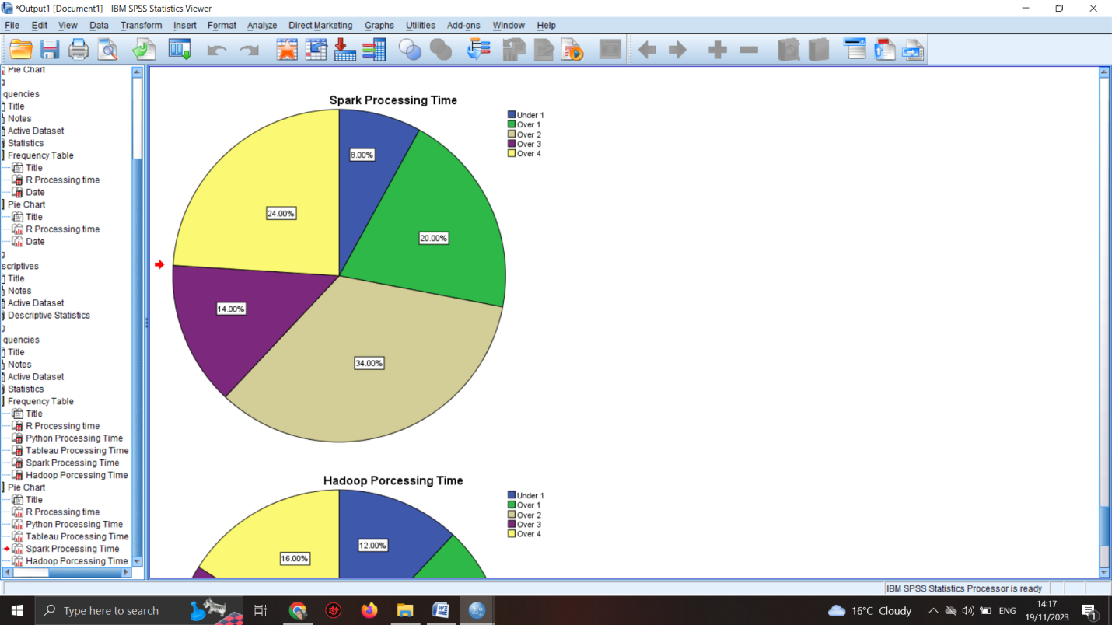
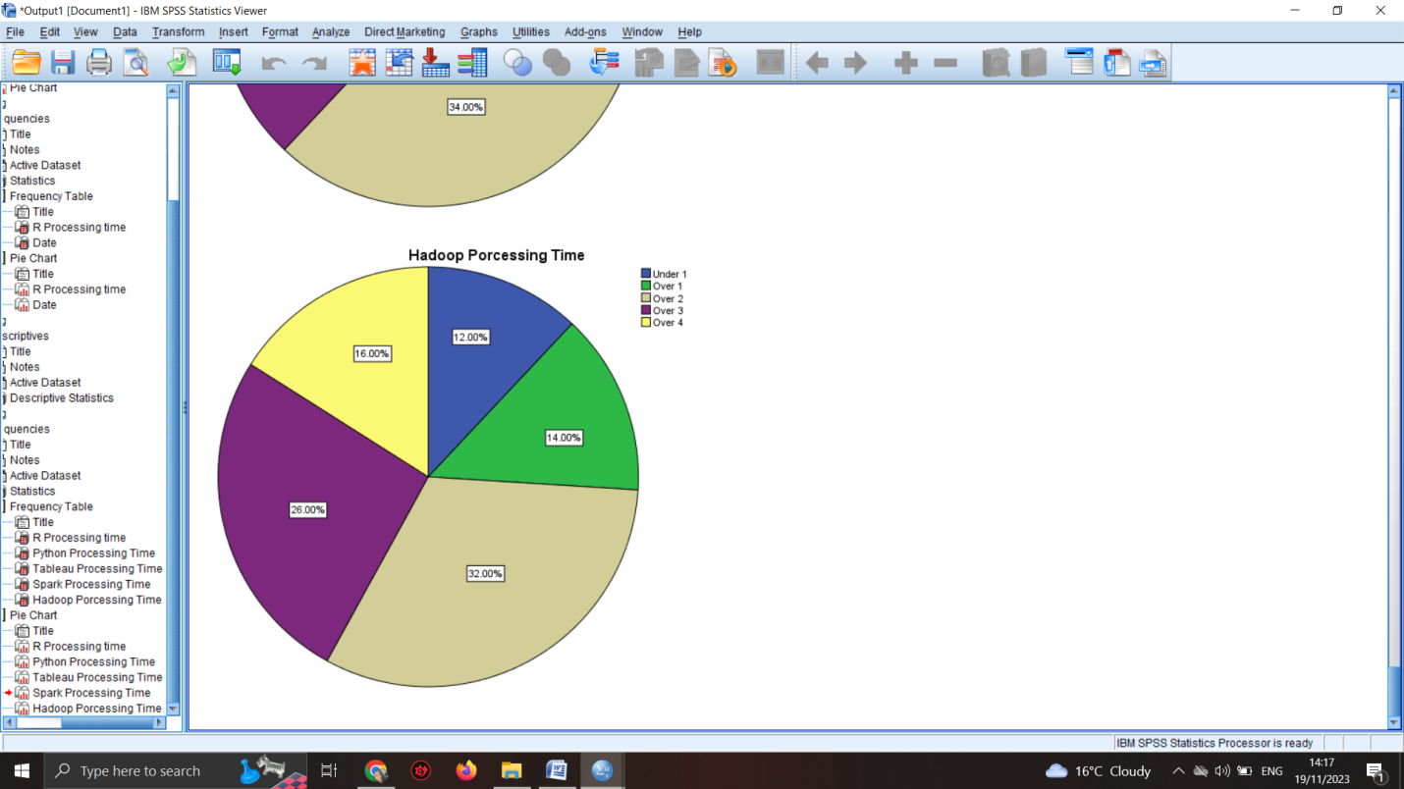

Statistics
 |  | R Processing time | Python Processing Time | Tableau Processing Time | Spark Processing Time | Hadoop Porcessing Time
N | Valid | 50 | 50 | 50 | 50 | 50
N | Missing | 0 | 0 | 0 | 0 | 0
Mean |  | 3.14 | 3.06 | 3.26 | 3.26 | 3.20
Median |  | 3.00 | 3.00 | 3.00 | 3.00 | 3.00
Std. Deviation |  | 1.309 | 1.346 | 1.242 | 1.259 | 1.229
Skewness |  | -.156 | -.061 | -.320 | -.005 | -.261
Std. Error of Skewness |  | .337 | .337 | .337 | .337 | .337
Minimum |  | 1 | 1 | 1 | 1 | 1
Maximum |  | 5 | 5 | 5 | 5 | 5
Sum |  | 157 | 153 | 163 | 163 | 160

R Processing time
 |  | Frequency | Percent | Valid Percent | Cumulative Percent
Valid | Under 1 | 7 | 14.0 | 14.0 | 14.0
Valid | Over 1 | 9 | 18.0 | 18.0 | 32.0
Valid | Over 2 | 13 | 26.0 | 26.0 | 58.0
Valid | Over 3 | 12 | 24.0 | 24.0 | 82.0
Valid | Over 4 | 9 | 18.0 | 18.0 | 100.0
Valid | Total | 50 | 100.0 | 100.0

The platform R had the lowest processing time according to the table above. The mean gives the value of the processing time and R had 3,14 mean, in comparison to the other 5 platforms.

Figure 8 - Can you interpret the difference in processing times across different tools or platforms?

One-Sample Statistics
 | N | Mean | Std. Deviation | Std. Error Mean
Hadoop Porcessing Time | 50 | 3.20 | 1.229 | .174
Spark Processing Time | 50 | 3.26 | 1.259 | .178
R Processing time | 50 | 3.14 | 1.309 | .185
Python Processing Time | 50 | 3.06 | 1.346 | .190
Tableau Processing Time | 50 | 3.26 | 1.242 | .176

One-Sample Test
 | Test Value = 0
 | t | df | Sig. (2-tailed) | Mean Difference | 95% Confidence Interval of the Difference
 |  |  |  |  | Lower | Upper
Hadoop Porcessing Time | 18.413 | 49 | .000 | 3.200 | 2.85 | 3.55
Spark Processing Time | 18.315 | 49 | .000 | 3.260 | 2.90 | 3.62
R Processing time | 16.956 | 49 | .000 | 3.140 | 2.77 | 3.51
Python Processing Time | 16.071 | 49 | .000 | 3.060 | 2.68 | 3.44
Tableau Processing Time | 18.556 | 49 | .000 | 3.260 | 2.91 | 3.61

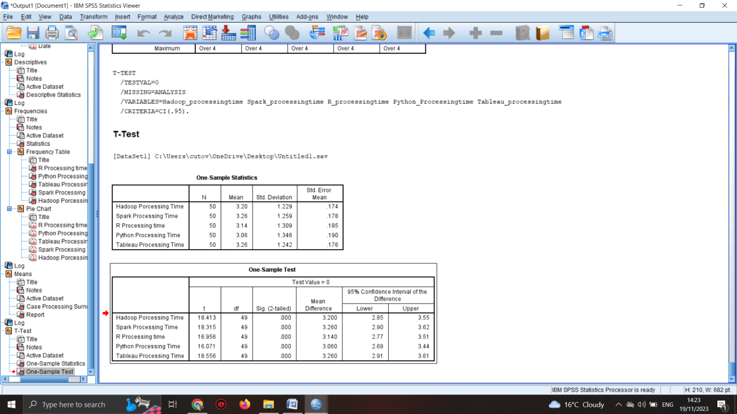

To begin analyzing differences between groups, one can use the Compare Means function, located at Analyze → Compare Means → Means (Alt+A, Alt+M, Alt+M). The independent (discrete) variable should be placed in the Layer 1 of 1 box, while the dependent (continuous) variable should be placed in the Dependent List box. The difference between variables in SPSS is given by the function Compare Means. The difference has similar values but not identical which means each program is being used in a different manner according to the processing time of each program (Field, 2013).

Microsoft Excel use

Microsoft Excel is a useful tool for many companies. It helps in creating spreadsheets with the data analytics that the company needs, such as functions, tables, charts, organizers (Suman, 2022). In the current case of GreenMed Healthcare, Microsoft Excel was used to create a pivot chart of all the programs used by the company in order to check the mean usage for each program or tool. The table is given below.

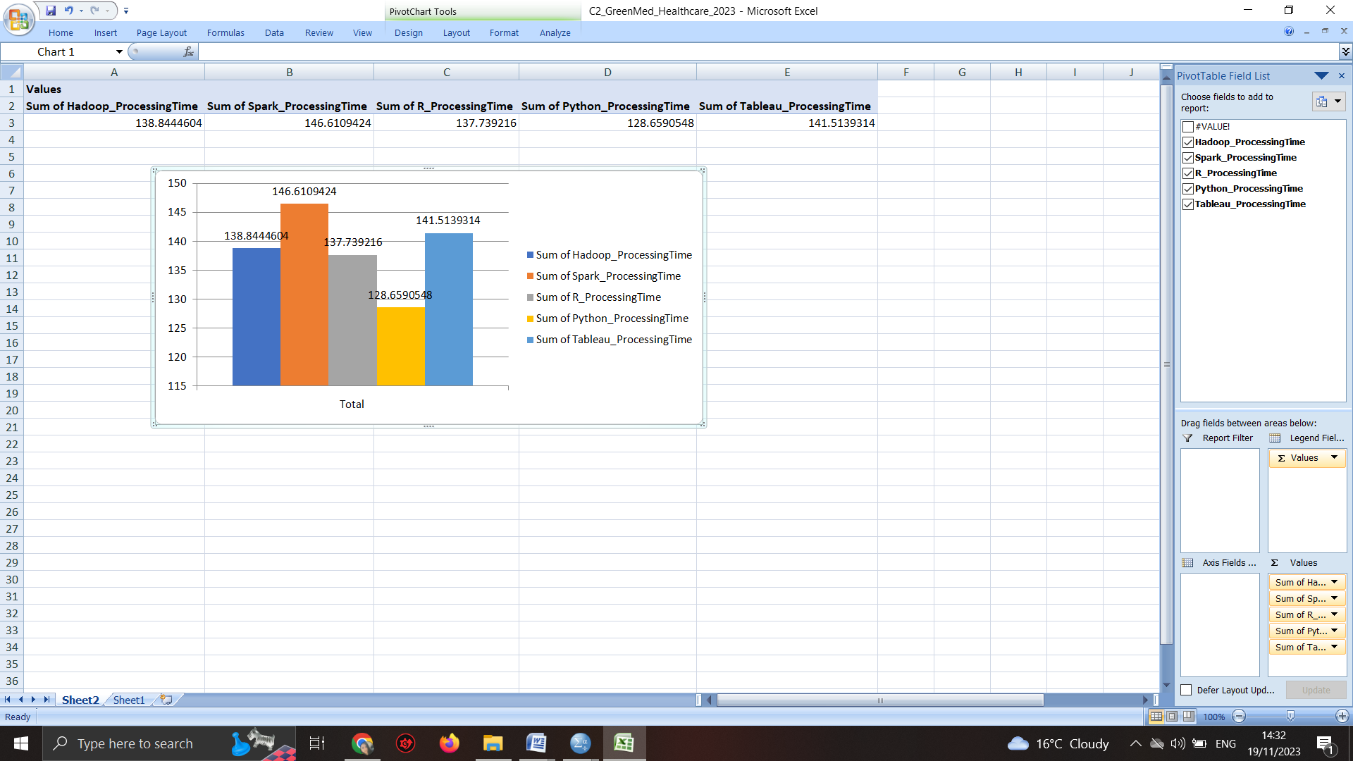

According to the mean function given in the pivot table, it can be noticed that the most used tool by the company was Spark followed by Tableau and Hadoop. These three are being currently used the most by GreenMed Healthcare.

SPSS use

SPSS is a software that is frequently employed as a statistical analytical tool in the social sciences. It is utilized in a variety of fields, such as market research, surveys, and competitor analysis. SPSS is a comprehensive and adaptable tool for statistical analysis and data management. It is one of the most prevalent statistical packages that can efficiently manipulate and evaluate intricate data. SPSS is intended for users who wish to interact with the program, as well as those who do not require such interaction (Babbie, 2020).
The metric known as the Pearson product-moment correlation coefficient, or simply Pearson's correlation, serves as a gauge for both the degree and orientation of the connection between two variables, provided that said variables are measured on a scale that is at least interval in nature (Levesque, 2007).
The goal of a Pearson's correlation is to create a line of optimal fit that accurately represents the data of two variables. The Pearson correlation coefficient, denoted as "r," measures the degree of deviation of the data points from this line of optimal fit. In other words, the Pearson correlation coefficient illustrates the extent to which the data points conform to this line of best fit.
The Pearson correlation is being used by GreenMed to check the correlation between Hadoop and Tableau and the results are shown below.

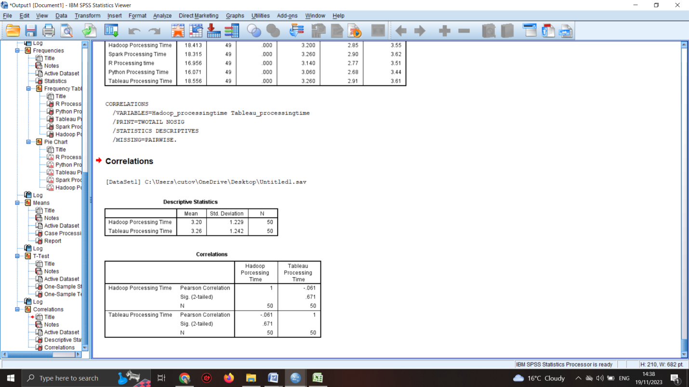

Descriptive Statistics
 | Mean | Std. Deviation | N
Hadoop Porcessing Time | 3.20 | 1.229 | 50
Tableau Processing Time | 3.26 | 1.242 | 50

Correlations
 |  | Hadoop Porcessing Time | Tableau Processing Time
Hadoop Porcessing Time | Pearson Correlation | 1 | -.061
Hadoop Porcessing Time | Sig. (2-tailed) |  | .671
Hadoop Porcessing Time | N | 50 | 50
Tableau Processing Time | Pearson Correlation | -.061 | 1
Tableau Processing Time | Sig. (2-tailed) | .671
Tableau Processing Time | N | 50 | 50

The correlation coefficient Pearson's r has a range of values from +1 to -1. A value of +1 indicates a perfectly positive correlation, while a value of -1 indicates a perfectly negative correlation. When the value of Pearson's r is 0, there is no significant linear correlation present.
In the case of GreenMed Healthcare, the correlation has the value 1 which means the correlation is positive between the two programs Tableau and Hadoop. The two tools are being used simultaneously and it makes the data analytics easier for the companies.

Conclusion

Both Microsoft Excel and SPSS are useful tools that can be used by GrenMed Healthcare to analyse the data analytics with the 6 tools. R and Spark are the most used by the company when analysing the data in SPSS and Tableau and Hadoop are being the most used when Microsoft Excel is being used by the company.

References

- Aljandali, A. (2016). Quantitative analysis and IBM® SPSS® statistics: A guide for business and finance
- Arkkelin, D. (2014). Using SPSS to Understand Research and Data Analysis. Psychology Curricular Materials
- Babbie, E. R. (2020). The practice of social research. Cengage AU
- Bala, J. (2016). Contribution of SPSS in Social Sciences Research. International Journal of Advanced Research in Computer Science, 7(6), 250-254.
- Field, A. P. (2013). Discovering statistics using IBM SPSS Statistics: And sex and drugs and rock ‘n’ roll (4th ed.). SAGE
- Lambert, J., Frye, C. (2022). Microsoft Excel Step by Step (Office 2021 and Microsoft 365). Microsoft Press; 1st edition
- Levesque, R. (2007). SPSS programming and data management: A guide for SPSS and SAS users
- Niño-Zarazúa, M. A. (2012). Quantitative analysis in social sciences: A brief introduction for non-economists. SSRN Electronic Journal
- NYU, (2021). Quantitative analysis guide: Which statistical software to use? Research Guides at New York University
- Suman, H. (2022). Excel Bible for Beginners: Microsoft Excel Book Containing the Best Excel Tools, Tips and Shortcuts you Need to Know. Independently published

