My Digital Life

My Screenshots/Photos

Screenshot/Photo 1
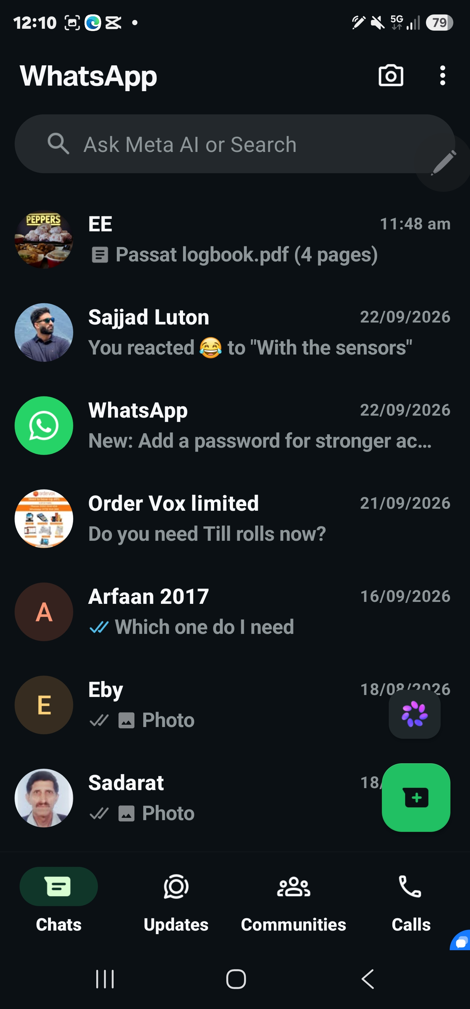

This is WhatsApp, I use WhatsApp to communicate with friends and family and business. I use it to call text send photos and videos, but also use it for my business

Screenshot/Photo 2
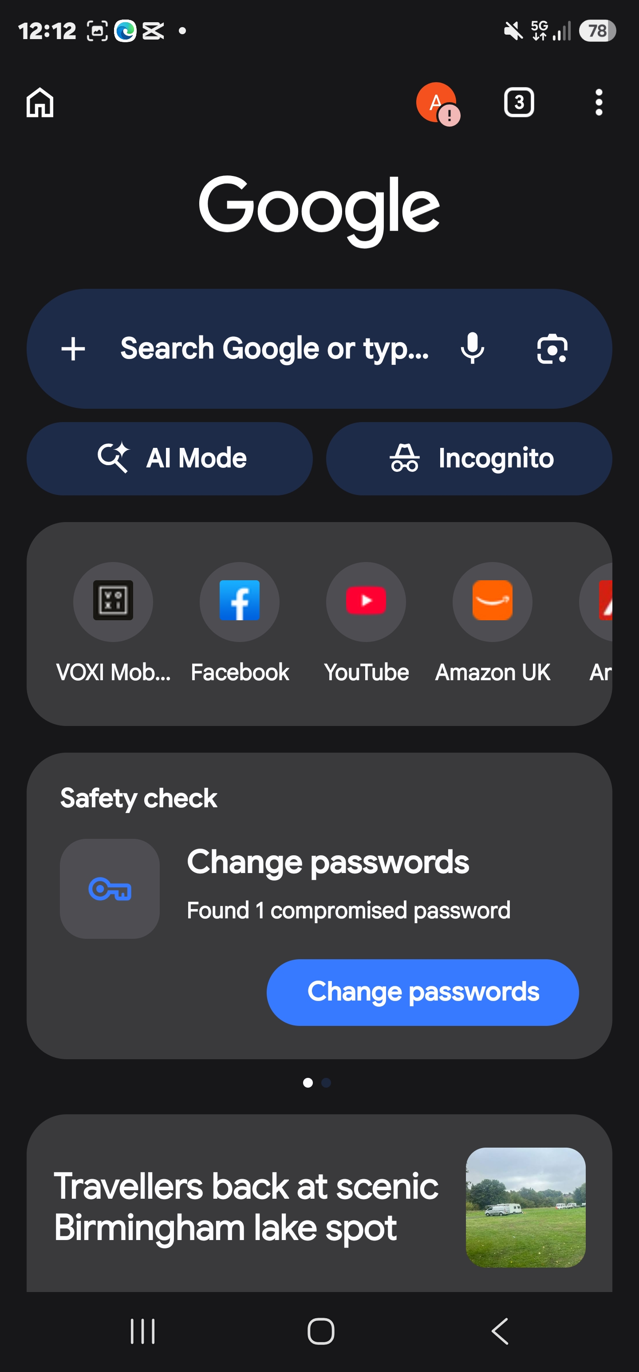
This is a screenshot of Google. I use this search engine to help me find things. its quick and convenient to find answers and info, it is on most phones these days which makes it accessible.

Screenshot/Photo 3
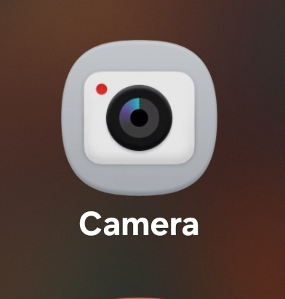
This is the camera used to take photos and videos most phones have good cameras so there is no need of buying cameras. I use it to take photos and videos for my social media pages for my business.

Screenshot/Photo 4
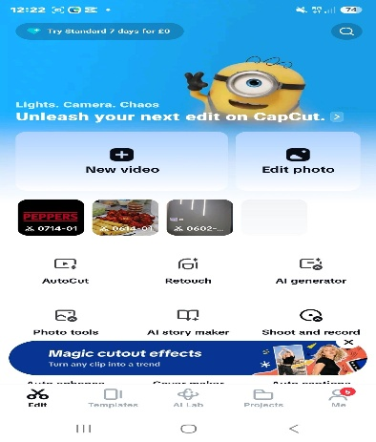
This is a screenshot of cap cut. I use cap cut to add music text and effects when I need to edit videos for my social media pages for my business.

Screenshot/Photo 5
This is the logo for Microsoft OneNote. I use this app to make notes of stock for my shop and day to day stuff that I need to complete all in one place.

Screenshot/Photo 6
This is Spotify this app is for listening to podcasts and music. I use this to listen to my favourite music either in the car or when I'm at the gym.

My Short Reflection
I use digital tools every day for various things.
I feel confident when I use my phone, laptop and the internet.
I want to improve my computer skills and learn how to use new programs, as it has been a longtime, I haven't used them and we are in a time where everything is moving along so quick.
I often use tools like Google, WhatsApp, email, Microsoft Word and YouTube as these are everyday tools I need in my daily life.
I sometimes feel nervous about using something new because I do not want to make a mistake and becomes so overwhelming.
I hope this module will help me become more confident with technology and will help me make everyday tasks more efficient .
Digital skills are important for me because I need them for work, studying and everyday life.
I use the internet to find information, complete tasks and communicate with other people.
I also use digital tools to stay organised and keep in touch with my friends and family.
I would like to learn more about online safety and use digital technology in a better way.
You can write more if you want.

Submission Checklist
Before you submit, please check:
​​​ ☒ I added 4–6 screenshots
☒ I wrote short sentences for each screenshot
☒ I wrote my short reflection
☒ My work is my own
☒ My file opens correctly

