AWD Torque Vectoring
Combined Advanced Vehicle Dynamics
Robin Williamson-Gillie
1800974
Table of Contents
1.0 Abstract 2
2.0 Introduction 3
3.0 Background 4
3.1 Base data 4
3.2 Lumped mass model 5
3.3 Torque vectoring 5
4.0 Vehicle dynamics 6
4.1 Centre of gravity (Cog) 6
4.2 Moments of inertia 6
4.3 Inertial conjugate 7
4.4 Vehicle dynamic index 7
5.0 Clutch Torque 7
5.1 Calculating the torque and the wear 7
5.2 Torque pathing 8
6.0 Longitudinal acceleration 9
7.0 Yaw moment affects 10
8.0 system controls 11
8.1 power on and off 11
8.2 Cornering 11
8.3 Sudden manoeuvres 11
8.4 Interaction with other systems 12
7.0 Conclusion 12
References 13

Abstract
The aim of this report is too analysis the Ferrari FF. this was a vehicle made in 2011 that made use of an all new AWD system, that was completely different to anything else at the time, it was also the first Ferrari with AWD.
The main aspects that will be looked at will be how it effects the dynamics of the vehicle, mainly in terms of its inertia and its dynamic index. There will then be further testing into the torque of the system and how the clutch plates used with in that system are affected by the transference of torque through the torque vectoring. Then it will be seen how there is improvement in acceleration compared to rear wheel drive in a number of different surfaces with reduced friction coefficients such as snow and iced.
Finally, it will be looked at how the system will use of other systems and sensors that are in the vehicle improve the overall experience for the driver and passengers and how it makes it an overall better vehicle.
This will all then be summarised based upon all the results to see the benefits of such a system.

2.0 Introduction
The Ferrari FF is unlike any other previously designed Ferrari before it, this is not only due to its interesting style as well as it being a 4-door family fast back, but it makes use of a an all new all wheel drive system. The 4rm system is completely unique in that it doesn’t make use of the commonly used All wheel drive systems that have been previously used in other vehicles.
It does not use electric differentials nor the vehicles brakes, but it instead has a secondary gear box mounted near the front of the engine, this is only used in the first 4 gears of the vehicles travel. The torque transferred through this is then passed though a series of wet clutches to the wheels. This provides all the benefits of a high grip all wheel drive system however it does not make use of large drive shafts or differential in the middle of the car, this allows for its mass to be kept low as well as maintaining cabin space.
The aim of this study is to analysis this system in all its dynamic considerations concluding weather his is a system that should replace all others or weather its increased complexity and cost is not worth it.

3.0 Background

3.1 Base data
To analyse the new AWD drive system of the Ferrari FF base data needs to be collected. This data will be used in calculations later on to understand the benefits of such a system.
Dimensions |  | Units
Length | 4.907 | m
Width | 1.953 | m
Height | 1.379 | m
Wheel base | 2.99 | m
Front track | 1.676 | m
Rear track | 1.66 | m
Table 1 showing the measured lengths of the Ferrari FF

Masses |  | Units
Kerb weight | 1880 | Kg
Dry weight | 1790 | Kg
Weight distribution front | 47 | %
Weight distribution rear | 53 | %
Fuel tank capacity | 91 | Lt
Mass of fuel | 0.74 | Kg
Fuel tank | 67.34 | Kg
Table 2 Showing the masses of the Ferrari FF

Table 3 Showing the engine specification including its outputs
Engine specs |  | Units
No. cylinders | 12
Bore | 94 | mm
Stroke | 75.2 | mm
Engine capacity | 6262 | cc
Power | 660 | Bhp
Torque | 683 | Nm
Maximum RPM | 8000

3.2 Lumped mass model
A lumped mass model is used to collect the masses of key areas of the vehicle. This is done to visual the masses on the vehicle for simplification of calculations, its used to also combine the systems, for example the suspension, wheels and tyres will be combined into one overall mass.
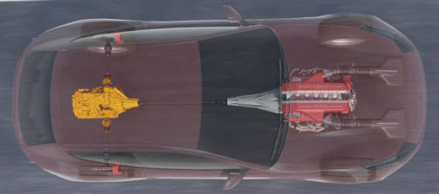

Figure 1 Lump mass model

Colour | Component | Mass (Kg)
Red | Passengers | 90 (average weight of men) (Roland, 2019)
Black | Fuel tank and fuel | 100 (based upon the weight of a fuel tank and the fuel inside )
Blue | Rear Gearbox | 300
Green | Engine and Gear box | 400
Yellow | Outboard suspension, wheels and tyres | 150

3.3 Torque vectoring
Torque vectoring is used within vehicles to control the distribution of torque and power between each wheel and axle. This technique is used to improve vehicle control during cornering as well as on surfaces where slip can occur. It does this by transferring the torque to an available wheel that has the largest amount of grip in the case of slipping conditions, or in the case of corning it is applied to the outside wheel keep the stability of the vehicle under high-speed cornering. (Radu, 2020)
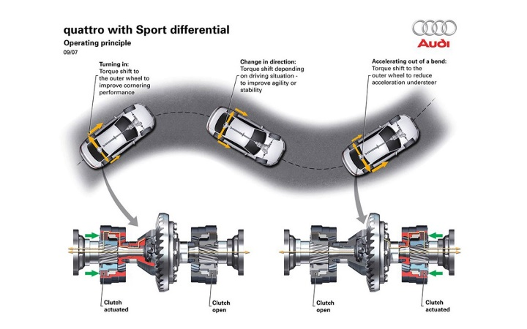
There are two main systems used to allow torque vectoring within a system. The first system which is far cheaper and simpler to build into a system is to use the brakes. The process used for this system is to apply the brakes to the slipping wheel, this then allows more torque to be transferred to the wheels with traction, allowing the vehicle to keep stability (Hirons, 2022). The second system is to make use of computer-controlled differentials, these systems make use of a multitude of clutches to reduce torque to transferred to the slipping to a wheel with traction to again allow the vehicle to accelerate out of the situation of slip (Hirons, 2022).
Torque vectoring is most commonly seen in vehicles that use an AWD system, allowing them to more easily transfer the engines torque from front to rear of the vehicle as well as right to left.
Figure 2 A demonstration of Audi's Torque vectoring system (Radu, 2020)

4.0 Vehicle dynamics

4.1 Centre of gravity (Cog)
Understanding the centre of gravity of a vehicle has great importance in understanding its movement dynamics both laterally and longitudinal. This is due to all the dynamic loading that the vehicle experiences act through the centre of gravity, therefore its understanding is key to understand the vehicles performance and how it needs to be changed depending on its specification (F1, 2019).
Cog of gravity is calculated by multiplying the Wheelbase by the weight distribution front to rear, this gives both the centre of gravity compared to front and rear. It is Key to calculate the Cog first as it is used throughout the rest of the calculations.
For the Ferrari it was calculated to be 1.405m from front and 1.584m from the rear. The further offset of the Cog to the front of the vehicle is due to larger mass at the rear of the vehicle and it trying to offset the affect of a heavier rear end.

4.2 Moments of inertia
Identifying the moments of inertia of a vehicle is key to understanding its handling dynamic. The two main affects of the inertia are the response time of handling and the NVH (Noise, vibration, and harshness). If the vehicle has a low moment of inertia, it has an improved response time during cornering, this greatly improves driver feel and enjoyment however, this increased response can reduce the comfortability of passenger as the sudden directional change can cause motion sickness, this is where a balance of the two must be considered (Carrie G. Bobier, 2008). Another aspect of human affect on the vehicle dynamic is down to driver capability, as a vehicle can be overly responsive for a driver with little training, thus meaning the maximum potential can not be exploited even with the best setup, the optimal choice is to have the best set up for the designated driver.
When a vehicle is being designed the desired inertia of the vehicle will be based around its purpose, in the case of the Ferrari FF it is considered a high-end GT (grand tourer) car (Ferrari, 2011). This means that it will be designed to have with a slightly inertia, this means that the car can be enjoyed in large dynamic zones such as switch back roads provided the recued time of response, however, will still be comfortable for passengers.

4.3 Inertial conjugate
The Inertial conjugate or the Centre of percussion (Cop) is the area where a impact or sudden loading will have the greatest amount of vibration absorption, meaning that the impulsive load will not be felt further on throughout the system. In an automotive application this mainly centres around the feeling of shock from a sudden change or impact in the suspension, where if the Cop is located as far to the rear axle as possible there will be reduced felt inside the cabin (Vijay G Kondekar, 2013)
In the case of Ferrari FF, it has a conjugate location of 1.59m from the rear axle, this will mean that during a sudden impact or surface change both axles will take a large amount of the forces therefore reducing eh feel within the cabin of the vehicle. It also a great consideration for the design for the AWD system, mainly with the aim to reduce the affect on the stability of sudden impact on the AWD system.

4.4 Vehicle dynamic index
A vehicle dynamic index is looking at the comparison of the vehicle Cog, wheelbase, and the yaw moment of the vehicle and how they correlate to affect the handling dynamic of the vehicle. It similarly to the inertia discussion, it represents the response time of the vehicle when receiving steering input, with the majority of the affect acting around the front axle to the Cog. The lower the dynamic index the sharper the turning response of the vehicle (sam, 2007). Most road going vehicle have a dynamic index of over one this is mainly due to it being aimed to a more comfortable and less erratic driver feel, where as a high performance trac vehicle such as a formula student racer has an index of around 0.5 to 0.6, this is due to the formula student vehicle being designed for tight sudden corning in short bursts therefore the handing performance is more key that the comfort.
In the case of the Ferrari FF, the index was calculated to be around one, this was not an exact figure due to certain assumptions needed to be made from a lack of viable data. The equation used to calculate this value was DI = $\frac{I_{zz}}{mab}$. Izz is the total inertia around the z axis, the mass being the mass of the vehicle and a is the distance of Cog from front and b is the distance of Cog from the rear.
The final value is to be expected this is due to the nature that the Ferrari was designed for, as previously stated it is a grand tour vehicle with the capability to carry out high performance manoeuvring when needed, there for the dynamic index is expected to be lower but not low where it could to greatly affect the comfort.

5.0 Clutch Torque

5.1 Calculating the torque and the wear
Calculating the torque of the system allows for far more understanding of what each wheel at the front axis will experience when the torque is transferred during slip. The maximum torque transfer of the system is 20% to the front, taking this of the total torque of 683Nm gives 136.6 Nm as can be seen in table 4.
Table 4 Table showing the specification of the clutch systems as well as their loads
Dynamic |  | Unit
Max torque | 683 | Nm
Torque front split | 136.6 | Nm
No. clutch packs | 2
No. plates | 4
No. faces/pack | 8
Total No. faces | 16
Inner plate diameter | 0.09 | m
Outer plate diameter | 0.11 | m
Axial force | 2500 | N
Mu of clutch | 0.1

Both of the diameters of the systems are assumed based on comparable systems using carbon ceramic clutch plates. Multiple equations where then used to gain further understanding of the output of the system, these were;
- W = $\frac{2T}{mu(r_{2}+r_{1})}$ [1]
Equation [1] is for uniform ware on the clutch trying to create an understand of the affect of constant torque inputs into the plates.
- w=$\frac{3T(r_{2}^{2}-r_{1}^{2})}{2mu(r_{2}^{3}-r_{1}^{3})}$ [2]
Equation [2] is the uniform pressure equation, giving some understanding of the pressure acting on the system.
- $p=\frac{W}{π({r_{2}}^{2}-{r_{1}}^{2})}$ [3]
Equation [3] was used to calculate the pressure acting on the torque plates validating the system could withstand the sudden torque change in the conditions of slip.
All of these equations were used with the data seen in table 4 to generate the results seen in table 5 below.
Table 5 results of torque pressure equations
Results |  | units
Uniform wear | 13660
Uniform wear per plate | 1707.5
Pressure | 13614.61794
Pressure per plate | 1701.827243
pressure produced | 1.989436789 | Mpa
It can be seen the peak pressure experienced by the clutch plates is 1.9Mpa this is far lower that the maximum pressure that the plates can withstand showing they are under low strain. Meaning the system will reliably work even under continues loading.

5.2 Torque pathing
Understanding the transfer of the torque to the front wheels is crucial to the design of the system as this is how the vehicle carries out the torque vectoring.
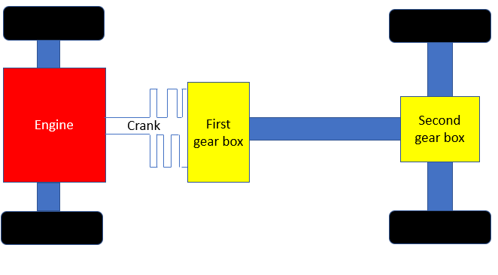
Figure 3 torque pathing model

Figure 2 is used to understand the direction the torque passes through the system during acceleration. Only a maximum of 20% of the torque will be sent to the front wheels, this will be done with first and second gear or in cases of slip. This will be done by sending it through the first gear box further through differential bolted to the end of the gear box. The rear gear box is always engaged and in the top gears of 5th and 6th it is the only active gear as the AWD is not required.
This system allows for reduced mass as there is no need for longer drive shafts as well as larger differentials in the middle of the car to transfer power, this lower mass improves the inertia of the car overall improving its handling dynamics

6.0 Longitudinal acceleration
To calculate the longitudinal acceleration of the vehicle the Cog height must be found, due to a lack of available data an assumption has been made, this was based upon the Ferrari being a high-performance vehicle therefor it is loser to the ground as well as having low centre of mass to increase handling dynamic, the Cog will be taken to be 0.3m high.
The given acceleration of the Ferrari to 100Km is 3.5s this equates to 7.94 m/s^2 or 0.8g. this is then used to calculate the weight transfer onto the rear tyres as the car surges. The equation for this is $∆W=\frac{Cogh}{Wheel base}*m*g$
This gives a mass transfer of 150.9Kg, this is then added to the current mass on the rear tyres of the 53% mass equalling 996.4 Kg, given a total mass transfer of 1147.3 Kg, giving the final weight transfer to be 11255.013 N. F=ma can then be used to find the acceleration of the vehicle which is 5.97m/s^2, this result however is based upon tarmac. To imply slip from conditions in this case snow and ice, which have a mu of 0.45 and 0.1 respectively compared to the 1.0mu of tarmac. When this friction reduction is applied, the acceleration is reduced to 2.69 m/s^2 for snow and 0.59 m/s^2, this is a huge drop in the vehicle’s acceleration. These results however are based upon rear wheel drive only, this will now be compared with the AWD 4rm system.
Adding the AWD system adds and additional drive load at the front of the vehicle, this additional thrust is calculated by taking the weight distribution of 47% of 1880, reducing it by the previously calculated weight transfer giving a mass of 732.7 Kg, this provides an additional load of 7187.79 N. with this additional the acceleration on each surface is recalculated to be 9.81 m/s^2 on tarmac, 4.41 m/s^2 for snow and finally 0.98 m/s^2 for ice. It can be clearly seen that the addition load from the front wheels being driven by the AWD greatly increase the longitudinal acceleration of the vehicle in all conditions. These results could alter with a correctly measure Cog height, however the overall theme of increase acceleration will still be seen clearly.

7.0 Yaw moment affects
The yaw of the vehicle is the rotation of the vehicle around its vertical axis, this is mainly to be considered during harsh cornering (Liske, 2020) . the yaw can have effect on many differ parameters on the vehicle, the main two is the aerodynamics of the vehicle as well as the handling dynamic, it can be used to improve both of these aspects especially the handling. One of the main risks of sudden cornering is over steer or understeer, in the case of the Ferrari this would most likely be oversteer due to the majority of the torque being driven through the rear wheels.
The use of the AWD however can reduce the negativity of the yaw effect, this is one of the primary designs of the system, as in either case of under or over steer there is slipping from the wheels, there for the drive to front wheels would bring the car back in the steering line, however would not be able to overcorrect due to the restriction on the amount of torque that can be sent to the front wheels (Rieveley, 2010).

8.0 system controls

8.1 power on and off
This consideration is mainly looked at through the longitudinal acceleration of the vehicle, as under harsh acceleration the front wheels will also be driven keeping stability and reducing the chance of wheel spin. This could also be looked at during deceleration as well or when lifting of the throttle, as the drive to all four wheels will provide a far more stable system and reduce the risk of lift of oversteer.

8.2 Cornering
During cornering the system will make use of sensors on the tyres themselves this will allow the system to instantly see if there is any slip occurring, allowing increased torque to be sent the wheels with the most traction creating steady acceleration out of the corner.
The system used would most likely be the traction control as that is the main system to register tyre slip during harsh manoeuvrers or conditions.

8.3 Sudden manoeuvres
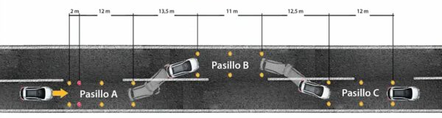
The main scenario for this is something such as a sudden lane change, this is looking at how the car will change dynamic under a sudden change from its original trajectory then suddenly returning back, this is often referred to as the moose test (king, 2020), this can be seen in figure 3.
Figure 4 Moose test example (North, 2020)
The Ferrari would be successful at this test this is due to not only the AWD system which could detect the loss of grip, but also comes down to its low Cog and low inertia acting on the body reducing the affects of roll.

8.4 Interaction with other systems
This is overall summed up in the previous systems connections, but the system will make use of all the sensors that would standardly be on the car, for handling it will link to the traction control to recognise there is slip, applying torque to the griping wheel, it could also sensors on brakes feeling the dynamic loading during cornering. Finally it will register with the suspension system, this will mainly to allow the system to see the reduction in the weight transfer especially in the case of harsh cornering where it could again increase the torque to the outside wheel, or the front tires int eh case of harsh accelerating loads.

7.0 Conclusion
Overall, the use of the AWD system in the Ferrari greatly improves its dynamic manoeuvring, allowing the system to increase stability through the use of the torque vectoring from the AWD. It is also more efficient than other comparable machines, this is due to it not having the usually drawback of an AWD system which is the increased mass from the differential and elongated drive shafts.
To improve the testing for next time having an actual vehicle to carry out measurements would further validate results as a large number of variables had to be assumed based upon other components and images, this would create a far more accurate data base of results.

References
Carrie G. Bobier, S. M. L. a. J. C. G., 2008. Transient Responses of Alternative Vehicle Configurations: A Theoretical and Experimental Study on the Effects of Atypical Moments of Inertia, Washington: American control confrence .
F1, T., 2019. Technical F1. [Online]
Available at: http://www.formula1-dictionary.net/centre_of_gravity.html#:~:text=The%20centre%20of%20gravity%20is,and%20cornering%20work%20trough%20it.
[Accessed 10 March 2022].
Ferrari, 2011. Ferrari FF. [Online]
Available at: https://www.ferrari.com/en-EN/auto/ff
[Accessed 11 March 2022].
Hirons, R., 2022. Car wow. [Online]
Available at: https://www.carwow.co.uk/guides/glossary/what-is-torque-vectoring#gref
[Accessed 8 March 2022].
king, K., 2020. What exactly is the moost test. [Online]
Available at: https://www.toyotaofnorthcharlotte.com/blog/so-what-exactly-is-the-moose-test/
[Accessed 16 march 2022].
Liske, 2020. Vehicle Pitch, Roll and Yaw, s.l.: Liske Accident and injury Experts.
North, T., 2020. Tesla North. [Online]
Available at: https://teslanorth.com/2021/09/16/tesla-model-y-impresses-in-moose-test-evasion-maneuver-video/
[Accessed 16 March 2022].
Radu, V., 2020. Auto evolution. [Online]
Available at: https://www.autoevolution.com/news/what-is-torque-vectoring-and-how-it-works-152235.html
[Accessed 8 march 2022].
Rieveley, R., 2010. The Effect of Direct Yaw Moment On Hyuman Controlled Vehicle Systems , Windsor: University of Windsor.
Roland, J., 2019. What’s the Average Weight for Men?. [Online]
Available at: https://www.healthline.com/health/mens-health/average-weight-for-men
[Accessed 5 March 2022].
sam, 2007. dynamic index. Wheels-inmotion, p. 7.
Vijay G Kondekar, N. D. W. B. B. D. K. N. W., 2013. Analysis of Center of Percussion and its Applications, s.l.: International Journal of Application or Innovation in Engineering & Management.

