University of Wales Trinity Saint David
School of Engineering

Coursework 2
Engineering Science II / M4X00386

Nathan Watson
1900683
05/04/20
Contents
Question One 2
Question Two 5
Question Three 7
Question Four 9

Question One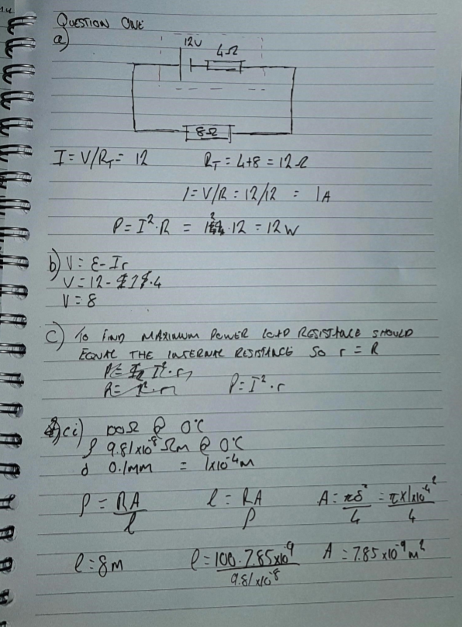
Figure 1-Chart for 1b
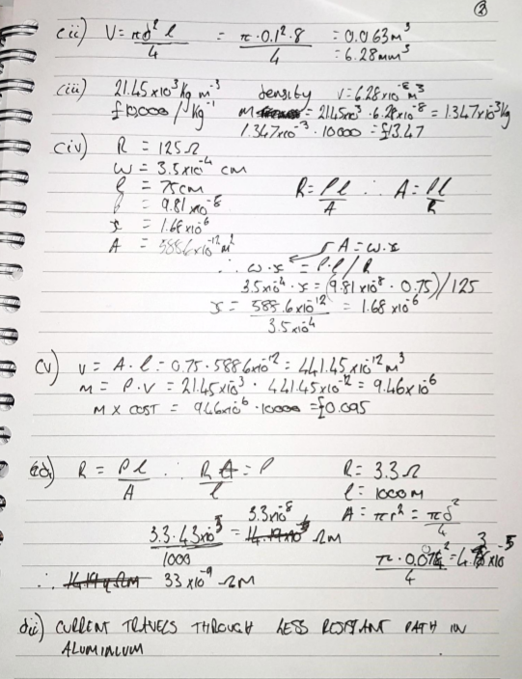

Question Two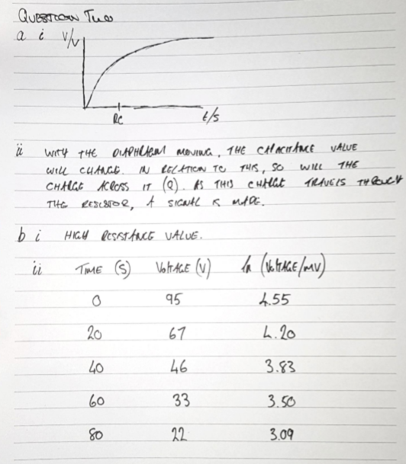 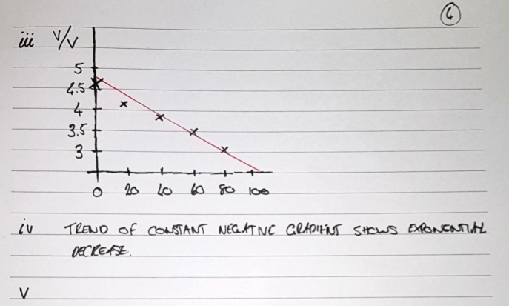

Question Three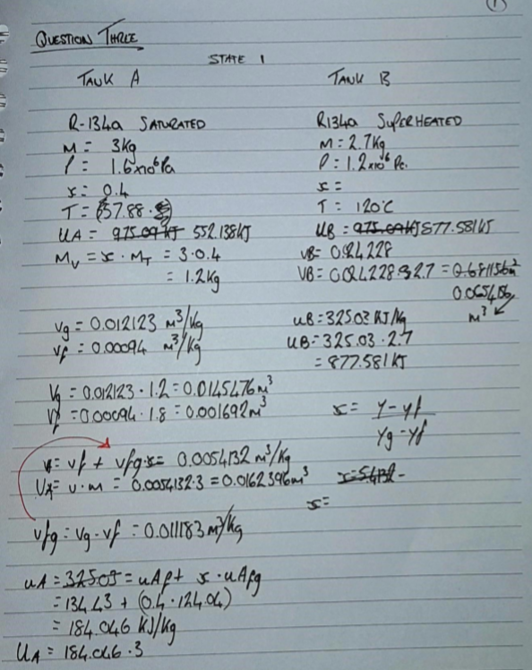 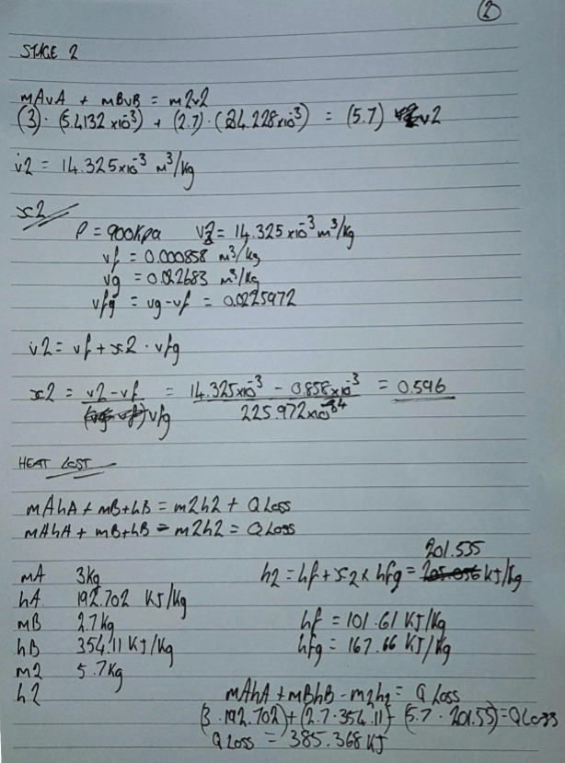

Question Four


