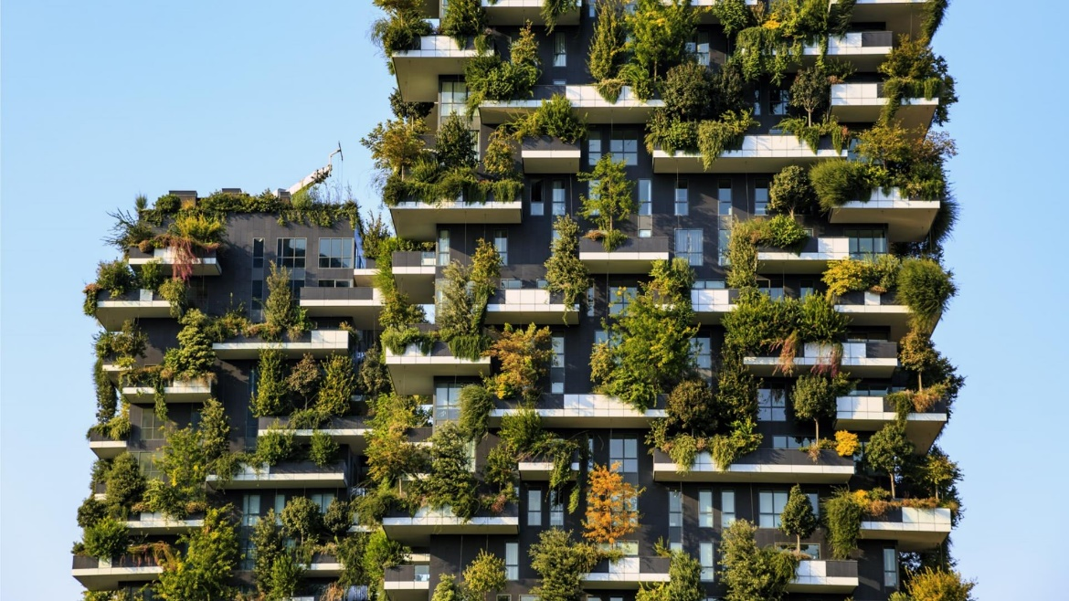

The Bosco Verticale
By
Nathan Chapman

Student Number - 2307154

Material Science and Building Services
Assignment 1 – Concrete Frame

December 2023

Table of contents
Introduction – 1
Main Body – 1,2,3,4,5
Conclusion – 5
Reference list - 5
Introduction
In the world of modern architecture and eco-friendly building practices, the choice of materials is crucial for creating structures that are both functional and environmentally conscious. This report takes a closer look at Bosco Verticale (Vertical Forest) in Milan, Italy—a great example of innovative urban living that combines smart design with eco-friendliness. Focusing on the mostly concrete towers covered in a thriving vertical forest, we'll explore how the building was originally planned, how it was built, and the possible impacts on society and the environment. We'll also check the durability of the concrete frames, the environmental effects of making them, and how easy they are to put together and adapt.
Main body
Original design plan
The original design plan of Bosco Verticale, conceived by Stefano Boeri Architects, envisioned a groundbreaking residential complex that challenged conventional notions of urban living. The project, located in the Porta Nuova district of Milan, Italy, was developed with the following key design elements: vertical forest concept, tower configuration, balcony layout, structural considerations, sustainable features, and urban integration.
Structural considerations
The structural design of Bosco Verticale's towers was a meticulous process that revolved around accommodating the substantial weight of the vegetation, ensuring the stability of the buildings, and implementing measures to support the flourishing vertical forest.
The backbone of Bosco Vertical’s structural innovation lies in the implementation of reinforced concrete frames, a resilient and enduring material carefully selected for its exceptional strength and durability. The incorporation of these frames represented a pivotal decision in supporting the unique challenge of cultivating a thriving vertical forest on the towers' facades.
- Material Characteristics:
Reinforced concrete, a composite material comprising concrete and reinforcing steel, was chosen for its innate ability to withstand substantial loads. The compressive strength of concrete combined with the tensile strength of steel provides a robust framework capable of supporting the dynamic weight distribution associated with extensive vegetation.
"The project consists of two towers of 80m and 112m, planted with almost 17,000 trees, shrubs and plants. This provides the equivalent greenery – over an urban surface of 1,500m² – of 20,000m² of forest and undergrowth.”
Author: Boeri, S.
Title: Bosco Vertical
Date: February 27, 2015
URL:https://www.ajbuildingslibrary.co.uk/projects/display/id/7158#:~:text=Subscribe%20now%20to%20instantly%20view%20this%20image&text=Bosco%20Verticale%20is%20an%20architectural,17%2C000%20trees%2C%20shrubs%20and%20plants.

- Engineering Precision:
The design and engineering process involved a meticulous calculation of the anticipated loads imposed by the vertical forest. Structural engineers carefully considered factors such as the weight of the soil, the mature trees, and the variation in water content within the soil to ascertain the optimal specifications for the reinforced concrete frames.
- Load-Bearing Capacity:
Recognizing that traditional structural configurations might not suffice for this distinctive project; the reinforced concrete frames were customized to enhance load-bearing capacity. This involved strategic placement of reinforcing steel within the concrete to bolster its resistance to the additional stresses induced by the planted balconies.
- Balcony Integration:
The integration of the reinforced concrete frames with the balcony structures was pivotal in achieving a seamless union between the architectural and natural elements of the project. The frames served as the supportive structure for the cascading layers of greenery, creating a symbiotic relationship between the built environment and nature. The layout of the balconies was carefully planned to distribute the weight evenly across the towers. The staggered arrangement of the balconies not only contributed to the aesthetic appeal of the towers but also played a crucial role in balancing the load on different sections of the structure.
- Longevity and Resistance:
Reinforced concrete frames, known for their durability, offered an assurance of longevity, withstanding the test of time and weathering the elements. This characteristic is vital for the sustained success of Bosco Verticale, ensuring that the structural integrity remains intact over the years, supporting the flourishing ecosystem it hosts.
In essence, the choice of reinforced concrete frames for Bosco Verticale epitomizes a fusion of engineering acumen and environmental consciousness. These frames, meticulously engineered and fortified, not only provide the structural stability required for the ambitious vertical forest but also encapsulate the ethos of sustainable urban living in a burgeoning metropolis.
Soil weight dynamics
Recognizing the inherent weight challenges associated with soil, particularly when saturated with water, the structural design of Bosco Verticale implemented a sophisticated hydrotechnical strategy. This approach adeptly factored in the dynamic weight distribution resulting from fluctuating moisture levels in the soil, ensuring the longevity and stability of the structure amidst the verdant expanse of the vertical forest.
- Dynamic Weight Considerations:
Soil, known for its capacity to retain water, can undergo significant weight fluctuations based on its moisture content. In response to this dynamic characteristic, the structural engineers meticulously analysed the potential weight variations, particularly during periods of saturation, and incorporated measures to accommodate these changes without compromising structural integrity.
- Moisture-Responsive Structural Adaptations:
The structural design embraced a responsive framework that could adapt to the varying moisture levels within the soil. This adaptability was crucial to withstand the added weight when the soil was saturated and to provide stability during drier periods. The flexibility of the design allowed for a harmonious coexistence between the structural elements and the ever-changing state of the soil.
- Integrated Drainage Systems:
Drainage systems were ingeniously integrated into the design to manage excess water efficiently. These drainage systems played a dual role in both preventing soil oversaturation and mitigating the potential burden on the structure. By channelling excess water away from the building, the drainage systems contributed to maintaining the equilibrium of the vertical forest ecosystem.
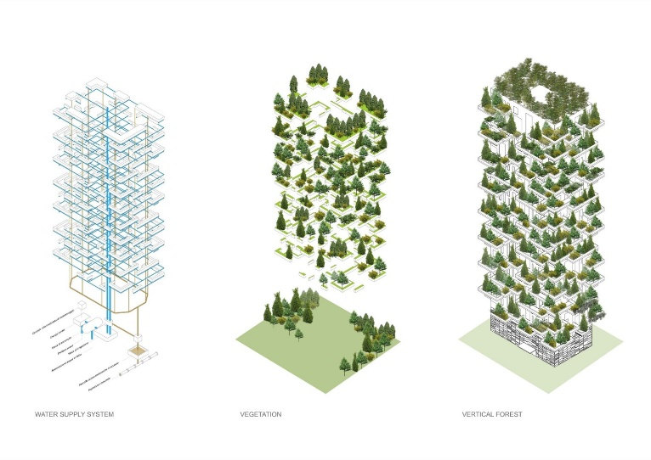
“Following micro-meteorological studies, the calculation of irrigation requirements was carried out by examining climatic characteristics and was diversified depending on the exposure of each façade and the distribution of vegetation on each floor.”
https://www.archdaily.com/777498/bosco-verticale-stefano-boeri-architetti
"Bosco Verticale / Boeri Studio" 23 Nov 2015. ArchDaily. Accessed 7 Dec 2023.

- Preventing Structural Overload:
The drainage systems were strategically positioned to alleviate the weight imposed by waterlogged soil. By preventing the accumulation of excess water, these systems acted as a safeguard against structural overload, ensuring that the reinforced concrete frames were not subjected to unnecessary stress due to prolonged saturation.
The integration of drainage systems with the concrete frame exemplifies a holistic approach to design—one that not only confronts the challenges posed by soil weight dynamics but transforms them into an opportunity for sustainable coexistence between urban architecture and nature. This synergy ensures that Bosco Verticale not only stands as a marvel of modern design but also as a testament to the harmonious integration of structural resilience and environmental conscientiousness.
Materials
The Bosco Verticale project in Milan, Italy, is distinguished not only by its architectural innovation but also by the careful consideration given to the materials used in its construction. While the predominant material is concrete for the building's structure, understanding the original production process sheds light on its social and ecological implications.
“The balconies are made from a 28-centimeter-thick post-tensioned reinforced, cantilevered, concrete floor. These support the weight and more importantly, the wind force the trees apply to the building.”
Author: Rose Barfield
Title: Bosco Verticale
Date: 1 April 2019
URL: https://www.bricsys.com/en-gb/blog/bosco-verticale
- Extraction of Raw Materials:
The initial phase in concrete production commences with the retrieval of raw materials, notably limestone, clay, and sand. This extraction process entails mining activities, which, if not managed responsibly, can give rise to ecological repercussions such as habitat disruption and soil erosion. To counteract these potential impacts, conscientious sourcing practices are employed with the aim of lessening environmental consequences.
- Production of Cement:
Cement, the essential component of concrete, is derived through the heating of limestone and other materials. This heating process, however, releases carbon dioxide (CO2), thereby contributing to greenhouse gas emissions. Mitigating these environmental effects involves initiatives such as incorporating alternative fuels and advancing the development of more sustainable formulations for cement production.
- Aggregates and Water Integration:
The amalgamation of aggregates (comprising sand and gravel) with water and cement constitutes the formation of concrete. The extraction of aggregates, if not executed judiciously, can exert adverse effects on ecosystems. Additionally, concerns regarding water resource depletion arise from the substantial water usage in concrete production. Sustainable practices address these concerns by incorporating recycled aggregates and implementing measures for the conservation of water resources.
- Transportation Considerations:
The logistical aspects of transporting raw materials to the production site and subsequently delivering the finalized concrete to the construction site play a significant role in energy consumption and emissions. To mitigate these environmental impacts, strategies encompass minimizing transportation distances and employing energy-efficient modes of transport. This holistic approach aims to reduce the carbon footprint associated with the transportation phase of concrete production.
The journey of concrete production, from the extraction of raw materials to the transportation of the final product, underscores the importance of environmentally conscious practices. Responsible raw material extraction, including limestone, clay, and sand, is imperative to avoid ecological repercussions. Cement production, a pivotal phase, necessitates ongoing efforts such as incorporating alternative fuels and sustainable formulations to mitigate carbon emissions. Integrating aggregates and water in the concrete-making process requires judicious management to prevent ecosystem threats and address water resource concerns. Additionally, minimizing transportation distances and adopting energy-efficient modes are critical strategies to curb the overall environmental impact. Overall, a sustainable future for concrete production hinges on a holistic and mindful approach at each stage of the process.

Conclusion
In conclusion, the exploration of Bosco Verticale, a remarkable example of modern architecture and eco-friendly building practices, reveals a meticulous fusion of innovative design and environmental consciousness. The original design plan, conceived by Stefano Boeri Architects, challenged conventional urban living by integrating a vertical forest concept into the towers, emphasizing sustainability and harmonious coexistence with nature. The structural considerations, particularly the use of reinforced concrete frames, showcase a strategic decision to support the weight of the flourishing vegetation, exemplifying a balance between engineering acumen and environmental stewardship. The adaptation to soil weight dynamics and the integration of drainage systems further underscores the project's commitment to sustainability, demonstrating a responsive framework that safeguards structural integrity while thriving amidst the verdant expanse. Additionally, the scrutiny of materials, particularly concrete, highlights the social and ecological implications of its production process, emphasizing the need for responsible sourcing and mitigation of environmental impacts. The journey from raw material extraction to transportation underscores the critical importance of environmentally conscious practices for a sustainable future in concrete production. Bosco Verticale stands not only as a marvel of modern design but as a testament to the transformative potential of integrating structural resilience and environmental conscientiousness in urban architecture.
Reference list
Author: Boeri, S.
Title: Bosco Vertical
Date: February 27, 2015
URL:https://www.ajbuildingslibrary.co.uk/projects/display/id/7158#:~:text=Subscribe%20now%20to%20instantly%20view%20this%20image&text=Bosco%20Verticale%20is%20an%20architectural,17%2C000%20trees%2C%20shrubs%20and%20plants.

Title: Bosco Vertical
URL: https://www.archdaily.com/777498/bosco-verticale-stefano-boeri-architetti

Author: Rose Barfield
Title: Bosco Verticale
Date: 1 April 2019
URL: https://www.bricsys.com/en-gb/blog/bosco-verticale

