Strategic Management for SMEs:
Academic report
Name: Florin Matei
Student ID: 1913208
Module code: BMSW6104
Lecturer name: Dr. Richmond Lamptey

Table of Contents
Introduction 3
Overview of the Company 3
Current Strategic Directions of Marshfield Coffee Company 4
Niche Strategy 4
Operational and Personnel 5
Operational Plan 5
Production 5
Business level strategy 6
Pricing 6
Management and Organization 7
PESTEL Analysis of Marshfield Coffee Co 7
SWOT analysis of Marshfield Coffee Co 10
Stakeholders Analysis 11
Power / Interest Matrix in Marshfield Coffee Co 13
Expectations and Power of different Stakeholders 14
Strategic growth of Marshfield Coffee Co 15
Conclusion 16
Recommendations 16
References 18

Introduction
Leadership is widely known as an important function for the success of the organization. MSME (Micro, Small and Medium enterprises) is the sector which is providing a larger number of employment opportunities and brings less capital than the large industries which helps show the industrialization benefits (Harris and Jones, 2018). There are almost 99% of the UK business and approximately 50% of all the private sector employment which is dealing with the private sector turnover and bring the economy to the larger functions ability and help in innovation at the larger stage. This report will highlight Marshfield Coffee Co, an SME business that is established in the UK. It will show all the analysis using PESTEL, and various scanning tools which better both the internal as well external environment (Harris and Jones, 2018). It will also discuss various stakeholders who are bringing the power at the defined level and help with some of the future recommendations by implementing the strategic decision. It also illustrates various challenges which SMEs help in gaining the performance and productivity in the competitive market.

Overview of the Company
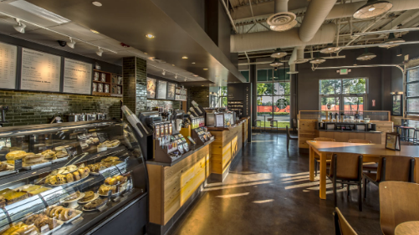
Figure 1 Marshfield Coffee Co. Source- (Harris and Jones, 2018).
Marshfield Coffee store is a small business that is operating its services and products in the UK. It offers various types of cakes, pastries, pieces of bread, buns, and coffee to its customers. It was established in the year 2013 and is located in London, England (Hewitt et al., 2021). The company is focusing which relate to the coffee blend and helps in giving attraction to the large customers and generating larger profit margins (Hewitt et al., 2021). It is giving value and helps in attracting the Marshfield coffee company and deals with the cakes and different flavors like the coffee capsules, blended coffee, popcorn, biscuits, buns, and pastries for breakfast and snacks as well. The major competitors of the Marshfield Coffee Company are “Starbucks, Costa, Greggs, Café Pod, Tassimo, and Nespresso coffee”. It is giving regular updates as compared to bringing the product quality and help in gaining the customer attention with the best range. It has got more than 30 products and is serving the users to a wider extent (Hewitt et al., 2021). The company has used advanced technology which can be in the form of Google analytics, G2Stack, and RFID, and improve the delivery of the products efficiently.
Marshfield Coffee store is generating a turnover of less than 2.3 trillion British Pounds and consists of less than 10 employees working there which is contributing most of the facilities at 953 billion pounds (Halkias and Neubert, 2020). Café and coffee shops are giving the wider aspects to the market in the UK along with the bakery and sandwiches. There is a rising trend in the number of coffee shops which are operating in the UK and specifies all the independent operators which are including all the non-specialists along with the branded chains (Halkias and Neubert, 2020). The long-term vision of the company is to establish more stores widely in the world and deliver the services by looking at all the customer’s needs and wants effectively along with the latest trends.

Current Strategic Directions of Marshfield Coffee Company

Niche Strategy
Marshfield coffee co is offering several rotational menus according to the days and seasons by bringing the flavor and products which is meeting the industry trend in unique aspects. With the help of this, there is involvement in the classic sense and help in bringing the innovative flavor along with the seasonal offerings as per the stage (Halkias and Neubert, 2020). There are more creative methods adopted to increase the sale of coffee and baked items in the wider aspects. The marketing area is looking for unique products or services and advertises the events to get people invested at the starting stage and help in showing the true engagement of the participants which is enlarging the developmental factors.

Operational and Personnel
The company is operating its services by making the production scheduled according to the source and enlarging the labor costs which can be adjusted as the major portion of the concepts. There is involvement up of the lean operations which help in showing dependence by originating the lower margin profit and gain all the staff in a better way (Karatepe, Aboramadan and Dahleez, 2020). Most of the products are being served to meet the demand of the users at a defined level without any wastage.
Karatepe, Aboramadan and Dahleez (2020) emphasizes that the objective of the company is to help in bringing the vital activity related to the food quality in the best manner. There is an efficient evaluation done for the raw materials which are brought and handled by increasing the optimal level of the business and help in showing the best quality management. All the complexity of the company is looked at by the assortment of the items and helps in dealing with the higher quality products (Hallinger, 2018). The firm here is too small to put enough resources into the growth at the starting stage so there is some major challenge which is faced by Marshfield Co. in the form of financial crisis hits, quality, and the value of the items (Karatepe, Aboramadan and Dahleez, 2020). All the internal processes need to be progressed by rising the management strategies and help in showing the business function by adopting all the abilities and fostering growth. This report will look into the negative experience which is faced by the company through internal problems and help in showing the start of the business along with the third party innovation by establishing the more area of knowledge (Hallinger, 2018).
Marshfield Coffee Co. has put internal practices and employed all the members by giving them well training and encouraging sharing all the latest ideas. It specifically focused on the communication for all the stages of the company whether it is from the lower or higher department (Hallinger, 2018). The characteristics of the business are mainly the goal setting, work-based control, social networking, and emotional aspects of all the staff in an efficient manner (Mansoor et al., 2021). The behavior process is included to drive the success and aim to bring the innovation with the adoption of recent changes and make the working environment better.

Operational Plan

Production
The company is dealing with the baked goods which are made in the kitchen and displayed at the front desk so that the customers get attracted to the items and this increases the sales of the products to a larger extent (Mansoor et al., 2021). Here, there is breakfast and lunch order prepared with all the best quality ingredients. The business hours will be Monday-Friday between 7:00 am-7:00 pm, while on Saturday, it will be 8:00 am- 5:00 pm, and For Sunday it will be 10:00 am- 3:00 PM. All the new items brought from the warehouse will first be tested before being transferred to the kitchen for use.

Business level strategy
Marshfield Coffee Co helps in broadening the effects of the customer base and offers several quality coffees and baked pieces of bread, cookies, and biscuits at an affordable range (Mansoor et al., 2021). It is bringing the effect of the differentiation business-level strategy and originates the higher quality coffee which brings efficiency to use all the social media platforms and build awareness from different stages. It helps in safeguarding the interests along with looking for the market goals. The company is launching various new potential by setting up the higher price and enlarging the barrier to entry (Ding, Choi and Aoyama, 2019). It is adding up the prospects which increases the supply of the products. Through the practice of this business strategy there is a rise in customer power and look for all the alternatives in the market. It determines the various stages which are effective in bringing the brand loyalty according to the unique offerings in the quality of the products.

Pricing
The company is combining all the ingredients and labor costs, as it not only serves the business products but considers the effective values (Ding, Choi and Aoyama, 2019). It brings the all the chain market which helps in increasing the quality of the items and supports all the economies of the scale inefficient way. It is looking for better value quality and the atmosphere which helps in the change in price level according to the trends launched in the recent scenarios since there is more small business operating in the UK (Ding, Choi and Aoyama, 2019). If there is a consideration in the effects for the margin which is sourcing the better outlook and encounter the account with the fluctuation in the supply price of the coffee.
For all the future competitors, it is responsible to provide the physical benefits as compared to the display in the effects with the better involvement in the percentage as there is the rise in the items sold off the café and help in increasing the benefits with the wider aspects generation of effects (Tapayan, 2018).

Management and Organization
The company is serving the stages at the larger range and helps in bringing the innovation which is related to the business. The staffs are working as a team which brings all the best effect and show the cooperation regarding the working environment (Tapayan, 2018). It helps in handling the different growth pattern and help in gaining trust and openness. The employees are bringing thoroughness in the values and help in listing out all the stages with the better stage in the management of a small business (Tapayan, 2018). There is higher handling of the vendors and look for all the major aspects which help in showing the larger level of order and plan according to the source.
Bakers at this company are specifying the goals which help in preparing the source. It deals with the new products and plans as per the level of the goals (Masih et al., 2019). It shows all the hourly behavior and response from the stage which is depending on the working hours, experience, and better development for the company. Here the order is taken into like for making coffee or drinks and keeping in front of the house clean and interacting with the customers in better ways.

PESTEL Analysis of Marshfield Coffee Co
It is the evaluation of the brand on the business strategy and help in knowing about all the external factors which impact the business growth along with the legal and environment effect on whole sector (Masih et al., 2019). It is the format which brings all the coffee companies at one place to know about the competitive market dynamic and progress the business in continuous operations.
Political - The factors is showing the effects with respect to analysis made on the different political aspects as, in the wider facility, it is bringing the friendly connection with the leaders who has got political background and gain the services even at the national level (Masih et al., 2019). It is easy for them to establish a new outlet in the most renowned area which has larger geographical position and bring the effect with related to the supporting of the exports as there is change in the business facilities (Morales Molina, Pérez and Vasquez, 2021). The GST and taxation value is helping in aiding the economic growth at the larger evaluation of the company by looking all the aspects at the better stages. The business is able to bring the economic growth with the help in political stability. It also help in focusing on all the norms which is regarding the atmosphere it is operating. It is increasing all the spending in the values which is connected to grab the opportunity and bring all the higher significance level which is encouraging the participants and develop the strategy. It is widely able to maintain the quality standards and help in regulations at the given values.
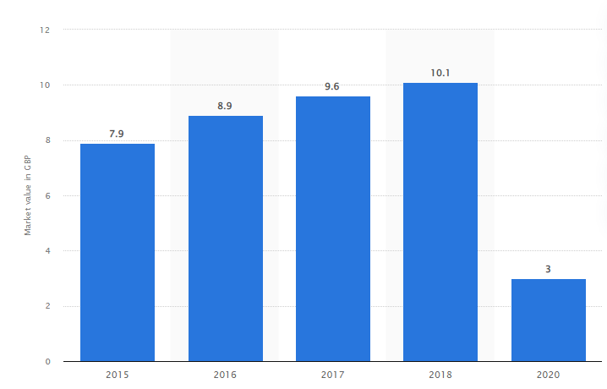
Figure 2 Estimated value of the branded coffee shop in UK Source- (Masih et al., 2019).
Economic- There is a higher rise in the pandemic effects which helps in increasing the unemployment and disposable income has increased to attain the profits of the company. The people are distributing the stage which is spending at the wider purpose and help in dealing with all the expensive items and rules (Morales Molina, Pérez and Vasquez, 2021). The exports are raising the exports of the coffee beans which are useful to make coffee. During the pandemic, there was a huge impact on the process and growth of the economy which give it new hope for participation in the company. The production of the business is raising the increase in the effects which raises the exports service as the major sources. It helps in focusing on the cost reduction of the operations and labor costs.
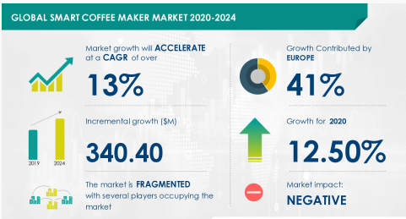
Figure 3 Global market of coffee Source- (Morales Molina, Pérez and Vasquez, 2021).
Social – These are the factors that help in establishing the effects on all the millennial and generation X groups who like to spend more in the outside environment and enjoy themselves with their friends (Dathe et al., 2022). The coffee company is a better place to meet a larger number of individuals and focus on the things which attract all the possible potential with the generation of the users, and launch several new outlets. The company is involving all the latest patterns and trends related to the lifestyle, and working conditions and leading to the growth in the urban population (Dathe et al., 2022). As there is a larger population of the middle-income group, it helps in showing the preferred value which changes the growth stage and brings the total spending related to tee disposable income which is based on the company goals and helps in social trending objectives.
Technological – Through this factor, the company is making innovations in their menu and food prices which help increase customer engagement by offering to the new customers. It also changes according to the seasonal values and helps in showing the effect with the better stage of development (Dathe et al., 2022). It has introduced a new internet-based source that betters the food service and its delivery. As with the practice of bigger data analytics values, there is an efficient need of its customers which helps in designing the personalized customer experience for the wider aspects (Helmold, 2021). There is the usage of the RFID technology so that there is no long queue which helps in changing the dimensions of the working.
Environmental – The awareness of the climate change and the weather of the company where it is located in responding to all the factors which help in increasing a lot of government rules and applications with the better imposition of the regulations and help in the reduction of the carbon footprint (Helmold, 2021). It gives more focus on the use of the sustainable items and continues to operate with enough fluctuations which are based on the production of the coffee materials. There is a rise in the effect of the company which is directly changing the customer’s values as there is a rise in the entire value of the chain system (Helmold, 2021). It is reducing the process which eventually helps coffee production.
Legal- Marshfield coffee company is making new rules and activities which protect the customers and operate by following all the norms in a better way. It makes sure that there is efficiency in the labor values and implementation process (Soegoto, 2021). It also involves the customer in different programs and enlightens the effect of the whistleblower policy which encourages the company's attention to the instance of the unethical behaviors and relates to the effective code of conduct (Soegoto, 2021). The higher authority looks at a better way that there is a misuse of the power and supports all the mis happenings related to the workplace. It also makes sure that the complaint which is raised by the customer is genuine and not fake to take the benefit. The company is following the legal requirements which bring the expansion in the policy and effects related to all the changing outlets.

SWOT analysis of Marshfield Coffee Co
Strength- It is known as the coffee and bakery chain which is operating its products or services in the UK (Soegoto, 2021). It offers the higher or premium quality items which are dealing with the coffee to its users and help in showing the advanced technologies progressing the effects related to the manufacturing of the coffee capsules and bring innovation in the wider aspects. It gives the best service to its consumers along with the WI-FI facility and increases the satisfaction level to a larger extent (Bardinov, 2019). There is high motivation related to the employees which attracts the store layout in the business and deals with the effective service of the culture which enables the major strength and capacity of the coffee stores in a better way.
Weakness – Marshfield Coffee Co, is facing a number of a problem it is important to know about the relationship establishment stage with the suppliers and the customers, as there is sometimes less no of materials are required during the particular season (Bardinov, 2019). There is a lack of facilities provided from the research and development effects which are building the concept and help in showing the variation related to the investment purpose and irregularities for the market. The absence of the advanced technology involved leads to less progress in the values of the company and disrupts the production level of the coffee and bread (Grub et al., 2020). For this, there needs to be the launch of the product diversification which is ceasing the operational effects to a better extent (Bardinov, 2019). The low market position is valued with the sharing of the social media presence and raises the difficulty of the brand awareness which is sourced with the effects of the weakness of the Coffee Company.
Opportunities - The Company is having the chance to expand the business and develop the process in China, India, and several other European countries. It brings the effectiveness in the innovation practice and sources the Marshfield coffee co, to create an environment by looking with the deeper innovation strategies which are building the concept and help in overcoming all the effects positively (Grub et al., 2020). There is progress with the connection in the customer relationship culture and bring a significant rise in the factors by looking for all the discounted values. It also extends the operations which are effective in bringing the implementation at the loyalty programs and bring the rise in the chance to outsource the items and help in raising the factors which connect with daily environment basis (Pop, Rus and Drența, 2019).
Threats- The major damage that SMEs in the UK is facing is that are many new competitors with enough funds in comparison to the smaller business and thereby making progress in the value (Grub et al., 2020). Especially today youth is more concerned about their health so there is a lack of use of the coffee and milk products which contain caffeine and is harmful for a longer period. Diverse customers are building vulnerable conditions and continue to operate the business (Pop, Rus and Drența, 2019). Product diversification is impacting the process and affecting the UK coffee business as it was difficult to retain the customers for a longer period in one place without serving them effectively.

Stakeholders Analysis
Customers | External | Marshfield Coffee co gives vital importance to its customer as their major goal is to satisfy by looking all the level in better way. They are considered here the king of the business and they are the only one who will consume the product and avail services and give rise in the sales (Zulkarnain, Wahyuningtias and Putranto, 2018).
Employees | Internal | Here, the Marshfield Co gives importance to its members and staff at the larger extent by enrolling them in the different programs and schemes effectively (Zulkarnain, Wahyuningtias and Putranto, 2018). It is the group of the people who work for the company wages.
Government | Outsiders | The company here is looking for the entire guide and is controlled by the UK government which betters the rules and regulations regarding the food quality and raw materials in effective way (Zulkarnain, Wahyuningtias and Putranto, 2018). It also make sure that the payment of the tax is enabled using the duties which help in business growth at the wider concept.
Suppliers | External | It is the stakeholders which is giving all the inputs to the company and help in dealing with all the coffee and bread making machines (Dawes, 2018).
Shareholders | Internal | They are the members which deal with the operations of the business and help in knowing about all the investors in better way (Dawes, 2018). It helps in knowing about the total money which is valued at the great extent of the organization.

Power / Interest Matrix in Marshfield Coffee Co
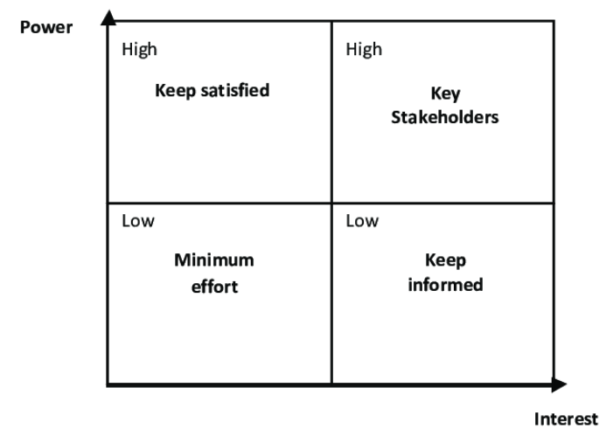
Figure 4 Power OR Interest MATRIX Source- (Dawes, 2018).
- High power / High Interest- It is the stage in which there is a rise in the promotional values which helps all the shareholders, and customers, and brings the effect to the larger portion (Khajezadeh et al., 2019). It is also carefully managing the monitored stage to gain a competitive edge.
- High power/ less interest – through this step there is a lower range of interest in the business and helps in bringing the decision-making values with the better possibility of the free service to its users (Khajezadeh et al., 2019).
- Low power/ high interest – with the help of this there is a rise in the members and deals with the section which is informing all the participants to build the stage and effects in the competitive market (Khajezadeh et al., 2019). Here they make responsible changes in the coffee business and enlighten the brand name to all the new geographical locations in the UK.
- Low power/ Low interest – In this step, there is the absence of the involvement of the higher authority as well as the staff who is not interested to do the work assigned, and there is no motivation level for the business growth as a whole disrupt the local community (Sukma, Lubis and Utami, 2019).

Expectations and Power of different Stakeholders
Shareholder – They are making better interests in Marshfield Coffee Co, which help in realizing the returns with the long and short-term benefits (Sukma, Lubis and Utami, 2019). It is playing an essential role in the effects on the performance of the firm. There is a rise in the voting right and help in gaining the active behavior.
Employee – It is giving the directions which are helpful in the decision-making process and show the performance in the higher wages, holidays and give a good working environment (Sukma, Lubis and Utami, 2019). It helps the company to meet the sources and bring the appraisal at the level by raising the target and helping in inviting the benefits with the employee satisfaction and morale.
Customer - The power of the company is that the customer is looking for better quality with the products gained and helps in retaining the users for a longer period (Mehta, 2022). It brings the experience in the facilities and enlarges the combo packs which are introduced in the value effects and thus deliver the items with the generation of the effective channel.
Suppliers- Here, the company is processing the wholesale of the supply and helps in generating more revenue which brings a higher level of significance and develops the new component to make coffee (Mehta, 2022). It joins the force which detects the values and assists in survival by earning profit in the wider aspects.
Government- It is essential for shaping both the external and internal environment. There is the rise in the UK offer which takes advantage of tax and gives the greater power with the network of locations and effectively enables the functioning (Mehta, 2022). It makes sure that the country regulations are looking for the customer safety and employment rights which has a larger interest and wants the coffee shops to excel in the beans and gives the facilities to its customers widely.

Strategic growth of Marshfield Coffee Co
It is the progress that can be explained through the Ansoff matrix which helps in analyzing all the patterns and trends which bring innovation in the wider aspects.
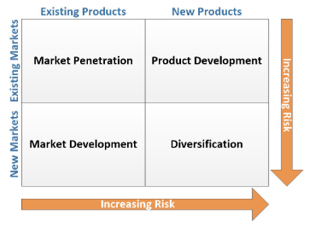
Figure 5 Ansoff growth matrix Source- (Shaposhnikov and Kosovan, 2020).
It is the model which is giving opportunities for Marshfield Coffee Co and help in reaching a better approach to the business.
Market penetration – It is the stage that helps in focusing the existing items and services to invite more customers within the same market level and innovate the products effectively. Marshfield Coffee co is storing the images of all the customers who visited a welcome the larger base (Shaposhnikov and Kosovan, 2020). This helped in increasing the sales and opening hours of the coffee with better loyalty.
Product growth – It is invested in the research and development of coffee and bakery items. There are acquiring the competitors like Starbucks which develop the technology and helps in meeting the current trend (Shaposhnikov and Kosovan, 2020). It also uses all the recycled items at a less price value and supports all the existing markets at a better level. There is the involvement of the customers and employers which help in increasing the business operations gain a competitive edge in a better way.
Market progress – It involves gaining a new location and establishing the newer segments which help in entering the domestic market in a better way (Ahsan, 2019). Marshfield Company is sharing the range which is bringing all the potential customers to enter the newer market and gain the survival.
Diversification – Here the company is entirely looking for the green field and help in entering the latest markets with the latest products (Ahsan, 2019). There is the adoption of the sustainable diversification strategy which is dealing the mobile payment and helps in showing the ethical sourcing and training the experience with relation to the generation of the digital receipts.

Conclusion
This report analyzed all factors which bring the important values which Marshfield operated and offered a higher quality of coffee and bread products. Marshfield Coffee Co helps in broadening the effects of the customer base and offers several quality coffee and baked bread, cookies, and biscuits in the affordable range. It is bringing the effect of the differentiation business-level strategy and originates the higher quality coffee which brings efficiency to use all the social media platforms and build awareness from different stages. The company is serving the stages at the larger range and helps in bringing the innovation which is related to the business. The staffs are working as a team which brings all the best effect and show the cooperation regarding the working environment. It helps in handling the different growth pattern and help in gaining trust and openness. It discussed various stakeholders’ analyses which are changing the plan as per the advantage and developing the process effectively. It highlighted all the SME business and sustainable strategies for the future development and a few recommendations to develop the activities and business vision to combat the difficulties in the process.

Recommendations
- From the analysis, it should determine all the significant changes in the customer presence based in Marshfield Coffee Co and implement the use of strategic direction as they lack in the management which needs to be innovated in the process and directly source the raw materials from another warehouse (Zinina et al., 2020).
- Since the coffee and bakery company is looking for its customers only, rather it should also give focus to its employees and staff working there who sometimes get frustrated from the assigned work and they too need some refreshment to provide the better results (Zinina et al., 2020).
- There should be sustainable use of the product as only the paper-made products should be available at the store, so that there is the minimization of harmful gas in the atmosphere.
- The company should focus on the reasonable price and reputation rather than only giving importance to the technology which brings the diversification of the coffee products (Loizia et al., 2021).
- It should increase the customer reach with better quality inspections rather than looking for the brand awareness and sales of the operations (Loizia et al., 2021).

References
- Ahsan, S.M., 2019. Market Development Strategy of a Technology-Based Firm: A Study on TechnoMagic.
- Bardinov, D., 2019. Establishing cafeteria bakery'Northern light'.
- Dathe, T., Dathe, R., Dathe, I. and Helmold, M., 2022. CSR as Part of the Corporate Strategy. In Corporate Social Responsibility (CSR), Sustainability and Environmental Social Governance (ESG) (pp. 1-22). Springer, Cham.
- Dawes, J., 2018. The Ansoff matrix: A legendary tool, but with two logical problems. But with Two Logical Problems (February 27, 2018).
- Ding, W., Choi, E. and Aoyama, A., 2019. Relational study of wise (phronetic) leadership, knowledge management capability, and innovation performance. Asia Pacific Management Review, 24(4), pp.310-317.
- Grub, B., Kim, S.D., McLean, A. and Sokolov, A.M., 2020. INCREASING PROFIT AND TIME VALUE FOR HOME BASED BAKERY USING PROCESS IMPROVEMENT AND QUALITY TOOLS. In Proceedings of the International Annual Conference of the American Society for Engineering Management. (pp. 1-10). American Society for Engineering Management (ASEM).
- Halkias, D. and Neubert, M., 2020. Extension of theory in leadership and management studies using the multiple case study design. Available at SSRN 3586256.
- Hallinger, P., 2018. Surfacing a hidden literature: A systematic review of research on educational leadership and management in Africa. Educational Management Administration & Leadership, 46(3), pp.362-384.
- Harris, A. and Jones, M., 2018. The dark side of leadership and management. School Leadership & Management, 38(5), pp.475-477.
- Helmold, M., 2021. Corporate Strategic Management. In Successful Management Strategies and Tools (pp. 11-31). Springer, Cham.
- Hewitt, L., Dahlen, H.G., Hartz, D.L. and Dadich, A., 2021. Leadership and management in midwifery-led continuity of care models: a thematic and lexical analysis of a scoping review. Midwifery, 98, p.102986.
- Karatepe, O.M., Aboramadan, M. and Dahleez, K.A., 2020. Does climate for creativity mediate the impact of servant leadership on management innovation and innovative behavior in the hotel industry?. International Journal of Contemporary Hospitality Management.
- Khajezadeh, M., Niasar, M.S.F., Asli, S.A., Davari, D.D., Godarzi, M. and Asgari, Y., 2019. Application of neural network in portfolio product companies: Integration of Boston Consulting Group matrix and Ansoff matrix. International Journal of Economics and Management Engineering, 13(6), pp.821-825.
- Loizia, P., Voukkali, I., Zorpas, A.A., Pedreno, J.N., Chatziparaskeva, G., Inglezakis, V.J., Vardopoulos, I. and Doula, M., 2021. Measuring the level of environmental performance in insular areas, through key performed indicators, in the framework of waste strategy development. Science of the Total Environment, 753, p.141974.
- Mansoor, A., Farrukh, M., Lee, J.K. and Jahan, S., 2021. Stimulation of employees’ green creativity through green transformational leadership and management initiatives. Sustainability, 13(14), p.7844.
- Masih, J., Rajkumar, R., Matharu, P.S. and Sharma, A., 2019. Market Capturing and Business Expansion Strategy for Gluten-Free Foods in India and USA Using PESTEL Model. Agricultural Sciences, 10(02), p.202.
- Mehta, S., 2022. Cravings: Baking a New Strategy for Growth. In SAGE Business Cases. SAGE Publications: SAGE Business Cases Originals.
- Morales Molina, T., Pérez, S.L. and Vasquez, G.B., 2021, June. Analysis of the Social Factors (PESTEL) of Popular and Solidarity Economy Enterprises Post Covid. In XV Multidisciplinary International Congress on Science and Technology (pp. 299-318). Springer, Cham.
- Pop, A.D., Rus, G. and Drența, R.F., 2019. Modeling and Simulation of Technological Factors in Bakery Industry. In Advances in Manufacturing Engineering and Materials (pp. 531-538). Springer, Cham.
- Shaposhnikov, I.I. and Kosovan, A.P., 2020. Key scenarios of russian bakery industry development in conditions of the economy digital transformation and rising of global risks. Vsyo o myase, pp.399-402.
- Soegoto, F.A., 2021. Product Development using SWOT Analysis. International Journal of Entrepreneurship & Technopreneur (INJETECH), 1, pp.1-10.
- Sukma, D., Lubis, P.H. and Utami, S., 2019. Analysis of Marketing Strategy of Minyeuk Pret Using STP, Ansoff Matrix, and Marketing Mix.
- Tapayan, A., 2018. Integrated marketing communications plan for a bakery.
- Zinina, O.V., Dalisova, N.A. and Olentsova, J.A., 2020, August. Dynamics and structure of manufacturing bread and bakery products in the Krasnoyarsk region. In IOP Conference Series: Earth and Environmental Science (Vol. 548, No. 2, p. 022028). IOP Publishing.
- Zulkarnain, A., Wahyuningtias, D. and Putranto, T.S., 2018, March. Analysis of IFE, EFE and QSPM matrix on business development strategy. In IOP Conference Series: Earth and Environmental Science (Vol. 126, No. 1, p. 012062). IOP Publishing.

