

Programme: Master Of Business Administration

Student Name: Rahul Amitkumar Shrimali

Module Name: Strategic Management (LCMB7003)

Lecturer Name: Hoang Nguyen

Submission Deadline: 12th August 2026

Table of Contents
Section 1: Strategic Analysis of Monzo Bank in the UK Market 4
1. Organisational Context and Overview 4
1.1 Overview of Monzo Bank 4
2. External and Internal Analysis 5
2.1 External Environment Analysis (PESTLE) 5
2.2 Internal Analysis (VRIO Analysis) 10
3.0 SWOT Analysis of Monzo 12
3.1 Strengths, Weaknesses, Opportunities, Threats 12
3.2 Comprehensive and Holistic View of the Organisation 15
4. Balanced Scorecard (BSC) 15
4.1 Porter’s Five Forces 17
5.Ansoff Matrix 19
5.1 Applying Ansoff’s growth options to Monzo: 19
5.2 SAFe Evaluation (Recommended Strategy) 21
Figure 11: SAFe Framework(Canva) 22
6.Final Strategic Recommendation 22
6.1 Implementation Challenges 23
Section 2: Reflective 25
1.1 Reflection Using Gibbs' Reflective 25
1.1.1 Description: 25
1.1.2 Feelings 25
1.1.3 Evaluation 25
1.1.4 Analysis 26
1.1.5 Conclusion 26
1.1.6 Action plan 26
2. References 27

Section 1: Strategic Analysis of Monzo Bank in the UK Market

1. Organisational Context and Overview

1.1 Overview of Monzo Bank
Monzo Bank is a digital bank headquartered in London, founded in 2015 to make money work for everyone. The service has no physical branches and is fully managed through an app that offers current accounts and credit cards. The company generates revenue through interchange transaction fees, interest on borrowings, and premium subscriptions. By the Fiscal Year (FY) 2024, Monzo had grown to 9.3 million personal and 0.4 million business customers – a tenfold increase since 2018. It is one of the largest UK digital banks. Having a high engagement and loyalty is a strategic strength – Monzo has an NPS of 70 and the #1 service quality in the United Kingdom. As many as 66% of new sign-ups happen via referral. Rival peers such as Revolute and Starling and retail lenders like Barclays and HSBC. For instance, in 2024, Revolut had 52.5m consumers and £1.1bn profit. This totally dwarfed Monzo with its UK-only 12m consumers and £113.9m profit 2025. Comparables in the industry are fierce and validate Monzo’s digital-first play.
Monzo’s digital-first market position with more than 1 in 5 UK adults as customers together with the product pipeline (investments, pensions, insurance, AI fraud tools) are strategic strengths. While it aims to be a “narrow bank” (deposits/payments) and not act as a lender, Monzo does little lending compared to traditional banks. It owes its growth to technology (fully cloud based in 2015) and data analysis (Google Cloud BigQuery to process tens of petabytes of data). This platform provides accessibility to rapid innovation like AI-based fraud detection, savings flexibility, etc. and personalized service. Importantly, Monzo's culture, obsessive focus on customers and insights-based decisions are strategic assets which enable rapid growth. The current trajectory of Monzo’s growth is being sustained by these fortitudes and negative customer love, driving a product diversification plan (launching ETFs, lending products, team banking) and geographic extension plan (setting up EU base in Ireland, and testing the US).

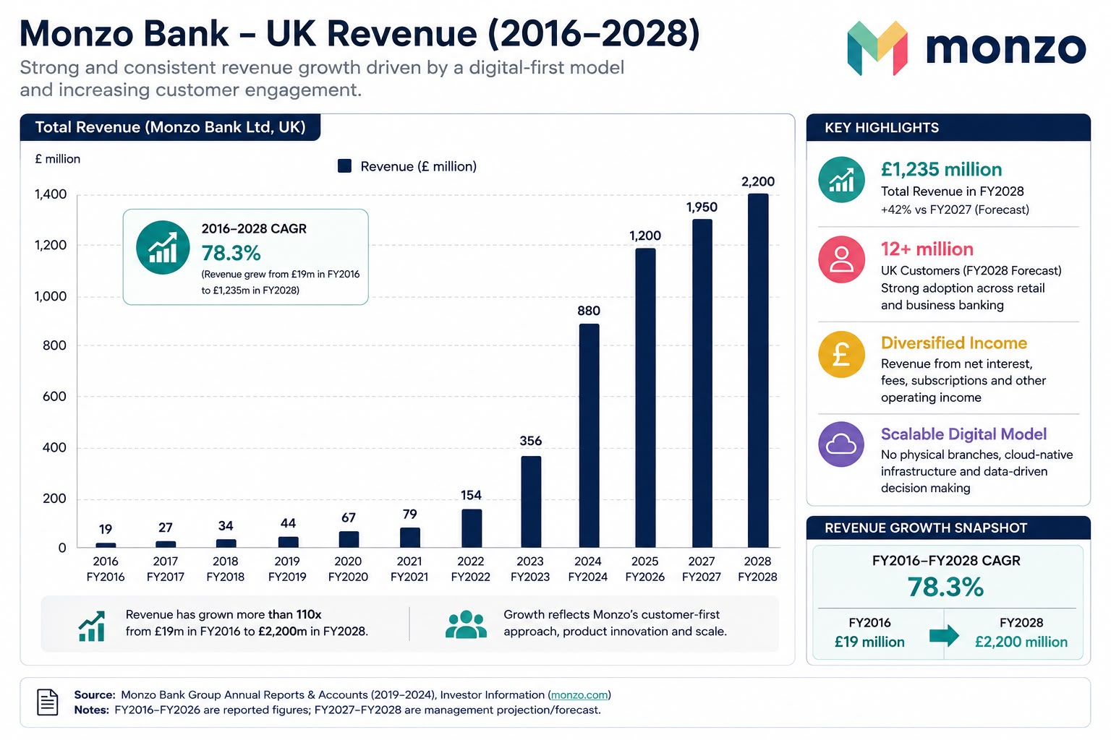
Figure 1: Revenue of the UK Monzo Bank

2. External and Internal Analysis

2.1 External Environment Analysis (PESTLE)

Political:
The British government and regulators back fintech and Open Banking (PSD2) initiatives and help create a conducive environment. Monzo makes use of open banking – its dashboard has 5.2 million users – to turn a regulatory change into an opportunity (e.g. aggregation of client data for new services). Nonetheless, there is also strong regulatory scrutiny. The FCA, which is emphasising consumer protection with new rules such as the Consumer Duty, makes compliance harder for all banks. The complexity of dual regulation caused by Brexit has forced Monzo to open an EU base to prevent a loss of access. On the whole, the trends on policy level (FinTech charters, digital finance taskforces) suggest innovation but Monzo is under political pressure to show that it is resilient and brings financial inclusion. The strategic implication is that regulatory headwinds (for example, fines) are compelling Monzo to strengthen its controls. However, support for fintechs from the government (for instance, a regulatory sandbox and support for startups) will enhance chances of long-term growth.

Economic:
The UK experienced high-interest rates (Bank Rate 3.75% in 2026) and moderate inflation (about 2.6%) because of the energy shocks. According to Coppola (2024), Monzo’s FY2024 net interest margin expanded as the Bank of England policy rate was at a high level. Monzo has already paid £130m interest to its customers since launch. Higher savings interest is better for customer loyalty. Although higher borrowing costs for mortgages and lending could deter spending and credit growth in the economy, which may slow transaction fees revenue. Consumer discretionary spending may be restrained by cost-of-living pressures. The impact of it is that Monzo is currently experiencing a boost to profitability from the net interest margin (opportunity). However, if rates stay high too long, credit risk could rise and customer growth might slow (threat).

Monzo ought to take advantage of strong deposit margins, both through better savings products and by hedging credit risk while planning for normalization of rates.
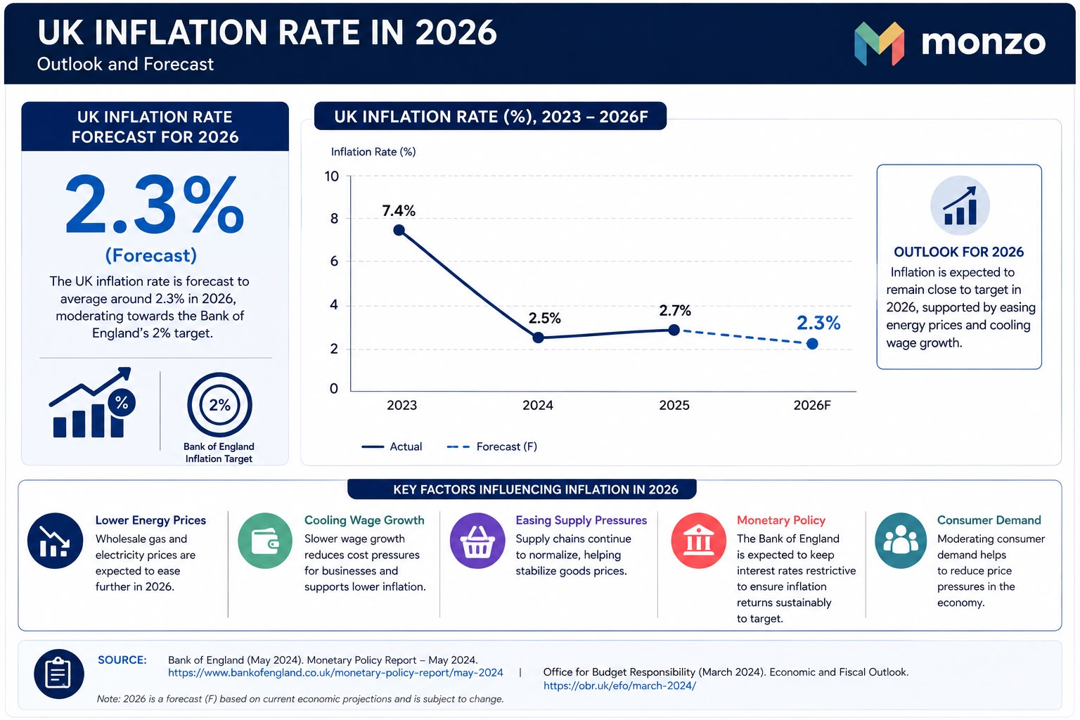
Figure 2: UK Inflation Rate

Social:
UK consumers, particularly the youth, are embracing digital banking. Monzo has 650,000 accounts for under-16s. It also has customers “in their 90s” so we are for all. As digital banks must overcome the brand familiarity of legacy banks, a high NPS of 70 and referral rate indicates a strong trust and satisfaction. Nonetheless, in 2024, only ~39% of adults expressed confidence in financial firms (FCA survey), a persistent trust deficit. Shifts in anticipation favor fintechs that create 24*7 services. Monzo uses pop-up branches (e.g. ‘hot coral’ branding) and strong social media presence as mean to amplify its brand. Targeting tech-savvy, younger consumers (Gen Z & Millenials) is an opportunity for Monzo. By using a simple mobile app, it resonates well with social trends. Other community development initiatives are also aligning well with social trends. The older or rural customers may remain loyal to their trading banks. Similarly, any outage in services or breach of security (implied risk to society) would impair trust itself.
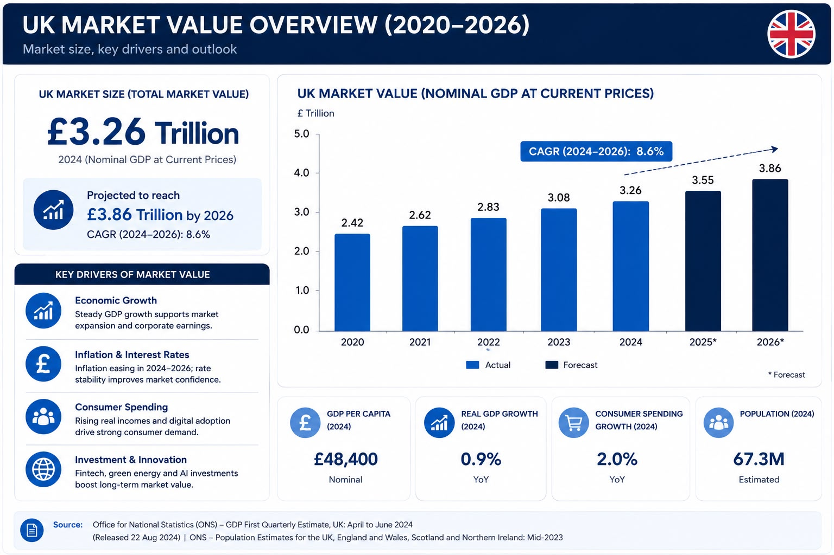
Figure 3: UK Market Value

Technological:
A major driver is rapid innovation. The bank used Google Cloud sooner than most. It crunches data and runs machine learning in BigQuery and Vertex for business intelligence and fraud fighting. The mobile-first platform enables ongoing product innovation as well as the launch of new services, such as instant payments and AI-driven fraud alerts. The advancement of tech provides the scalability at a minimal cost. However, technological threats include cybersecurity risks and fintech competition. Monzo must follow the UK’s push on AI ethics and data standards (FCA/BoE AI Consortium). The advanced technology stack of Monzo is rare and valuable which creates a competitive advantage. Nonetheless, it should protect against hacksters. The implication is that while Monzo could invest in tech (eg, ML for lending) to improve personalisation, it also needs to invest in cybersecurity and regulatory (RegTech) compliance.
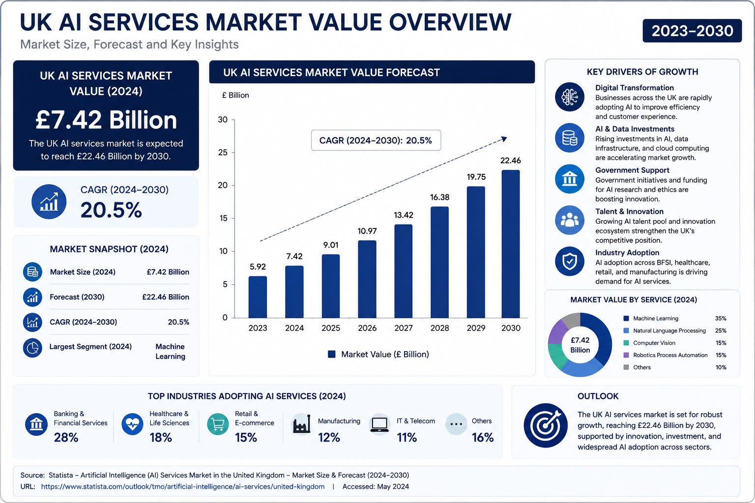
Figure 4: UK AI Services Market Value

Legal/Regulatory:
Monzo complies with fundamental UK banking regulations set by the PRA and FCA as well as the GDPR. The FCA fined Monzo £21m in July 2025 for failings in anti-financial crime from 2018 to 2020. Monzo has broken regulations on high-risk clients several times, a sign of prior failings. The FCA's activities, as well as its regulatory emphasis on fintech crime, are vital indicators that it is critical to comply with the law.
Brexit resulted in rules becoming less uniform. On the other hand, new rules could present opportunities. The compliance failures can damage the reputation severely (threat, see FCA fine) but having strong governance can be a differentiator (see FCA sandbox). To restore trust, it is crucial that Monzo focuses on regulatory adherence such as AML/KYC systems, data protection, etc. And compliance can be positioned as a trust-building CSR activity.
Environmental:
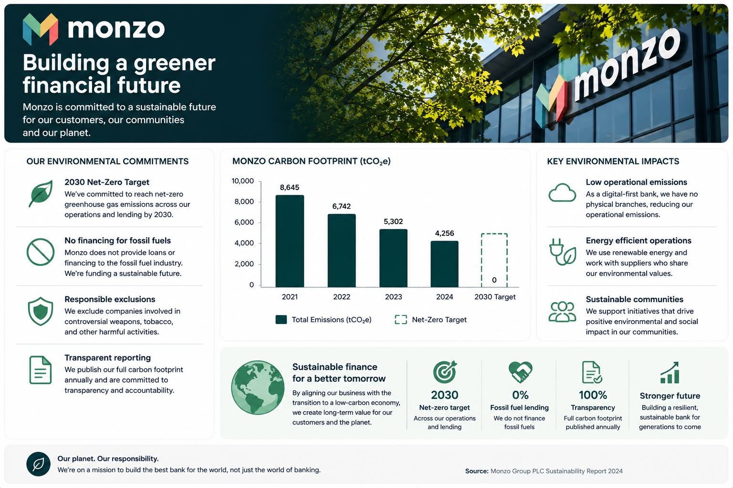
Monzo is a digital bank with no branches, which means low emissions on the branch side. The bank aims to achieve net-zero by 2030 and publishes its carbon footprint yearly. The organization doesn't provide loans to the fossil fuel industry which indicates that they avoid financing carbon-intensive sectors according to this excerpt. They also exclude arms and tobacco. Organizational initiatives are keeping pace with the increasing growth in ESG expectations. Monzo, together with Nationwide and Co-Op, doesn’t fund fossil fuel projects, according to Triodos (2026). Still, being a financial institution, it has a limited environmental impact, more so from its energy use and its suppliers. The trends of ESG which refer to sustainable finances, green bonds etc have marketing benefits. Monzo goes green: Following the footsteps of the tech giant Apple Inc., British digital bank Monzo has imposed a ban on fossile-fuel lending of its clientele.

2.2 Internal Analysis (VRIO Analysis)

- Brand & Customer Base: Monzo's brand is quite valuable (trusted by millions, NPS top) and rather rare (first mover UK neobank). With a quick rise to 12–13m users (22% of UK adults), it saw network effects (growing through word-of-mouth). In the short run, network scale and regulatory sandboxes make it hard to imitate. Monzo has structured its operations to seize this opportunity. Competitive advantage: Likely sustained as brand loyalty and scale are difficult for late entrants to replicate.
- Technology & Data: The technology and data platform of Monzo helps them in solving old banking problems and achieve low-cost service delivery and innovation. Monzo has been using cloud technology since 2015, which is relatively rare for banks. It invests in skilled teams in order to harness this (thousands of data models in BigQuery. Advantage: Temporary source of competitive advantage - other competitors can emulate tech partnerships, however, Monzo’s history of data/models will provide it an advantage.
- Innovation Culture: The bank has an agile and customer-focused culture that is valuable and hard to imitate. By having shared values (“customers love”) and a management style (flat, tech-driven), XYZ enhances its innovative capacity. A moderate rarity is seen as a lot of fintechs try this. It has a headquarters in Silicon Roundabout designed to maximize the creativity of staff. The advantage is that it results in competitive parity. It results in a temporary advantage. The culture leads to rapid products (Instant savings into Undo payments). But, the peer group also innovates similar products.
- Financial Resources: Monzo’s healthy capital (raised £500m in FY24; FY25 profit £113.9m) is valuable, and somewhat rare, among challengers. It enables investment in technology and products. Organized through sound management and approved RWA based lending. Advantage: Temporary – Monzo’s funding means it can increase its loan book faster than rivals limited by debt. Other banks can also raise capital.

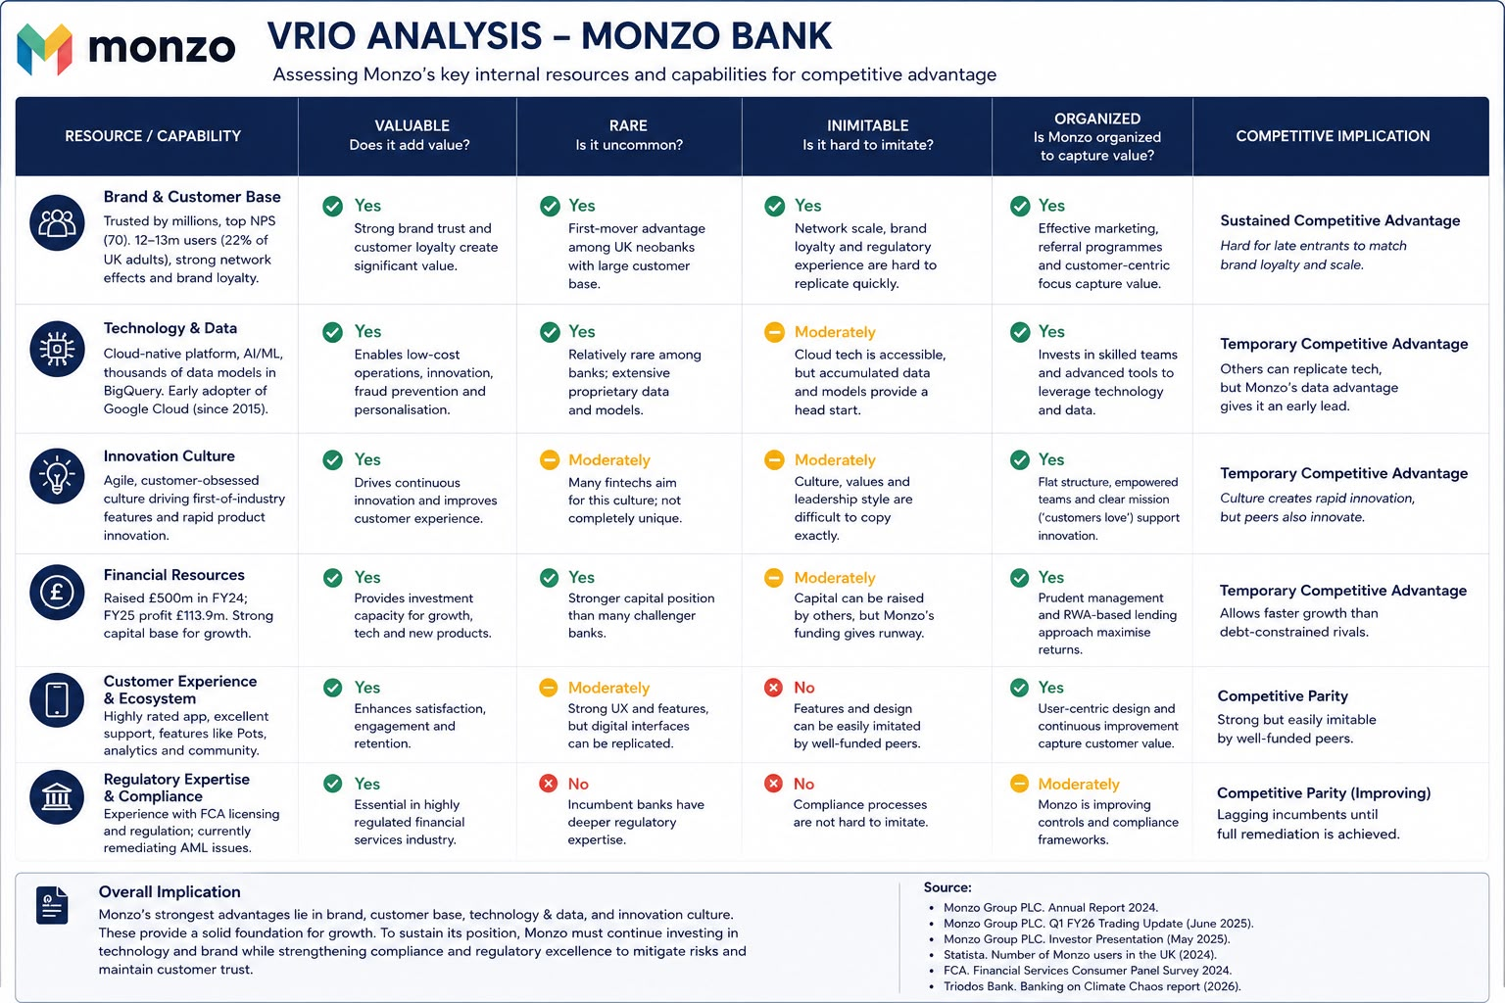
Figure 6: VRIO ANALYSIS (Canva)
Currently, Monzo has a short or long term advantage in brand, technology and data but not one on its own is sufficient for a sustained lead: rival challengers are agile and large banks are scale. Usually, the systems and culture of the bank are synchronized to get value from these resources. Monzo can enhance its tech and brand strength, while improving its weak areas such as compliance in order to stay ahead.

3.0 SWOT Analysis of Monzo

3.1 Strengths, Weaknesses, Opportunities, Threats

Strengths:
Monzo’s strong growth and loyalty: Monzo has acquired a large customer base in the UK of over 12 million users, which is ~22% of the adult population. 79% of users joined via referrals. Monzo maintains around a 70 Net Promoter Score (versus a +30 for legacy banks) indicating exceptionally high service quality and customer brand advocacy. Industry analysts have said that the strength of customer trust and engagement users switching to Monzo as their primary bank for salary, savings, and spending. Many brand and network effects aren’t easily replicated by competitors, and they reflect strong, differentiated brands.
Monzo provides a digital platform that is unique in being an all-in-one platform combined with a mobile-only proposition. Monzo offers a varied set of products including current accounts, savings, loans, credit cards, investments and soon insurance. It includes an easy to use budgeting tool called “Pots”, instant notifications on all transactions, and AI – powered alerts for possible frauds and hacks. It even started new accounts for children and pensions. This digital innovation drives customer engagement and goes further than value-added banking that strengthens Monzo’s proposition.
Weaknesses:
Monzo has had serious control issues with compliance and regulating. FCA fined in 2025 for “inadequate anti-financial crime systems” during 2018–2020 (£21.09 million). The regulator found that Monzo's financial-crime controls could not keep up with its fast-growing. Such failures in compliance have harmed its brand reputation and required expensive remediation.
The business model constraints Monzo’s business model is still relatively “narrow”, focused on deposit-taking and payments, while lending is very limited. The high Bank of England interest rates on deposits are primarily behind its latest profits, but that makes earnings vulnerable to falling rates. Also, Monzo has no branches which may hinder take-up among less tech-savvy or older customers. Due to constraints on diversification, segments that rely on only traditional banks may distrust these institutions due to a lack of trust.

Opportunities:
UK fintech sector is large, growing (market size ~£34.7 bn in 2026) with a high CAGR (~20% from 2020–25) that is conducive for entry. One of the top three fintech banks (alongside Revolut and Wise) is Monzo. It is building on this by opening abroad: it has set up an EU banking arm (in Ireland) and is moving forward with a US launch. This opens new customer pools beyond the UK. At the same time, Monzo can deepen its product stack (e.g. the recent launch of contents insurance and mobile plans, plus youth/pensions accounts) to increase wallet share as a one-stop-financial-app.
Consumer adoption of digital banking is very high. Recent study shows that ~86% of UK adults now use fintech apps for financial management. Monzo’s emphasis on digital assets suits its core demographic of young tech-savvy users. And Monzo’s commitment to sustainability (e.g. no fossil fuel financing and a pledge for net-zero by 2030) is going to meet rising ESG expectations. Climate-conscious customers will be happy, as too will any emerging regulations regarding green finance.
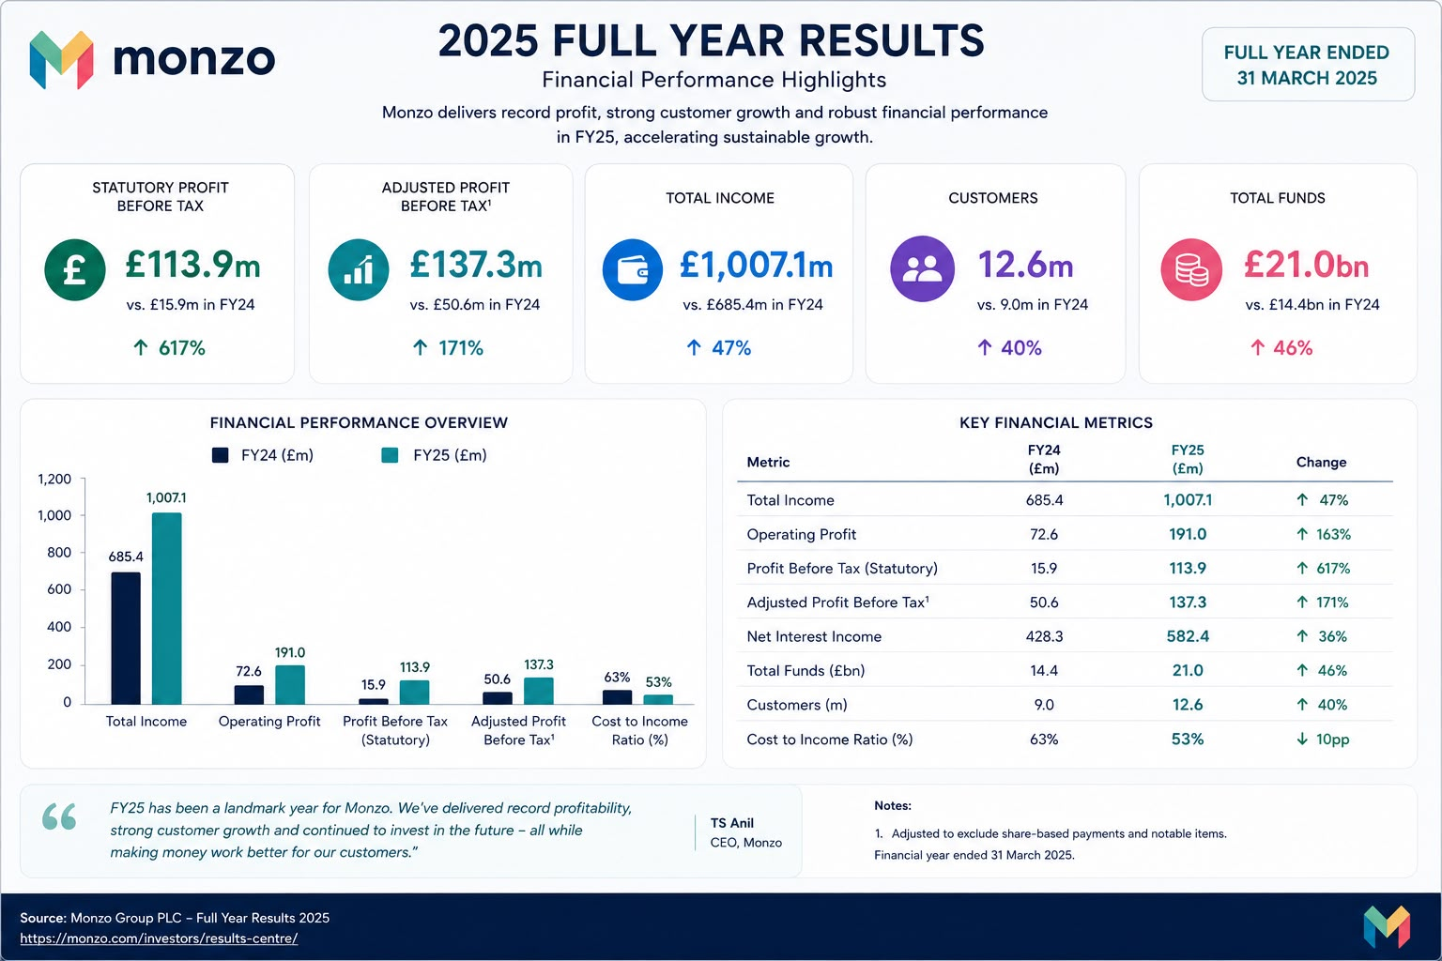
Figure 8: Financial Performance

Threats:
The banking market in the United Kingdom has intensive competition. Monzo not only competes with illustrious digital challengers such as Revolut, Starling and Wise but also with traditional banks enhancing their mobile offerings. According to industry data, the growing and high competition in UK fintech. If the competitors catch up on Monzo’s features then they will lose their differentiation.
Operational and Trust Risks: Monzo’s brand is based on reliability and trust. Any disruption of service or breach of security would result in a material risk. For instance, in January 2026, the platform’s failure to work made it impossible for thousands of users to access the app. In an area of business that is often seen to be underpinned by trust, this kind of incident – or perhaps a big cyber attack, might do considerable harm to Monzo’s reputation and hurt customer faith. Changes in regulations or economic downturns (for instance, a decrease in interest rates lowering net interest income) are external threats which could derail Monzo’s strategy.
Sources: Monzo’s official reports and UK fintech industry analyses.

3.2 Comprehensive and Holistic View of the Organisation
Critical Evaluation: These CSR/ESG activities do create strategic value: they strengthen Monzo’s brand and customer trust (especially among younger consumers concerned with ethics). For instance, Triodos notes Monzo as a leader on climate (no fossil loans) – a PR plus in the eco-conscious market. Financially, Monzo’s transparency on climate (scope 3 footprint published) can attract ESG-focused investors and customers. However, some critics argue these are partly reputational. The FCA fine shows that at least historically, corporate governance was weak, so Monzo’s CSR commitments have been tested by actual compliance failings.
Link to Strategy: Monzo’s ESG stance aligns with its mission and appeals to its target demographic (social responsibility factor). It may indirectly support customer growth (positive word-of-mouth, aid retention). Yet these efforts (e.g. carbon reporting) cost resources with unclear direct ROI – but in the banking sector, good governance and ESG often become license to operate. Overall, Monzo’s CSR appears to create strategic value by differentiating its brand (“bank you love” model) and pre-empting regulatory trends (e.g. forthcoming sustainability rules).

4. Balanced Scorecard (BSC)
Monzo’s Balanced Scorecard helps align the growth strategy across four perspectives namely, Financial, Customer, Internal Processes and Learning & Growth. All perspectives have objectives, KPIs and targets that reflect Monzo’s FY2025 results (e.g. ~25% revenue growth, NPS≥70, 99.9% uptime) and initiatives such as AI fraud detection and cloud analytics that drive its outcomes.
Financial Perspective
The initial financial goal focuses on enhancing revenue and profitability, which can be measured via revenue growth percentage. An example goal would be ~25% yearly growth. In FY2025, Monzo’s revenue rose by ~48% to ~£1.2 billion and it made £113.9m adj pre-tax profit. Efforts include growing fee-based revenues (lending, subscriptions, business banking) and cross-selling new products. Monzo has attracted hundreds of thousands of users by launching paid account tiers (Perks, Extra, Max) and a pension product.
Enhance cost efficiency as the second financial objective (KPI: cost-to-income ratio). For example, <60% might be a target. Monzo keeps its overhead down as a digital only, cloud-native company (no branches) and automates manual work. Fraud loss detection was reduced by AI. With cloud infrastructure and shared services, small teams can scale without a proportional increase in costs keeping a lean cost structure. This approach helps Monzo to grow profitably through technology.
Customer Perspective
Increasing satisfaction and loyalty is the first goal of the client (KPI: Net Promoter Score). Monzo's NPS was ~ +76 for FY2025 (versus ~30 average), so ≥ 70 is illustrative. This reflects a high degree of loyalty, ~79% of customers came through referrals. Planned enhancements to the app might include improved UX in the app like instant notifications, budgeting option, 24/7 support, and personalized insights in the app【spending analytics, savings challenges, etc.】. To reinforce loyalty, Monzo also has referral incentives and premium subscription perks.
Customer goal number two is to increase the number of customer accounts. Aim for 2 million new active accounts per year (illustrative). Monzo opened almost two million accounts in FY2025 to reach over 12 million total accounts. Growth is targeting underserved segments like young tech-savvy users and the SME sector. Monzo Business clientele developed ~49% to 625k in FY2025 after launching “Monzo Team” for bigger SMEs. Growth will be driven by enhanced digital onboarding and marketing programs.
Internal Processes Perspective
An important goal is to improve security and compliance. The KPIs measure fraud incidents or compliance breaches (target: no increase) Monzo’s fraud prevention investment included developments like “Known Locations” and “Trusted Contacts.”The number of unauthorized fraud prevented from 2022 to 2023 was around three times greater in FY2025 than in the previous year. Monzo is also finalising AML KYC changes to meet FCA requirements. These measures enhance customer security and comply with regulations.
Learning & Growth Perspective
The first learning expected is to strengthens technical skills. Research and development spend (target ~5–10% of revenue) and percentage of tech staff trained. Monzo is investing heavily in data and AI; it partners with Google Cloud for ML tools and trains engineers on BigQuery, Vertex AI, etc. Most developers are kept current by the internal training the bank runs (data/AI workshops, running security certification). Fintech experts are also hired to develop new systems.

4.1 Porter’s Five Forces
Threat of New Entrants (Moderate): While digital-only banking has relatively low physical barriers to entry, entrants must have a banking licence and sufficient capital. This increases the hurdles to entry for digital-only banks. Regulatory barriers are created by the FCA licensing process (Monzo faced an issue in 2015). However, open banking lowers switching costs, which fintech and bigtech firms (e.g. applepay, stripe) are exploring banking.
Evidence: Licenses for new challengers still being issued (e.g. Atom, OakNorth). Monzo customer base deters new entrants. Monzo needs to stay ahead on user experience, according to warnings from those appearing before a parliamentary inquiry. It should also lobby for pro-growth regulations.
Bargaining Power of Suppliers (Low): The primary suppliers of Monzo are the fintech service providers (cloud, data platforms) and card networks. Though Google Cloud has some pricing power, Monzo can technically switch to other cloud providers if required. Payment processors impose standard interchange rules (EU limit on interchange fees). Evidence shows Monzo has a long-term and strategic partnership with Google Cloud and that the market has alternatives. The implication of supplier power not being too much of a constraint is that Monzo will be able to negotiate better terms as it scales (the $500m funding in FY24 will likely help with larger contracts).
Bargaining Power of Customers (High): UK consumers have lots of options (Revolut, Starling, high street apps like Barclays Mobile). Switching accounts is not difficult to do. Customers are sensitive to price and are demanding high service (Monzo’s #1 service ranking indicates expectations). According to evidence, customers are willing to switch businesses and don’t hesitate to take away their business if unhappy.
Threat of Substitutes (High): There are other substitute institutions available like traditional banks, credit unions, etc. Even fintech payment apps (Paypal, mobile wallet), etc. Fintech aggregators allow customers to manage all their accounts across providers, thanks to Open Banking. Some clients may go back to pure branch banking for complex needs. According to FCA surveys, consumers do not fully trust digital banks on their own. Monzo’s unique offerings (Instant Pots, easy saving) offset substitutes somewhat. Monzo has to strategize around the unique value (budgeting tools, community) that other rivals cannot offer. So it is costly to substitute for other rivals in terms of lost features.
Competitive Rivalry (Intense): There is a stiff competition in the UK digital banking space. Monzo under pressure over pricing and features by Revolut (52m users, global expansion) and Starling (2.9m accounts, £301m profit). Established banks are also increasing their digital offerings to prevent customer loss.
Evidence: Revolut has been pushing its growth (profit was up 149% in 2024) with aggressive expansion plans. Crypto and digital wealth products are some of the offerings we now have for their consumers. Starling Bank’s profitability and the performance of its Engine platform also demonstrate intense competition in SME lending.
Implication: Monzo is facing stiff competition, and they will need to defend their niche (customer experience, fintech culture), and maybe avoid price wars with the giants. Joining forces with Chase UK and cooperating with fintechs could be a strategy.

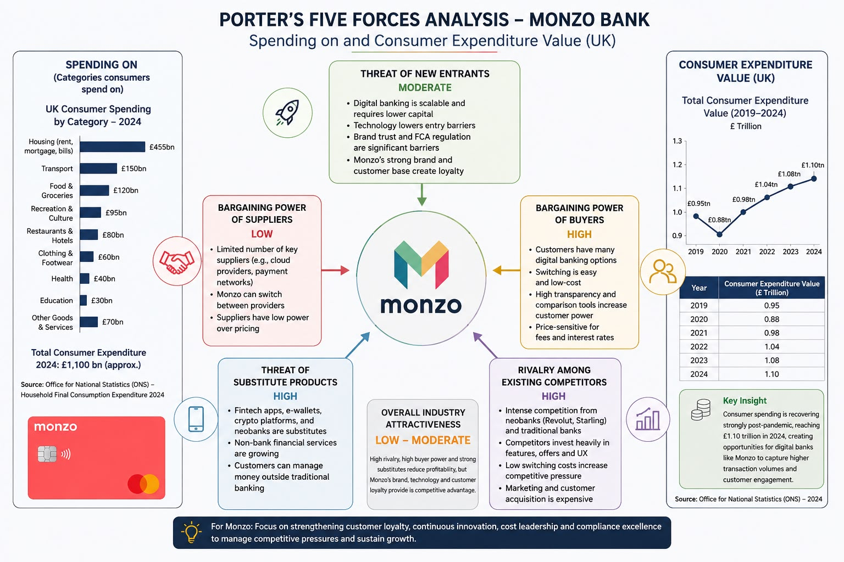
Figure 9: Spending On And Consumer Expenditure Value (Canva)

5.Ansoff Matrix

5.1 Applying Ansoff’s growth options to Monzo:

Market Penetration: Boost presence in UK current sectors. For instance, Monzo could enhance personal account uptake with tailored messaging to under-penetrated demographics (older users). The company has a 20% adult market share already, so further penetration without innovation is likely to yield diminishing returns. It may create further interaction with existing customers (e.g. cross-sell new products). Market risk: scenario is getting overcrowded, others are doing the same. Appropriate: low risk, low reward.
Product Development: Introduce innovative monetary services. Monzo has come up with features (immediate saving pots, automatic investing). Some plans for the future include mortgages similar to some challengers, advanced wealth management similar to crypto ETFs, who are already doing ETFs. Monzo's technology and customer base are leveraged which increases the capability of this organization. The advantage is significant, as this approach raises the revenue generated from each user (evident by the contribution of pay plans and lending services to FY25 revenue). Risk: Development costs, regulatory approvals (mortgages are a specialized field).
Market Development: Broaden your reach or target new customers. Monzo have started EU expansion (Ireland office) and has US intent It could also target corporate or international students with banking requirements. Use a conglomerate structure to benefit from high potential large new markets
Risk entails a high complexity involving regulation culture competition each market. Monzo’s technical capability to execute passporting makes the EU move low hanging.
Diversification: Expand into new areas that do not relate to core banking e.g., fully digital wallet like a crypto exchange, or B2B fintech service. Launching a complete crypto trading platform or BNPL, for instance. It is uncertain if Monzo fits into the e-commerce field as they are a finance company. Risk is considered to be very high as there are unfamiliar markets along with regulatory hazards. Potential high reward in the event of success (crypto was lucrative for Revolut)
Recommendation: Developing Products Seems Most Strategic. Monzo already has the digital infrastructure and loyal customers in place to absorb new products. The launch of products like pensions and ETFs is successful. By broadening its offering, Expanding products can leverage core competencies within VRIO strength of tech and data.
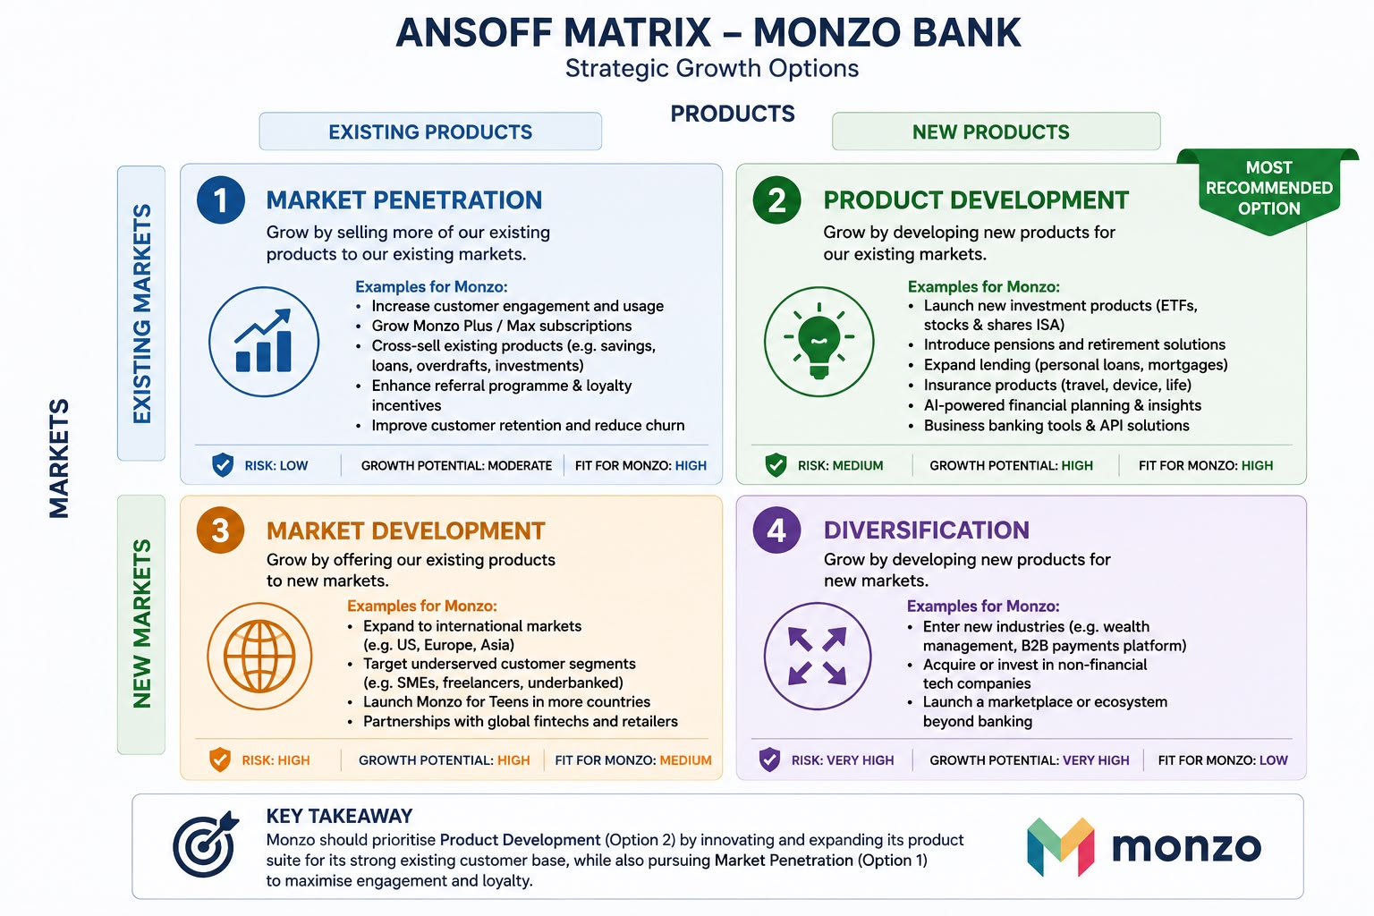
Figure 10: (Canva) ANSOFF MATRIX

5.2 SAFe Evaluation (Recommended Strategy)

Assuming Monzo’s Strategic Recommendation is To Pursue Broader Product Offering in the UK (esp. sme banking and artificial intelligence-based personal finance tools). We utilize SAFe for assessment.
Suitability: The recommended strategy takes advantage of opportunities created by technological advancement and the needs of SMEs. It utilises Monzo’s VRIO Strengths (tech/data) and reduces the “narrow banking” weakness by adding lending/products. It fits the external environment: SMEs will require enhanced banking services in tough times and customers want clever finance. The strategy closely aligns with Monzo’s mission and values (supporting small businesses, empowering customers) and builds on key trends (FinTech AI adoption).
Acceptability: Promising returns may be huge. For example, adding SME lending could drive up interest income (as the business segment expanded 12% of revenue).
Customer engagement could be enhanced with AI tools while keeping NPS high and unlocking subscription revenue. It includes execution risk i.e. failed launches and compliance. Nevertheless, Monzo's stakeholders – tech-savvy customers – might want more innovation. Investors can still expect high growth, which this strategy allows for, albeit at risk of costs rising. The investors’ faith in growth is highlighted by the capital injection (£500m F24). Overall, acceptability is moderate-to-high: rewards are compelling if managed well.
Feasibility: Monzo has financial resource (profitability, funding) to invest. In FY2024, the profit of £15.4m is small, but FY2025’s £113.9m shows capital. The technology and people capabilities are in place (Monzo has 3,700 engineers). Indeed, Monzo can financially commit to new risk assessment systems for SME banking because of new governance structures. Monzo already has banking licenses; however, if they add lending, they will need to build compliance teams. The likelihood of success at technical level is high (they have cloud/AIdata). In general terms, most of the things are there, only marketing and some training will be incremental.
To summarize the above analysis, Monzo has found a strategy which is appropriate to its environment and resources, acceptable to stakeholders and feasible, given its capabilities. It is vital to pay attention to regulatory compliance (which is nothing new), cost control and brand alignment of new offerings.
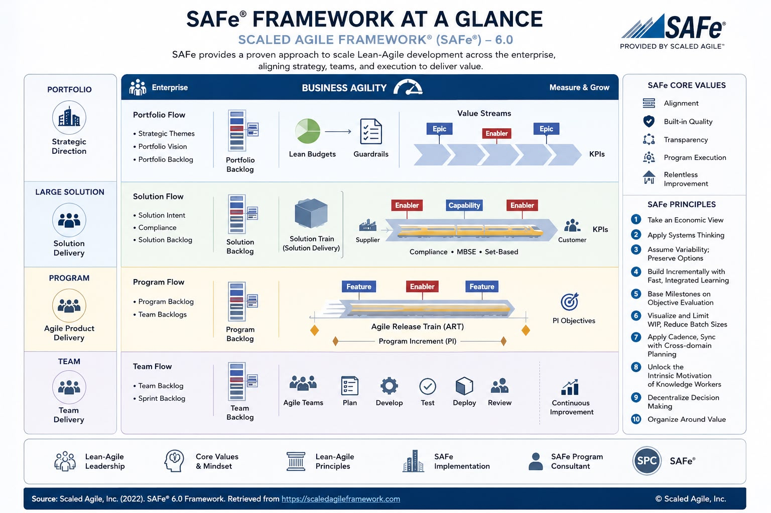

Figure 11: SAFe Framework(Canva)

6.Final Strategic Recommendation
In summary, Monzo should further deepen and broaden market penetration in the UK through product improvement measures and further SME banking expansion. Monzo literally can.
Expand SME Banking: Leverage on its momentum 625k business customers and be the preferred small business bank. This aligns with Monzo’s easy mobile tech and its brand resonance (40% female led businesses) with younger entrepreneurs. SME customers often need banking services (loan, payroll) that traditional competition is slow to go digital with. Monzo can help itself by tailoring a business loan to increase deposits and revenues or adding integrated accounting tools.
Launch AI-Driven Financial Tools: Create personal finance options empowered by AI (e.g. automated saving suggestions, credit optimisation, investment advice).
The implementation of this personalization capability can be accomplished due to Monzo’s advanced data analytics powered by Google BigQuery and Vertex AI. The initiation of such actions would enhance engagement and justify new fees/subscriptions (premium budgeters). Monzo is also distinguished from rivals.
Work with fintechs (e.g. Google Cloud) to develop new offerings (e.g. loyalty programs, open finance APIs). That matches natural growth and the risk.
Why This Strategy: It responds directly to the identified risk of narrowing banking models. (Monzo has lots of deposits given low lending) The strategy leverages Monzo’s VRIO strengths (its tech, data and customer trust) as well as external opportunities (SME demand, tech adoption). Monzo's brand is an important one to leverage. It can also result in lower regulatory hurdles. International expansion is riskier and dissimilar. These projects are funded thanks to the impressive financial performance (revenue £1.2bn, profit £113.9m FY25).
Risks and Mitigation: If SME loans are offered, credit risk would be the main risk and execution risk. The phased rollouts and conservative credit underwriting can mitigate these. Monzo should keep developing its compliance framework, as regulatory scrutiny (FCA) is here to stay (learning from the £21m fine). To enhance your skills, choose a subject area that interests you.
Measuring Success: Key measures will encompass: business deposit balance growth (for SME strategy); SME products revenue and profit; feature uptake; NPS (must not be less than 70); and user retention.

6.1 Implementation Challenges
The execution of this strategy by Monzo necessitates close alignment of the banking, product, marketing and risk teams, along with transparent individual accountabilities and sufficient resources. The credit, regulatory and data-privacy risks will be tackled on aggressive timelines through pilot programs, automation, and phased-rollouts, which are the main challenges.

The business banking team will create the SME loan product with the help of new funding and insurer partnerships. A time frame of 6 to 12 months is feasible, given Monzo’s recent lending pilots and the existence of ~700K SME customers, loan volume and revenue as KPIs. The main risks are credit defaults and delays in receiving FCA approval; these are mitigated through a pilot on our own automated ML credit-scoring and early contact with regulators.

Monzo, the online-only bank, is working on a new artificial intelligence budgeting tool for its users which will be available in about 3-6 months.
Metrics used include adoption and usage rate. Data privacy and algorithmic bias are serious risks. Mitigating them requires a GDPR privacy-impact assessment and model transparency. Monzo's mature ML platform allows for rapid prototyping, although extensive testing will be conducted.

CMO Marketing and Strategy team Fintech partnerships run in parallel A marketing campaign targeting a niche business channel will run for two–three months and will monitor new accounts’ ROI. Mitigation of mis-targeting risk can be done through careful messaging (e.g. emphasis on Monzo’s 40% women entrepreneurs) and referrals. Collaborations aimed to develop new features over ~6-9 months. Further, if integration takes time or partner does not work out, it will be vetted rigorously and also integrated via low-risk pilots.

The continuous improvements to compliance mechanisms and staff training (CRO-led) happen all the time, with audits and zero breaches being KPI’s. The FCA's notice of 2025 called attention to Monzo's insufficient controls for financial crime. Regulatory lapses, as well as cultural inertia, form a risk. The ownership of compliance will be embedded in all teams and not restricted to one. Training will be continuous and policies will be regularly updated. Monzo has finished a financial-crime remediation programme which shows a need for governance.

We will deliver new features in agile sprints of 1–2 months, based on feature releases. Strict product governance (MVP focus, code reviews) manages scope creep and tech debt. Monzo operates using a cloud-native tech stack (BigQuery, Vertex AI) to innovate. Wesfarmers’ headcount has grown from around 3,300 at end-2023 to 5,200 at end-2026 which is a scaling challenge. Importantly, SME growth would fuel demand for higher support. Monzo employs LLMs/chatbots to troubleshoot customer queries already, but further recruitment and training will be needed for service levels.

Section 2: Reflective

1.1 Reflection Using Gibbs' Reflective

1.1.1 Description:
The approach to Section 1 included the use of official data from Monzo and strategic frameworks. I consulted Monzo’s 2025 Annual Report and associated investor communications for relevant financial and customer metrics and reviewed FCA publications for relevant regulatory context (e.g. a press release on Monzo’s £21m fine for compliance failures). I carried out PESTEL Analysis (which includes tech trends and regulatory change) and a VRIO analysis of Monzo’s resources (customer base, tech platform, brand). After the first couple of graphs, I realized I’d miss-filled a SWOT analysis. I had initially deleted it. I added it back. A SWOT analysis links external opportunities and threats to internal and organizational capabilities. Monzo’s CSR commitments were assessed by developing a Balanced Scorecard that aligns financial, customer, process and learning objectives. Ultimately, I identified strategic options and created the recommendation and implementation plan through the use of Porter’s Five Forces, Ansoff’s Matrix, and SAFe criteria.

1.1.2 Feelings
Initially, I felt eager and confident as I looked forward to applying strategic models to the case of Monzo. Working with PESTEL and VRIO was easy at the start. However, I was frustrated and anxious when I found the SWOT section was missing and that it was an essential component of digest. This mistake made me anxious to correct it. As I moved along and watched the analysis come together, like embedding Monzo’s CSR goals into the Balanced Scorecard, I began feeling satisfied, content, and accomplished in how the sections connected. At the end, though, I was glad and more confident, as I saw how everything fit together.

1.1.3 Evaluation
One of the strengths of my approach was a structured framework, which ensured comprehensive coverage of Monzo’s situation. Using actual numbers from the annual report from Monzo and the FCA press release informed the analysis. Making real the CSR analysis were Monzo’s emissions targets (net-zero by 2030 and carbon reporting transparency). During the writing process, I realized I hadn't included a SWOT. Conversely, I realized what was not effective: I miscalculated the requirement for time to source a diverse range – industry and academic opinions – and I didn’t ask for feedback early enough. The first SWOT failure reflected these flaws, requiring additional rework. To sum up, the methodology aided in focusing the analysis, but time management and oversight-checks require improvement.

1.1.4 Analysis
What happened serves as a valuable lesson. The belated inclusion of SWOT made it apparent to me that I must launch a complete checklist linking PESTEL and VRIO findings. The technological strengths of Monzo aligned with the market opportunities identified in the PESTEL analysis, only after consolidating with a SWOT did that clear. Kaplan and Norton realized that financials are not enough; when you include customer satisfaction and learning perspective measures, the view becomes more balanced. This is illustrated in the Balanced Scorecard work. It was a revelation that multiple views require multiple strategies. Moreover, by looking into Monzo’s official reports and FCA guidance, I understood the benefits of relaying on credible sources. Additionally, experience pointed out that an iterative review (including peer feedback) may have caught the missing SWOT earlier.

1.1.5 Conclusion
This reflection shows that planning, good sources, and review are critical features in the strategy analysis. Catching the missing SWOT mid-way signifies adaptability and doing things properly. I learnt to give careful consideration to assignment criterias and allocate time to each framework. We engaged with official reports from Monzo, guidance from the FCA and strategy concepts from the academic literature. All in all, I feel much more assured in applying these frameworks systematically in the future, having seen how everything fits together.

1.1.6 Action plan
After reflecting on the experience, I will take many practical measures to enhance the quality and organisation of future projects. To begin with, in the **first week of the next project**, I will prepare a checklist of PESTEL, SWOT, VRIO and other analyses required for the entire project. The main success measure will be completing the checklist and ensuring that no crucial portions are missed in the project.

Next, I will hold bi-weekly meetings with a supervisor or co-workers throughout the project. The focus of these reviews is to help you uncover any weaknesses, gaps or unclear argumentation early in the day, rather than close to the deadline. All feedback from each review will be evaluated and responded to in the upcoming phases of the research. The successful outcome of this intervention will therefore be measured by checks ensuring that feedback is documented consistently into the final work.

Eventually, I will broaden my research sources by the halfway point of the project. I’ll be looking for relevant academic journals, industry reports, and publications, instead of mostly depending on a limited number of sources. The target will include at least three additional scholarly or industry sources in the research. This should increase the quality of evidence for the analysis and ensure a wider range of gaps.

Overall, I will structure my future research so that it is more complete and evidence-based. I can reduce omissions and improve quality in my academic work through better planning, continual feedback and use of a wider range of materials.

2. References

1. Ansoff, H.I. (1957) ‘Strategies for diversification’, Harvard Business Review, 35(5), pp. 113–124.
2. Barney, J. (1991) ‘Firm resources and sustained competitive advantage’, Journal of Management,
17(1), pp. 99–120. doi: 10.1177/014920639101700108.
3. Financial Conduct Authority (2025) FCA fines Monzo £21m for failings in financial crime controls.
Available at:
https://www.fca.org.uk/news/press-releases/fca-fines-monzo-21m-failings-financial-crime-controls (Accessed: 8 August 2026).
4. Financial Conduct Authority (2026a) About the Consumer Duty. Available at:
https://www.fca.org.uk/firms/consumer-duty/about (Accessed: 8 August 2026).
5. Financial Conduct Authority (2026b) Innovation insights 2025. Available at:
https://www.fca.org.uk/publications/corporate-documents/innovation-insights-2025 (Accessed: 8 August 2026).
6. Gibbs, G. (1988) Learning by Doing: A Guide to Teaching and Learning Methods. Oxford: Oxford Polytechnic.
7. Kaplan, R.S. and Norton, D.P. (1992) ‘The balanced scorecard—measures that drive performance’,
Harvard Business Review, 70(1), pp. 71–79.
8. Monzo Bank Limited (2024) Monzo Annual Report 2024. Available at:
https://monzo.com/annual-report/2024 (Accessed: 8 August 2026).
9. Monzo Bank Limited (2025) Monzo Annual Report 2025. Available at:
https://monzo.com/annual-report/2025 (Accessed: 8 August 2026).
10. Monzo Bank Limited (2026) Monzo Annual Report 2026. Available at:
https://monzo.com/annual-report (Accessed: 8 August 2026).
11. Porter, M.E. (1979) ‘How competitive forces shape strategy’, Harvard Business Review, 57(2), pp. 137–145.
12. Whittington, R., Regnér, P., Angwin, D., Johnson, G. and Scholes, K. (2023) Exploring Strategy:Text and Cases. 13th edn. Harlow: Pearson.
13. Information Commissioner’s Office (ICO) (2026) Artificial intelligence. Available at:
https://ico.org.uk/for-organisations/uk-gdpr-guidance-and-resources/artificial-intelligence/ (Accessed: 8August 2026).
14. Information Commissioner’s Office (ICO) (2026) AI and data protection risk toolkit. Available at: https://ico.org.uk/for-organisations/uk-gdpr-guidance-and-resources/artificial-intelligence/guidance-on-ai and-data-protection/ai-and-data-protection-risk-toolkit/ (Accessed: 8 August 2026).
15. Office of the Information Commissioner (ICO) (2026) Legal framework for explaining decisions made with artificial intelligence. Available at: https://ico.org.uk/for-organisations/uk-gdpr-guidance- and resources/artificial-intelligence/explaining-decisions-made-with-artificial-intelligence/part-1-the-basics of-explaining-ai/legal-framework/ (Accessed: 8 August 2026)

