Programme: | MSc Public Health and Social Care in Practice
Module: | Population Health and Digital Health Promotion
Module code: | LCHS7009
Lecturer: | Dr Ping Wu
Assignment Title: | Component 1: 2 Blogs
Student Name: | Mst. Shahrin Sultana
Student ID: | 2503591

“Blog 1: The Influence of The Apple Watch on Health Enhancement and Wellness”

The Apple Watch and Health Promotion
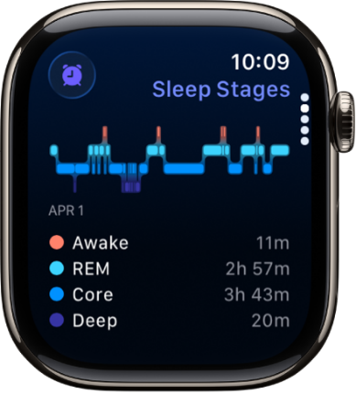
A link exists between the contemporary fast-paced environment and a rise in sedentary lifestyles, cardiovascular diseases, and inadequate sleep (Asimakopoulos et al., 2024). The Apple Watch and similar wearables are advantageous for health. This blog discusses the Apple Watch's health promotion, public health effect, and limitations (Apple, 2024).
Get started with health features on Apple Watch

Apple Watch: A Revolutionary Advancement in Health Promotion
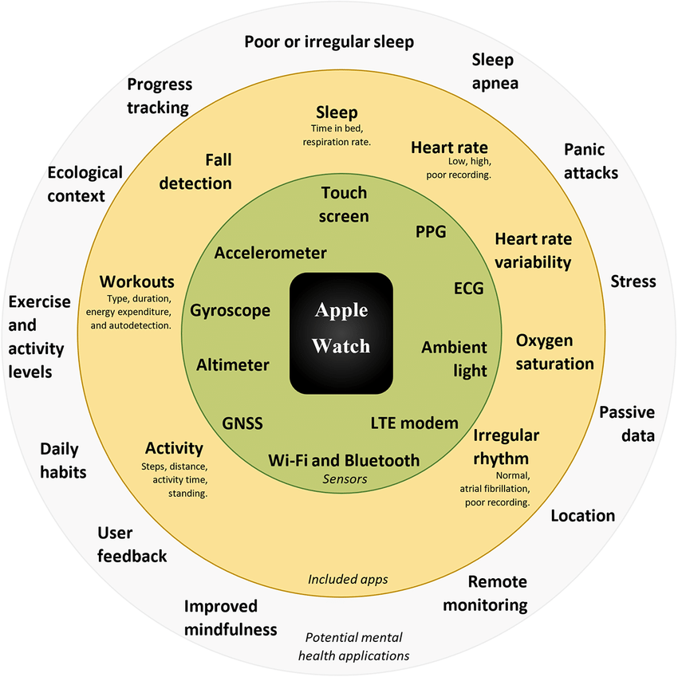
The Apple Watch promotes physical activity, health monitoring, and the attainment of wellness goals with its health-tracking features and personalised feedback. The primary objectives are heart rate, ECG, sleep patterns, and step count. The Apple Watch monitors HR using photoplethysmography (PPG) with optical sensors, EE with its own algorithms, and steps with a built-in accelerometer and gyroscope (Choe and Kang, 2025). Combining sensors to measure health parameters may provide more accurate findings than accelerometery or PPG alone. The Apple Watch Fitness app promotes users to stand, move, and exercise every day, hence enhancing their overall health (Lui et al., 2022).
(Lui et al., 2022)

Tackling Public Health Issues
Inactivity poses a substantial public health issue because to its association with cardiovascular disease, diabetes, and obesity. The World Health Organization identifies inactivity as a significant factor contributing to global mortality. The problem is addressed with the Apple Watch by establishing daily movement objectives. Engaging in physical activity, including mobility and exercise throughout three distinct fitness circles, is highly recommended (Lui et al., 2022). Metrics and reminders on an Apple Watch may significantly impact users' habits (World Health Organization, 2024).

Benefits of the Apple Watch in Health Enhancement
There are defects with the Apple Watch. Users may misinterpret the electrocardiogram (ECG) results, even if it is beneficial since it does not provide a comprehensive clinical diagnosis. The iPhone's accessibility is constrained by its elevated cost and requisite nature, particularly for those with poor means or insufficient technological skills. Users may cultivate an unhealthy reliance on the device, since it cannot address fundamental health concerns such as poor diet or insufficient sleep (Löchner et al., 2025).

Constraints and Deficiencies
The Apple Watch, although useful, has several drawbacks. It operates in real-time but does not provide the diagnostic advice of a physician or medical expert. The electrocardiogram (ECG) diagnosis is very beneficial; nonetheless, it cannot replace a clinical assessment. The Apple Watch's elevated price and need for an iPhone render it less accessible, particularly in low-income or technologically deprived regions (Diano, 2023).

Confronting the Limitations
If Apple want to enhance public health, it should consider increasing the accessibility of the Apple Watch. Subsidies or collaborations with health institutions might make the gadget accessible to economically disadvantaged individuals. The Apple Watch might enhance its use for health and wellbeing by including mental health applications and refining health analytics.

References
Apple (2024). Apple Watch. [online] Apple. Available at: https://www.apple.com/watch/.
Asimakopoulos, G., Asimakopoulos, S. and Spillers, F. (2024). ‘It tracks me!’: An analysis of apple watch nudging and user adoption mechanisms. Health Informatics Journal, 30(4). doi: https://doi.org/10.1177/14604582241291405.
Choe, J.-P. and Kang, M. (2025). Apple watch accuracy in monitoring health metrics: a systematic review and meta-analysis. Physiological Measurement. doi: https://doi.org/10.1088/1361-6579/adca82.
Diano, F. (2023). Empower Psychotherapy with mHealth Apps: The Design of ‘Safer’, an Emotion Regulation Application. Information, 14(6). doi: https://doi.org/10.3390/info14060308.
Löchner, J., Carlbring, P., Schuller, B., Torous, J. and Sander, L. (2025). Digital interventions in mental health: An overview and future perspectives. Internet Interventions, [online] 40(100824). doi: https://doi.org/10.1016/j.invent.2025.100824.
Lui, G.Y., Loughnane, D., Polley, C., Jayarathna, T. and Breen, P.P. (2022). The Apple Watch for Monitoring Mental Health–Related Physiological Symptoms: Literature Review. JMIR Mental Health, [online] 9(9), p.e37354. doi: https://doi.org/10.2196/37354.
Lui, G.Y., Loughnane, D., Polley, C., Jayarathna, T. and Breen, P.P. (2022). The Apple Watch for Monitoring Mental Health–Related Physiological Symptoms: Literature Review. JMIR Mental Health, [online] 9(9), p.e37354. doi: https://doi.org/10.2196/37354.
World Health Organization (2024). Physical activity. [online] World Health Organization. Available at: https://www.who.int/news-room/fact-sheets/detail/physical-activity.

Blog 2: “A Smartphone Application for Mental Health Awareness and Coping Support”

An Application for Mental Health Awareness and Coping Mechanisms
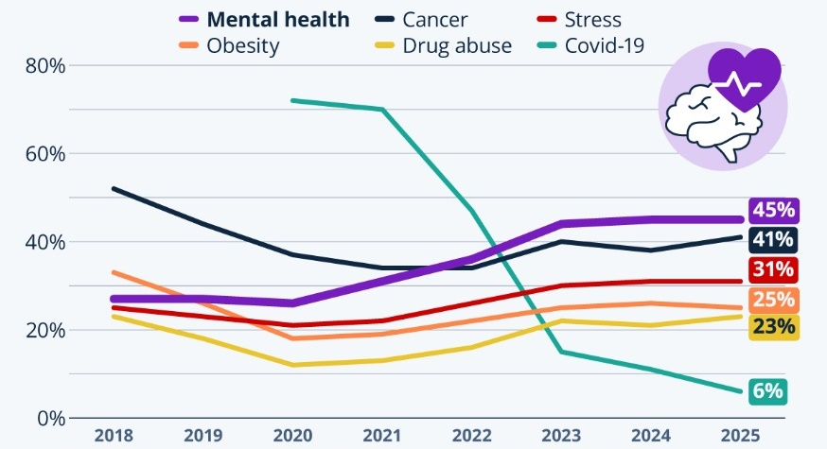
Over 1 billion people, or approximately 1 in 7 globally, live with a mental health disorder, with anxiety and depression being the most common, say the World Health Organization (2025). In 2020, just 27% of respondents saw it as one of their nation's most urgent health concerns. By 2024 and 2025, that percentage had increased to 45% (Fleck, 2025).

(Fleck, 2025)
Traditional mental health treatments include therapy, medication, and institutionalisation. Mental health and well-being mobile apps have great promise. This blog will discuss a mobile app that teaches coping skills and improves awareness of mental health, its effects, and possible issues (Moitra et al., 2023).

Tackling Mental Health Issues
Alternatives for managing stress, anxiety, and mild to severe depression. It encompasses mood monitoring, mindfulness, guided meditation, cognitive behavioural therapy (CBT) approaches, and mental health education (Nabi et al., 2025). These partnerships also increase well-being, mood regulation, and coping mechanisms. Individuals seeking anonymity or lacking access to professional assistance might employ the initiative, since it promotes early intervention and mitigates stigma. Firth et al. (2017) demonstrate that digital therapy, psychoeducation, and rapid assistance enhance mental health outcomes.

Characteristics of the Designed App
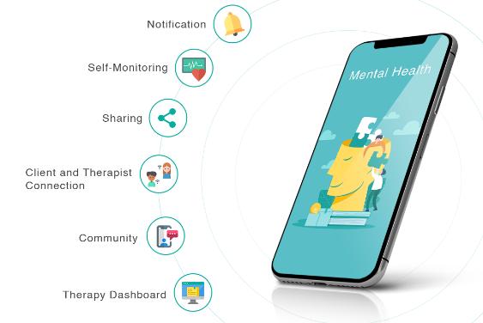
The program monitors mood to identify triggers and enhance mental well-being. According to Goyal et al. (2014), mindfulness practices and meditation alleviate anxiety and depression. Cognitive behavioural therapy (CBT) enhances cognitive quality by eradicating negative ideas. The app covers topics such as self-care, coping mechanisms, mental health, podcasts, and videos. A peer support group is a voluntary assembly where individuals may interact, converse, and motivate one another within a nurturing atmosphere (Firth et al., 2017).

Influence of the Application on Health Promotion
The program aids users in managing and seeking support for their mental health. This program promotes proactive mental health management by offering self-help tools and information. Normalising discussions and creating a safe space for seeking solutions mitigates the stigma around mental health (Moitra et al., 2023).

Limitations
Despite its use, the program has many limitations. It may be unsuitable for those with severe mental health disorders necessitating specialised treatment. Applications may diminish in appeal due to their reliance on human interaction. Not all individuals possess the requisite digital skills or resources, such as a mobile phone or internet access, to use the program (Yang and Zhao, 2019).

Resolving the Limitations
For customers unable to surmount these limitations, the program may recommend contacting helplines or pursuing in-person therapy. The software should include video conferencing with qualified therapists. Gamification, customised messages, and reminders may enhance long-term adherence (Nabi et al., 2025).

References
Firth, J., Torous, J., Nicholas, J., Carney, R., Pratap, A., Rosenbaum, S. and Sarris, J. (2017). The efficacy of smartphone-based mental health interventions for depressive symptoms: a meta-analysis of randomized controlled trials. World Psychiatry, 16(3), pp.287–298. doi: https://doi.org/10.1002/wps.20472.
Fleck, A. (2025). Infographic: Mental Health Awareness Has Gained Ground Worldwide. [online] Statista Daily Data. Available at: https://www.statista.com/chart/35268/top-health-concerns-as-30-country-average/?srsltid=AfmBOorLn_lUc9lRLyA4UstvPDLMhQICWbTdq3LtTKEMyHej8dOIybai
Goyal, M. (2014). Meditation Programs for Psychological Stress and Well-being. JAMA Internal Medicine, [online] 174(3). doi: https://doi.org/10.1001/jamainternmed.2013.13018.
Moitra, M., Owens, S., Hailemariam, M., Wilson, K.S., Mensa-Kwao, A., Gonese, G., Kamamia, C.K., White, B., Young, D.M. and Collins, P.Y. (2023). Global mental health: Where we are and where we are going. Global Mental Health: Where We Are and Where We Are Going, [online] 25(7). doi: https://doi.org/10.1007/s11920-023-01426-8.
Nabi, A.A., Ahmad, I., Muhammad, Zaman, K. and Anser, M.K. (2025). Advancing Mental Health Care: A Comprehensive Review of Digital Tools and Technologies for Enhancing Diagnosis, Treatment, and Wellness. Health care science. doi: https://doi.org/10.1002/hcs2.70018.
World Health Organization (2025). Over a billion people living with mental health conditions – services require urgent scale-up. [online] Who.int. Available at: https://www.who.int/news/item/02-09-2025-over-a-billion-people-living-with-mental-health-conditions-services-require-urgent-scale-up.
Yang, X. and Zhao, X. (2019). Factors Influencing User’s Adherence to Physical Activity Applications: A Scoping Literature Review and Future Directions. International Journal of Medical Informatics, [online] 134. doi: https://doi.org/10.1016/j.ijmedinf.2019.104039.

