Module Assignment Submission
Cover Page

Student Name: | Holly Seymour
Student Number: | 1811537
Module No: | BMSK 6004
Module Title: | Strategic Management of SME

Date submitted:
Time submitted:
Statement of Confirmation of Authenticity
By the act of making this submission, the student declares that this is the work of the student named above. Where materials have been used from other sources it has been properly acknowledged. If this statement is untrue, the student acknowledges that an assessment offence has been committed. Proven incidents of plagiarism, collusion or cheating can result in a learner being withdrawn from a
qualification.
Attention is drawn to the Plagiarism, Collusion and Cheating Policy and Unfair Practice policies of the University and ILM.
Permission for ILM to use this script
ILM uses learners’ submissions – on an anonymous basis – for assessment standardisation. By submitting, both the centre and the learner agree that ILM may use this script on condition that identifying information is removed. However, if you are unwilling to allow ILM use this script, please refuse by ticking the box: □

Contents
1.0 Introduction 3
1.1 What is strategy? 3
1.2 What is Strategic Management? 3
2.0 Macro Analysis 5
2.1 Political 5
2.2 Economic 6
2.3 Social 6
2.4 Technology Advancement 6
2.5 Legal 6
2.6 Environmental 6
3.0 Micro Analysis 7
3.1 Customers 7
3.2 Employees 7
3.3 Competitors 8
3.4 Media 8
3.5 Shareholders 8
3.6 Suppliers 8
3.7 Culture 8
3.8 Conclusion 8
4.0 Admiral’s Mission Statement and Strategy for Growth 9
4.1 Values 9
4.2 Objectives 9
4.3 Understanding Strengths and Weaknesses 9
4.4 Employee Engagement 10
4.5 Progress 10
5.0 Alberto’s PSSVC model 10
6.0 Conclusion 11
References 12
Appendix A 14
Appendix B 15
Appendix C 16
Appendix D 17
Appendix E 18
Appendix F 19
Appendix G 20

1.0 Introduction
Admiral Insurance was the source of information for this study. The student is currently employed as a Compliance Officer at Admiral; as part of her job, she interacts with colleagues and customers, so she is aware of critical stakeholders. She's worked with senior executives before, giving her an overview of Admiral's strategic management, including its vision, values, current developments, and future ambitions. During her time at the organisation, the student has seen changes done across the board, giving her a comprehensive understanding of how they handle change and their strategic management direction.

1.1 What is strategy?
The broad determination of an undertaking's aims and the specification of different courses of action to be adopted to accomplish the undertaking's planned goal is known as strategy. Corporate strategy, according to Chandler, A. D. (1962), is "the establishment of an enterprise's essential long-term goals, as well as the choice of courses of action and resource allocation necessary to achieve those goals." Ansoff, H. I. (1979) believes that strategy provides a broad notion of a company's operation, establishes particular criteria by which the company can conduct its search, and subjects the company's decision to the most appealing opportunity. According to Drucker, P., (1954), strategy is a company's fundamental approach to accomplishing its overall goals. It is a method for defining organisational goals, making strategic decisions, and monitoring progress toward those goals that is cautious, methodical, and systematic. Johnson and Scholes (1997) believe that strategy is an organisation's long-term direction and scope in a changing environment; it creates organisational benefits by forming resources that enable them to satisfy the demands of their stakeholders. Strategies provide organisations a feeling of direction and purpose. It is clear from this sequence of definitions that strategy is in play. According to this chain of definitions, strategy is the pattern of decisions in a company that determines and reviews its objectives, purposes, and goals, produces the primary policies and plans for achieving these goals, and defines the type of business the company will pursue, the type of economic and human organisation it will be, and the nature of economic and noneconomic contributions it will make to its beneficiaries. Essentially, corporate strategy is concerned with product market positioning: how the firm will choose marketing and product areas in which to compete (i.e. product marketing combination), the path in which the firm will look to grow and progress, the profit and growth objectives it seeks to achieve, the interaction between the firm and its external parameters (the world around it or the environmental domain), its internal adjustment policies and programmes to changes in marketing places or other elements in its external environment; the competitive tool the company will use, such as price changes, offering quality discounts to customers, introducing new product lines, using consulting services, and the way the company will configure its resources. ‘The essence of strategy formulation is coping with competition. Yet it is easy to view competition too narrowly and too pessimistically. While one sometimes hears executives complaining to the contrary, intense competition in an industry is neither coincidence nor bad luck.’ (Porter, 1979)

1.2 What is Strategic Management?
The process and strategy of defining an organization's objectives, adopting policies, programmes, paradigms, and plans to attain those objectives, and allocating resources to implement those policies, programmes, paradigms, and plans is known as strategic management. To put it another way, strategic management can be perceived as management of the coordination of the three stages of the strategy process: strategy development, strategy implementation, and strategy evaluation. T. Morden (2013) examines strategic management and claims that it is concerned with an organization's direction; where it is today and where it wants to be in the future. Understanding an organization's strategic position, making future strategic decisions, and managing strategy in action are all part of strategic management. Exploration and management of an organization's business strategy is part of strategic management. It also entails modelling and analysing the system's entire corporate strategy, which includes the organisation's strategic position, strategic decisions, and strategy in action within and around the organisation, as shown in Appendix A.
The external environment's impact on strategy, an organization's strategic capability (resources and competencies), stakeholder expectations and influence, as well as cultural and historical influences such as organisational, sectoral, and national historical parameters are all part of the strategic position. Understanding the underlying foundations for future strategy at the business unit, corporate, and international levels, as well as the possibilities for developing strategy in terms of both the directions and technique of development, are all part of strategic decisions. The goal of strategy in action is to ensure that created plans are implemented effectively. This usually entails a detailed examination of the organization's strategy formulation processes, as well as restructuring the organisation to promote effective and efficient performance (optimal productivity) in terms of organisational structures, processes, and relationships. Ritson, N. (2008) delves deeper into strategic management, defining it as the "organised development of resources in pursuit of objectives" Ritson views strategic management is a set of policies designed by higher executives that will influence the scope and direction of the company. Strategic management will eventually identify an company’s intention and capabilities, as well as give a framework for future decision-making and management planning. Strategic management, like strategy definition, allows organisations to define their perceptive, objectives, and strategies. Understanding the objective and type of business that an organisation is in is an important aspect of strategic management.
As published on Admiral’s website their business model is “Prioritising satisfied customers and happy staff”.
Valued Customers
They mention that every day revolves around attracting, keeping and satisfying their customers. They value customers above everything else and strive to design products that customers want and that represent value for money.
Great place to work
They also go out of their way to make Admiral a GREAT place to work and believe that if people like what they do, they’ll do it better. They have created an environment where Admiral employees look forward to coming to work and providing great service to customers.
Focus on profitability
Admiral continues to focus on bottom-line profitability in the short, medium and long term, and this perspective guides the decisions we make across all of their business operations. The Group’s strategy is to build profitable and sustainable business operations for the long term.
Efficient capital employment
Sharing risk with co- and reinsurance partners is an important part of Admiral’s business and these relationships are underpinned by strong underwriting results. Sharing risk allows Admiral to provide capital backing for a minority of its business. This results in a superior return on capital for Admiral shareholders whilst also providing financial support if things go wrong.
Shareholder Returns
Admiral are committed to returning excess capital to shareholders. They believe that keeping management hungry for cash keeps them focused on the most important aspects of the business. They don’t starve our businesses, but neither do they allow them the luxury of excess capital.

2.0 Macro Analysis
T. Levitt (1960) emphasises the significance of an organisation's strategic decision-making being based on a clear understanding of what kind of business it is. Comparably, Lloyd and Maguire (2002) emphasise the importance of an organisation's understanding of itself and its environment, declaring that this experience is essential for long-term organisational success. Beamish and Ashford (2007) suggested that companies conduct macro-environment and micro-environment analyses to bring together the organization's strengths, weaknesses, threats, and opportunities, allowing them to identify and prioritise issues that need to be addressed before making decisions or implementing changes.
Before making decisions or changing, Drummond, G., and Ensor, J. (2006) feel that a study of the external environment is required to allow the organisation to recognise the emerging opportunities and dangers that may need to be handled. Kotter, J. (1997) mentioned that macro-environmental influences are becoming increasingly powerful, forcing organisations to cut costs while maintaining service quality, which Admiral does not appear to have.

2.1 Political
Government 'help' to business is just as disastrous as government persecution... the only way a government can be of service to national prosperity is by keeping its hands off." Ayn Rand (1986)
The company's businesses are regulated by various governmental and regulatory authorities in the countries of its operation. Changes in government policy, law, or regulatory interpretation could have an impact on the company's product line, distribution routes, capital needs, and reported results and financing needs. Changes in statutory pension systems and policies, as well as regulation of selling practises and solvency criteria, are among them. The insurance industry in the United Kingdom is regulated by the Prudential Regulatory Authority (PRA) and the Financial Conduct Authority (FCA). The government announced a trade credit insurance guarantee scheme to aid firms during the COVID-19 outbreak, among the regulatory reforms adopted in May 2020. The government launched the post-Brexit Global Health Insurance Card (GHIC) in January 2021 for medical care of UK residents travelling to European Union countries. To alleviate the impact of the coronavirus (COVID-19) outbreak, the FCA published a Policy Statement in July 2020 on changes to regulatory fee and levy rates for the year 2020/21. The UK government released modifications to the Money Laundering and Terrorist Financing Regulations 2017 in January 2020, which included rules for customer due diligence, electronic identity, and KYC standards. The Ogden rate for calculating personal injury claims in road traffic incidents was increased by the UK Ministry of Justice in July 2019, taking effect from August 5, 2019. Political concerns that affect business are frequently given a lot of weight. Several components of government policy can have an impact on the economy. All businesses must abide with the law. Managers must determine how upcoming laws will impact their operations. Business organisations are affected by the political climate in a variety of ways. It could raise the stakes and result in a significant loss. It's important to realise that political forces have the ability to influence outcomes. It has the potential to influence local, state, and federal government policy. Companies must be prepared to deal with the consequences of politics on a local and international level. Changes in the government policy make up the political factors. The change can be economic, legal or social. It could also be a mix of these factors. A political factor could be an increase or decrease in taxation. Your government may decide to raise taxes on some businesses while lowering them on others. Your enterprises will be directly affected by the decision. As a result, you must always be aware of such political developments. Government interventions, such as interest rate changes, can have an impact on a company's demand patterns. With Admiral, if there is an increase in tax, it means customers will be paying more for their car insurance and can have a negative impact on the amount of new customer that they have per year. Due to the current pandemic, majority of vehicle owners are not driving as much as the previous years due to people working remotely from home, therefore people are finding less need to own vehicles which could negatively impact Admiral as a company. In support of this Jacques Chirac states that "Never before has information been so important, to governments and businesses alike. And please don't imagine that some of you gathered here today may be less concerned than others. Globalization means that the "butterfly effect" is everywhere at work. The mistakes of a stockbroker in Singapore or the collapse of the Baht in Bangkok, the decisions of a Finnish industrial concern, or what the Governor of Minas Gerais in Brazil decides to do about his State's debt, have had consequences for the world as a whole." when having a conversation about the invasion in Iraq.

2.2 Economic
Financial considerations, according to Hoque, Z. (2005), are an overriding limitation in insurance organisations, implying that financial concerns might prevent the organisation from accomplishing its objectives to the fullest extent possible. Due to reduced finances and increased demand for services, Admiral must be clear about the areas that are most important to their consumers and how they will deliver services in a way that prioritises the demands of the customer, ensuring that their goals and objectives coincide with customer perceptions.

2.3 Social
Factors in societal change may be summarised under three main headings: economic, political and cultural. Marx is perhaps the most famous proponent of the notion that societies/forms of social organisation are largely determined by economic factors, and in particular the impact of industrial capitalism. Among political influences the state – government – now plays a very large role in social life and change in industrial societies. Cultural influences clearly play an important part in social change. For example, secularization and the development of science have had major effects on the way in which we think, attitudes to legitimacy and authority, and have thus also influenced social structures, systems and values (Giddens and Duneier, 2000).

2.4 Technology Advancement
According to Marwick (2001), technology may play a vital part in overcoming the crippling obstacles of time and space; more modern IT systems have boosted services and provided reduced wait times, maximising consumer interaction. Technology advancements have had a significant impact on the progression and improvement of Admiral services, but there are drawbacks. Not all customers are capable of learning and adapting to technological change, and while technology has advanced significantly over the last 15 years, there are some customers of an older generation who have difficulty using new technology systems.
Admiral have made great use of the latest technology and have apps available to enable customers to access their documents quicker and in a more efficient way, they have online chat available for any queries or even to set up insurance policies. They also make great use out of the social networking websites such as twitter and Facebook to cater to the younger generation. Even though they are moving with the times and a lot of their default options are catered to ease and online use, they still offer the standard documents in the post and telephone conversations for those who find it more comfortable. Many of Admiral’s customers may not have access to online facilities and may even not know how to use them so they will always ensure that there is an option that suits everyone.

2.5 Legal
Admiral Insurance is subject to a number of legal obligations, some of which are discussed in Appendix B.

2.6 Environmental
Climate change is a significant issue for the insurance sector in two respects according to Abi.org.uk. 2021.
- Increased frequency and severity of significant weather events means more expensive claims for insurers to deal with, both globally and in the UK.
- Hurricanes Florence and Michael, which struck the United States in the second half of 2018, are estimated to have cost more than $10 billion in insured losses.
- Insurers paid a record sum for burst pipes due to the harsh frost that rocked the UK early in 2018 - £194 million in three months.
2. During the unprecedented heatwave of 2018, more than 10,000 homes needed to file claims for subsidence damage, costing more than £64 million.
- Insurers are in charge of investing billions of pounds in assets that must grow in order to support people's retirements and pay claims in the future.
- If a chaotic transition to a low-carbon economy occurs, the value of many of the assets in which insurers invest could plummet without notice.
- This, on the other hand, creates opportunity for companies that make the switch to more sustainable assets early on.
- Insurers in the United Kingdom alone have about £1.8 trillion in investment assets. Only about 1.2 percent of all assets under management in the UK are invested in environmental, social, and governance (ESG) assets like renewable energy at the moment.

3.0 Micro Analysis
According to Marshall (2013), Porter's Five Forces model (Appendix C) supports a strategic examination of the interactions between organisations and the structure that frame their relative performance and places within that structure. The Porter Five Forces concept is best suited to private-sector businesses. Although the threat people new to the industry, rivals, and substitution to Admiral is not severe, there is the possibility other companies will try to compete and offer services that Admiral now provides, according to Porter's Five Force analysis. According to Marshall, S. (2013), in addition to Porter's Five Forces, a micro environmental analysis should be conducted to completely comprehend an organization's internal environment, as this includes other influential elements such as staff members and governments.

3.1 Customers
According to the Financial Conduct Authority (FCA), Admiral's main responsibilities include establishing overall vision and goals, providing services to customers, treating them fairly and making choices that impact their staff, customers, and organisation, which underpins strategic management definitions and emphasises the importance of customers during decision-making. Shane, S., 2008 discusses customer’s needs in his book and A usable representation of a product, according to Krishanan and Ulrich (2001), is a vector of attributes, which includes customer needs, customer requirements, product specifications, engineering characteristics, and technical performance measurements. These terms are frequently used interchangeably by customers as well (e.g., Captain, 2004). Green et al. (2006) found that customer wants are context-dependent, particularly in terms of utilisation (where and how the product is used), consumer (who would use it), and market (what competing products are available).

3.2 Employees
When it comes to providing quality services and setting the organization's direction, Bowie and Buttle (2013) emphasise the importance of having skilled employees. Staff employees are the public face of any organisation and so have a big impact on how it is viewed and how services are delivered. Admiral places a strong emphasis on employee engagement, holding sessions with senior management, training sessions on key commitments, and employee surveys, all with the goal of continuously improving Admiral and developing an effective workforce to deliver services and meet strategic goals and objectives. However, cultural challenges that arise inside Admiral may be traced back to employee ideas, values, and attitudes. Some employees are resistant to change, believing that their method of working is the best way, and are stuck in a rut. Admiral must be aware of these types of employees in order for them to be able to plan and act on their behaviour using lean thinking principles, preventing more problems. Admiral care a lot about their employees and say that “Our 11,000+ colleagues are at the heart of everything that we do.” They have been voted the best place to work on many occasions and have a share scheme that every staff member benefits from as an Admiral employee.

3.3 Competitors
AGP competes in a highly competitive insurance industry, which may have an impact on its market share and profitability. Admiral competes with other insurance companies on a variety of factors, including premiums charged and other terms and conditions, products and services, financial ratings from independent rating agencies, speed of claims payment, reputation, selling effort, perceived financial strength, and the insurer's or reinsurer's experience in the line of insurance or reinsurance to be written. Aviva Insurance UK Limited, Direct Insurance Group Plc, Direct Line Insurance Group Plc, LV, and RAC Insurance Ltd are some of the company's primary competitors. Admiral being the largest UK Insurance company have an advantage over the other UK companies as they have many sister brands, so if on a price comparison site Admiral does not come up as the cheapest, it is likely that one of the sister brands will be near the top. Admiral also have many different way to enable their customer’s to geta discounted price by doing multi car or multi cover insurance, so even if our price is competitive in the customer’s eyes, they still bring it down which is even a better selling point.

3.4 Media
The media can have a significant impact on insurance firms and their public image; it disseminates both positive and negative customer service stories. To promote positive organisational updates and decrease the influence of bad articles on their reputation, media management is critical. The media has a significant impact on strategic management, especially when plans and adjustments can attract press attention. Many customers do not hesitate to make complaints via twitter or Facebook which can be very influential on customer’s decisions to insure with Admiral.

3.5 Shareholders
Every employee of Admiral are shareholders, so how each person performs individually has an overall impact on how they do as a company which can increase or decrease the share price. When it comes to strategic management, there is an emotional component that must be considered. Stakeholders and shareholders frequently only embrace change when it benefits them. When it comes to something they don't agree on, shareholders can be resistant to change.

3.6 Suppliers
Admiral’s supply chain is varied and includes direct (claims settlement) and indirect suppliers. Admiral provide insurance and ancillary products and services in the UK and internationally and, in addition, use services in India and Canada to support these operations.
'When the supplier's input elements account for a significant amount of the total cost of the product to the buyer, the supplier's potential negotiating power is considerably strengthened,' according to VisualParadigm (N.D). Suppliers who meet [certain] standards will, on average, have more bargaining power.'

3.7 Culture
‘This represents the way things are done and, particularly, the way the leadership team conducts itself in the organisation. The leadership’s style will influence how the rest of the employees behave. Therefore, if the leadership visibly embraces, champions, and demonstrates cost transformation and management, then people around the organisation will typically follow.’ (CGMA, N.D)
G. Johnson (1992) developed a model called the Cultural Web, which incorporates what Johnson considers to be the primary influencing variables of culture, all of which contribute to Admiral's culture and are visible when conducting both macro and micro environmental evaluations (see appendix D).

3.8 Conclusion
Factors such as technology advancements, as identified in the environmental studies, are constantly evolving. Organizations may not always be able to control micro-environmental issues, but they must make an effort to manage them alongside macro-environmental factors. According to Gifford, J. (2010), leaders must foster an organisational culture that anticipates change and is willing to adapt when it occurs. Organizations that actively manage their strategy management and work direction are more likely to stay ahead of the game.

4.0 Admiral’s Mission Statement and Strategy for Growth
Miller (2021) explains that an organisation must first have a vision or a purpose, then create a mission statement, and finally put in place a plan to achieve that vision and mission.
As stated in the introduction, the student works for Admiral Insurance as a Compliance Officer. Their mission statement is as follows; ‘Our purpose is to help more people to look after their future. Always striving for better together. Our philosophy is that people who like what they do, do it better.’
Admiral's objective is to create long-term value through establishing successful, sustainable enterprises. It intends to invest in both its core business and the future.
Admiral intends to focus on prolonged competitive advantage, continuing expansion, and continued development through investing in its core business. Admiral intends to use modern technology to develop new goods for clients and improve their experience in this direction. It also intends to focus on client retention to take advantage of expanding prospects in the UK motor and household insurance markets. It emphasises price, expenses, and costs in order to ensure a profitable firm.
The student feels that Admiral’s mission statement is very personal and gives the impression that the organisation has a family feel to it. It suggests that the organisation is very team orientated and highly values its employees. According to Ritson (2008), organisations should have a mission statement that outlines their purpose for continuing to exist; this statement should be succinct.

4.1 Values
‘Your core values are part of your strategic foundation. They are the beliefs that guide the conduct, activities, and goals of your organization. They establish why you do what you do and what you stand for. Values are deeply held convictions, priorities, and underlying assumptions that influence the attitudes and behaviours of your organisation.’ As stated by OnStrategy (N.D). Values become the benchmarks by which organisations perform, and they can influence the strategic direction in which they move.

4.2 Objectives
Admiral plans to invest in price comparison, foreign insurance, and new products in the United Kingdom as part of its Investing Future initiative. As a result, it intends to create websites that allow clients to compare a variety of financial services, general insurance, and other items. It focuses on implementing various tactics in the United States, the United Kingdom, and Europe in order to meet client requests, with goals to expand and develop a multi-product strategy in Europe and beyond. It intends to improve the online shopping experience and products for UK clients, as well as enhance Admiral Loans.

4.3 Understanding Strengths and Weaknesses
Admiral recognises that in order to fulfil their vision, they must first analyse the company's strengths and limitations, so they create a graph to track their progress (See Appendix E). This graph shows how they've performed in comparison to prior years and allows Admiral to compare their performance to previous years. It's important for Admiral to plan for improvements and compare their performance to previous years. Understanding an organization's strengths and flaws can help prevent services from deteriorating.
The student has created a SWOT Analysis to highlight Admiral’s Strength, weakness, opportunities and threats. (See Appendix F)

4.4 Employee Engagement
As a huge organisation, it is critical for all employees to be working toward the corporate vision and objectives. At Admiral, objectives are put out for each individual and department, with further detail on how objectives will be delivered and achieved within their function, similar to a business plan. Admiral is doing an excellent job with employee involvement and inclusiveness. The CEO has supported sessions where he meets with employees in order to better understand the problems that front-line staff encounter when providing services, particularly since the COVID 19 outbreak. During these meetings, the CEO can outline Admiral's aims and objectives, as well as how they expect to reach them. Employees are also encouraged to suggest methods to improve services, which gives them a sense of belonging and helps them feel included in company choices and suggestions.

4.5 Progress
Admiral understands that the Corporate Plan must be monitored and measured in order to be effective and successful. Admiral created high-level pledges, performance indicators, and associated milestones to allow them to track their progress. Each target has a lead member who is accountable for moving the goal forward and executing it across the authority; this ensures clear accountability for each goal and allows for more precise monitoring and measurement.
Targets set against objectives and priorities are the primary means of tracking progress and determining whether or not goals have been met. There are a number of meetings set up for top management to provide input and evaluate Admiral's performance, as well as regular service performance reports that provide Admiral's performance more visibility.

5.0 Alberto’s PSSVC model
Staff members are the most substantial part of insurance companies, as the successful result of a service simply depends on how on they perform. Alberto (2013) states that the quality of staff is vital to establish competitive quality and customer satisfaction, and that service delivery is ultimately defined by the effectiveness and efficiency of the workforce and its management.
In Admiral, employees are hired based on behavioural characteristics that align with the company's principles; yet, subjective evidence from the company shows that managers frequently hire owing to a pressing need to fill a position rather than recruiting the best candidate. This has a negative impact on employee value and resources; employees who are not hired based on the right criteria may fail to add value to Admiral, resulting in additional costs in either training the individual in the hopes of moulding them or increasing staff turnover, resulting in additional recruitment costs. Long-serving employees have a broader understanding of the organisation and are more devoted to helping the organisation achieve its goals.
Heintzman and Marson (2010) outline a number of significant motivations for employees while delivering services in the PSSVC (see Appendix G), and these factors are also important for keeping personnel and building an efficient workforce. Workplace quality encapsulates the motivations, which include clear goals, career advancement, and quality management, among others. All of these are necessary for Admiral to look after their employees and try to keep them within the company. Employees are valuable assets to Admiral, and their departure can result in severe gaps. Although these related more to public-sector companies, it does fit in with Admiral too. Admiral places a strong emphasis on professional development; each employee is obliged to complete a PPDR, with many of the objectives relating to their day-to-day function, including career growth. Focusing on employee development and supporting a culture where excellent people use their abilities to successfully deliver high-quality services to users generates an organisational culture that comes from inside the organisation rather than only from senior management.

6.0 Conclusion
This essay has looked at what business strategy is and how it relates to the company's mission statement and, where appropriate, fundamental values. Before examining Admiral's expansion plan, the assignment assessed certain well-known theories.
Admiral is demonstrating a high level of commitment to the parts of their strategic direction; they are clear about what they want to accomplish and how they intend to do it. Recent accolades show that they are achieving success in the UK, and the company is continuing to grow. However, businesses should continually strive to enhance their strategic orientation. Admiral will have to make some challenging choices in the future regarding how they will deliver their services in order to keep their consumers happy and meet their financial goals.

References
Abi.org.uk. 2021. Climate Change | Sustainability ABI. [online] Available at: <https://www.abi.org.uk/products-and-issues/topics-and-issues/climate-change/> [Accessed 14 November 2021].
Admiralgroup.co.uk. 2021. Business Model & Strategy | Admiral Group plc. [online] Available at: <https://admiralgroup.co.uk/our-business/business-model-strategy> [Accessed 14 November 2021].
Advantage-marketline-com.ezproxy.uwtsd.ac.uk. 2021. [online] Available at: <https://advantage-marketline-com.ezproxy.uwtsd.ac.uk/Company/Profile/admiral_group_plc?companyprofile#BusinessSegments> [Accessed 14 November 2021].
Attributed to Jacques Chirac speaking to Silvio Berlusconi over the invasion of Iraq in 2003, 20 o'clock news, TF1, March 11, 2007.
Ansoff, H. I. (1979). Strategic management. London, Macmillan.
Ayn Rand, Nathaniel Branden, Alan Greenspan, Robert Hessen (1986). “Capitalism: The Unknown Ideal”, p.131, Penguin
Beamish, K Ashford, R. (2007) CIM Coursebook 07/08 Marketing Planning. Oxford: Butterworth-Heinemann
Bowie, D. Buttle, F. (2013) Hospitality Marketing, Principles and Practice. 2nd ed. Oxon: Routledge
CGMA. (2013). Porter’s Five Forces of Competitive Position Analysis. [Online]. Available at: https://www.cgma.org/resources/tools/essential-tools/porters-five-forces.html. (Accessed on 09/11/2021)
CGMA. (N.D). What is It?. [Online]. Available at: https://www.cgma.org/resources/tools/cost-transformation-model/mckinsey-framework.html. (Accessed on 09/11/2021)
Chandler, A. D. (1962). Strategy and structure: chapters in the history of the industrial enterprise. Cambridge, M.I.T. Press.
Corporate Strategy Model (Adapted from Gerry J., Kevan S. and Richard W. (2008), Exploring Corporate Strategy, page 12

Drucker, P., 1954. The practice of management. New York: Harper & Row.
Drummond, G. Ensor, J. (2006) Introduction to Marketing Concepts. Oxford: Elsevier Butterworth-Heinemann
Giddens,A. and Duneier, M. Introduction to Sociology (3rd edition), New York and London: W.W. Norton and Company,Inc., 2000.
Gifford, J. (2010) 100 Great Leadership Ideas: From successful leaders and managers around the world. London: Marshall Cavendish Business
Hoque, Z. (2005) Handbook of Cost and Management Accounting. London: Spiramus Press
Johnson, Gerry (1992) "Managing Strategic Change—Strategy, Culture and Action". Long Range Planning Vol 25 No 1 pp. 28-36.
Johnson G., Scholes, K. (1997) Exploring Corporate Strategy. 4th ed. New York: Prentice Hall
Levitt, T. (1960) Marketing Myopia, Harvard Business Review, July-August.
Kotter, J. (1997) Leading Change. Boston: Harvard Business School Press
Lloyd, M. and Maguire, S. (2002) The possibility horizon. Journal of Change Management, 3 (2) pg. 149-57
Marshall, S. (2013) Evaluating the Strategic and Leadership Challenges of MOOCs. MERLOT Journal of Online Learning and Teaching, vol. 9 (June 2013) pgs. 215-219.
Marson, B. and Heintzman, R. 2010. People, Service and Trust: Key Links in Organizational Performance: An ICCS Symposium on Public Sector Service Value Chain Research and Implementation, Toronto, May 26, 2010. Institute for Citizen Centred Service.
Miller, N. (2021). Strategy, Mission and Vision: How they all fit Together. [Online]. Available at: https:// hrdailyadvisor.blr.com/2014/09/09/strategy-mission-and-vision-how-do-they-all-fit-together/. (Accessed On 12/11/2021)
Morden, T. (2007) Principles of Strategic Management. 3rd ed. Hampshire: Ashgate Publishing Ltd.
Omalaja, M.A., Strategic management Theory, EA (2011, Vol. 44, No. 1‐2, 59‐77)
Porter, M. E. (1980) Competitive Strategy: Techniques for Analysing Industries and Competitors. New York: Free Press
Ritson, N. (2008) Strategic Management. [Online] Available from: http://www.e-booksdirectory.com/details.php?ebook=4027 (Accessed on 12/11/2021)
Shane, S., 2008. The Handbook of Technology and Innovation Management. John Wiley & Sons, 2008, p.512.
VisualParadogium. (N.D). Porter’s Five Forces Analysis Tutorial. [Online]. Available at: https://www.visual-paradigm.com/tutorials/five-forces-analysis-tutorial/. (Accessed on 13/11/2021)

Appendix A

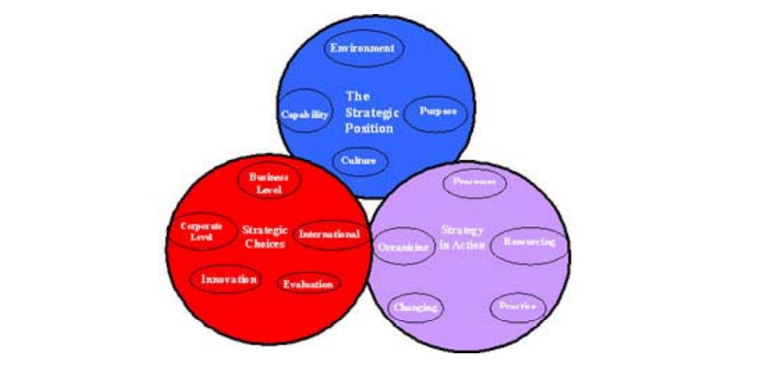

Appendix B

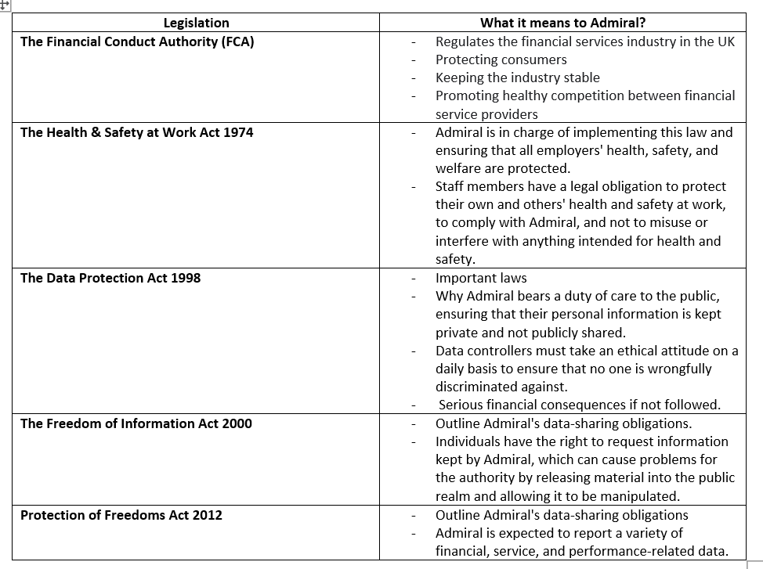

Appendix C

pro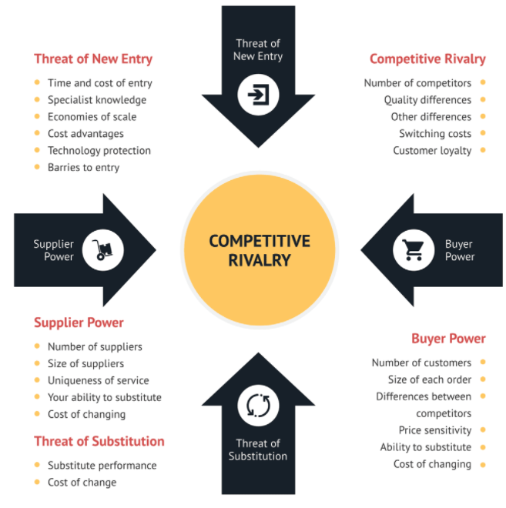

Appendix D
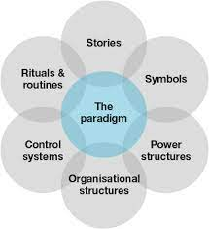

Appendix E

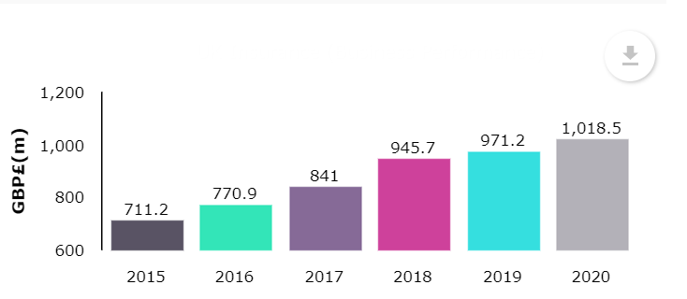

Appendix F

Strengths | Weaknesses
- Solvency Position  - Combined Ratio  - Cost Efficiency | - High Combined Ratio: International Insurance
Opportunities | Threats
- Strategic Partnership  - Business Streamlining  - Growing Non-Life insurance Segment in the UK | - Competition  - Covid-19 Outbreak  - Changing Regulations

Appendix G


