Tuckman’s Theory
Parul Begum



History on Bruce Tuckman:
Bruce Wayne Tuckman was born on November 24th, 1938. Tuckman developed a theory that contained four stages, which were; ‘’storming, norming, performing and forming’’ during 1965. However, Bruce Tuckman decided to add a fifth stage to the ‘’Tuckman’s theory’’ in 1977, the fifth stage is called ‘’adjourning’’. Following on, Tuckman served as a professor of educational psychology at the ‘’Ohio State University’’, during which he provided students form a variety of background with college success strategies which allowed them to enter and exceed in pro-secondary education, which they were enabled to complete. This was known as the ‘’Walter. E. Dennis Learning Centre’’, which he founded and directed.
Belbin:
The Belbin’s theory also known as ‘’The Belbin Team Inventory’’ is an evaluation used to obtain an insight into an individual’s behavior in a team environment.
Comparison:
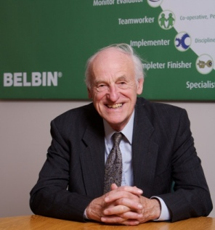
Both men have formulated theories of their own. However, Tuckman’s and Belbin’s theories compared are drastically different. This is because firstly Tuckman’s is based around a group of individuals altogether whereas Belbin’s is formulated around each person individually.

Spice Cube Takeaway
Forming:
The new staff were more focused on the chef to give them guidance and keeping a polite but distant relationship with others.
Storming:
Staff were more concerned on making a good impression on the manager rather than doing their job. Tandoori man starting challenging the chef and other team members.
Norming:
Manager has given everyone’s jobs and roles and told them what to do. All team members within the takeaway form new ideas which they turn into a reality.
Performing:
Tandoori man orders chef around which creates conflict and prevents customers form getting food on time. However, by working efficiently they solved their problem.
Adjourning:
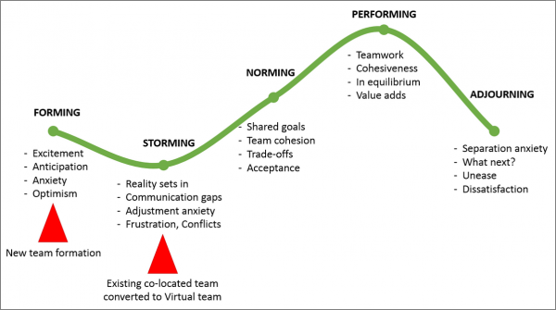
The chef and tandoori man became best friends and when the chef left the job the tandoori man was upset.

Referencing:
https://the-happy-manager.com/articles/teamwork-theory/
- Accessed at: 20:07pm Wednesday 5th June © 2007 - 2019 The Happy Manager | Tel: +44 (0)7580 693712 | Web Design by Sutton Silver
The Happy Manager is owned by Apex Leadership Ltd.
Krystal Server: 228 queries in 1.145 seconds.
https://teambuilding.co.uk/theory/forming-storming-norming-performing .html - Accessed at: 19:57pm Wednesday 5th June (Copyright © 2019 The Teambuilding Company)
https://www.belbin.com/resources/blogs/belbin-and-tuckman/ - Accessed at: 22:32pm Wednesday 5ht June
(by The Belbin Team | Victoria Bird, 25 Jul 2017)

