Research question:
How can Surface Pattern Designers use predictions of colour trends to influence consumer purchases?

Introduction
Within this essay my focus is to clarify the theory of colour forecasting and how Surface Pattern Designers use these predictions to influence consumer purchases.
I will review leading trend forecasters such as WGSN and Dulux to understand how they forecast trends and how they publicise their findings. Discover why there are different types of trends and how they come about and what influences need to be considered when developing trends. My case study is based on a leading manufacturing UK company Design Group UK Ltd and how they use and are influenced by the market trends. Concluding I visited numerous retailers to see whether these trends are visible in the high street.

Colour Forecasting

“To understand what is coming, we need to understand where we are” (Hård, 2021)

Although there is little information that exists about colour forecasting and its methodology, it is considered to be a driving influence for all industries. It is considered to be the very first process of manufacturing and the practice of predicting colours is to influence direction and to change the way we think. Forecasting companies have their own methodology to predict and influence trends for the future. Marc Worth argues that “We don’t forecast, we don’t predict. We provide inspirations for creatives to create trends; we track trends as they evolve, but we’re not forecasters in the traditional sense,” (Abnett, 2015). WGSN a world leading digital forecasting business uses a 5-stage approach that enables their teams to have precise forecasting skills. First step is to observe; covering a range of specialisms they build foundational research that focuses on creative culture, politics, technology, society, environment, and industry. Secondly, they synthesise the changes within these observations adding industry context to identify future aesthetics to become the basis for their next step which is their forecasts. In order to focus the abundance of research they add “diversity and inclusion, sustainability and global representation” (WGSN, n.d.) to categories and industries allowing predictions to be actionable across any product level. Although trends are made year on year, season by season, forecasting is a continuous process. Staying on top of developments through the constant flow of market communication and new research allows them to reach their final stage which is to re-evaluate bringing rising trends to customers daily.
The trend forecasting process is launched usually 18 months to 2 years prior, this amount of time developing ideas and colour stories allows designers and companies to plan ahead allowing them to produce better suited products for their target audience. Collecting global knowledge from areas such as colour, design, materials, fashion, architecture, and the economy (Shillingford, 2018) stimulates their processes in predicting trends all year round. Designers like myself, buyers, range developers and merchandisers use the colour trend

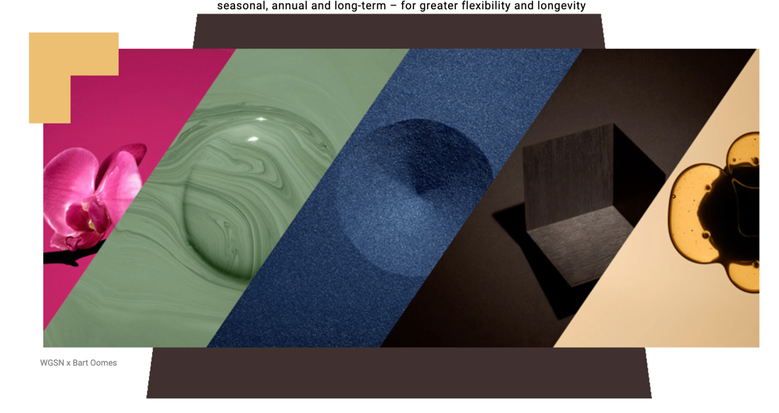
predictions and the information that is shared to influence their own direction when developing their company’s colour range. In order for these companies to have inspiration there must be something for them to follow such as mood boards or reports. WGSN issue daily, seasonal, and yearly reports for a variety of sectors, some that are more industry specific, and some that are global like colour. These are usually influenced by the previous season’s trends.
Each report provides a brief summary to capture the essence of the overall report findings. WGSN Global Colour Forecast Report of A/W 22/23 expresses “a sense of optimism and luxury for challenging times” and “highlights rich and upbeat tones” (WGSN, n.d.). As seen in figure_ they have used visual imagery to showcase the mood of the leading colours of this particular season. The reports also provide action points for the clients to consider, these could evoke thought and form strategy for the client to apply within their own colour ranges. To support these action points and visual imagery WGSN conclude each report with a methodology section. This section is broken down into subsections explaining their research and analysis that has influenced their findings for each report.

The leading forecasting groups are Pantone Color Institute and the Akzo Nobel Global Aesthetics Centre (DULUX). Both companies have an impact on a range of industries such as fashion, graphics, interiors.

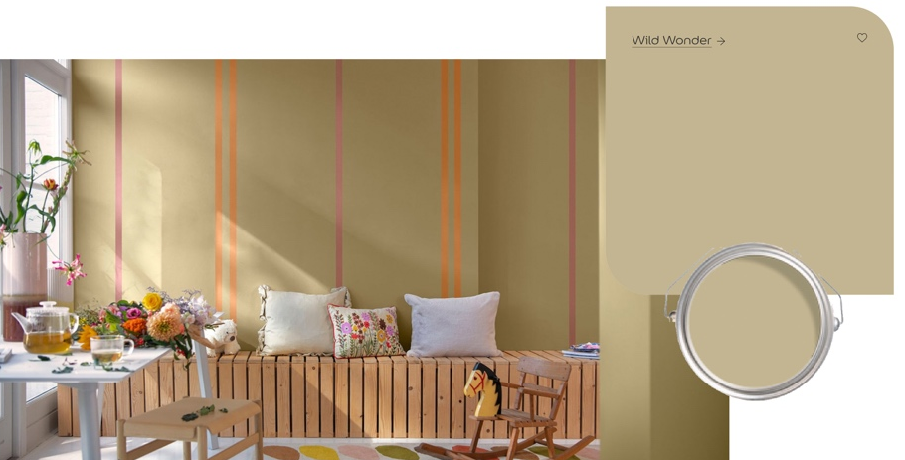
Dulux focus is to encapsulate mood and key trends of that coming year in order to select the most relevant colour for that year. Unlike WGSN, Dulux have a colour of the year alongside colour palettes and five trend stories. In turn to get to this stage Dulux have a dedicated team of colour forecasters who work with design experts from various fields at least eighteen months ahead to narrow down trend concepts. They very much work around the Zeitgeist effect enabling them “to capture the mood of the moment” (Dulux, n.d.). Similar to WGSN they create mood boards that help them provide a clear idea of the meaning behind each trend.
2021 Trend Forecast agenda focused solely on the natural world, and how nature supports and will inspire us in 2023. Dulux colour of the year 2023: Wild Wonder captures a natural glowing tone that connects us with nature making us feel uplifted in our homes.


The Color Marketing Group describes colour forecasting as a form of “art” (Arel, 2018), it is the interpretation of creative skill that is usually in a visual form, most forecasting company’s create mood boards to support their stories, stories that convey emotion. As colour forecasters they must consider the psychology, meaning and symbolisms behind each colour. Colour psychology works on the ideologies that the affect colour has on us goes beyond aesthetic (Perryman, 2021). Colour is vital to human experience making it a vital role within the design industry. Christine Olmstead says, “colour communicates so much” (Olmstead, n.d.), it is a strong communication tool that can influence mood, phycological and physical responses, influencing many of our daily decisions. “Colour has very personal and emotional qualities” (Diane and Cassidy, 2005) which from my understanding as a Surface Pattern Designer is key to any part of designing, we must think about how these colours affect our target audience. As individuals our mood, age, cultures, and beliefs allow us to interpret colours differently. An example of this is the colour red which symbolises luck in China, whereas in figure_ in South Africa red is considered a mourning colour. There are also some colours that are universal for their meaning and symbolism, (Bruna, 2020) such as green. The colour green has long been associated with growth, vegetation, and nature across the globe, green also has the most shades than any other colour (Colormatters.com, 2019). This makes predicting forecasts more complex as we have to consider a combination of factors when deciding on what colour trends to use to portray our stories.

A trend is a general direction where something is developing or changing. Where colour trends are about understanding the psychology of people at any given time, other trends such as fashion or interiors are based on innovations, the creation of something new. The type of trends that exist within the design industry are described as mega, macro, micro and fads. First level starts with the megatrends which has a longevity of up to 10 years. This is often associated with big changes in the world that could be affected by politics, social development, economics, or culture. The following trend layer, Macro, focuses more on current environment and society, or a particular change in consumer behaviour, this type of trend can last between three to five years. Similar to this are micro trends often lasting a season, it refers to a smaller shift in consumer behaviour, possibly more influenced by seasons and the everlasting rise of social media. The last layer of trends is referred to as fads, a short-lived trend that can last less than a month, novelty driven choices that fade as quickly as they appear (Mühlstedt, 2021). Marc Worth one of the original founders of WGSN quoted that “Social media dictates trends today. The trend emerges overnight and disappears almost as quickly.” (Abnett, 2015).

In order for me to understand and make it more relatable to my context, I have looked through WGSN’s reports to find trends that match different categories.

Mega Trend – Traditional Christmas
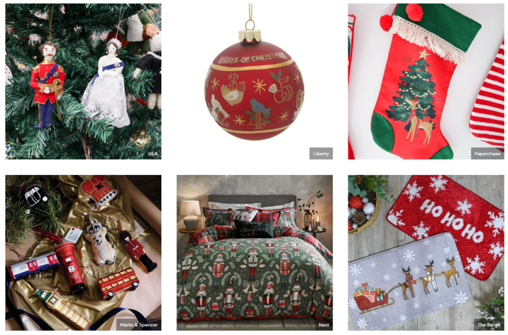
Taken from WGSN’s UK Retail Previews: Christmas Key Trends 2022 report

Traditional Christmas is a mega trend as it focuses on icons that are constant year on year and traditional. In figure – you can see a clear connection to the British Monarchy which will be in demand around the world due to the passing of the Queen and also iconic symbols of London. The classic nutcracker dominates surface designs and also animals dressed in festive accessories provide fun and laughter to the finished product. All of these are featured in the traditional colours of Christmas, red, green, and gold.

Macro trend – Positive Affirmation
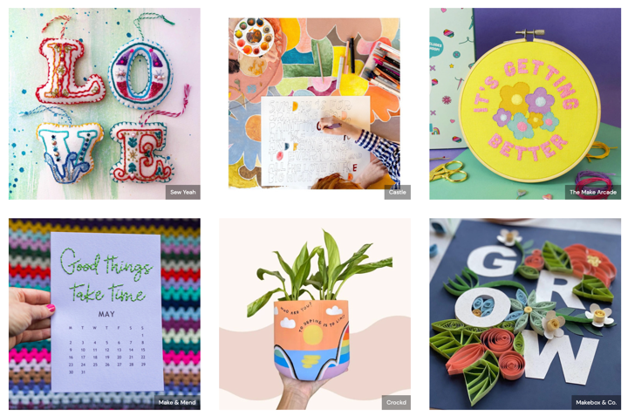
Taken from WGSN’s Key Trend: Crafting for Wellness report

Positive Affirmation is a macro trend which focuses on symbols and slogans of providing positive thoughts and helping individuals ‘look on “the bright side” (WGSN, 2022b). Colours chosen for this trend reflect calm and happiness and feel-good attitude.

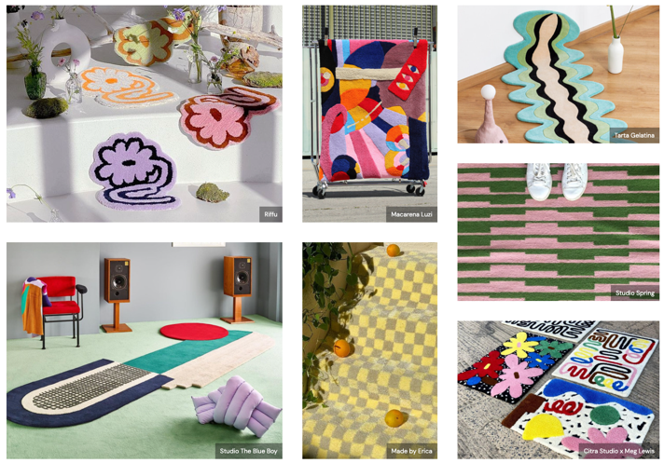
Micro Trends – Graphic Pop Rugs
Taken from WGSN’s Key Trend: Statement Rugs report.

Graphic Pop Rugs is classed as a micro trend. Reason behind this trend is influenced by Tik Tok. Idea behind this is that they provide a youthful and playful quality whilst experimenting with shapes and pattern. These colour palettes are bright and vibrant and remind me of the work of Andy Warhol.

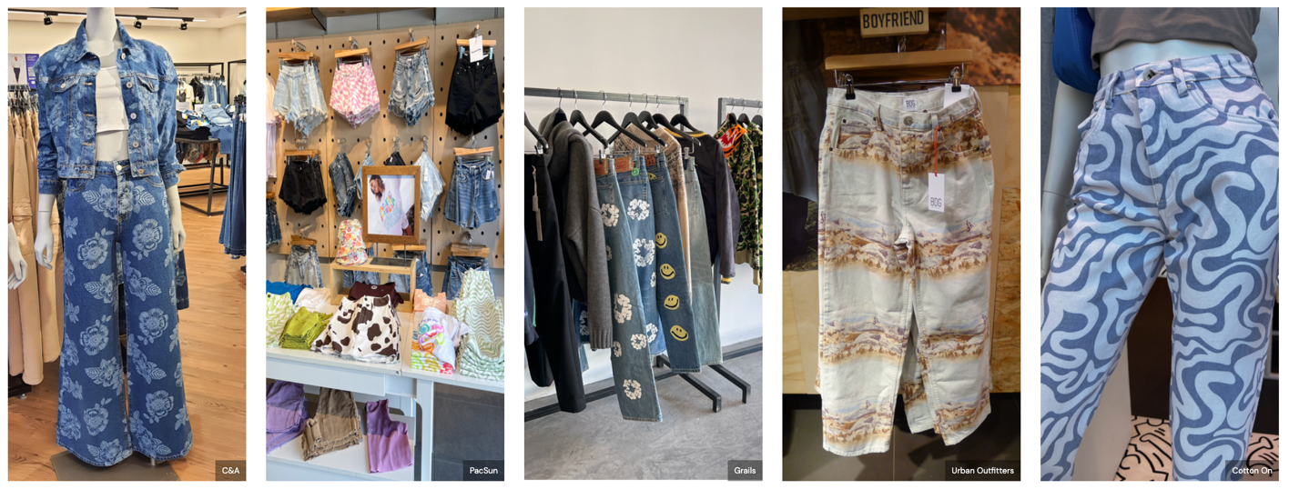
Fads -Festival Patterns

Taken from WGSN’s Global Retail Analysis: Denim S/S 22 report
Festival patterns is a fad trend. This trend is usually seen around festivals like Glastonbury and Coachella where they usually last for a very short period of time.

From researching all of the above it is clear to see that the leading forecasters all have a similar methodology and approach to developing trends. They appear to all have dedicated teams that are focused on trend development. It is surprising to see how many factors are considered when colour forecasting like symbolism and emotions etc and that these need to be taken into consideration when publicising trends that are used by companies worldwide.
Considering these leading forecasters create these trends, are they being followed, and can they be seen in your high street?

Case study – How a business uses colour trends to drive design collections and ensures successful sales and how can I interpret this into my own practice?

Whilst having work experience time at Design Group UK Ltd, I was fortunate to have an insight into how one of the largest manufacturing design businesses in the country work to ensure success within the marketplace, this has then provided me with a platform to use them as my case study and gain further information on how they use trends within their business.

Design Group develop trend focused and market appropriate products across Everyday and Christmas ranges such as stationery, creative play products, crackers, greeting cards and gift wrap which spans across many different retail sectors. Their customer base is UK high-street, grocers, trade, and wholesalers along with international retailers.
The company’s creative design team feature a range of exceptionally experienced designers, utilising skills such as Illustration, textiles, graphic design and so on. In line with trend forecasting, market research and industry shows, the trend team focus on thought provoking and unique capsule trends. Combining product alterations with an array of disciplines to cross boundaries and launch new commercial themes (igdesigngroup.uk, n.d.).

My study of Design Group and my previous work experience allowed me to ask further questions to the designers about their day-to-day approach on creating finished products. I constructed a questionnaire and sent this to the Creative Manager for herself and other Senior Design Managers to complete in order to see if I would receive varied responses. From the responses to the questionnaire, I have been able to gain further insight into Design Group’s trend forecasting. Compared to WGSN’s 5-stage approach to forecasting trends, Design Group uses a more simplistic approach. Design Group create macro trends which are a long-term strategy, “suitable for all customers and micro trends which are more customer specific” (Creative Manager, 2022). They develop their macro trends a year in advance and are currently working on 2024 trends. They believe that “pattern and colour come hand in hand within the industry and are researched together” and that “You may have a beautiful commercial design, but in the wrong colourway it does not work” (Senior Design Manager, 2022). Their trends are started from researching consumer trends as well as creative trends, this is done by reviewing trend forecasting reports from companies like WGSN, Trend Bible and Paper & Cloth and identifying key themes and colour ways that are relevant to their product categories. There are certain colour combinations or variations of shade that are used repeatedly each year such as within Christmas there always tends to be a “red theme, silver & blue theme, or a bright theme” (Creative Manager, 2022). However, across all themes they will propose refreshes each year. Alongside this their research includes competitor shopping throughout various seasons, looking at products outside of their product categories such as lifestyle, homeware, and fashion. They are influenced by brands such as “Liberty, Harrods, Fortnum & Mason, Anthropologie, Oliver Bonas, and Zara Home” (Senior Design Manager, 2022). Even with all this research there are other factors to consider, Robins don’t work so well in America based on EPoS sales data and reindeers cannot have red noses in Canada as they are patented.

Each year Design Group also receive and review EPoS sales from the market and are able to understand what the bestselling trends, designs etc are for that season. EPoS sales are the data recorded through the Electronic Point of Sale (till point) this system includes “value of the order, the items sold, the payment method, the staff member who recorded the sale” (Access, 2022). Hence why the barcode is an integral part of retail products. Within the retail sector each product sold has a unique barcode, and from this the retailers can determine best-selling designs/colours. This plays a big part in developing their ranges for the following year.
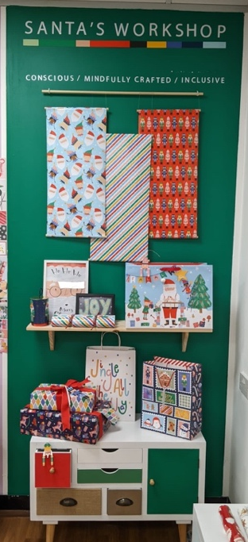
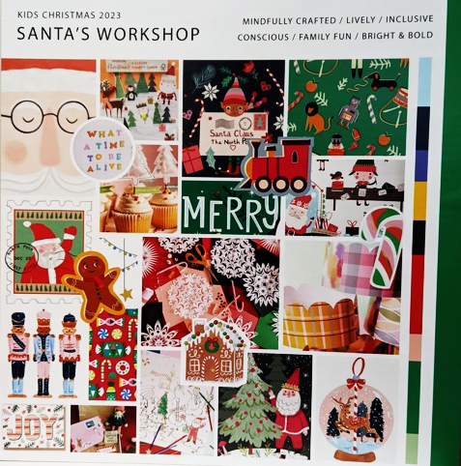
I asked the Creative Manager whether all their customer base, request their designs to be based on current/future trends and they advised that “artworks are not always based on current trends, they have trends that are carried over year on year across their product categories, examples of these are icons such as rainbows, unicorns, dinosaurs, marble etc” (Creative Manager, 2022). Leading retailers such as John Lewis, Sainsbury’s, Tesco etc will provide their own trends, however Design Group will also create their own. These trends could be presented to the leading retailers as well as retailers that do not have their own design departments.

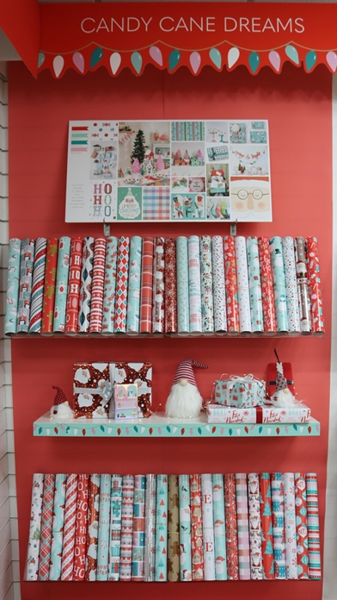
In order to present their trends to customers Design Group create both digital and physical boards. Since the pandemic digital trend boards have been more commonly used but in order to “wow customers” (Senior Design Manager, 2022), they are now starting to create physical boards again. For Christmas trends they set up each theme into sections within one of their board rooms, complete with mocked up samples and props to tell each story. As you can see in figure_ this is a physical trend board whereas as figure_ is a digital board. If Design Group are presenting to a customer in one of their showrooms, they would set up a showroom based on trends but will also add designs relating to that trend for the customer to select from, see figure_ (Candy Cane Dream). Relating to this within my own projects working on live briefs, I have presented digital boards that visualise mood, narrative, market, and colour. This has allowed interim feedback from the clients themselves, in order for both parties to understand the end goal. As a result, the finished products are presented in an exhibition for the clientele to review.

In Surface Pattern design, choice of colour must be carefully selected, in order to achieve this, analysis and research is required. As designers we must establish the importance and suitability of the information found within the research. (Berry and Martin, 1991). Asking questions such as “who is it aimed at - gender, age, occasion?” for example red is often associated with Christmas, blue and pink for the birth of a child and so on.
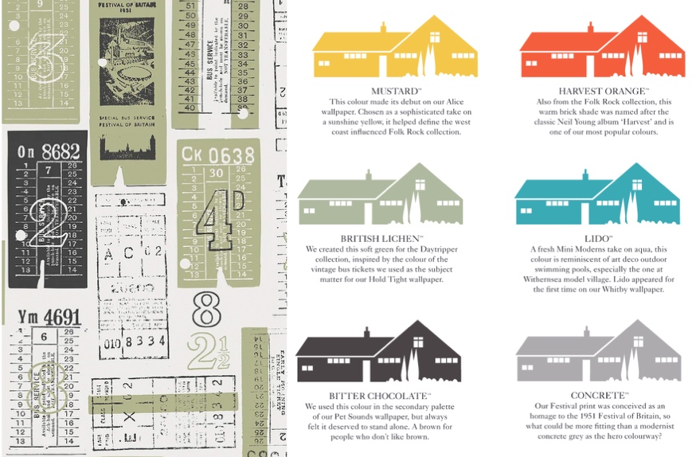
Within my own practice I have completed several projects some of these being live briefs from companies such as Rolls Royce and Mini Moderns. Both of these companies are diverse, one being a high-end car manufacturer and the other a wallpaper design company. With both company’s research had to be undertaken to understand their clientele. Having worked with Mini Moderns it is quite apparent that they limit themselves to a specific spectrum of colours. “We create pattern with a story” (Mini Moderns, n.d.). Their colour and patterns are influenced by many aspects of their lives whether that is field trips, holidays at home or abroad, mid-century modern British textiles, literature, vintage toys, or childhood memories. Although it is obvious that their pattern designs have a story, it is not without saying that their colours also have a story or meaning. As you can see in figure _ they keep within their own colour palette and don’t draw inspiration from leading forecasters like WGSN. One of my favourites is “British Lichen”, this particular colour was inspired by vintage bus tickets referenced in their Hold Tight wallpaper from their Day Tripper collection, also seen in above figure_. To me it appears that their design development is truly a personal story.

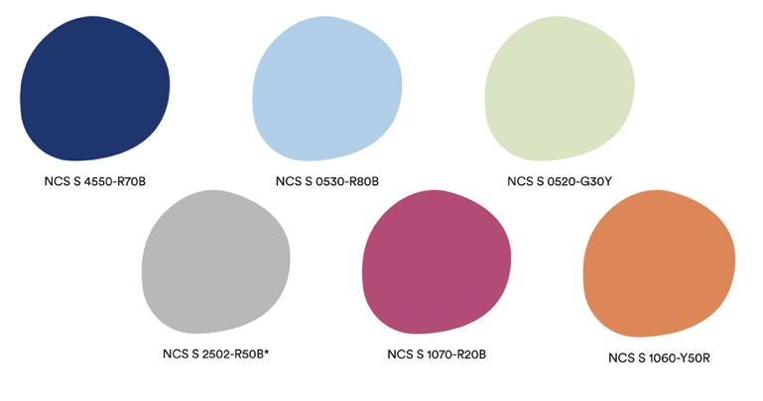
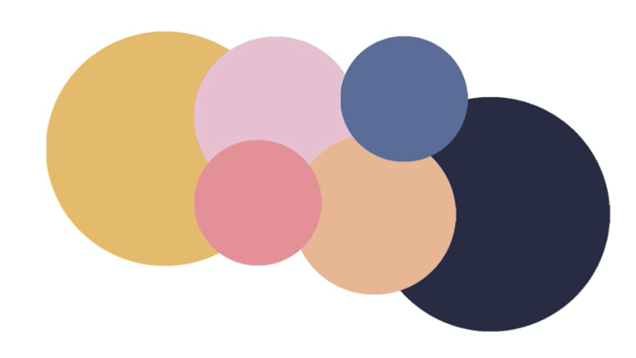
One of my projects last year was to create my own brief, I drew inspiration from the Spode Blue Italian range chinaware collection that has been passed down through my family. My aim for my final designs was to focus the colour story on the colour blue. Looking back on this project I can see there are similarities between my methodology and that of Mini Moderns. In order to bring additional colours into this project I researched colour trends that would go on to influence my own range of colours and accentuate the colour blue.
During my research I attended a webinar hosted by NCS (Natural Colour System), this webinar focused on a “year of Re-Nual” (NCS, 2022). KidultZ, the fourth trend that was shown during the trend webinar provided innovation to complete my own colour palette. As you can see in figure_ these colours from NCS trend report 2023+ portray playfulness and joy. NCS quotes that “Kidultz presses the accelerator of flair and pushes on orange, ultramarine blue and fuchsia. And it forces them to contaminate with sage green and sugar paper pastels, as well as with the neutrality of soft grey” (Fotia, 2022). As you can see in figure_ which is the NCS KidultZ colour palette and figure _ which is my final colour palette, you can see a similarity that the tones and shades are different.

Having reviewed how Design Group and Mini Moderns approach trends and comparing it to how I develop my own work, it has led me to believe that trends can be important, however it is also imperative to make it a personal journey. From interviewing the designers in Design Group, it gave me an insight into how businesses are run compared to how much freedom we have creating projects in university. The designers are briefed what they need to create and colours to use, as they need to follow trends, whereas as a student, we are encouraged to create our own narrative whether that is for a colour palette or our artwork. However, in order for me to progress into my preferred context, it has made me realise that I need to understand and follow the importance of trends for the industry.

Locating colour trends

For my next area of focus I wanted to establish that I could link colour trends from the last few years into today’s current market. I chose Cardiff city centre as this would provide me with a variety of retailers varying between grocers and highstreet. The aim was to focus on stationery and greetings products and the stores that I visited were inspired by Design Groups customer base such as Wilko, Sainsburys, John Lewis and WHSmith’s along with those that they do not supply like Paperchase.

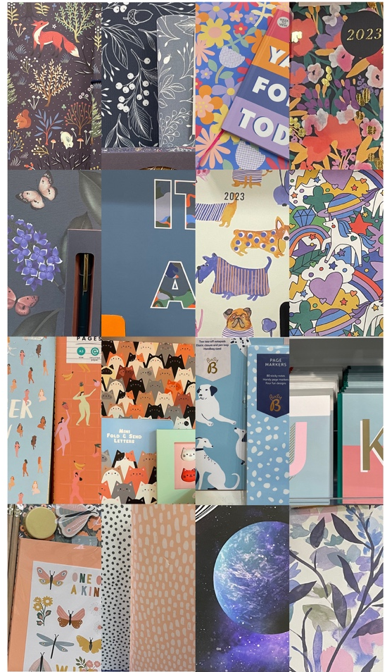
Across all types of shops both grocers and highstreet it was apparent that they were all following similar colour palettes, as you can see from figure _ where the imagery taken on the day shows this as a collective. After researching and reviewing with colour trend reports I found a colour palette that resonates with what was on the high-street and in grocers at the moment. Below in figure_ is the Digital Coloro Global Colour Palette of the year A/W 20/21 (WGSN, 2018), it has artificial hues that embraces bright and mid-tones to invigorate autumn/winter collections. Action point from A/W 20/21 trend report was to celebrate digital tones; spending more time observing screens which will change the way we see colour, focus on sustainable colours, those that do not harm the environment and colours that will live beyond autumn/winter. This also relates to action point 5 that WGSN has made which is to make palettes trans seasonal; creating designs that are less seasonal dependent and more flexible.

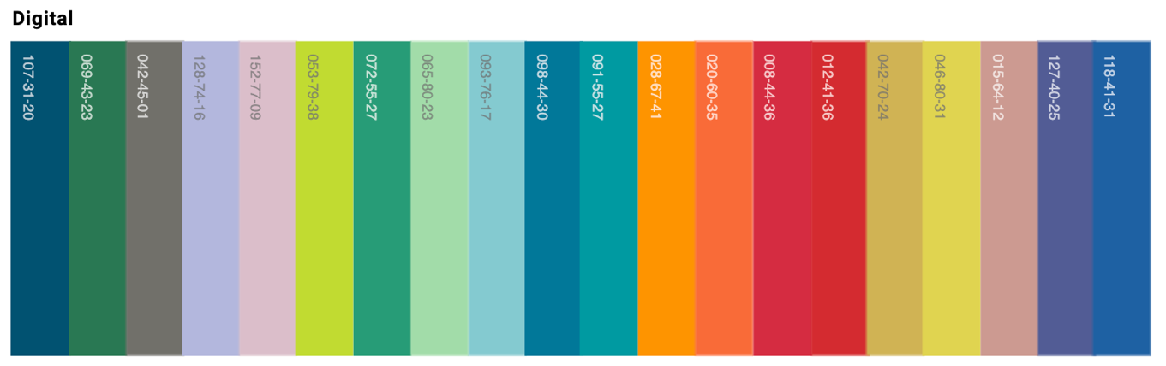

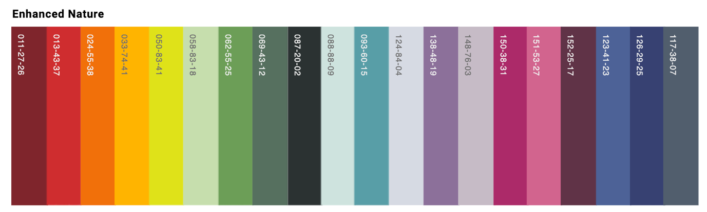
After more exploration through WGSN and their colour trends I noticed that they were re-using a range of colours for the following seasons. As you can see in figure _ WGSN have released Global Colour trend concept for S/S 22 a very similar concept trend as A/W 20/21. The S/S 22 Global Colour trend concept Palette: The Enhanced Nature is flexible for online and physical frameworks representing colours that are “rooted in nature, but also have an unnatural edge”. WGSN says that this colour palette will “activate senses, igniting feelings of joy, pleasure and tranquillity” (WGSN, 2020).

S/S 22 concept trend “balances the need for newness with the appeal of the familiar” this supports their methodology report that they “carry over 30%” (WGSN, 2020) of the colours from previous seasons. Over the last few seasons tints, tones, and shades of orange are consistent, this could be because it can be used as a warm and cosy autumnal colour or a bright and cheerful spring/summer colour, as shown in figure_. This is also known within Design Group, who often re use their colour palettes for Christmas.
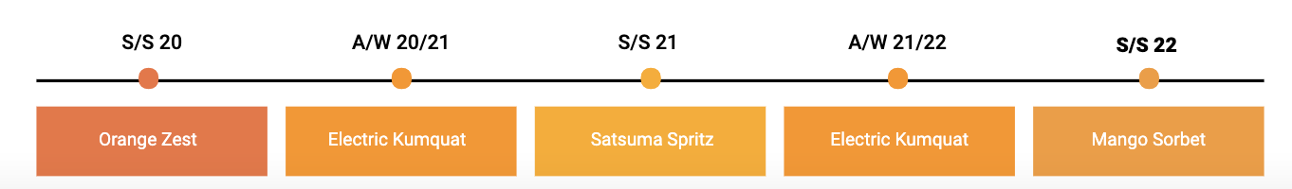

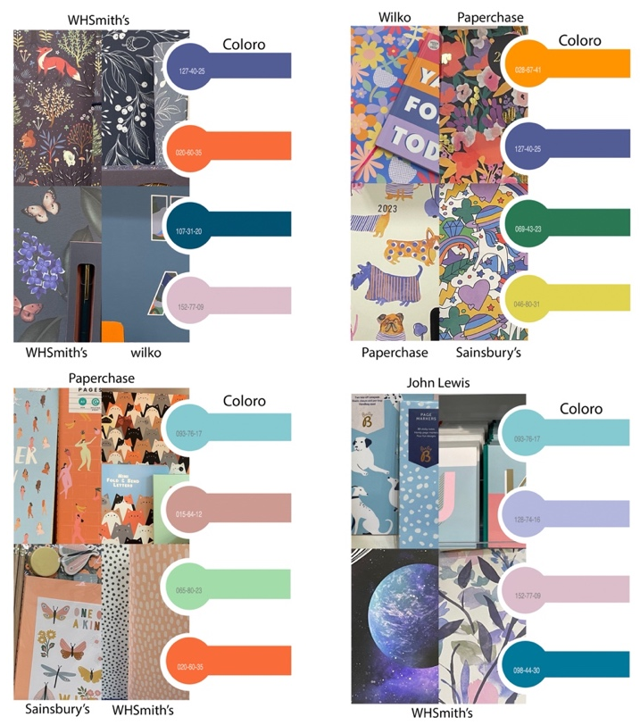
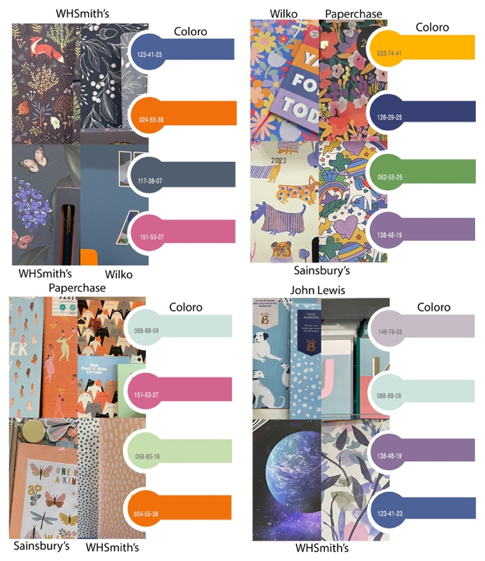
Although the colours have been carried over, the reasoning and meaning behind these palettes are completely different. S/S 22 was released during an uncertain time of the Covid-19 pandemic, consumers became more cautious and there was a demand for “sense of comfort and joy” (WGSN, 2020). NCS said that they “believe that 2022+ will be a post pandemic world” (NCS Colour AB, n.d.), time spent at home has given people time to reflect personal and spiritual matters and embracing present moments. After isolation people are opening their doors to a world of new comforts and freedom again. Individuals are re-evaluating what nature truly means to them, to be more conscious and positive towards the planet and are thinking more critically on how we live on a day-to-day basis. Across all the stores it was difficult to determine if the colour palettes were used across all stationery and greetings products as there were limited ranges on display in store due to the Christmas greetings products being on sale. However, as you can see in figure _ and _ what was available can be easily linked to both S/S 22 and A/W 20/21 colour palettes.

Whilst communicating with the studio team in Design Group they also mentioned that “due to the pandemic retailers have a large amount of stock left in their warehouses” (Creative Manager, 2022) which could also be another reason why there is not a clear change in trends within the stores.

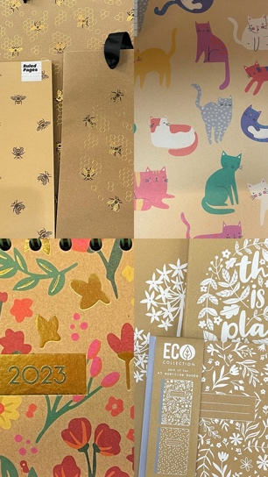
Something else that was clearly visible whilst reviewing stores in Cardiff was the amount of product that was made from kraft substrate. This was evident across all stationery and greetings products. This is a reaction to the stores wanting to offer their customers a more “eco sustainable” product in relation to the publicity over the last few years about saving the planet. WGSN action point 1 from Intelligence: Sustainable Giftwrap 2021 has reported that “consumers have clearly indicated” they are eager to invest in sustainable giftwrap.
As you can see in figure_ kraft products in the market are limited with colour, there were only a few that used splashes of colour that referenced the colour palette. Design Group have created a new sustainable brand designed and manufactured using recycled kraft substrate, in the UK called Eco Nature. This range is inspired by nature and the design team are encouraged to visit nature reserves, botanical gardens and local parks and using sketchbooks, paints and pencils to bring their creative ideas to life. Since the launch of the range, they have taken it one step further and have identified that the trends are changing, and the consumer is looking for more vibrant colours. By doing so they have applied more vibrant, playful colours in their product range which is more appealing to the wider market whilst still using kraft substrate.

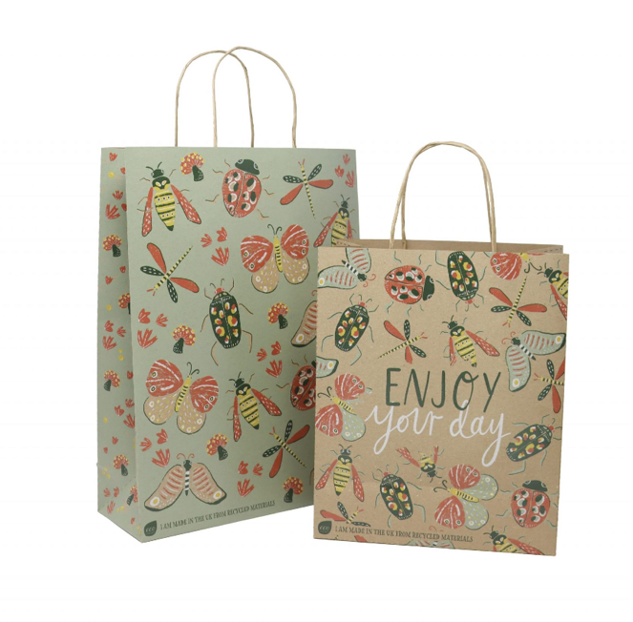
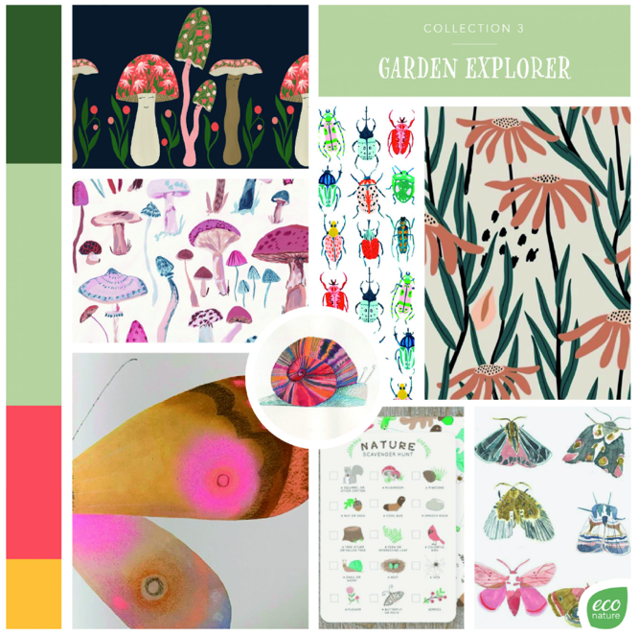

(Econature.co.uk, n.d.)

Design Groups’ vison for their Eco Nature range is to be a carbon neutral brand, which reduces waste and supports the local economy and respects the environment every step of the way from design to the store. All products are made within the UK manufacturing site and the site is powered by “electricity exclusively from renewable sources” (econature.uk, n.d.). They have a partnership with The Woodland Trust where they mitigate all emission from the production of Eco Nature products whilst working towards a carbon neutral brand. Product and packaging are all made from recycled materials and can be fully recycled. Their UK site only uses water-based printing and has zero landfill from the site. From reviewing the above it is clear that Design Groups’ Eco Nature brand does not fall under “greenwashing” Greenwashing can be described where a company is advertising or giving the impression it is doing something that it is not to appear environmentally sustainable and greener than it actually is. As mentioned previously, there has been an uplift on consumers purchasing decisions where they are trying to ensure that they are selecting more environmentally, sustainable products and “companies have a real financial incentive to appear sustainable and socially conscious” (ClientEarth Communications, 2020).

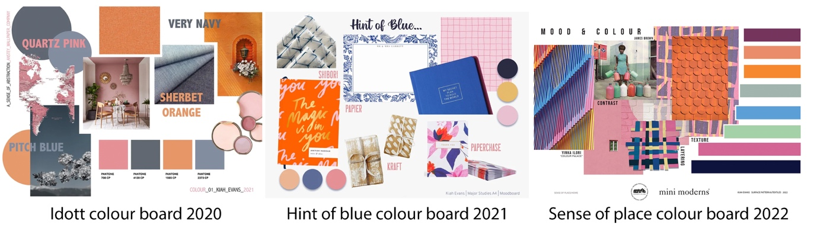
Conclusion

Looking now at my own work produced at university over the last few years. Has this research now given me a further insight into colour and trend exploration? As you can see in figure_ which are colour boards I have created for the variety of my projects, I have used very similar colours, orange, pink and blue. This has made me realise that these are the colours that instil joy and happiness for me but may not necessarily be leading colours in global trends.

I personally like Marc Worth’s comment “We provide inspirations for creatives to create trends”. As a surface pattern designer there is so much scope of influential materials available to work with, that trends can provide you with a focus of what works and what doesn’t.

