Chemistry Assignment 2020- The Chemistry of a Fragmentation Grenade
L4 - Chemistry (OME) (ACDA4011)
Thomas A Harwood (1906968)
University of Wales Trinity Saint David

Abstract
This report discusses how a hand grenade works with its ignition train from the safety lever to the main charge, it takes a brief look at the history of the hand grenade and versions used throughout the last century. it compares a current military hand grenade the M67 with the original British hand grenade the Mills bomb. it discusses the M213 fuze used in the M67 hand grenade and compares the delay time of the M67 and mills bomb, it draws a comparison between the Mills Bomb and M67 grenade. It examines at the mechanism of the process required to produce both TNT and RDX and explains how they both use a form of nitration to be produced, it also discusses the produces used to produce Baratol and Composition B. it calculates the heat release of TNT and RDX and shows that RDX outputs a larger amount of energy on detonation when compared to TNT. reviews the differences between the materials used in both the M67 and Mills bomb and their chemical and physical properties. Finally, it briefly discusses the performance differences between the M67 hand grenade and the Mills bomb.

Contents
- Introduction

- How does fragmentation grenade function?

- The production of a HE grenade and the chemistry behind it

  - Design and manufacturing of a hand grenade

  - Percussion cap and Detonator

  - Main Charge

    - TNT - Trinitrotoluene (C7H5N3O6)

    - RDX- 1,3,5-Trinitroperhydro-1,3,5-triazine (C3H6N6O6)

    - Baratol

    - Composition B

- Physical and chemical properties of the materials used in the compositions

- The performance differences between the M67 hand grenade and the Mills grenade

- Conclusion

- Introduction
High explosive hand grenades have been issued in the military since the First World War, where the Imperial Germans created an early version of the “stielhandgrenate” in 1915 which loosely translates to stick hand grenade. The British military followed suit and introduced the Mills bomb which was produced later in 1915, the Mills bomb remained in service until the 1980s. With World War II on the horizon the United States military made the Mk 2 hand grenade standard issue in 1922 with the M26 and M33 grenades following the Mk 2 throughout the Vietnam war. The US military introduced their new hand grenade the M67 which was standardised as part of the military equipment towards the back end of the Vietnam war, the M67 hand grenade is still in service today. The British military produced the L2A2 in the 1950s which was subsequently replaced by the L109A1 in 2001 as its anti-personal grenade. The comparison of the M67 and Mills Bomb gives an overview of what was used in the past to what is currently being used in the military today. [1]

- How does a fragmentation grenade function?
A standard fragmentation Hand grenade consists of a body, safety lever and safety pin, the body houses a powder delay fuze, as detonator and a main charge. Underneath the safety lever there is a striker, a striker spring and prime. To cause this grenade to function the operator squeezes the safety lever against the body of the grenade with one hand then pulls the safety pin with their other hand, providing the operator does not let go of the safety lever the grenade will not function. Once the operator has thrown the grenade the safety leaver will be released with the striker spring rotating the striker until it strikes the primer this is were our chemical ignition train starts to take place as the primer ignites, the delay fuze will burn for approximately 4 seconds, as the fuze burns it will initiate the detonator which will explode and cause the main charge to explode thus fully functioning the grenade. [2]

- The production of a HE grenade and the chemistry behind it
the composition and ignition train depends on each version and type of high explosive grenade, The M67 and Mills bomb are two similar types of fragmentation grenades but differ in composition and the materials used but achieve a similar affect. The mills grenade shown in figure 1.2 uses a cast iron body to house the main charge and the other internal components. Whereas the M67 hand grenade (figure 1.1) uses a steel alloy as its housing material, the M67 grenade uses a M213 fuze as its delay mechanism. The M213 fuze has a burn time of 4-5.5 seconds and uses a zinc cast housing. Like the M67 hand grenade the Mills Bombs fuze had a delay time of around 5 seconds, both grenades use a similar method of ignition. They both use a striker spring and Stricker to create enough percussion to initiation the delay fuze. [3]f

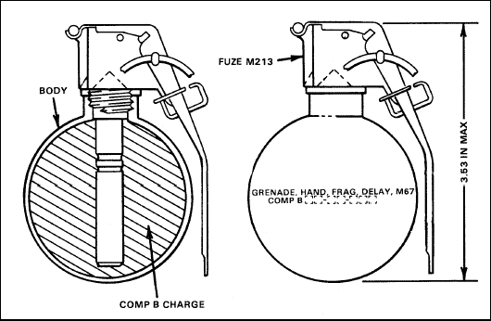
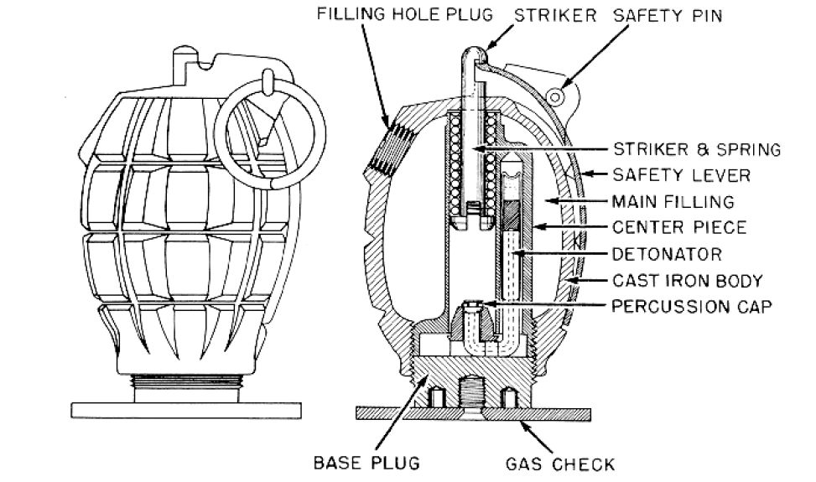
M67-
Figure 1.1 [20]
Mills Bomb-
Figure 1.2 [21]

  - Design and manufacturing of a hand grenade
Figure 1.1 shows a technical drawing of US military standard issue M67 hand grenade, the M67 grenade is produced by a company called Day & Zimmermann who have eight manufacturing facilities across the US. The M67 is known for its 6.35 cm diameter steel sphere housing, since it was first manufactured in 1968, Day & Zimmermann have produced around 43 million M67 hand grenades. The RDX used in the M67 hand grenades is produced in Kingsport, Tennessee which is the only facility licensed to produce RDX in the United States. Whereas the original Mills Bomb shown in figure 1.2 was only manufactured in one facility in the UK which was the Mills munitions factory in Birmingham. The design of the Mills bomb is renowned for its 6.1 cm diameter egg shape and pineapple like exterior grooves, over the 60 plus years of production over 75 million Mills bombs were produced. [4] [5]

3.2 Percussion cap and Detonator
The Mills bomb and M67 hand grenade use percussion caps as the first step in the ignition train which initiates their fuze, once the percussion is hits it initiates the fuze which then ignites the pyrotechnic time-delay before initiating the detonator. The fuze in a hand grenade typically uses a pyrotechnic composition and a time delay, a M213 fuze which appears in the M67 handed grenade uses a W/MnO₂ composition as it gives a suitable time delay for the performance requirements. The detonator used in an M67 hand grenade is the C70 detonator, which is made with a mixture of RDX, lead styphnate and lead azide. Lead azide and lead styphnate are primary explosives, lead azide (Pb(N₃)₂) is created by reacting sodium azide and lead nitrate in an aqueous solution under standard conditions. Lead azide is a white powder or white needles at room temperature, lead styphnate (C₆HN₃O₈Pb) on the other hand is orange crystalline solid and is produced by continually reacting a mixture of lead acetate and magnesium salt in an aqueous solution. [3] [6]

3.3 Main Charge
The main charge in a hand grenade is usually composed of a combination of TNT and other chemical compounds, the first generations of the mills grenade in the 1910’s used a Amatol which is a mixture of TNT and ammonium nitrate in the proportion 60:40. Amatol was then replace in 1920’s by Baratol, Baratol is a chemical mixture of TNT and barium nitrate in the proportion of around 30:70. This combination of TNT and (Ba(NO₃)₂) was used as the main charge in the mills grenade until it was decommissioned in the 1970’s. TNT has been used in hands grenades since the first world war and continues to be a component of the modern day hand grenade. The M67 which is currently the US Military’s choice of hand thrown ordnance uses a compound called composition B. According to the fifth edition of Explosives by Koehler & Meyer, composition B is a “castable mixture of Cyclonite (RDX) and TNT in the proportion 60:40”. Composition B has been used in munitions since the 1930’s, composition B has been used in many different forms of munitions buts its current use is mainly in M67 grenades. [7]

3.3.1 TNT- Trinitrotoluene (C₇H₅N₃O₆)
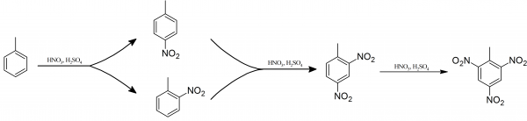
The preparation of TNT was first discovered by a German Chemist called Julius Wilbrand in 1863 and has been used in munitions sin the early 1900’s. the modern process for the preparation of TNT is the nitration of methyl benzene (Toluene), this is done by mixing the methyl benzene in a concentrated solution of hydrogen nitrate and hydrogen sulphate. These reacts with produces a mixture of 2-nitromethylbenzene and 4-nitromethylbenzene and then water as a biproduct, the two nitromethylbenzene isomers that were formed in the previous reaction are then reacted again with the concentrated solution of HNO₃ and H₂SO₄ to produce 2,4-dinitromethylbenzene. The previous process is then repeated with the 2,4-dinitromethylbenzene to produce the final product of 2,4,6-trinitromethylbenzene (TNT). AS shown below in Figure 2.1. [8] [9]
Figure 2.1

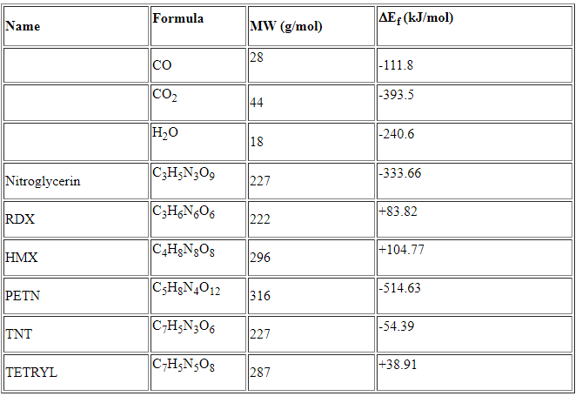
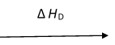
Heat of detonation of TNT-
C₇H₅N₃O₆ 6CO + 2.5H₂ + 1.5N₂+C

3C + 2.5H₂ + 3N₂ + 3.5O₂
Figure 2.2
Heat Release/Heat of Detonation of TNT
Before Detonation
ΔH = C₇H₅N₃O₆
= -54.39kJ/mol

After Detonation
ΔH = 6CO + 2.5H₂ + 1.5N₂+C
= 6(-111.8) + 2.5(0) + 1.5(0) + 1(0)
= -670.8 kJ/mol

Heat Release of TNT
ΔH= (-54.4) – (-670.8) = 616.4 kJ/mol
[22]

∆ H₁

∆ H₂

3.3.2 RDX- 1,3,5-Trinitroperhydro-1,3,5-triazine (C₃H₆N₆O₆)
The one of the process’ used to synthesize RDX is called the Woolwich process which was created in between the end World war I and the start of world war II on a research site In Woolwich. The Woolwich process takes Hexamine an organic heterocyclic compound and reacts it with a high concentration solution of hydrogen nitrate (HNO₃) at a standard temperature of between 25-30 degrees Celsius. This process produces around a 70% purity product of RDX and three biproducts nitrogen, carbon dioxide and water. The Woolwich process is shown below in figure 2.3. The other process used to synthesize RDX is call the Bachman process, this process was engineered in the United States in the 1940’s. this process starts of similar to the Woolwich process by taking hexamine but the diverges by adding the hexamine to a solution of acetic anhydride mixed with hydrogen nitrate and ammonium nitrate. This process similarly to the Woolwich process produces product of RDX with a purity of 70% but in place of the three non-explosive biproducts, the Bachmann produces Octogen or HMX as a biproducts of an average purity of between 8-10%. The Bachmann process is illustrated in figure 2.4, the Bachmann process maybe considered as a higher risk process as its products have a higher shock sensitivity over their counterparts from the Woolwich process. [10]

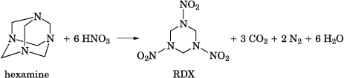
Woolwich process-
Figure 2.3

Bachmann process-
Figure 2.4

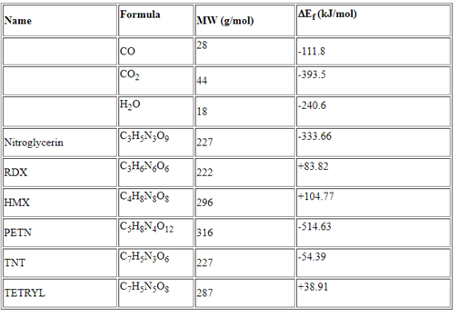
Heat of detonation of RDX-
C₃H₆N₆O₆ 3CO + 3H₂O + 3N₂

3C + 3H₂ + 3N₂ + 3O₂
Figure 2.5
Heat Release/Heat of Detonation of RDX
Before Detonation
ΔH = C₃H₆N₆₊O₆
= +83.82 kJ/mol

After Detonation
ΔH = 3CO + 3H₂O+ 3N₂
= 3(-111.8) + 3(-240.6) + 3(0)
= -1057.2 kJ/mol

Heat Release of RDX
ΔH= (+83.82) – (-1057.2) = 1141.02kJ/mol
[22]
∆ H_{D}

∆ H₁

∆ H₂

3.3.3 Baratol
The high explosive used in the Mills Bomb is called Baratol, Baratol is a mixture of TNT and Barium nitrate. The production of barium nitrate is achieved by dissolving nitric acid into a solution of saturated Barium carbonated, the nitrate produced is then crystalised to produce the colourless crystals of Barium Nitrate. The combination of TNT and barium nitrate is no longer being used by the UK military, but the military still uses Barium nitrate for a chemical called “flash powder”. Flash powder is a mixture of the barium nitrate and aluminium powder, the powder produced is then mixed with thermite to created Thermite-TH3 which is the explosive composition found in thermite grenades. [11]

3.3.4 Composition B
The high explosive used in the M67 hand grenade is composition B, composition B is a mixture of TNT and RDX. The production of composition B is achieved by melting TNT then adding wet RDX, the mixture is then cast. According to a report published by Sandia National Laboratories on the “COOKOFF OF A MELT-CASTABLE EXPLOSIVE (COMP-B)”, composition B “fails many insensitive munitions (IM) requirements. Currently, IMX-104 is being evaluated as a replacement for Comp-B”. [12]

- Physical and chemical properties of the materials used in the compositions
The two hand grenades discussed in this assignment were made using slightly different materials for their outer housing. The mills bomb used a cast iron body whereas the M67 grenade was made from a steel alloy, cast iron is made by smelting a carbon-iron alloy into moulds. Cast Iron is known for being robust and resistant to wear and indentation, its resistance to corrosion and it has a low cost to manufacture. On the other hand, the M67 HE grenade uses steel for the housing of the hand grenade, steel is used due to its high tensile strength, malleability, and high melting point. Lead azide used in the detonators of the M67 grenade is known for being insoluble in water and has a melting point of 190 °c, the chemical is also known for its sensitively to heat shock and friction when dry. The last few properties mentioned are the reasons it’s a common explosive for a detonator, but these properties make it dangerous to manufacture and operate. Lead azide is also sensitive top light and when exposed to sunlight it produces a covering of brown film. The chemical lead styphnate is an orange-dark brown crystalline solid at room temperature, C₆HN₃O₈Pb has a higher melting point than lead azide as it starts to melt at 235 °c, its insoluble in water and other organic solutions, is very stable at room temperature but is sensitive to static discharge and is highly toxic with heavy metal poisoning. TNT (2,4,6-trinitrotoluene) is an odourless pale-yellow solid at room temperature and is insoluble in water, standard TNT explodes at around 240 °c and has melting point of 80.1 °c. Whereas RDX is a white crystalline powder at room temperature, standard RDX starts to melt at 205.5°c, RDX is also sensitive to shock and rapid temperature changes. [13] [14] [15] [16] [17] [18]

- The performance differences between the M67 hand grenade and the Mills grenade
Both the M67 grenade and Mills Bomb were used as hand thrown fragmentation grenades. The M67 hand grenade uses 180g of composition B (a mix of both TNT and RDX) and has a lethality radius of 5 metres and a causality radius of 15 metres according to the specification from the manufacturers. Whereas the Mills Bomb had an overall mass of 760g and used TNT as its main high explosive, the blast radius of the Mills bomb was around 32 metres which was at the time was larger than it could be thrown. Comparing the calculations from figures 2.2 and 2.5, the heat release for TNT shows a that there is a considerable amount of energy being released upon detonation with 616.4 kJ/mol. Comparatively the heat release for RDX shows a larger amount of energy released when the same mass of RDX is detonated as the heat release was 1141.02kJ/mol. Not having the exact value for the mass of High explosive in the Mills Bomb makes it difficult to give a true comparison between the M67 grenade and Mills Bomb. [4]

- Conclusion
If the comparison is made between just the materials used by each manufacturer, we can the increase in complexity of a hand grenade as there has been discovery’s in the field and more tests have been completed. The M67’s use of steel instead cast iron to decrease the overall mass which allows the operator to throw the device a greater distance and the introduction of RDX and lead azide into the explosive composition to create a larger threat show the two biggest developments in the of hand grenades. With the USA military now looking to replace the M67 Hand grenade with the Enhanced Tactical Multi-Purpose (ET-MP) which would be a blend of a lethal and non-lethal piece of ordnance, allow the operator to select between a concussion and fragmentation grenade, shows the new developments in the field looking to reduce the amount and overall weight a solider has to carry and increasing the amount of chemical reaction require to produce a grenade to allow both a stun and high explosive function. [19]

References

[1] | M. WILL DABBS, "Tactical Life- M67 Grenade: The Evolution of Our Favorite Frag and How to Throw It," ATHLON OUTDOORS, 17 April 2020. [Online]. Available: https://www.tactical-life.com/lifestyle/military-and-police/m67-frag-grenade-history/. [Accessed 22 November 2020].
[2] | N. Watanabe, "International Encyclopedia of the First World War," International Encyclopedia of the First World War, 2018 August 29. [Online]. Available: https://encyclopedia.1914-1918-online.net/article/hand_grenade. [Accessed 22 November 2020].
[3] | DSIAC, "DSIAC Journal," A Quarterly Publication of the Defense Systems Information Analysis Center, vol. 6, no. 2, p. 18, 2019.
[4] | D. &. Z. M. Group, "DayZim," Day & Zimmermann Munitions Group, Not Referenced Not Referenced Not Referenced . [Online]. Available: https://cdn2.hubspot.net/hubfs/208537/assets/PDF/Product%20Sheets/NewWebsite_Mun_CloseCombat_M67%20hand%20grenade.pdf. [Accessed 2020 November 25].
[5] | L. Traynor, "The Mills bomb hand grenade," Not Referenced Not Referenced Not Referenced. [Online]. Available: https://royalarmouries.org/stories/the-mills-bomb-grenade/. [Accessed 25 November 26 ].
[6] | G. C. M. A. C. P. H. F. M. Yang, "Hand grenade fuze-US7712419B1". United States of America Patent US7712419B1, 11 May 2010.
[7] | J. K. A. H. Rudolf Meyer †, Explosives 5th edition, Not referenced : John Wiley & sons, 2002.
[8] | J. Clark, "Chemguide," Chemguide, Not Referenced Not Referenced 2004. [Online]. Available: https://www.chemguide.co.uk/organicprops/arenes/nitration.html.
[9] | M. B. Hocking, Handbook of Chemical Technology and Pollution Control (Third Edition), Victoria, Canada: Academic Press, 2005, p. 19.8.5.
[10] | R. Hudson, "Investigating the factors influencing RDX," CRANFIELD UNIVERSITY, CRANFIELD UNIVERSITY, 2012.
[11] | T. C. Crawford, "High explosive compound". Los Alamos, NM Patent 03/559081, 5 11 1976.
[12] | M. J. K. a. M. U. A. M.L. Hobbs, "COOKOFF OF A MELT-CASTABLE EXPLOSIVE (COMP-B)," Sandia National Laboratories, Albuquerque, NM, 2012.
[13] | B. C. Eula Bingham, Patty's Toxicology, 6 Volume Set, 6th Edition, New York: John Wiley & Sons, 2012.
[14] | M. O'Neil, The Merck Index: An Encyclopedia of Chemicals, Drugs, and Biologicals, 14th edition, WHitehouse Station, NJ: Merck and Co., Inc, 2006.
[15] | Kirk-Othmer, Encyclopedia of Chemical Technology, Index to Volumes 1 - 26, 5th Edition, New York: John Wiley & Sons, 2007.
[16] | W. V. J. S. W. J. a. E. A. P. Lawrence T. Fairhall, "The Toxicity of Lead Azide," Public Health Reports(1896-1970), vol. 58, no. 15, p. 607, (1896-1970) 1943.
[17] | R. Foundry, "Reliance Foundry," Reliance Foundry , 17 May 2017. [Online]. Available: https://www.reliance-foundry.com/blog/cast-iron-vs-cast-steel. [Accessed 27 November 2020].
[18] | S. K. Sarna, "The Applications of the Cast Iron, Iron Castings Made in China," Reliance Foundry, Not Referenced Not Referenced Not Referenced . [Online]. Available: https://www.reliance-foundry.com/blog/cast-iron. [Accessed 27 November 2020].
[19] | D. Szondy, "US Army developing first new hand grenade in 40 years," NewAtlas, 18 September 2016. [Online]. Available: https://newatlas.com/us-army-hand-grenade-et-mp/45481/. [Accessed 27 November 2020].
[20] | M. U. CAPT Michael John Hughey, "operationalmedicine," Operational Medicine, 1 January 2001. [Online]. Available: https://www.operationalmedicine.org/Safety/Weapons/M67_Fragmentation_Grenade.htm. [Accessed 21 November 2020].
[21] | L. Peverelli, "Grenades, mines and boobytraps," Grenades, mines and boobytraps, Not referenced Not Referenced Not Referenced . [Online]. Available: https://www.lexpev.nl/grenades/europe/unitedkingdom/no36.html. [Accessed 21 November 2020].
[22] | FAS.org, "FAS.org," FAS.org, Not Referenced Not Referenced Not Referenced. [Online]. Available: https://fas.org/man/dod-101/navy/docs/es310/chemstry/chemstry.htm. [Accessed 26 November 2020].

