Business Skills for International Hotel Industry
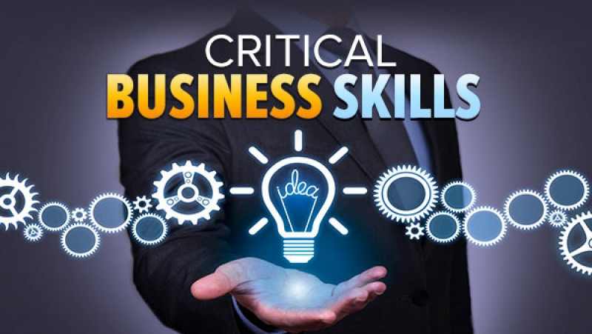
Lecturer: Dale Clark
Written Assignment part 1
Student ID:1904383
Module Code: MAX 01917
Assignment Title:

BMSK4001:
Business Skills for International Hotel Industry
Assessment Component 1

Table of Contents

Introduction…………………………………………………………….3
Skills……………………………………………………………………….4
SWOT……………………………………………………………………….6
Personal Development Plan PDP…………………………………7
Conclusion……………………………………………………………….9
References………………………………………………………………10

Introduction

In this report I have been tasked to evaluate SWOT analysis as an individual, and to analyze what I know and what I should know and how am I supposed to gain skills and how to create a better version of myself.
I am a passionate professional individual who is looking for a new challenging career after 5 years of hospitality and customer-service.
I am a hard-working individual who struggles to accomplish the best in all areas, and I am always keen to learn new skills and advance my career. As I have quite a good understanding of the business world, I am serious to build upon my information and continue to study within this sector.
As a self-motivated individual I would be open to a fresh challenge that can enhance my skills and develop new ones and I would also describe myself and my experience up to my current situation.
,,When you really want something, the whole Universe conspires in helping you to achieve it’’(2018) Coelho, P.

Skills

My current academic skills:

- Artistic- growing up with music and listening most of the time with my friends I realized that I enjoyed music and I began playing at some private party’s which it really gave me a lot of confidence and encourage me to work on my passion.
- Communication- Due to my experience in London and working as a Bartender I’ve had contact with many different cultures and different types of people. Being a good listener is one of the best ways to be a good communicator and the best way of learning. I am so much more aware of the impact that I have on others. It has made me more patient and thoughtful, which allows me to take feedback and helped me to treat difficult situations with tact and diplomacy.
- Psychological- Ability to empathise with other people and anticipate what they need at any and all times and able to take initiative when required. Can talk calmly and peacefully and maintain composure in stressful environments and remain focused on the task at hand

Employability skills

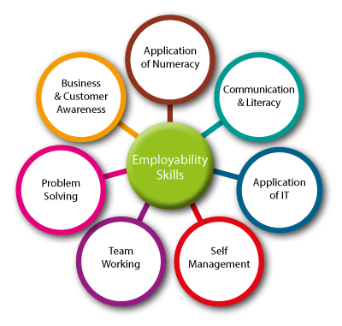

- Team working- As a strong individual I’m very keen in my colleagues work and we need to work as a team and got to be focused on creating enthusiasm and initiative to make things happen
- Self-Management- getting rid of the negative thoughts in our head it is very important for daily routine especially self-management and all the time think positively and be happy with small things
- Communication Literacy- means that all the way thorough our managerial skills we need to pass meaningful messages to the listeners and also we need to make sure that our employees from different countries understand to the fullest.

SWOT

A study started by an organization to classify its internal strengths and weaknesses as well as its external opportunities and threats.
A personal SWOT analyses is a self evaluation about an individual which contains all the necessary steps to make thing about who you are and what you want to become in your future but in the same time it can be used from any other purposes like businesses, individual, in the work field as well as in studies.
To manage the threats and weaknesses I have to be able to build strategically on strengths and opportunities

,,Kotler used SWOT analyses to attain an orderly approach to decision making, many researchers in different fields apply SWOT analyses.
SWOT analyses is a practical methodology pursued by managers to construct successful strategies by analysing strengths, weaknesses, opportunities and threats.
SWOT analyses is a powerful methodology for making accurate decisions.
Organization’s construct strategies to enhance their strengths, remove weaknesses, seize opportunities and avoid threats. Has been applied in education domain healthcare, government and not-for-profit organizations to handle country level issues and for sustainable investment related decisions.’’ (Mohamed Abdel-Basset, 2018). An Extension of Neutrosophic AHP-SWOT Analysis for Strategic Planning and Decision Making)

By doing this research as part of analysing my employability, I ensured a SWOT analysis to restore my strengths and opportunities as well as my weaknesses and threats to my success.
Strengths:

-I adapt fast to new changes
-ability to mobilize followers
-ability to solve problems with tact and diplomacy
-keep an upbeat energy
-always focusing on people building loyalty and trust
-advanced English language skills and good communication skills

Weaknesses:

-Paying to much attention on unnecessary details
-Not comfortable taking risks
-Too focus/Lack of focus
-Take on too much responsibilities
-Procrastination (used to think that is not such a bad habit because I am only creating stress for myself)

Opportunities

-Embrace change
-Being my own boss
-Willing to acquire new skills and advance my career
-Local and global events
-To learn and achieve experience from the most experienced individuals
-To contribute others in providing feedback about their experience of me

Threats

-Time pressure-because it can delay my plan for self-improvement back to my usual habits
-The everyday things demand, which conspires against self-reflection
-Unknown competition

Personal Development Plan

Personal development plan is an instrument used today for companies but also is used for individuals who can better asses and plan for development. The main purpose of personal development plan is to reveal strength and weaknesses, to improve and to find the target goals and possible objectives. Personal Development Plan can help you to achieve great self-confidence and to realise where you’re wrong or right.
It also helps you to find new directions, achieve your full potential, make more time to look after yourself, maximise your career potential, etc.
Personal Development Plan is a lifelong process, it is a way for people to asses their skills and qualities, considering their aims and objectives in life and set goals in order to understand and exploit their potential. (Bridgewater UK, 2018)

In the next part of my work it will be my Personal Development Plan, which is explained considering both, working skills and academic skills, professional goals and academic goals.

SHORT TERM LONG TERM

1.Improve English 1. Travel the world
2.Gain essential IT skills 2. Open a business
3.Achieve my full potential 3. Start a family
MY GOALS 4. Open more choices 4. Pursue new career
5.Maximize my career potential 5. Publish a book

SKILLS AND 1. Leadership 1. Communication skills,
KNOLEDGE TO 2. Adaptability listening, speaking and
BE LEARNED 3. Time Management writing.
4.Office basic knowledge 2. Interpersonal Abilities
5.Ability to work under pressure 3. Leadership/
Management skills
4.Flexibility/Adaptability
5.Ability to plan,
Organise and
Prioritise work

HOW TO AQUIRE 1. Doing research 1. Start working on being
THEM 2. Reading books leader
3.Focusing on deadlines 2. Record yourself
4.Reviewing notes 3. Join a group
5.Being organised 4. Time travel
5.Become a professional
individual

RESOURCES 1. Another people knowledge 1. Graphic information
2.Internet, books, laptop 2. Company expansions
3.Practical articles 3. Time, course
4.Curriculums 4. Lectures
As I wrote above I have established high goals to be achieved in the next 2 years while I’ll be studying and I will try with every small phase I want to take and what I need to learn to accomplish the person that I want to become
All those elements and skills are very important for me because it will edify my future in very good way which I’m certain.

,When we are no longer able to change a situation, we are challenged to change ourselves.’’ Frankl, E. V.

Now a days in the current society that we’re living IT skills are essential in any type of job you are looking for, it doesn’t matter is it’s accounting, finance or customer service, every candidate with good IT skills will be chosen instead of a candidate with no IT skills at all because all the companies need people that are multitasking, people that have skills and are able to maintain the company standards at the very high levels.

Conclusion

By doing this research it made me think about achieving my goals and to be more serious about my future, about the goals, the target, about who I want to be and where in the next 5 years.
Over my readings to realize this report I realized how important is to have a plan in life which is very motivating and only if you are motivated you can make your dreams come true and to follow your path.
I am aware about the fact that big dreams come with high responsibilities and great sacrifice in order to reach them. With the help of this analysis I set my targets, my goals and with the combination of technical and soft skills I would be able to sustain a job and grow by getting all the necessary tools to develop a culture of lifelong learning like Anthony P. Carnevale said: ,,In today’s work world, those skills are as important as cognitive skills’’.

References

Basset, M.A.,(2018). An Extension of Neutrosophic AHP-SWOT Analysis for Strategic Planning and Decision Making. (online). Available at: https://books.google.co.uk/books?id=_IluDwAAQBAJ&pg=PA2&dq=lit+review+swot&hl=ro&sa=X&ved=0ahUKEwj988qIr6rjAhUZhlwKHbFmDcoQ6AEIMDAB#v=onepage&q=lit%20review%20swot&f=false. (Accessed: 5.07.2019)

Coelho. P. (2018), The Alchemist [30th Anniversary Edition], Harper Collins (2018).

Frankl, V.E. (1984). Man’s search for meaning: an introduction to logotherapy. New York, Simon & Schuster.

Wellington, J.K. (2005). The ‘’Soft Skills’’ of success. Vital Speeches of the Day, 628-634.

ZEHR, A. (1998). NEW OFFICE ECONOMY.

Geneva: International Labour Office

