

Module code: LCLM4002
Informative Poster
Task 2

Name of the Student: Dragos Costinel Ocneanu
Student ID: 2411678
Module Leader: Koushik Modak
Submission Date: 29th November 2024

Table of Contents
Task 2 3
Reference List 5

Task 2
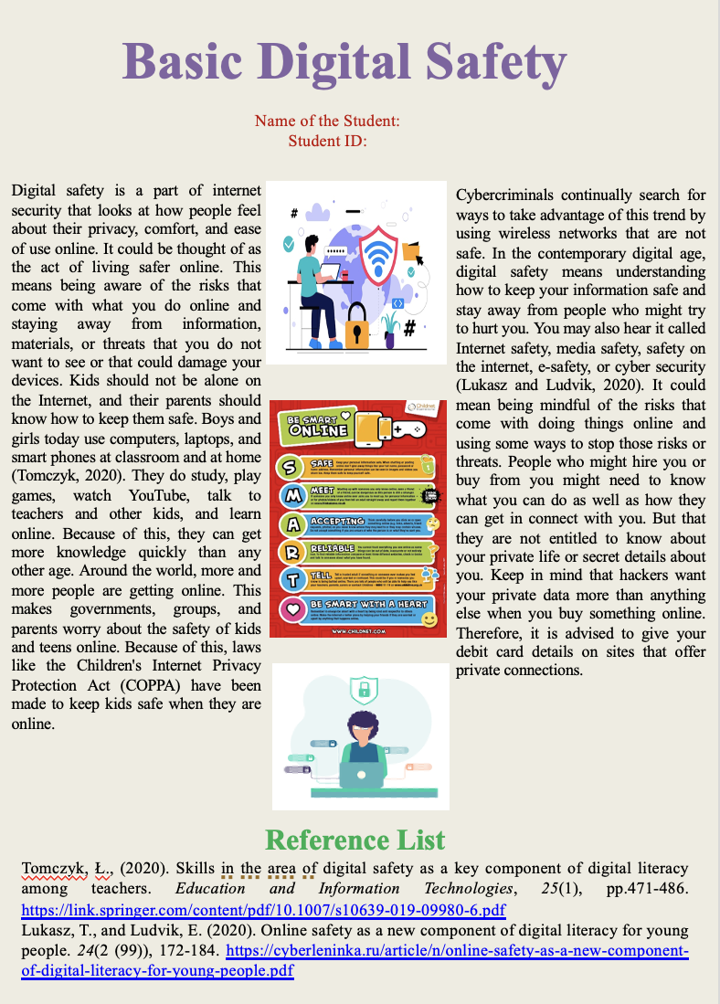
Digital safety is a part of internet security that looks at how people feel about their privacy, comfort, and ease of use online. It could be thought of as the act of living safer online. This means being aware of the risks that come with what you do online and staying away from information, materials, or threats that you do not want to see or that could damage your devices. Kids should not be alone on the Internet, and their parents should know how to keep them safe. Boys and girls today use computers, laptops, and smart phones at classroom and at home (Tomczyk, 2020). They do study, play games, watch YouTube, talk to teachers and other kids, and learn online. Because of this, they can get more knowledge quickly than any other age. Around the world, more and more people are getting online. This makes governments, groups, and parents worry about the safety of kids and teens online. Because of this, laws like the Children's Internet Privacy Protection Act (COPPA) have been made to keep kids safe when they are online.
Cybercriminals continually search for ways to take advantage of this trend by using wireless networks that are not safe. In the contemporary digital age, digital safety means understanding how to keep your information safe and stay away from people who might try to hurt you. You may also hear it called Internet safety, media safety, and safety on the internet, e-safety, or cyber security (Lukasz and Ludvik, 2020). It could mean being mindful of the risks that come with doing things online and using some ways to stop those risks or threats. People who might hire you or buy from you might need to know what you can do as well as how they can get in connect with you. But that they are not entitled to know about your private life or secret details about you. Keep in mind that hackers want your private data more than anything else when you buy something online. Therefore, it is advised to give your debit card details on sites that offer private connections.

Reference List
Tomczyk, Ł., (2020). Skills in the area of digital safety as a key component of digital literacy among teachers. Education and Information Technologies, 25(1), pp.471-486. https://link.springer.com/content/pdf/10.1007/s10639-019-09980-6.pdf
Lukasz, T., and Ludvik, E. (2020). Online safety as a new component of digital literacy for young people. 24(2 (99)), 172-184. https://cyberleninka.ru/article/n/online-safety-as-a-new-component-of-digital-literacy-for-young-people.pdf

