

BA BUSNIESS MANAGEMENT
COMMUNITY ENGAGEMENT
Assessment 2

Module Code: LCBB4002
Module: Community Engagement
Lecturer :Akinseye Rahman
Student ID: 2123374
Student Name: Maria-Alexandra Chesoiu

Executive Summary
A reflective report has been developed to compare the impact and role of the Birmingham Commonwealth Games and Queensland Commonwealth Games in community engagement. During the course of this discussion, various aspects of both of these mega-events have been explained.

Table of Contents
Contents
1.0 Introduction 4
2.0 Discussion 4
2.1 Description of the Differences between Two Projects 4
2.2 Analysis, Comparison and Evaluation of Best Community Practices of Both Projects 6
2.3 Impact of Active Participation, Consultation, Communication and Inclusion of Stakeholders 7
2.4 Social Engagement and Community Mapping through Social Media 8
2.5 Impact of Evaluation, Justification and Analysis of Best Practices 9
2.6 Reflection (Reflect on what could have been done differently and why?) 9
3.0 Conclusion 11
References 12

Introduction

The word “community” is a broad term and is often used to denote a lot of people together. These people either can be stakeholders, citizen groups or interest groups. A community can be defined and classified into various types. A community can be determined either on the basis of geographic locations or people belonging to the same community which is called a community of practices. There are other types of communities as well such as the community of identity, a community of sporting clubs or a community of affiliation. Community engagement on the other hand is a process of working in collaboration with many people who are often affiliated either by special interests, or geographic proximity. Sports or any kind of sporting event are great facilitators of community interaction or engagement. These kinds of events are often organised for building stronger bonds with the neighbours (Bice et al., 2019). For this reason, sports should be engaged greatly in every community. The following assignment has been developed in the form of a reflective report to understand the impact of the Birmingham Commonwealth Games and Queensland Commonwealth Games of 2018.

Discussion

2.1 Description of the Differences between Two Projects
About 5054 athletes from about 72 Commonwealth nations participated in the Birmingham Commonwealth Games (Birmingham 2022). This prestigious event acted as a catalyst for the city as it helped to drive economic growth in the nation and determine long-term social and economic benefits. I felt that the effects of this event will stay in the following years as well. The value of the UK investment market increased during the event.
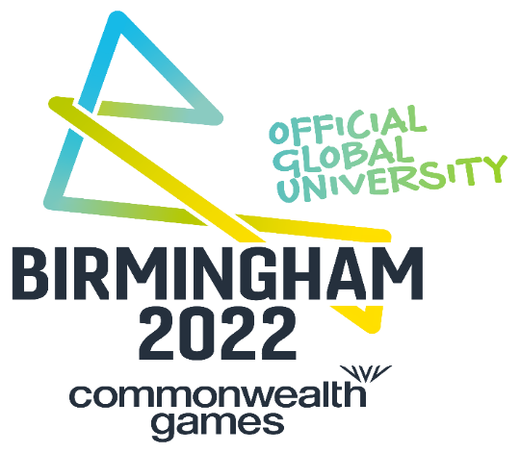
Figure 1: Logo of Birmingham Commonwealth Games
(Source: Birmingham 2022)
I have also observed that these kinds of events often help to boost regional, local and national GDP. The game came with an economic benefit of about £1 billion (Carlini et al., 2020). As per the reports published by the Federation of Commonwealth games, the national economies exhibited a growth of about £800 million. The local residents also benefitted from these games as national infrastructural development took place before the occurrence of these events. Multiple legacy venues were constructed where people can go and enjoy sports events (de Ruyter et al., 2021). An investment of about £778m was undertaken to regenerate the whole region of West Midlands and Birmingham. Public funding played a major role in this regression process.
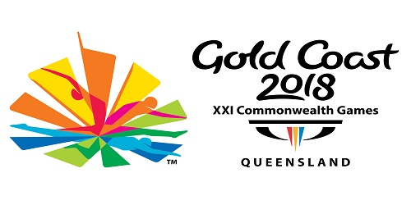
Figure 2: Logo of Gold Coast
(Source: Gold Coast 2018)
Besides Birmingham Commonwealth Games the success and impact of the Queensland Commonwealth Games held in 2018 cannot be denied. The nation has developed world-class infrastructure and developed many events that attracted millions of audiences and sports lovers from all over the world (Gold Coast 2018). The event was accompanied by Corrina Bonshek’s Song to the Earth which flourished the culture of the Commonwealth Games to a great extent. The event engaged about 50 musicians that helped to illuminate the sculptures. The event was full of songs and dance performances and some of the pieces were even nominated for various national and international awards and some of them own too.

2.2 Analysis, Comparison and Evaluation of Best Community Practices of Both Projects

Both of the chosen projects were significant in their own way. Commonwealth Games play a major role in not only engaging only Commonwealth Countries but also other countries as well. Birmingham Commonwealth games have been proven to be spectacular in this case. This event was special due to various reasons such as it broke about four world records, a total of 877 medals were awarded to the participants and it also broke about 96 previous Commonwealth Records (James, 2022). This event will also remain special for arranging more medal events for women as compared to men. More para-sports have also appeared. In addition to that during this event, three games were introduced for the first time in the history of the Commonwealth Games which are Women’s T20 cricket, Wheelchair basketball and multi-sport basketball. The event took place in 15 different venues across Birmingham, London and West Midland. It has been reported that this event became successful in entertaining about 1.5 million ticketed spectators (Kelly and Coleman, 2019). The organizers arranged about 9 free festival sites throughout the entire city and also hosted a neighbourhood festival in 7 different locations. The competition took place for about 11 days. This event played a major role in uniting different nations and delivering a beautiful sports culture.
The Queensland Commonwealth Games of 2018 is also known as the Gold Coast Event. About 600,000 people live here. Gold Coast already had several infrastructures but it also developed three more venues so that the event could be held successfully (Kuhn et al., 2021). These venues are Leisure Centre, Coomera Indoor Sports Centre and the Coast Sport. More contracts were also given to the lighting, temporary power, broadcast, seating and event staging companies. The value of the construction contract was $657 million and the construction company also developed a well-equipped games village. About 90% of the total partner companies were from Queensland. Moreover, it can be stated that the occurrence of this particular event provided many opportunities for local business organisations to earn profits (McKinley et al., 2021). The authorities of the Commonwealth Games and the government of Queensland agreed to construct or renovate various sporting grounds and buildings in such a way that matches the Commonwealth standard. This is how infrastructural development occurred in the city.

2.3 Impact of Active Participation, Consultation, Communication and Inclusion of Stakeholders

West Midland is a culturally diverse and vibrant city and hence it has provided a great opportunity for the entire organising committee to engage the whole community across the country. This particular event has created a huge positive impact on various stakeholders of the game such as the organizers, participants, spectators, partners and investors. The event recognized diversity and tried to provide all the underrepresented groups with a platform (Mosadeghi et al., 2020). The vision of this game was to improve the community and to increase the engagement of the common people in sports. The game has also been proven to be accessible and inclusive for every vital stakeholder such as team officials, media, spectators, athletes and volunteers. The event focused on ensuring inclusivity, sustainability and creativity. The Commonwealth Games are also designated as friendly Games these games are arranged not to increase competition and enmity among various communities but rather to promote the message of unity (Steinmetz et al., 2021).
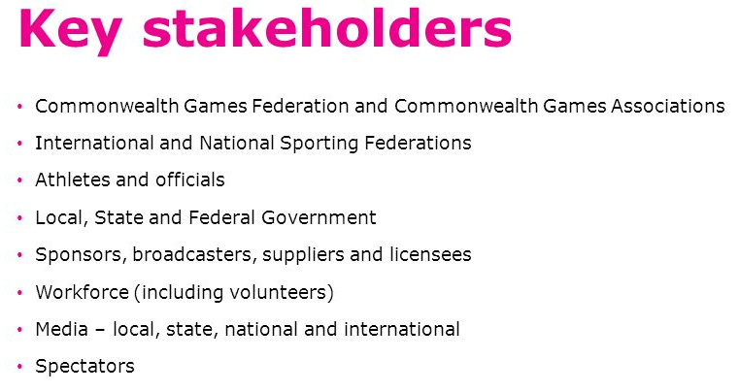
Figure 3: Key Stakeholders of Commonwealth Games
(Source: Steinmetz et al., 2021)
The Commonwealth Games of 2018 on the other hand focused more on promoting culture and heritage through the exhibition of regional music and dance. The event also tries to bring all people together with each other with the help of their attractive campaigns and by allowing active participation. People from different cultural as well as socio-economic backgrounds participated in the event irrespective of their gender or disability. The event focused on developing equality in all aspects of the event and all the stakeholders were encouraged greatly to participate. The event delivered an inclusive and highly accessible game (Stevenson, 2020). The event organizer encouraged every stakeholder to create an open, fair and supportive throughout the entire delivery of the event. The Gold Coast event also tried to keep the entire community informed through the development of various events during the entire event duration. Educating the mass about the issues related to inequality has become a part of this event. Even all the stakeholders were kept informed about the progress of the event as well as construction.

2.4 Social Engagement and Community Mapping through Social Media

Over the last few years social media platforms are being used extensively as an important tool for engaging a bigger community. In the case of developing countries, graffiti reporting is conducted with the help of social media platforms and on the other hand, in developed countries development of the local community are taken place with the help of these platforms (WHATMAN, 2022). During the Commonwealth Games, social media platforms played an important role in making athletes and their efforts popular to a great extent.
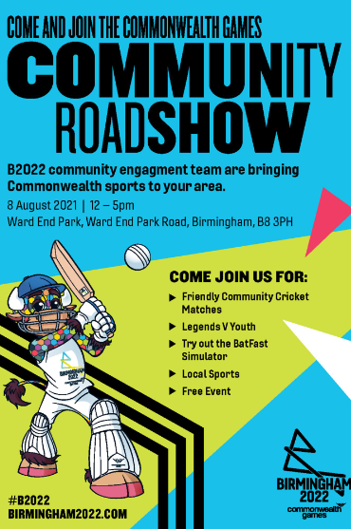
Figure 4: Social Media Post for Community Engagement
(Source: WHATMAN, 2022)
These platforms also played a major role in stealing the glances of the youths and making them interested in games. I have already mentioned that during the entire duration of the event various programs took place for making people aware of community engagement, unity, games, etc. Social media platforms have been used effectively for promoting all these programs so that both national and international audiences can get attracted.

2.5 Impact of Evaluation, Justification and Analysis of Best Practices

Birmingham Commonwealth Games became a huge success in the implementation of many innovative ideas during the event. This event not only broke 97 commonwealth records but also four world records (Wise, 2020). This event also created an extraordinary impact in promoting gender equality. Women’s T20 cricket was introduced for the first time in the Commonwealth Games. This event will also be remembered for introducing more para games. The GDP of the country become increased to a greater level after receiving investments from various national and international agencies. Moreover, it can be stated that the arrangement of the Commonwealth is completely justified not only for promoting sports and culture but also for uniting many countries and communities together.
One of the major actions performed by the Gold Coast Games was the establishment of accessibility, greater inclusion of stakeholders and promotion of diversity. This event also brought many growth opportunities for local business organisations. This event also caused huge infrastructural development in the nation (WHATMAN, 2022). A huge and well-equipped games village was constructed for the athletes which also enhanced the reputation of the organizing committee.

2.6 Reflection (Reflect on what could have been done differently and why?)

From the above discussion, an idea has been developed about community engagement that this process is very effective not only in engaging the community and for infrastructural development but also in providing various growth opportunities to the stakeholders. It makes the participants confident by providing them with a global platform and by offering medals to all the worthy athletes this event motivates them. I have realized that Commonwealth Games are one such mega events that provide many national and international athletes with many growth opportunities. There are many volunteer service providers who obtain immense knowledge in their area of concern by working during the event. Moreover, it can be stated that these events are crucial for providing various growth opportunities. Commonwealth games are also important for bringing economic growth. During the Gold Coast, the origin of about 90% of the partners of the event was Queensland itself (Wise et al., 2021). Hence, I can assume that the country has observed rapid economic growth and a sudden rise in the national GDP during this event. In the case of both projects many national and international exhibited their interests in investing which has brought huge capital to both of these nations for further development. Despite having many growth opportunities and greater community engagement these events also experienced many issues. The Birmingham Commonwealth experienced a huge budget crisis for quite some time. The majority of the cost that about 75% of the cost was paid by the Government while about 25% of the expenses were managed by the city council. To raise this fund the city started collecting hotel tax which offended many people. This huge expenditure will also make the city council indebted for the coming years. Insolvency became a common issue during the entire duration of the game.
The Commonwealth Games of 2018 was not free from any controversies either. The event experienced faulty ticket printing procedures which made many visitors confused (Kelly and Coleman, 2019). Some of them attended the wrong event on the wrong day which caused huge harassment. There were also frequent activities caused by the aboriginals and as a result of which many protests took place.

Conclusion

The following assignment has been developed in the form of a reflective report and focused on comparing various aspects of the Birmingham Commonwealth Games of 2022 and Queensland Commonwealth Gemes of Australia. In this report, the impact of the games on the local community, the social impact of the games on the people, economic growth related to the event, etc. different areas of these events have been discussed.

References
Bice, S., Neely, K. and Einfeld, C., (2019). Next generation engagement: Setting a research agenda for community engagement in Australia's infrastructure sector. Australian Journal of Public Administration, 78(2), pp.290-310.
Birmingham (2022) ((2022)) Home of the Birmingham (2022) commonwealth games, Commonwealth Games - Birmingham (2022). Available at: https://www.birmingham(2022).com/ (Accessed: November 29, (2022)).
Carlini, J., Coghlan, A., Thomson, A. and O'Neil, A., (2020). From legacy rhetoric to business benefits: A case study of the gold coast (2018) commonwealth games. Event Management, 24(1), pp.75-96.
de Ruyter, A., Hearne, D., Beer, J. and Zaman, Y., (2021). Brexit, Birmingham and the (2022) Commonwealth Games: an opportunity for regeneration and rejuvenation?. Managing Sport and Leisure, 26(5), pp.413-428.
Gold Coast (2018) ((2018)) Gold Coast (2018) commonwealth games, Gold Coast (2018). Available at: https://gc(2018).com/ (Accessed: November 29, (2022)).
James, L., (2022). Sustainability commonwealth games: The commonwealth games': Green asprations: Fact or fiction?. Engineering & Technology, 17(7), pp.20-24.
Kelly, K. and Coleman, E., (2019). Community Engagement in Independent Performance-making in Australia: A case study of Rovers. Social Alternatives, 38(1), pp.53-64.
Kuhn, T., Jayaratne, R., Thai, P.K., Christensen, B., Liu, X., Dunbabin, M., Lamont, R., Zing, I., Wainwright, D., Witte, C. and Neale, D., (2021). Air quality during and after the Commonwealth Games (2018) in Australia: Multiple benefits of monitoring. Journal of Aerosol Science, 152, p.105707.
McKinley, E., Crowe, P.R., Stori, F., Ballinger, R., Brew, T.C., Blacklaw-Jones, L., Cameron-Smith, A., Crowley, S., Cocco, C., O'Mahony, C. and McNally, B., (2021). ‘Going digital’-Lessons for future coastal community engagement and climate change adaptation. Ocean & Coastal Management, 208, p.105629.
Mosadeghi, R., Barr, D. and Moller, R., (2020). The Use of GIS in Major Sport Events Management; the Host City’s Lessons Learned from Gold Coast (2018), Commonwealth Games. Applied Spatial Analysis and Policy, 13(1), pp.51-67.
Steinmetz, C., Rahmat, H., Marshall, N., Bishop, K., Thompson, S., Park, M., Corkery, L. and Tietz, C., (2021). Liking, Tweeting and Posting: An Analysis of Community Engagement through Social Media Platforms. Urban Policy and Research, 39(1), pp.85-105.
Stevenson, N., (2020). Having a say? The potential of local events as a tool for community engagement. Event Management, 24(4), pp.435-445.
WHATMAN, C., (2022). Post the glow of Birmingham gold, time to maximise the opportunity sport provides. BEST OF BRITISH (2021) 6, 49(1), p.5.
Wise, N., (2020). Commonwealth Games: How could sport tourism benefit Birmingham?.
Wise, N., Harris, J. and Whittam, G., (2021). Regeneration, communities and contemporary issues in sport and leisure. Managing Sport and Leisure, 26(5), pp.341-345.

